LIQUID BIOFERTILIZERS AS A SUSTAINABLE SOLUTION FOR AGRICULTURE
N.SOWNTHARYA *and G .MANIMEKALAI

Sengamala thayaar educational trust women’s college (autonomous)sundarakkottai, mannargudi -614016

Corresponding author*:
manistet@gmail.com

INTRODUCTION
The current increase in the world population to 7.8 billion has placed an increasing demand on agricultural crops, thus posing great challenges in terms of how to feed such a large population.According to the United Nations Food and Agriculture Organization’s estimates, the demand on agricultural crops will increase to 60% by the year 2030.To reach self-sufficiency, chemical fertilizers have been widely used by countries to increase crop yield. However, these chemical fertilizers are causing serious environmental pollution by reducing water-holding capacity in the soil and thus its fertility, increasing soil acidity, and reducing the number of microorganisms, resulting in nutritional imbalances in the soil In addition, these hazardous substances are not taken up by plants, but accumulate in ground water affecting the soil negatively. Therefore, it is vital to shift the focus to the production of safe and environmentally friendly methods for sustainable crop production.
Consumer awareness about the hazards of chemical fertilizers, soil deterioration, and nitrate emissions, as well as government measures, are increasing with years. Hence, the market for biofertilizers is expected to increase from 2.3 billion USD in 2020 to 3.9 billion in 2025. Biofertilizers are known for their ability to provide plants with nutrients such as nitrogen, phosphate, zinc, phosphorus and also help in promoting plant growth.Since carrier based biofertilizers have a short shelf life, low cell count, and difficulties in storage and handling, liquid biofertilizers which a have a high cell count of more than 10⁹ were developed to overcome these problems.
Production of low cost, effective biofertilizers involves multiple phases, starting from choosing the suitable carrier, isolation and screening of microbes to find the most potent one, to undergoing several tests, before scaling it up from flask-stage to commercial stage.It is also important to find cheaper raw materials that are high in nutrients, carbon, and nitrogen source and use it as a substrate or possible liquid media to culture microorganisms. Some industries are required to pay to get rid of their waste or have a difficult time in treating their wastes. Thus, these wastes and byproducts can be used as possible substrates to develop a sustainable, eco-friendly biofertilizer . Moreover, biofertilizers can be tailored to provide plants with nitrogen, phosphate, zinc, or other nutrients in different soil types using certain types of bacteria compared to using none or chemical fertilizers.
In the light of these features, this review first compares biofertilizers with chemical and organic fertilizers, then evaluates the production processes and compares the liquid inoculants and their impacts on plant growth. The development of liquid biofertilizers is discussed based on how it is developed from different substrates, or by-products and wastes of some industries. Finally, the challenges and recommendations for future studies are discussed to improve the production and development of liquid biofertilizer, benefiting its expansion and commercialization for the agricultural industries.

BIOFERTILIZERS

Biofertilizers in general
Biofertilizers are one of the most promising ways to increase crop production while staying environmentally friendly .
.Unlike organic fertilizers which consist of animal manure, compost, slurry waste, peat, bones, and blood meal , biofertilizers contain one or more living microorganisms (i.e., bacteria, fungi, algae) alone or in combination that settle down in the rhizosphere and enhance soil productivity by fixing down atmospheric nitrogen and solubilizing different nutrients, thereby exerting direct or indirect beneficial effects on crop growth and yield through different mechanisms.
In organic fertilizers, some organisms like earthworms need to convert the fertilizer into useful material which plants can absorb easily. Plant-growth promoting rhizobacteria is the most used bacteria in producing biofertilizers since it enhances plant growth by releasing potassium (K), fixing nitrogen (N), solving phosphorus (P), and producing hormones. Biofertilizers come in solid, liquid, polymer entrapped formulations, and fluidized bed dry formulations.Table 1 shows the differences between biofertilizers, chemical, and organic fertilizers with the pros and cons analyzed.
Plants need 14 essential mineral elements to grow and develop, which are macronutrients – N, P, K, Ca, Mg and S, and micronutrients – Fe, B, Cl, Mn, Zn, Cu, Mo, and Ni Although most of the elements are found in soil, they cannot be taken up by the plants because they are in forms that plants cannot assimilate. Some of these elements are absorbed by plants only in certain forms like nitrogen that is absorbed as either nitrate or ammonia. As shown in Figure 1, using microorganisms will promote plant growth and provide plants with nutrients Biofertilizers are classified based on the groups of microorganisms they contain and the functional features they have developed during the interactions with plants in the rhizosphere.

Liquid biofertilizers

Liquid biofertilizers are used as an alternative to carrier-based formulations.They are also called flowable or aqueous suspension. They are based on broth culture, mineral and organic oil, oil in water, and polymer based suspension Liquid biofertilizers typically consist of 10–40% microbes, 1–3% suspender ingredient, 1–5% dispersant, 3–8% surfactant, and 35–65% carrier liquid (water or oil) . Liquid biofertilizers should contain special cell protectants that contribute to the development of cysts and dormant spores.
Liquid biofertilizers are more attractive than solid inoculants because they have a long shelf life of 1.5–2 years, have no contamination, do not need sticky materials, can be used with modern machinery, can withstand high temperatures up to 45 C, are easy to handle and use, are easy for adding ingredients that enhance the growth of microbial strains, and are easy to apply on both seeds and soil . Also, liquid inoculants have higher microbial densities that allow for lower dosages compared to solid-inoculants yet obtain the same effect.
The carrier material for liquid biofertilizers should be cheap, abundantly available, non-toxic, and easy to use. The carrier also must have a suitable pH, high water holding capacity, and physical and chemical homogeneity to enhance microbial growth. Although liquid biofertilizers can be stored for a long time, microorganisms may face nutrient depletion, hypoxia, and environmental stresses which cause the microbial population to dramatically decrease. Therefore, special storing conditions are needed such as cool temperatures.

Liquid biofertilizers can reduce the use of chemical fertilizers by 15–40%. In addition, their dosages are less than solid biofertilizer by 10%, thus less amount is needed, allowing for smaller storage spaces.
There are four types of liquid biofertilizers: suspension concentrates, ultralow volume suspension, oil-miscible flowable concentrate, and oil dispersion. Suspension concentrates are favored by farmers more than wettable powders because they are not dusty, easier to measure, and can be poured in spray tanks. Suspension concentrates are made by combining solid active ingredients with low water solubility and acceptable hydrolysis stability. Before using, suspension concentrates must be diluted in water. Using surfactants and other chemicals can increase their storage and solubility. Ultralow volume suspension is a ready-to-use formulation that can be dispersed by ultralow volume aerial or ground spray machinery in a very fine spray. Oil miscible flow concentrate is a dispersion of active ingredients in an organic liquid. It must be diluted before use . Oil dispersion contains active ingredients in oil or in water immiscible solvent.
Oil is known to evaporate much less than water, so it stays in contact with plants for a longer time. It can be applied as an emulsion or an inverted emulsion (water in oil). Table 3 shows some of the companies that produce liquid biofertilizers in Jordan, India, Sri Lanka, and the United States.

Mechanism of biofertilizers
Plant growth-promoting rhizobacteria stimulate plant growth through a variety of methods. They are frequently divided into direct and indirect methods. The bacteria may either directly increase plant growth by altering hormone levels or resource acquisition, or indirectly increase plant growth by reducing the impact of numerous pathogenic agents on plant growth and development

Direct mechanism
Nitrogen becomes available to plants by the energy intensive process of biological nitrogen fixation (BNF) due to the fact that most of it is available in the atmosphere. Diazotrophs which consist of bacteria and archaea use the large stock of N₂ from the soil to biologically fix nitrogen. Atmospheric N₂ is catalyzed and reduced into ammonium (NHþ₄) by the nifH gene that encodes the highly conserved iron-protein subunit of the nitrogenase enzyme which consists of dinitrogenase reductase that has Fe as its co factor and dinitrogenase with Fe and Mo as its co factor as well as it being controlled by diazotrophs.
These microorganisms are divided into two groups symbiotic, and non-symbiotic. The symbiotic family consist of Rhizobiaceae and Cyanobacterium anabaena with azolla fern water where it has been used for more than 1000 years as a biofertilizer (Azolla-Anabaena symbiosis). The non-symbiotic family consists of Azospirillum sp. and Cyanobacteria sp. Phosphate is the second most important element for plant growth and development after nitrogen, except that it is not available to plants since it is in an insoluble form and only 0.1% is available to plants. Microorganisms help solubilize insoluble P like dicalcium phosphate, tricalcium phosphate, hydroxyapatite, and rock phosphate by acids and other mechanisms that reduce the soil’s pH into soluble forms of monobasic and dibasic which increase plants yield. Sometimes these bacteria mobilize the phosphorus.
Phosphate solubilizing bacteria efficiency depends on soil buffering capacity and its carbon and nitrogen sources.
Table 2. Grouping of biofertilizers with functions .
No. Nature of Functions Examples organisms
1 |  | Free-living |  | Nitrogen-fixing biofertilizers |  | Azotobacter, Beijerinckia,  Clostridium, Klebsiella, Anabaena, and Nostoc
2 |  | Symbiotic | Phosphorussolubilizing biofertilizers |  |  | Rhizobium, Frankia, and Anabaena azollae
3 |  | Associate symbiotic |  |  |  | Azospirillum
4 | Bacteria |  |  |  |  | Bacillus megaterium var phosphaticum, Bacillus subtilis,  Bacillus circulans, and  Pseudomonas striata
5 |  | Fungi | Phosphorusmobilizing biofertilizers |  |  | Penicillium sp. and Aspergillus awamori
6 | Arbuscular mycorrhiza |  |  |  |  | Glomus sp., Gigaspora sp.,  Acaulospora sp., Scutellospora sp., and Sclerocystis sp.
7 | Ectomycorrhiza |  |  |  |  | Laccaria sp., Pisolithus sp., and Boletus sp.
8 | Ericoid mycorrhizae |  |  |  |  | Pezizella ericae
9 | Orchid mycorrhiza |  |  |  |  | Rhizoctonia solani
10 |  | Silicate and zinc solubilizers |  | Biofertilizers for micronutrients |  | Bacillus sp.
11 |  | Pseudomonas |  | Plant-growthpromoting rhizobacteria |  | Pseudomonas fluorescens
microorganisms and indole-3-acetic acid (IAA) primarily controls plant cell differentiation, cell division, and root length.
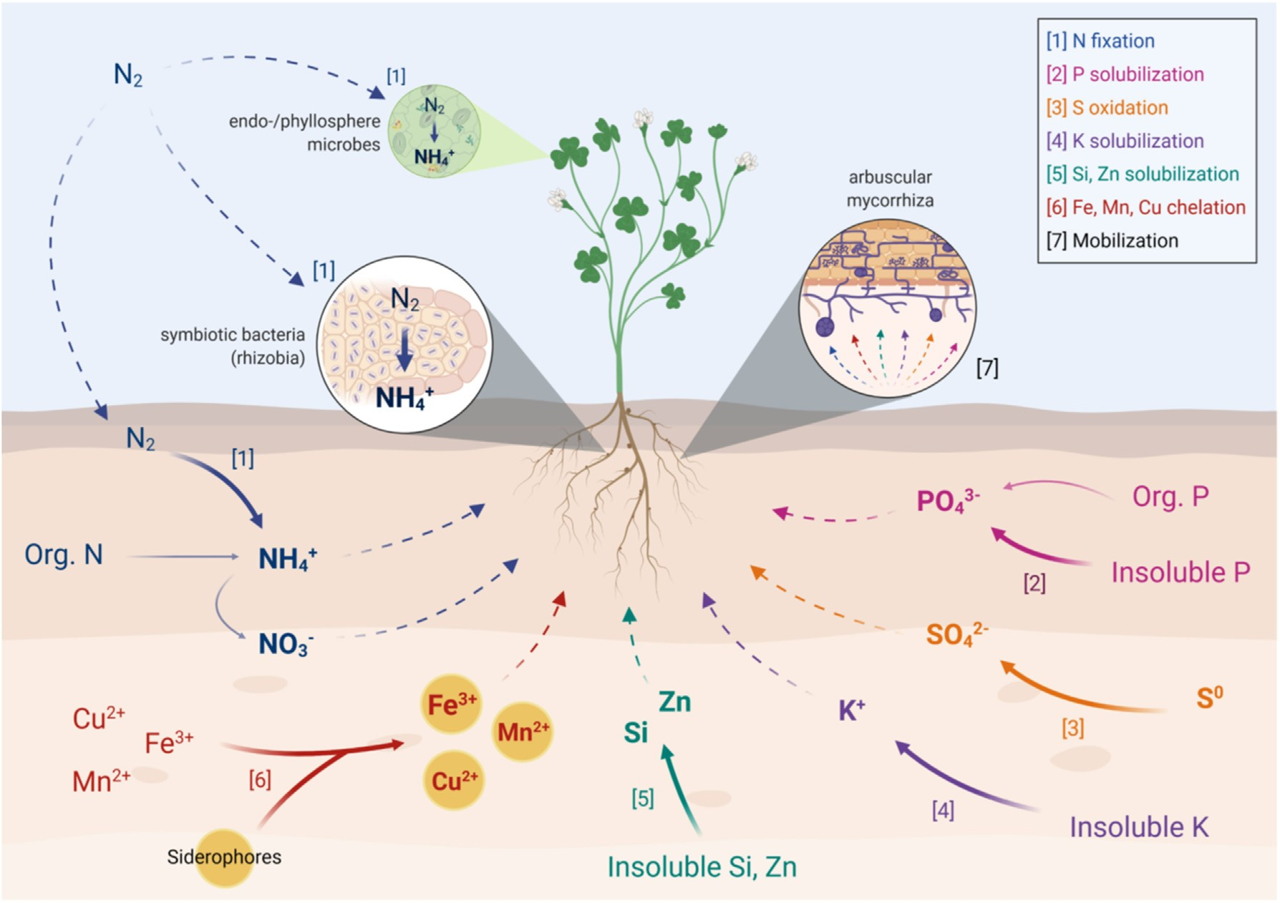
Figure 1. Key microbially-mediated nutrient transformation/acquisition pathways associated with biofertilizers. Full arrows represent microbial transformations whereas dashed arrows represent mobilization/movement of nutrients (Mitter et al., 2021).

Table 3. Companies providing liquid biofertilizers in Jordan, India, Sri Lanka and the United States.

Company Biofertilizer Composition Possible function Target crops Reference
Al Anfal Fert.  Industry CO.,  Jordan |  | Anfazyme |  | Seaweed with enzymes: 20–25% organic matter:  vitamins, cytokinin, and auxins |  | Increases yield and improves plants quality |  | Fruits, vegetables, and field crops |  | (Al Anfal Fertilizer  Industry Co.,  2018)
Bio Power  Lanka, Sri Lanka |  | Bio Vaccine |  | Trichoderma viride |  | High productivity, prevents the plants from diseases and rot |  | Used for nursery plants |  | (Bio Power Lanka,  2021c)
 |  | Bio Gold |  | Azotobacter chroococcum, Pseudomonas fluorescens |  | Nitrogen fixing, phosphorus solubilizing, and prevent diseases |  | Fruits, vegetables, potted plants, and crop trees |  | (Bio Power Lanka,  2021a)
 |  | Bio Phos |  | Bacillus megatherium |  | Phosphorus solubilizing |  | Plantation crops and vegetables |  | (Bio Power Lanka,  2021b)
Indogulf bioag,  India |  | Fermogreen |  | Nitrosomonadales, Rhizobiales, Cantharellales, and 16 types of micro and micronutrients fortified with soil bacteria |  | Increases plant growth, fixes nitrogen, solubilizes phosphate like tricalcium iron and aluminum phosphate |  | Vegetables, fruits, medicinal crops, sugar crops, and plantation crops |  | (Indogulf Bioag, n.d-c)
 |  | Revive (Bio.) |  | Azotobacter chroococcum, Acetobacter aurantis,  Pseudomonas striata, Paenibacillus mucilaginosus, Bacillus magaterium Var. phosphate, Trichoderma virens, and Streptomyces gelaticus |  | Atmospheric nitrogen fixation, and solubilizes potassium and phosphorus salts |  | Aromatic crops, sugar crops, vegetables, fruits, and orchards |  | (Indogulf Bioag, n.d-d)
 |  | Fermacto |  | Essential nutrients, nitrogen fixing bacteria, phosphorus fixing bacteria, cytokinin, betaines, and auxins |  | Reduces disease causing organisms and produces growth promoting hormones |  | Put on soil before sowing |  | (Indogulf Bioag, n.d-a)
 |  | Multi-Bio |  | Pantoea spp., azotobacter sp., plant growth promoting rhizobacteria, LB planetarium, cyanobacteria, Bacillus sp., and Rhizobium sp. |  | Provides plants with nitrogen, phosphorus, phytohormones, and iron |  | Tea, coffee, sugar, tomatoes, peanuts, lettuce, legumes, carrots, and rice |  | (Indogulf Bioag, n.d-b)
Agri life, India |  | AgriLife nitrofix |  | Azotobacter chroococcum, Azotobacter vinelandii,  Paenibacillus durus, Azospirillum Lipoferum,  Rhizobium japonicum, Herbaspirillum frisingense, and  Gluconocetobacter |  | Nitrogen fixation |  | — |  | (Agrilife, 2020d)
 |  | P Sol B |  | Bacillus megaterium, Bacillus polymixa, and  Pseudomonas striata |  | Phosphorus solubilization |  | — |  | (Agrilife, 2020e)
 |  | Mn Sol B |  | Penicillium citrinum |  | Mobilizes manganese |  | — |  | (Agrilife, 2020c)
 |  | S Sol B |  | Acidithiobacillus thioxidans |  | Sulphur mobilizing |  | — |  | (Agrilife, 2020f)
 |  | Zn Sol B |  | Starkeya novella |  | Zinc mobilizing |  | — |  | (Agrilife, 2020h)
 |  | Fe Sol B |  | Acidithiobacillus ferroxidans |  | Iron mobilizing |  | — |  | (Agrilife, 2020a)
 |  | Si Sol B |  | Bacillus mycoides |  | Solubilizes silica and helps the plant to tolerate biotic and abiotic stresses |  | Rice, sugarcane and cereal |  | (Agrilife, 2020g)
 |  | K Sol B |  | Frateuria aurantia and Bacillus mucilaginosus |  | Potassium mobilization |  | — |  | (Agrilife, 2020b)
Nico Orgo, USA |  | BioAll |  | Nitrogen fixer, PSB, and potash mobilizing bacteria |  | Fixes atmospheric nitrogen, solubilize potash and phosphate |  | — |  | (Nico Orgo,  2015a)
 |  | BioMicro |  | Bacillus coagulans, zinc, Sulphur, and ferrous mobilizing bacteria |  | Mobilizes iron, zinc, and Sulphur |  | — |  | (Nico Orgo,  2015b)
 |  | K-Sol |  | Bacillus coagulans |  | Potash mobilizing |  | — |  | (Nico Orgo,  2015c)
 |  | P-Sol |  | Bacillus megaterium and Bacillus coagulans |  | Phosphate solubilizing |  | — |  | (Nico Orgo,  2015d)
 |  | N-Fix |  | Azotobacter chroococcum and Azospirillum lipoferum |  | Nitrogen fixation |  | — |  | (Nico Orgo,  2015e)
Novozymes,  Denmark |  | Optimize  Gold |  | Sino rhizobium meliloti, lipo-chitooligosaccharides  (LCO) |  | Nitrogen fixation, and increases nutrient availability |  | Forages |  | (Novozymes,  2020f)
 |  | Optimize |  | Bradyrhizobium sp. arachis, lipochitooligosaccharides (LCO) |  | Nitrogen fixation, helps with effective nodulation, and increase nutrient availability | Peanuts |  |  | (Novozymes,  2020a)
 |  | TagTeam  LCO |  | Bradyrhizobium sp. arachis, lipo-  chitooligosaccharides (LCO), Penicillium bilaiae |  | Increases nitrogen fixation by forming nodules, and increases phosphate availability in soil which helps root and shoot growth as well as nitrogen fixation |  |  |  | (Novozymes,  2020c)
 |  | Cell-Tech |  | Rhizobium leguminosarum |  | Nitrogen fixation, increases yield potential, and supports early vigor | Pulses |  |  | (Novozymes,  2020d)
 |  | TagTeam  LCO |  | Rhizobium leguminosarum, lipo- Increases nitrogen fixation by forming chitooligosaccharides (LCO), Penicillium bilaiae nodules, and increases phosphate  availability in soil which helps root and shoot growth as well as nitrogen fixation |  |  |  |  |  | (Novozymes,  2020b)
 |  | Optimize XC |  | Bradyrhizobium japonicum, lipochitooligosaccharides (LCO) |  | Double the rate of early nodulation, nitrogen fixation, increases mycorrhizal | Soybeans |  |  | (Novozymes,  2016b)
(continued on next page)
Table 3 (continued)

Company Biofertilizer Composition Possible function Target crops Reference
 |  |  |  |  |  | association, and increases nutrient availability
 |  | TagTeam  LCO XC |  | Bradyrhizobium japonicum, lipo-  chitooligosaccharides (LCO), Penicillium bilaiae | Double the rate of early nodulation, nitrogen fixation, and increases mycorrhizal association |  |  |  |  | (Novozymes,  2016a)
 |  | Cell-Tech |  | Bradyrhizobium japonicum |  | Nitrogen fixation, increases yield potential, and supports early vigor |  |  |  | (Novozymes,  2020e)

Indirect mechanism
Indirect plant growth stimulants include the production of hydrogen cynide (HCN) and ammonia. The generation of ammonia can help the host plant fulfill its needs for nitrogen while simultaneously lessening pathogen invasion. Because of its great toxicity against phytopathogens, HCN is extensively used as a biocontrol agent in agricultural settings. However, HCN is also used to chelate metal ions, and therefore indirectly contributes to phosphate availability. Another method for controlling plant infections has been thought to involve microbial production of chitinase. Chitinase causes the disintegration of the cell wall, which impairs the stability of the structure and prevents the growth of pathogens. An integral part of the fungal cell wall known as chitin (1,4-Nacetylglucosamine) is attacked by the enzyme chitinase. A defense mechanism employed by the host plant against a variety of plant diseases, induced systemic resistance (ISR) is brought on by jasmonate and ethylene signaling. ISR is recognized to lessen the severity of disease in a variety of plant species. Through the interaction of specific rhizobacteria with plant roots, it is possible to establish plant resistance against pathogenic bacteria, fungi, and viruses.

Biofertilizer Production
Biofertilizer was registered in the United Kingdom in 1896 and first produced by Nobbe and Hiltner as a product named “Nitragin”. It was also produced on a commercial scale in the United States, Malaysia and India in the 1930’s, 1940’s and 1960’s, respectively .
Biofertilizer production consists of six steps – screening for inoculant strains, deciding on biofertilizer functional traits, product formulation, strain cultivation, testing product type and efficiency, and commercial production . Each of these steps is crucial to achieving a high-quality biofertilizer and must be carried out under strict conditions
As shown in Figure 2, in the first step, the microbial strains are isolated from soil, rhizosphere, and plant tissues such as stems, leaves, seeds, and roots. These strains must withstand the different cultivation methods. Then the microbes that can help enhance the plant growth are identified, isolated, and the functional traits are decided. Culturing improvements broaden the range of recovered microorganisms, increase the chances of discovering useful characteristics.
In the second step, a pure culture is selected based on the desired functional traits like nitrogen fixation, nutrient mobilization and solubilization, and phytohormone production. The suitability and applicability of the selected strains are tested using different lab testing methods, for example, growth on selective media and quantitative testing to determine efficacy degree . Also, before producing biofertilizers on a commercial scale, biofertilizer must undergo greenhouse tests to determine their efficiency before application on fields to make sure that it does not have any eco-toxicological effects and has beneficial impacts in promoting plant growth.Moreover, the strains are analyzed to see how they promote plant growth. This knowledge can help in formulating the best formula for biofertilizer that can work in different ecosystems, since it is not profitable to produce a biofertilizer for each soil type.
In the third step, the carrier material, which is an inert material that transform microorganisms from the biofertilizer to the soil, is selected, either carrier-based or liquid (broth, broth þ polyvinylpyrrolidone). Choosing the suitable carrier is very important to keep the microbes alive and in the right amount must be non-toxic, biodegradable, environmentally friendly, stable at room temperature, and cheap. Compared to solid carriers, liquid inoculants do not need sticky materials, need a fewer number of cells, and can be put in a bottle in larger amounts.
In the fourth step, the microbial strains are cultivated and multiplied using fermenters in laboratories under optimal conditions, as well as the appropriate reproduction method. Solid state and liquid fermentation methods are used for producing biofertilizers. In the fifth step, different types of the product (microbial type, product type, and product properties) are tested to select the one with the best performance. In the sixth step, large-scale field testing of biofertilizers is done to determine their efficiency and shortcomings in a variety of ecological regions and environments before finalizing a standardized method for production and processing. Finally, the produced biofertilizers must be packed and the package must contain the following information: product name, date of production in addition to expiry date, the microbial strains in it, target crops, name and address of manufacturer, and instructions and recommendations for application.

Liquid Inoculants
For liquid biofertilizers, peat is the most used carrier for biofertilizers due to its properties in supporting the microorganism’s growth and survival. Still, due to its high sterilization cost, difficulty of application in large fields, and difficulty in processing, liquid inoculants were invented to be used as an alternative to solid inoculants. Liquid inoculants can be made from single mixed cultures that improve the cell survival in application and storage conditions . The selected carrier should provide the microorganisms with a protective and suitable medium to survive, as well as staying effective over a long period of release. They also must be at neutral or near neutral pH in addition to being environmentally friendly.
tested the survivability, nitrogenase activity, indole acetic acid production, ammonia, and siderophore production of 43 isolates obtained on Jensen’s medium of Triticum aestivum (wheat), Zea mays (Maize), Solanum tuberosum (potato), Aloe baradensis (Aloe vera), and Bacopa monnieri (Brahmi) soil samples. Four different liquid carriers of compost tea, biogas slurry, vermiwash, and minimal growth medium (peptone water) were used to develop the liquid biofertilizer. The viable cell count was counted over six months with samples drawn at monthly intervals. All the 43 bacterial strains were compared to a reference strain of A. chroococcum. It was found that only 18 isolates produced more than 150 nmol C₂H₄ h¹mg¹ of protein nitrogenase activity. In addition, out of these 18 isolates, only six showed higher nitrogenase activity compared to the reference bacterial strain of A. chroococcum, 13 produced IAA, nine produces siderophores, and 11 produced ammonia. Out of these isolates, the isolate from wheat rhizosphere was the most efficient. Based on the 16S rRNA gene sequencing, it

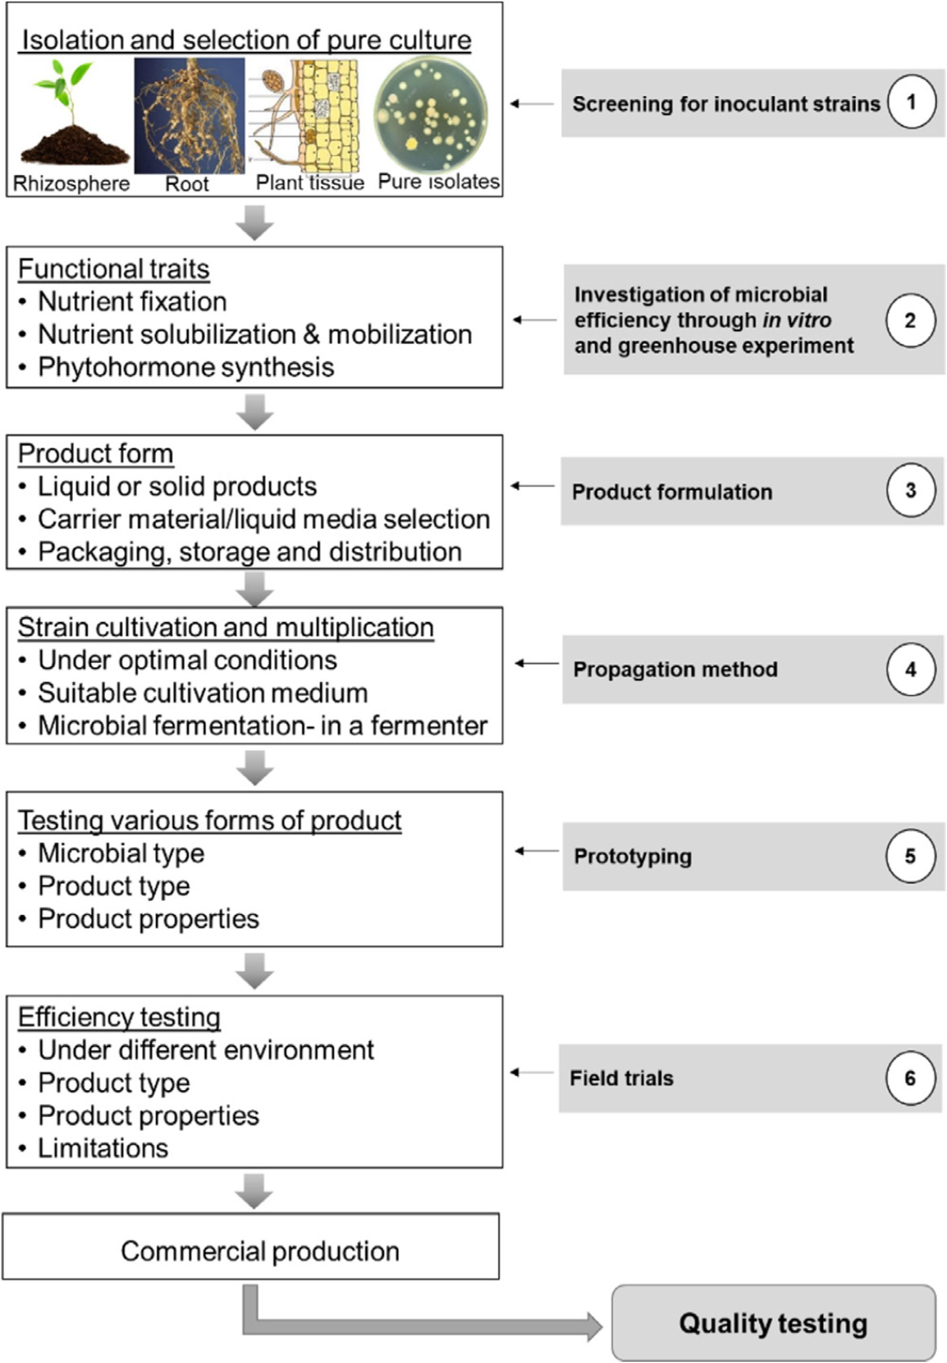
Figure 2. Standardization process for commercial biofertilizer production
was identified as S. rhizophila (WT-A2). As for the survivability test, only strain. After compost tea, biogas slurry was the second-best carrier folthe most efficient isolate of WT-A2 was tested. The compost tea carrier lowed by vermiwash and minimal growth medium. Glycerol can also be showed a mean value of cell count higher than that of the reference added to liquid carriers to increase biofertilizer’s shelf life

Table 4. Summary of studies using wastes as growth media for bacteria.
Bacterial strain Liquid media Viable cell Spore count References sources count (CFUmL¹)
(CFUmL¹)
Bacillus sp. and other bacteria |  | MSG by-product |  | 7.45 10⁹ |  | 6.45 10⁶ |  | (Namfon et al.,  2017)
Bacillus siamensis |  | Anaerobic digestate of fruit and vegetable waste (with sucrose additive from sugar beet) |  | 1.5 10⁸ |  | - |  | (Pastor-Bueis et al., 2017)
Lactobacillus |  | Glycerin pitch |  | - |  | - |  | (Nasarudin et al., 2020)
Bacillus subtilis |  | Corn steep liquor |  | 3.9 10⁹ |  | - |  | (Z. He et al.,  2020)
Azotobacter | Cane molasses |  |  | 1 10⁸ |  | - | (Hindersah et al., 2020)
Bacillus |  |  |  | - |  | 1 10¹⁰
Microbial consortia |  | 5 isolates from activated dairy sludge, and 1 isolate from marine coastal waters at 1:1 ratio |  | 7.36 10⁷ |  | - |  | (Halder et al.,  2020)
Bacillus anthracis, B. fusiformis, and B. licheniformis |  | Mixed fishery wastewater from mackerel and brown seaweed |  | 16.2 10⁷mineral N at 80% produced much better results than the ones with merely 80% of N and 100% of N without the biofertilizer.  High-cost materials are usually used for the f |  | - |  | (Jung and  Kim, 2020)

Effects of liquid biofertilizers on plant growth
Table 5 summarizes some selected studies conducted on different crops with different liquid inoculants and bacteria strains. did an experiment on alfalfa seed, which is a leguminous plant of the pea family (Fabaceae) used to fix nitrogen to other plants, because it houses rhizobia bacteria. Alfalfa is planted as a cover crop to enhance the soil properties and increase its nutrient levels. It can also tolerate drought, heat, and cold weather. The Sinorhizobium meliloti L3Si strain was grown in yeast mannitol broth (YMB). As for the liquid inoculant, ten different media were prepared. They were added in combination or separately. For the survival of L3Si during a storage time of 150 days, the most suitable liquid inoculant was found to be a glycerol medium formulated with agar or sodium-alginate. Sinorhizobium meliloti L3Si’s effectiveness on alfalfa seeds were studied on nodulation, plant height, shoot dry weight, and nitrogen content in the shoot dry weight. After one-month storage, alfalfa seeds pre-inoculated with YMB, YMB with agar, and YMB with sodium-alginate for up to three months produced successful alfalfa plants with nitrogen content ranging from 3.72 to
4.19%.

Microalgae-based biofertilizers have also been evaluated. In liquid biofertilizers extracted from Chlorella vulgaris and Spirulina platensis were applied on green gram Vigna radiata (L.). Among all the treatment concentrations, the two treatments at 100% showed the highest yield of green gram yielding 29 and 30 pods plant¹ for Chlorella vulgaris and Spirulina platensis, respectively. Also, the plant height, root and shoot dry weight, nutrient compositions were increased significantly. Amino acids were found to be higher in plants treated with Chlorella vulgaris, whereas N, P, and K were found to be higher in plants treated with Spirulina platensis

Table 5. Selected studies conducted on different crops with different liquid inoculants and bacteria strains in recent years.

Plant | Liquid  Inoculant  Medium | Bactria type | Cell count  (CFU mL1) | Nitrogen (%, unless specified) | Phosphorus (%, unless specified) | Potassium (%, unless specified) | Nodulation  (%) | Plant growth (cm/  plant) | Root dry mass (g/ plant) | Shoot dry weight (g/ plant) | References
Alfalfa |  | Yeast mannitol broth agar |  | Sinorhizobium meliloti L3Si |  | 8.1✕10⁸ |  | 3 |  | - |  | - |  | 100 |  | 16 |  | - |  | 0.018 |  | (Buntic et al.,  2019)
Vitis vinifera  L. (grape) |  | Nutrient agar |  | Pseudomonas putida  Rs-198 |  | 1.4✕10¹³ |  | 44 mg  kg¹ |  | 29 mg kg¹ |  | 192 mg  kg¹ |  | - |  | - |  | - |  | - |  | (Lu et al.,  2020)
Cucumber (Cucumis sativus) |  | Glycerin pitch |  | Lactobacillus |  | - |  | - |  | - |  | - |  | - |  | 40 |  | - |  | - |  | (Nasarudin et al., 2020)
Pepper (Capsicum spp.) |  | Nutrient medium |  | Pseudomonas putida  Rs-198 |  | 1✕10⁹ |  | 18 |  | 25 |  | 25 |  | - |  | - |  | 0.434 |  | 3 |  | (Y. He et al.,  2019)
Oryza sativa  L. (rice)  Toledo | N/A |  |  | Azospirillum brasiliense Ab-V5 and Ab-v6 |  | 2✕10⁸ |  | - |  | - |  | - |  | - |  | 108 |  | 32 |  | 195 | (Guimar~aes et al., 2020)
Oryza sativa  L. (rice)  Palotina |  |  |  |  |  |  |  |  |  |  |  |  |  |  |  | 106 |  | 32 |  | 189
Oryza sativa  L. (rice)  Cascavel |  |  |  |  |  |  |  |  |  |  |  |  |  |  |  | 111 |  | 33 | 192
Oryza sativa  L. (rice) S~ao  Miguel do  Iguaçu |  |  |  |  |  |  |  |  |  |  |  |  |  |  |  | 107 |  | 33 | 189
Green gram (Vigna radiata L) |  | Tap water |  | Chlorella vulgaris at  100%  concentration |  | - |  | 25* |  | 43 |  | 17* |  | 133 (on day  6) |  | 42 |  | 0.68 |  | 0.7 | (Dineshkumar et al., 2020)
 |  |  |  | Spirulina platensis at  100%  concentration |  |  |  | 46 |  | 66 |  | 17* |  | 142 (on day  6) |  | 40 |  | 0.67 | 0.66
Cotton |  | Nutrient agar |  | Pseudomonas putida  Rs-198 |  | 1✕10¹⁴ |  | - |  | - |  | - |  | - |  | 20 |  | 0.19 |  | - |  | (Y. He et al.,  2016)
Onion |  | Nutrient broth |  | Azotobacter sp. þ  Sphingobacterium sp. þ Burkholderia sp. |  | 1✕10¹⁰ |  | - |  | - |  | - |  | - |  | 42 |  | - |  | - |  | (Tinna et al.,  2020)
Chickpea |  | - |  | Bacillus subtilis |  | 3.6✕10⁹ |  | 30 |  | - |  | 18 |  | - |  | - |  | 2 |  | 3.0 |  | (Abd_Allah et al., 2018)
Wheat |  | - |  | Azotobacter þ PSB  KMB ZSB |  | >8.5  ✕10⁸ |  | - |  | - |  | - |  | - |  | 92 |  | - |  | - |  | (Jain et al.,  2021)
þ þ
enhanced plant growth, grain yield, and benefit-cost ratio. Statistically, BF₁ and BF₂ with 75% of the recommended dose of inorganic fertilizer can be used, yielding very close results to BF₂ þ 100%, so it could save about 25% of inorganic chemical fertilizer. In a similar manner, experimented with a combination of a bacterial consortia with an inorganic chemical fertilizer. They reached the same conclusion that a combination of both chemical and biofertilizer could save up to 25% of chemical fertilizer, enhancing the plant height, bulb yield, and number of leaves of onions.

Challenges and future perspectives
Most of the biofertilizers produced are effective on certain crops, soil types, and climates. Plant growth and development is affected by several biotic and abiotic stresses in the soil environment Moisture is needed for nutrient uptake and absorption by plants. Yet, due to climate change, drought stress is considered one of the most serious abiotic environmental stresses affecting the hemostasis of soil, and the morphological, physiological, and nutritional traits of plants . The results of applying liquid biofertilizers are sometimes unpredictable like what happened in Belgium in the 1999–2000 season when a biofertilizer had positive effects at the start of the winter season, but as weather conditions worsened, the final yield did not reach its full potential . The same happened in Uruguay, where at first plant growth was observed, but decreased with time with no significant difference between inoculated and non-inoculated plants. When the experiment was done outside of the growth season, the results were negligible . Therefore, biofertilizers must be developed to resist drought stress and other environmental stresses due to seasonal changes, as well as to search for microbial strains that can withstand stressful conditions. By doing so, farmers in harsh environments or developing countries will benefit from such biofertilizers.
When transforming liquid biofertilizer from laboratory scale to large scale, it may act poorly due to other variables not being studied on the lab scale. These variables must be taken into consideration to produce liquid biofertilizers suitable for various weather conditions and soil types. Another challenge is that for liquid biofertilizers, different or more advanced machinery might be required for large-scale application, thus making it energy intensive. Therefore, liquid biofertilizers must be produced in a way that can be used on the current or low-cost machinery.
To evaluate their viability, a cost-benefit analysis must be done to deduce the profitability of biofertilizer. After discounting the gross cost and benefit, an organization will be profitable if the benefit-to-cost ratio surpasses 1. For example, the benefit-cost ratio was found to be 17 for soybean by fixing 100 kg N ha¹, and 416 for clover by fixing 200 kg kg N ha¹ based on n-fixation since they are legume crops. Also, the biofertilizer energy requirement is fully paid by nature when compared to chemical fertilizers that require 80 MJ for N, 12 MJ for P, and 8 MJ for K leaving many small-holder farmers unable to afford the expensive energy bill. In legume plants, 48–300 kg N ha¹ is fixed in a season. The amount of biofertilizers required to supply plants with the same amount of nutrients is much less than chemical fertilizers. Additionally, this low-cost method of supplying nutrients to soil makes it attractive to small-holder farmers. Therefore, more studies are required to conduct cost-benefit analyses of biofertilizers based on plant yields.
Some biological molecules such as flavonoids, strigolactones, and polysaccharides can promote a symbiotic relationship between arbuscular mycorrhiza fungi and the host plant, as well as rhizobium during nodule formation. For improved product formulation, these compounds should be explored. The existing bacterial strains help in improving one trait of the plant, but scientists may need to develop genetically engineered strains that are more efficient while ensuring that these developed strains do not cause any hazards or risk.
Some studies have shown that biofertilizers can affect the surrounding environment by introducing microorganisms that can affect the structure of native microflora and some non-target effects like changes in biogeochemical cycles, soil texture, and soil properties. However, it is still unknown how these microorganisms react with the presented microflora. In addition, the severity of the changes on the ecological systems have yet to be revealed. No recent studies have explored the safety of bioinoculants for commercial use.
In addition, there is a need to improve education about biofertilizers and their long-term benefits compared with chemical fertilizers, and to correct the misconception about microorganisms being a source of disease. Biofertilizers will require new and innovative techniques for the growth, transportation, formulation, storage, and application of microorganisms as they go from small scale (laboratory and greenhouse tests) to large scale production. More investment is needed in the existing and future technologies via research to produce cost-effective and environmentally friendly biofertilizers. However, there is a lack of communication between farmers, industry, researchers, and governmental sectors. Multi-stakeholder partnerships are definitely crucial in order to develop biofertilizers that do the best job possible.
LIQUID BIOFERTLIZER APPLICATION
Seed Treatment
Seed treatment is the most common method adopted for all types of inoculants. The seed treatment is effective and economic. For small quantities of seeds (up to 5 kg), the coating can done in a plastic bag. For this purpose, a plastic bag sized 21” x 10” or larger can be used. The bag should be filled with 2 kg or more of seeds. The bag should be closed in such a way so as to trap the air as much as possible. The bag should be squeezed for 2 minutes or more until all the seeds are uniformly wetted. Then the bag is opened, inflated again and shaken gently. The shaking can stop after each seed gets a uniform layer of culture coating. The bag is opened and the seeds are dried in the shade for 20–30 minutes. For large amounts of seeds, the coating can be done in a bucket and the inoculant can be mixed directly by hand. Seed treatment with Rhizobium, Azotobacter, Azospirillum, along with PSM can be done.

The seed treatment can be done with any of two or more bacteria. There is no side (antagonistic) effect. The important things that have to be kept in mind are that the seeds must be first coated with Rhizobium, Azotobacter or Azospirillum. When each seed gets a layer of these bacteria, then the PSM inoculant has to be coated as an outer layer. This method will provide a maximum number of all bacteria required for better results. Treatments of seeds with any two bacteria will not provide a maximum number of bacteria on individual seeds.

Root dipping
This method is used for application of Azospirillum/ /PSM on paddy transplanting/ vegetable crops. The required quantity of Azospirillum/ /PSM has to be mixed with 5–10 liters of water at one corner of the field and the roots of seedlings have to be dipped for a minimum of half-an-hour before transplantation.

Soil application
Use 200ml of PSM per acre. Mix PSM with 400 to 600 kgs of cow dung FYM along with ½ bag of rock phosphate if available. The mixture of PSM, cow dung and rock phosphate has to be kept under any tree or in the shade overnight and 50% moisture should be maintained. The mixture is used for soil application in rows or during leveling of soil.

CONCLUSION
Liquid biofertilizers consist of living microorganisms that enhance soil properties and increase plant growth and yield. Liquid biofertilizers have been applied to different crops and yielded the best results when compared to other types of chemical or carrier-based fertilizers. In some cases, plant growth increased two-fold. Biofertilizers can be produced by using a single or a mix of microorganisms based on the role the biofertilizer is produced for. Also, liquid biofertilizers can be made from wastes and by-products of some industries as they could be a suitable and low-cost option for the growth of the bacterial cells instead of using specially made media. Finally, in order to develop effective liquid biofertilizers, more research is needed to overcome their limitations in the aspects of better climate adaptation, longer shelf life, better liquid inoculant, and use of low-cost or existing machinery for large-scale application. Cost-benefit analyses, field trials, long-term safety and effectiveness evaluations, and multi-stakeholder partnerships are the essential elements to evaluate the feasibility of the liquid biofertilizer on a case-by-case basis, taking into consideration the location, crop type, soil type, and climate.
REFERENCE
- Abd_Allah E.F., Alqarawi A.A., Hashem A., Radhakrishnan R., Al-Huqail A.A., Al-Otibi F.O.N.…Egamberdieva D. Endophytic bacterium Bacillus subtilis (BERA 71) improves salt tolerance in chickpea plants by regulating the plant defense mechanisms. J. Plant Interact. 2018;13(1):37–44.

- Agrilife . 2020. Fe Sol B.https://www.agrilife.org.in/fe-sol-b-2006553.html Retrieved from.

3.Agrilife . 2020. K Sol B.https://www.agrilife.in/products/ksolb-fa.php Retrieved from.
4.Agrilife . 2020. Mn Sol B.https://www.agrilife.in/products/mnsolb.php Retrieved from.
5. Agrilife . 2020. Nitrofix-PD.https://www.agrilife.in/childcat-agri.php Retrieved from.
6.Agrilife . 2020. P Sol B.https://www.agrilife.in/childcat-psolb.php Retrieved from.

7.Agrilife . 2020. S Sol B.https://www.agrilife.in/products/ssolb.php Retrieved from.

8.Agrilife . 2020. Si Sol B.https://www.agrilife.in/products/sisolb.php Retrieved from.

9.Agrilife . 2020. Zn Sol B.https://www.agrilife.in/products/znsolb.php Retrieved from.

10.Al Anfal Fertilizer Industry Co. 2018. http://www.alanfal.net/en/ Retrieved from.

