Hydroelectric Power:

Prabhat Singh¹,
Sagarika Kabra²,
Sadique³,
Shikhar Verma⁴
Deepika Saini⁵,

^{1,2,3,4}Maharishi School of Pharmaceutical Sciences, Maharishi University of Information Technology, Lucknow, Uttar Pradesh
⁵Department of Zoology, Chaman Lal Mahavidyalaya, Landhora, Haridwar, Uttarakhand

Introduction
Hydropower is defined as the sustainable energy source that generates electricity by changing the natural flow of rivers and some other water bodies by using dams and deviation structures. Hydropower produces one-sixth of the world's electricity and will produce around 4,500 TWh by 2020, this is much higher than all energy sources and nuclear power combined. Hydropower has the ability to provide as much less carbon electricity as needed and it is the dominant source of safe and clean electricity. The amount of electricity a turbine can produce depends on how much water passes through the turbines (flow) and how much the water "falls” from the height. Hydropower is the largest renewable energy source in the world. When water falls under gravity, it is used to spin turbines and generators to generate electricity. It plays an important role in numerous parts of the world, and about 150 countries producing electricity. The world has approximately 700 GW of installed capacity producing 2,600 TWh per year, about 19% of global electricity production.
The first electric generator was built in 1870 in Cragside, Rothbury, England. The use of electricity began in the 1880s in Grand Rapids, Michigan, with the use of electric generators to light theatres and shops. Electric brushes attached to flour mills provide street lighting in Niagara Falls, New York, 1881. The world's first 12.5-kilowatt hydroelectric power station was commissioned on September 30, 1882, at the Vulcan Street Mill in Appleton, Wisconsin, USA, on the Fox River, using two generators and lighting, with the generator connected to electricity from a generator. house.
Although India built electricity in the first major location, Darjeeling, in 1897, to support the economy, the electricity system was built on the Cauvery coast at Sivasamudrum in 1902 having the electrical producing capacity of 7.92 megawatts and in 1902 at the appropriate construction time. increasing level over time. The final installed capacity of the power plant in 1938 was 47 megawatts. Electricity was initially supplied to the Kolar Gold Mine for development and operation, and later to the cities of Bangalore and Mysore.

Hydropower Technology

Power is defined as the rate of doing work. Hydropower is a renewable energy source that uses the power of flowing water to generate electricity. The water is typically channelled through a dam or turbine, which spins a generator to create electricity. The amount of electricity generated depends on the volume of water, the height of the drop, and the efficiency of the turbine and generator.
Hydropower is a clean and sustainable energy source that does not produce greenhouse gases. It is also a reliable source of electricity, as it is not affected by weather conditions like solar and wind power. However, hydropower can have negative environmental impacts, such as flooding and habitat loss.
Here are the main steps in how hydropower works:
- Water is stored in a reservoir behind a dam.
- When electricity is needed, water is released from the reservoir through a penstock.
- The water flows through a turbine, which spins a generator.
- The generator creates electricity, which is then sent to homes and businesses.
- The water that has passed through the turbine is returned to the river or ocean.
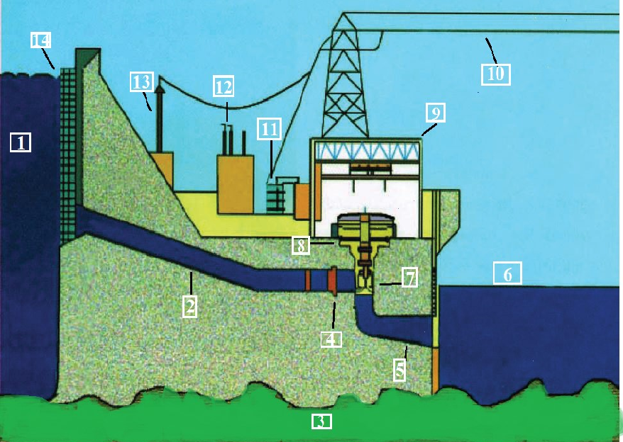
[1] Reservoir [2] Penstock [3] Bed Rock [4] Valve

[5] Draft tube [6] Watercourse [7] Turbine [8] Generator

[9] Powerhouse [10] Imparting lines [11] Transformer [12] Insulators

[13] Imparting tower [14] Trash rack

Figure 1: Model of a Hydroelectric Power station with its major parts.
Classification of Hydropower Project by Facility type

Hydroelectric power projects are different in that although installed power is same, the design of the hydroelectric power station will be different depending on local conditions. The uniqueness of these water projects makes their distribution mandatory, mainly in terms of technology and use. Hydroelectric power projects can mainly be classified into three categories such as Run-of-River, Storage Hydropower or Reservoir, and Pumped Storage.

- Run-of River Type Hydropower (RoR HP):

RoR HP mainly supplies power to generate electricity from existing water resources. Such hydroelectric power plants often include some short duration (hourly, daily, or weekly) to allow for some variation in needs. The electrical output of the flow generator depends on the amount of water in the river. River type power plants are different and can be optimized for large rivers with small currents in large rivers or optimized for small and long bodies of water in mountains. The RoR hydroelectric system will have a variable capacity following the flow of the river. To provide some flexibility in the case of demanding electricity, the RoR HP consists of some short- water storage to meet additional electricity when needed. Without proper storage systems, RoR HP conditions are unsafe to changes in water flow that disturb the flow and water quality, such as drought, flooding, and dewatering. The RoR HP concept is said to be suitable for rivers with minor differences or rivers controlled by large dams. In a RoR HP, some of the flow can be diverted to lines or pipes (hanging) that send the water to turbines connected to generators. RoR hydropower plants are relatively inexpensive and generally have a lower environmental impact than larger scale hydro storage facilities.
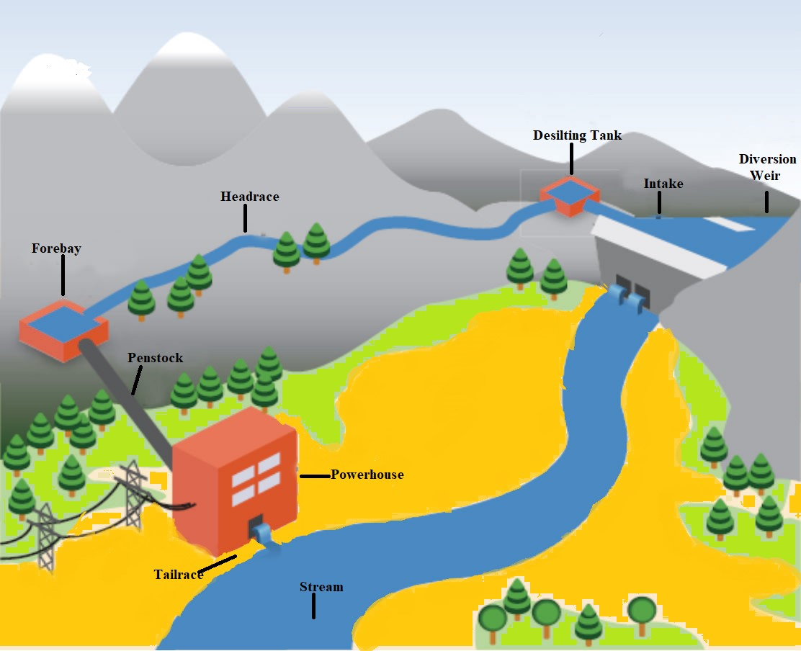
Figure 2: Diagrammatic view of Run-of-River Hydropower Project

- Storage hydropower (Reservoir):

Energy storage plants rely less on natural water flows and instead rely on water storage behind dams. To generate electricity, water is pumped from a reservoir and sent to turbines. The power station can be built directly at the bottom of the swimming pool without running water, or it can continue to the bottom, displacing the river; This station is connected to the lake by channels, tunnels, or penstocks. Storage of hydroelectric power generation has a higher energy efficiency compared to pure water flowing from rivers. One of the key benefits of energy storage is that energy is stored in the form of potential energy, this energy can be used to produce electricity when demand, allowing generators to be used to provide both basic and advanced equipment. Hydroelectric storage projects control water flow downstream of dams. Hydroelectric power plants with large reservoirs provides the best service. Such facilities can store energy on a large scale during low demand and provide energy when needed during peak demand. Also, their fast response times allow them to meet rapid changes in demand. Small power plants are designed to realize daily or weekly production.
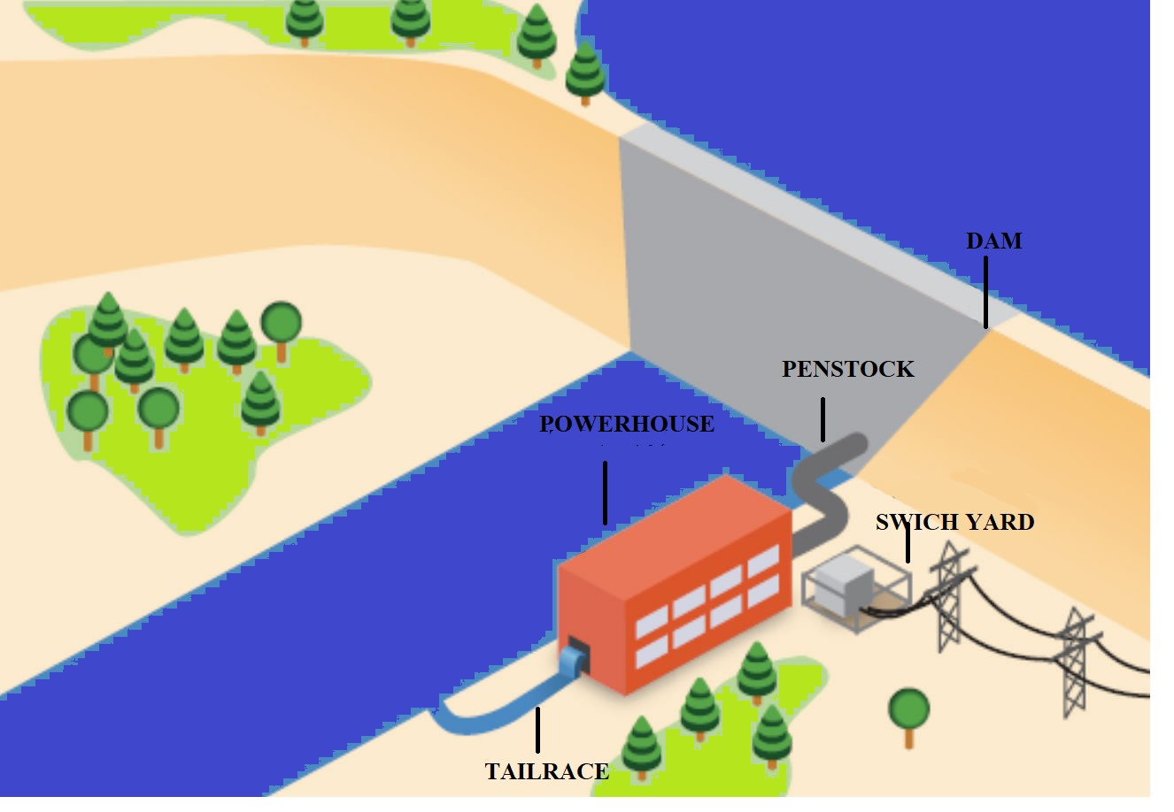
Figure 3: Diagrammatic View of Storage Hydropower (Reservoir).

- Pumped Storage Hydropower (PSH):

Pumped storage power plant is storage, not energy. The pumped storage hydroelectric power station uses two reservoirs - a lower reservoir and an upper reservoir. The two reservoirs are connected by tunnels or locks. In such a system, water can flow from the bottom chamber to the higher chamber. In the storage pump, water is pumped to provide hydraulic power. During a power outage or at other times when the demand is low, water is used from the lower water to the upper water tank by using the excess electricity from the hydroelectric power plant. During peak load or other times when more power is needed, the water stored in the higher tank is pumped back into the bottom reservoir by the turbines, thus generating more electricity. Pumped storage hydroelectric power plants are currently the most efficient and largest form of energy storage, with cycle efficiency of between 70% and 85%. Although losses in the water use process make such facilities all energy consumers, facilities can provide the benefits of large power generation. In fact, pumped hydro is currently the largest source of grid electricity storage available worldwide.

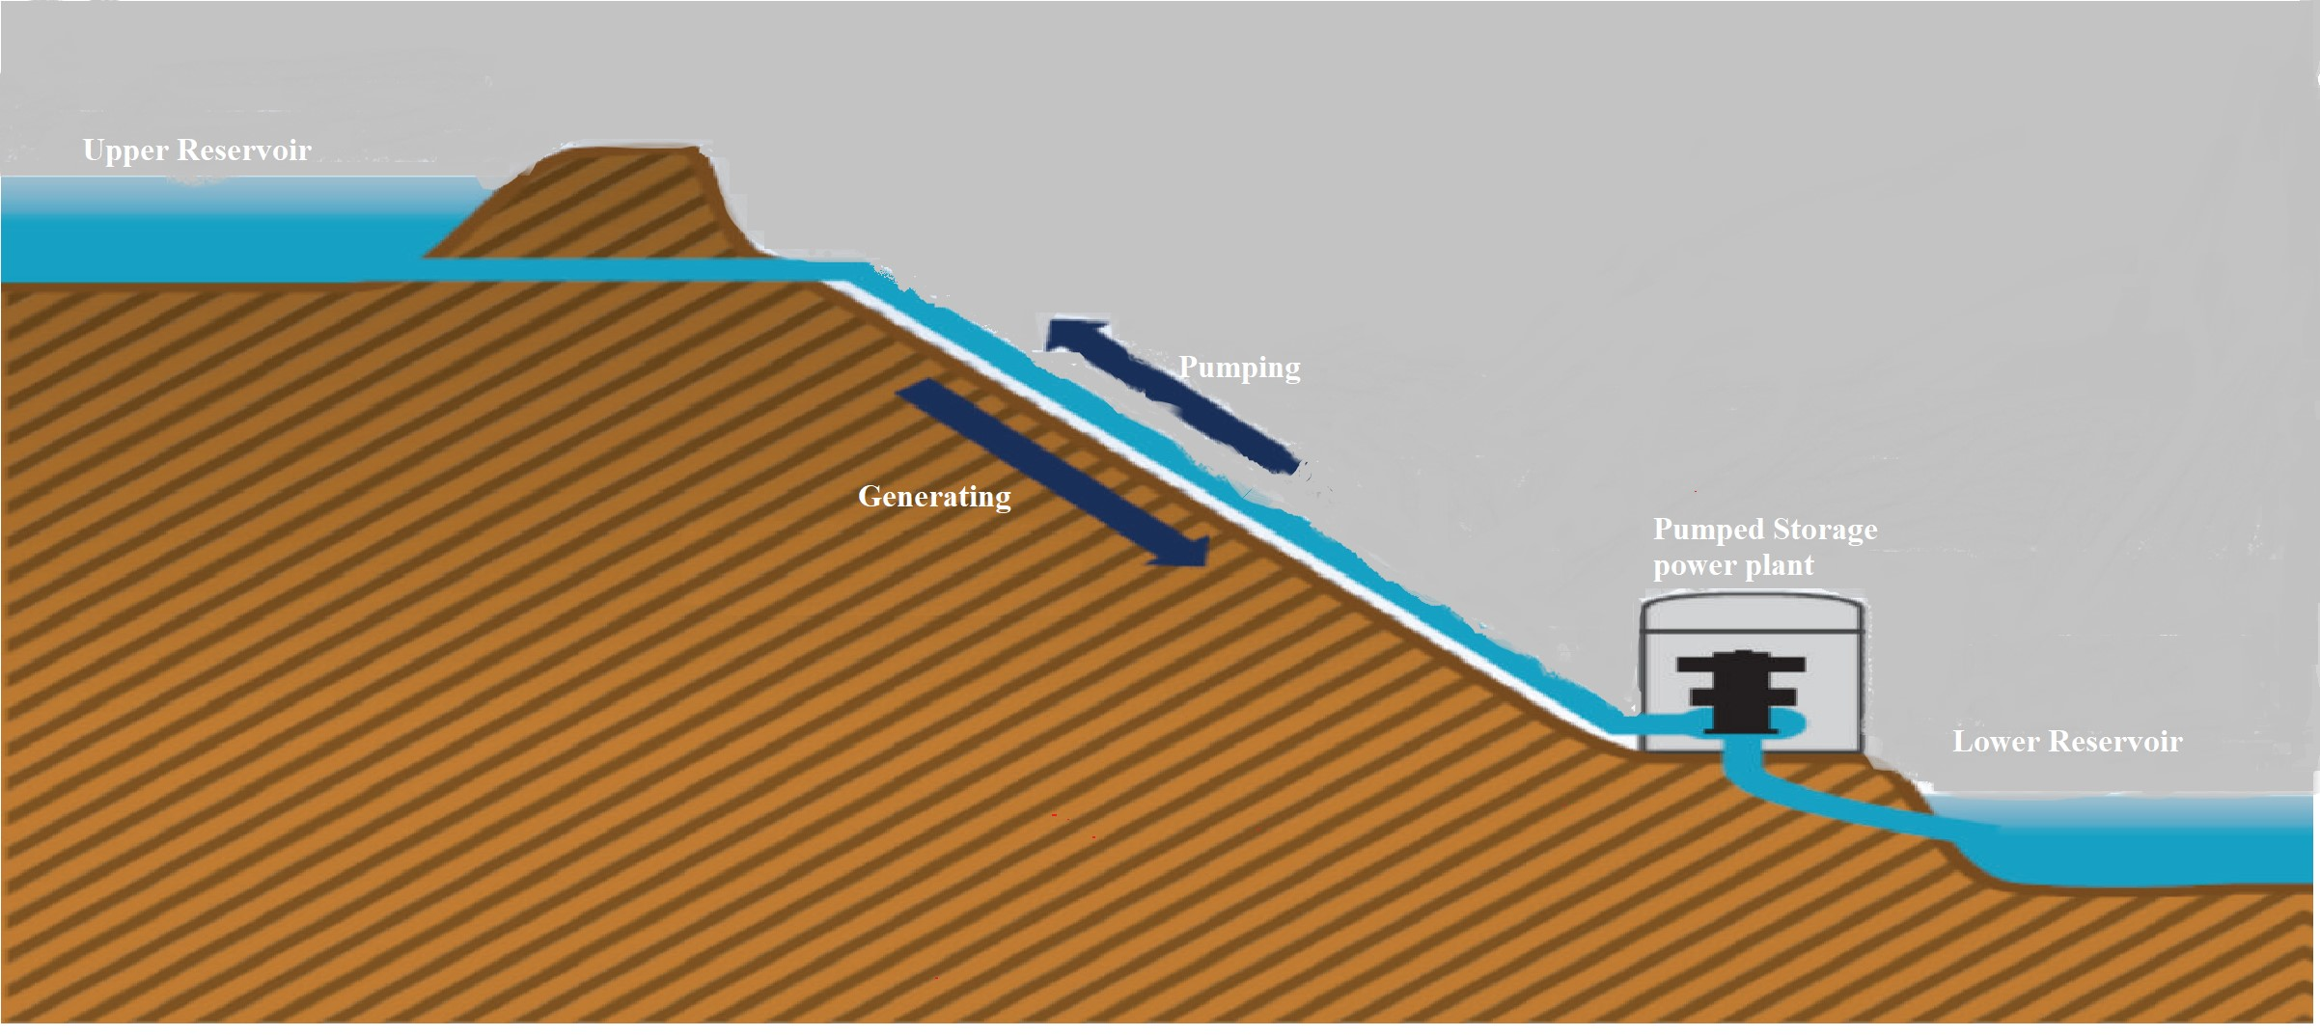

Figure 4: Diagrammatic view of Pumped Storage Hydropower (PSH)
Social and environmental impacts of hydroelectric power projects
Hydroelectric power projects can have significant social and environmental impacts, both during construction and operation.
- Construction impacts
The construction of a hydroelectric power project can involve clearing large areas of land, building dams and reservoirs, and laying power lines. This can lead to deforestation, habitat loss, and displacement of people.
- Operational impacts
The operation of a hydroelectric power project can also have environmental impacts. Reservoirs can disrupt river flows, affecting downstream ecosystems. They can also release methane and other greenhouse gases into the atmosphere.
Mitigation measures
There are a number of mitigation measures that can be taken to reduce the environmental impacts of hydroelectric power projects. These include:
- Relocating and compensating people who are displaced by the project
- Reforesting areas that have been cleared for construction
- Using fish ladders to help fish migrate around dams
- Designing dams and reservoirs to minimize methane emissions
Hydroelectric power projects can be a clean and renewable source of energy, but they can also have significant environmental impacts. It is important to carefully consider the potential impacts of these projects before they are built.
Here are some additional details about the environmental impacts of hydroelectric power projects:
- Reservoirs can disrupt river flows, affecting downstream ecosystems. This can lead to changes in water temperature, sediment levels, and nutrient concentrations. These changes can impact fish populations, aquatic plants, and other wildlife.
- Reservoirs can release methane and other greenhouse gases into the atmosphere. Methane is a potent greenhouse gas with a global warming potential 25 times greater than carbon dioxide. The amount of methane released from a reservoir depends on several factors, including the size of the reservoir, the amount of organic matter in the water, and the temperature of the water.
- Hydroelectric power projects can displace people and communities. The construction of a dam or reservoir can force people to relocate their homes and businesses. This can be a major disruption for communities, especially if they have lived in the area for generations.
However, large hydropower plants are also called to release the greenhouse gases (GHG) especially methane and carbon dioxide as entombed organic materials due to lack of sufficient oxygen. Since the main fuel in all gas emissions from hydroelectricity is methane, it is encouraged that GHG emissions from hydroelectric reservoirs should no longer be ignored in the national GHG problem. Methane produces global warming more than the carbon dioxide.

Greenhouse gases within sediments can escape into the atmosphere through the formation of bubbles on the surface of the sediments. Dissolved gases in the water can also run away during the process of turbulent deviation where water flows through the turbine runner during operation. Due to high mineralization rates and high-water pressure (high gas solubility), the deep-water layers of reservoirs are typically enriched with CO₂ and CH₄. Passing through the turbine, the gas is subjected to low pressure and high temperature conditions, which causes rapid degassing along with turbulent action and is exhausted into the atmosphere.
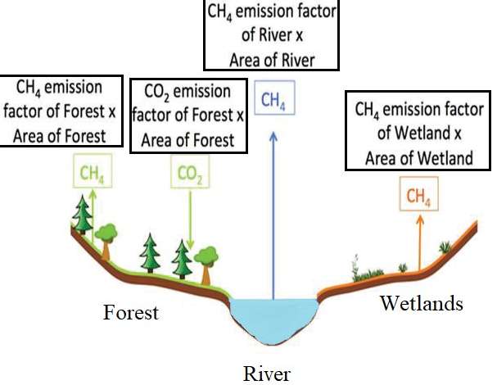
Figure 5: Nature of Greenhouse gases with different Ecosystem

Hydroelectricity Power towards sustainability:

Sustainable development is the development that provides all the necessary needs of the present without loss the ability of future generations, it requires a balance between nature and living being. The term "sustainable energy" means the provision and use of energy in a way that supports in the development of community, financial rewarding, and environment. This means not just expanding energy, but gradually moving to energy sources and technologies that support people's long-term health and safety.
In previous few years, the biggest and most important challenges to the sustainability of hydropower plants have been mainly unmanaged deforestation, mismanagement of agricultural land, housing development and infrastructure development around formerly protected power plants. how to deal with reservoir sedimentation and storage loss caused by Forest catchments.
Hydropower is a resource that does not have life energy and does not emit pollution. Hydropower is considered an efficient, low-cost, and clean energy source. Hydropower has many uses and strong adaptability. Due to the limited capacity involved, a significant route in hydroelectric power can be reserved for years. Flow planning can be done to ensure continuous updates. Accordingly, hydropower can be more economical, reduce non-renewable energy outputs and encourage unregistered energy such as wind power.

Advantages of Hydropower:

- The efficiency of electricity generation is about 90%, and electricity generation is the largest, accounting for about 19% of total energy consumption in the world.
- By building an electric generator, nearby communities can find new jobs and help revive the economy.
- When there is no need of electricity, we can close the water gate to stop generating electricity. Water can be stored for later use when power demand increases.
- The use of hydroelectric dams and dams facilitates the control of floods. But when this water is retained by dams, monitoring and maintenance is easier and reduces the risk of flooding.
- Hydropower is a ductile form of electric because power plants can rise and fall rapidly to meet changing energy needs.
- Hydroelectric power plants do not consume fuel, so no carbon dioxide is produced when generating electricity. While project construction initially produces carbon dioxide and the reservoir emits some methane each year, hydropower has lowest greenhouse gas discharge.
- The cost of generating electricity from electricity is low, averaging $0.05/kWh.

Disadvantages of Hydropower:

- The cost of generating energy is low, but the construction cost is too high. Underwater installation requires the use of special equipment and materials, which is expensive.
- The presence of dams changes available water, which often has a significant impact on the life of the fish, depending on the type and growth of the fish.
- In addition to the temperature change caused by the heat generated during the operation of hydroelectric power plants, the use of hydroelectric power can also affect water flow in communities and cause global warming.
- Physical collisions between wild animals and dam walls.
- Turbines in hydroelectric power plants can make a lot of noise.
- Hydroelectric power plants are very expensive to build. High prices mean that factories must work long-term to make a profit.

Conclusion

The above chapter concludes that the hydroelectric power is the largest renewable source for generating electricity, with very less loss of water. Unlike other sustainable energy sources such as solar and wind, hydropower plants provide electricity supply by producing stable and continuous electricity. Small hydropower release no or very a smaller number of harmful gases. On the other hand, large hydropower put a great impact on our environment and even on climate by releasing harmful gases such as CH₄ (Methane) and CO₂ (Carbon di-oxide), these gases are widely disturbed greenhouse and result in global warming. This project has an ability to store energy for a week or a month and or a year along which is utilized when electric demand is high along with this it has disadvantage that it makes too much noise during producing electricity.

References:

- John Twidell, Renewable Energy Resources, Second edition, Taylor & Francis Group.
- Central Board of Irrigation and Power 2012 Publication No. Hydro Electric Projects in India.
- USA Department of Energy, Hydropower Technology Information. Basic Energy Information, http://www1.eere.energy .gov/water/hydro plant types.html, 2012.
- 2005. U.S. Bureau of Reclamation, Hydro Electric Power, department of the interior.
- International Energy Agency, Hydropower, and the Environment: Present Context and Guidelines for Future. Action, Subtask 5 Main IEA Report, Volume 2, International Energy Agency, Amsterdam, The Netherlands, 2000.
- H. Raghunath, Hydrology: Principles, Analysis and Design, New Age International, New Delhi, India, 2nd edition, 2009.
- Intergovernmental Panel on Climate Change, “Special report on renewable energy sources and climate change mitigation, chapter 5: hydropower,” Special Report of IPCC, Cambridge University Printing Press, 2012.
- Peter Gevorkian, 2010. Alternative Energy Systems in Building Design, McGraw- Hill.
- M. Cernea, “Hydropower dams and social impacts: a sociological perspective,” Social Development Papers, World Bank Paper 16, 1997.
- R. Howarth, R. Santoro, and A. Ingraffea, “Methane and the greenhouse-gas footprint of natural gas from shale formations,” Journal of Climatic Change, vol. 106, no. 4, pp. 679–690, 2011.
- A. Kemenes, B. Forsberg, and J. Melack, “Methane release below a tropical hydroelectric dam,” Geophysical Research Letters, vol. 34, article L12809, 2007.
- Kamal M 2017 Scenario of small hydro power projects in India and its environmental aspect International Research Journal of Engineering and Technology 4(10) 228-34.
- World Energy Assessment; UNDP, UNDESA, World Energy Council; 2000.
- Samad E, and Hosien S 2008 Desilting of deposited sediment at the upstream of the Dez reservoir in Iran. J. of Applied Sciences in Environmental Sanitation Surabaya, Jakarta 25-35.
- Askari Mohammad Bagher, Mirzaei Vahid, Mirhabibi Mohsen, Dehghani Parvin, "Hydroelectric Energy Advantages and Disadvantages.," American Journal of Energy Science, pp. 17-20, 2015.
- Atkins, William (2003). "Hydroelectric Power". Water: Science and Issues. 2: 187–191.
- Silva, Sebastian Naranjo, and Javier Álvarez del Castillo, "An Approach of the Hydropower: Advantages and Impacts. A Review," Journal of Energy Research and Reviews, vol. 8, no. 1, pp. 10-20, 2020 Hydroelectric Energy Pros and Cons by Mathias Aarre Maehlum.

