Sustainable Filter Media of Coconut Fiber and Rice Husk
^{*,1}K.K. Sivakumar, ²S. Kumar and ³S. Nandhini
Department of Chemistry, AMET University, Chennai.
Department of Mechanical Engineering, Wollega University, Ethiopia.
Department of Public Health, SRIHER University, Chennai.

ABSTRACT
As the population is increasing, the discharge of domestic effluent is being increased rapidly all over the world in specific developing countries like India since water is the most vigorously tremendous element required for the existence of all living beings on the earth. Considering all the challenges, domestic effluent treatment is a feasible alternative in order to looking for fresh water resources to consider for new water demands. The main objective of this study is to inspect the pollutants qualitatively and quantitatively present in domestic effluent as well as to bring of the effectiveness of using coconut fibers and rice husk combination with sand and stone chips for the filtration of collected domestic effluent. The domestic effluent was collected from the residential hall of marine institute, Chenai. Several domestic effluent quality parameters were measured for collected samples with inflow water as well as outflow water through filter media. The parameters tested in this research include physical and chemical tests such as suspended solids, Chemical Oxygen Demand (COD), Phosphate, Chloride, Nitrate, pH, turbidity, total coliform and faecal coliform. It has been observed that, both coconut fiber and rice husk can be used as an effective filter media for the removal of pollutants available in domestic effluent. Rice husk acts as an adsorbent for removal of contaminants from domestic effluent and coconut fiber removes fungus as there are huge amount of micro-pores with standard surface area.
Key Word: Adsorption, Domestic effluent treatment, Pollutants, Coconut fiber, Rice husk, Water quality parameters.

INTRODUCTION
Ecosystem of this planet is passionately dependent on water. But water is not an unmixed blessing when it is turned into domestic effluent. Untreated or poorly treated domestic effluent can pose a health risk for humans. When present in certain levels, fecal coliform bacteria, which are found in human intestines, are indicators of untreated or minimally treated sewage. The presence of these bacteria in water is considered an indicator of recent fecal contamination. Fecal coliform bacteria are not usually harmful, but are easily detected and may indicate the presence of other disease-causing organisms carried in the human intestine such as cholera, diphtheria, E. coli and streptococcal diseases. Drinking water sources in developing and underdeveloped countries are facing serious threat from contamination problems due to both man-made industrial and agricultural activities. In many developing countries ground water is used for drinking purposes and it is polluted with toxic anions, heavy metals, organic compounds and dyes due to effluents from industries¹. Due to fast population growth the amount of domestic effluent has been increasing rapidly all over the world. Good water quality is essential to a healthy ecosystem. Domestic effluent containing high nitrogen and phosphorus concentrations promotes the growth of plants and animals that thrive in nutrient-rich conditions, and over time this can have a negative impact on marine life. Domestic effluent from septic systems can seep into the surrounding porous limestone and pollute the groundwater, introducing excessive nutrients and even harmful bacteria into surface waters. Domestic effluent is still the vital cause of ecological damage. For the last few decades it has been burning issue for the scientist to select a viable filter media for domestic effluent treatment. Crisis of natural fresh water resource is becoming a concerning issue for the experts as extensive use of ground water for decades after decades has led to recent emergency of natural fresh water resources. Treatment of domestic effluent can serve two purposes at the same time. Firstly, purpose of treatment of domestic effluent can be fulfilled and secondly, recent crisis of fresh water resources can be solved. So treatment of domestic effluent has turned into an indispensable issue considering the ecological sector. Several researchers have developed many methods such as microbial degradation, chemical oxidation, photolysis and adsorption are used for the treatment of domestic effluent^{2,3,4}. Most of these methods suffer from drawbacks like high capital and operational cost and there are problems in disposal of the residual metal sludge⁵. This has led to search for cheaper and efficient substituents. The consumption of local available biomass resources as a natural biofilm provision media for the domestic effluent treatment is of an increasing attention for solicitation due to its low cost and low technology.
Agricultural by-product is one of the major sources of activated carbons. The use of activated carbons to remove organic and inorganic pollutants from waters is widely extended, because of their high surface area, micro porous character and the chemical nature of their surface⁶. The production of activated carbon from agricultural by-products serves two purposes. Firstly, it converts agricultural waste to useful adsorbents. Secondly, activated carbons are being used in water for removing organic chemical and metals of environmental or economic concern⁷. In this research without using activated carbon a new substituent has been searched for which should be purely natural. Both as a pure natural substituent and agricultural waste, coconut fiber and rice husk can be considered. Because in India coconut fiber is available everywhere and it is cheap. India is an agricultural country where rice is produced in a large amount. As the main by-product of rice, rice husk accounts for approximately 20% of all rice products⁸.
The coconut fiber has hard organic matters such as cellulose and lignin with high specific surface area and wetting ability, therefore, it seems suitable for microorganism’s adhesion and biofilm⁹. Coconut fiber biofilm treatment system has been introduced at some local authorities in Sri Lanka to treat the collected sewage and leachate at waste disposal sites¹⁰. There are huge amount of micro-pores with standard surface area are existing in coconut fibers. The more headstrong lignocelluloses can simultaneously function as a support material because of its slower degradation rates as organic material can perform a dual activity by providing substrate for the bacterial metabolism¹¹. Rice husk comprises of lignin, cellulose, hemicelluloses and minerals with 21.44%, 32.24%, 21.34% and 15.05% respectively¹². Rice husk has a granular structure, good chemical stability, high mechanical strength, unique chemical composition and low cost¹³. Rice husk, if it is used as filter media, after the expiration of efficiency of filter media, the disposal of the used rice husk might not cause any damage to the environment. Moreover it can be used as fertilizer. For these reasons, coconut fiber and rice husk have been taken under the case study.
The objectives of this study include developing a low cost filter media for domestic effluent filtration as well as to investigate the efficiency of the developed coconut fiber and rice husk filter, determining selected physical and adsorptive properties of coconut fiber, rice husk were also another one. Moreover, to assess operation and maintenance difficulties as well as filter run time and filtration rate of a developed filter and providing some recommendation for sustainable use of the developed filter were also the main goals of this research.

METHODOLOGY
The experiment was based on some stages. The stages are described here in details.

Materials
Coconut fiber, rice husk, ½” downgraded stone chips and sand was used as the materials of filter media. Grain size analysis of coconut fiber, rice husk and stone chips is depicted in Figure 1 to Figure 6. Besides, fineness modulus of sand is presented in Table 1.
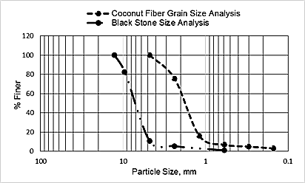
Figure 1: Grain Size analysis of coconut fiber and stone chips
Figure 2: Grain Size analysis of rice husk and stone chips
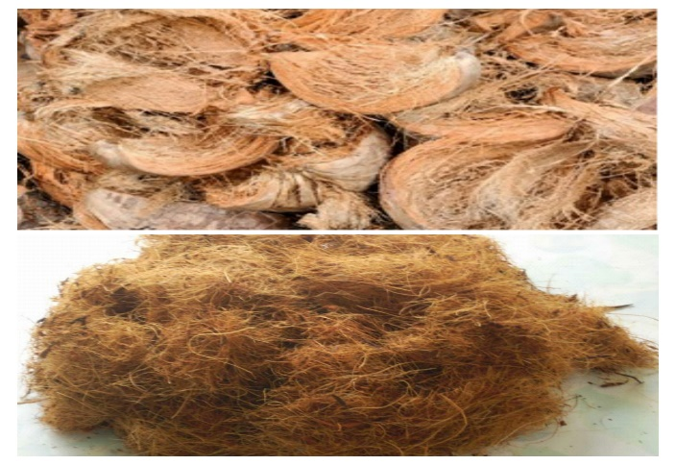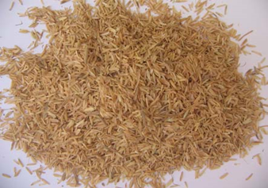
Figure 3: Coconut fiber Figure 4: Rice husk
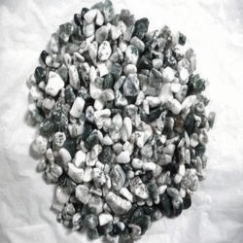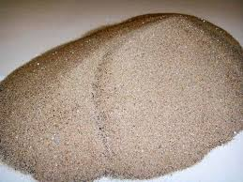
Figure 5: Stone chips Figure 6: Sand
Table 1: Fineness modulus of sand
Sl. No. | Sieve No. | Weight retained (gm.) | Cumulative Weight retained (gm.) | Percent cumulative weight retain | FM value
1 | 4 | 12.5 | 12.5 | 2.6 | 2.86
2 | 8 | 31.8 | 44.3 | 9.25
3 | 16 | 97.7 | 142 | 29.64
4 | 30 | 143.4 | 285.4 | 59.58
5 | 50 | 121.1 | 406.5 | 84.86
6 | 100 | 72.5 | 479 | 100

Set Up of Filter Media
The experiment had been accomplished in two different set up which is shown in Figure 7. First of all a bucket was taken which had a diameter of 40.50 cm and a height of 40 cm. The instrumental set up has given below. In every phase 2.5 cm sand and 5 cm stone chips were provided. Coconut fiber and rice husk were provided in mid layer with 20 cm thickness.
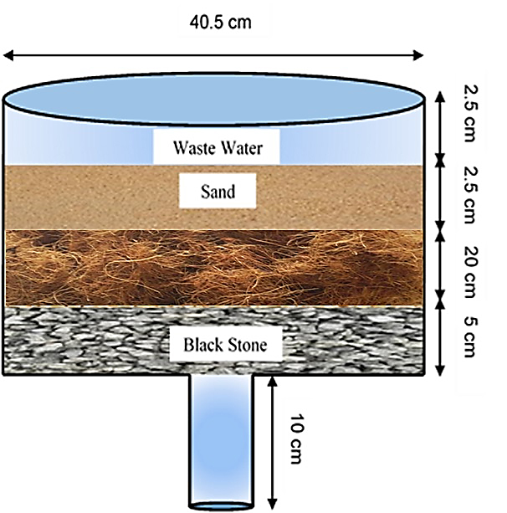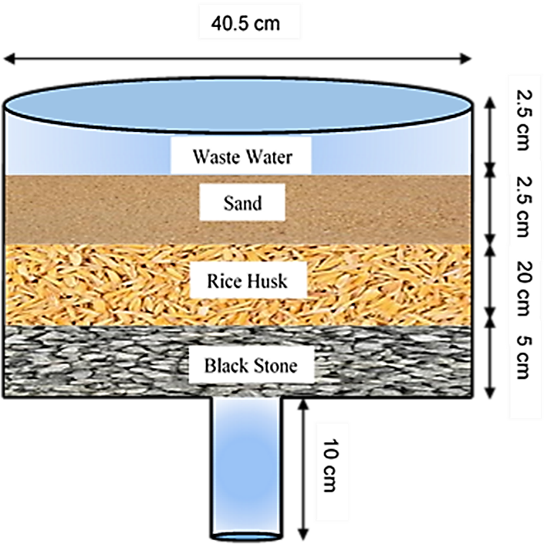
Coconut Fiber
Figure 7: Experimental set up of filter media

RESULTS AND DISCUSSION
Several domestic effluent parameters were measured for collected samples with inflow water as well as outflow water through filter media. The important tested domestic effluent quality parameters in this research include chemical oxygen demand (COD), pH, turbidity, phosphate, chloride, nitrate, total suspended solids (TSS), total dissolved solids (TDS), total coliform and faecal coliform, were measured for collected samples with inflow water as well as outflow water through filter media which is shown in Table 2.

Table 2: Test result of different filter media for domestic effluent treatment
Parameters | Unit | Domestic effluent | Coconut Fiber as Filter Media | Rice Husk as Filter Media | India Standard for Discharge  (Irrigated land)
COD | mg/L | 1920 | 1860 | 1790 | 600
pH | -- | 7.69 | 7.71 | 7.57 | 6.5 - 8.5
Turbity | NTU | 223 | 59 | 74 | 50
Phosphate | mg/L | 60.5 | 53.5 | 38.5 | -
Chloride | mg/L | 850 | 845 | 830 | 600
Nitrate | mg/L | 70 | 46 | 45 | 10
Total suspended solids (TSS) | mg/L | 2870 | 1395 | 1480 | -
Total dissolved solids (TDS) | mg/L | 2890 | 1420 | 1500 | 2100
Total Coliform | Nos. | 31 | 7 | 5 | 1000
Faecal Coliform | Nos. | 26 | 0 | 5 | 200
It has been observed that the state of chemical oxygen demand (COD) in filtered water in both case has decreased. In both cases, pH was in allowable range because according to India water quality standards for surface water for water supply, the allowable range of pH is between 6.5 to 8.5. Turbidity has also reduced from the initial condition. The presence of nitrate and phosphate in filtered water has also decreased from the initial condition. In this investigation the amount of total suspended solids (TSS) and total dissolved solids (TDS) have been reduced. Increased level of faecal coliform provides a warning of failure in water treatment, a break in the integrity of the distribution system, possible contamination with pathogens. The amount of total coliform and faecal coliform have reduced in both filter media. The variation of result between the two different set up has shown here by some graphical representation in Figure 8.
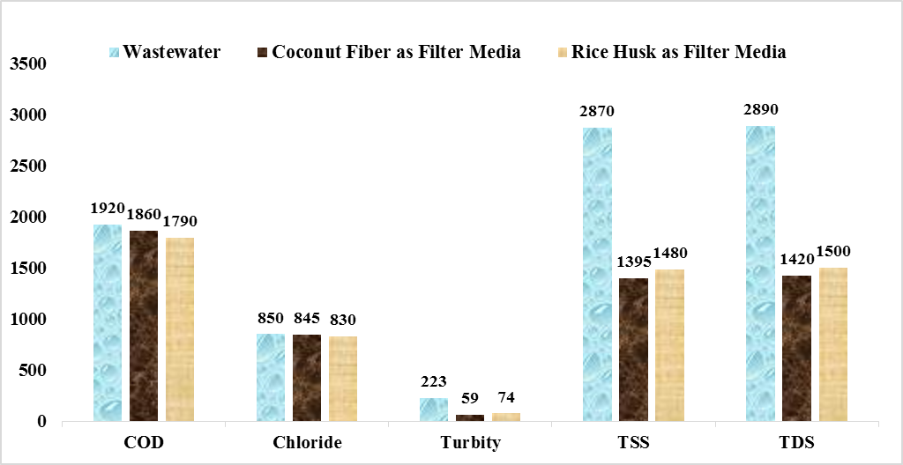
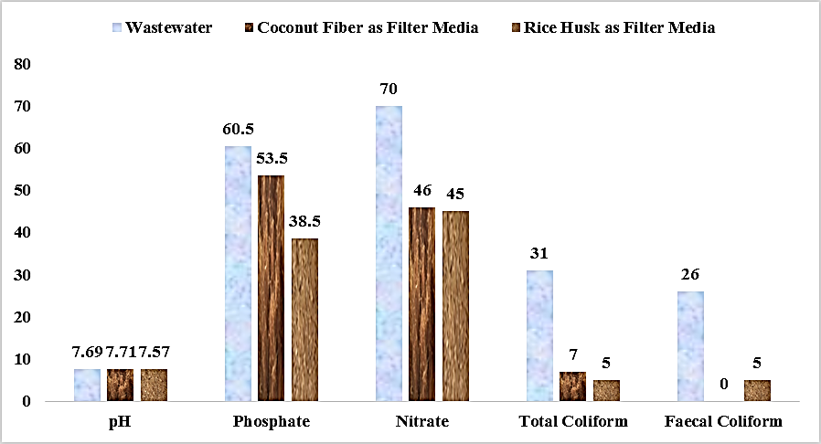
Figure 8: Variation of waste water testing parameters for different filter media

CONCLUSION
The research investigates inspection of pollutants present in domestic effluent as well as evaluation of the effectiveness of using coconut fiber and rice husk combination with sand and stone chips for the filtration of collected domestic effluent. The pH value and total coliform value according to Indian water quality standards for surface water is well enough in this case. The amount of total suspended solids and total dissolved solids have been decreased from the initial condition of domestic effluent. Moreover, growth of total coliform and fecal coliform has reduced perfectly. So, both coconut fiber and rice husk are suitable for domestic effluent treatment as filter media.

RECOMMENDATION
Though some parameters in this research were quite good, some parameters have taken under further investigation for their improvement and some other parameters also should investigate like
- Biochemical Oxygen Demand (BOD)
- Dissolved Oxygen (DO)
- Heavy metal
Even both coconut fiber and rice husk may be used together as filter media with stone chips and sand for further improvement of domestic effluent treatment. This may be found cost effective.

REFERENCES
1. Namasivayam, C. and Sangeetha, D. Recycling of agricultural solid waste, coir pith: Removal of anions, heavy metals, organics and dyes from water by adsorption onto ZnCl₂ activated coir pith carbon. Journal of Hazardous Materials. 2006, 135, 449–452.
2. Lankford, P.W. and Eckenfelder, W.W. Toxicity Reduction in Industrial Effluents, Van NostrandReinhold, 1990.
3. Kim, D.H. and Anderson, M.A.. Photoelectrocatalytic degradation of formic acid using a porous titanium dioxide thin-film electrode. Environmental Science and Technology. 1994, 28.3, 479-483.
4. Daifullah, A.A.M. and Girgis, B.S. Removal of some substituted phenols by activated carbon obtained from agricultural waste. Water Research. 1998, 32.4, 1169–1177.
5. Sharma, D.C. and Forester, C.F.. A preliminary examination into the adsorption of hexavalent chromium using low-cost adsorbents. Bioresource Technology. 1994, 47.3, 257-264.
6. Sivakumar K.K., Mohamed Haroon Basha and Nandhini, ZnO/UV induced photocatalytic degradation of textile dyes, Research Journal of Chemistry and Environment, 25(5), 2021, 160-165.
7. Daifullah, A.A.M., Girgis, B.S., and Gad H.M.H.. Utilization of agro-residues (rice husk) in small domestic effluent treatment plans. Materials Letters. 2003, 57.11, 1723–1731.
8. Mansaray, K.G., and Ghaly, A.E.. Thermogravimetric analysis of rice husks in an air atmosphere. Energy Source. 1998, 20.7, 653-663.
9. Sivakumar K.K. and M.S. Dheenadayalan, Utilization of environmental waste materials in the removal of heavy metals from industrial effluents, European Chemical Bulletin, 1(5), 2012.
10. Sato, N., Kawamoto K., Sato H., Lokuliyanaga M., Koide T. and Tanaka N.. Utilization of a localavailable biomass resource for domestic effluent treatment in Sri Lanka: Comparison between initial and current performance of coconut-fiber biofilm treatment system (COTS). Proceedings of 14th International Waste Management and Landfill Symposium. 2013.
11. Chanakya, H.N., Ramamurthy, N., Shanmukhappa, V., Vinutha, D. and Deepa, G.B.. Biomassbiofilm bioreactors for liquid and solid wastes of agro processingfield performance studies. International Conference on Advances in Industrial Domestic effluent Treatment. 2004, 441-450.
12. Grover, P.D.. Thermochemical characterization of biomass residues for gasification. Indian Institute of Technology. 1989.
13. Abdel-Ghani, N., Hefny, M. and ElChaghaby, G. A.. Removal of lead from aqueous solution using low cost abundantly available adsorbents. International Journal of Environmental Science and Technology. 2007, 4.1, 67-73.

