**Breaking the outer layer of the virus (Covid-19) with the help of electrical stimulation and protect the Human body against virus (Covid-19) infection.**

**Mamata Soni1, Bhavin Soni1**

**GRAPHICAL ABSTRACT**

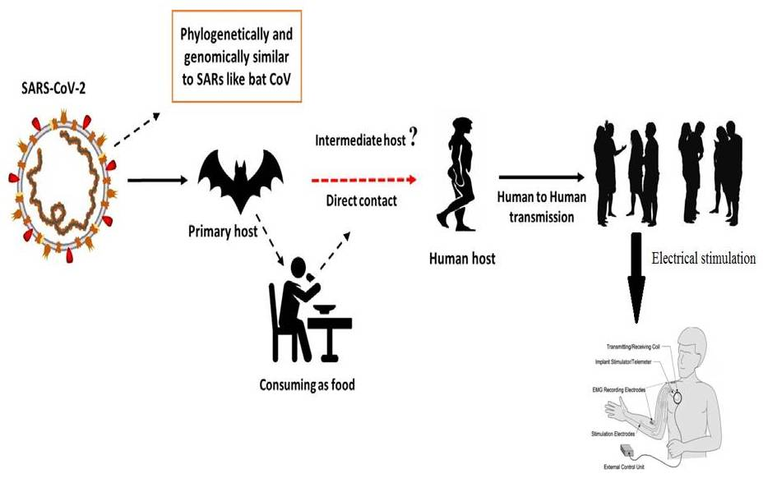

**KEY WORDS**

Electrical stimulation, Covid-19, Current, Voltage, SARS-CoV, MERS-CoV,

**INTRODUCTION**

Corona viruses belong to the Corona viridae family in the Nidovirales order. Corona represents crown-like spikes on the outer surface of the virus; thus, it was named as a corona virus. Corona viruses are minute in size (65–125 nm in diameter) and contain a single-stranded RNA as a nucleic material, size ranging from 26 to 32kbs in length (Fig. 1). The subgroups of corona viruses family are alpha (a), beta (b), gamma (c) and delta (d) corona virus. The severe acute respiratory syndrome corona virus (SARS-CoV), H5N1 influenza A, H1N1 2009 and Middle East respiratory syndrome corona virus (MERS-CoV) cause Acute Lung Injury (ALI) and Acute Respiratory Distress Syndrome (ARDS) which leads to pulmonary failure and result in fatality. These viruses were thought to infect only animals until the world witnessed a Severe Acute Respiratory Syndrome (SARS) outbreak caused by SARS-CoV, 2002 in Guangdong, China [Zhong et al., 2003]. Only a decade later, another pathogenic corona virus, known as Middle East Respiratory Syndrome corona virus (MERS-CoV) caused an endemic in Middle Eastern countries [Wang et al., 2013].

Recently at the end of 2019, Wuhan an emerging business hub of China experienced an outbreak of a novel corona virus that killed more than eighteen hundred and infected over seventy thousand individuals within the first fifty days of the epidemic. This virus was reported to be a member of the b group of corona viruses. The novel virus was named as Wuhan corona virus or 2019 novel corona virus (2019-nCov) by the Chinese researchers. The International Committee on Taxonomy of Viruses (ICTV) named the virus as SARS-CoV-2 and the disease as COVID-19 [Cui et al, 2019; Lai et al., 2019;WHO 2020]. In the history, SRAS-CoV (2003) infected 8098 individuals with mortality rate of 9%, across 26 countries in the world, on the other hand, novel corona virus (2019) infected 120,000 individuals with mortality rate of 2.9%, across 109 countries, till date of this writing. It shows that the transmission rate of SARS-CoV-2 is higher than SRAS-CoV and the reason could be genetic recombination event at S protein in the RBD region of SARS-CoV-2 may have enhanced its transmission ability.



**Figure: 1**Structure of respiratory syndrome causing human corona virus

**History of the electrical stimulation therapy use in various diseases**

One of the issues in this case is the use of electrical devices (Black Box, Magnetic Pulse Generators) for the use of blood electrification with the claim that use of such devices can be used to treat infections such as viruses, bacteria and yeast and diseases such as cancer. There is a historical basis in the scientific literature for these claims. In 1990, Lyman and colleagues reported that the passage of 50 to 100 microamperes of D.C. electrical current through Aids infected blood would inactivate the Aids virus and stop viral replication (Lyman et al., 1990). This research was presented at the First International Symposium on Combination Therapies (an AIDS conference) in Washington DC on March 14th, 1991.

Over the last few decades, the development of more efficient drugs against bacterial infections has revolutionized medical treatment, causing a drastic reduction in mortality caused by microbial diseases. On the other hand, the widespread use of antibiotics has lamentably led bacteria to develop defenses against antibacterial agents, resulting in increasing resistance, imposing serious limitations on the options for treating bacterial infections, which is a major threat to public health(Castro et al., 2002; Silveira et al.,2006). In the world scenario of bacterial resistance, bacteria of the genus *Enterobacter* and *Staphylococcus* stand out and the antibiotics used to control them are usually not effective, making treatment difficult (Martins et al.,2012).The genus *Enterobacter* is characterized as facultative anaerobic gram-negative bacilli belonging to family Enterobacteriaceae. Two of its species, *Enterobacter* *aerogenes* and *Enterobacter cloacae* are opportunistic bacteria and stand out as pathogens of intensive care unit patients capable of developing resistance mechanisms to β-lactams (Regli et al., 2015).

The greater the expression of the Amp-C gene by *Enterobacter*, the greater the mechanism of resistance to certain antibiotics such as cephalosporin, and there are reports of carbapenemase-producing strains (Tuon et al., 2015). On the other hand, *Staphylococcus aureus* is a bacterium of the gram-positive cocci group found in the skin and nasal passages of healthy individuals; it is the main etiological agent of skin infections due to its ability to change the integrity of the skin barrier. *S. aureus* can cause serious infections such as pneumonia, meningitis, endocarditis, septicemia and even systemic infections, which can lead to death. Furthermore, infections caused by this agent present high morbidity and mortality rates in both hospital and home-based cases (Martins et al.,2012).

The high ability of this bacterium to acquire resistance to antimicrobials has made it an important etiology of hospital infections, causing it to become a worldwide concern(Almeida et al.,2007; Zavadinack et al., 2001). Since the discovery of treatment-resistant *S. aureus* in the 1950s, several outbreaks of hospital and community infections have been associated with resistant bacteria, viruses and parasites(Barradas et al., 1997). In fact, a high prevalence of purulent skin infections caused by *S. aureus* is commonly observed in general practice and in the emergency department (Sukumaran et al.,2016). Furthermore, antimicrobial drug resistance is one of the most important reasons that change the epidemiological behavior of diseases, leading to an increase in prevalence and lethality of several diseases that were previously considered under control (Barradas et al., 1997).Due to the great importance of the evolution of microbial resistance and the need for control of hospital and non-hospital infections, it is necessary to develop new bacteriostatic and bactericidal agents that improve the therapy of infected individuals. One of the promising alternatives is the High Frequency Equipment (HFE). HFE produces alternating currents (high voltage and low intensity), has vacuum or gas glass electrodes that conduct current and ionize air molecules, forming fluorescence. The effect of ozone (O3) formed by the current-generated spark when it crosses the electrode and the thermal action of the equipment generated by the electric field formation are responsible for the physiological effects observed. For example, the local peripheral vasodilation that improves blood flow and oxygenation stands out(Martins et al.,2012;Korelo et al., 2013). The equipment is widely used by physiotherapists and aesthetics professionals to treat skin conditions, as an analgesic, anti-inflammatory and mainly to accelerate cicatricial processes (Martins et al.,2012;Korelo et al., 2013; Sa HP et al., 2010).

In contact with the skin, O3 is converted into molecular oxygen (O2) and atomic oxygen (O), which is extremely aggressive due to its oxidative capacity. The effectiveness of O3 action on bacteria is guaranteed because it acts on the bacterial membrane by compromising its enzymatic activity, altering the cell permeability, and causing oxidation of amino acids and nucleic acids, leading to bacterium death(Martins et al.,2012;Korelo et al., 2013; Oliveira et al., 2011). In this context, this research investigated the bactericidal action, many times and in many intensities, of HFE in standard *S. aureus* and *E. aerogenes* strains and determined the sensitivity of this electrotherapeutic resource on these bacteria.

The bacterial growth of *E. aerogenes* at 30, 60, 90, 120 and 180 seconds after irradiation with 6, 8 or 10 mA HFE is presented in **Figure 2 a**. Compared with the control group, the spark at intensity of 6 mA had no bactericidal effect; however, a significant bacterial growth reduction occurred at intensity of 8 mA at 120 and 180 seconds, and at 10 mA, reduction could already be verified at 30 seconds; however, total bacterial growth inhibition only occurred at 10 mA at 180 seconds.

For *S. aureus*, there was a strong growth inhibition at all intensities used; however, at 6 mA, absence of bacterium growth was observed after 120 and 180 seconds. By increasing the flashing intensity to 8 and 10 mA, it was observed that the bacterium growth was inhibited after only 30 seconds of irradiation, demonstrating that the higher the intensity, the shorter the time taken for the equipment to induce a bactericidal effect **(Figure 2 b.).**

|  |  |
| --- | --- |
|  |  |
| **Figure: 2a.** Antimicrobial effect of the high frequency equipment on the growth of *Enterobacter aerogenes* standard culture at different times (seconds).  **Notes:** Results are expressed as mean ± standard error of the mean. Data were analyzed by one-way analysis of variance, followed by Tukey post hoc*.* \**p*<0.01, compared with the control group. | **Figure: 2b.** Antimicrobial effect of the high frequency equipment on the growth of *Staphylococcus aureus* standard culture at different times (seconds).  **Notes:** Results are expressed as mean ± standard error of the mean. Data were analyzed by one-way analysis of variance, followed by Tukey post hoc*.* \**p*<0.01, compared with the control group. #*p*<0.05 compared with 6 mA in 30 seconds. |

**DISCUSSION**

It is my opinion that there is a scientific basis for the use of electrical stimulation devices in the treatment of many illnesses. Like cancer, AIDS, Herpes and many more. So here, we discuss that current Global epidemic covid-19 were spread on the earth. For this epidemic covid-19 we also use this method and break the outer surface of the corona virus and burst its cell. Use of this method to stop the replication of cell. In some case electrical stimulation can suppress the activity of cell.

**ACKNOWLEDGEMENT**

We will gratitude **Evellyn Claudia Wietzikoski Lovato and his team** who published research article on **“High frequency equipment promotes antibacterial effects dependent on intensity and exposure time”** its published in journal **Clinical, Cosmetic and Investigational Dermatology** in **2018**. This article helps the analysis of result in my review article.

**REFERENCES**

1. Almeida MC, Simoes MJS, Raddi MSG. [Ocorrencia de infeccao urinaria em pacientes de um hospital universitario]. *Revista de Ciências Farmacêuticas Básica e Aplicada*. 2007;28(2):215–217. Portuguese.
2. Barradas RC. [O desafio das doencas emergentes e a revalorizacao da epidemiologia descritiva]. *Revista Saúde Pública*. 1997;31(5):531–537. Portuguese.
3. Castro MS, Pilger D, Ferreira MBC, Kopittke L. [Tendencias na utilizacao de antimicrobianos em um hospital universitario, 1990–1996.] *Revista Saúde Pública*. 2002;36(5):553–558. Portuguese.
4. Cui J, Li F, Shi Z-L. Origin and evolution of pathogenic corona viruses. Nat Rev Microbiol 2019;17(3):181–92.
5. Korelo RIG, Oliveira JJJ, Souza RSA, Hullek RF, Fernandes LC. Gerador de alta frequencia como recurso para tratamento de ulceras por pressao: estudo piloto. *Fisioter Mov*. 2013;26(4):715–724.
6. Lai C-C, Shih T-P, Ko W-C, Tang H-J, Hsueh P-R. Severe acute respiratory syndrome coronavirus 2 (SARS-CoV-2) and corona virus disease-2019 (COVID- 19): the epidemic and the challenges. Int J Antimicrob Agents 2020;105924.
7. Lyman WD, et al. Lab Test Results of HIV inactivation by electric current: Reporting Inactivation of AIDS Virus by Electric Current. First International Symposium on Combination Therapies in Washington DC on March 14th, 1991.
8. Martins A, Silva JT, Graciola L, et al. [Efeito bactericida do gerador de alta frequencia na cultura de *Staphylococcus aureus*]. *Fisioterapia e Pesquisa*. 2012;19(2):153–157. Portuguese.
9. Oliveira LMN. [Utilizacao do ozonio atraves do aparelho de alta frequencia no tratamento da ulcera por pressao]. *Revista Brasileira de Ciências da Saúde.* 2011;9(30):41–46. Portuguese.
10. Organization WH. Laboratory testing for coronavirus disease 2019 (COVID-19) in suspected human cases: interim guidance, 2 March 2020. World Health Organization, 2020.
11. Regli AD, Pages JM. *Enterobacter aerogenes* and *Enterobacter cloacae*: versatile bacterial pathogens confronting antibiotic treatment. *Front Microbiol*. 2015;6:392.
12. Sa HP, Nunes HM, Santo LAE, et al. [Estudo comparativo da acao do laser GaAIInP e do gerador de alta frequencia no tratamento de feridas cutaneas em ratos: estudo experimental]. *ConScientiae Saúde*. 2010;9(3):360–366. Latin.
13. Silveira GP, Nome F, Gesser JC, et al. [Estrategias utilizadas no combate a resistencia bacteriana]. *Revista Química Nova*. 2006;29(4):844–855. Portuguese.
14. Sukumaran V. Bacterial skin and soft tissue infections. *Aust Prescr*. 2016;39(5):159–163.
15. Tuon FF, Scharf C, Rocha JL, Cieslinsk J, Becker GN, Arend LN. KPC-producing *Enterobacter aerogenes* infection. *Braz J Infect Dis*. 2015;19(3):324–327.
16. Wang N, Shi X, Jiang L, Zhang S, Wang D, Tong P, et al. Structure of MERS-CoV spike receptor-binding domain complexed with human receptor DPP4. Cell Res 2013;23(8):986.
17. Zavadinack MN, Herreiro F, Bandeira COP, et al. *Staphylococcus aureus*: incidencia e resistencia antimicrobiana em abcessos cutaneos de origem comunitaria. *Acta Scientiarum*. 2001;23(3):709–712.
18. Zhong N, Zheng B, Li Y, Poon L, Xie Z, Chan K, et al. Epidemiology and cause of severe acute respiratory syndrome (SARS) in Guangdong, People’s Republic of China, in February, 2003. The Lancet 2003;362(9393):1353–8.