Review of Protein and Peptide Delivery-What We Learned from Covid-19 - What's Next?
Jampala Rajkumar*¹, Jithendar Reddy Mandhadi³, M.D. Arif Pasha², Chandrashekar Thalluri³,
¹Vaageswari College of Pharmacy, Karimnagar-505527, T.S, India.
²Jyothismathi institute of pharmaceutical sciences, Karimnagar-505527, T.S, India.
³Faculty of Pharmaceutical Science, Assam Down Town University, Panikhaiti, Guwahati, Assam-781026, India.

Corresponding author: Dr. Jampala Rajkumar, HOD,
Dept. of Pharmaceutics
Vaageswari College of Pharmacy,
Karimnagar, Telangana.
Email: jampalarajkumar@gmail.com

Abstract
Protein and peptide-based drug delivery technologies are emerging, as they are abundant in living cells and play roles in enzymes, hormones, structural elements, and immunoglobulins. These molecules are commonly delivered via injection, injection, or injection. Recent protein and peptide research has shifted infectious disease treatment, particularly in the COVID-19 pandemic. Understanding viral infection at the molecular level may lead to new antiviral drugs targeting viral proteins or host components. These peptides could help clinical scientists develop and test COVID-19 therapeutic and preventative medications.
Keywords: Proteins and peptides, COVID-19, Viable therapy, Anti-viral medicines, SARS-CoV.

INTRODUCTION
The use of proteins and peptides as a drug delivery system is cutting-edge research. Most living systems and cells contain protein and peptides [1]. Hormones, enzymes, structural elements, and immunoglobulins are all in there [2, 3]. It also plays a role in various metabolic processes, immunogenic defense, and biological functions [4]. When it comes to biological systems, proteins are among the most common organic substances. The Greek term Proteios, from which we get the English word "protein," meaning "first." Proteins are large polymers of alpha-amino acids with peptide links between them. Protein contains the elements nitrogen, oxygen, and sulphur [5-7]. The Covenant Linkages hold the molecules with linear chain amino acids together. Peptide Bonds Peptides are Alpha Amino Acid Condensed Products[8]. An amino acid's alpha amino group is a condensed alpha carboxyl group. Protein is found in all living cells and is used for nutrition and bodybuilding. It is vital for plant and animal cells. Proteins operate as enzymes in biochemical reactions and transport metabolites and genes. It is used to shape and strengthen cells and tissues. It can affect temperature, PH, osmotic pressure, and metabolic processes. [9, 10]. Insulin regulates blood sugar levels. Muscle growth and mechanical work require it. Two amino acids are dipeptides, three amino acids are tripeptides, four amino acids are tetrapeptides, and polypeptides are 2-20 amino acids. Proteins are polymers of 100 or more amino acids. Proteins are categorized into two categories based on solubility and architectural complexity. First, they are split into two categories according to their solubility in protein, globularity, and fibrousness. Water or common salts may dissolve globular proteins, however water or common solvents cannot dissolve fibrous proteins. The second type of protein is categorized by complexity [11]. Thirdly, physiological agents including heat, chemicals, and enzymes hydrolyze protein molecules to form derived proteins. Protein structure has four classes. Protein primary structure. Protein's fundamental structure is its amino acids, polypeptide chain, and quantity. Secondary protein structures include alpha helical and beta pleated sheets. The (R-) group is a side chain amino acid, hence these folding results are mostly (H-) bound. Proteins' ultimate tertiary structures are elapsed, spherical, or irregular [12]. Hemoglobin has a quaternary structure comprising two or more polypeptide chains linked together by non-covalent bonds. Endogenous Proteins and Peptides support biological environments. Several hormones and peptides have important medical, pharmacological, and research uses. [13].

NECESSITY OF PROTEIN AND PEPTIDE IN DELIVERY SYSTEM OF DRUG
1. Biological organisms and chemical compounds rely heavily on proteins and peptides.
2. A deficiency in proteins and peptides can lead to health problems including diabetes mellitus. (As a lack of the protein INSULIN is to blame)
3. Protein and peptide-based medications are increasingly making use of R-DNA technology and hybridoma techniques.[14].

ADVANTAGES OF PROTEIN AND PEPTIDE IN DELIVERY SYSTEM OF DRUG [15-21]

1. Erythropoietin is mostly used in the formation of red blood cells.

2. Tissue plasminogen activator is a protein that is used to treat heart attacks and strokes.

3. Oxytocin is used to relieve labor pain.

4. Bradykinin stimulates peripheral circulation.

5. Hemorrhaging from stomach ulcers is lessened with somatostatin.

6. Ovulation is persuaded by gonadotropin.

7. Blood Glucose levels are regulated by insulin.

FUNCTIONS OF PROTEIN AND PEPTIDE DRUG DELIVERY SYSTEM [22-28]
1. Transport and storage of biological and other small molecules.
2. Coordination of movement is possible because of muscle contraction.
3. Protein fibers serve as a structural backbone.
4. Nerve impulse generation and transmission
5. Catalysis by enzymes in biological reactions.
6. Antibodies provide immune defense.
7. Hormones are used to control growth and differentiation.
INCORPORATION OF PROTEINS AND PEPTIDES INTO DRUG DELIVERY MATRIX

The drug incorporated into the Protein and Peptide system in drug delivery is subjected to three different processes, which are as follows: [29-34]

1. Emulsification

2. Drying with Extrusion and Spray Drying

3. Polymerization

1. EMULSIFICATION Aqueous medium -soluble medicines first dissolve in aqueous medium. Mixing the two liquids produces an emulsion-free mixture. The main emulsion is made w/o/w by adding the emulsifier. At last, the emulsion's organic solvent is burned out using a combination of filtering and heating. [35].

2. EXTRUSION AND SPRAY DRYING

There are two ways to make microspheres: with the help of extrusion and spraying. The Solution, which acts as the matrix and contains the active ingredient, and the Particulate, which are the tiny droplets that emerge from the orifices, which are very small tubes or nozzles. The ratio of the orifice diameter to the velocity of the jet is the primary factor in determining the droplet size, along with the liquid's characteristics.

3. POLYMERIZATION
Polymerization in hydrogels created by mixing monomer, drug, initiator, and cross linking agents. Intra vascular protein distribution by a photo polymerized hydro system on the inner side of a blood artery. Protein and peptide medication delivery methods have the drawback of losing protein molecule integrity when exposed to radiators.

APPLICATION
1. Cardiovascular system-affecting medications Anti-Angiotensin-II antagonists, Bradykinin, and Captopril are proteins and peptides crucial to the treatment of heart failure because of their roles in reducing blood pressure and improving peripheral circulation.
2. Cholecystokinin and B-endorphin are CNS active proteins and peptides that are essential for appetite control and pain alleviation.[36].
3. GI-active proteins and peptides (Gastrin antagonists, pancreatic enzymes) are essential for digestion supplements and are vital for lowering gastric acid production.[37].
4. Protein and peptide immunomodulation (Cyclosporin, Bersin, and Interferon) is required for selective B-cell differentiation. T-lymphocyte activity is inhibited while killer cell activity is increased.[38].
5. Proteins and peptides that modulate metabolism (Insulin, Vasopressin) are critical in the treatment of diabetes mellitus and diabetes insipidus.[39]

The characteristics of SARS-CoV and SARS-CoV-2 proteins, as well as their usefulness in drug discovery
SARS-CoV-2 has four structural proteins: spike (S), envelope (E), membrane (M), and nucleocapsid (N). 16 non-structural proteins (NSPs) might be medicines. S protein has two subunits [40]. S1. S2. S1's receptor-binding domain (RBD) helps viral entry and ACE2 binding, whereas S2 helps viral fusion. 41, 42 M and E proteins mainly assemble viruses. Viral replication and genome packaging need RNA-binding multivalent N protein. Structural and nonstructural protein changes affect virulence and viral propagation, thus they should be considered when creating therapies and vaccines.[43]
The human innate immune system has never seen SARS-genetic CoV-2's changes. Research shows this virus can infect a large percentage of humans. Ganesh et al. collected the data, which may be used to compare SARS-CoV-2 epidemiology and pathobiology to SARS and MERS as therapies are developed. [44].
Scientists created three medication development strategies to combat coronaviruses. First, test existing broad-spectrum antivirals. Their spectrum is too vast, notwithstanding their advantages in terms of metabolic properties, doses, potential efficacy, and adverse effects. Second, high-throughput screening of molecular databases for anti-coronavirus drugs [45]. Novel coronavirus-targeted drugs are the third option. We gathered peptide therapy and molecular mechanism studies from these findings. This article reviews SARS-CoV peptide therapeutics that might be reused for SARS-CoV-2 and updates previously produced peptides. Wet lab and clinical studies are needed to understand SARS-CoV-2 infection and enhance therapy development.[46].

SARS-CoV-2 and peptide therapies.
Existing antivirals have adverse effects, insufficient activity, resistance, safety, and effectiveness issues. They disrupt lengthy protein binding surfaces poorly. Pharma is embracing peptides. Peptide-based drugs outperform small molecule treatments due to their lower toxicity, adverse effects, and selectivity [47]. Synthesized and chemically stabilised. Chemical biology embraces peptides and peptidomimetics. Protein-mimicking peptides compete for binding. Peptide medications are unstable, hydrolysis and oxidation-prone, have a short half-life, and low membrane permeability. Over 60 peptide-based drugs are in clinical development. Peptides may enable epitope-based vaccine screening. Peptide-based SARS-CoV-2 treatments are ineffective.[48].
Antiviral peptides (AVPs) may fight SARSCoV2. AVPs are more effective than other antivirals at preventing viral infection. AVPs prevent adsorption, penetration, endosomal escape, uncoating, genome replication, and mature viri release. High-throughput screening and natural and biological studies help uncover a possible AVP. Seven AMPs may treat MERS. Fosgerau et al. examined peptide treatment methods and possibilities. Existing antiviral peptide drugs may treat MERS-CoV. Antivirals and SARS and MERS expertise can handle the present coronavirus epidemic.[49-55].
Several studies have examined COVID-19 therapy using peptides. Cherian et al. examined virus- and host-based medicine repurposing for coronaviruses and SARS-CoV-2 [56]. Many papers emphasize SARS-CoV-2 drug repurposing. Peptides can combat SARS-CoV-2. We also evaluate SARS-CoV-2-targeted peptides with therapeutic and preventative potential. Tables 1–3 show significant improvement since SARS-CoV was discovered.[57-60].

Mechanism-based COVID-19 peptide therapeutic classification.
Anti-coronavirus medicines target either the virus or the host/immune system. We classified the peptides as viral entry/fusion blockers, virus replication blockers, and immune modulators based on their potential effects.
Influencing viral entrance and fusion peptides
Human angiotensin-converting enzyme 2 (hACE2) receptor binding by the SARS-CoV spike (S) protein enables coronavirus entry into cells. Bioinformatics was employed by Lu et al. to locate SARS-cove S protein peptides that had B cell diagnostic epitopes. RBD is a target for viral attachment inhibitors, neutralising antibodies, and vaccines in the S1 component of the spike protein. Potential SARS-CoV-2 spike RBD inhibitor peptides were discovered by Barh et al. They discovered crucial residues interacting with the spike RBD using bioinformatics. The development of SARSCoV-2 peptide inhibitors involved the use of -helices from the protease domain of ACE2. RBD S1 binds to ACE2 PD directly. The SARS-CoV-2 spike protein's ability to connect with ACE2 can be inhibited by SBP1, a 23 MER peptide fragment of the ACE2 PD 1 helix.[61].
Coronavirus spike proteins are class I fusion proteins with HR1 and HR2 heptad repeats (HR). The target cell's ACE2 receptor and the heptad repeat form a six-helical bundle, a conserved viral fusion and entry mechanism. Many fusion inhibitors for CoV infections have been tried. HR2 peptides that inhibit SARS-CoV may also inhibit SARSCoV-2 because their HR1 and HR2 portions share 92.6 percent and 100% sequence homology, respectively [62, 63]. Tang et al. tested HR2-based inhibitory peptides for SARS-CoV and MERS-CoV, allowing peptide or small molecule anti-CoV fusogenics to suppress SARS-CoV-2 membrane fusion. A few HR2 sequence-based fusion inhibitors prevented cell fusion in a SARS-CoV-2 research. Xia et al. developed HR1-targeting pan-coronavirus inhibitor EK1. They also developed the potent lipopeptide EK1C4, which targets pan-coronavirus fusion spike protein [64]. By adding cholesterol residue to EK1, EK1C4 increased SARS-CoV-2 inhibitory effectiveness. EKIC4 blocked membrane fusion by SARS-CoV-2 spike protein and pseudotyped human coronaviruses like SARS and MERS. EK1C4, with an EC50 of 36.5 nm, is stronger than the EK1 peptide, which has 2.47 M. HR2-based lipopeptide fusion inhibitor IPB02 blocked SARS-CoV-2 spike protein-mediated cell-cell fusion and pseudovirus transmission. EK1C4, unlike other peptide drugs, may be inhaled as an aerosol to reduce lung viral load and pulmonary inflammation. Intranasal EK1C4 may treat SARS-CoV-2. The HR1 domain of the S2 subunit of the S protein is highly conserved, making drug resistance mutations difficult to evolve. [64, 65].
Peptides preventing the release and multiplication of viruses processing of polyproteins.
When the coronavirus invades a host cell, it modifies the transcriptional machinery to make copies of itself. Two polyproteins, pp1a and pp1ab, are encoded by the SARS-CoV positive stranded RNA genome at ORF1a and ORF1b, respectively. Proteolytic breakdown of these polyproteins generates 16 non-structural proteins necessary for viral replication, including two proteases, 3-chymotrypsin-like (3CLpro/Nsp5) and papain-like (PLpro/Nsp3). The sequence identity between SARS-CoV and SARS-3CLpro CoV-2 is 99.02. While looking into the feasibility of developing peptide inhibitors that target the substrate binding site of SARSCoV-2 3CLpro, two peptidomimetic aldehydes, 11a and 11b, were discovered. Both showed significant effectiveness against SARS coronavirus type 2 infection. As an alternative protease involved in the proteolytic processing of the replicase polyprotein, PLPro (Papain like protease) is an attractive target for antiviral therapy. Glutathione, which is used to treat liver problems, was shown to be effective against PLPro with a docking score of 20.[66-68].
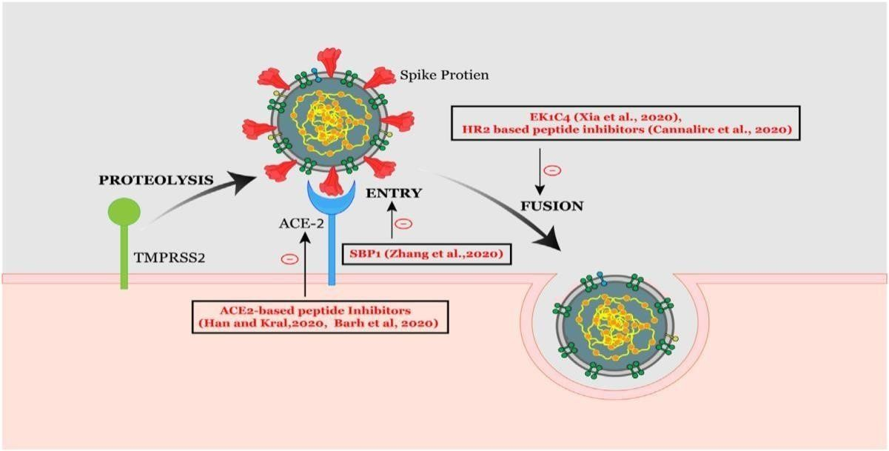
Figure 1. This schematic illustrates the CoV-2's and fusion mechanism during SARS infection. Represented are peptide compounds that have been linked to coronavirus entrance and fusion.
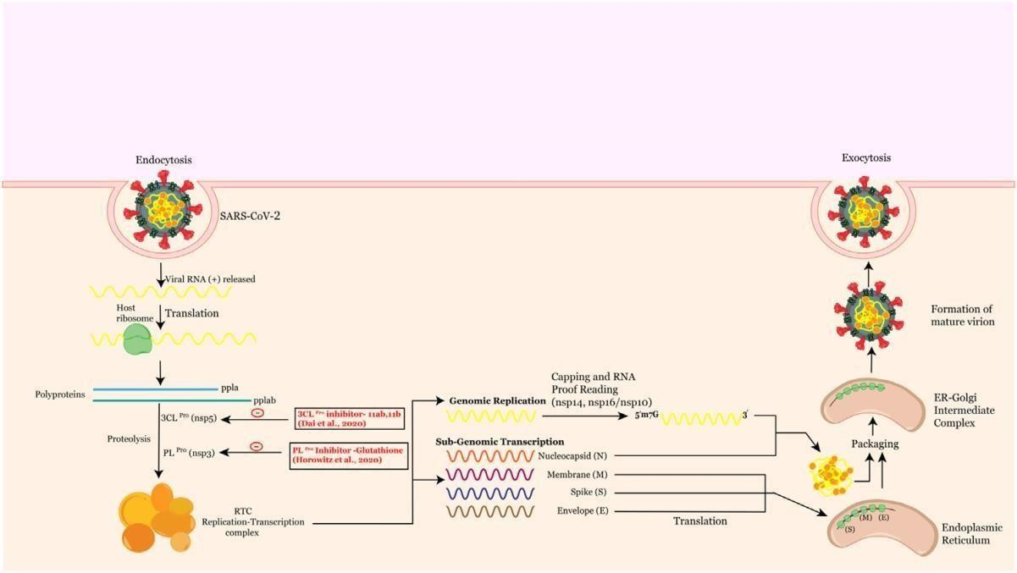

Figure 2. Peptide therapies target viral replicase, a protein complex controlling RNA synthesis. Remdesivir, a nucleoside analogue, targets Nsp12 and targets Ebola, Nipah, RSV, SARS-CoV, and MERS-CoV. It may affect viral RNA synthesis in these coronaviruses, potentially aiding COVID-19 emergency therapy.
Remdesivir reduced respiratory tract infection in COVID-19 adults in a recent placebo-controlled trial.
SARS-CoV-2 Cryo-EM structural investigations confirm Nsp12's conserved mode of action with SARS-CoV. Nsp12 contains a right-hand RdRp domain and a nidovirus nucleotidyl transferase architecture. Nsp12 and Nsp7/Nsp8 may synthesize viral RNA. Nsp7-Nsp8 synthesizes a 6-nucleotide primer for RdRp RNA transcription to enhance Nsp12's RNA binding and enzymatic activity. Nsp12-Nsp8 interaction is therapeutically promising.
Nsp9 is thought to be involved in viral replication, pathogenicity, and viral genomic RNA reproduction. Selinexor, a synthetic peptide, is an inhibitor of CRM1 (Chromosome region maintenance protein), also known as exportin 1 (XPO1), involved in nuclear export. Currently, low oral dosages of this peptide are being evaluated against COVID19. In addition to inhibiting adipogenesis, the mushroom-derived Ternatin 4-N-methylated cyclic hexapeptide also inhibits the translation machinery. Because ternatin 4 affects host translation, it is included as a potential SARS-CoV-2 preclinical compound.
Viral pathogenicity involves epigenetic changes that alter chromatin. SARS-CoV study emphasises epigenetic regulators. ACE2 DNA methylation research illuminated SARS-CoV-2 epidemiology. BET epigenetic readers control ACE2 expression. Gordon et al. found a BRD4-SARSCoV-2 E protein interaction, suggesting peptide-based bromodomain inhibitors for SARS. The SARS-CoV-2 interactome found an HDAC2-Nsp5 connection. Nsp5 inhibits HDAC2 nucleus trafficking. Since COVID-19 seems to flip, we suggest Nsp5 peptide inhibitors. HDAC inhibitors may prevent COVID-19. Epigenetic therapeutics like epidrugs may aid treatment or prevention. Intriguingly, Apicidin was found utilising a cyclic 3-tetrapeptide scaffold, which may be used to develop new anti-coronaviral peptide inhibitors. [69-73].

RNA processing

The coronavirus replicase employs many RNA processing enzymes not present in other RNA viruses, including RNA polymerase, RNA helicase, and protease. The cap is then ribose 2-O-methylated to hide viruses from the host immune system. Nsp13, an RNA/NTP triphosphate triphosphatase and helicase; Nsp14, an RNA cap N7 methyltransferase; and Nsp16, a ribose-O methyltransferase and unknown guanylyl translocator. Nsp14's N7-Methyltransferase domain is an attractive antiviral target since it folds differently from cellular methyltransferases. Coronavirus methyltransferases are intriguing antiviral targets.[74-78]

Virus maturation

RTC negative-stranded intermediates produce offspring genomes and subgenomic mRNAs. These mRNAs produce structural proteins S, M, E, and N. SARS-CoV-2 E protein participates in envelope synthesis, pathogenicity, budding, and assembly. N is the sole structural protein that forms the nucleocapsid with the CoV RNA genome. SARS-N CoV-2's protein resembles SARS- CoV's. Cascarina et al. found that the SARS-CoV-2 N protein regulates biomolecular interactions with RNA and key host cell proteins. N protein-stress granule protein interaction activates host immunity. Stress granules may reduce coronavirus proliferation. N protein-G3BP1 interactions inhibit RNA virus replication. [79-81].

Peptides that act as immune modulators

The virus activates the target cell's immune system. SARS-CoV-2 infects ACE2 receptor-expressing cells in the lungs via the nose and mouth. These viruses reproduce unchecked by innate immune cells. Immune cells like macrophages release cytokines.[82]

Innate immune response
SARS-CoV-2 upper and lower respiratory tract infections produce ARS. AMY-101 effectively cured COVID-19 pneumonia-induced severe ARDS. An interleukin-1 receptor antagonist and remdesivir diminish SARS-CoV-2 pathogenic immune response.[83].
NK cells lyse virus-infected cells. COVID-19 patients have less peripheral NK cells. Chemokine production boosted lung NK cell migration in SARS-CoV mice. NK cells may move from the blood to the lungs because to COVID-19 patients' increased chemokine expression. A transcriptome signature revealed CXCR3-mediated NK cell lung invasion. Peptide inhibitors that block chemokine receptors may cure SARSCoV-2 by recruiting NK cells to kill the virus. New peptide therapies are also required since peptide antagonism activates NK cells.[84].
Adaptive immune response
Vaccination depends on antibody response and immunological memory. Vaccines should activate antigen-specific B-cells, CTLs, or T helper cells. SARSCoV-2 causes antibodies, CD4+, and CD8+ T cells. T cells release cytokines after identification. Others provide CD4+ T cells SARS-CoV peptides. Vaccines should boost immunity to the target infection. Kiyotani et al. discovered 781 HLA class I and 418 Class II SARS-CoV-2 peptide epitopes using computational screening. ITLCFTLKR, a vaccine candidate from the SARS-CoV-2 proteome, has HLA allele binding affinity. Peptides binding to MHC class I and II were promising epitope-based peptide vaccination candidates for envelope protein. Ten structural protein-based SARSCoV-2 peptide vaccine epitopes were found by molecular docking against MHC-I. New vaccines may be developed using immunogenic epitopes. In silico procedures are preferred over expensive and time-consuming experimental methods. [85-88].
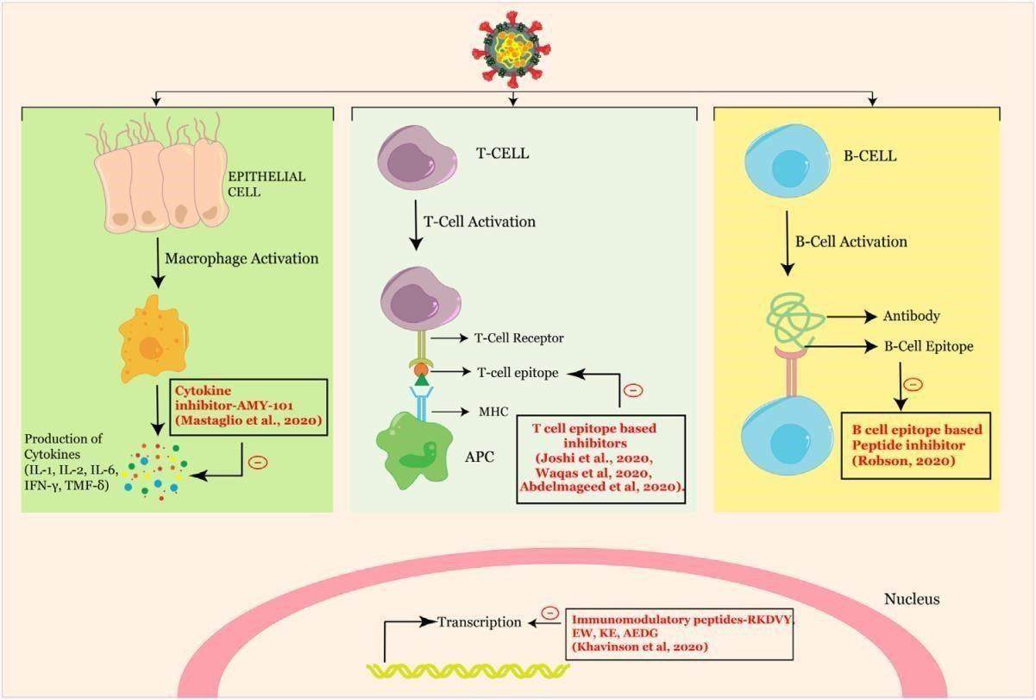Figure 3. Peptide treatments in the foreground show how SARS-CoV-2 affects the immune system.

Conclusion
Peptide therapies face challenges in ADME performance, prompting pharmaceutical companies to explore innovative approaches. SARSCoV treatment insights can improve the process, but further research is needed for COVID-19 solutions.

Author contributions

All authors contributed to manuscript revision, read and approved the submitted version.

Conflicts of interest

The authors declare that they have no conflicts of interest.

Consent to participate

Not applicable

Consent to publication

“Not applicable.

REFERENCE
1. Gaunt ER, Hardie A, Claas ECJ, Simmonds P, Templeton KE. Epidemiology and clinical presentations of the four human coronaviruses 229E, HKU1, NL63, and OC43 detected over 3 years using a novel multiplex real-time PCR method. Journal of Clinical Microbiology. 2010;48:2940-7.
2. Al-Hajjar S. SARS: Challenge of the new century. In: King Faisal Specialist Hospital and Research Centre; 2003, p. 116-7. (ISBN No. 0256-4947)
3. Chafekar A, Fielding BC. MERS-CoV: understanding the latest human coronavirus threat. Viruses. 2018;10:93.
4. Marty AM, Jones MK. The novel coronavirus (SARS-CoV-2) is a one health issue. One Health. 2020;9.
5. Chan JFW, Kok KH, Zhu Z, Chu H, To KKW, Yuan S, et al. Genomic characterization of the 2019 novel human-pathogenic coronavirus isolated from a patient with atypical pneumonia after visiting Wuhan. Emerging Microbes and Infections. 2020;9:221-36.
6. Morse JS, Lalonde T, Xu S, Liu WR. Learning from the Past: Possible Urgent Prevention and Treatment Options for Severe Acute Respiratory Infections Caused by 2019-nCoV. ChemBioChem. 2020;21:730-8.
7. Neerukonda SN, Pathogens UK, undefined. A review on SARS-CoV-2 virology, pathophysiology, animal models, and anti-viral interventions. mdpicom.
8. Parasher A. COVID-19: Current understanding of its pathophysiology, clinical presentation and treatment. Postgraduate medical journal. 2021;97:312-20.
9. Zhu N, Zhang D, Wang W, Li X, Yang B, Song J, et al. A Novel Coronavirus from Patients with Pneumonia in China, 2019. New England Journal of Medicine. 2020;382:727-33.
10. Zhu Y, Yu D, Yan H, Chong H, He Y. Design of Potent Membrane Fusion Inhibitors against SARS-CoV-2, an Emerging Coronavirus with High Fusogenic Activity. Journal of Virology. 2020;94.
11. Gorbalenya AE, Baker SC, Baric RS, de Groot RJ, Drosten C, Gulyaeva AA, et al. Severe acute respiratory syndrome-related coronavirus: The species and its viruses–a statement of the Coronavirus Study Group. BioRxiv. 2020.
12. Astuti I. Severe Acute Respiratory Syndrome Coronavirus 2 (SARS-CoV-2): An overview of viral structure and host response. Diabetes & Metabolic Syndrome: Clinical Research & Reviews. 2020;14:407-12.
13. Chen L, Zhong L. Genomics functional analysis and drug screening of SARS-CoV-2, Genes Dis.(2020). In.
14. Hatmal MmM, Alshaer W, Al-Hatamleh MA, Hatmal M, Smadi O, Taha MO, et al. Comprehensive structural and molecular comparison of spike proteins of SARS-CoV-2, SARS-CoV and MERS-CoV, and their interactions with ACE2. Cells. 2020;9:2638.
15. Premkumar L, Segovia-Chumbez B, Jadi R, Martinez DR, Raut R, Markmann AJ, et al. The receptor-binding domain of the viral spike protein is an immunodominant and highly specific target of antibodies in SARS-CoV-2 patients. Science immunology. 2020;5:eabc8413.
16. Tomaszewski T, DeVries RS, Dong M, Bhatia G, Norsworthy MD, Zheng X, et al. New pathways of mutational change in SARS-CoV-2 proteomes involve regions of intrinsic disorder important for virus replication and release. Evolutionary Bioinformatics. 2020;16:1176934320965149.
17. Ganesh B, Rajakumar T, Malathi M, Manikandan N, Nagaraj J, Santhakumar A, et al. Epidemiology and pathobiology of SARS-CoV-2 (COVID-19) in comparison with SARS, MERS: An updated overview of current knowledge and future perspectives. Clinical epidemiology and global health. 2021;10:100694.
18. Zumla A, Chan JF, Azhar EI, Hui DS, Yuen K-Y. Coronaviruses—drug discovery and therapeutic options. Nature reviews Drug discovery. 2016;15:327-47.
19. Chan JF, Chan K-H, Kao RY, To KK, Zheng B-J, Li CP, et al. Broad-spectrum antivirals for the emerging Middle East respiratory syndrome coronavirus. Journal of Infection. 2013;67:606-16.
20. De Wilde AH, Jochmans D, Posthuma CC, Zevenhoven-Dobbe JC, Van Nieuwkoop S, Bestebroer TM, et al. Screening of an FDA-approved compound library identifies four small-molecule inhibitors of Middle East respiratory syndrome coronavirus replication in cell culture. Antimicrobial agents and chemotherapy. 2014;58:4875-84.
21. Dyall J, Coleman CM, Venkataraman T, Holbrook MR, Kindrachuk J, Johnson RF, et al. Repurposing of clinically developed drugs for treatment of Middle East respiratory syndrome coronavirus infection. Antimicrobial agents and chemotherapy. 2014;58:4885-93.
22. Mohammadi Pour P, Fakhri S, Asgary S, Farzaei MH, Echeverria J. The signaling pathways, and therapeutic targets of antiviral agents: focusing on the antiviral approaches and clinical perspectives of anthocyanins in the management of viral diseases. Frontiers in Pharmacology. 2019;10:1207.
23. Smith MC, Gestwicki JE. Features of protein–protein interactions that translate into potent inhibitors: topology, surface area and affinity. Expert reviews in molecular medicine. 2012;14.
24. Cretich M, Gori A, D’Annessa I, Chiari M, Colombo G. Peptides for infectious diseases: From probe design to diagnostic microarrays. Antibodies. 2019;8:23.
25. Cunningham AD, Qvit N, Mochly-Rosen D. Peptides and peptidomimetics as regulators of protein–protein interactions. Current opinion in structural biology. 2017;44:59-66.
26. Di L. Strategic approaches to optimizing peptide ADME properties. The AAPS journal. 2015;17:134-43.
27. Lee AC-L, Harris JL, Khanna KK, Hong J-H. A comprehensive review on current advances in peptide drug development and design. International journal of molecular sciences. 2019;20:2383.
28. Madhavan M, Mustafa S. En route to peptide therapeutics for COVID 19: harnessing potential antigenic mimicry between viral and human proteins. Transactions of the Indian National Academy of Engineering. 2020;5:411-5.
29. Chowdhury SM, Talukder SA, Khan AM, Afrin N, Ali MA, Islam R, et al. Antiviral Peptides as Promising Therapeutics against SARS-CoV-2. Journal of Physical Chemistry B. 2020;124:9785-92.
30. Ahmed A, Siman-Tov G, Hall G, Bhalla N, Narayanan A. Human antimicrobial peptides as therapeutics for viral infections. Viruses. 2019;11:704.
31. Vilas Boas LCP, Campos ML, Berlanda RLA, de Carvalho Neves N, Franco OL. Antiviral peptides as promising therapeutic drugs. Cellular and Molecular Life Sciences. 2019;76:3525-42.
32. Agarwal G, Gabrani R. Antiviral Peptides: Identification and Validation. International Journal of Peptide Research and Therapeutics. 2021;27:149-68.
33. Fosgerau K, Hoffmann T. Peptide therapeutics: current status and future directions. Drug discovery today. 2015;20:122-8.
34. Mustafa S, Balkhy H, Gabere MN. Current treatment options and the role of peptides as potential therapeutic components for Middle East Respiratory Syndrome (MERS): a review. Journal of infection and public health. 2018;11:9-17.
35. Kiplin Guy R, DiPaola RS, Romanelli F, Dutch RE. Rapid repurposing of drugs for COVID-19. Science. 2020;368:829-30.
36. Harrison C. Coronavirus puts drug repurposing on the fast track. Nature biotechnology. 2020;38:379-81.
37. Khavinson V, Linkova N, Dyatlova A, Kuznik B, Umnov R. Peptides: Prospects for Use in the Treatment of COVID-19. Molecules. 2020;25:4389.
38. Mousavi Maleki MS, Rostamian M, Madanchi H. Antimicrobial peptides and other peptide-like therapeutics as promising candidates to combat SARS-CoV-2. Expert Review of Anti-Infective Therapy. 2021;19:1205-17.
39. Cherian SS, Agrawal M, … ABTIjo, undefined. Perspectives for repurposing drugs for the coronavirus disease 2019. ncbinlmnihgov.
40. Chen YW, Yiu C-PB, Wong K-Y. Prediction of the SARS-CoV-2 (2019-nCoV) 3C-like protease (3CL pro) structure: virtual screening reveals velpatasvir, ledipasvir, and other drug repurposing candidates. F1000Research. 2020;9.
41. Li G, De Clercq E. Therapeutic options for the 2019 novel coronavirus (2019-nCoV). Nat Rev Drug Discov. 2020;19:149-50.
42. Elfiky AA. Anti-HCV, nucleotide inhibitors, repurposing against COVID-19. Life sciences. 2020;248:117477.
43. Zhou Y, Hou Y, Shen J, Huang Y, Martin W, Cheng F. Network-based drug repurposing for novel coronavirus 2019-nCoV/SARS-CoV-2. Cell discovery. 2020;6:1-18.
44. Han DP, Penn-Nicholson A, Virology MWC, undefined. Identification of critical determinants on ACE2 for SARS-CoV entry and development of a potent entry inhibitor. Elsevier.
45. Huang Y, Zhao R, Luo J, Xiong S, Shangguan D, Zhang H, et al. Design, synthesis and screening of antisense peptide based combinatorial peptide libraries towards an aromatic region of SARS-CoV. Journal of Molecular Recognition. 2008;21:122-31.
46. Guo Y, Tisoncik J, McReynolds S, Farzan M, Prabhakar BS, Gallagher T, et al. Identification of a new region of SARS-CoV S protein critical for viral entry. Journal of molecular biology. 2009;394:600-5.
47. Chu LHM, Chan SH, Tsai SN, Wang Y, Cheng CHK, Wong KB, et al. Fusion core structure of the severe acute respiratory syndrome coronavirus (SARS-CoV): In search of potent SARS-CoV entry inhibitors. Journal of Cellular Biochemistry. 2008;104:2335-47.
48. Struck A-W, Axmann M, Pfefferle S, Drosten C, Meyer B. A hexapeptide of the receptor-binding domain of SARS corona virus spike protein blocks viral entry into host cells via the human receptor ACE2. Antiviral research. 2012;94:288-96.
49. Lu W, Wu X-D, Shi MD, Yang RF, He YY, Bian C, et al. Synthetic peptides derived from SARS coronavirus S protein with diagnostic and therapeutic potential. FEBS letters. 2005;579:2130-6.
50. Yuan K, Yi L, Chen J, Qu X, Qing T, Rao X, et al. Suppression of SARS-CoV entry by peptides corresponding to heptad regions on spike glycoprotein. Biochemical and biophysical research communications. 2004;319:746-52.
51. Bosch BJ, Martina BEE, Van Der Zee R, Lepault J, Haijema BJ, Versluis C, et al. Severe acute respiratory syndrome coronavirus (SARS-CoV) infection inhibition using spike protein heptad repeat-derived peptides. Proceedings of the National Academy of Sciences of the United States of America. 2004;101:8455-60.
52. Xia S, Yan L, Xu W, Agrawal AS, Algaissi A, Tseng C-TK, et al. A pan-coronavirus fusion inhibitor targeting the HR1 domain of human coronavirus spike. Science advances. 2019;5:eaav4580.
53. Jr BS, Mossel EC, Gallaher WR, Research WCWV, undefined. Inhibition of severe acute respiratory syndrome-associated coronavirus (SARS-CoV) infectivity by peptides analogous to the viral spike protein. Elsevier.
54. Liu I-J, Kao C-L, Hsieh S-C, Wey M-T, Kan L-S, Wang W-K. Identification of a minimal peptide derived from heptad repeat (HR) 2 of spike protein of SARS-CoV and combination of HR1-derived peptides as fusion inhibitors. Antiviral research. 2009;81:82-7.
55. Zhu GX, Tao H, He W, Tien P, Shan GFM, Tang J, et al. Screening and identification of severe acute respiratory syndrome-associated coronavirus-specific CTL epitopes. Am Assoc Immnol. 2022;177:2138-45.
56. He Y, Zhou Y, Siddiqui P, Niu J, Jiang S. Identification of immunodominant epitopes on the membrane protein of the severe acute respiratory syndrome-associated coronavirus. Journal of Clinical Microbiology. 2005;43:3718-26.
57. Choy W-Y, Lin S-G, Chan PK-S, Tam JS-L, Lo YD, Chu IM-T, et al. Synthetic peptide studies on the severe acute respiratory syndrome (SARS) coronavirus spike glycoprotein: perspective for SARS vaccine development. Clinical Chemistry. 2004;50:1036-42.
58. Hu H, Li L, Kao RY, Kou B, Wang Z, Zhang L, et al. Screening and identification of linear B-cell epitopes and entry-blocking peptide of severe acute respiratory syndrome (SARS)-associated coronavirus using synthetic overlapping peptide library. Journal of Combinatorial Chemistry. 2005;7:648-56.
59. Tai W, He L, Zhang X, Pu J, Voronin D, Jiang S, et al. Characterization of the receptor-binding domain (RBD) of 2019 novel coronavirus: implication for development of RBD protein as a viral attachment inhibitor and vaccine. Cellular & Molecular Immunology 2020 17:6. 2020;17:613-20 .
60. Barh D, Tiwari S, Silva Andrade B, Giovanetti M, Almeida Costa E, Kumavath R, et al. Potential chimeric peptides to block the SARS-CoV-2 spike receptor-binding domain. F1000Research 2020 9:576. 2020;9:576.
61. Han Y, Král P. Computational Design of ACE2-Based Peptide Inhibitors of SARS-CoV-2. ACS nano. 2020;14:5143-7.
62. Xu Y, Zhu J, Liu Y, Lou Z, Yuan F, Liu Y, et al. Characterization of the heptad repeat regions, HR1 and HR2, and design of a fusion core structure model of the spike protein from severe acute respiratory syndrome. ACS Publications. 2004;43:14064-71 .
63. Xia S, Zhu Y, Liu M, Lan Q, Xu W, immunology YWm, et al. Fusion mechanism of 2019-nCoV and fusion inhibitors targeting HR1 domain in spike protein. naturecom.
64. Tang T, Bidon M, Jaimes JA, Whittaker GR, Daniel S. Coronavirus membrane fusion mechanism offers a potential target for antiviral development. Antiviral research. 2020;178:104792.
65. Cannalire R, Stefanelli I, Cerchia C, Beccari AR, Pelliccia S, Summa V. SARS-CoV-2 entry inhibitors: Small molecules and peptides targeting virus or host cells. mdpicom. 10.3390/ijms21165707.
66. ul Qamar MT, Alqahtani SM, Alamri MA, Chen L-L. Structural basis of SARS-CoV-2 3CLpro and anti-COVID-19 drug discovery from medicinal plants. Journal of pharmaceutical analysis. 2020;10:313-9.
67. Yang H, Xie W, Xue X, Yang K, Ma J, Liang W, et al. Design of wide-spectrum inhibitors targeting coronavirus main proteases. PLoS Biology. 2005;3.
68. Dai W, Zhang B, Jiang XM, Su H, Li J, Zhao Y, et al. Structure-based design of antiviral drug candidates targeting the SARS-CoV-2 main protease. Science. 2020;368:1331-5.
69. Corley MJ, Ndhlovu LC. DNA Methylation Analysis of the COVID-19 host cell receptor, Angiotensin I Converting Enzyme 2 gene (ACE2) in the Respiratory System Reveal Age and Gender Differences. 2020;10.20944/preprints202003.0295.v1.
70. Qiao Y, Wang XM, Mannan R, Pitchiaya S, Zhang Y, Wotring JW, et al. Targeting transcriptional regulation of SARS-CoV-2 entry factors ACE2 and TMPRSS2. Proceedings of the National Academy of Sciences of the United States of America. 2020;118.
71. Takahashi Y, Hayakawa A, Sano R, Fukuda H, Harada M, Kubo R, et al. Histone deacetylase inhibitors suppress ACE2 and ABO simultaneously, suggesting a preventive potential against COVID-19. Scientific Reports 2021 11:1. 2021;11:1-9 .
72. Pruimboom L. Methylation Pathways and SARS-CoV-2 Lung Infiltration and Cell Membrane-Virus Fusion Are Both Subject to Epigenetics. Frontiers in Cellular and Infection Microbiology. 2020;10:290.
73. Olsen CA, Ghadiri MR. Discovery of potent and selective histone deacetylase inhibitors via focused combinatorial libraries of cyclic α3 β-tetrapeptides. Journal of Medicinal Chemistry. 2009;52:7836-46.
74. Mousavizadeh L, Ghasemi S. Genotype and phenotype of COVID-19: Their roles in pathogenesis. Journal of Microbiology, Immunology and Infection. 2021;54:159-63.
75. Daffis S, Szretter KJ, Schriewer J, Li J, Youn S, Errett J, et al. 2′-O methylation of the viral mRNA cap evades host restriction by IFIT family members. Nature 2010 468:7322. 2010;468:452-6 .
76. Viswanathan T, Arya S, Chan SH, Qi S, Dai N, Misra A, et al. Structural basis of RNA cap modification by SARS-CoV-2. Nature Communications 2020 11:1. 2020;11:1-7.
77. Chen Y, Cai H, Pan Ja, Xiang N, Tien P, Ahola T, et al. Functional screen reveals SARS coronavirus nonstructural protein nsp14 as a novel cap N7 methyltransferase. Proceedings of the National Academy of Sciences. 2009;106:3484-9.
78. Wang Y, Sun Y, Wu A, Xu S, Pan R, Zeng C, et al. Coronavirus nsp10/nsp16 Methyltransferase Can Be Targeted by nsp10-Derived Peptide In Vitro and In Vivo To Reduce Replication and Pathogenesis. Journal of Virology. 2015;89:8416-27.
79. Haan CAMd, research PJMRAiv, undefined. Molecular interactions in the assembly of coronaviruses. Elsevier.
80. Cascarina SM, Ross ED. A proposed role for the SARS-CoV-2 nucleocapsid protein in the formation and regulation of biomolecular condensates. FASEB Journal. 2020;34:9832-42.
81. Yang W, Ru Y, Ren J, Bai J, Wei J, Fu S, et al. G3BP1 inhibits RNA virus replication by positively regulating RIG-I-mediated cellular antiviral response. Cell Death & Disease 2019 10:12. 2019;10:1-15.
82. Gallenga CE. Induction of pro-inflammatory cytokines (IL-1 and IL-6) and lung inflammation by COVID-19: anti-inflammatory strategies. Article in Journal of Biological Regulators and Homeostatic Agents. 2020;10.23812/CONTI-E.
83. Franzetti M, Pozzetti U, Carugati M, Pandolfo A, Molteni C, Faccioli P, et al. Interleukin-1 receptor antagonist anakinra in association with remdesivir in severe COVID-19: A case report. International Journal of Infectious Diseases. 2020;97:215-8.
84. Fadda L, Borhis G, Ahmed P, Cheent K, Pageon SV, Cazaly A, et al. Peptide antagonism as a mechanism for NK cell activation. Proceedings of the National Academy of Sciences of the United States of America. 2010;107:10160-5.
85. Liu J, Wu P, Gao F, Qi J, Kawana-Tachikawa A, Xie J, et al. Novel Immunodominant Peptide Presentation Strategy: a Featured HLA-A*2402-Restricted Cytotoxic T-Lymphocyte Epitope Stabilized by Intrachain Hydrogen Bonds from Severe Acute Respiratory Syndrome Coronavirus Nucleocapsid Protein. Journal of Virology. 2010;84:11849-57.
86. Joshi A, Joshi BC, Mannan MAu, Kaushik V. Epitope based vaccine prediction for SARS-COV-2 by deploying immuno-informatics approach. Informatics in Medicine Unlocked. 2020;19:100338.
87. Robson B. Computers and viral diseases. Preliminary bioinformatics studies on the design of a synthetic vaccine and a preventative peptidomimetic antagonist against the SARS-CoV-2 (2019-nCoV, COVID-19) coronavirus. Computers in Biology and Medicine. 2020;119:103670.
88. Palatnik-de-Sousa CB, Soares IdS, Rosa DS. Editorial: Epitope discovery and synthetic vaccine design. Frontiers in Immunology. 2018;9:826.

