Plants Structures and Functions for Biomimetic Innovations

Dr. M. Padma Sundari,

Assistant Professor,

St.Joseph’s college for women,

Visakhapatnam

Introduction

Biomimicry or biomimetics is ‘‘a novel science that take natural world prototypes and then emulates or takes as a model from these nature inspired innovations to solve human challenges’’ (Benyus 2002). ‘‘The term ‘Biomimicry’ first came across in 1962 in the scientific literature, and was used more amongst material researcher in 1980s. Vast interest in Biomimicry has been developed during the last decade, based on scientific work carried by life science researcher like Janine Benyus (professor of biology) Steven Vogel and Julian Vincent (professor of Biomimetics). Julian Vincent defines Biomimetic as ‘the abstraction of good design from nature’, while Janine Benyus describes it as ‘the conscious emulation of nature’s genius” (Michael,2011). Thus, imitation of nature is used in developing environmentally sustainable long-term biologically inspired design solutions. With exploitation of natural resources and high pressure on the environment, there is a greater need to look for alternatives for the sustainable design technology for industries without destructing ecosystem (cf. European Commission 2012). Bio inspired innovation main objective is building a great bio design by imitating various lifeform which are into existence since 3.8 billion years.

The nature particularly, plant kingdom has gifted many designs with morphological features like shape, surface structures (Poppinga et al., 2020).Plant respond to external changes by adjusting its physiological system and anatomical features, there by expressing in the “morphology” in growth and development (Pfeifer and Gomez, 2009; Guo et al., 2015). This vigorously active interactions between plant and the environment make them adapt to the new environment, and alter in their morphology and physiology ,and is the primary cause of “morphological computation” (Zambrano et al., 2014).

Plants, the dominating flora on this globe, are static with high diversity in morphological features and functions make clear mechanical properties like-influence on reflection and absorption of spectral radiation, water regulation like decrease or increase of water uptake, adhesion and non-adhesion, drag and turbulence increase, air retention under water for drag reduction or gas exchange.

The ways the plant kingdom has inspired human sustainable designs are:

1.Hook and loop

Burdock plants (Articum) have hooked seed pods. These seeds stuck to clothes and other fur animals. The seeds when examined under a microscope, the burrs were covered with tiny hooks which were caught with a loop. With this Biomimicry George de Mestral, a swiss electrical engineer in 1940s created Velcro. This Hook and loop structure became an essential fastening on clothes, shoes and on the space suits of astronauts.

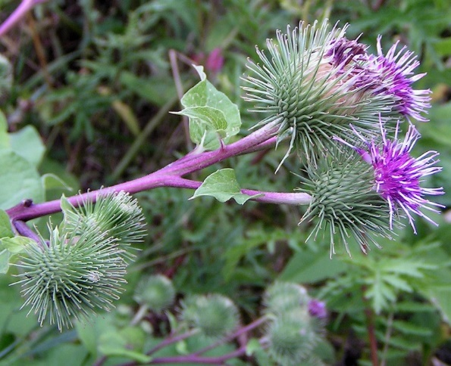
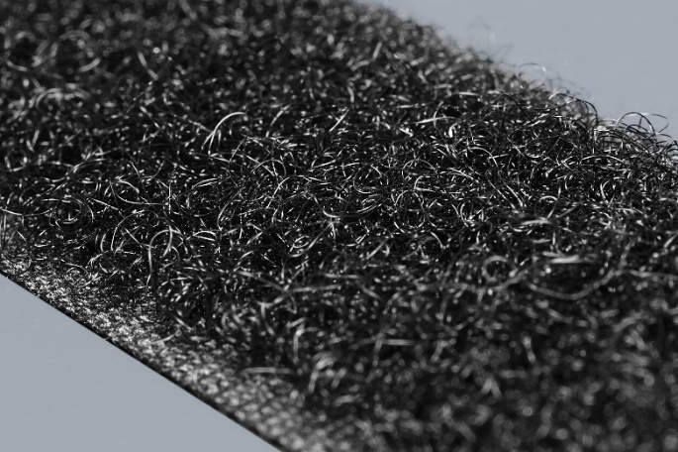

Fig1: Articum Hook and loop biomimicry on nylon fibre

2. Lotus effect Self Cleaning

Nelumbo is an aquatic plant with attractive flowers. In many parts of the world it is edible. The leaves are superhydrophobic and when water drops on leaf it rolls on its surface. The surface consists of tiny papillae with hard waxy tubes, which prevent leaves from sticking together by decreasing the contact area between water and leaf.

This tiny papillae arrangement on leaf surface, keeps the leaf dry and free from dirt particles .This effect is called a self-cleaning mechanism.

Mimicking the structure of Lotus leaves nanotechnologists developed superhydrophobic technology to create water proof and stain resistant clothing, coating metals that prevent corrosion and also in making low maintenance, self-cleaning solar panels

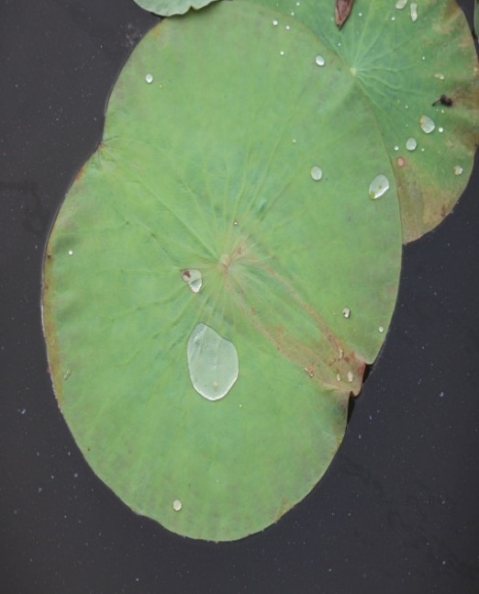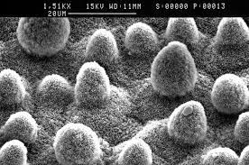
Fig:2 Lotus leaf with SEM Image of leaf surface

3.Colour from shapes

There is striking colour variation in flowers and fruits among plant world. This pigmentation is due to absorption of light of specific wavelength and reflecting specific colours back.
The berries of Pollia condensata are brightest blue in the nature, due to structural colour. The cells structure inside the fruit have stacked cellulose microfibrils arranged spirally, which helps in scattering of light into different wavelengths, thereby producing berries deep blue colouring.

Structural colours have inspired engineers to mimic its function in developing paints, to create coats for heat reflected windows and roofs on buildings.

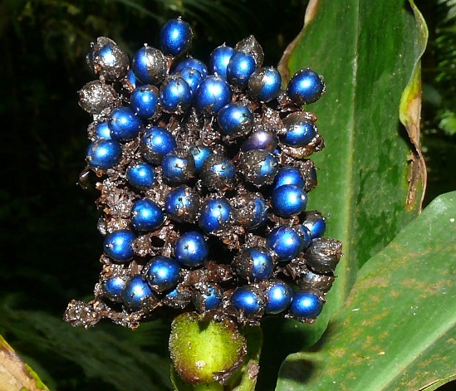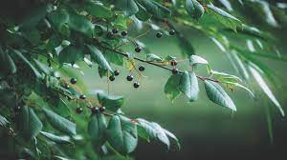

Fig 3: Berry fruit of Pollia condensata

4.The plant Movements and its Structural Strategies

Plants echo to the external and internal stimuli by the plant movements .The plant movememt to stimuli are because of the structural strategies of the plant (Studart and Erb, 2014). Based on the environmental stimuli the movement of plants are classified into Tropistic and Nastic movements. Tropistic movement are the movements of plant in response to environmental stimuli like gravity, light, water, contact. For example- Grape vine and Cucurbita, stem tendrils growth depends on contact of the supporting object. Nastic movements are plant component reaction that has no effect by direction of external stimuli. The closing of the Venus fly trap leaf of Dionaea is because if the three sensitive hairs on inside of the trap being touched (Fig:4). Thus, these bioinspired structures and functions present on plant surfaces can be applied for soft actuation.

A 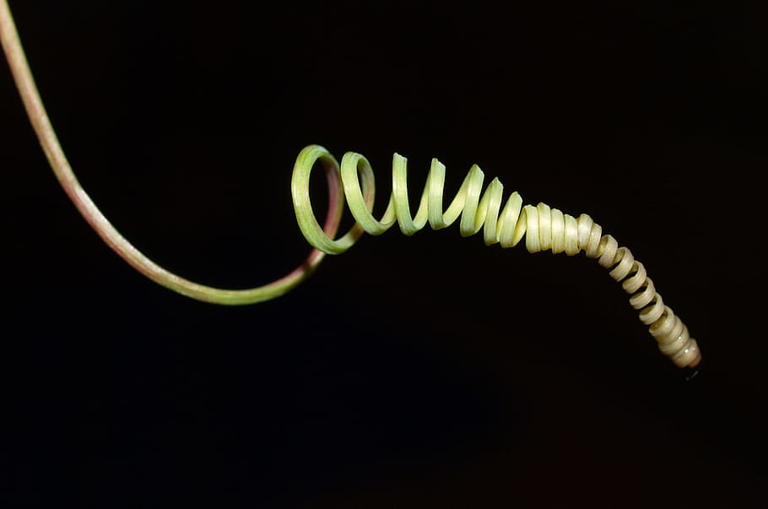 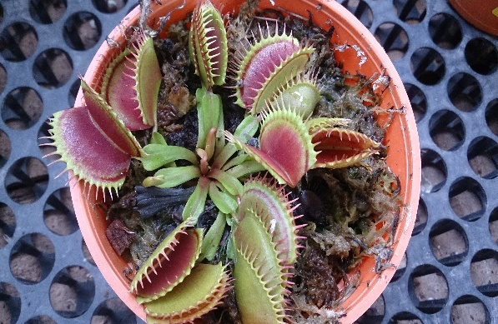 B

Fig4: Plant movement (A) Tropical Tendril (B)Nastic (Dionea trap)

5.Cellular Organization

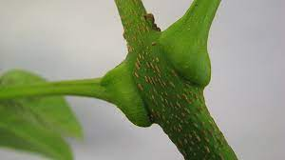
Cellular organization which varies in different part of plant is very often used to measure various movements of homogeneous materials in the active and passive actuation systems. The locomotion of Pulvinus stem is due to change in volume and pressure difference in the epidermal and supraepidermal motor cells. In Selaginella lepidophylla the passive movements make their stems curl and forms spheres due to variation in cell density in the lower and upper regions of dry tissue. In Ice plant, the seed dispersal from capsule is another example of passive actuation. The seed plant capsule have protective valves. These remain folded during dry condition but when get wet the valves are unfolded and seeds dispersed(Fig.5).This mechanism is used in making synthetic polymer honeycomb structures from 3D printer.

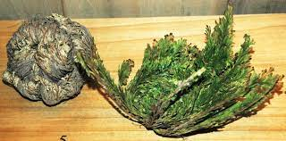

a.Pulvinus stem b.Selaginella lepidophylla

c.Mesembryanthemum crystallinum L.

Fig5: Cellular organization for active and passive actuation

Conclusion

The plants diversity is because of evolutionary processes that happen billions of years.This great diversity in plant surface structures and functionality is evolved due to interaction with environment. With the process of evolution, plants diversity is a free information to material engineers and scientists for their innovations. The research in Bionics though started in 1800, but plant surface structures and functions for biomimetic application were used very lately, except hook and loop fasteners in 1950s. Plant surfaces and structures play an important role in the international market for nanocoating’s. By 2019 The global market for nanocoating’s is estimated to 14.2 billion US dollars (Bauer 2008). Plant surfaces structures and function offers number of discoveries in the last three decades and this diversity of plant kingdom present as possible role models.

References

Benyus, J. M. (2002). Biomimicry. Innovation inspired by nature. New York: Harper Perennial
Bauer U., Bohn H.F., Federle W., (2008). Harmless nectar source or deadly trap: nepenthes pitchers are activated by rain, condensation and nectar. Proc. R. Soc. B 275, 259–265

Pfeifer, R., and Gomez, G. (2009). “Morphological computation – connecting brain, body, and environment,” in Creating Brain-Like Intelligence. Lecture Notes in Computer Science, Vol. 5436, eds B. Sendhoff, E. Körner, O. Sporns, H. Ritter, and K. Doya (Berlin: Springer), 66–83
Michael Pawlyn(2011) Biomimicry in Architecture, Reprint edition., RIBA Publishing.

European Commission (2012). Manifesto for a resource-efficient europe. (http://europa.eu/rapid/pressrelease_MEMO-12-989_en.htm)

Studart, A. R., and Erb, R. M. (2014). Bioinspired materials that self-shape through programmed microstructures. Soft Matter 10, 1284–1294.

Zambrano, D., Cianchetti, M., and Laschi, C. (2014). “The morphological computation principles as a new paradigm for robotic design,” in Opinions and Outlooks on Morphological Computation, eds H. Hauser, R. Fuchslin, and R. Pfeifer (Zurich: E-Book), 214–225.

Guo, Q., Dai, E., Han, X., Xie, S., Chao, E., and Chen, Z. (2015). Fast nastic motion of plants and bio-inspired structures. J. R. Soc. Interface. 12:20150598.

Barthlott W., Rafiqpoor D., Erdelen W., (2016). Bionics and Biodiversity- Bio-Inspired Technical Innovation for a Sustainable Future, in Biomimetic Research for Architecture and Building Construction-Biological Design and Integrative Structures, ed. by J. Knippers, K. Nickel, T. Speck (Springer, Berlin)

Poppinga, S., Weisskopf, C., Westermeier, A. S., Masselter, T., and Speck, T. (2016). Fastest predators in the plant kingdom: functional morphology and biomechanics of suction traps found in the largest genus of carnivorous plants. AoB Plants 8:lv140.

