TITLE PAGE:
Type of Manuscript: Research.
Title: Design, Development and evaluation of Herbal soap against bacterial skin infections.
Dr. Yelmate A.A.*
Dayanand College of Pharmacy, Latur, Maharashtra, India.
archanayelmate1@gmail.com. Mob. 09822336268.
Dr. Satpute K.L²
Dayanand College of Pharmacy, Latur, Maharashtra, India.
Satputekranti80@gmail.com
Ms. Gaikwad S.P. ²
Dayanand College of Pharmacy, Latur, Maharashtra, India.
Ms. Patil V.P. ²
Dayanand College of Pharmacy, Latur, Maharashtra, India.

Corresponding author:
archanayelmate1@gmail.com
Ph.no-9822336268.
Title: Design, Development and evaluation of herbal soap against bacterial skin infections.
ABSTRACT:
Bacterial infections are more common and use of herbs on skin disorders has been for thousand years. Number of chemicals, micro- organisms present in the environment may cause infections and causes harmful effects to skin. Medicinal plants have the rich source of different Phytoconstituents possesses various pharmacological actions. Murraya koneigii leaves extract possesses different medicinal properties like anti- inflammatory, antifungal, antibacterial etc. The herbal soap using Murraya koneigii leaves extract find effective antimicrobial activity against S. aureus, Candida albicans and B. subtilis.
Keywords: herbal soap, Murraya koneigii, Antimicrobial etc.
INTRODUCTION
Soap is a salt fatty acid used in variety of cleansing and lubricating products. In a domestic use soap are usually used for the different purposes like washing, bathing and many more house holding uses. In industry soaps are used for the purpose of thickening agent, important components of lubricants and precursors for many catalyst. When soaps are used for cleaning purposes, soap solubilizes particles and separated from the article being cleaned. Soap is prepared by mixing fats and oils with a soap base as opposite to that of detergent which is prepared by combining chemicals in one mixture. Humans being used soap for cleaning purposes. Herbal soaps are made from herbal plant mixture and other ingredients that are safe to the skin and less likely to cause any harm. (1)
Natural treatments to offer the best treatment solution for the skin infections and 100% natural herbal soaps prepared by using herbal plant extract beneficial for the skin. The medicinal plants selected in these soaps have medicinal properties and healing activity that offer skin nourishment, and moisturizing properties. These type of herbal soaps also contain coconut oil possesses beneficial effects to the goodness of skin and overall skin health. Herbal soaps are also effective in curing different dermal diseases. Glycerin along with coconut oil generally not used in commercial soaps. (2) Glycerin helps to retain the moisture in the skin and act as emollient thereby making these soaps dry. Soap helps to remove dirt, slag from skin to keep skin clean and brilliant glow. The main excipients used in material soap are oil and fats. The quality and category of soap is depend on type of the raw components used in soap preparation. (3)
Soap is any water-soluble salt of fatty acid, which contain eight or more than eight carbon atom. The common metal used in soap are sodium and potassium, for water soluble soap that are used in laundry for cleaning purposes. Herbal soap preparation is an herbal formulation contains ant-bacterial and anti-fungal agent which mainly uses of leaves extract of selected plant. (4)
Medicinal plants are natural product found useful in the treatment of all diseases and skin problem due their therapeutic value, cheap, and easy availability. The properties of soap include softens the skin, produces lather, protection against dermal disorder, treatment of skin infection. In comparison to synthetic, herbal treatment has benefits of being cheap and easily available and having minimum side effects. (5)

Aim and Objectives:
- To formulate and evaluate the herbal soap for dermal disorders.
- To promote utilization of coconut oil and plant extract as a raw material for soap making.
Materials and Methods:
Plant used in formulation of herbal Soaps:
Sr.no | Materials
1 | Murraya Koneigii (Murraya koneigii)

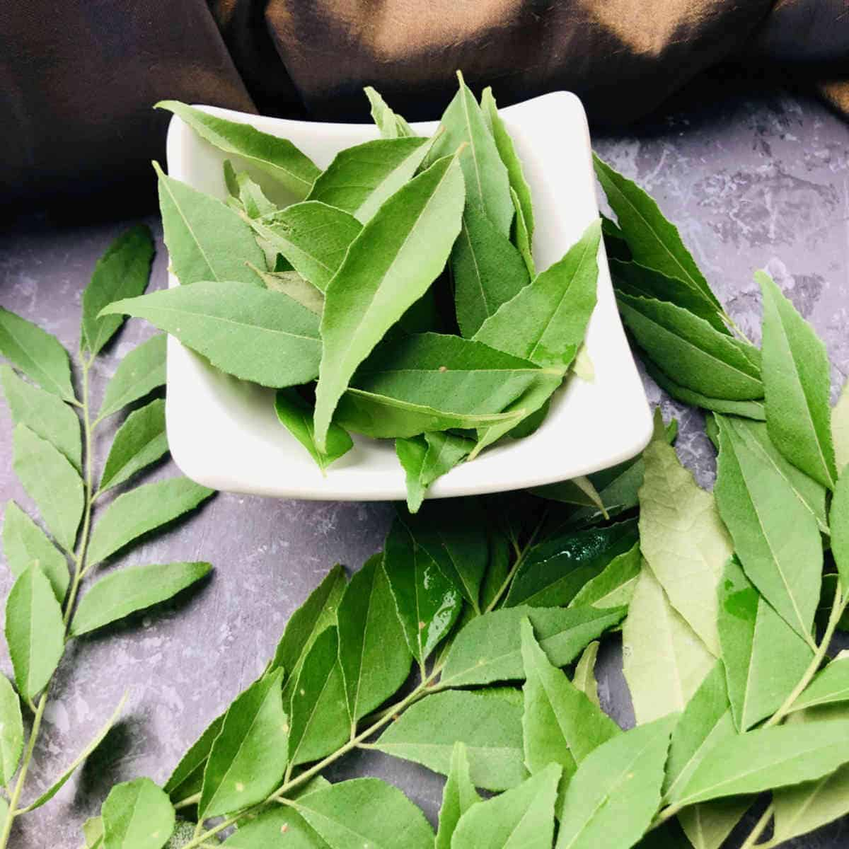
Murraya koneigii
The herb used in formulation is Murraya koneigii (Curry) leaves selected on the basis of documented literature. Collection and identification and processing of plant: The leaves of Murraya koneigii were collected from different matured plant and plant samples authenticated at Dayanand science college Latur.
Extraction: The Murraya koneigii were extracted with water by maceration process. 100 gm of above stated powder was taken in conical flask and extracted with water for 72 hours with occasional agitation then filtered. Obtained filtrate were concentrated on water bath to get semisolid residue. Obtained extract Murraya koenigii, was incorporated into a soap formulated with basic glycerin soap. (6, 7)

Murraya koneigii (Curry leaves) and Neem Extraction
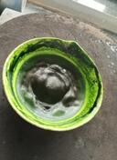

Murraya koneigii leaves extract

EXPERIMENTAL WORK
Preparation of basic glycerin soap:
Formula of Soap base
Sr.no | Ingredients | Quantity
1 | Sodium hydroxide | 20gm
2 | Coconut oil | 50ml
3 | Glycerin | 10ml
4 | Distilled Water | Quantity sufficient

Procedure for Basic Glycerin –
- Take sodium hydroxide than add water in that and dissolve it than add glycerin stir it and leave for half hour.
- Take coconut oil heat it and then add sodium hydroxide solution in it. Cook for 5 min.
- Then add water and add to any container leave it for 1 day.
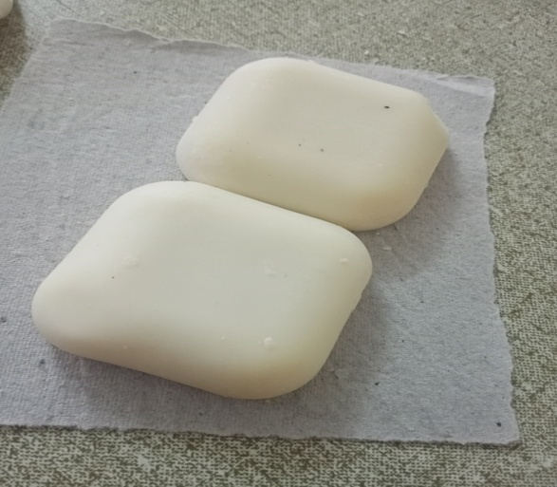
Fig: Soap Base

Formulation of Herbal Murraya Koenigii (Curry Leaves) Soap:
Murraya commonly call as curry leaves is an aromatic shrub upto 6 m in height found in India. In traditional system of medicines, it is used as an antiemetic, antidiarrheal, blood purifier flavoring agent in curries and chutneys. (12, 13)
Formulation Table for Preparation of Murraya Koenigii (curry leaves) soap (F3):
Sr.no | Ingredients | Quantity |  |  | Uses
 |  | F1 | F2 | F3
1 | Soap base | 20gm | 20gm | 20gm | Soap base
2 | Curry leaves extraction | 0.5gm | 1gm | 1.5gm | Antiseptic
3 | Shikekai | 1.5gm | 1.5gm | 1.5gm | Cleanser
4 | Sandal wood oil | 1.5 ml | 1.5 ml | 1.5 ml | Perfume

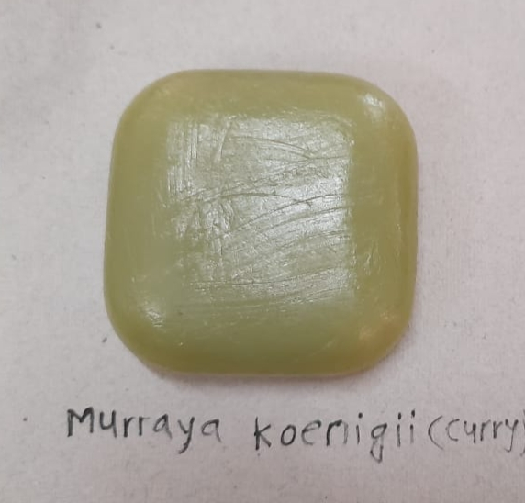z

EVALUATION TEST OF SOAP:
1. Organoleptic Evaluation:
Color - Color was checked by naked eyes.
Odor – The smell of formulation was checked by applying preparation on hand and feels the fragrance of perfume.
2. Physical Evaluation:
PH- The pH was determined by using pH paper, the pH was found to be basic in nature.
Foam Retention- 25ml of 1% soap solution were taken into a 100ml measuring cylinder and it was covered with palm and rigorously shaken for 10 times. The volume of foam at every 1 minute interval for 4 minute recorded and it was found to be 5 minutes.
Foam Height- for the determination of foam height 0.5 gm of sample soap were taken dispersed in 25ml of distilled water. Then, transferred it in to 100ml measuring cylinder, the volume was make up to 50ml with water. 25 strokes were given and stand still aqueous volume measured up to 50ml and measured the foam height, above the aqueous volume was measured. (8,9)

Result and Discussion:
Sr.No | Evaluation Test | Murraya Koneigii  (curry leaves)
1 | PH | 7
2 | Color | Green
3 | Odor | Pleasant
4 | Foam height | 5.4cm
5 | Foam retention | 35%
6 | Washability | Good  washable

3. Anti-microbial Activity: For the determination of antimicrobial activity overnight cultures were prepared. The antimicrobial activity of soaps were performed by Agar well diffusion method. Agar well diffusion method were used to detect antimicrobial activity. The 0.1 ml saline suspension of test microorganisms were inoculated on the surface of sterile Nutrient agar plates. Prepared sample using different concentrations of the prepared soap were aseptically transferred directly into the surface of plates. All inoculated plates were firstly placed in refrigerator for 30 min for diffusion and then incubated at 37⁰C for 24-48 hours and then observed for zone of inhibition. (12)The zone of inhibition was determined by measuring the diameter in millimeters of zone to which the soap inhibited the growth of the organism. The present research investigation was carried out to determine the antimicrobial efficacy of prepared herbal soap of Curry leaf against skin micro flora isolates Staphylococcus aureus, Bacillus subtilis and Candida albicans. Results obtained from the experimental data revealed that prepared soap have antimicrobial activity. We have studied the anti-microbial activity on the bacteria such as Staphylococcus Aureus, Candida Albicans, and Bacillus Subtilis bacteria cause skin infections. (13, 14)
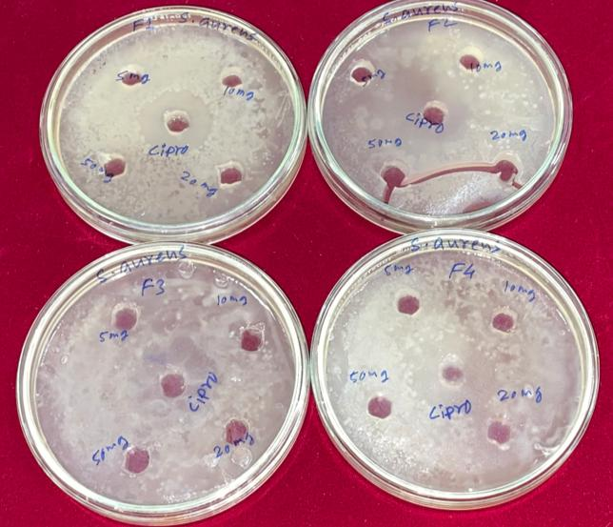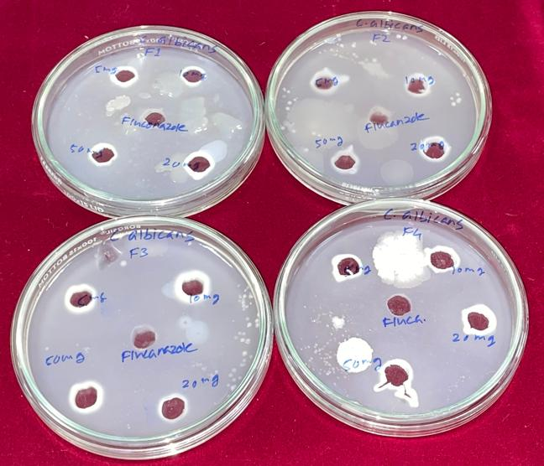
Bacillus subtilis Staphylococcus aureus
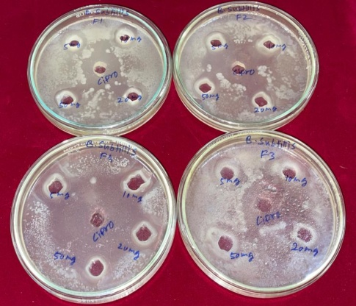
Candida albicans
Antimicrobial activity: Zone of inhibitions
Sr.  No. | Sample (Conc. mg/ml) | Staphylococcus aureus | Bacillus subtilis | Candida albicans
 |  | Zone of inhibition in mm
1. | F1
 | 5 | 3 | 5 | 4
 | 10 | 5 | 8 | 6
 | 20 | 4 | 8 | 8
 | 50 | 5 | 9 | 9
2. | F2
 | 5 | 2 | 4 | 6
 | 10 | 3 | 5 | 4
 | 20 | 5 | 7 | 7
 | 50 | 6 | 8 | 8
3. | F3
 | 5 | 3 | 8 | 7
 | 10 | 5 | 7 | 7
 | 20 | 5 | 8 | 10
 | 50 | 6 | 7 | 11

Among the different concentrations of herbal soaps, highest concentration of plant extract containing soaps showed highest antimicrobial activity against all pathogen studied. F3 formulation shows highest activity against candida albicans as compared Staphylococcus aureus and Bacillus subtilis. The soaps are cleaning agents routinely used for cleaning purposes. Soaps and detergents exhibit antimicrobial activity by disrupting the microbial cell membrane and also cells proteins. The main aim of this study was to formulate the soap and evaluate its antimicrobial activity.
Conclusion:
The plant Murraya Koneigii (curry leaves) extract prepared using water and subjected to various preliminary phytochemical test as per guidelines of standardization of herbals. The prepared formulations of herbal soap when tested for antimicrobial activity against different microorganisms shown good results. The soap does not give any irritancy to skin. Furthermore, the prepared herbal soaps were standardized by evaluating various physico chemical properties such as pH, appearance, odor, color, foam height, foam retention and washability in which all prepared soaps exhibit satisfactory effect. The prepared soap shows greater zone of inhibition against selected microorganisms. The soap is routine requirement of life, but it should have good active ingredients or plant extracted material which has the ability to kill bacteria but not to harm body tissues when used constantly.

References:
- Chaudhari VM. Studies on antimicrobial activity of antiseptic soaps and herbal soaps against selected human pathogens. Journal of Scientific and Innovative Research. 2016; 5(6):201-4.
- Inoue Andrade F, Purgato GA, Faria Maia TD, Pais Siqueira R, Lima S, Diaz G, Diaz MA. Chemical constituents and an alternative medicinal veterinary herbal soap made from Senna macranthera. Evidence-Based Complementary and Alternative Medicine. 2015 Mar 3; 2015.
- Yelmate A, Rajkumar M, Swami J. Anti-mycobacterial potentiality of leaves and stem extracts of Argemone mexicana Linn. Journal of Global Trends in Pharmaceutical Sciences. 2015; 6(4):2933-7.
- Nadaroglu H, Baran A. The Antimicrobial Activity of Herbal Soaps against Selected Human Pathogens. Tenside Surfactants Detergents. 2020 Sep 16; 57(5):354-60.
- Yelmate AA, Thonte SS. Antibacterial activity of some Indian medicinal plants against methicillin resistant Staphylococcus aureus (MRSA). Journal of Pharmacognosy and Phytochemistry. 2019; 8(5):376-80.
- Igbeneghu OA. The antimicrobial assessment of some Nigerian herbal. African Journal of Traditional, Complementary and Alternative Medicines. 2013 Oct 14; 10(6):513-8.
- Yelmate AA, Thonte SS, Satpute KL. Trace Element Determination in Medicinal Plant Samples by ED-XRF Analysis. InHerbs and Spices-New Advances 2022 Dec 8. IntechOpen.
- Wijayawardhana N, Cooray D, Jayasuriya B, Uluwaduge I, Meedin F, Arawwawala M. Antimicrobial activity of a combination of three natural plant extracts and development of a herbal soap. Pharmaceutical Sciences Asia. 2021 Nov 1; 48(6).
- Yelmate AA, Thonte SS. Ethnobotanical survey of plants on hattibet (Deverjan) district Latur Maharashtra. Journal of Pharmacognosy and Phytochemistry. 2018; 7(3):1345-8.
- Karnavat DR, Amrutkar SV, Patil AR, Ishikar SK. A Review on Herbal Soap. Research Journal of Pharmacognosy and Phytochemistry. 2022 Jul 1; 14(3):208-13.
- Abdu AN OA, Agboola GO, Igbeneghu IO, Omobuwajo OR. Preliminary investigation of an herbal soap incorporating Cassia senna (L) Roxb leaves and Ageratum conyzoides Linn whole plant powders. cont. j. pharm. Sci. 2011:1-0.
- Archana Y, Gundewar P. NOVEL THERAPEUTIC APPROACHES TOWARDS TYPE 1 DIABETES MELLITUS. European Journal of Biomedical. 2018; 5(7):176-85.
- Lima S, Diaz G, Diaz MA. Antibacterial Chemical Constituent and Antiseptic Herbal Soap from Salvinia auriculata Aubl. Evidence-Based Complementary and Alternative Medicine. 2013 Jan 1; 2013.
- Oladele AT, Dairo BA, Elujoba AA, Oyelami AO. Management of superficial fungal infections with Senna alata (“alata”) soap: A preliminary report. Afr J Pharm Pharmacol. 2010 Mar 1; 4(3):98-103.

