A study on shoreline changes over the coast of Chennai district, Tamil Nadu, India
*Dr. K. Jayakumar¹ & Ms. Abirami Ravi² & Ms. K. Madhushree³
¹Senior Consultant- Disaster Management, Tamil Nadu Disaster Risk Reduction Agency, Ezhilagam, Chennai, Email: jaikumar.gis@gmail.com,
² PhD Scholar, Department of Geography, Bharathi Women’s College, Chennai
³GIS Analyst, Tamil Nadu Disaster Risk Reduction Agency, Ezhilagam, Chennai

Abstract
Shoreline change is recognised as one of the most complex phenomena, and it has been studied over the Chennai coast using geospatial techniques. The multi-temporal remote sensing data used to capture the shorelines from 1988, 1991, 2006, 2010, 2013 and 2016. The HTL (High Tide Line) must be periodically mapped and observed as a coastline that has been demarcated by using satellite images by visual interpreting techniques. It was then accompanied by an overlay analysis to quantify erosion and accretion areas in the region under study. The findings showed that, due to erosion and accretion, the coast of the Chennai district lost 273 hectares and increased by 423.4 hectares. This was confirmed following a ground truth survey in the study area. High erosion and accretion were reported along the Chennai's Northern and Southern part of district, respectively. The conclusion can be reached that natural and man-made processes influencing the coastal ecosystem are the primary causes of the coastal erosion and accretion in this present study.

Keywords – Chennai Coast, Remote Sensing, GIS Techniques, Shoreline Changes, overlay analysis

- Introduction
The shoreline is the area where the land and the water meet. This particular line that can be considered a coastline can’t be defined by the principle of the coastline. Indian coastline stretches 3,214 kilometres (north - south) and 2,933 kilometres (east - west). The country's whole land border is 15,200 km long, while its entire coastline length is 7,516.6 kilometres, including island coastline (India State of Forest Report, 2015). The coastline of Tamil Nadu is approximately 1076 km long, which covers 14 coastal districts, accounting for about 15 percent of the national length of the coastline. India's coastline runs towards the Arabian Sea, Indian Ocean, and Bay of Bengal. One of India's 29 states is known as Tamil Nadu. Chennai, the state capital of Tamil Nadu and a major economic and industrial centre in the country, is situated under the Tiruvallur district in the northern region of the state and has a coastline length of 19 km. It is the longest and also the last or thirteenth largest shore in Tamil Nadu, and it borders the Bay of Bengal. The principal coastal landform elements of the Chennai district's shore comprise rivers, beaches, coastal dunes, mudflats, backwaters, and mangroves, among others (Jayakumar and Malarvannan, 2016). Shoreline transition is one of the most common natural processes in coastal areas, including winds, tidal currents, waves, tsunami, cyclone, storm surge and floods. For instance, the recent effects of natural disasters continues to strike the coasts in terms of the tsunami (26th December, 2004), the Jal Cyclone (10th November 2010), the Cyclone Nilam (30th December, 2011) and the Chennai Flood (8th November, 2015, and the Cyclone Nilam (6th – 13th November, 2012), the Cyclone Gaja (10th-16th November, 2018), Nivar Cyclone (25th November, 2020), Burevi Cyclone (3rd December, 2020), Tauktea Cyclone (15th May, 2021), Yass Cyclone (26th May, 2021) and Mandous Cyclone (8th December, 2022). On the other hand, the man-made disturbance like pollution, coastal development, and the introduction of non-native species to an area, beach sand mining, urban development activities, garbage dump, expansion activities of industries, tourism activities and construction of dams’ causes declined in sediment supply from the rivers. In order to improve planning and management, it is important to evaluate shoreline changes and determine their threat to the natural resources of the coastal region. These are the primary causes of shoreline alterations, which contribute to both short-term and long-term erosion and accretion. These two factors play a crucial role which also affects the local ecosystems and shoreline. The most critical aspect of coastal area management is the classification of the location and the transition over shoreline time. It requires frequent observation of the shoreline over time using satellite images (Kaviraj and Kartic Kumar, 2016; Sindhu Tyagi et al., 2020; Jayakumar, 2014, 2021; Jayakumar and Malarvannan, 2016).

1.1 Role of Remote Sensing Technique for the delineation of shoreline change:
Remote sensing techniques have been used worldwide since 1980 to identify and illustrate the causes and amount of shoreline changes (Saad et al., 2021; Jennifer Murray et al., 2023; Faik Ahmet Sesli, 2010; Dao Dinh Cham et al., 2020). Geospatial approaches are frequently employed in geomorphology, notably to monitor natural processes along the coast and shoreline patterns through time, as well as to assess erosion and accretion (Faik Ahmet Sesli, 2010; Sindhu Tyagi et al., 2020; Jayakumar, 2021). A recent study from Lemonia Ragia and Pavlos Krassakis (2019) highlighted using high resolution satellite images such as Quickbird and WorldView-3 for an analysis of shoreline changes in the coastline of Georgioupoli, a part of the island of Crete. Luca Cenci et al. (2017) had used remote sensing and GIS tool for mapping and modelling evolution of two different coastal environments including, Oceanic and Mediterranean from 1980 to 2011. According to Mishra Monalisha, Panda GK (2018) had examined the shoreline changes along the Ganjam Coast, South Coast of Odisha by using geospatial techniques. Hashmi and Ahmad (2018) studied coastal erosion and accretion along the coast of Sindh Pakistan by using GIS and Digital Shoreline Analysis System (DSAS) modelling. Jayakumar (2021) had used multi temporal satellite images and evaluated accretion and erosion in the coastal district of Tiruvallur, Tamil Nadu, India. Faik Ahmet Sesli (2010) conducted a study that investigated multi temporal images, including aerial and digital photogrammetry images, and mapped and tracked the coast in Samsun, Turkey, from 1935 to 2006. A recent research from Jayakumar and Malarvannan (2016) had used WebGIS tool, which was developed by using open source software for the better management of the shoreline in the Northern Tamil Nadu coast, India. The purpose of this present research work is to use multi-temporal dataset and to document the impact of disasters both from natural and man-made on the coast of Chennai and also to examine morphological variations, shoreline changes and erosion and accretion. The coastal change survey carried out on the coast of Chennai district was not extensive. It is time to discuss shoreline changes along the Chennai coast and often publish policies that lead to better coastal resource planning and management. This study aims to investigate coastal changes on the Chennai coast and assess erosion and deposition over the 28 years period from 1988-2016.

- Study area
The district of Chennai is situated in the northernmost district under the Tiruvallur district in Tamil Nadu, India. The district is divided into 15 administrative zones, seven of which come within the coastal area of Tiruvottiyur, Tondiarpet, Ayanavaram, Royapuram, Adayar, Perungudi and Sholinganallur (Figure 1). As per the Census of India (2011) reported that the Chennai district population is about 4,681,087 of which more than half of the total population of the city living in coastal zones itself. Furthermore, the Chennai is the sixth-most populated city in India and the fourth-most populated urban agglomeration. Chennai has a strong industrial base in the automobile, computer telecommunications, hardware, and healthcare industries, fishing, shipping and tourism, these made this city the economic hubs of the district, state, and country. The present study region occupies a position at an elevation of 6 metres between 12° 59' and 13° 9' in the northern latitudes and 80°12' and 80° 19' in the eastern longitudes. The Chennai district's coastal zone is a flat coastal plain bounded on the east by the Bay of Bengal, on the north by Tiruvallur district, on the south by Chengalpattu district and on the west Kancheepuram district. The main impact involves shoreline changes due to both from natural and anthropogenic factors affecting the study area, which is situated along the coastline near the road, residence and companies. In addition, Ecologically Sensitive Areas (ESA) is also located along this coastline within a distance of 100 meters: Ennore Creek, Ennore and Chennai Ports, Rayapuram Fishing Harbor, Cooum and Adyar Rivers Mouth, Marina Beach and Besant Nagar Beach etc. When there have been any natural disasters, the impact on an example of a region sunk in the sea due to coastal erosion would be very high. The shoreline improvements were identified and analysed in detail in relation to the present shoreline, whether direct or indirect. Analysing coastal changes for the Chennai coast and evaluating erosions and deposition between 1988 and 2016 is the main aim of this scientific research.

Figure 1. Chennai District Location and Coastal Extent

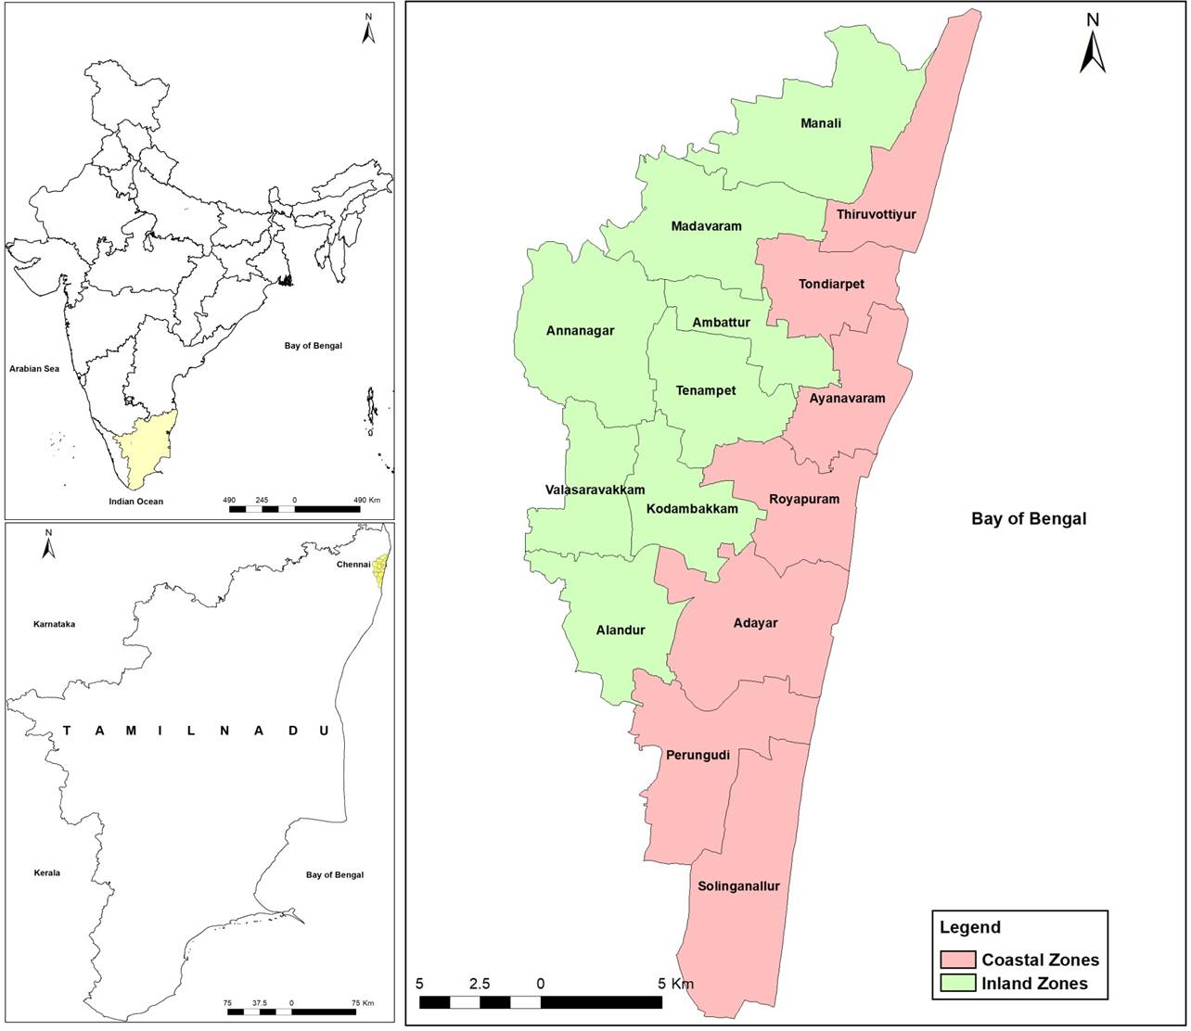
- Materials and Methods
This study made use of two types of data: topographical maps and satellite data. First, topographical maps of the 66 C2, 66 C6 – 66 C8 were obtained from the Survey of India (SOI) for the year 1976 at a scale of 1:50,000. and scanned them and Geo-referenced and used as a base map as well as GCP (Ground Control Points) used to rectification of satellite data. Second, multi-temporal satellite data downloaded from the US Geological Survey website (https:/glovis.usgs.gov) Landsat-5 TM (Thematic Mapper) data for 1988, 1991, 2006 and Landsat-7 ETM+ (Enhanced Themetic Mapper Plus) data for 2010, 2013 and 2016. These multi temporal satellite data have been added into ERDAS IMAGINE (2014) software, and layer stacking was done, followed by gap filling for Landsat-7 ETM+'s 2010 image. All satellite data has been corrected for distortion using topographic maps, adjusted using ground control points, and rectified using the WGS 84 datum UTM projection. Following the projection method, a visual interpretation technique was used to demarcate the Chennai shorelines for each year (high water level line). Then, using an overlay analysis for the various shorelines, the erosion and accretion for the Chennai coast were computed, as shown in Figure 2 of the method flow chart. Digital datasets of shoreline changes were finalised after ground truth verification and Google Earth images.

Figure 2. A methodology flowchart
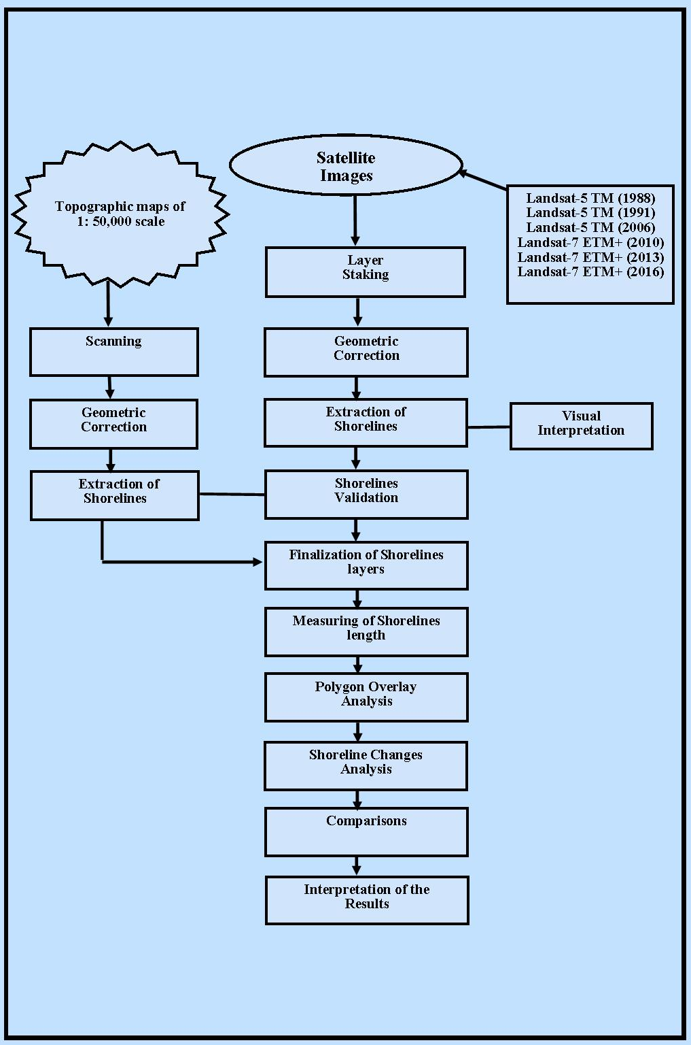

- Results and Discussion
In this study used remote sensing and GIS techniques, which are known as one of most effective and efficient scientific tools for mapping, monitoring, and examining shoreline changes, as well as evaluating erosion and accretion on the Coast of Chennai district for 4 decades from 1988 to 2016. The coastline around Chennai is shrinking while shifting as it becomes more susceptible to cyclone, storms surges, floods, and others disasters that cause coastal erosion and loss of shorelines. Furthermore, human-made factors that cause coastal erosion in Chennai has reached disastrous levels threatening the viability of the city zones including, Tiruvottiyur, Tondiarpet, Royapuram, Ayanavarm, Adayar, Perungudi and Sholinganallur. Coastal erosion, caused by waves, is causing a half-meter to one-meter loss of shoreline per year. In some areas, up to two metres have vanished at the same time. When sea level raises that affect infrastructure such as roads, buildings, plants and freshwater supplies, coastal and terrestrial ecosystems, a portion of the land may get submerged. In a similar study, Jayakumar (2014, 2018) applied geospatial techniques to map and monitor coastlines for the management of Tiruvallur's coastline over the past four decades and the Godavari wetlands over the past seven decades. He observed in those reports that both man-made and natural disasters were the primary causes of the coastline's and its environments' near reduction. The shorelines were demarcated for 1988, 1991, 2006, 2010, 2013 and 2016 (Figure 3). To detect regions of erosion and accretion, these shorelines were overlay during 1988-1991, 1991-2006, 2006-2010, 2010-2013, and 2013-2016 (Figure 4). Studies on shoreline shifts from Ramasubramanian et al. (2006), Jayakumar and Malarvannan (2016) and Jayakumar (2018) used overlay analysis to determine the shifting and unmodified regions of the coastline. For example, in figure 4 the 1988 coastline was utilised as the starting point line, followed by an inner line and an outer line (1991) identified as erosion and accretion, respectively. The erosion and accretion processes are shown in red and green, respectively. The amount of erosion and accretion from 1988 to 2016 is easily accessible, and it will aid users to forecast the extent of loss and deposition in the future. This study may be viewed as an aid to decision-making for the coast of Chennai since it displays changes in time and space in the study area, which is essential for those engaged in coastal area management.

Figure 3. Chennai shoreline changes maps (1988 – 2016)

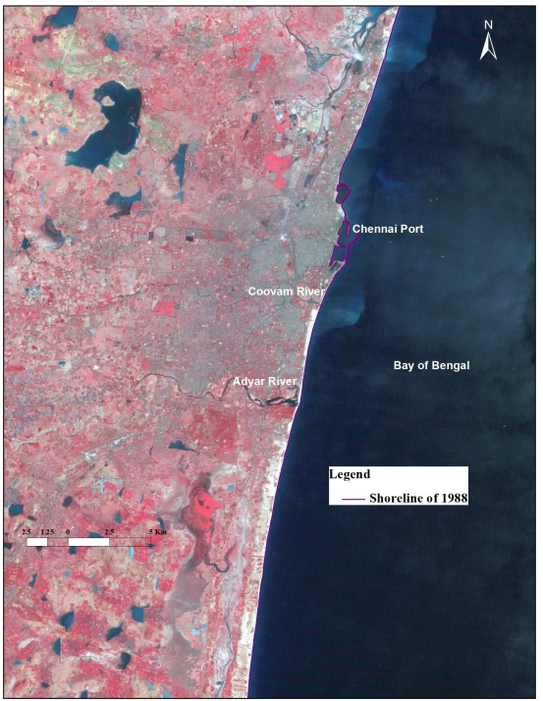
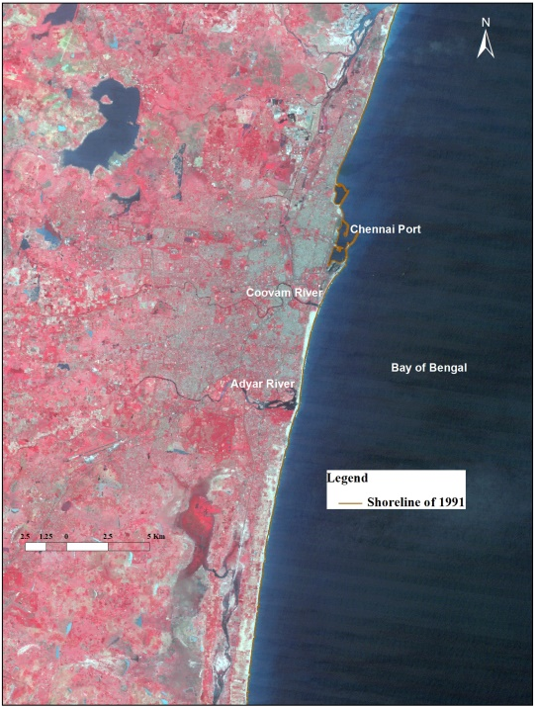
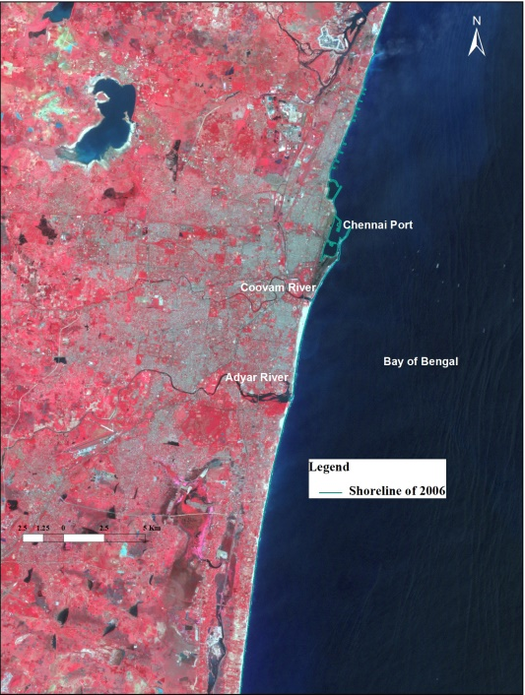
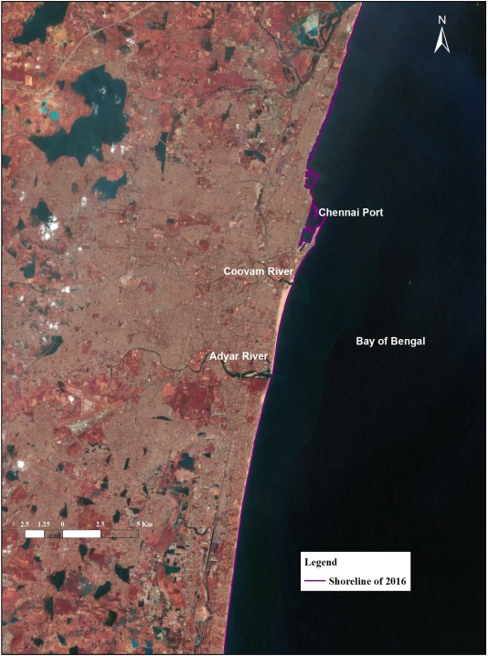
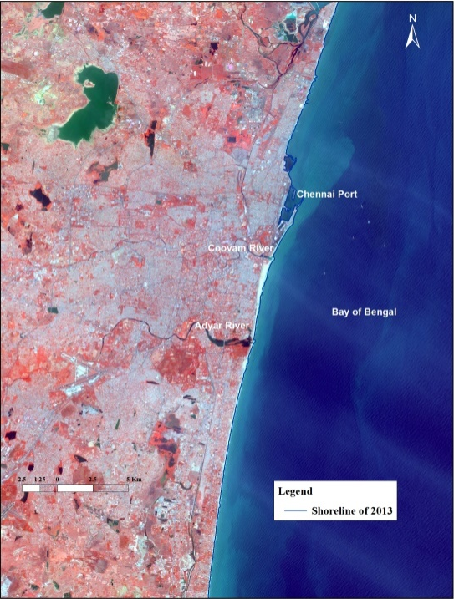
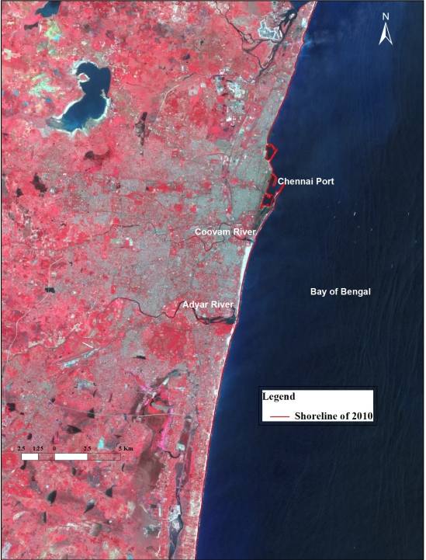

Figure 4. The maps depicted variations in erosion and accretion between 1988 and 2016

4.1. Chennai Coast:
The Chennai coastline extends 19 km and includes seven administrative taluks, namely Tiruvottiyur, Tondiarpet, Royapuram, Teynampet, Adyar, Perungudi and Sholinganallur, which covers of 8,917,749 people, of which 9,101 are fishing communities; 44 are fishing villages; 2 are revenue villages; and 12 are fishing centres. The most dangerous zones within the study area have been identified as Ennore, Mastan Koil Kuppam to Popular Weigh Bridge, a portion between Savorit and the northern breakwater of the fishing port, Chennai port to Foreshore estate, and Besant Nagar. Fishermen's community predominates in the major coastal villages of Ennore, Thiruvottiyur, Royapuram, Ice House, and Foreshore Estate, and fishing is also the main business. Over the course of 28 years in the study region, remote sensing indicated 418.3 ha of accretion and 273 ha of erosion, as shown in Table 1. In detail, between 1988 and 1991, the erosion was approximately 14.2 ha followed by 125.6 ha between 1991 and 2006, 79.5 ha between 2006 and 2010, 26.8 ha between 2010 and 2013, 26.9 ha during 2013 and 2016. The accretion was noticed at around 109.3 ha between 1988 and 1991, 66.5 ha between 1991 and 2006, 52.7 ha between 2006 and 2010, 114.1 ha between 2010 and 2013, 75.8 ha between 2013 and 2016 (Figure 4).

Table 1: Details of Erosion and accretion (Areas in ha)
District |  | Chennai
Sl. No. | Year | Erosion | Accretion
1 | 1988 - 1991 | 14.2 | 109.3
2 | 1991 - 2006 | 125.6 | 66.5
3 | 2006 - 2010 | 79.5 | 52.7
4 | 2010 - 2013 | 26.8 | 114.1
5 | 2013 - 2016 | 26.9 | 75.8
Total |  | 273.0 | 418.3

The following satellite images were analysed to determine the coastline sites for the aforementioned years and to overlay them one by one, estimating erosion and accretion during the 28-year period from 1988 to 2016. Additionally, the topographic maps of Survey of India from 1976 were used as a reference map. The changes in the Chennai coastline have been mapped and the erosion and accretion areas were determined, as illustrated in Table 1 and Figure 5.

Figure 5. Variations in erosion and accretion from 1988 to 2016.

  - Chennai District Coast Morphological Changes:
The Chennai district shoreline is highly vulnerable as a result of both man-made activity and natural intervention, which served a critical role over the past thirty years, as observed using remote sensing. The total length of the Chennai district coastline is around 19 km. The assessment of multi temporal satellite data and topographical maps of the district of Chennai showed that the stretch of shoreline is narrow, with both points at Cooum and Adyar Rivers Mouth has been covered with mud flat. Furthermore, built structures have been found in a few locations, notably Chennai Port, built in 1881, Navy Quarters near the mouth of Cooum River, and groins in the northern part of Chennai coast. The man-built structures combined with dense housing, industrialization, urbanization, port growth and fishing activities built shoreline more fragile, dominated by erosion, while the deposits were fewer. This study of shoreline changes with satellite image support showed the Chennai district coast vulnerability zone. It is important to note that the presence of dense population, construction of man-made structures such as ports, jetties, groynes, beach nourishment, and so on, are the primary causes of the detrimental influence of the coastal environment. Kasinatha Pandian et al. (2004) also revealed a research indicating the influence of natural disasters such as tides, waves, currents, tsunami, coastal floods, climate change, and bathymetry also leads to alteration of coastline and its environments. Further to a research study carried out by Jayakumar and Malarvannan (2016) the reasons for the change in shorelines mainly due to the development and expansion of port activities, as well as other structures such as construction, dredging, transportation, excavation, construction, and offshore machinery, which cause a number of modifications over the coast.

- Conclusion:
The Chennai coast is extremely susceptible because of to both man-made and natural factors. In the current research, geospatial technique has been utilized using multi temporal remote sensing data to monitor the Chennai shoreline for 28 years, from 1988 to 2016. It may be stated that the impacts of the coastal environment were mostly caused by the development of artificial structures, natural occurrences, and the presence of a dense population. This type of research will provide several benefits to various users in establishing strategies and making management decisions. It takes hours to examine and monitor the coastal region environment on a regular basis, allowing decision-makers to swiftly understand and discuss research findings and accelerate up the assessment process during disasters.

- References

- Dao Dinh Cham, Nguyen Thai Son, Nyuyen Quang Minh, Ngu Yen Tien Thanh. 2020. An Analysis of Shoreline changes using combined multitemporal Remote Sensing and Digital Evaluation Model. Civil Engineering Journal, 6, 1: 1-10.
- Faik Ahmet Sesli. 2010. Mapping and monitoring temporal changes for coastline and coastal area by using aerial data images and digital photogrammetry: A case study from Samsun, Turkey. International Journal of the Physical Sciences, 5, 10: 1567-1575.
- Hashmi and Ahmad. 2018. GIS-Based Analysis and Modeling of Coastline Erosion and Accretion along the Coast of Sindh Pakistan. Journal of Coastal Zone Management, 21:1, DOI: 10.4172/2473-3350.1000455.
- India State of Forest Report, 2015. Forest Survey of India, Ministry of Environment, Forest and Climate change, Government of India, Dehraun. pp 300.
- Jayakumar, K and Malarvannan, S. 2016. An Assessment of Shoreline Changes over the Northern Tamil Nadu Coast using Open source based WebGIS Techniques.The Journal of Coastal Conservation, 20:6, 477-487.
- Jayakumar, K. 2014. Remote Sensing and GIS Application in the Management of Godavari Mangrove Wetland, Andhra Pradesh, South India. Thesis submitted to University of Madras. pp 150.
- Jayakumar, K. 2021. Analysis of Shoreline Changes along the Coast of Tiruvallur District, Tamil Nadu, India. Journal of Geography and Cartography, 1, 1-9. DOI:10.24294/jgc.vli3.764
- Jennifer Murray, Elhadi Adam, Stephan Woodborne, Duncan Miller, Sifiso Xulu and Mary Evans. 2023. Monitoring Shoreline Changes along the Southwestern Coast of South Africa from 1937 to 2020 Using Varied Remote Sensing Data and Approaches. Remote Sensing, 15, 2: 317.
- Kasinatha Pandian, P., Ramesh, S., Ramanamurthy, M.V., Ramachandran, S and Thayumanavan, S. 2004. Shoreline changes and nearshore processes along Ennore Coast, East Coast of South. India. J. Coastal Res., 20, 828-845.
- Kaviraj, M. S., and Kartic Kumar, M. 2016, Assessment of Shoreline Changes Due to Anthropogenic Activities using Remote Sensing & GIS, International Journal of Engineering Research & Technology (IJERT) Geospatial, 4:20.
- Lemonia Ragia and Pavlos Krassakis 2019. Monitoring the changes of the Coastal Areas using Remote Sensing Data and Geographic Information Systems, In: Seventh International Conference on Remote Sensing and Geoinformation of Environmentʼ RSCys2019, Cyprus, DOI:10.13140/RG.2.2.17273.9328
- Luca Cenci, Leonardo Disperati, Maria Giuseppina Persichillo, Eduardo R Oliveira, Fátima L Alves and Michael Phillips. 2018. Integrating remote sensing and GIS techniques for monitoring and modeling shoreline evolution to support coastal risk management. GIScience & Remote Sensing, 55:3, 355-375, DOI: 10.1080/15481603.2017.1376370
- Mishra Monalisha and Panda, G.K. 2018. Coastal Erosion and Shoreline Change in Ganjam Coast along East Coast of India. J Earth Sci Clim Change, 9:4, DOI: 10.4172/2157-7617.1000467.
- Ramasubramanian, R., Gnanappazham, L., Ravishankar, R and Navamuniyammal, M. 2006. Mangroves of Godavari – Analysis through Remote Sensing Approach. Wetland Ecology and Management, 14:29-37.
- Saad, R,, Gerard, J., A. and Pierre Gerard. 2021. Detection of the Shoreline Changes Using DSAS Technique and Remote Sensing: A Case Study of Tyre Southern Lebanon. Journal of Oceanography and Marine Research, 10, 004: 1-18.
- Sindhu Tyagi and Rai, S., C. 2020. Monitoring Shoreline changes alsong Andhra Coast of India using remote sensing and geographic information system. Indian Journal of Geo Marine Sciences, 49, 2:218-224.

