Performance Improvement of Energy Efficiency in Heat Pipe Solar Collector with Nano composite –Review

Prof. Shamkant Desale¹, Dr. Premendra Bansod²
Department of Mechanical Engineering
^{1,2}G H Raisoni College of Engineering and Management
Domkhel Road,Wagholi,Pune-412 207.
Shamdesale27@gmail.com
Abstract - The intension of this research work is to improve the performance of evacuated heat pipe collector with Nano composite. Solar collector includes absorber unit in order to transfer the heat energy to a working fluid. In this research it was intended to evaluate performance considering with Nano composite. The Challenge in the production of future generation solar tube collector technology is the control of operating temperature and heat generation. An essential aspect of Solar collector design and application is the heat produced by the evacuated tube solar collector. Losses are present in design of solar system but must be reduced into a heat recovery system. From the past research, Authors have analysed the performance with numerous trials. The result shows that evacuated tube heat pipe collector with Nano composites give the better result than heat pipe collector without Nano composites. The coefficient of heat increases with higher mass transfer hence use of Nano material give more efficiency.

Keywords - Copper pipe, Evacuated tube, base fluid, Nano material

INTRODUCTION
A broad range of industrial processes involve the exchange of energy. In any industrial process, thermal energy must be added, removed, or moved from one process to another and it has become a major task for industrial necessity. These processes provide a source for thermal energy recovery and process of heating and cooling. The improvement of heating or cooling in an industrial process may create a saving in thermal energy, reduce time, raise thermal heating and increase the overall life of equipment. Some processes are even affected by the action of more heat transfer. The improvement of performance thermal energy for heat transfer is more popular in coming days. A work has been performed to gain a more output heat transfer for their practical application. Thus the appearance of high heat flow processes has created significant demand for new technologies to improve heat transfer. There are more methods to improve the heat transfer efficiency. Some methods are utilization of extended surfaces, application of vibration to the surfaces in contact, and usage of micro channels. Thermal efficiency can also be improved by increasing the conductivity of the working material. Commonly used heat transfer fluids such as water, ethylene glycol, and engine oil have relatively low thermal conductivities, when compared to the thermal conductivity of solid material. High thermal conductivity of solids can be used to increase the thermal conductivity of a fluid by adding small solid particles to working material.
The thermal efficiency of solar system is today a key topic in the utilization of solar energy. The basic principle of solar heat collection is that when solar radiation strikes a surface, a part of it is absorbed, thereby increasing the temperature of the system. Water heaters of solar system are available in two different Technologies. Flat Plate Collector and Evacuated Tube Collector system. The Evacuated tube collector is an improvement on the flat plate collector system.
The evacuated tube system operates at a higher efficiency because a vacuum with the glass tubes eliminates conductive heat losses and the cylindrical tubes are always at the most effective perpendicular angle to the sun.
Heat pipes are used to transfer thermal energy in automobiles and computer applications as for laptops with improvement of technological equipment it is necessary to find effective ways to manage heat energy transfer in heat pipe technology. Nano materials have been utilized as a working fluid for cooling purposes include engine oil, water and ethylene glycol. These Nano materials have lower thermal conductivity than metals and ionic components such as silicon carbide and copper oxide materials. Heat pipe works on the principle of two-phase thermal energy transfer in which the fluid flow of working fluids within a device changes its phase continuously. When one end of the heat pipe called the evaporator that is heated, the working material evaporate and increase the pressure of vapor, which goes through the adiabatic section and reaches another end called the condenser. Vapor gets cooledin the condenser and returns with small structure by capillary force. Thermal energy is transferred through latent heat in vapor and sensible heat transfer by liquid slurry. The heat pipe as a two-phase heat transfer tool, with high effective thermal conductivity in comparison with normal thermal conductors such as metal rods and fins, plays a crucial role in many industrial applications, including cooling of electronic equipment’s, power generation, aerospace, cooling of high wattage lights and chemical processes. Traditional thermal transfer fluids like water and alcohols have been used in heat pipes; their low thermal properties become a primary barrier of the thermal performance of heat pipe-heat exchangers. As a new class of heat transfer materials Nano fluids are developed over the past few years for heat transfer application in industry. Thermal properties of the Nano fluids are more effective of their heat transfer properties. It is important in the control for the industrial and energy saving equipment’s. There is more industrial interest in Nano materials. Nanoparticles have more potential to improve the thermal properties compared to conventional particles suspension, millimeter and micrometer sized particles. In the last few years, Nano materials have gained significant attention due to its improvement thermal properties.

It is important to utilize the energy with low cost and more efficiency. India is running large renewable capacity expansion program in the world. The power generation in India depends on coal and oil mainly and that increases carbon di oxide emission to the environment. Solar energy has a capacity to save heat. The problem came in the development of equipment for solar energy use is the low flux density that requires more area to collect solar energy for more utilization. It is partly true an economically feasible, energy source and can be used in a variety of thermal applications like heating of air or water, removal of moisture of agriculture products, heating of food, cooling etc. In India more population lives in urban area and they have more demand than rural area. Evacuated tube collector is a heat exchanger, transfers the heat energy of the sunrays to heat to a heat transfer material. In chemical process thermal energy transfers from one process to another process. These processes provide a source for energy recovery and process fluid heating/cooling. Reduce time, raise thermal rating and increase the working life of equipment. Some processes are even affected qualitatively by the action of enhanced heat transfer. The development of high performance thermal systems for heat transfer enhancement has become popular nowadays. Thus the advent of high heat flow processes has created significant demand for new technologies to enhance heat transfer. Heat transfer efficiency can also be improved by increasing the thermal conductivity of the working fluid
Table 1: Thermal conductivity of different solids and liquids

Solid/Liquid | Material | Thermal Conductivity (W/m K)
Metallic solid | Silver | 429
 | Copper | 401
 | Aluminum | 237
Non-metallic solids | Diamond | 3300
 | Carbon nanotubes | 3000
 | Silicon | 1458
 | Aluminum oxide (𝐴𝑙₂𝑂₃) | 40
Metallic liquids | Sodium @ 644K | 72,3
Non-metallic liquids | Water | 0,613
 | Ethylene glycol | 0,253
 | Engine oil | 0,145

MATERIALS AND METHODS

The Challenge in the production of future generation EVTC technology is the control and management of operating temperature and heat generation. An essential aspect of EVTC design and application is the heat produced by the evacuated tube solar collector. Difficulties in filling ratio and concentration level of Nano fluids to increase the stability. Copper oxide Nanoparticles are used in this study with purity 99.9 % and average particle size of 50 nm. The copper oxide nanoparticle Dispersion ratio used is 0.1%, 0.2%, 0.5%, 1%, 2%, 3%.

Table 2
Equipment's details
SN. | Equipment’s
 | Particular | Qty
1 | Evacuated Tubes | 4
2 | Copper Heat Pipe | 4
3 | Header for Heat Pipe | 1
4 | Inlet Outlet Pipe | 1
5 | Water Recirculating Pump | 1

Table 3Copper Oxide Nanoparticles

CuO | Description
Purity | 99.9%
Average Particle Size | 30-70 nm
SSA | 60-80 m2/g
Bulk Density | 0.66 g/cm3

Table 4Copper Oxide Nanoparticles Dispersions

ITEM-CODE | PRODUCTS OF DISPERSIONS | RATIO OF CONTENT | QUANTITY IN LITER
AD-CCHC | Copper Oxide Nanoparticles Dispersions in Water | 0.1%, 0.2%, 0.5%, 1%, 2%, 3%, 5%, Customize | 1 / 5 / 25 / 50 / 200 Liter
AD-CCAcC | Copper Oxide Nanoparticles Dispersions in Acetone | 0.1%, 0.2%, 0.5%, 1%, 2%, 3%, 5%, Customize | 1 / 5 / 25 / 50 / 200 Liter
AD-CCIC | Copper Oxide Nanoparticles Dispersions in IPA | 0.1%, 0.2%, 0.5%, 1%, 2%, 3%, 5%, Customize | 1 / 5 / 25 / 50 / 200 Liter
AD-CCDC | Copper Oxide Nanoparticles Dispersions in DMF | 0.1%, 0.2%, 0.5%, 1%, 2%, 3%, 5%, Customize | 1 / 5 / 25 / 50 / 200 Liter
AD-CCDAC | Copper Oxide Nanoparticles Dispersions in DMA | 0.1%, 0.2%, 0.5%, 1%, 2%, 3%, 5%, Customize | 1 / 5 / 25 / 50 / 200 Liter
AD-CCXC | Copper Oxide Nanoparticles Dispersions in Xylene | 0.1%, 0.2%, 0.5%, 1%, 2%, 3%, 5%, Customize | 1 / 5 / 25 / 50 / 200 Liter
AD-CCEC | Copper Oxide Nanoparticles Dispersions in Epoxy | 0.1%, 0.2%, 0.5%, 1%, 2%, 3%, 5%, Customize | 1 / 5 / 25 / 50 / 200 Liter
AD-CCPC | Copper Oxide Nanoparticles Dispersions in PU | 0.1%, 0.2%, 0.5%, 1%, 2%, 3%, 5%, Customize | 1 / 5 / 25 / 50 / 200 Liter
AD-CCAC | Copper Oxide Nanoparticles Dispersions in Acrylic | 0.1%, 0.2%, 0.5%, 1%, 2%, 3%, 5%, Customize | 1 / 5 / 25 / 50 / 200 Liter
AD-CCCC | Copper Oxide Nanoparticles Dispersions Customized | 0.1%, 0.2%, 0.5%, 1%, 2%, 3%, 5%, Customize | 1 / 5 / 25 / 50 / 200 Liter

The involvement of nanoparticles seeks to increase the thermal properties of Nano material since the added nanoparticles have higher thermal conductivity than base material. Water and other conventional fluids have much lower thermal conductivity than common metallic and non- metallic solid materials.

EXPERIMENTAL SETUP

Experimental system consists of Heat Pipe with Copper oxide mixed with DI Water to absorb solar energy and that solar energy transferred to Recirculating water and converts in Thermal Energy and completes the cycle. The mass flow rate at inlet of Header is controlled by Rota meter. Inlet and outlet Temperature measured by Thermocouples.

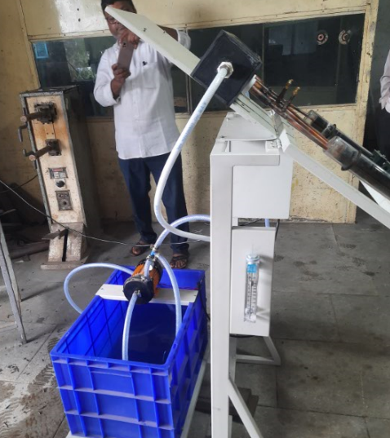

Figures 01 Experimental Setup

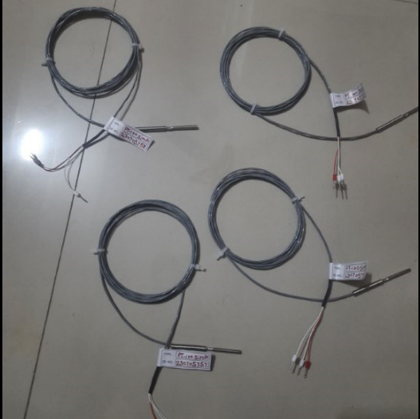

Figures 02 PT 100 Sensors used with multipoint temp indicator

The solar system consists of evacuated tubes, copper pipes, and tank with circulation pipe, and a suitable frame for mounting. The dimensions of evacuated tube heat pipe selected as shown in Table 2. There are four copper tubes which absorbs heat energy from the sun heats the inside Nano material as shown in Fig 01. These copper tubes are surrounded by glass tubes with vacuum in between the two tubes to reduce the heat loss. Tubes were mounted on a structure which when put under the sun make an angle of 15⁰ while facing south. The header is connected to the storage tank. Thermometers were placed at inlet and outlet of the storage tank. Another thermocouple was placed inside the storage tank. Water was circulated through the header. The heat pipe removes heat from the glass tubes with the highest efficiency. Copper tube solar collector controls operating temperature and prevent overheating which is common problem in solar system. During the experimentation, each of the copper tubes and evacuated tubes will be arranged in tilted position and tested in outdoor conditions with reference to Table 5.

Table 5: Monthly solar radiation at location of pune,India for experimentation
(Longitude 74.15⁰ , Latitude 18.6⁰ ).

Month | Sunshine hour | Day length
Jan | 8.7 | 11.15
Feb | 8.9 | 11.53
March | 9.0 | 12.02
April | 9.7 | 12.55
May | 9.6 | 12.99
June | 5.0 | 13.21
July | 2.6 | 13.11
August | 2.9 | 12.74
Sept | 5.7 | 11.24
Oct | 7.8 | 11.72
Nov | 8.3 | 11.27
Dec | 8.4 | 11.03

RESULT AND DISCUSSION

The Ansys Fluent software is used to calculate the outlet temperature.

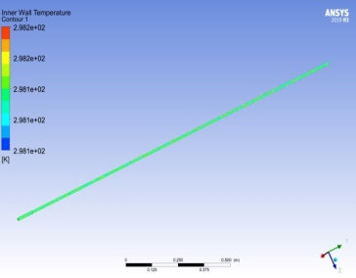

Figure. 3 Inner wall Temperature contour (Copper Tube)

The copper tubes thermal systems with Nano composition material for heat transfer improvement has become popular in present days. A number of works has been performed to gain an understanding of the heat transfer performance for their practical application to heat transfer improvements. Thus the improvement of increase in thermal energy has created more demand for new technologies to increase heat transfer rate of solar system. There are many methods to improve the thermal performance of solar system. Some methods are use of extended surfaces, application of vibration to contact surfaces, and usage of Nano composite materials. The efficiency can also be improved by increasing the thermal conductivity of the working Nano composite materials.

CONCLUSION

Nano composite materials are proposed and developed over the past few years for heat transfer applications. Thermal properties of the Nano fluids are quite good to study their heat transfer analysis. It is necessary to control for the industrial and energy saving in chemical processes. Nanoparticles have more potential to increase the heat energy transfer properties compared to conventional fluid materials of small size. In the last few years, Nano fluids have gained significant attention due to its enhanced thermal properties

Acknowledgment

My sincere thanks go to my supervisor Dr. P.J. Bansod who provided me valuable guidance and constant support for this research work.

References

- Baquer A. Alhabeeb, Thualfaquir J. Kadhim, Hasan T. Hashim, `Enhancement of the Thermal Efficiency of the Evacuated Tubes solar Water Heater by Adding a Reflector`, International Energy Journal 20(2020)57-66.
- B kiran naik, P Muthukumar, `Performance assessment of evacuated U-tube solar collector-a numerical study`, Indian Academy of Sciences, (2019) 44-23
- Dineh Mevada, Hitesh Panchal, Hagar Alm , `Application of evacuated tubes collector to harness the solar energy`, International Journal of Ambient Energy, (2019) ISSN 0143- 0750
- Adel A. Ghoneim ` Performance optimization of evacuated tube collector for solar cooling of a house in hot climate`, International Journal of Sustainable Energy, (2016) ISSN 1478-6451
- Sakthivel M, Rajanikanth Reddy` Analytical Investigation of solar eater heating using heat pipe with evacuated tubes`, International Journal of innovative and exploring engineering-2278-3075,Vool-8 Issue-8,june2019.
- ] Harender, Dhruv mittal, Deepak Deo, S Aditya, Arvind kumar, `Computational Analysis of Active and passive evacuated tube solar collector, (2019) springer Nature Singapore P Ltd,doi /10.1007/978-981
- Rim Farjallah, Monia Chaabane , Hatem Mhiri, Philippe Bournot, Haten Dhauadi` Thermal Performance of U tube solar collector using computational fluid dynamics simulation`, Journal of solar Energy Engineering,ASME, Dec 2016/Vol 138/061008-1
- Alicja Siuta Olcha, Tomasz Cholewa, Kingo Dopieralska Howoruszko` Experimental studies of thermal performance of an evacuated tube heat pipe solar collector in polish climate conditions`, Environment Science and pollution Research, Springer Ltd, doi.org/10.1007/s11356-020-07920-3/ 12 feb 2020.
- Mustafa Ali Ersoz,`Effect of different working fluid on the energy and exergy performance for evacuated tube solar collector with thermo syphon heat pipe`, Elsevier Ltd, Renewable Energy 96(2016)244-256.
- S S Kumar, K Mohan Kumar, S R Snjeev Kumar ,` Design of Evacuated tube solar collector with heat pipe `, Elsevier Ltd, Materials Today-4(2017)12641-12646.

