Applications of Artificial Intelligence in the Aviation Industry
Anmol Agarwal
School of Computing ,
DIT University Dehradun, Uttarakhand, INDIA

Ishaan Dawar
School of Computing ,
DIT University Dehradun, Uttarakhand, INDIA
Abstract
Future can now be predicted sophisticatedly by using A.I ie. Artificial Intelligence. Real time complexities are not cumbersome anymore. Inculcation of Artificial Intelligence using a set of Defined algorithms pave the way for better solutions thereby making the procedure "time efficient" .Machine Learning, Deep Learning and Natural Language processing come under one Umbrella. A Lot of data can now be stored and processed intelligently which would obviously show an impact on macro level .It is suggested by many artificial intelligence specialists that growth of artificial intelligence will be exponential. Artificial intelligence has already scattered many jobs, especially white collar jobs. A typical task such as Graphic Designing can now efficiently be done with the help of artificial intelligence tools. This technology is getting smarter as each day passes, it learns by itself; trains employees and works for even bigger purposes. integration of advanced Artificial Intelligence Systems in IOT devices is a great example to learn from. Artificial intelligence is ultimately a game changer. Needless to mention, digitalization drives artificial intelligence.

Introduction

In a random esteemed daily anyone can find tons of NEWS regarding bumper growth in the advanced sector called Artificial Intelligence. The technology is not confined to theories anymore. Indeed, it has a vital practical approach- works for a common citizen. Artificial Intelligence is a wise dominance of science cum art all together on a set of obstacles.
Furthermore, it is one of the key pillars in growth and development of Emerging Companies and startups.
Artificial Intelligence adds fuel to The Aviation Industry. A.I can be fitted right into the pocket.
Upon looking back in time, it is evidently visible that without this helping hand tasks would have been not easier to manage at the stipulated time.
Correct implementation of object-oriented algorithms benefitted many ranging from Small Scale Industries to Multinational Companies. It holds the capability to adapt itself no matter how vigorous the real-time complexities are.
Advance A.I, equipped with enormous data, is capable enough to make things Picture Perfect.
In accordance with the current timeline the whole overview has been depicted with a variety of real life examples.
Artificial Intelligence technology has its own merits. Problems get quickly resolved at backend using duly guided A.I models.
The Whole concept of A.I in Aviation Industry is binded altogether in a concise manner for better understanding of the Reader.The language is simple for easy grasping.
"Time efficiency is a need of an hour".
Therefore, A.I came into effect and has become an indispensable part of the transport network system especially The Airways.

Literature Review
Relevant to all applications of AI are concerns about societal effect, accuracy and trust, and governance. Oncologists may increase the benefits of AI while minimizing its risks by using AI ethics and trust frameworks. As AI continues to permeate every industry, it will be crucial for companies to work together to exchange knowledge and best practices; this includes creating unusual collaborations in fields as different as engineering and oncology [1]. In order to shed light on the current state of Conversational AI in the AEC sector, this study performed a Focus Group Discussion to identify obstacles and verify promising avenues of research. The results show that the potential of Conversational AI applications in the AEC sector is substantial yet underexplored at the present time[2]. In[3] this article explores the current tools that use machine learning and mixed reality in the aviation sector. Intelligent design, production, testing, and service in aeronautical engineering are being investigated to improve worker efficiency. To that end, studies are being conducted on autonomous systems, self-service systems, and data visualization systems.In[4] , the companies may save money on storage and better serve their clientele and employees by employing a well-thought-out inventory categorization system. Using the Neutrosophic Fuzzy EDAS approach, this research seeks to achieve high inventory management efficiency in the aviation sector by categorizing spare parts stocks. In[5], studying what factors influence blockchain adoption in the airline business reveals useful information. Blockchain technology has the potential to revolutionize many areas of the aviation industry, and this article uses the technology acceptance model to explain why this change is happening. It was proposed that aircraft MRO procedures be simulated using the discrete-event simulation system AnyLogic, which would allow for the integration of Lean and Industry 4.0 techniques. In [6], authors proposed a simulation process methodology and a process flow chart for airplane repair. Offers a list of inventions, together with a discussion of technical path dependence and value proposition, all of which contribute to the development of modern aviation. Academics and professionals may use this summary to confirm that these developments have led to a more efficient, agile, sustainable, and safe industry all over the globe[7]. This essay examines the potential allure of clusters for worldwide affiliates during the Fourth Industrial Revolution using the Aviation Valley in Poland as an example[8]. In[9], Authors have examined the many uses to which aerospace has put smart materials. This report will set the path for future work to be done in the subject of aerospace by assisting future students and researchers in gaining a comprehensive understanding of smart materials employed in that industry[9]. In order to better equip decision-makers with Safety Intelligence, the paper provides examples of data-driven studies and a comprehensive safety dashboard that can be constructed utilizing TOKAI data. This is made feasible by standardizing on a common vocabulary and taxonomy for discussing not just extraordinary but also routine matters[10]. Specifically for the aviation sector, it is important to evaluate the most recent developments in AM technology, material concerns, post-processes, and design considerations. The economic impacts of the AM process, such as the digitization of spare parts and its impact on the environment, are also studied. This analysis has useful implications for both the academic and business worlds[11]. In[12], examines the accident problem and suggests solutions based on machine learning strategies that make use of cutting-edge tools in Natural Language Processing. The methods are then applied to the standard accident causation model developed by the Software Hardware Environment Liveware (SHEL) and evaluated on a dataset of actual collisions. Among the themes identified for future strategic planning following the recovery from the pandemic crisis are the potential of the Southeast Asian MRO market, strong government assistance, and the development of modern digital technologies. Strategic priorities should be on bolstering local transportation infrastructure and supply networks, enforcing strict rules, adopting cutting-edge technologies, and training workers in specialized fields[13]. Chlorella pyrenoidosa microalgae are processed into jet fuel.Experiments using a Box-Behnken design conserved costs.Robust prognostic modeling using a neuro-fuzzy technique, with an R-value greater than 0.9995[14]. In[15], Authors have identified the most significant human variables influencing the unsafe conduct of Brazilian offshore aviation operations by pilots. Managers and aviation safety professionals may get a deeper understanding of the industry and their own organizations by mapping these human variables and the impact they have on pilots' safety behavior[15].
Advantages of Artificial Intelligence
There are various Advantages of AI are
[1] A.I plays a significant role in the Aviation Industry under Profit Maximization techniques.
[2] It is equipped with a lot of useful data of individuals which helps the manager for catalog building and classification.
[3] Due to the robust nature it is being used by big firms to generate their outreach.
[4] A.I specialists explicitly suggest that Implementation of A.I models and Machine Learning possibly generates a good R.O.I
[5] Implementation of A.I driven chatbots simplifies the task to a great extent.
[6] Google Lens, an image recognition technology, is capable of translating text in various languages supported by Google.
[7] More advanced deep learning routines are used to empower real-time detection capabilities
[8] One of the biggest merits of using A.I is that it works 24×7 without interruptions and has no downtime.
[9]Because of A.I, 40% relative improvement is seen in accuracy of weather forecasting and wind patterns identification.
[10] Last but not least, Artificial Intelligence refines operational efficiency, avoids costly mistakes and increases end user satisfaction.

Importance of Aviation Industry
"Quality standards seek no compromise." As per capital income is increasing since then various operations have been digitized there is a potential requirement of resources that will maximize the outcome and balance the economy.
Apart from carrying passengers as a tier1 or tier 2 flight major part of aviation goes towards import and export of goods.There is an importance of aviation education in fostering future Industry professionals.

Did you know?
>>In early 1900’s a 245 metre long airship was made that was launched at Friedrichshafen, Germany.The "Golden Age" of the airships ended on May 6, 1937, when the Hindenburg(airship) caught fire. A total of 36 people were killed in the mishap.

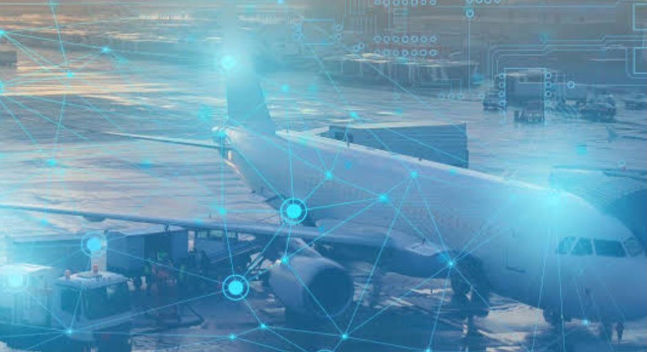
Fig.1. Golden Age
We need sophisticated aviation stuff not only to travel from one country to another which comes under tourism but also for economic balance along with optimum supply of resources.
Let us understand with an example- Mango from west India is exported to different parts of neighboring countries. Another example is that mostly online parcels arrive from metro cities because manufacturing plants have been installed there. So a major portion of cargo is transported via Airways.
Techniques like machine Learning and deep learning are used in Industries to optimize the output speed and streamline processes. Such mechanisms indirectly help boosting this industry thereby making tedious procedures easy and get them done in an efficient manner.
Note- Air India is one of the largest tycoons of the Aviation Industry. Furthermore, it holds more than 18% market share in this field if we talk of aviation giants that have emerged from India.
Challenges in Aviation Industry
Many hurdles affect the aviation sector thereby making procedures complex and time consuming. Some of them directly impact this industry like:-
[1] Stringent environmental restrictions
[2] Severe competition
[3] System complexity
[4] An increase in air pollution.
[5] Loss of control in flight [LOC1]
[6] Last but not the least, aerodynamics of the model.

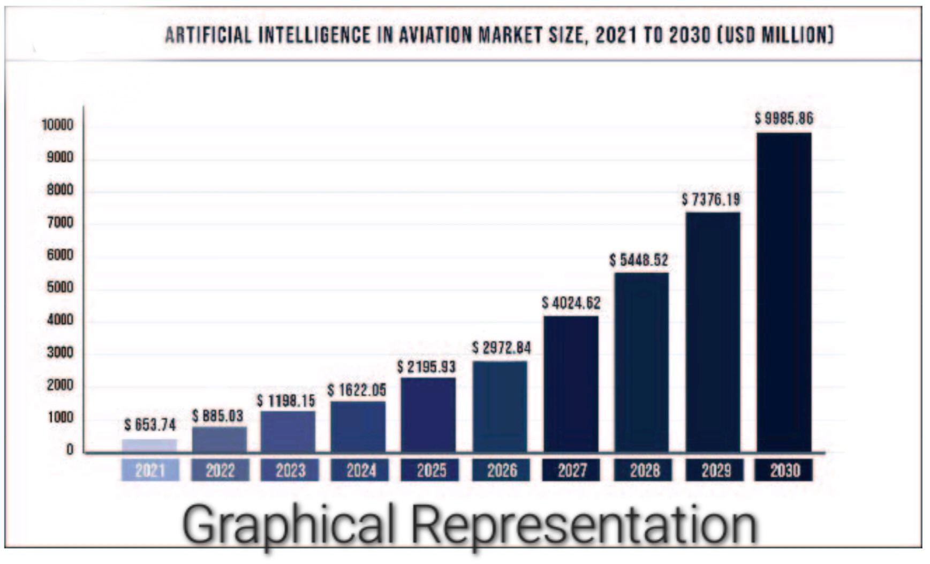
Fig. 2. Graphical representation of AI and Aviation in market

A.I in Aviation System

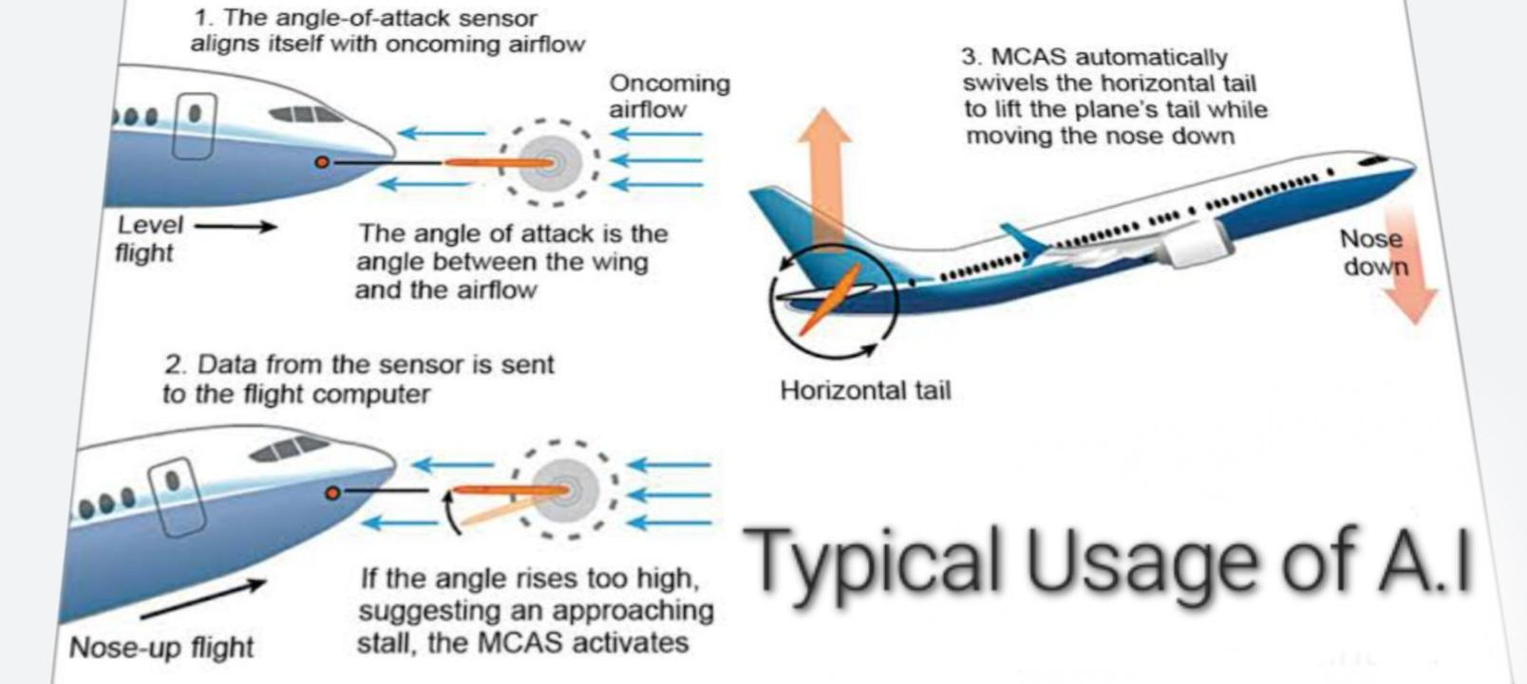

Did you know?
>>Private Airlines account for more than 70 percent share of the domestic aviation market. Various virtual tracks have been laid down just in order to minimize any kind of traffic. They follow the same paths for daily movement of freight and passengers.

- TRAINING OF NOVICE ASPIRANTS- A.I driven tools help to serve as a guide because usually A.I simulators train them for upcoming opportunities .The whole module / simulator can be customized according to the trainee's academic background and intellect . Furthermore, A.I systems are deployed in the cockpit to assist the pilot .e.g The Maneuvering Characteristics Augmented System ( MCAS) is an advanced tool to correct any inaccuracy in the Angle of Attack(AOA).Above figures shows the use of MCAS.
- AVOIDANCE OF CATASTROPHIC MISHAPS - Airways is the only form of transport in which you can't just apply brakes in order to stop the vehicle when an obstacle is right at the front. But in rare cases , due to some misunderstanding, two planes can fly via the same path. To avoid collisions, A.I systems are installed so that any risk factor can be speculated well in advance. It can tell either of them to change the altitude. Air traffic controllers are also able to oversee planes leaving or approaching the runway by use of AI and smart cameras.
- PRIORITIZE CUSTOMER EXPERIENCE- Commercial Airlines apart from seeking Profit they also ensure to make the customer feel comfortable. At the end of the day, client satisfaction and service quality are crucial.Therefore,a robot does the job perfectly. They are available mostly at check-in point and are free to move on the desired predefined pathways.
- PASSENGER IDENTIFICATION - At the international airport, security is one of the topmost concerns. Since illegal activities such as smuggling can be done and terrorist may also travel via international borders if proper checking is not done.Therefore, safety of an individual is ensured by using facial recognition to detect suspect individuals. Security has refined as a result of the use of biometric scanners and facial recognition technologies.
- CREW MANAGEMENT- Since the scheduling department has to assign crews to each of thousands of flights operated every day. This is a tedious task. By putting multiple factors into the task basket: flight route, crew member licensing and qualification, aircraft type and fuel usage, work regulations. Personal issues such as vacations and days off to approve conflict-free schedules for pilots and flight attendants.Training requirements like the pairing of senior crew members with junior ones, and government regulations that have to be taken into account. Thanks to A.I for making tasks easier.

Conclusion
Upon critical analysis on this technology, it is highly expected that it will result in causing exponential benefits to the different modes of transport especially Airways. Still much left undiscovered in this domain. New mind boggling features such as Auto-Pilot mode is capable of passing instructions on its own without human intervention. Undoubtedly, A.I is the building block of such systems. Impact of Artificial Intelligence will surely be seen on the transport network in the years to come.
References
[1] R. Hallows, L. Glazier, M. S. Katz, M. Aznar, and M. Williams, “Safe and ethical artificial intelligence in radiotherapy – lessons learned from the aviation industry,” Clinical Oncology, vol. 34, no. 2, pp. 99–101, 2022. doi:10.1016/j.clon.2021.11.019
[2] A. B. Saka et al., “Conversational Artificial Intelligence in the AEC industry: A review of present status, challenges and opportunities,” Advanced Engineering Informatics, vol. 55, p. 101869, 2023. doi:10.1016/j.aei.2022.101869
[3] Y. Jiang, T. H. Tran, and L. Williams, “Machine learning and mixed reality for smart aviation: Applications and challenges,” Journal of Air Transport Management, vol. 111, p. 102437, 2023. doi:10.1016/j.jairtraman.2023.102437.
[4] E. Cakmak and E. Guney, “Spare parts inventory classification using neutrosophic fuzzy EDAS method in aviation industry,” SSRN Electronic Journal, 2022. doi:10.2139/ssrn.4068618
[5] X. Li, P.-L. Lai, C.-C. Yang, and K. F. Yuen, “Determinants of blockchain adoption in the aviation industry: Empirical evidence from Korea,” Journal of Air Transport Management, vol. 97, p. 102139, 2021. doi:10.1016/j.jairtraman.2021.102139
[6] A. Korchagin, Y. Deniskin, I. Pocebneva, and O. Vasilyeva, “Lean maintenance 4.0: Implementation for Aviation Industry,” Transportation Research Procedia, vol. 63, pp. 1521–1533, 2022. doi:10.1016/j.trpro.2022.06.164
[7] B. A. Pereira, G. Lohmann, and L. Houghton, “Technology trajectory in aviation: Innovations leading to Value Creation (2000–2019),” International Journal of Innovation Studies, vol. 6, no. 3, pp. 128–141, 2022. doi:10.1016/j.ijis.2022.05.001
[8] B. Jankowska, E. D. Maria, and J. Cygler, “Do clusters matter for foreign subsidiaries in the era of industry 4.0? the case of the Aviation Valley in Poland,” European Research on Management and Business Economics, vol. 27, no. 2, p. 100150, 2021. doi:10.1016/j.iedeen.2021.100150
[9] K. Sharma and G. Srinivas, “Flying smart: Smart materials used in aviation industry,” Materials Today: Proceedings, vol. 27, pp. 244–250, 2020. doi:10.1016/j.matpr.2019.10.115
[10] R. Patriarca, G. Di Gravio, R. Cioponea, and A. Licu, “Safety intelligence: Incremental proactive risk management for Holistic Aviation Safety Performance,” Safety Science, vol. 118, pp. 551–567, 2019. doi:10.1016/j.ssci.2019.05.040
[11] A. Gisario, M. Kazarian, F. Martina, and M. Mehrpouya, “Metal additive manufacturing in the Commercial Aviation Industry: A Review,” Journal of Manufacturing Systems, vol. 53, pp. 124–149, 2019. doi:10.1016/j.jmsy.2019.08.005
[12] G. Perboli, M. Gajetti, S. Fedorov, and S. L. Giudice, “Natural language processing for the identification of human factors in aviation accidents causes: An application to the shel methodology,” Expert Systems with Applications, vol. 186, p. 115694, 2021. doi:10.1016/j.eswa.2021.115694
[13] J. Liangrokapart and T. Sittiwatethanasiri, “Strategic direction for aviation maintenance, repair, and overhaul hub after crisis recovery,” Asia Pacific Management Review, vol. 28, no. 2, pp. 81–89, 2023. doi:10.1016/j.apmrv.2022.03.003
[14] Z. Said et al., “Multi-attribute optimization of sustainable aviation fuel production-process from microalgae source,” Fuel, vol. 324, p. 124759, 2022. doi:10.1016/j.fuel.2022.124759
[15] D. A. Sant’Anna and A. V. Hilal, “The impact of human factors on pilots’ safety behavior in offshore aviation companies: A Brazilian case,” Safety Science, vol. 140, p. 105272, 2021. doi:10.1016/j.ssci.2021.105272

