A REVIEW ON ARTIFICIAL SKIN

Pavankumar Krosuri*¹, G.Tejaswini¹, P.Bhavya sree¹, D.Karishma Banu¹,Sk.Arshiya¹, K.Kiranmai¹.

1. Department of pharmaceutics, Santhiram college of pharmacy, Nandyal, Andhrapradesh, India.

Corresponding authors mail: pavankumarmph@gmail.com

Abstract:
According to gift ways of regenerative medication, it's focus on altered skin (such as burnt skin) which might be transplanted with combination of scaffold and biomolecules . In current years, biologically active scaffolds are being employed as extracellular matrix that may induce synthesis of tissues and organs . Scaffold is needed for the restoration of the performace of tissue and its regeneration because it acts as short term matrix for cell proliferation and extracellular matrix deposition. Scaffolds are used for tissue engineering like bone, cartilage, ligament, skin, vascular tissues, neural tissues, and muscle and as vehicle for the controlled delivery of medicine, proteins, and DNA covering finds its application in a very broad vary of areas as well as artificial intelligence, human-computer interfaces and different areas that involve mechanical deformation. In this paper, an summary of the anatomy of skin, forms of burns, covering scaffolds, its material properties that are used for treating burnt scars and its application is mentioned.
KEY WORDS: covering, collagen, ECM, cuticle freeze drying, grafting, death tissue scaffold.
Introduction
The skin is the largest organ within the form. Skin is created from 3 layers, the cuticle, dermis and also the fat layer, conjointly referred to as the layer. The cuticle is the outer layer of skin that keeps important fluids in and harmful bacterium out of the body. The dermis is the inner layer of skin that contains blood vessels, nerves, hair follicles, oil, and sweat glands. Severe injury to giant areas of skin exposes the human organism to dehydration and infections that may lead to death.
Traditional ways of managing giant losses of skin are to use skin grafts from the patient (autografts) or from AN unrelated donor or a corpse. The previous approach has the disadvantage that there might not be enough skin accessible, whereas the latter suffers from the chance of rejection or infection. Till the late twentieth century, skin grafts were created from the patient's own skin. This became an issue once skin had been broken extensively, creating it not possible to treat severely skinned patients entirely with autografts.
The human skin is the outer covering of the body. In humans, it's the most important organ of the system. The skin has up to seven layers of ectodermic tissue and guards the underlying muscles, bones, ligaments and internal organs. Human skin is analogous to most of the opposite mammals skin, and human skin is incredibly like pig skin. although nearly all human skin is roofed with hair follicles, it will seem depilous. There are 2 general forms of skin, bushy and hairless skin (hairless). The adjective cutaneous virtually means that "of the skin" (from Latin body covering, skin).Because it interfaces with the surroundings, skin plays a vital immunity role in protective the body against pathogens and excessive water loss. Its different functions are insulation, temperature regulation, sensation, synthesis of cholecarciferol, and also the protection of vitamin B folates. Severely broken skin can attempt to heal by forming connective tissue. This is often stained and depigmented.
In humans, skin pigmentation varies among populations, and skin sort will vary from dry to oily. Such skin variety provides a rich and diverse habitat for bacteria that number roughly 1000 species from 19 phyla, present on the human skin

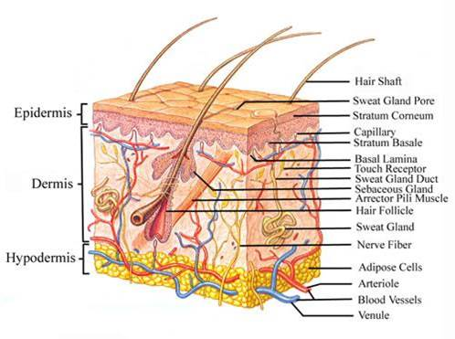
The skin has vital important functions for keeping the physiological and organic chemistry conditions of the body in its optimum state. the foremost necessary functions of the skin are:
1. Regulates blood heat.
2. Prevents loss of essential body fluids, and penetration of nephrotoxic substances.
3. Protection of the body from harmful effects of the sun and radiation.
4. Excretes nephrotoxic substances with sweat.
5. Mechanical support.
6. immunologic perform mediate by Langerhans cells.
7. Sensory organ for bit, heat, cold, socio-sexual and emotional sensations.
8. cholecarciferol synthesis from its precursors underneath the impact of daylight and introversion of steroids.
Burns
Burns are one in every of the foremost common home injuries, particularly among kids. The term “burn” means that quite the burning sensation related to this injury. Burns are characterized by severe skin injury that causes the affected skin cells to die.
Most people will live through burns while not serious health consequences, reckoning on the cause and degree of injury. Additional serious burns need immediate emergency treatment to forestall complications and death.
Pictures of burns
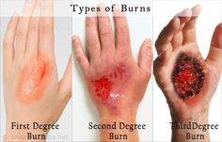
Burn levels
There are 3 primary forms of burns: first-, second-, and third-degree. every degree relies on the severity of injury to the skin, with first-degree being the foremost minor and third-degree being the foremost severe. injury includes:
• first-degree burns: red, nonblistered skin
• second-degree burns: blisters and a few thickening of the skin
• third-degree burns: widespread thickness with a white, leathered look
There also are fourth-degree burns. this kind of burn includes all of the symptoms of a burn and conjointly extends on the far side the skin into tendons and bones.
Burns have a spread of causes, including:
• vituperative from hot, boiling liquids
• chemical burns
• electrical burns
• fires, as well as flames from matches, candles, and lighters
• excessive sun exposure
The type of burn isn't supported the explanation for it. Scalding, for instance, will cause all 3 burns, reckoning on however hot the liquid is and the way long it stays involved with the skin.
Chemical and electrical burns warrant immediate medical attention as a result of they will have an effect on the within of the body, whether or not skin injury is minor.
First-degree burn
First-degree burns cause nominal skin injury. they're conjointly referred to as “superficial burns” as a result of they have an effect on the outmost layer of skin. Signs of a burn include:
• redness
• minor inflammation, or swelling
• pain
• dry, peeling skin happens because the burn heals
Since this burn affects the highest layer of skin, the signs and symptoms disappear once the skin cells shed. First-degree burns typically heal at intervals seven to ten days while not scarring.
You should still see your doctor if the burn affects an outsized space of skin, quite 3 inches, and if it’s on your face or a significant joint, that include:
• knee
• ankle
• foot
• spine
• shoulder
• elbow
• forearm
First-degree burns are typically treated with home care. Healing time could also be faster the earlier you treat the burn. Treatments for a burn include:
• soaking the wound in cool water for 5 minutes or longer
• taking Panadol or Nuprin for pain relief
• applying Xylocaine (an anesthetic) with aloe gel or cream to assuage the skin
• victimisation AN antibiotic ointment and loose gauze to safeguard the affected space
Make sure you don’t use ice, as this might build the injury worse. ne'er apply cotton balls to a burn as a result of the little fibers will persist with the injury and increase the chance of infection. Also, avoid home remedies like butter and eggs as these aren't well-tried to be effective.
Second-degreeburn:
Second-degree burns are additional serious as a result of the injury extends on the far side the highest layer of skin. this kind burn causes the skin to blister and become extraordinarily red and sore.
Some blisters pop open, giving the burn a wet or weeping look. Over time, thick, soft, scab-like tissue referred to as protein exudate could develop over the wound.
Due to the fragile nature of those wounds, keeping the world clean and binding it properly is needed to forestall infection. This conjointly helps the burn heal faster.
Some second-degree burns take longer than 3 weeks to heal, however most heal at intervals 2 to a few weeks while not scarring, however typically with pigment changes to the skin.
The worse the blisters are, the longer the burn can fancy heal. In some severe cases, skin graft is needed to mend the injury. Skin graft takes healthy skin from another space of the body and moves it to the positioning of the burned skin.
As with first-degree burns, avoid cotton balls and questionable home remedies. Treatments for a light burn usually include:
• running the skin underneath cool water for quarter-hour or longer
• taking over-the-counter pain medication (acetaminophen or ibuprofen)
• applying antibiotic cream to blisters
However, ask for emergency medical treatment if the burn affects a widespread space, like any of the following:
• face
• hands
• buttocks
• groin
• feet
Third-degree burn
Excluding fourth-degree burns, third-degree burns are the foremost severe. They cause the foremost injury, extending through each layer of skin.
There is a idea that third-degree burns are the foremost painful. However, with this kind of burn the injury is so intensive that there might not be any pain due to nerve injury.
Depending on the cause, the symptoms third-degree burns will exhibit include:
• waxy and white color
• char
• dark brown color
• raised and leathered texture
• blisters that don't develop
Without surgery, these wounds heal with severe scarring and muscle contraction. there's no set timeline for complete spontaneous healing for third-degree burns.
Never try to self-treat a burn, whereas you’re anticipating medical treatment, raise the injury on top of your heart. Don’t get undressed, however ensure no wear is stuck to the burn.
Complications:
Compared with first- and second-degree burns, third-degree burns carry the foremost risk for complications, like infections, blood loss, and shock, that is usually what may lead to death. At the identical time, all burns carry the chance of infections as a result of bacterium will enter broken skin.
Severe burns conjointly carry the chance of physiological state and blood disorder. Perilously low body temperatures characterize physiological state. Whereas this might look like A surprising complication of a burn, the condition is truly prompted by excessive loss of body heat from an injury, blood disorder, or low blood volume, happens once your body loses an excessive amount of blood from a burn.
When properly and quickly treated, the outlook for first- and second-degree burns is nice. These burns seldom scar however may result in a very amendment in pigment of the skin that was burned. The secret's to reduce any injury and infection. intensive injury from severe second-degree and third-degree burns will cause issues in deep skin tissues, bones, and organs. Patients could require:
•surgery
• physiotherapy
•rehabilitation
• womb-to-tomb power-assisted care
Surgery includes usage of covering in situ of burnt skin that is usually referred as skin grafts.
• covering could be a scleroprotein scaffold that induces regeneration of skin in mammals like humans.
The term was employed in the late Nineteen Seventies and early Nineteen Eighties to explain a brand new treatment for enormous burns. it absolutely was later discovered that treatment of deep skin wounds in adult animals and humans with this scaffold induces regeneration of the derma. it's been developed commercially underneath the name IntegraTM and is employed in massively burned patients, throughout cosmetic surgery of the skin, and in treatment of chronic skinwounds.
• instead, the term “artificial skin” generally is employed to consult with skin-like tissue fully grown in a very laboratory, though this technology continues to be quite an approach off from being viable to be used within the medical field. 'Artificial skin' also can consult with versatile semiconductor materials that may sense bit for those with prosthetic limbs, (also experimental).
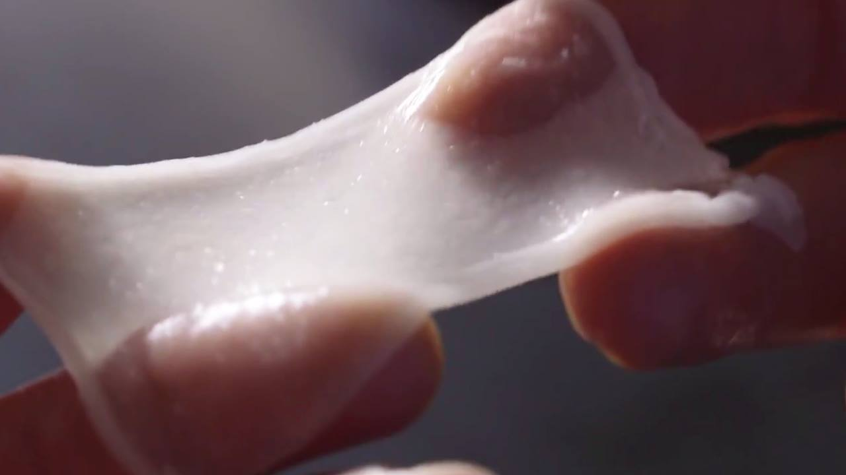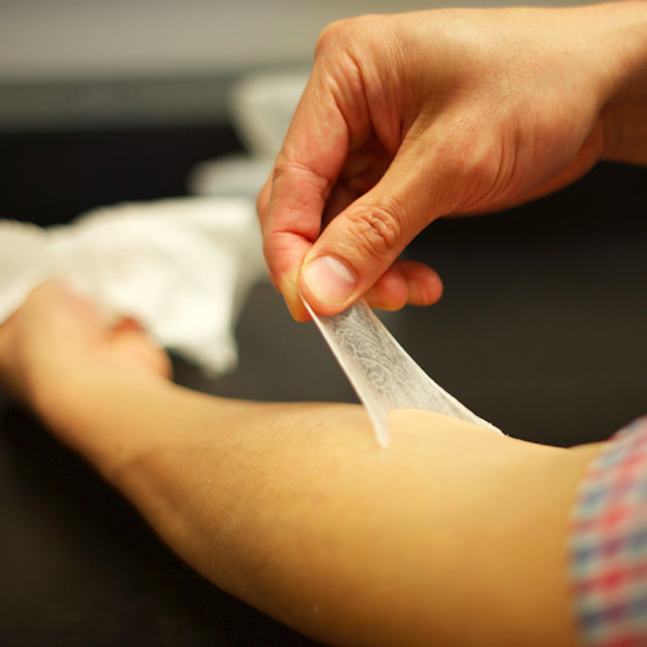
Artificial skin is very used for burnt victims and different skin connected disorders and it's not used as permanent replacement however to hide till natural skin growth takes place.
AREAS OF APPLICATION:
Artificial skins are used for especially for skin loss or damage on burnt patients
Application of artificial skin includes:
1. Treatment of patients with skin diseases such as diabetic foot ulcers and severe scarring.
2.Plastics and cosmetic surgery.
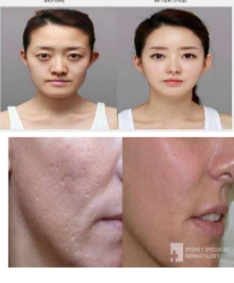 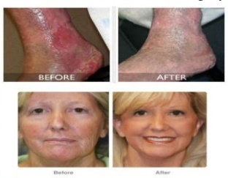
When the skin has been seriously broken through illness or burns, the body cannot act quick enough to manufacture the mandatory replacement cells. Wounds, like skin ulcers suffered by diabetics, might not heal and limbs should be amputated. Burn victims could die from infection and also the loss of plasma. Skin grafts were developed as the way to forestall such consequences further on correct deformities. As early because the sixth century B.C.Hindu surgeons were concerned in nose reconstruction, graft skin flaps from the patient's nose. Gaspare Tagliacozzo, An Italian MD, brought the technique to Western medication within the sixteenthcentury.
Until the late twentieth century, skin grafts were created from the patient's own skin (autografts) or corpse skin (allografts). Infection or, within the case of corpse skin, rejection were primary issues. whereas skin grafted from one a part of a patient's body to a different is proof against rejection, skin grafts from a donor to a recipient are rejected additional sharply than the other tissue graft or transplant. though corpse skin will offer protection from infection and loss of fluids throughout a burn victim's initial healing amount, a resultant graft of the patient's own skin is usually needed. The MD is restricted to what skin the patient has accessible, a set disadvantage within the case of severe burn victims.

In a variation of this method developed by different researchers, the extracted fibroblasts are superimposed to scleroprotein, a fibrous supermolecule found in animal tissue. once the compound is heated, the scleroprotein gels and traps the fibroblasts, that successively organize themselves round the scleroprotein, turning into compact, dense, and fibrous. Once many weeks, keratinocytes, conjointly extracted from the given foreskins, are seeded onto the new dermal tissue, wherever they produce an dermal layer.
An artificial skin offers many benefits over those derived from the patient and cadavers. It eliminates the necessity for diagnostic test.
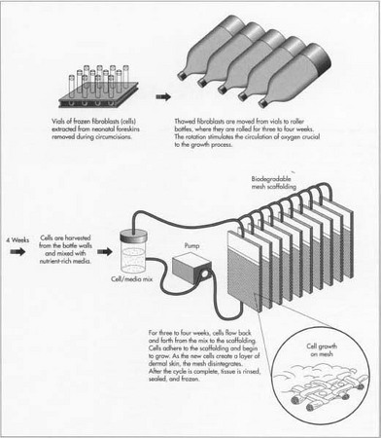
Artificial skin can be made in large quantities and frozen for storage and shipping, making it available as needed. Each culture is screened for pathogens, severely curtailing the chance of infection. Because artificial skin does not contain immunogenic cells such as dendritic cells and capillary endothelial cells, it is not rejected by the body. Finally, rehabilitation time is significantly reduced.

Raw Materials for preparation of Artificial skin:
The raw materials required for the assembly of covering represent 2 classes, the biological parts and also the necessary laboratory instrumentation. Most of the given skin tissue comes from baby foreskins removed throughout circumcision. One foreskin will yield enough cells to form four acres of graft material. Fibroblasts are separated from the dermal layer of the given tissue. The fibroblasts are unintegrated whereas they're tested for viruses and different infectious pathogens like hepatitis B and C, and true bacteria. The mother's case history is recorded. The fibroblasts are hold on in glass vials and frozen in atomic number 7 at
-94°F (-70°C). Vials are unbroken frozen till the fibroblasts are required to grow cultures. Within the scleroprotein methodology, keratinocytes also are extracted from the foreskin, tested, and frozen.
If the fibroblasts are to be fully grown on mesh system, a compound is made by combining molecules of carboxylic acid and hydroxyacetic acid, the identical parts wont to build dissolving sutures. The compound undergoes a chemical process leading to a bigger molecule that consists of repetition structuralunits.
In the scleroprotein methodology, a little quantity of bovine scleroprotein is extracted from the extensor muscle connective tissue of young calves. The scleroprotein is mixed with an acidic nutrient and hold on in a very white goods at 39.2°F (4°C).
Laboratory instrumentation includes glass vials, tubing, roller bottles, graft cartridges, molds, and freezers.
Manufacturing Process:
The manufacturing process is deceptively simple. Its main function is to trick the extracted fibroblasts into believing that they are in the human body so that they communicate with each other in the natural way to create new skin.

Mesh scaffolding method :
1 . Fibroblasts are thawed and dilated. The fibroblasts are transferred from the vials into roller bottles, i.e., cubic decimetre soda bottles. The bottles are revolved on their sides for 3 to four weeks. The rolling action permits the circulation of O, essential to the expansion method.
2. Cells are transferred to a culture system. The cells are off from the roller bottles, combined with a nutrient-rich media, flowed through tubes into skinny, cassette-like bioreactors housing the perishable mesh system, and sterilized with e-beam radiation. because the cells flow into the cassettes, they adhere to the mesh and start to grow. The cells are flowed back and forth for 3 to four weeks. Each day, leftover cell suspension is removed and contemporary nutrient is superimposed. Oxygen, pH, nutrient flow, and temperature are controlled by the culture system. because the new cells produce a layer of dermal skin, the compound disintegrates.
3 Growth cycle completed. once cell growth on the mesh is completed, the tissue is rinsed with additional nutrient-rich media.
A cryoprotectant is superimposed. Cassettes are hold on singly, labeled, and frozen.
Collagen methodology :
• Cells are transferred to a culture system. alittle quantity of the cold scleroprotein and nutrient media, some twelve-tone system of the combined answer, is superimposedto the fibroblasts. The mixture is distributed into molds and allowed to come back to temperature because the scleroprotein warms, it gels, tack the fibroblasts and generating the expansion of recent skin cells.
• Keratinocytes superimposed. period once the scleroprotein is superimposed to the fibroblasts, the extracted keratinocytes are thawed and seeded onto the new dermal skin. they're allowed to grow for many days then exposed to air, causation the keratinocytes to make dermal layers.
• Growth cycle completed. The new skin is hold on in sterile containers till required.
Applications:
1. carcinoma : Cancer could be a varied illness whose initiation and progression is tightly modulated by cell to cell and cell to matrix interactions. For these reasons, the utilization of 3D culture models has been steady growing in studies of neoplasm biology. Skin cancers like malignant melanoma, skin reconstructs are terribly appropriate for modelling not solely the expansion and progression of malignant melanoma cells in a very 3D microenvironment, however conjointly for learning the communication among malignant melanoma cells and close dermal keratinocytes and dermal fibroblasts. The utilization of covering has shown that near fibroblasts are recruited by the first malignant melanoma and supply survival signals within the type of altered EW deposition and growth factors, further as stimulating the assembly of matrix metalloproteinase, promoting neoplasm cell invasion.
2. Skin disorders and clinical applications Skin : reconstructs are presently being tested and employed in clinics for many skin pathologies. Disorders which can take pleasure in the event of human skin equivalents embody skin disorder, vitiligo, keloids, mar and genodermatoses like xeroderma pigmentosum . the most use of homologous skin grafts is within the treatment of severe burns and skin disorders. the most new clinical indications for skin allografts embody skin loss, surgical wounds, and genodermatoses. 2key factors thought of essential for the use of skin substitutes in clinical applications is that the ability to grow keratinocytes in vitro and also the increasing apply of early wound excision within the extensively burned patient.
3. pharmacological applications : within the field of medicine, drug discovery is usually dependent upon the prognosticative capability of cell-based assays. Most often, the effectualness of anti-cancer medication is tested in 2nd monolayer cells refined on plates throughout the initial drug development and discovery part. However, variations are discovered once these medication are tested in vivo. These variations could also be the results of completely different cell surface receptors, proliferation dynamics, ECM components, cellular densities, and metabolic functions of 2D-maintained cells. Skin from cadavers was employed in drug transport studies, however restricted accessibility and huge variations between specimens have currently augmented the appliance potential of skin reconstruct models. The 3D model has porosity characteristics and metabolic activity like native skin that is significant, as metabolic activity could have an effect on the porosity of some medication and their potential for analysis on irritation, toxicity, and keratinocytes differentiation. one in every of the issues relating to the skin reconstruct model is its lack of skin appendages, as well as pilose baceous units, hair follicles, and sweat glands. Due to this lack, this model provides a lot of lower barrier properties than that found in whole skin. As a result, the skin reconstruct model is superior to a monolayer model, the kinetic parameters of skin permeation obtained from these studies should still be thought of an overestimation compared to the flux across human skin.

Future scope:
The medical community is victimization covering technology to pioneer organ reconstruction. it's hoped that this questionable designed structural tissue can, for instance, sometime replace plastic and metal prostheses presently wont to replace broken joints and bones. Ears and noses are reconstructed by seeding gristle cells on compound mesh.
The regeneration of breast and channel tissues is presently underneath study within the laboratory. Through this technology, it's potential that in the future, livers, kidneys, and even hearts, are fully grown from human tissues.
CONCLUSION :
In patients with major burns, artificial derma permits early wound closure nearly as good a take as transplant and once coated with a dermal graft it provides a permanent cowl that is satisfactory compared to presently accessible skin graft techniques and uses donor grafts that are agent and leave donor sites that heal quicker and it's value effective methodology.
Authors Contributions: All authors contributed equally.
Conflict of Interest: The Authors declare no conflict of interest.

References:
1. McCracken, Thomas (2000). New Atlas of Human Anatomy. China: Metro Books. pp. 1–240. ISBN 978-1-58663-097-3.
2. Hettiaratchy S, Dziewulski P (2004) ABC of burns: pathophysiology and types of burns. BMJ 328:1427-1429.
3. Peck MD (2012) Epidemiology of burns throughout the World. Part II: Intentional burns in adults. Burns 38: 630-637.
4. Moctezuma-Paz L, Páez-Franco I, Jimenez-González S, Miguel-James KD, Fonserrada-Ortega G, et al. (2015) Epidemiology of burns in Mexico. Rev Esp Méd Quir. 20: 78-82.
5. Jackson DM (1953) Нe diagnosis of the depth of burning. Br J Surg 40: 588-596.
6. R. Langer and J. P. Vacanti, “Tissue engineering,” Science, vol. 260, no. 5110, pp. 920–926, 1993.
7, pp. CE8–CE12, 1992. 3. R. Langer and D. A. Tirrell, “Designing materials for biology and medicine,” Nature, vol. 428, no. 6982, pp. 487–492, 2004.
8. J. R. Fuchs, B. A. Nasseri, and J. P. Vacanti, “Tissue engineering: a 21st century solution to surgical reconstruction,” Annals of Thoracic Surgery, vol. 72, no. 2, pp. 577–591, 2001.
9. I. V. Yannas, J. F. Burke, C. Huang, and P. L. Gordon, “Suppression of in vivo degradability and of immunogenicity of collagen by reaction with glycosaminoglycans,” Polymer Preprints, vol. 16, pp. 209–214, 1975.
10. I. V. Yannas, J. F. Burke, P. L. Gordon, and C. Huang, “Multilayer membrane useful as synthetic skin,” US patent
11. McGrath J.A, Eady R.A, Pope F.M. (2004). Rook's Textbook of Dermatology (7th ed.). Blackwell Publishing. pp. 3.1–3.6. ISBN 978-0- 632-06429-8.
12. Godin, B., and Touitou, E. (2007). Transdermal skin delivery: Predictions for humans from in vivo, ex vivo and animal models. Adv. Drug Deliv. Rev. 59, 1152– 1161.
13. Sheridan RL, Moreno C. Skin substitutes in burns. Burns. 2001.
14. Victoria Tang,Thomas Mak,Louise Tsang,Zero Wong, Iris Ting .Artificial skin.2010.

