Studies on effect of gastro intestinal parasites on weight gain in goat of the Sundarban areas, West Bengal.

Ria Bhar^{1*}, Amit Gamit²

¹Department of Biotechnology, School of Life Science and Biotechnology, Adamas University, Kolkata, India.
²ICAR-IVRI, ERS, Kolkata-700037

*Corresponding Author

Address for Correspondence:

E-mail addresses: bhar.riya89@gmail.com (R.Bhar)

Abstract:
A study was conducted to evaluate the effect on weight gain due to gastro-intestinal parasites of goat of some selected villages (viz. Kholakhuli, Dosorabhagwanpur, Purba Raghunathpur) of Sunderban areas of South 24 Parganas district of West Bengal. A total 720 faecal samples of goats were collected for six months in this study. About 40 samples were collected from each village in every month to check the parasitic burden and processed by standard sugar flotation technique to broadly discriminate the ova of cestode, nematode and coccidian parasites. In this study, goats were found severely infected with coccidian than strongyle and cestode in all villages. Out of three villages, strategic anthelmintic treatments along with mineral mixture supplementation were provided to goats of two villages and one village (Purba Raghunathpur) was kept as control. After intervention for 6 months, it was found that rate of weight gain in animals in two intervene villages were 0.18 g and 0.14 g as compare to control village where it was 0.03 g.
Keywords: Gastrointestinal Parasite, Goat, Helminth parasites' eggs, fecal flotation, Nematode
Introduction:
It is generally accepted that goat husbandry has been practised extensively in west Bengal since the dawn of civilization, particularly in rural areas and at all altitudes without regard to the local topography. For small and marginal farmers, goat farming has proved a viable crop production alternative. Goat population in 2007/2008 was 8,135,880, and it increased by 1.37 times in 2016/2017, showing that the rearing of goats is a major industry in the nation (MOAD 2018). The Village region appears to be one of the best consumers of goats, despite the fact that their numbers were low in the Kolkata city area, which includes the North Kolkata and Howrah districts. The goat markets of the village area obtain goats mostly from outsides like other districts at different landscapes of the country. But it all relies on the breeds, which could include regional races like the Terai, Khari, Sinhal, and Chyangra, as well as international breeds like the Boer, Barbari, Sannen, Beetal, Sirohi, and Jamunapari, as well as hybrid varieties like the Boer cross and Jamunapari c. It's interesting to note that after selling goats for meat, smallholder farmers are thought to have a net income of 5,000–8,000 annually. It is true that the goat markets have long brought goats from various parts of Nepal to the Valley in order to supply the Valley with goat meat. However, due to poor farmer husbandry practices, genetic weaknesses in local breeds, and a lack of animal health, the domestic supply is unable to keep up with the expanding demand (MOAD 2014). This explains why supplies from China and India have been widely used, particularly during religious and celebratory occasions. Therefore, it has been interesting to learn how microbes including parasites, viruses, bacteria, and fungus have contributed to the poor health of these goats. Although parasites can cause significant morbidity and mortality in goats, they are frequently overlooked as etiologic agents (Babják et al. 2017; Chartier and Paraud 2012; Chikweto et al. 2018; Das et al. 2017; Dixit et al. 2017; Donkin and Boyazoglu 2004; Fakae 1990; Godara et al. 2014; Hashemnia et al.). For instance, the Nepal Journal of Science and Technology released postmortem findings on goats in a hilly region of the country from NAST, identifying a total of 27 etiologies, some of which included parasitosis including monieziasis, hydatid cyst, and strongylosis. West Bengal has a significant parasite problem, as shown by the author's (Khakural 2003) quantification of around 64% of the primary parasitic illnesses treated by specialists in a small number of locations. The NAST laboratory has already discovered tapeworm eggs in the liver, abomasum, faeces, stomach, and intestinal tract of goats in west Bengal, along with Haemonchus in the abomasum, Trichostrongylus in the liver, and oocysts of Eimeria and Isospora. It's interesting to note that many people think male goats at goat markets may be pathogen-free because of their robust and healthy physical appearances. However, a pilot study carried out by our group revealed widespread protozoal and helminthes infection in goats (Ghimire 2018), demonstrating that these agents are typically prevalent in asymptomatic hosts. Understanding the presence of different endoparasites that are secreted via the goats' GI tract is crucial. The goal of the current study was to determine the prevalence of several protozoan and helminthic parasites in goat faeces collected from the goat market in the Sundarban region of West Bengal.
Material & methods:
Goat faecal samples were collected & stored at 10% formalin, every month from 40 goats. Saturated sugar is prepared by dissolving 454 grams of sugar in 355 ml of water for faecal flotation solution. Other instruments that were plain microscopic slides cover slips, vials (6ml), stirring rod, & microscope. A vial containing freshly excreted waste was appropriately labelled with the date and the name of the animal that gave the specimen. After adding the saturated sugar solution, thoroughly combine using a stirring stick. More solution was added, and it was then poured through a cheesecloth or sieve to get rid of the big particles. After adding more liquid until the vial was completely full, a microscope cover slip was placed on top, making sure that there was no space between the cover slip and the liquid. The eggs floated to the top and stuck to the glass dish after more than 20 minutes. We looked for worm eggs and coccidia oocysts on the sample slides. The microscope was then cautiously turned on and started at the lowest power (40X).
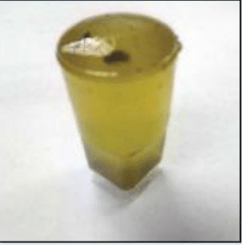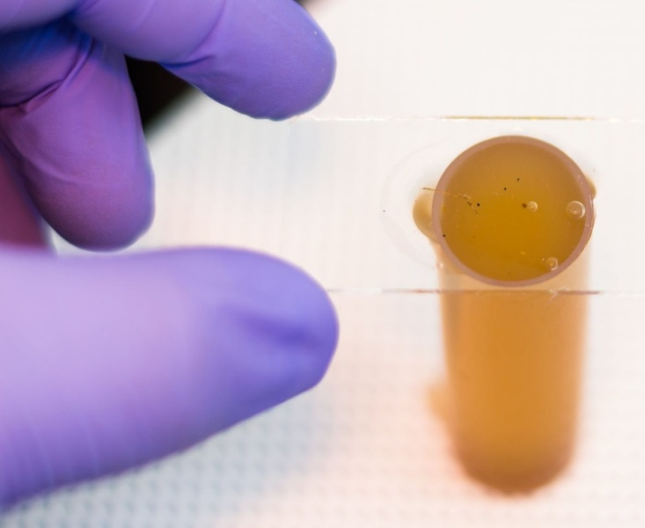
Fig 1: Cover slips placed over menisci for fecal flotation test.
The results of this research corroborated those of Biswas et al. (2014) and Admasu & Nurlign (2014), who discovered that hosts with poor bodily condition had higher parasite infection rates than hosts with moderate and good condition. Due to hunger and other parasitic illnesses that are present at the same time, the host will actually only have a minimal immune response to the infective stage of the parasites (Watson et al., 1994). Etter et al. (1999) discovered that immunocompromised animals exhibited a rise in parasite fecundity in the interim. Small ruminant infections with coccidia and strongyles induce diarrhea, protein-losing enteropathy, poor weight gain, and loss of body condition, according to Soulsby (1982) and Idika et al. (2012).

Result:
Eggs of helminth parasites were found in this investigation using fresh and preserved samples with the Mini-FLOTAC technology and the sedimentation and flotation method, respectively.
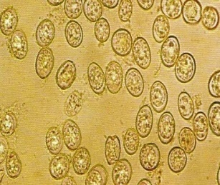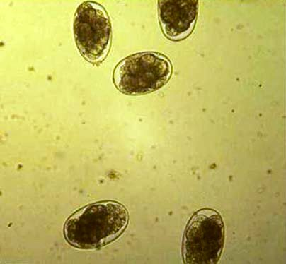
Fig 2: Coccidia Fig 3: Strongyle eggs

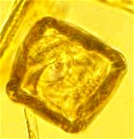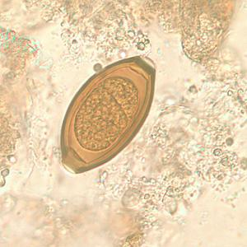
Fig 4: Cestode Fig 5: Trichuris trichuris

Weight gain in goat in two villages after strategic anthelmintic treatment as compare to control villages:

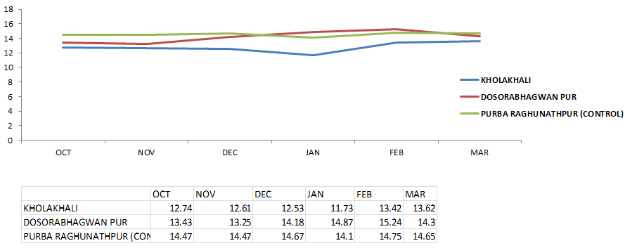
Males and females both had equal rates of GI parasite infection, according to the results of the study on the sex-related prevalence of gastrointestinal parasites (Windsor et al., 2018; Mpofu et al., 2020). This finding can be attributed to the fact that both sexes are maintained under the same management systems. On the other hand, it has been discovered in the past that the occurrence of GI parasites is highly connected with host sex, with females being affected more frequently than males (Islam et al., 2017; Singh et al., 2017). Due to stress and weakened immune systems during pregnancy, parturient paresis, and lactation, women are thought to have greater infection rates than men (Golo et al., 2017).
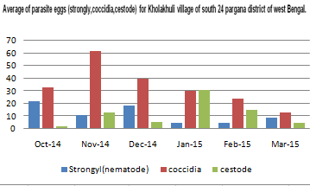
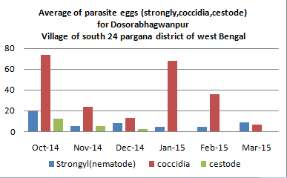

Discussion:
The study of GI parasites in goats is thought to be exciting research because the Kathmandu Valley receives a variety of goats brought in from across the nation raised in various environments, and as a result, the goats may come with a variety of parasites. The goal of the current investigation was to determine how common GI parasites were in those goats. In this study, the prevalence of 87.25% was greater than that of other Indian States (50.51-86.05%), but lower than that of the West area, where Kholakhuli, Dosorabhagwanpur, and Purba Raghunathpur reported prevalences of 90.4%, 95.9%, and 91.5%, respectively. Different deworming and management techniques, seasons, host age and sex, altitude, and climatic conditions could all have an impact on the outcomes (Daniel et al. 2014; Gul and Tak 2016). It's interesting to note that every sample showed concurrent infection with multiple parasites, up to and including septuple infection, indicating a high parasite density in those goats. Mixed infections are important since they ultimately cause host mortality. For instance, the combined infection of Moniezia and Trichuris has been reported to have caused severe malnutrition that resulted in pulmonary edoema after the death of the Black Bengal goat kid (Maity et al. 2018).
According to this study's findings (Agyei et al. 2004, Hassan and Barzinji 2018, Kaur et al. 2019), Eimeria is the most prevalent species of GI tract in which it causes goat coccidiosis, the most frequent enteric disease in goats. This coccidian parasite may result in significant rates of death and a decline in productivity.
A different coccidian parasite, Cryptosporidium sp., now has a prevalence rate (0.5%) that is lower than that of another country. Elmadawy and Diab (2017) state that 20% of imports originate in Pakistan, 14% in China, 4% in Brazil, and 7.1% in Greece (Mi et al. 2014). Although C. xiaoi and a zoonotic species, C. ubiquitum, have been associated with slightly older age groups of goats, adult animals gain immunity, and usually, Cryptosporidium spp. are known to preferentially infect goat juveniles (Utaaker et al. 2017; Robertson et al. 2014). The majority of the samples were taken from mature animals, which may be the reason for the low prevalence. but very few. Based on earlier research (Li et al. 2018, Kamaruddin et al. 2014, Dimasuay and Rivera). P. hominis has been identified in semisolid, solid, and diarrheal feces; however, the latter can produce an anaerobic environment that favors the opportunistic development of this flagellate (Li et al. 2016). Its low prevalence may be caused by the normally solid, dry structure of goat feces samples, which lack an optimal environment for growth and reproduction. According to Elmadawy and Diab (2017), the prevalence rates of Giardia sp. in the United States were lower than those in China (4.8%), Egypt (5%), Brazil (9.0%), and other nations.
Notably, we are the first to explain how common Cyclospora-like oocysts are in feces (1% prevalence). Although prior studies revealed that household animals and birds in Nepal did not harbor Cyclospora-like oocysts (Ghimire et al.2010) and Haiti (Mark et al. 1999), the prevalence rate in our samples was slightly lower than that found in the previous study in Tamil Nadu, India, where the range of prevalence was found to be 0-33.3% (average prevalence 1.85%). Therefore, additional research on this coccidian in goats acting as natural reservoir hosts should be looked at in the absence of epidemiologic proof.
We labeled "strongyle" for the strongyle-type of eggs produced by Haemonchus, Ostertagia, Trichostrongylus, Teladorsagia, Cooperia, Bunostomum, and Oesophostomum because we lacked the requisite larval cultures for nematodes to make a complete diagnosis. In different Indian states, the prevalence varied from 26.9 to 85.1%, which is remarkable (Dixit et al. 2017; Singh et al. 2015; Verma et al. 2018; Dappawar et al. 2018). We found that it was common (59.25%). Because goat populations display a diluting effect of GI diseases across domestic livestock species, the occurrence of these parasites is negatively linked with goat densities (Sun et al. 2018). The fact that strongyle infection was shown to be the reason for 7.4% of goat deaths in Nepal indicates the importance of these worms there (Khakural 2003). According to research by Chikweto et al. (2018), strongyles have been identified in sheep (66%) and goats (89%), and Haemonchus contortus has been associated to 29% mortality. This suggests that strongyles are crucial for the health of livestock. The prevalence of Trichuris sp. was almost 29.75%, exceeding the 3.24–20.8% prevalence recorded in India (Sorathiya et al. 2017, Das et al. 2017, Dappawar et al. 2018, Singh et al. 2015, Shakya et al. 2017). In comparison to reports from India (0.79-11.9%) (Sorathiya et al. 2017; Singh et al. 2015; Dappawar et al. 2018; Dixit et al. 2017) and from Iraq (7.7% in children and 8.9% in adults) (Hassan and Barzinji 2018), the prevalence rate of Strongyloides egg includes larva was 28.75%, which was higher. Despite resembling Trichuris, Capillaria species are vital.
Cestodes like Moniezia were more common in goats (2.0%) than in India (3.0-18.7%), according to Das et al. (2017), Bihaqi et al. (2017), Choubisa and Jaroli (2013), Singh et al. (2015), and Verma et al. (2018). By consuming infected pasture mite larva, it is disseminated. Although this parasite is believed to be non-pathogenic, postmortem reports of 13.95% of goat deaths in Nepal were associated with monieziasis (Khakural 2003), and these cases may reflect the impact of coinfection (Maity et al. 2018). The paper mentions the trematodes Fasciola and Paramphistomum. In comparison to the prevalence rates of Fasciola reported from India (0.32 to 4.06%) (Dixit et al. 2017; Singh et al. 2015; Sorathiya et al. 2017), the prevalence rate of 10.25 percent was greater. Paramphistomum has a lower prevalence rate (0.5%) than that of India (4.9–13.6%) (Godara et al. 2014; Maitra et al. 2014). They have the potential to lead to anaemia, haemorrhage, weight loss, frailty, increased mortality, and decreased production because they are extremely pathogenic (Singh et al. 1984; Godara et al. 2014; Hashemnia et al. 2015). Due to the presence of metacercaria in the lower portions of the straw, fascioliosis is more common in stall-fed buffaloes than grazing populations in Nepal, where these trematodes are spread through consumption of water or food containing metacercarial stages (Joshi and Mahato, 2013).
Conclusion:
Three villages (viz., Kholakhuli, Dosorabhagwanpur, PurbaRaghunathpur) were selected in Sunderban areas of South 24 Parganas district. From each village faecal samples were collected every month from 40 goats for monitoring parasitic infection and weights of every animal were also recorded. Out of three villages, strategic anthelmintic treatments along with mineral mixture supplementation were provided to two villages and one village (PurbaRaghunathpur) was kept as control. After intervention for 6 months, it was found that rate of weight gain in animals in two intervene villages were 0.18 g and 0.14 g as compare to control villages where it was 0.03 g.

Acknowledgement:
I express my sincere thanks to my guide Dr .S .Bndyopadhyay, Station incharge, IVRI, ERS, at the same time I am very greatful to Dr. A. Gamit, M.Vsc. Student of IVRI for their precious supervision & support.

Reference:
- Admasu P., Nurlign L.. Prevalence of gastrointestinal parasites of small ruminants in Kuarit District, North West Ethiopia. African J Basic Appl Sci. 2014;6: 125–130.
- Bhuyan MA (1970). A survey of helminths parasiting the livers of domesticated ruminants in Bangladesh. M. Sc. Vet. Sci. Thesis, Submitted to the Department of Parasitology, BAU, Mymensingh.
- Baoxia Mi (2014).Graphene Oxide Membranes for Ionic and Molecular Sieving. Science,Vol 343,6172.740-742.
- Biswas H., Dey A.R., Begum N., Das P.M.. Epidemiological aspects of gastro-intestinal parasites in buffalo in Bhola, Bangladesh. Indian J Anim Sci. 2014;84:245–250.
- Divya Sharma a, Aarti Singh b, Kanika Verma et al. (2017). Fluoride: A review of pre-clinical and clinical studies.Environmental Toxicology and Pharmacology, 56, 297-313.
- Ghimire, L.P. and Kim, Y. (2018). An Analysis on Barriers to Renewable Energy Development in the Context of Nepal Using AHP. Renewable Energy, 129, 446-456.
- Etter E., Chartier C., Hoste H., Pors I., Bouquet W., Lefrileux Y., Borgida L.P.. The influence of nutrition on the periparturient rise in fecal egg counts in dairy goats: Results from a two-year study. Rev Med Vet (Toulouse). 1999;150:975–980.
- Idika I.K., Chiejina S.N., Mhomga L.I., Nnadi P.A., Ngongeh L.A.. Correlates of resistance to gastrointestinal nematode infection in Nigerian West African dwarf sheep. Asian Pac J Trop Med. 2012;5:529–532. doi: 10.1016/S1995-7645(12)60093-5.
- Karma Bikash O Karja Kram (1998). Department of Livestock Services (DLS). An annual report. Livestock and poultry development activities, June.
- Kadek Diah Arie Purnami, Luh Gede Sri Artini (2016). Pengaruh investment oppourtunity set total asset turn over dan sales growth terhadap kebijakam dividen. E-Jurnal Manajemen Unud, Vol. 5, No. 2, 2016: 1309-1337.
- Karen Scrivener, Fernando Martirena, Shashank Bishnoi, Soumen Maity (2018).Calcined clay limestone cements (LC³). Cement and Concrete Research.Volume 114, December 2018, Pages 49-56.
- Kjersti Selstad Utaaker, Eystein Skjerve, Lucy J. Robertson (2017). Keeping it cool: Survival of Giardia cysts and Cryptosporidium oocysts on lettuce leaves. International Journal of Food Microbiology. Volume 255, Pages 51-57.
- Laurie C. M. et al. (2014). Community Development and Livestock Promotion in Rural Nepal: Effects on Child Growth and Health.International nutrition foundation (INF).35, Issue 3.
- MOAD. (2014). Agriculture Development Strategy. Ministry of Agricultural Development, Government of Nepal, Kathmandu.
- Sagar Maitra, et al. (2020). Evaluation of Gerbera (Gerbera jamesonii L.) Cultivars for Growth, Yield and Flower Quality under Protected Cultivation. Indian Journal of Natural Sciences.10 ,Issue 60.
- Soulsby E.J.L. Helminths, arthropods and protozoa of domesticated animals. 7th edition. Bailliere Tindall, East Sussex, UK: 1982. p. 809.
- Tirth Raj Ghimire, Namita Bhattarai.(2019). A survey of gastrointestinal parasites of goats in a goat market in Kathmandu, Nepal. Journal of parasitic disease. 2019 Dec; 43(4): 686–695.
- Tirth Raj Ghimire (2018). Investigating the contribution of parasites in the domestic animals researched at the Nepal Academy of Science and Technology (NAST). International journal of infectious diseases: IJID: official publication of the International Society for Infectious Diseases
- Tirth Raj Ghimire, Namita Bhattarai (2019). A survey of gastrointestinal parasites of goats in a goat market in Kathmandu, Nepal. Journal of Parasitic Diseases volume 43, pages686–695.
- Tirth Raj Ghimire1, Namita Bhattar, (2019). A survey of gastrointestinal parasites of goats in a goat market in Kathmandu, Nepal. J Parasit Dis. 43(4):686–695.
- Thu T. M. Pham, Ya-Li Huang, et al. (2021). Plasma 25(OH)D Concentrations and Gestational Diabetes Mellitus among Pregnant Women in Taiwan. Nutrients.13(8): 2538.

