CONTENTS

- ABSTRACT
- INTRODUCTION
- HISTORY OF DRUG DISCOVERY
- TARGET IDENTIFICATION
- HIT GENERATION
- LEAD OPTIMIZATION
- DRUG DEVEOPMENT
- PRECLINICAL RESEARCH
- INVESTIGATIONAL NEW DRUG APPLICATION
- CLINICAL TRIALS
- NEW DRUG APPLICATION APPROVAL
- REGULATORY APPROVAL
- POST MARKETING SURVELLIANCE
- CONCLUSION
- REFERENCES

Aaliya Naaz¹*, Shweta Verma²

¹ Six Sigma Institute of Technology and Science, Rudrapur, US Nagar, (UK) 263153

² Faculty of Pharmacy, IFTM University, Lodhipur, Moradabad (UP) 244001

*Corresponding author- Aaliya Naaz

(aaliyanaaz801@gmail.com, +91-9557643650)

ABSTRACT
Drug discovery and development is a complex and iterative process aimed at identifying, designing, and bringing new drugs to the market for the treatment of diseases. It involves a series of stages, starting from target identification and validation, hit generation, lead optimization, and preclinical research, followed by clinical trials, regulatory approval, and post-marketing surveillance.
The process begins with the identification of potential disease targets, such as specific proteins or receptors involved in the disease process. Through various techniques, researchers explore these targets and validate their role in disease pathology. Once a target is identified, the search for suitable drug candidates begins. Hit generation involves the screening of large libraries of compounds, natural products, or synthetic molecules to identify those that interact with the target and exhibit desirable biological activity. Hits that show promise are further refined and optimized during the lead optimization phase to enhance their potency, selectivity, and pharmacokinetic properties.
Preclinical research involves extensive testing of the lead compounds in laboratory settings and animal models to evaluate their safety, efficacy, pharmacokinetics, and toxicology. This stage helps researchers assess the potential risks and benefits of the drug candidate and determine the appropriate dosage and formulation for subsequent clinical trials.
Clinical trials are conducted in three phases (I, II, and III) to evaluate the safety, efficacy, and optimal dosage of the drug candidate in human subjects. These trials involve rigorous protocols, patient recruitment, data collection, and statistical analysis to establish the drug's safety and effectiveness.

Once the clinical trials are successfully completed, an application for regulatory approval, such as the New Drug Application (NDA), is submitted to the appropriate regulatory authority. The regulatory authorities thoroughly review the application, including the data from preclinical and clinical studies, manufacturing processes, and proposed labeling, to assess the drug's safety, efficacy, and quality.
If approved, the drug can be marketed and made available to patients. Post-marketing surveillance or pharmacovigilance is conducted to monitor the drug's safety and detect any adverse effects that may have been missed during the clinical trials. Ongoing safety monitoring, regulatory inspections, and labeling updates ensure the drug's continued safety and appropriate use.
Drug discovery and development is a time-consuming, resource-intensive, and highly regulated process that requires collaboration among scientists, researchers, clinicians, and regulatory authorities. It combines scientific innovation, rigorous testing, and regulatory scrutiny to deliver safe and effective therapies for the prevention, treatment, and management of diseases.

INTRODUCTION

Drug discovery is the initial phase of the drug development process, which involves the identification of potential drug candidates. Scientists and researchers employ several approaches to discover new drugs, including:
- Target Identification: This step involves identifying specific molecular targets, such as proteins or enzymes, that play a crucial role in disease progression. Understanding these targets helps researchers develop drugs that can interact with and modulate their activity.

- Hit Generation: In this stage, researchers screen large libraries of chemical compounds, natural products, or utilize computational methods to identify molecules that have the potential to interact with the identified target. These molecules are known as "hits" and serve as starting points for further development.

- Lead Optimization: After identifying hits, scientists work to optimize their chemical structures to enhance their potency, selectivity, and safety profile. This process involves modifying the molecules through medicinal chemistry techniques to improve their pharmacological properties.
Once promising drug candidates have been identified and optimized, they move into the drug development phase. Drug development encompasses a series of rigorous steps designed to evaluate the safety and efficacy of the drug candidate. These steps typically include:
- Preclinical Testing: In this stage, the drug candidate undergoes extensive laboratory testing using in vitro (cell-based) and in vivo (animal) models. These studies assess the drug's pharmacokinetics (absorption, distribution, metabolism, and excretion), toxicity, and effectiveness in disease models.

- Investigational New Drug (IND) Application: If the preclinical studies yield positive results, an IND application is submitted to regulatory authorities, such as the U.S. Food and Drug Administration (FDA). The IND application provides detailed information about the drug candidate, including preclinical data, manufacturing procedures, and proposed clinical trial plans.
- Clinical Trials: Clinical trials are conducted in human volunteers or patients to assess the safety, dosage, and efficacy of the drug candidate. They are typically conducted in three phases: Phase I (small-scale studies to evaluate safety and dosage), Phase II (larger-scale studies to assess effectiveness and side effects), and Phase III (large-scale studies to confirm safety and efficacy).
- New Drug Application (NDA): If the results of the clinical trials are positive, a New Drug Application is submitted to regulatory authorities. The NDA contains comprehensive data from preclinical and clinical studies, along with information on manufacturing, labeling, and proposed usage.
- Regulatory Review and Approval: Regulatory authorities review the NDA to evaluate the drug's safety, efficacy, and manufacturing quality. If the authorities are satisfied with the data, they grant approval for the drug to be marketed and made available to patients.
- Post-Marketing Surveillance: Once a drug is approved and on the market, post- marketing surveillance is conducted to monitor its long-term safety and efficacy. Adverse effects or interactions with other drugs may be discovered during this phase, leading to modifications in usage guidelines or even withdrawal from the market.

HISTORY OF DRUG DISCOVEY
The history of drug discovery dates back thousands of years when ancient civilizations began exploring natural substances for medicinal purposes. Here is a brief overview of the major milestones in the history of drug discovery:
- Ancient Times: The earliest recorded instances of drug discovery can be traced to ancient civilizations such as the Sumerians, Egyptians, and Chinese. They used plant- based remedies and substances like opium, cannabis, and various herbs for treating ailments.
- Classical Era: Greek and Roman physicians like Hippocrates and Galen made significant contributions to medicine and pharmacology. They emphasized observation, experimentation, and the use of natural substances to treat diseases.
- Middle Ages: During this period, Islamic scholars in the Middle East, such as Avicenna (Ibn Sina), built upon the knowledge of Greek and Roman physicians. They compiled extensive pharmacopeias and conducted experiments on drugs derived from plants and minerals.
- Renaissance and Enlightenment: The Renaissance period saw a resurgence of interest in natural sciences, including pharmacology. Influential figures like Paracelsus promoted the use of chemicals and minerals in medicine, challenging the reliance on herbal remedies.
- 19th Century: The isolation and identification of active compounds from plants became more systematic during this period. For example, morphine was isolated from opium, and quinine was extracted from cinchona bark for the treatment of malaria. The development of organic chemistry facilitated the synthesis of new compounds.
- Early 20th Century: The establishment of the pharmaceutical industry and advancements in scientific techniques greatly influenced drug discovery. Key breakthroughs included the discovery of insulin for diabetes treatment, vaccines for diseases like diphtheria and tetanus, and the first antibiotics like penicillin.

- Modern Era: The latter half of the 20th century witnessed significant advancements in drug discovery. The emergence of molecular biology, genomics, and high-throughput screening technologies revolutionized the process. Scientists gained a better
understanding of diseases at the molecular level, leading to the development of targeted therapies and biologics.
- Recent Advances: In recent years, drug discovery has been accelerated by computational approaches, machine learning, and artificial intelligence. These technologies help analyze vast amounts of biological and chemical data, predict drug- target interactions, and design novel compounds.
It is important to note that the history of drug discovery is an ongoing process, with continuous research and innovation aiming to improve treatment options and address unmet medical needs. Collaboration between academia, pharmaceutical companies, and regulatory agencies plays a vital role in advancing drug discovery and bringing new medications to the market.
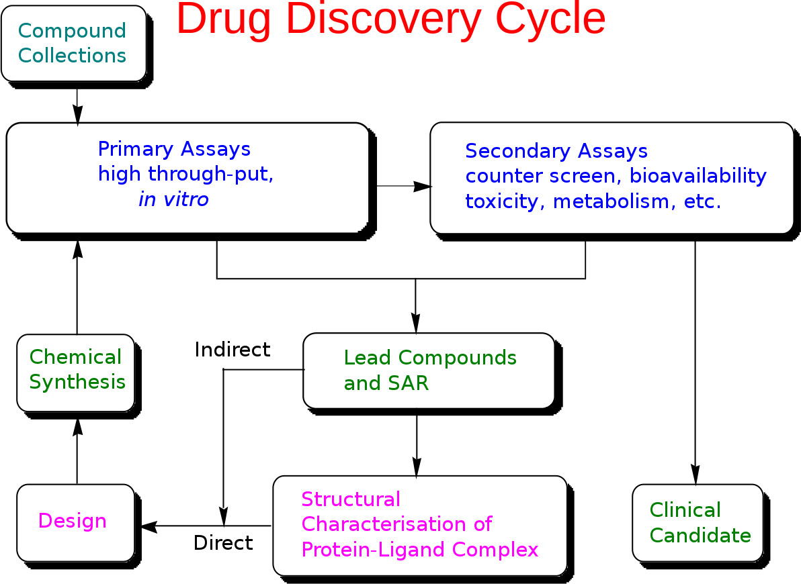

TARGET IDENTIFICATION
Target identification is a crucial step in the drug discovery process, aiming to identify specific molecular targets that play a key role in disease development and progression. It involves the identification of proteins, enzymes, receptors, or other biomolecules that can be modulated by drugs to achieve therapeutic effects. Target identification forms the foundation for subsequent steps in drug discovery, such as hit generation, lead optimization, and clinical development. Here is a detailed exploration of target identification in drug discovery:
Importance of Target Identification:

- Understanding Disease Mechanisms: Identifying the molecular targets associated with a disease helps researchers gain a deeper understanding of the underlying biological mechanisms involved. This knowledge enables the development of targeted therapies that can intervene at specific points in the disease pathway.

- Selectivity and Efficacy: By focusing on specific molecular targets, researchers can develop drugs that exhibit selectivity, meaning they act specifically on the desired target without significantly affecting unrelated molecules. This selectivity enhances drug efficacy while minimizing side effects.

- Personalized Medicine: Target identification plays a crucial role in the emerging field of personalized medicine. By identifying individual genetic or molecular targets that contribute to a disease, tailored therapies can be developed to address specific patient populations or subtypes of a disease.

Approaches to Target Identification:

- Genetic Approaches: Advances in genomics and genetics have provided powerful tools for target identification. Techniques such as genome-wide association studies (GWAS), gene expression profiling, and functional genomics help identify genetic variations or dysregulated genes associated with specific diseases.

- Proteomics and Metabolomics: Proteomic and metabolomic approaches aim to identify disease-associated proteins or metabolites that can serve as potential drug targets. Mass spectrometry, protein microarrays, and other techniques enable the characterization and quantification of proteins or metabolites in disease states.

- Target Deconvolution: In cases where a drug's mechanism of action is not fully understood, target deconvolution approaches can help identify the specific target(s) with which the drug interacts. Techniques like affinity-based proteomics, chemical proteomics, and activity-based protein profiling assist in determining the target proteins of a drug.

- Computational Methods: Computational approaches play an increasingly significant role in target identification. Bioinformatics tools, molecular modeling, and virtual screening methods aid in the identification and prediction of potential targets based on their structure, interaction networks, or similarities to known targets.

- Phenotypic Screening: Phenotypic screening involves the screening of compounds or libraries of molecules in disease models or cellular systems to identify compounds that demonstrate a desired therapeutic effect. Subsequent target identification techniques, such as genetic perturbation or proteomic profiling, can help uncover the underlying molecular targets of these compounds.

Challenges and Limitations:

- Complexity of Diseases: Many diseases have complex and multifactorial causes, involving interactions between multiple genes, proteins, and pathways. Identifying a single target that can effectively modulate the disease process may be challenging.

- Target Validation: It is crucial to validate the identified targets to ensure their relevance and suitability for drug development. This involves confirming their role in the disease, understanding their function, and establishing their druggability.

- Off-Target Effects: Some drugs may interact with unintended targets, leading to off- target effects or adverse reactions. Comprehensive target identification strategies can help minimize the risk of off-target interactions.

- Lack of Structural Information: In some cases, target identification is hindered by a lack of structural information about the target protein or limited knowledge of its function. This can make it challenging to design drugs that specifically interact with the target.

In conclusion, target identification is a critical and complex process in drug discovery. Advances in genetics, proteomics, metabolomics, and computational methods have significantly expanded our ability to identify and characterize potential drug targets. A thorough understanding of disease

HIT GENERATION

Hit generation is a pivotal stage in the drug discovery process that involves identifying and selecting chemical compounds or molecules with the potential to interact with a specific molecular target of interest. Hits serve as starting points for further optimization and development into potential drug candidates. This stage requires a combination of scientific expertise, innovative screening methods, and a vast array of chemical libraries. Here is a detailed exploration of hit generation in drug discovery:
- Purpose of Hit Generation:

- Identifying Compounds: The primary objective of hit generation is to identify chemical compounds or molecules that interact with the target of interest. These compounds are referred to as "hits" because they show a positive response or activity against the target.
- Establishing Proof of Concept: Hit generation provides initial evidence that targeting a specific molecular target may be a viable approach for developing a therapeutic intervention. Hits help validate the feasibility of modulating the target to achieve a desired therapeutic effect.

- Generating Chemical Diversity: Hit generation involves screening large chemical libraries to explore diverse chemical structures. This diversity allows researchers to identify hits with a range of properties, including potency, selectivity, and pharmacokinetic profiles, which can be further optimized during lead optimization.
- Approaches to Hit Generation:

- High-Throughput Screening (HTS): HTS involves testing a large number of compounds in a systematic and automated manner. Screening assays are designed to measure the interaction of the compounds with the target of interest. HTS allows for rapid screening of thousands to millions of compounds, enabling the identification of hits with desired properties.

- Virtual Screening: Virtual screening involves the computational screening of databases of chemical compounds or molecular libraries using computational models and algorithms. This approach uses molecular docking, ligand-based methods, or structure-based methods to predict the potential interactions between compounds and the target of interest. Virtual screening helps prioritize compounds for experimental validation and reduces the time and cost associated with experimental screening.
- Fragment-Based Screening: Fragment-based screening involves the screening of small, low molecular weight compounds or fragments. Fragments are selected based on their chemical diversity and potential to bind to the target. The hits obtained from fragment-based screening can be further optimized through fragment growing or merging strategies to develop more potent lead compounds.
- Natural Product Screening: Natural products, derived from plants, microorganisms, or marine sources, have historically been a rich source of hits and lead compounds.
Natural product screening involves the identification and isolation of bioactive compounds from these sources and subsequent evaluation against the target of interest.
- Hit Validation:

- Confirmatory Assays: Hits obtained from screening assays are subject to additional validation to confirm their activity and specificity. This may involve performing secondary assays to assess the hit's ability to modulate the target and exclude false positives.
- SAR (Structure-Activity Relationship) Analysis: Hits that demonstrate promising activity are subjected to SAR analysis, which involves synthesizing analogs or derivatives of the hit compound with subtle structural modifications. The SAR analysis helps identify key chemical features responsible for the activity and guides further optimization efforts.

- Selectivity Profiling: It is essential to evaluate the selectivity of hits by testing their activity against related targets to ensure they interact selectively with the intended

target. This reduces the risk of unwanted off-target effects in subsequent stages of drug development.
- Physicochemical and ADME (Absorption, Distribution, Metabolism, and Excretion) Assessment: Hits are assessed for their physicochemical properties and ADME characteristics, which influence their pharmacokinetic and toxicological profiles. This assessment helps identify hits with favorable drug-like properties for further development.

Hit generation is a critical phase in drug discovery, bridging the gap between target identification and lead optimization.
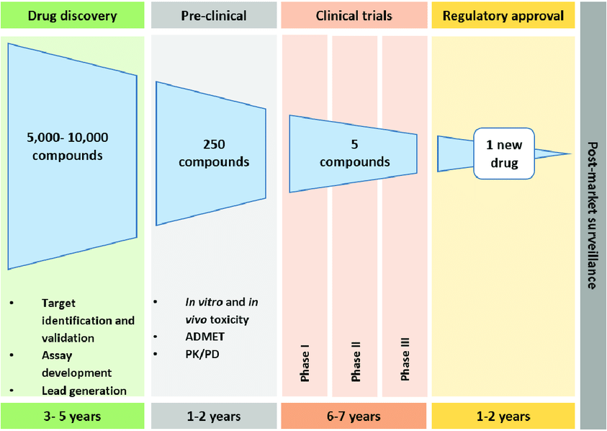

LEAD OPTIMIZATION

Lead optimization is a vital stage in the drug discovery process that focuses on improving the properties of identified hits or lead compounds to enhance their therapeutic potential, selectivity, efficacy, safety, and pharmacokinetic profile. This stage involves iterative cycles of chemical modification, testing, and optimization to transform hits into more advanced drug candidates. The primary goal of lead optimization is to develop compounds with improved potency, selectivity, and drug- like properties that can progress into preclinical and clinical development. Here is a detailed exploration of lead optimization in drug discovery:
- Structure-Activity Relationship (SAR) Analysis:

- SAR analysis involves studying the relationship between the chemical structure of a lead compound and its biological activity. It aims to identify key structural features responsible for the compound's potency and selectivity against the target.
- By systematically modifying the lead compound's chemical structure, such as substituting functional groups, altering stereochemistry, or changing scaffold moieties, researchers can optimize the compound's activity and properties.
- Optimization of Pharmacokinetic Properties:

- Lead optimization focuses on enhancing the pharmacokinetic properties of a compound, which determine its absorption, distribution, metabolism, and excretion (ADME) characteristics.
- Modifications to improve a compound's pharmacokinetic profile may include optimizing its solubility, lipophilicity, stability, metabolic resistance, and reducing the potential for drug-drug interactions.
- Selectivity and Safety Optimization:

- Lead compounds often interact with multiple targets in the body, leading to potential off-target effects or adverse reactions. Optimization efforts aim to improve selectivity by minimizing interactions with unintended targets.

- Selectivity profiling assays are conducted to evaluate the compound's activity against a panel of related targets or off-targets, helping researchers assess its selectivity and safety profile.
- Toxicity Assessment:
- Lead optimization involves evaluating the toxicity of compounds to identify and mitigate potential safety concerns. This includes assessing cytotoxicity, genotoxicity, cardiotoxicity, hepatotoxicity, and other adverse effects.
- Structure-activity relationship data, as well as in vitro and in vivo toxicological studies, guide the optimization process to ensure that compounds have an acceptable safety profile.

- Drug Metabolism and Pharmacokinetics (DMPK) Optimization:
- DMPK studies focus on understanding the compound's metabolic fate, bioavailability, distribution, elimination, and pharmacokinetic properties. This information guides optimization efforts to improve the compound's overall drug-like properties.
- Strategies for DMPK optimization may include prodrug design, modification of functional groups to enhance metabolic stability, and fine-tuning physicochemical properties to improve oral bioavailability or tissue distribution.

- Intellectual Property Considerations:

- During lead optimization, it is essential to consider intellectual property (IP) protection. Structure modifications should be carefully evaluated to ensure that the resulting compounds are distinct and have novel chemical structures eligible for patent protection.

- Iterative Process:

- Lead optimization is an iterative process, involving the synthesis of modified compounds based on SAR analysis, followed by biological testing and evaluation of their properties.
- Iterative cycles of optimization and testing continue until a compound with satisfactory potency, selectivity, safety, and pharmacokinetic profile is achieved.

- Preclinical Evaluation:

- Once an optimized lead compound is obtained, it undergoes preclinical evaluation, including in vitro studies and animal testing, to assess its efficacy, safety, and pharmacological profile before progressing to clinical trials.

Lead optimization is a complex and resource-intensive stage, aiming to identify a lead compound with optimal drug-like properties for further development.
It requires expertise in medicinal chemistry, computational chemistry, pharmacology, toxicology, and ADME sciences.
Successful lead optimization sets the stage for preclinical development and eventual clinical trials, representing a crucial step in the journey of bringing a potential drug candidate to market.

DRUG DEVELOPMENT

Drug development is a comprehensive and regulated process that transforms a promising compound or lead candidate into a safe, effective, and marketable medication. It encompasses a series of stages, including preclinical research, clinical trials, regulatory approval, and post-marketing surveillance. Here is a detailed exploration of the various steps involved in drug development:

- Preclinical Research:

- Preclinical research involves extensive laboratory testing and animal studies to assess the compound's safety, efficacy, pharmacokinetics, and toxicology. This stage aims to gather essential data on the compound's mechanisms of action, potential side effects, and dosage range.
- Preclinical studies also contribute to the formulation development, identifying appropriate dosage forms and optimizing the compound's delivery system.
- Investigational New Drug (IND) Application:
- Once preclinical studies are completed, an Investigational New Drug (IND) application is submitted to the regulatory authorities, such as the U.S. Food and Drug Administration (FDA). The IND contains data on preclinical studies, the compound's chemistry, manufacturing, and control, as well as proposed plans for clinical trials.
- The regulatory authorities review the IND application to ensure the compound's safety and ethical considerations before approving the initiation of clinical trials.
- Clinical Trials:
- Clinical trials involve the evaluation of the compound's safety, efficacy, and dosage in human subjects under controlled conditions. These trials are typically conducted in three phases:
  - Phase 1: Small-scale studies with healthy volunteers to assess safety, dosage, and potential side effects.

  - Phase 2: Larger-scale studies involving patients with the targeted disease or condition to evaluate efficacy and further assess safety.
  - Phase 3: Large-scale studies conducted on a larger patient population to confirm efficacy, monitor side effects, and compare the compound to existing treatments or a placebo.
- Clinical trials follow strict protocols, involve informed consent from participants, and are monitored by ethical review boards and regulatory authorities to ensure patient safety and scientific integrity.
- New Drug Application (NDA) Submission:
- Upon successful completion of clinical trials, the drug developer submits a New Drug Application (NDA) to the regulatory authorities. The NDA includes comprehensive data on the compound's safety, efficacy, pharmacokinetics, manufacturing processes, labeling, and proposed use.
- Regulatory authorities review the NDA to assess the drug's risk-benefit profile and determine whether to grant approval for marketing and commercialization.
- Regulatory Approval:
- Regulatory authorities, such as the FDA in the United States or the European Medicines Agency (EMA) in Europe, evaluate the NDA and conduct a thorough review of the submitted data. This evaluation assesses the drug's safety, efficacy, quality, and labeling information.
- If the regulatory authorities deem the drug to be safe and effective, they grant regulatory approval, allowing the drug developer to market and distribute the medication.
- Post-Marketing Surveillance:
- Once a drug is approved and available on the market, post-marketing surveillance begins. This phase involves ongoing monitoring of the drug's safety and effectiveness in larger patient populations and real-world settings.
- Adverse events, unexpected side effects, or long-term effects that were not evident during clinical trials may be identified during post-marketing surveillance.

This information helps ensure the drug's continued safety and enables updates to the drug's labeling or prescribing information if necessary.

- Lifecycle Management:

- After a drug is launched, ongoing research and development efforts continue to optimize its use and explore potential new indications or formulations.

This includes conducting post-approval clinical trials, developing pediatric formulations, exploring combination therapies, or pursuing new applications for the drug.

Drug development is a complex and time-consuming process that typically spans several years and involves collaboration between pharmaceutical companies, researchers, clinicians, regulatory authorities, and patients.

It requires adherence to strict regulations, ethical considerations, and continuous assessment of safety and efficacy to bring safe and effective medications to those in need.

PRECLINICAL RESEARCH

Preclinical research is a vital stage in the drug development process that takes place before clinical trials and involves extensive laboratory testing and animal studies. It aims to gather essential data on the safety, efficacy, pharmacokinetics, and toxicology of a potential drug candidate. Preclinical research provides critical insights into the compound's mechanism of action, dosage range, potential side effects, and formulation development. Here is a detailed exploration of preclinical research:

- In vitro Studies:

- Preclinical research begins with in vitro studies, which are conducted using cells or tissues in a controlled laboratory setting. In vitro studies help researchers understand the compound's interaction with the target of interest and its biological effects.
- These studies involve evaluating the compound's potency, selectivity, and mechanism of action. They also provide preliminary information on the compound's pharmacokinetic properties, such as its absorption, distribution, metabolism, and excretion (ADME).
- Animal Studies:

- Animal studies play a crucial role in preclinical research to assess the compound's safety and efficacy in living organisms. These studies are conducted using a variety of animal models, such as rodents, rabbits, dogs, or non-human primates.
- Safety Assessment: Animal studies evaluate the compound's acute toxicity, subchronic toxicity, and chronic toxicity. These studies help determine the maximum tolerated dose (MTD) and identify potential adverse effects.
- Efficacy Assessment: Animal models that mimic the disease or condition of interest are used to evaluate the compound's efficacy. These studies assess the compound's ability to treat or ameliorate the targeted disease or condition.
- Pharmacokinetic Studies: Animal studies provide valuable information on the compound's pharmacokinetics, including its absorption, distribution, metabolism, and

excretion. These studies help determine the compound's bioavailability, half-life, and tissue distribution.
- Pharmacodynamics and Toxicology Studies:
- Pharmacodynamics studies investigate how the compound interacts with the target of interest and modulates the biological processes involved in the disease. These studies assess the compound's efficacy, dose-response relationship, and potential side effects.
- Toxicology studies evaluate the compound's potential adverse effects on various organ systems. These studies assess organ toxicity, genotoxicity, reproductive toxicity, carcinogenicity, and other potential safety concerns.
- The data obtained from pharmacodynamics and toxicology studies guide the determination of safe starting doses and the design of subsequent clinical trials.

- Formulation Development:

- Preclinical research also includes formulation development to optimize the compound's delivery system. Formulation scientists work to develop suitable dosage forms, such as tablets, capsules, injections, or topical formulations, that ensure the compound's stability, bioavailability, and controlled release.
- Formulation development aims to optimize the compound's physical and chemical properties to enhance its efficacy, improve patient compliance, and facilitate administration.
- Regulatory Considerations:

- Preclinical research is conducted in accordance with regulatory guidelines and requirements. The data generated during preclinical studies are documented in comprehensive reports, which form the basis for an Investigational New Drug (IND) application submitted to regulatory authorities.

- Regulatory authorities review the preclinical data to assess the compound's safety and potential for human testing. This evaluation ensures that ethical considerations are met, and adequate measures are in place to protect the well-being of human subjects during clinical trials.

- Ethical Considerations:

- Preclinical research adheres to ethical guidelines to ensure the humane treatment of animals involved in studies. Researchers follow animal welfare regulations and ethical review processes to minimize pain and suffering and optimize animal care and handling.
- Data Analysis and Decision-Making:

- The data generated from preclinical research are thoroughly analyzed to assess the compound's safety, efficacy, and pharmacokinetic profile
. This analysis helps determine the compound's potential for further development and guides decision-making for advancing the candidate to clinical trials.
Preclinical research provides crucial insights into the compound's safety and efficacy, guiding the decision-making process for proceeding to clinical trials. It serves as the foundation for ensuring the ethical and scientific integrity of drug development and helps identify the most promising candidates for further evaluation.
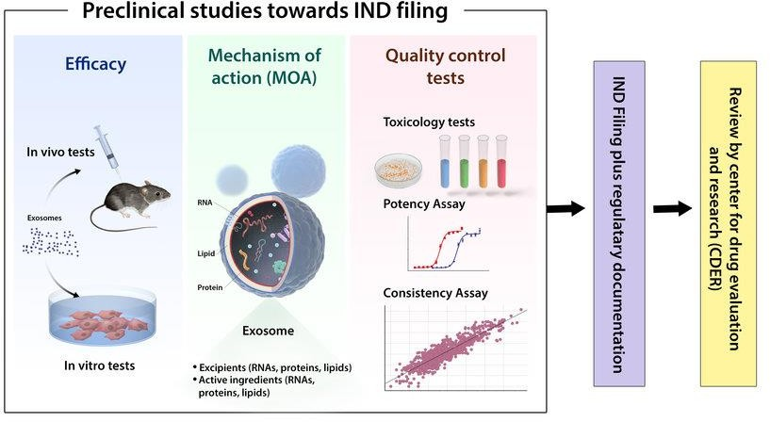

INVESTIGATIONAL NEW DRUG APPLICATION

The Investigational New Drug (IND) application is a crucial regulatory document submitted to the appropriate regulatory authorities, such as the U.S. Food and Drug Administration (FDA) in the United States or the European Medicines Agency (EMA) in Europe, to seek permission to conduct clinical trials with an investigational drug. The IND application provides comprehensive information about the drug candidate, including preclinical data, manufacturing details, and proposed plans for clinical studies. Here is a detailed exploration of the components and importance of the IND application:
- Components of an IND Application:

- Cover Letter: The IND application begins with a cover letter that provides an overview of the submission, including the purpose of the application, a brief description of the drug candidate, and a request for permission to initiate clinical trials.
- Table of Contents: A detailed table of contents helps organize the information within the IND application for easy reference.
- Investigator's Brochure (IB):
- The IB is a comprehensive document that provides essential information about the drug candidate to the investigators involved in the clinical trials. It includes data from preclinical studies, such as pharmacology, toxicology, pharmacokinetics, and potential side effects.
- The IB also contains information about the drug's formulation, stability, manufacturing process, and any known interactions with other medications.
- Chemistry, Manufacturing, and Control (CMC) Information:

- The CMC section of the IND application focuses on the drug candidate's manufacturing details, quality control procedures, and stability data. It provides information about the drug's composition, formulation, manufacturing process, and packaging.
- This section also outlines the measures taken to ensure the consistency, purity, and quality of the drug candidate throughout its development and future production.

- Preclinical Data:
- The IND application includes a comprehensive summary of the preclinical research conducted on the drug candidate. This section provides detailed information on the compound's pharmacology, toxicology, ADME (absorption, distribution, metabolism, excretion) data, and any potential adverse effects observed in animal studies.
- The preclinical data aims to demonstrate the compound's safety, efficacy, and rationale for further evaluation in human subjects.
- Clinical Study Protocol:
- The IND application outlines the proposed plans for clinical studies, including the study design, patient population, dosing regimen, endpoints, and safety monitoring procedures. This section also includes details on the ethical considerations, informed consent process, and measures to protect the rights and well-being of study participants.
- Investigational Plan:

- The investigational plan describes the overall development strategy for the drug candidate. It includes information on the proposed clinical phases, the intended use of the drug, potential indications, and the rationale for pursuing specific therapeutic areas.
- The investigational plan also outlines the projected timeline, anticipated number of patients, and the resources required for the clinical development of the drug candidate.
- Safety Data:

- The IND application includes a summary of the safety data obtained from preclinical studies, including any observed adverse effects or toxicities. It also provides information on the compound's potential risks and the strategies in place to monitor and manage those risks during clinical trials.
- Regulatory Overview:

- The regulatory overview section provides a summary of the regulatory status of the drug candidate in other countries, if applicable. It also highlights any previously

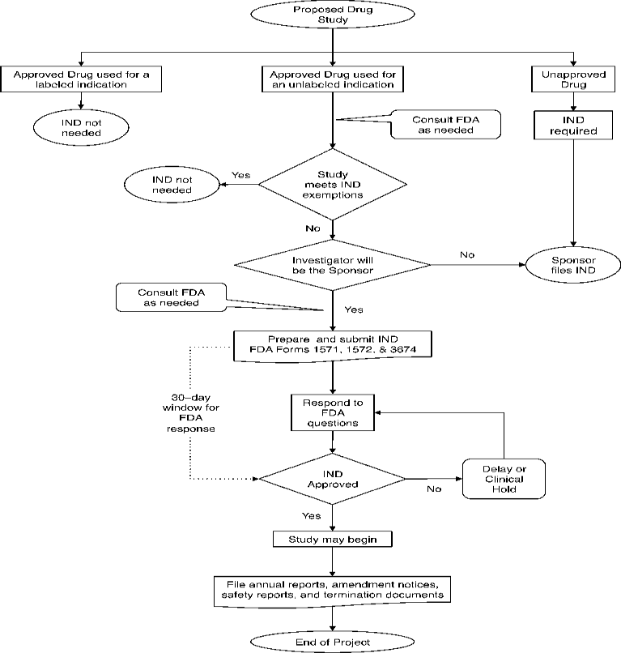
granted regulatory approvals, orphan drug designations, or special status the compound may have received.
- IND Application Forms and Administrative Documents:
- The IND application includes various forms and administrative documents required by the regulatory authorities. These may include the completed application form, financial disclosure forms, investigator information, and details of the research site(s) where the clinical trials will be conducted.
The IND application serves as a comprehensive package of information that
demonstrates the scientific and medical rationale for conducting clinical trials with the investigational drug. It provides the regulatory authorities with crucial data to assess the drug candidate's safety, potential efficacy, and the ethical considerations involved in conducting human trials.
Upon successful review and acceptance of the IND application by the regulatory authorities, the drug developer receives permission to initiate clinical trials. The IND application is an essential step in the drug development process, as it marks the transition from preclinical research to clinical evaluation, allowing researchers to gather further evidence on the drug candidate's safety and efficacy in human subjects.

CLINICAL TRIAL
Clinical trials are rigorous and systematic studies conducted in human subjects to assess the safety, efficacy, tolerability, and pharmacokinetics of investigational drugs or medical interventions. They play a vital role in the drug development process, providing essential data to determine the effectiveness and safety profiles of new treatments. Clinical trials follow a well-defined protocol and are typically conducted in multiple phases. Here is a detailed exploration of the phases and key aspects of clinical trials:

- Phase 1: Safety and Dosage

- Phase 1 trials are the first step in testing an investigational drug in humans. These trials involve a small number of healthy volunteers or individuals with the targeted disease or condition.
- The primary objective of Phase 1 trials is to evaluate the drug's safety profile, dosage range, and pharmacokinetics (how the drug is absorbed, distributed, metabolized, and excreted in the body).
- Phase 1 trials also aim to identify potential side effects, determine the drug's tolerability, and establish the initial recommended dose for further studies.

- Phase 2: Efficacy and Side Effects

- Phase 2 trials involve a larger group of patients with the targeted disease or condition. These trials assess the drug's efficacy in treating the specific indication or condition.
- The primary goal of Phase 2 trials is to gather preliminary evidence of the drug's effectiveness, assess the optimal dosage, and further evaluate its safety profile.
- Phase 2 trials also provide insights into the drug's mode of action, potential side effects, and any specific patient populations that may benefit most from the treatment.

- Phase 3: Confirmatory Studies
- Phase 3 trials are large-scale studies involving a significant number of patients. These trials are designed to confirm the drug's efficacy, monitor its side effects, and compare it to existing standard treatments or a placebo.
- The main objective of Phase 3 trials is to provide robust evidence of the drug's safety and effectiveness, establish the overall risk-benefit ratio, and gather additional information on its optimal use.
- Phase 3 trials also assess the long-term effects of the drug and further explore its safety and efficacy in diverse patient populations.

- Expanded Access or Compassionate Use:
- In certain cases, expanded access or compassionate use programs may be available for patients who do not meet the eligibility criteria for clinical trials but have a critical or life-threatening condition.
- Expanded access programs provide access to investigational drugs outside of the clinical trial setting, allowing patients to receive the treatment under specific circumstances and with regulatory oversight.

- Randomization and Blinding:

- Randomization is a key feature of clinical trials. It involves assigning participants randomly to different treatment groups, such as the investigational drug group or a control group (placebo or standard treatment).
- Blinding (single-blind or double-blind) refers to the concealment of treatment allocation from participants, investigators, or both. Blinding helps minimize bias and ensures the objectivity of the trial's results.

- Informed Consent:
- Informed consent is an essential ethical requirement in clinical trials. Participants must provide voluntary, informed consent after receiving detailed information about the trial's purpose, procedures, potential risks, benefits, and alternatives.
- Informed consent ensures that participants understand their rights, the potential benefits and risks of participation, and the freedom to withdraw from the trial at any time without negative consequences.

- Data Collection and Analysis:

- Clinical trials collect comprehensive data on participants, including their medical history, treatment responses, adverse events, and other relevant parameters specified in the study protocol.
- The collected data undergoes rigorous analysis using statistical methods to assess the drug's efficacy, safety, and overall benefit to the study population.
-

Data analysis involves comparing treatment groups, examining outcomes, evaluating statistical significance, and generating evidence-based conclusions.

- Regulatory Oversight and Monitoring:
- Clinical trials are subject to strict regulatory oversight by governmental authorities, such as the FDA in the United States or the EMA in Europe. These regulatory bodies review the trial protocols, informed consent forms, and other relevant documentation to ensure participant safety and ethical conduct.
- Independent ethics committees or institutional review boards (IRBs) also provide oversight to protect the rights and welfare of trial participants.

- Clinical trials are monitored by qualified professionals, known as clinical research associates (CRAs), who ensure adherence to the protocol, data integrity, and participant safety throughout the trial.

- Reporting and Publication:

- The results of clinical trials are documented in detailed reports, including the study design, methodology, outcomes, and analysis. These reports are submitted to regulatory authorities for review and consideration in the drug approval process.
- Positive or significant trial results are typically published in scientific journals, contributing to the medical and scientific knowledge base. Publication allows other researchers and healthcare professionals to evaluate the findings and incorporate them into clinical practice.
Clinical trials are critical in advancing medical knowledge, evaluating new treatments, and improving patient care. They involve a rigorous scientific process and adherence to ethical guidelines to ensure participant safety, data integrity, and reliable conclusions. The information obtained from clinical trials forms the basis for regulatory decisions regarding drug approval and subsequent patient access to new treatments.
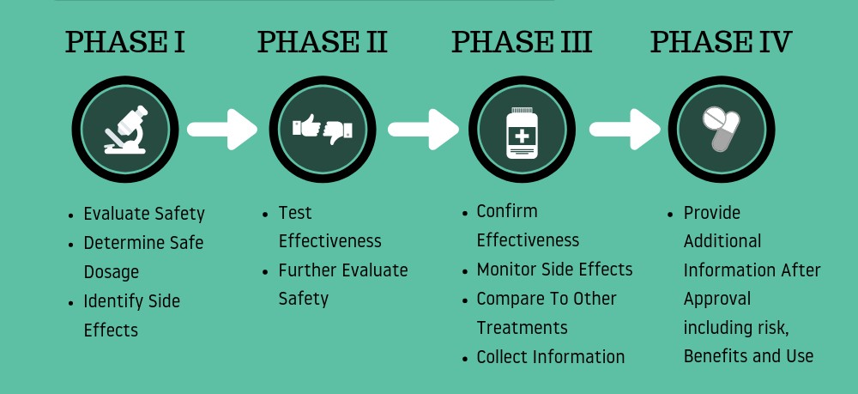

NEW DRUG APPLICATION APPROVAL

A New Drug Application (NDA) is a comprehensive regulatory submission made to the appropriate regulatory authority, such as the U.S. Food and Drug Administration (FDA) in the United States or the European Medicines Agency (EMA) in Europe. The NDA represents the culmination of the drug development process and contains extensive data and information about a new drug candidate to seek regulatory approval for its marketing and commercialization. Here is a detailed exploration of the components and importance of the New Drug Application:
- Cover Letter:
- The NDA begins with a cover letter that provides an overview of the submission, including the purpose of the application, a summary of the drug candidate, and a request for regulatory approval for marketing.
- Table of Contents:

- A detailed table of contents helps organize the information within the NDA for easy reference.
- Summary:

- The NDA includes a comprehensive summary of the drug candidate, including its chemical and pharmaceutical properties, proposed indications, dosage forms, and proposed labeling information.

- Chemistry, Manufacturing, and Control (CMC) Information:
- The CMC section of the NDA focuses on the drug candidate's manufacturing details, quality control procedures, and stability data. It provides detailed information about the drug's composition, formulation, manufacturing process, and packaging.
- This section also includes data on the drug's stability, impurity profiles, specifications, and methods of analysis to ensure consistent quality.

- Nonclinical Studies:
- The NDA includes a summary of nonclinical (preclinical) studies conducted on the drug candidate. This section provides data on the compound's pharmacology, toxicology, pharmacokinetics, and any potential adverse effects observed in animal studies.
- Nonclinical data aims to demonstrate the drug candidate's safety profile, mechanism of action, and supporting evidence for its therapeutic use.

- Clinical Data:

- The NDA presents the results of clinical trials conducted with the drug candidate. This section includes information on the study design, patient population, efficacy outcomes, safety data, and statistical analysis.
- Clinical data demonstrate the drug candidate's effectiveness, safety profile, and support the proposed indications, dosages, and administration routes.

- Safety Data:

- The NDA provides detailed safety information, including data from preclinical studies, clinical trials, and post-marketing surveillance. This section highlights the drug candidate's safety profile, potential risks, adverse events, and any specific patient populations that may require special considerations.
- Safety data also include information on drug-drug interactions, drug-food interactions, and potential risks associated with long-term use.

- Proposed Labeling:
- The NDA includes the proposed labeling information for the drug candidate. This includes the package insert, prescribing information, patient information leaflet, and other labeling components.

- The proposed labeling provides essential information for healthcare professionals and patients, including indications, dosage and administration instructions, contraindications, warnings, precautions, adverse reactions, and storage conditions.

- Benefit-Risk Assessment:

- The NDA includes a thorough benefit-risk assessment that summarizes the overall clinical benefit of the drug candidate compared to its potential risks. This assessment is based on the available data from nonclinical and clinical studies.
- The benefit-risk assessment is critical in determining the drug candidate's suitability for approval and commercialization.

- Post-Marketing Commitments:

- The NDA may include post-marketing commitments, such as additional studies or surveillance requirements, to gather more data on the drug candidate's safety and efficacy in real-world settings.

- Regulatory Overview:
- The regulatory overview section provides a comprehensive overview of the regulatory status of the drug candidate in other countries, if applicable. It includes information on regulatory approvals or rejections, orphan drug design

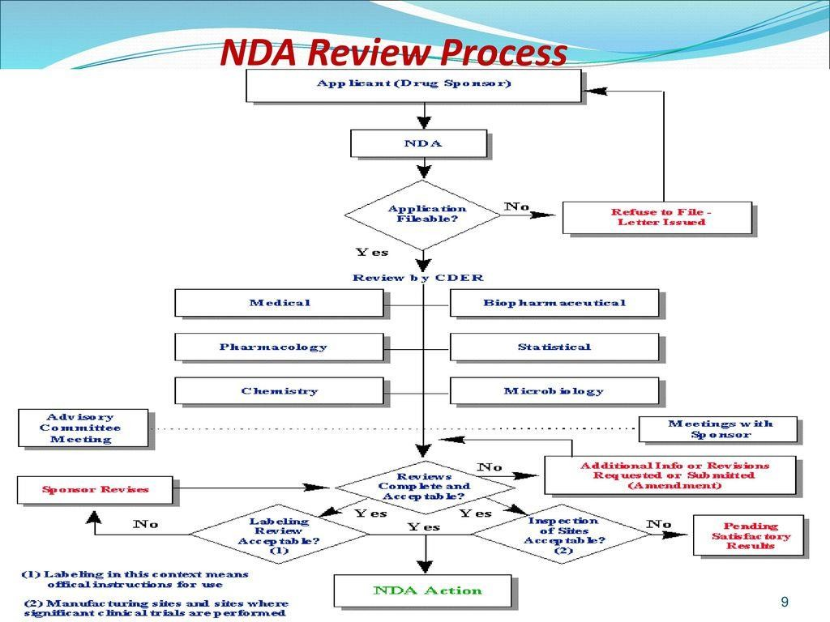

REGULATORY APPROVAL PROCESS
Regulatory approval is a crucial milestone in the drug development process. It involves the evaluation of scientific data, clinical evidence, and safety profiles of a new drug candidate by regulatory authorities to determine its safety, efficacy, and quality. The regulatory approval process varies across countries but generally follows a standardized framework. Here is a detailed exploration of regulatory approval in drug development:
- Regulatory Authorities:
- Regulatory authorities, such as the U.S. Food and Drug Administration (FDA) in the United States, the European Medicines Agency (EMA) in Europe, and other national regulatory bodies, are responsible for reviewing and approving new drugs.
- These authorities ensure that drugs are developed, manufactured, and marketed in compliance with established regulations to protect public health and ensure their quality, safety, and efficacy.
- Preclinical Data Review:
- Before a drug candidate can proceed to clinical trials, regulatory authorities review the preclinical data generated from laboratory and animal studies.
- The authorities assess the drug candidate's pharmacological properties, toxicology, pharmacokinetics, and potential adverse effects to determine whether it is safe for human testing.
- Clinical Trials:

- Clinical trials play a pivotal role in gathering evidence on the safety, efficacy, and optimal use of a drug candidate.
- Regulatory authorities review the data generated from clinical trials to assess the drug candidate's performance, benefits, and risks in the target patient population.
- New Drug Application (NDA) or Marketing Authorization Application (MAA):
- After completion of clinical trials, the drug developer submits a comprehensive regulatory application, known as the New Drug Application (NDA) in the United States or the Marketing Authorization Application (MAA) in Europe.

- The NDA or MAA contains extensive data on the drug candidate, including preclinical and clinical data, manufacturing details, safety information, proposed labeling, and benefit-risk assessments.
- Review Process:
- Regulatory authorities conduct a thorough review of the submitted NDA or MAA to ensure compliance with regulatory requirements.
- The review process involves multiple disciplines, including clinical evaluation, pharmacology, toxicology, manufacturing, and quality control.
- The authorities evaluate the scientific data, safety profiles, efficacy results, and overall benefit-risk assessments to make informed decisions regarding the drug's approval.
- Review Types:
- Different review types exist depending on the nature and urgency of the drug candidate. For example, accelerated review processes may be available for drugs targeting life-threatening conditions with significant unmet medical needs.
- Expedited pathways, such as the FDA's Fast Track, Breakthrough Therapy, or EMA's Priority Medicines (PRIME), aim to expedite the review process for drugs that show promising results in addressing critical medical needs.
- Advisory Committees:
- Regulatory authorities often consult independent advisory committees or expert panels composed of medical professionals, scientists, and patient representatives.
- These committees provide external expertise and recommendations on the drug candidate's safety, efficacy, and appropriate use, assisting regulatory authorities in their decision-making process.
- Labeling and Package Insert:

- If the regulatory authorities grant approval, they work closely with the drug developer to finalize the drug's labeling, package insert, and prescribing information.

- The labeling provides crucial information for healthcare professionals and patients, including indications, dosage instructions, contraindications, warnings, precautions, and potential adverse effects.
- Post-Marketing Surveillance:
- Once a drug is approved and on the market, regulatory authorities continue to monitor its safety and efficacy through post-marketing surveillance.
- Adverse event reporting systems, pharmacovigilance programs, and ongoing safety studies help identify any previously undetected or rare adverse effects and ensure the drug's ongoing safety in real-world settings.
- Regulatory Inspections:

- Regulatory authorities conduct regular inspections of drug manufacturing facilities to ensure compliance with Good Manufacturing Practices (GMP) and quality standards.
- These inspections assess the manufacturing processes, quality control procedures, record-keeping, and adherence to regulatory guidelines to ensure consistent product quality.
- Post-Approval Changes:

- After approval, any changes to the drug's manufacturing process, labeling, or indications typically require submission of supplemental applications to regulatory authorities for review and approval.

Regulatory approval is a complex and rigorous process that aims to safeguard public health by ensuring that only safe, effective, and high-quality drugs reach the market. The process involves close collaboration between drug developers and regulatory authorities to evaluate scientific data, conduct comprehensive reviews, and make informed decisions that balance patient needs with safety and efficacy considerations.

POST MARKETING SURVELLIANCE
Post-marketing surveillance, also known as pharmacovigilance, is a crucial component of drug safety monitoring after a drug is approved and available on the market. It involves the ongoing collection, assessment, and evaluation of data on adverse events, side effects, and other safety-related information associated with the use of a medication. Here is a detailed note on post-marketing surveillance:
- Purpose of Post-Marketing Surveillance:
- The primary objective of post-marketing surveillance is to monitor the safety and effectiveness of drugs in real-world clinical practice.
- It helps identify previously unknown or rare adverse drug reactions (ADRs), drug interactions, and long-term effects that may not have been apparent during preclinical and clinical trials.
- Post-marketing surveillance aims to ensure the continued assessment of a drug's risk-benefit profile and to detect and minimize potential risks to patients.
- Adverse Event Reporting:
- Post-marketing surveillance relies on the reporting of adverse events by healthcare professionals, patients, and other stakeholders.
- Regulatory authorities require pharmaceutical companies, healthcare providers, and sometimes even patients to report any suspected adverse events associated with drug use.
- Adverse event reporting systems, such as the FDA Adverse Event Reporting System (FAERS) or the EudraVigilance system in Europe, serve as central databases to collect and analyze reported events.
- Pharmacovigilance Programs:

- Pharmaceutical companies are responsible for establishing pharmacovigilance programs to actively monitor and evaluate the safety of their marketed drugs.
- These programs include dedicated teams that receive, review, and analyze reported adverse events, and take appropriate action based on the findings.

- Pharmacovigilance programs also involve the continuous assessment of scientific literature, medical databases, and other sources for emerging safety concerns or new information.
- Signal Detection and Evaluation:
- Post-marketing surveillance aims to detect "signals" of potential safety concerns by identifying patterns, clusters, or trends in reported adverse events.
- Statistical and epidemiological methods are employed to analyze data and evaluate the strength and significance of the observed signals.
- Once a signal is identified, further investigations, such as observational studies or clinical trials, may be initiated to better understand the risk and determine appropriate regulatory actions.
- Risk Management and Labeling Updates:
- Post-marketing surveillance plays a crucial role in the ongoing evaluation of a drug's risk-benefit profile and may lead to updates in the drug's labeling or prescribing information.
- If new safety concerns emerge or additional information becomes available, regulatory authorities may require pharmaceutical companies to update the drug's labeling to include warnings, precautions, or contraindications.
- Risk management strategies, such as Risk Evaluation and Mitigation Strategies (REMS), may be implemented to ensure the safe and appropriate use of certain high- risk medications.
- Signal Dissemination and Communication:

- Post-marketing surveillance findings and safety updates are communicated to healthcare professionals, regulatory authorities, and the public.
- Timely and transparent communication helps healthcare providers make informed decisions about the use of medications and promotes patient safety.
- Regulatory authorities often issue safety alerts, advisories, or educational materials to raise awareness about identified risks and appropriate mitigation strategies.

- Collaboration and International Cooperation:
- Post-marketing surveillance involves collaboration and information sharing among regulatory authorities, pharmaceutical companies, healthcare professionals, and other stakeholders.
- International cooperation, such as the World Health Organization's Programme for International Drug Monitoring (PIDM), facilitates the exchange of safety data and harmonization of pharmacovigilance practices across countries.
- Continuous Evaluation and Benefit-Risk Assessment:
- Post-marketing surveillance is an ongoing process throughout the drug's lifecycle, continuously assessing its safety profile and benefit-risk balance

CONCLUSION
In conclusion, drug discovery and development is a complex and multifaceted process that plays a critical role in the advancement of healthcare. It involves a series of interconnected stages, from target identification to post-marketing surveillance, with the ultimate goal of bringing safe and effective drugs to the market for the benefit of patients. Through extensive research and innovation, scientists and researchers identify disease targets and develop potential drug candidates that interact with these targets. The hit generation and lead optimization phases aim to refine and enhance the efficacy, selectivity, and pharmacokinetic properties of the drug candidates. Preclinical research, including in vitro and animal studies, provides crucial data on the safety, toxicity, and pharmacological effects of the drug candidates. This stage helps in making informed decisions about progressing to clinical trials. Clinical trials are conducted to evaluate the safety and effectiveness of the drug candidates in human subjects. These trials follow strict protocols and involve multiple phases to gather robust data on the drug's therapeutic benefits and potential risks. Regulatory approval is a vital step in the drug development process. Regulatory authorities carefully review the submitted data, including preclinical and clinical studies, manufacturing processes, and proposed labeling, to ensure that the drug meets stringent safety, efficacy, and quality standards. Post-marketing surveillance or Pharmacovigilance continues after regulatory approval to monitor the drug's safety in real-world settings. Adverse event reporting systems and ongoing safety monitoring help identify and manage any potential risks associated with the drug. The field of drug discovery and development relies on collaboration among researchers, pharmaceutical companies, regulatory authorities, healthcare professionals, and patients. It requires substantial resources, expertise, and adherence to ethical and regulatory standards to ensure patient safety and optimize health outcomes.
Overall, drug discovery and development is a dynamic and evolving field that continues to contribute to advancements in medicine and the treatment of various diseases. It represents a significant investment in scientific research, innovation, and regulatory oversight, with the ultimate aim of improving patients' lives and addressing unmet medical needs.

REFRENCES
- "Principles of Drug Discovery and Development" by Benjamin E. Blass
- "Drug Discovery and Development: Technology in Transition" by Raymond G. Hill
- "The Process of New Drug Discovery and Development" by Charles G. Smith
- "Drug Discovery and Development: From Molecules to Medicine" by Louis A. Carpino
- "Drug Discovery: Practices, Processes, and Perspectives" by Jie Jack Li and E. J. Corey
- "Pharmaceutical Preformulation and Formulation: A Practical Guide from Candidate Drug Selection to Commercial Dosage Form" by Mark Gibson
- "Drug-Like Properties: Concepts, Structure Design and Methods" by Li Di and Edward H. Kerns
- "Drug Metabolism and Pharmacokinetics Quick Guide" by Siamak Cyrus Khojasteh, Cornelis E.C.A. Hop, and Xiaoling Li
- "The Practice of Medicinal Chemistry" edited by Camille G. Wermuth, David Aldous, and Pierre Raboisson
- "Clinical Pharmacology and Therapeutics: Questions for Self-Assessment" by Timothy G. K. Mant and Lionel D. Lewis

IMAGE REFRENCES

  - https://slideplayer.com/slide/12680447/76/images/9/NDA+Review+Process.jpg
  - https://www.researchgate.net/profile/Blair- Holbein/publication/26671573/figure/fig1/AS:340443561775111@1458179478 936/Flowchart-for-a-clinical-drug-study-that-may-require-an-IND-application- for-an.png
  - https://upload.wikimedia.org/wikipedia/commons/thumb/1/10/Drug_discovery
_cycle.svg/1200px-Drug_discovery_cycle.svg.png
  - https://pubrica.com/academy/wp-content/uploads/2019/08/Phases-of-Clinical- Trials.png
  - https://www.researchgate.net/profile/Niroshini- Nirmalan/publication/308045230/figure/fig1/AS:613907634872358@15233783 94724/Drug-discovery-and-development-timeline-The-current-drug-approval- pipeline-can-take-15.png

