Inverse Agonism: Exploring New Frontiers in Receptor Pharmacology

Dr. Mohammad Irfan Shah^{1 and} Dr. Rusheeba Manzoor²

¹Veterinary Assistant Surgeon, Department of Animal Husbandry Kashmir, J&K.
² Deputy Director SAMETI, Directorate of Extension, SKUAST-K, J&K.

Abstract:

In the field of receptor pharmacology, the interactions between ligands and receptors are crucial for controlling cellular responses and determining therapeutic strategies. While agonists and antagonists have been well studied, researchers have now start focusing on the intriguing and previously unknown phenomenon known as "inverse agonism." As a novel idea, inverse agonism challenges the accepted notions of receptor function and provides new opportunities for drug development. In this article, we examine the subtleties of inverse agonism, as well as its mechanics, ramifications, and prospective application to the development of new drugs and treatment approaches.

Key words: Inverse agonism, constitutive active receptors, Therapeutic Implications

Introduction:

The field of receptor pharmacology is rapidly evolving There has been a major shift in our understanding of the drug receptor interactions during the past three decades. The traditional concept in receptor pharmacology was that the receptors are functionally quiescent and do not produce any signal. However, with the discovery of agonist-independent receptors, this concept has been challenged. There are receptors that produce an inherent low-level signal or a cellular response even when no ligand is bound to them. Such receptors are called constitutive active receptors (CAR). With the emergence of the concept of inverse agonism, there has been a paradigm shift in our understanding of receptor behaviour.

Basics of Receptor Pharmacology

Receptors are the cellular macromolecules to which a drug binds to commence its action. They are essential participants in cellular communication, and their interactions with ligands impact therapeutic approaches. Proteins are the most significant type of drug-receptor.
A two-state receptor model has been proposed for explaining the action of agonists, antagonists, partial agonists and inverse agonists According to this model, the receptor can exist in equilibrium in two conformational states, active (Ra) and inactive configuration (Ri). Normally when no ligand is present, the equilibrium lies towards the left i.e. the inactive state predominates, and basal signal output is low. But in the case of constitutive active receptors (CAR), an appreciable proportion of receptors adopt an active configuration without the presence of any ligand and, an elevated basal response is observed. Depending upon the shift in the equilibrium of the receptor conformation towards an active or inactive state, the drugs are classified as agonists, antagonists or inverse antagonists. Agonists have both affinity (the ability of a drug to bind to a receptor) and intrinsic efficacy (the ability of a drug to produce the cellular response). Agonist has a higher affinity for the Ra than Ri and shifts the equilibrium towards Ra i.e. prompting a cascade of events that lead to cellular responses. Since intrinsic efficacy is a drug-dependent property, the agonists can be characterized as full or partial agonists depending upon the cellular response produced. Antagonists have only affinity but zero intrinsic efficacy and bind with equal affinity to either conformation with the result natural resting state is not altered. However, as the antagonist occupies the receptors, it reduces the likelihood of receptor occupancy by other ligands. In contrast, the inverse agonist shows selectivity for the inactive state of the receptor and shifts the equilibrium towards Ri., thus producing an effect opposite to that of an agonist (Figure 1,2). This unique property differentiates inverse agonists from neutral antagonists. Inverse agonists have negative intrinsic efficacy (decrease the activity of a receptor). Like agonists, inverse agonists also have different degrees of negative intrinsic efficacy and can be characterized as strong and weak (partial) inverse agonists.

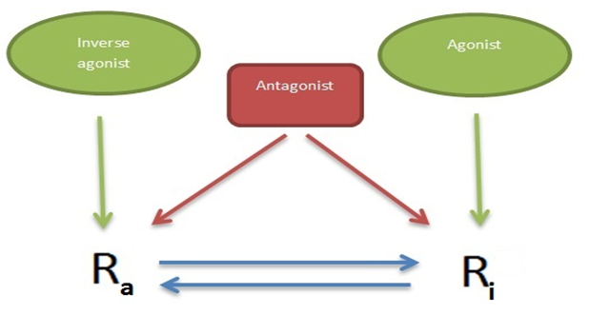
Figure1. Illustration of the two-state receptor model.

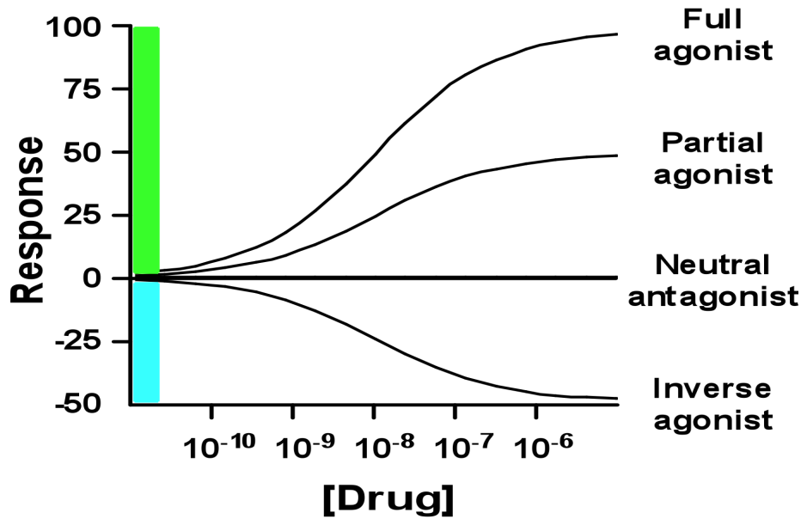
Figure2. Dose response curves of a full agonist, partial agonist, neutral antagonist, and inverse agonist.

Definition:
Inverse agonists are defined as ligands that selectively bind to the inactive state of the receptor and stabilize the receptor in its inactive conformation, thus attenuating the constitutive signalling. Since they produce effects opposite to that of agonists, they were called inverse agonists. A ligand with a higher intrinsic efficacy, such as an agonist, an antagonist or an inverse agonist with a weak negative intrinsic efficacy, can reduce the response of an inverse agonist. In systems where constitutive activity is not present, inverse agonist behaves like competitive antagonist.
History:

Constitutive receptor activity was first demonstrated by Ceriore and co-workers in 1984 in ß2-adrenergic receptors and later in 1989 by Costa and Herz in delta opioid receptors.These authors demonstrated an increased baseline GTPase activity using radioligand binding assays and transfected cell systems. They called such ligands “negative antagonists”.

Basis of Inverse Agonism –Constitutive receptor activity:

The discovery of constitutive active receptors led to the discovery of the phenomenon of inverse agonism. Only such receptors show inverse agonism which has the Constitutive receptor activity. Such receptors produce the signal or cellular response spontaneously i.e. they are agonist-independent. In other words, they spontaneously activate downstream signalling pathways without the need for an external ligand to bind to the receptor. This phenomenon is often attributed to mutations or modifications that alter the receptor's conformation and activity. Such receptors spontaneously undergo a conformational change and bind and activate G protein (GTPase) or alternate pathways. Inverse agonists play the role of receptor silencers by preferentially binding to the inactive state, stabilizing it and reducing the probability of the receptor transitioning to the active state. Inverse agonists often interact allosterically, binding to sites distinct from those of agonists or antagonists. This binding modifies the receptor's conformation, propagating changes to the active site and influencing signalling pathways. The behaviour of a ligand is system dependent due to which the same drug could act as an agonist a partial agonist, or an antagonist when tested in different systems. For example, ß1-adrenergic receptor agonist, prenalterol, behaved as a full agonist (compared with isoproterenol), a partial agonist, or antagonist, in different tissues. In systems where constitutive activity is not present, inverse agonist behaves like competitive antagonist and may be erroneously classified as competitive antagonists. Inverse agonists can also influence biased signalling or functional selectivity, thus offering a new tool for modulating cellular responses.
Generally, the fraction of receptors that are constitutive active (CA) are very few for the observation and to determine whether the drug acts as the inverse agonist, such test systems need to be used where there is measurable constitutive activity. In order to achieve the measurable constitutive activity for testing the inverse agonistic activity of a drug, the following methods are employed:
1. Mutating the receptors: Natural or experimentally induced mutations in the receptor gene can cause alterations in the receptor protein's structure. These changes in turn increase the isomerisation and receptor-effector coupling efficiency.
2. Overexpression: overexpression of receptors increases the fraction of receptors in an active state as the regulatory mechanisms are overwhelmed.
3. Amplifying the signalling cascade: The use of substances like phosphodiesterase inhibitors (PDEI) and forskolin (adenylate cyclase activator) amplifies the signalling cascade and results in appreciable constitutive activity.
Magnitude of constitutive receptor activity:

Three factors influence the magnitude of constitutive receptor activity and thus the efficacy of inverse agonists.
1. Conformational flexibility / Allosteric transition constant, L: It determines the ability of a receptor protein to isomerise from inactive to active conformation, which in turn depends upon the number and strength of intramolecular forces. There is a direct relationship between the isomerization efficiency of a receptor and the proportion of active receptors. L is an inherent property of a receptor and therefore varies for each receptor
2. Receptor density, RT.: At any given value of L, a proportion of the receptor population is in an active conformation. There are proportionally more active (and inactive) receptors present as receptor density rises. RT is a cell/tissue-dependent feature, unlike L, which is a receptor-dependent property. As a result, observed constitutive activity and inverse agonist effectiveness associated with a particular receptor subtype will change depending on receptor expression levels in various cells or tissues.
3. Efficiency of receptor-effector coupling in the cell Ke.: Receptor-effector coupling is the process by which the activated receptor leads to cellular response. This in turn is dependent upon the number and type of signal transduction molecules (e.g., G proteins) and effectors. As such, Ke, like RT, is also cell/tissue-dependent. It mainly depends on the phenotype of the cell. Cells that have a high level of receptor expression will have more active receptor density, level of expression of signalling and regulatory molecules
Because of these cell/tissue-dependent characteristics, the efficacy of an inverse agonist on reducing a baseline response would differ when evaluated in various cells or tissues with varying RT or Ke. All the three variables determine how effective an inverse agonist is. A receptor with a lot of intramolecular limitations may still have a lot of constitutive receptor activity if the receptor density or stimulus-response coupling efficiency is high.

Examples of Receptor Systems and Inverse Agonism:
Numerous receptor systems have undergone substantial research on inverse agonism. For various families of 7TM receptors (GPCRs), inverse agonism has been well investigated. It is hypothesised that antagonists are uncommon since the majority of ligands at G protein-coupled receptor antagonists are inverse agonists. Most antagonistic drugs—if not all of them—have inverse agonistic characteristics. Many hormone receptors, such as the thyroid hormone receptor (Nuclear Receptors), display spontaneous agonist-independent activity and can, in theory, be targeted by bioregulators or drugs that act as inverse agonists. Only GABAA channel inverse agonists have been identified for ion channels. Beta carbolines FG-7142 and DMCM, heterocyclic annelated 1,4-diazepine Ro19-4603, and pyrazolo triazine MK-016 are examples of GABAA chloride channel inverse agonists. These molecules attach to the benzodiazepine site of GABAA channels, stabilising them in a resting, closed state. Inverse agonists are proconvulsive and anxiogenic. In appropriate in vitro experimental settings, receptors such as benzodiazepine, serotonin, cannabinoids, histamine, adrenergic receptors, Angiotensin II receptor type 1 (AT1) exhibit CA.
Experimental methods to study inverse agonism:
Due to various technical difficulties, inverse agonism was not a well-studied phenomenon. However, with advancements in experimental methodologies and detection technologies, identifying new inverse agonists has become easy. Inverse agonism research is a complicated and diverse endeavour that combines molecular biology, pharmacology, cellular physiology, and computational approaches. The various techniques and methods used to study inverse agonism are receptor characterization (GTP-S binding assays), radioligand binding assays, functional assays (Western blotting, ELISA, real-time PCR, and reporter gene assays), and molecular modelling and dynamic simulations. Cellular and animal models, as well as clinical studies, have also proven invaluable in identifying and studying inverse agonists. These tools facilitate the investigation of ligand binding affinities, receptor conformational changes, and the underlying molecular mechanisms of inverse agonism.
Therapeutic Implications:
The discovery of Inverse agonism has important ramifications in the discipline of pharmacology. In cases where constitutive receptor activation contributes to disease pathogenesis, inverse agonists represent a prospective therapeutic intervention pathway.Inverse agonists can offer effective therapeutic alternatives by lowering the baseline activity of receptors linked to diseases like anxiety or hypertension. This potential has sparked interest in investigating inverse agonists as a novel drug class.
Inverse agonism may have therapeutic application in the following conditions:
1. Cancer: Certain malignancies are linked to constitutively active GPCRs. Chronic elevations of second messengers in cells caused by constitutive G-protein activity have been shown to cause cell transformation. Constitutive GPCR activity, which leads to prolonged elevations in cell metabolism, may play a role in tumour pathogenesis. Studies have shown that the adrenoceptors could act as agonist-independent protooncogenes and have a role in cell cycle regulation and proliferation. Therefore, alpha-adrenergic receptor inverse agonists may be used as potential antitumor agents. Studies have shown that rauwolscine inhibits tumour development in mammary tumor cell lines by enhancing tumour cell apoptosis.
2. Anxiety and Depression: Constitutive Activity in Subtype GABA A receptor has been linked to anxiety and depression. Inverse agonists can ameliorate the symptoms of these conditions by reducing aberrant signaling. It is postulated that the therapeutic efficacy of the pimavanserin, which is used to treat Parkinson's disease associated psychosis, is a result of IA on serotonin type 2A receptors (5-HT_{2A})
3. Cardiovascular diseases: Inverse agonism offers a novel approach in managing cardiovascular disorders. Both beta-1(β1) and beta- 2 (β₂) adrenoreceptors exhibit constitutive receptor activity, and studies have revealed that the b-blocker class of medications has varied IA potencies; for example, metoprolol is a powerful inverse agonist, but carvedilol is a weak IA. This variation in inverse agonistic activity may alter hemodynamic parameters and aid in the selection of the optimal b-blocker in cardiovascular illness. Both β1and β₂ adrenoreceptors exhibit constitutive receptor activity, and studies have revealed that the b-blocker class of medications has varied IA potencies; For example, metoprolol is a strong inverse agonist, but carvedilol is a weak IA. This variation in inverse agonistic activity may alter hemodynamic parameters and aid in the selection of the optimal β -blocker in cardiovascular illness.
4. Asthma: some beta-blockers with inverse agonist action may even be useful in asthma when taken long-term. In mouse models, β2--blockers with inverse agonist action (nadolol and carvedilol) enhanced β2--receptor expression and produced bronchodilation.
5. Autoimmune Disorders: Constitutively active GPCRs may play a significant role in autoimmune illnesses, and inverse agonists could prove effective in such disorders by suppressing excessive receptor signaling.
6. Neurodegenerative Diseases: Receptors with constitutive activity have been linked to neurodegenerative disorders like Parkinson's disease. Inverse agonists could prove useful in such disorders.
7. Other conditions: Inverse agonists targeting the Leptin receptors could be used as novel therapeutic agents in obesity. In Traumatic brain injury, drug Raloxifene rescues functional deficits and associated pathologies after mild TBI and the benefit of drug appears attributable to its CB2 inverse agonism rather than its estrogenic actions.
Challenges and Future Directions:
Inverse agonism has clear therapeutic promise, but there are a number of issues that need to be taken into account:
1. Selective Targeting: It might be difficult to create inverse agonists that only bind to receptors with constitutive activity, leaving other receptors unaffected. The prevention of unwanted side effects should be an important consideration before using these drugs.
2. Deciphering mechanisms: Further investigation is required to understand the complex molecular processes by which inverse agonists interact with receptors and affect signalling pathways.
3. Clinical Translation: The transition from preclinical studies to clinical trials necessitates comprehensive validation and safety evaluation to guarantee that the projected advantages are realised. The majority of studies are carried out in in-vitro systems, and in-vivo, the response may be by countering the effect of an endogenous agonist. This makes it difficult to determine whether a drug's in-vivo therapeutic impact is predominantly attributable to its inverse agonistic qualities.
In the future, research may concentrate on creating novel medicines that target constitutive receptor activation and using the potential of inverse agonists for precision medicine.
Conclusion:
Inverse agonism as a novel concept in receptor pharmacology opens up new opportunities for drug development and provides insights into basic cellular functions. Inverse agonists may become important tools for precision medicine, enabling tailored therapies with fewer side effects, as research into their molecular underpinnings and therapeutic potential advances.

References:
Aloyo, V. J., Berg, K. A., Clarke, W. P., Spampinato, U., & Harvey, J. A. (2010). Inverse Agonism at Serotonin and Cannabinoid Receptors. Progress in Molecular Biology and Translational Science, 1–40. https://doi.org/10.1016/s1877-1173(10)91001-6
Berg, K. A., & Clarke, W. P. (2018, August 6). Making Sense of Pharmacology: Inverse Agonism and Functional Selectivity. International Journal of Neuropsychopharmacology, 21(10), 962–977. https://doi.org/10.1093/ijnp/pyy071
Brunton, L., Knollmann, B., & Hilal-Dandan, R. (2017, December 31). Goodman and Gilman’s the Pharmacological Basis of Therapeutics, 13th Edition.
Dickey, B. F., Walker, J. K., Hanania, N. A., & Bond, R. A. (2010, June). β-Adrenoceptor inverse agonists in asthma. Current Opinion in Pharmacology, 10(3), 254–259. https://doi.org/10.1016/j.coph.2010.03.002
Hacksell, U., Burstein, E. S., McFarland, K., Mills, R. G., & Williams, H. (2014, March 30). On the Discovery and Development of Pimavanserin: A Novel Drug Candidate for Parkinson’s Psychosis. Neurochemical Research, 39(10), 2008–2017. https://doi.org/10.1007/s11064-014-1293-3
Honig, M. G., Del Mar, N. A., Moore, B. M., & Reiner, A. (2022, November 1). Raloxifene Mitigates Emotional Deficits after Mild Traumatic Brain Injury in Mice. Neurotrauma Reports, 3(1), 534–544. https://doi.org/10.1089/neur.2022.0052
Khilnani, G., & Khilnani, A. (2011). Inverse agonism and its therapeutic significance. Indian Journal of Pharmacology, 43(5), 492. https://doi.org/10.4103/0253-7613.84947
Michel, M. C., Michel-Reher, M. B., & Hein, P. (2020, August 19). A Systematic Review of Inverse Agonism at Adrenoceptor Subtypes. Cells, 9(9), 1923. https://doi.org/10.3390/cells9091923
Sato, J., Makita, N., & Iiri, T. (2016). Inverse agonism: the classic concept of GPCRs revisited [Review]. Endocrine Journal, 63(6), 507–514. https://doi.org/10.1507/endocrj.ej16-0084
Thomson, N. C., & Barnes, P. J. (2009). Drugs. Asthma and COPD, 515–521. https://doi.org/10.1016/b978-0-12-374001-4.00040-7
Townsend, C. (2021). Ion Channels. Reference Module in Biomedical Sciences. https://doi.org/10.1016/b978-0-12-820472-6.99998-5

