**CASE BASED PERSPECTIVES ON ADDRESSING HIGH EMPLOYEE ATTRITION IN BPO INDUSTRY**

Dr. Prashanth Pai M1

*Associate Professor, Department of Mechanical Engineering*

*P.A. College of Engineering*

*Mangaluru, Karnataka State, India – 574153*

[shanth.pai@gmail.com](mailto:shanth.pai@gmail.com)

Dr. Ramachandra C G2

*Professor,, Department of Mechanical*

*Presidency University*

*Bengaluru, Karnataka, India – 560064*

[ramachandra.cg@gmail.com](mailto:ramachandra.cg@gmail.com)

ABSTRACT

BPO industry is considered to be the most sensitive of the knowledge industries when it comes to encouraging and motivating the employees. Business Process Outsourcing leverages process driven efficiencies in terms of organizational excellence, responsiveness & branding, financial efficiency and customer relationship The findings will enable the researchers to make an in-depth study on the employee attrition in BPOs by analyzing the attrition factors under specific titles such as critical, non-critical factors, stress related, compensational factors, etc. HR Strategists at the corporate level of the BPO industry have a huge challenge before them and their approach has to be proactive and they have to develop innovative employee retention strategies.

Keywords— Business Process Outsourcing, IT Enabled services, Employee attrition, Critical and non-critical factors, Stress related and Compensational factors

# INTRODUCTION

Outsourcing is a journey of two organizations seeking jointly to overcome predictable challenges” says William B. Bierce, and Kennerson, P.C. Enterprises today are focused on identifying new opportunities and innovations to sustain and maximize growth. Human Capital is the most crucial resource on which the Information Technology& Information Technology Enabled Services (IT&ITES) depends. Over the past decade, the Indian IT-BPO sector has become the country’s premier growth engine, crossing significant milestones in terms of revenue growth, employment generation and value creation, in addition to becoming the global brand ambassador for India. Business process outsourcing (BPO) is the long term contracting out of non-core business processes to an outside provider to help achieve increased shareholder value. It is the delegation of one or more IT – intensive business processes to an external provider that in turn owns, administers and manages the selected process based on defined and measurable performance criteria. .

Out sourcing is not a new phenomenon. Adam Smith wrote about it 200 years ago. The theory of ‘Cost Advantage’ and Michael Porter’s ‘Value chain concept’ actually paved the way for BPO. According to McKinsey study (2004) giant US pharma firms can reduce the cost of developing a new drug currently estimated at betweenUS $ 600 million and US $ 900 million by as much as US $ 200 million, if development work is outsourced to India. The trend of outsourcing customer support services (also called as call centers) to India began in 1998, when GE established a facility in Noida. Benefits derived from BPO are productivity improvements**, f**ocus on company’s core business, achieve cost reductions, gain greater internal flexibility, achieve world-class standards/benchmarks, achieve revenue enhancements, gain access to advanced technology, meet changing customer demands, obtain outside expertise, maintain competitive edge, improved service quality, improved performance, profitability & shareholder value.

# PURPOSE

1. The study titled Case based perspectives on addressing high employee attrition in BPO Industry was done with the following objectives.
2. Assess the nature and state of employee attrition in BPOs.
3. Study the factors causing high employee attrition in BPOs/Call centers.
4. Study the difference in perceptions of the causes of high employee attrition in BPO/call centers.
5. Identify the stress related, compensational and non-compensational factors.
6. Identify the critical& non-critical factors which cause high attrition in the above sector.
7. Suggest workable / suitable measures for addressing the high employee attrition caused by the above factors.
8. Suggest retention strategies for effective and efficient management of BPOs.

# RESEARCH ISSUE

The BPO Industry in India is growing at a phenomenal pace. BPO companies in India have been growing at a compound annual growth rate (CAGR) of over 40 percent for the last seven years. The BPO industry in the country which is expected to employ millions of people is facing the challenge of finding quality human resources given the current attrition rate of around 20-40 percent. The core of a knowledge based industry is the people and its success depends on the quality of available talent. Many organizations do not even know what their attrition rates are, and those that do often lack enough data to pinpoint where the problem is most severe, or to uncover the specific causes of attrition. According to the Corporate Advisory Board of Washington DC, the cost of replacing staff can be anything between 50% and 175% of that person’s annual salary. The loss of key employees, even in small numbers, can be devastating to a company. The costs of unplanned attrition can be catastrophic for a company’s well-being, survival and growth

# THE PROBLEM OF ATTRITION

Attrition means: A gradual diminution in number or strength because of constant stress. A gradual, natural reduction in membership or personnel, as through retirement, resignation, or death.

Employee attrition is a reduction in the number of employees through retirement resignation or death. NASSCOM ITES BPO forum has identified HR as one of the key challenges of the sector. There are several factors that represent additional costs of attrition that often go overlooked. These include the lost productivity of a vacant position and subsequent recruiting and training costs for a new employee, as well as the costs of lost opportunities with the company’s clients and the lag time in getting innovative new products and services to market. The average costs of replacing today's defecting work force are eating away the profitability of even the healthiest organizations. Of late workers have shown a tendency not to pursue ITES as a full-time career.

In this context, an in-depth study of the factors causing high employee attrition in the BPO Industry is the need of the hour.

# DESIGN / METHOD

The study has been conducted choosing a sample of 110 BPO employees working in Bangalore. A sample size of 110 was selected from employees of 4 BPOs namely Cambridge Integrated Services, Axes Online Private Limited, Ocwen Financial Solutions Private Ltd and International Business Machines (IBM), Daksh., located in Bangalore. The population of the study includes 1150 employees chosen from 4 BPOs and the sample size 110 is selected on the basis of convenient sampling technique. A well designed self administered questionnaire had been used for collecting the primary data. Also personal discussions and deliberations with employees within the level starting from entry level to team leader have been conducted for this purpose. Responses on each factor have been taken for all the 30 factors with the chosen sample of 110. The secondary data has been collected from different sources namely websites, articles and journals and text books. The data has been tabulated and descriptive analysis has been done using various statistical tools such as percentage bars, pie diagrams, etc. Likert type 5 point scale (summated scale) was used to convert qualitative nature of the data into quantitative type. The summated scale consists of a number of statements which express either a favourable or unfavourable attitude towards the given object to which the respondent is asked to react. The respondent indicates his agreement or disagreement with each statement in the instrument. Each response is given a numerical score, indicating its favorableness or unfavourableness, and the scores are totaled to measure the respondent’s attitude. Each factor response is tabulated and descriptive analysis of each factor has been done.

# RESULTS & DISCUSSIONS

## **Data Analysis**

The collected data has been codified; tabulated and descriptive analysis has been done using various statistical tools such as percentage bars, pie diagrams, etc. Each factor response is tabulated and descriptive analysis of each factor has been done.

After analysis, the factors have been grouped under the following heads:

1. Critical and non-critical factors
2. Stress related factors
3. Compensational factors
4. Non-Compensational Factors

**1. Critical and non-critical factors**

Based on the opinion (percentage) of the respondents the factors causing high attrition has been grouped into critical factors and non-critical factors.

**Critical factors (Fig. 1) causing high employee attrition in BPO employees**

1. Job Security
2. Lack of stress reduction programmes like yoga, etc.
3. Job Satisfaction
4. Limited career growth
5. Repetitive and monotonous job nature
6. Ineffective grievance redressal arrangement
7. Inadequate incentives and lack of celebration for achievement
8. Odd working hours
9. Mismatching of work life with family life

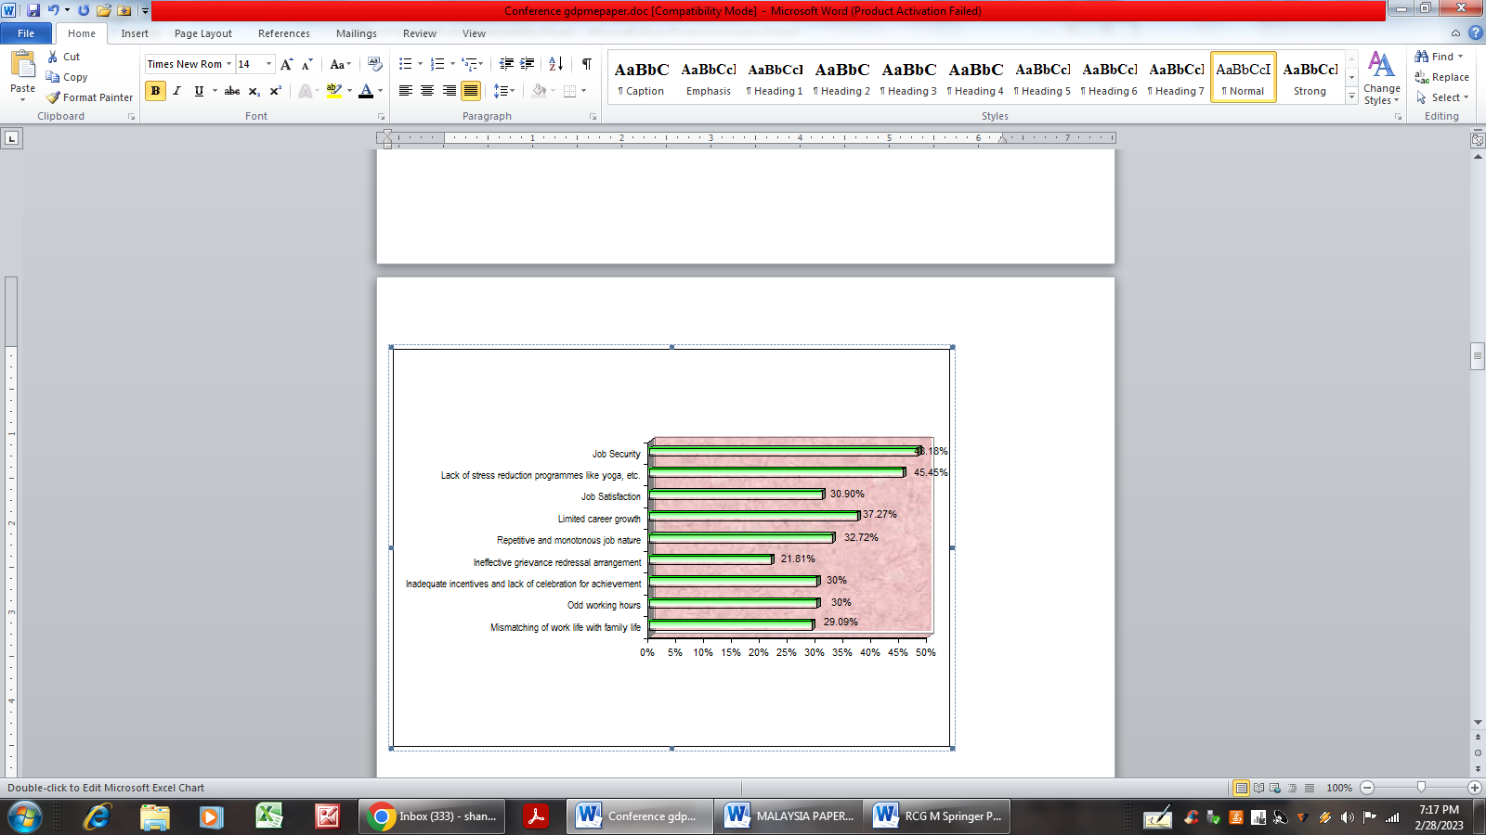

**Fig. 1. Diagrammatic presentation of critical factors**

Non-critical factors (Fig. 2) causing high employee attrition in BPO employees

1. Mismatching of educational qualification with the job
2. Absence of effective motivational programmes
3. Lack of competency models for recruitment and selection
4. Absence of logical, fair, and bias free promotion policy
5. Improper compensation and benefits system
6. Lack of empowerment in decision making
7. Absence of welfare measures like housing schemes, etc.
8. Lack of provision for hygienic and timely food to the employee
9. Highly stressful job

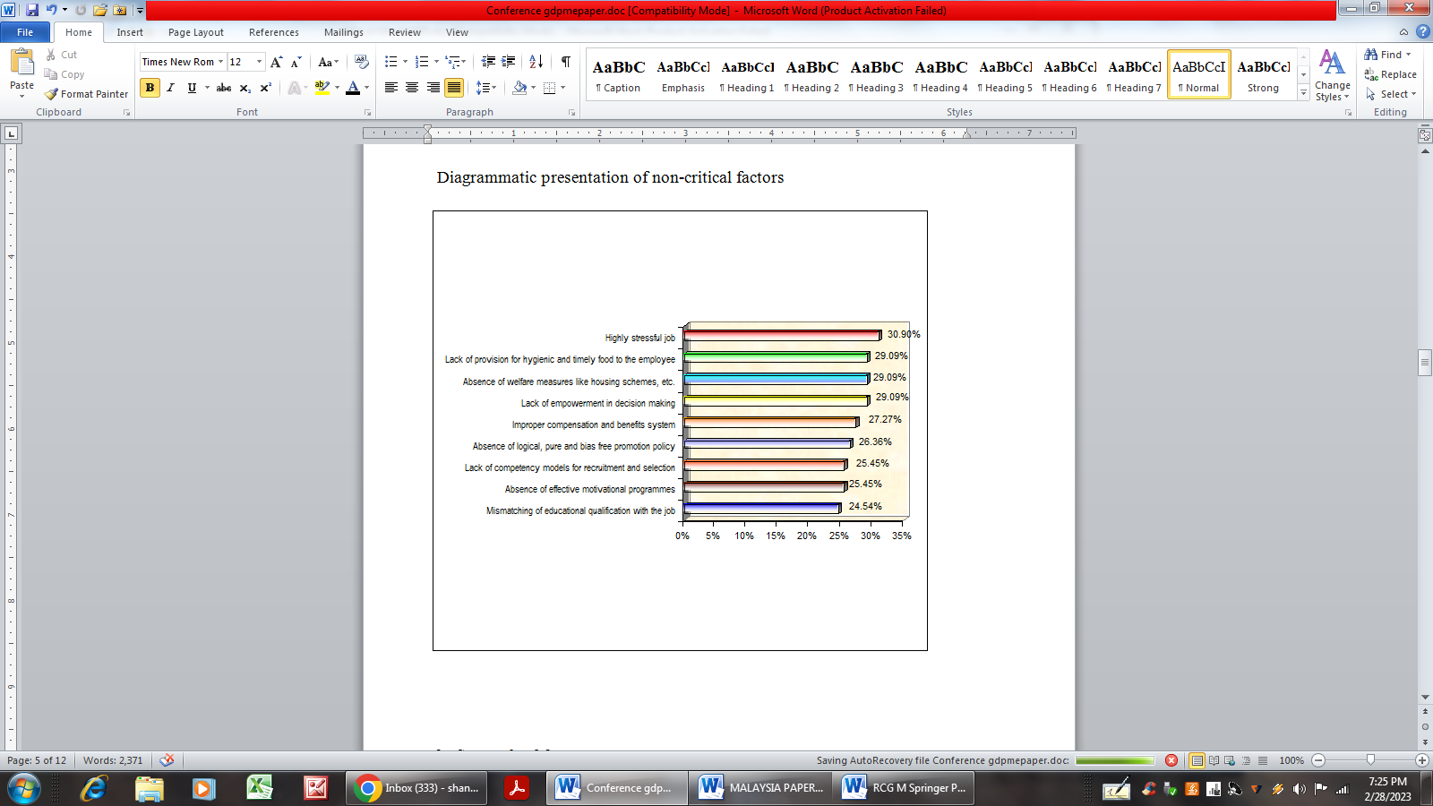

**Fig. 2. Diagrammatic presentation of non-critical factors**

**2. Stress related factors**

The study leads to the grouping of the following stress related factors (Fig. 3), which causes high employee attrition.

1. Odd working hours
2. Repetitive and monotonous job nature
3. Absence of stress reduction programmes.



**Fig. 3. Diagrammatic presentation of stress related factors**

**3. Compensational factors**

The study leads to the grouping of following compensational factors (Fig. 4):

1. Inadequate incentives and lack of celebration for achievement
2. Improper compensation and benefits system
3. Lack of fair, bias free promotion policy
4. Absence of welfare measures like housing schemes etc.



**Fig. 4. Diagrammatic presentation of compensational factors**

**4. Non-Compensational Factors**

The study leads to the grouping of the following non-compensational factors (Fig. 5):

1. Lack of job security
2. Lack of Job satisfaction
3. Limited career growth
4. Improper redressal arrangement
5. Improper selection methods,
6. work life – imbalance,
7. Mismatch of education al qualification
8. Lack of provision for hygiene food
9. Lack of empowerment in decision making
10. Lack of effective motivational programmes

.

**Fig. 5. Diagrammatic presentation of non-compensational factors**

# CONCLUSIONS

The problem of addressing high employee attrition in BPOs/call centers can be solved successfully by considering the critical and non-critical factors identified in the study. The grouping and the study of the factors under stress related, compensational and non-compensational categories will lead to an in depth understanding of the problem of high employee attrition. Manage attrition through smart people management tools and scientific approach rather than creating collaborative intra industry agreements. The study reveals that BPO is emerging as a powerful and flexible approach that business leaders can use to achieve a wide range of tactical and strategic aims. The study gives a warning signal to the BPO industry managements and call centers to pay immediate attention on addressing the high employee attrition. Emerging trends are pointing to the needs that business and human performance experts must address: not only survival and security needs, but also the higher-level needs for respect, recognition, achievement, and life-long learning.

# SUGGESTIONS

Based on the study the following suggestions may be adopted for the effective reduction of the employee attrition in BPOs:

1. Bring in Innovative and practical employee policies pertaining to flexible working schemes.
2. Select the right people in the first place through behavior based testing and competency screening.
3. Communicate goals, roles and responsibilities so that people know what is expected of them and feel a part of the crowd.
4. Work-life balance policies would have a positive impact on attracting high caliber recruits.
5. Encourage and groom employees to take up higher positions/openings and if not fulfilled, then they will look outside the organization.
6. Demonstrate respect for employees at all times, treat them well and provide dignity of job.
7. Reach out to the families of the potential candidates with sustained and focused messages in the media about the excellent prospects in the BPO industry
8. Outsource the Exit Interviews process to external consultants to get a realistic and unbiased feedback. BPO must concentrate on becoming an 'employer of choice'
9. Encourage humor and laughter in workplace to deal with stress which will ensure that the employees are happy which gets reflected in their services especially critical in voice based transaction.
10. Feeling valued by their manager in the workplace is a key to high employee motivation and morale.
11. Introduce “work from home” option as per the need of the employee.
12. Using psychometric tests to get people who can work at night and handle the monotony.
13. Granting compassionate and urgency leave.
14. Providing health care for self, family and dependents etc should be adopted.
15. Look for talents within the organization and encourage them.
16. Hiring should result in only ‘stress hardy’ candidates being chosen for the job.
17. Implement organizational culture measurement tools like Adversity Quotient (AQ).
18. Draw lessons from the Indian Army, for their command and control leadership where the troops are highly skilled, motivated and morale is high.

# LIMITATIONS OF THE STUDY

The study involves the following limitations:

1. The study was limited to only 4 BPO firms in Bangalore.
2. Lack of time in conducting the research survey and completion of the project.
3. Inability to answer the questions considering all the view points.
4. Inability to meet all the respondents.
5. Lack of co-operation in answering sincerely.
6. Data analysis focused mainly on descriptive analysis.

##### REFERENCES

1. S. Nakkiranand D.John Franklin (2005), “Business process outsourcing “Deep & Deep Publications Pvt. Ltd.
2. Chetan Bhagat (2005) “ One night @ the call center” Rupa & Co., New Delhi.
3. Kothari C.K, (2002) “Research Methodology” Vishwa Prakashan, 3rd Ed., New Delhi.
4. Sircar, Nabanita, “Government to Tackle Rising Absenteeism in Call Center”, [www.hindustantimes.com](http://www.hindustantimes.com), March 6, 2002.
5. Subba. Rao P (2003) “Personnel and Human Resource Management”, 3rd Edition, Himalaya Publications, Mumbai.
6. Indian ITES-BPO Fact Sheet,<http://www.nasscom.org>.
7. ITES Industry Threatened by Attrition , Price Wars,<http://www.ciol.com, Feb.13, 2003.
8. Attrition, Absenteeism Bug BPO Cos,<http://www.thehindubusinessline.com, April21, 2004.
9. “Comparing India with other BPO Destinations,<http://www.xicom.biz.,13 April, 2004.