Feeding Behavior and Strategies in Fish: Implications for Diet Formulation
Hafeef Roshan¹, K. S. Wisdom¹, Shambhavi Kumari Mishra¹, Husain Nottanalan²
^{,1}College of Fisheries Science, Gumla, Birsa Agricultural University, Ranchi, Jharkhand (835207), India
²Central Institute of Fisheries Education, Mumbai (400061), India

Abstract
One of the most significant environmental cues for fish that promotes feeding and growth is food. The key determinant of efficiency and cost in a fish farming business is feed intake, which maximizes production efficiency. The first and most important condition is that diets must provide all necessary nutrients and energy in sufficient amounts to meet the needs of the species in question for physical or gonadal growth, health, and well-being. The optimization of feeding includes analyzing fish feeding behavior. A complex habit that is directly related to food intake is feeding behavior. Understanding a fish species' feeding behaviors and diets is essential for comprehending many facets of its biology, physiology, and behavior. To choose baits and to optimize fishing tactics, one might use knowledge of prey preferences, feeding grounds, and daily feeding activity cycles. Numerous environmental influences as well as intricate homeostatic systems, including metabolites and central and peripheral hormone components, control feeding behavior. Fish feeding behavior and food intake are significantly influenced by extraneous influences. Here, we look at recent developments in the study of fish feeding behavior with regard to nutritional preference and selection, as well as some significant external factors that affect feed intake and feeding behavior. In order to completely determine the functional significance of feeding behavior in fish, we also identified information areas for further investigation.
Keywords – Feeding behavior, feed intake, external factors

Introduction
Any behaviour that an animal engages in to obtain nutrition is considered feeding. The wide range of methods used to obtain food is a reflection of the variety of foods consumed and the wide range of animal species (Ruiter,2023). Feeding behavior, is necessary for survival and physiologically regulated by actions related to nutrient and energy requirements (Lorenzetti, Byrne, 2008). Feeding behavior is also known as foraging behavior, every living being requires food for living. Fish show different feeding behaviors. Behavior and methods that animals use to find food are referred to as feeding behavior or foraging behavior. Depending on their physiology, ecology, and evolutionary adaptations, they comprise a broad range of tasks connected to locating, seizing, and consuming food supplies. It also varies widely across various species. Different species have distinct feeding behavior. Fish feeding behavior is diverse and has been extensively studied from an ecological point of view in both wild and farmed fish, while behavioral responses to feeding have been linked to feeding approaches, feeding habits, feeding regularity, feed detection mechanisms, and feed preferences. Information about the external and internal environment is analyzed by signaling molecules and receptors in fish to control feeding behavior (Assan, Huang et.al.,2021).
Feeding Behavior
The fish feed operations primarily produce two different kinds of fish feeds: those for herbivorous fish (like tilapia), which contain 30–35% crude protein, and those for carnivorous fish (like catfish), which include 45–50% crude protein (Royes and Chapman, 2003). In order to achieve maximum output at the lowest possible cost (Ahmad et al. 2012) the main goal of feed formulation is to offer fish species raised with an appropriate diet that fits their nutritional needs at various life stages. The ingredients used in fish meals come from crop waste, mill waste, food processing waste, or agro-industrial waste.
There are different types of feeding behavior in fish:
Filter feeding:
Animals and some plants that filter feed on microscopic particles of other organisms from their surroundings, usually through water or air are known as filter feeders. These creatures have unique structures or mechanisms that enable effective food particle collection and concentration. Many pinniped species and all baleen whale species engage in filter-feeding on small fish and crustaceans, where it has evolved for incredibly efficient batch feeding on creatures that are quite near to primary -secondary production (Croll et al. 2023). Baleen whales, Mussels, Oysters, Clams, Sponges, Krill, Flamingos, Anemonefish, Fanworms, and Basking sharks are examples of filter feeders.
Biting or Chewing:
Many fish species have well-developed jaws and teeth for biting or chewing their food, including carnivorous ones like piranhas and herbivorous ones like parrotfish.
Suction Feeding:
Suction feeding involves creating a flow of water into an expanding mouth cavity in order to capture prey. This buccal and opercular cavity enlargement in fish occurs at the same time as a sub-ambient pressure inside the mouth. Prey is transported through the gaping mouth if it does not respond quickly enough to escape due to forces exerted by the rushing water. Without this method of eating, the predator would simply approach and force the prey away with a bow wave of water that followed it (Assan, Huang et al. 2021). Examples: Otocinclus Catfish, Chinese Algae Eater, Zebra pleco, Sailfin plecostomus
Fishes' feeding habits and behavior are related to the process of finding and consuming food. The process triggers that lead to feeding are also included. Fishes can be categorized based on their diet and food, which refers to the things they frequently eat. Those animals that only consume plant matter are called herbivores. Carnivores are animals that consume only animal products. Those that consume both plants and animals for food are known as omnivores. Planktivores are creatures that eat plankton, which is a diminutive form of aquatic plant and animal life that includes microorganisms. Detritivores are animals that consume decomposing matter. (Croll et al. 2018)
Herbivorous Feeding Behavior:
Fish that are categorized as herbivorous have a predilection for plants and use plant matter as their main source of nutrition. These fish have a predilection for grazing on vegetation, including aquatic plants, and frequently need to do so frequently to meet their nutritional needs. These herbivorous fish will still engage in their intrinsic behavior of nibbling at nearby vegetation even in aquariums or other aquatic habitats where they receive a steady supply of specially manufactured herbivore fish food. Their innate grazing behavior is an important part of their eating habits since it guarantees that they get the nutrients they need to flourish in either their natural habitat or captivity.
Herbivorous fishes are Labeo rohita, L. fimbriatus, L. calbasu, L. bata, L. gonius, Cirrhinus mrigala, C. reba, Ctenopharyngodon Idella, Liza tade, Mugil cephalus etc.
Carnivorous Feeding Behavior
Carnivores are fishes that consume flesh. They require at least 45% protein in their diet or risk becoming extremely malnourished. Carnivores are happiest when they are fed live food like worms, even if many prepared foods are injected with extra protein to aid such fish. Another advantage is that chasing their prey tends to increase their appetite. The following foods are suggested for carnivores: Daphnia, Tubifex, Red, and Earthworms, Fruit flies or mosquito larvae, Fish, oysters, prawns, and clams. If kept frozen, these must be thawed before being cut into slivers. Salmon, lean chicken, and turkey. These must be prepared, but not fried. Supplements with extra nutrients in the shape of flakes, granules, and pellets. Carnivores have a relatively simple and short gut, with thick mucosa for absorption while herbivores have a long and thin gut to increase gut retention time and enhance digestion and absorption (Croll et al. 2018).
Examples include barracuda, piranha, lionfish, moray eel, tuna, swordfish, marlin, and great white shark, etc.

Omnivorous Feeding Behavior
An omnivore consumes a wide range of animal and vegetable products. Even though omnivores may and will consume plant stuff, some grains and plants are indigestible to them. Their teeth and digestive system share some characteristics with both carnivores and herbivores. Fish that are omnivores are the simplest to feed because they will consume both live and flake feeds, as well as everything in between. Omnivores are a great option for a communal tank because of this. Examples: Angelfish, Arowana, Mozambique tilapia, Catfish, etc.

Table 1. List of fish species of different feeding groups (Rahman et al. 2009)
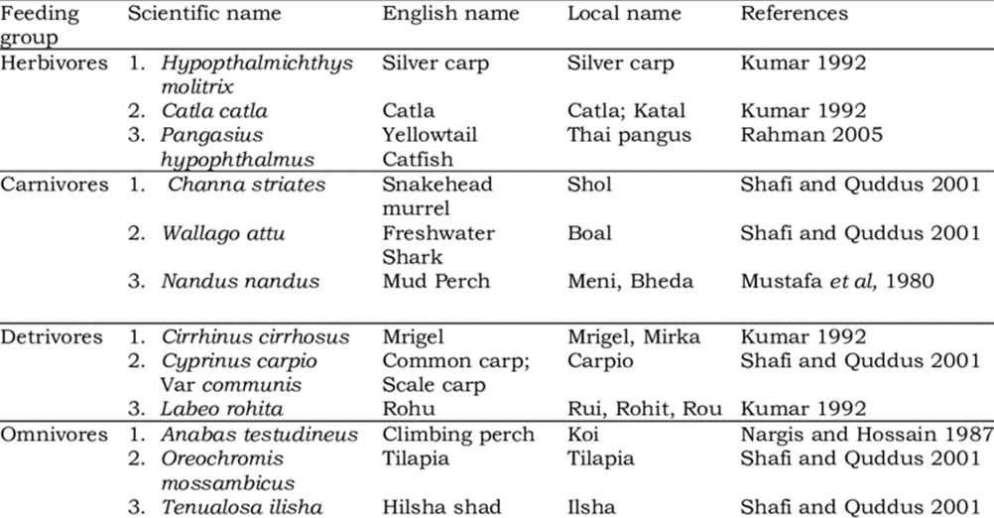

Environmental Factors Influencing Feeding Behavior
- Stress
Stress can interfere with a variety of fish feeding behaviors, such as the pursuit, discovery, or capture of prey, which can cause growth to fall in a number of fish species. Fish that are under stressful situations consume less and grow more slowly than fish that are not under stress. These circumstances are known to cause a fall in the conversion efficiency of the feed taken, which results in a lower growth rate in fish even when food intake levels are maintained (Assan, Huang et.al.,2021).
- Temperature
Fish are extremely sensitive to variations in water temperature because they are ectothermic. The need for energy rises as oxygen consumption and metabolic rates rise with rising water temperatures. Despite species-specific variations, fish typically increase their food intake with moderate temperature. According to a few studies, these feeding alterations are associated with changes in a few endocrine variables that control hunger, such as ghrelin and leptin plasma concentrations in Atlantic salmon Salmo salar and CART expression in Atlantic cod Gadus morhua. One of the key factors influencing a fish's ability to perform essential activities is the water temperature currently in the area. Temperature has a considerable impact on growth rate, feed intake, feed conversion efficiency (FCE), and stomach evacuation rate. Feed consumption and water temperature are positively correlated. Thus it is recommended to halt feeding at temperatures beyond optimum levels as warm water fish perform better at temperatures between 25 – 32 °C (Shinde,2023).
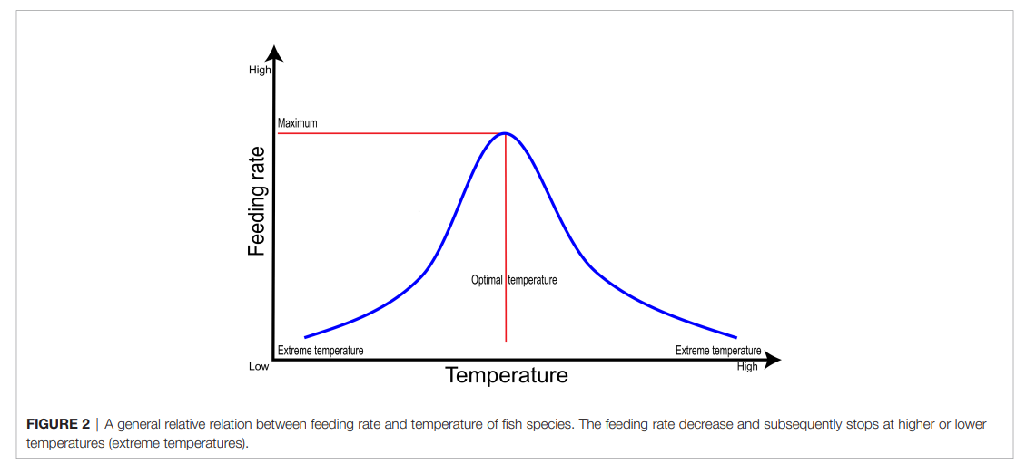
Fig. 1. | A general relative relation between feeding rate and temperature of fish species. The feeding rate decreases and subsequently stops at higher or lower temperatures (Shinde, 2023).
- Hypoxia
Fish have been shown to exhibit primary, secondary, and tertiary stress responses in response to hypoxia. However, the majority of fish can adjust to changes in DO levels, but if severe hypoxia persists, fish will eventually perish (Assan, Huang et al. 2021). A condition known as hypoxia occurs when there is not enough oxygen in the body's tissues. While hypoxia predominantly impacts distinct physiological functions and might have detrimental effects on health, it can nonetheless indirectly affect feeding behavior in a variety of ways.
- Photoperiod and light regime
Fish-eating behavior is one of many physiological and behavioral traits that are greatly influenced by photoperiod and light regimes. For fish, light is a potent environmental cue that affects their daily cycles and behaviors. According to some research, day length is the most significant environmental element influencing Atlantic salmon appetite, and as day length decreases, so does feeding. Similar to this, the length of the day appears to have a significant impact on turbot appetite; optimal feeding days were those with photoperiods longer than 15 hours. According to some reports, juvenile turbot grows more quickly when exposed to continuous light, however, this effect was only sustained for a short time. (Shinde, 2023).
- Waves, Water Current, and Wind (WWW)

Fish feeding can be affected by waves and water movement. Fish kept in non-rigid cages, which disperse very little wave energy, can be affected by both wave heights and frequency. Fish may shift away from the water's surface due to winds and rain, which may limit their ability to feed by keeping them in particular areas of the water column. The direction of the wind could affect feeding.
While the creation of moderate water currents in fish tanks may increase feed distribution and provide better feeding circumstances, excessive water velocity may decrease the capacity of fish to collect passing food items.
Infrequently, fish that exercise in moderate water currents eat more food and grow more quickly (Shinde, 2023).
- Salinity
Salinity is needed by fish to regulate fluid balance and can stimulate growth faster (Prananingtyas et al. 2019). Fish are subjected to energy restrictions when exposed to an excessive salinity gradient. At the middle of the salinity tolerance range, food intake and growth are at their highest. Raising freshwater species at the top end of the salinity range may be advantageous because these conditions reportedly allow some fish to tolerate lower oxygen concentrations. (Assan, Huang et al. 2021).
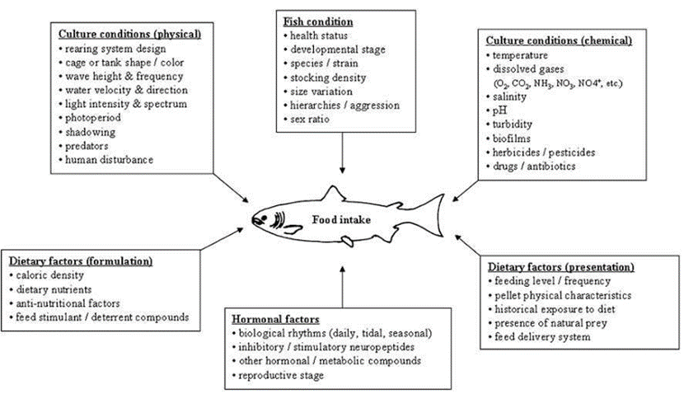
Fig.2. The complexity of factors affecting feeding behavior in fish (Shinde et al. 2023).

Feed formulation
Commercial use is the process of deciding how much of each ingredient and additive to combine to make compound feeds that match the known nutrient needs of the targeted species and help producers reach their targets at the lowest possible cost. The formulation of feeds presupposes two conditions: Essential nutrients needed, and Potential sources of these nutrients suit the feeding behaviour (Lall et al. 2022).

Nutritional Requirements of Fish

In fish production systems, a healthy, high-quality product can only be produced economically with good nutrition. Nutrition is essential in fish farming (aquaculture), where feed typically accounts for around 50% of the variable production costs. Recent years have seen significant advancement in fish nutrition thanks to the creation of new, balanced commercial diets that support ideal fish growth and health. The result of fresh, safe, species-specific diet formulations aids the aquaculture sector as it grows to meet the rising demand for fish and seafood products of all kinds (Craig et al. 2017). Nutrients are classified as macronutrients (protein, lipid, carbohydrates, and energy) and micronutrients (the 10 essential amino acids, vitamins, minerals, and essential fatty acids) (Da silva et al. 2016). Protein:18-50%, Lipids(fat):10-25%, Carbohydrate:15-20%, Ash: <8.5%, Phosphorus: <1.5%, Water: <10%, Trace amounts of vitamins and minerals (Craig et al. 2017).
Fish is a high-quality, low-fat protein. Omega-3 fatty acids, vitamins D and B2 (riboflavin) are abundant in fish. In addition to being an excellent source of minerals like iron, zinc, iodine, magnesium, and potassium, fish is also high in calcium and phosphorus. A healthy diet should include fish at least twice a week, according to the American Heart Association. Protein, vitamins, and nutrients found in fish can lower blood pressure and help lower the risk of a heart attack or stroke. Fish is also a great source of nutrition. (Riche, 2008)
Feeding Behavior and Growth Performance
In multispecies culture, diet dynamics and growth performance are important biological properties since these traits have a significant impact on fish yields. Fish species like C. carpio and Mrigal carp, which have a broad niche and feed throughout the water column, typically grow well (Mohanty et al. 2019). Additionally, competition has a significant impact on how quickly fish grow.
Faster growth and better feed conversion in farmed fish translate into lower feed costs, shorter culture times, and higher fish yields. Growth promoters are chemicals that are injected into the body at very low doses in order to produce a quantifiable improvement in growth, weight gain, and feed conversion. Many of these medications that can be given through feeds have been tested, with varied degrees of success. Protein hormones and anabolic steroids that are given through feeds cause more weight growth, and research into these topics is ongoing.
The potential effects of consuming hormone-administered fish on people are unknown, though. Additionally, non-hormonal compounds with growth-promoting qualities for fish are available and can be added to meals. Livol Amchemin-Aq, Aquagram, Grow-Fast, Bio Boost, G-Probiotic, Lykamin, Colymbi, and others are some of the growth promoters used in feeds in India. While the use of growth boosters in aquaculture is a desirable idea, their impact on weight gain, growth, and FCR should all be quantifiable simultaneously to rule out any potential adverse impacts on water quality and human health. Researchers must pay immediate attention to these aspects.
Nutritional Requirements Based on Feeding Behavior
The processes of maintenance and growth (anabolism) and the creation of energy (catabolism) within cells both need nutrients as fuel. The only source of energy for multicellular animals is the oxidation of complex chemical compounds, primarily carbohydrates and lipids. Animals are classified as heterotrophic organisms since they can only survive on the remains of other living things or other living things. In the end, all animal life depends on the presence of organisms (mostly green plants) that can utilize inorganic sources of energy, of which solar radiation is by far the most essential. Some microbes, however, acquire energy via the oxidation of simple inorganic substances (Ruiter et al. 2023).
Carnivorous finfish are those with a high need for protein, which should mostly come from animal sources. Salmonids, as well as several marine and freshwater species like seabass, seabream, eels, amberjack, groupers, and snakeheads, are included in this group. These species need between 20 and 40 percent of their diets to be made up of fishmeal. Herbivorous/omnivorous finfish: These fish have a reduced requirement for protein, which can come from either plant or animal sources. Examples include common carp, grass carp, other cyprinids, catfish, and milkfish, all of which need about 5% of their meals to be made up of fishmeal. Omnivorous/scavenger crustaceans, which include marine prawns, freshwater prawns, crabs and crayfish, need between 15 and 25 percent fishmeal in their diets. Finfish that feed on phytoplankton and zooplankton as their sole source of nutrition are known as filter-feeding species. They consist of rohu, catla, silver carp, and bighead carp.

Protein Requirement
Protein is the most expensive component of fish feed, so it's critical to precisely ascertain what each species and cultured life stage needs in terms of protein. Individual amino acid connections result in the formation of proteins. Although there are more than 200 amino acids in the natural world, only roughly 20 amino acids are widespread. Ten of these are essential (indispensable) amino acids that fish are unable to synthesize. Methionine, arginine, threonine, tryptophan, histidine, isoleucine, lysine, leucine, valine, and phenylalanine are the 10 essential amino acids that must be provided by food. Lysine and methionine are frequently the first limiting amino acids out of this group. Thus protein required by different feeders is not the same. Protein needs of omnivore (fish that eat both plants and animals) and herbivorous (fish that eat plants) fish are lower than those of carnivorous (fish that eat animal flesh). Carnivorous requires 45 percent protein Fish raised in high-density systems, such as recirculating aquaculture, have higher protein needs than fish raised in low-density systems, like ponds. (Craig et al. 2017)

Lipid requirement
A gram of protein or carbohydrate has 2.5 times as much energy as a gram of fat. The following factors can affect how easily fat is digested: Dietary intake; Type of fat; The heat of the water; Intensity of unsaturation; and Carbon chain length. The ideal lipid requirement for IMC fingerlings was discovered to be between 12 and 15%. It has been discovered that the requirement for lipids is temperature-dependent. The amount of dietary fat needed by mature fishes varies from 1 to 8 percent depending on the temperature and condition of the pond. (Riche, 2008 ). Lipids (fats) are high-energy nutrients that can be used in aquaculture feeds to partially spare (replace) protein. Proteins and carbs have about half the energy density of lipids. Fish diets typically contain lipids in amounts ranging from 7 to 15 percent, which provide important fatty acids and act as carriers for fat-soluble vitamins. (Craig et. al. 2017)

Carbohydrate Requirement
Carbohydrates serve as a crucial source of energy for fish, alongside proteins and lipids. While fish do not have strict dietary requirements for carbohydrates, they are commonly included in their diets for their cost-effectiveness and as a binding agent in pellets. Carbohydrates also play a vital role in forming metabolic intermediates necessary for growth. They exhibit a protein-sparing effect in many aquaculture species, aiding in efficient nutrient absorption in the gastrointestinal tract. Certain species like carp, tilapia, milkfish, and prawns excel in utilizing carbohydrates for energy, while carnivorous fish have limited metabolic capacity for it. Inadequate dietary carbohydrates lead to fish utilizing protein for energy, at the expense of growth. Herbivorous species like carp rely heavily on digestible carbohydrate sources. Understanding the varying capacities of different fish species to utilize carbohydrates is crucial in formulating balanced diets. For instance, rainbow trout efficiently utilize specific carbohydrate forms, whereas even a small inclusion of starch is beneficial for salmon. Prawns exhibit high efficiency in utilizing poly- and di-saccharides. Optimum carbohydrate requirements range from 22-40%, with carp needing 22-26%, common carp requiring 30-40%, and rainbow trout needing less than 25%. Commercial prawn diets generally contain 35-40% carbohydrates, highlighting their significance in aquaculture nutrition.

Vitamins and Mineral
Vitamins are crucial organic compounds essential for supporting fish growth and overall health. Since fish often lack the capacity to synthesize them internally, they must be provided in their diet. Vitamins are divided into two groups: water-soluble and fat-soluble. Water-soluble vitamins encompass B vitamins, inositol, choline, and vitamin C, with the latter playing a particularly vital role as a potent antioxidant and immune enhancer. Fat-soluble vitamins include A, D, E, and K, with vitamin E garnering significant attention for its antioxidant properties. Both vitamins E and C, when included in the feed, act as effective inhibitors of dietary lipid oxidation, thus extending product shelf life. Specific vitamin deficiencies lead to distinct symptoms, yet reduced growth remains the most prevalent sign. Ascorbic acid deficiency may result in scoliosis, characterized by a bent backbone, while folic acid deficiency can lead to dark coloration. According to the required quantity and presence of fish, minerals can be divided into two groups: macrominerals and microminerals. Minerals are necessary for regular physiological processes. Fish can make up for nutritional deficiencies thanks to their extraordinary capacity to absorb nutrients straight via their skin and gills. Macrominerals like calcium, sodium, chloride, potassium, sulfur, phosphorous, and magnesium are essential for maintaining bone growth and integrity as well as managing osmotic balance. Microminerals, on the other hand, are essential parts of enzyme and hormone systems and are needed in lesser amounts. Examples include iron, copper, chromium, iodine, manganese, zinc, and selenium. Together, these minerals support the general health and well-being of fish, highlighting their importance for aquaculture nutrition. (Craig et. al. 2017)

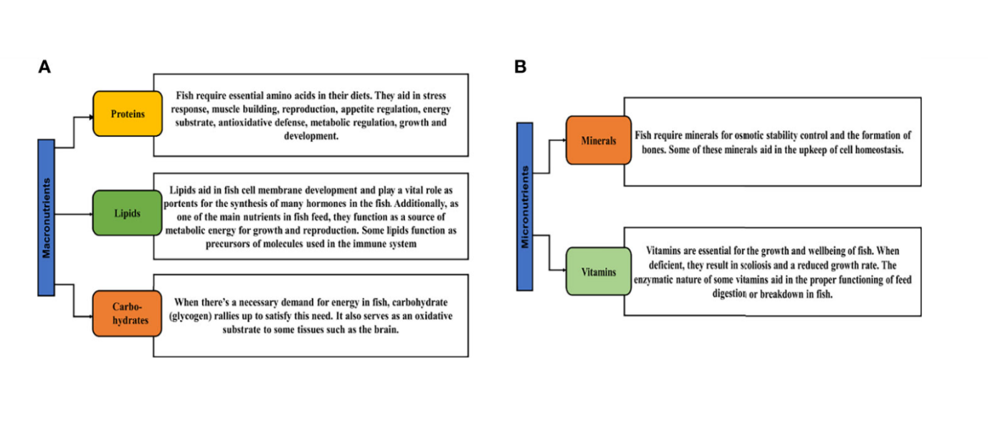
Fig.3. The role and importance of key macronutrients (A) and micronutrients (B) in fish food. Proteins; lipids; carbohydrates; minerals and vitamins; (Assan, Huang et al. 2021).
Feeding and Reproduction
The health, growth, reproduction, and lifespan of fish are all greatly enhanced by the wise selection and consumption of food and nutrients. However, dietary needs vary depending on an animal's life cycle, physiological state, and reproductive status. Several hypothalamic neuroendocrine factors, including orexin, galanin, neuropeptide Y (NPY), agouti-related peptide (AgRP), proopiomelanocortin (POMC), cocaine- and amphetamine-regulated transcript (CART), among others, may be important in the complex behavior of feeding that is regulated by central and peripheral neuroendocrine/endocrine signals. In addition to the "classical" neuroendocrine factors, e.g., gonadotropin-releasing hormone (GnRH), dopamine, g-aminobutyric acid (GABA), serotonin and NPY, new actors as gonadotropin-inhibitory hormone (GnIH), kisspeptin (Kiss), spexin (SPX), neurokinin B/tachykinin (NKB/TAC) and secretoneurin (SN) have gained increasing importance in the regulation of fish reproduction over the last decade.The endocrine system plays a key role in mediating interactions between physiological systems, such as nutrition and reproduction, and changes in the external environment and internal reactions. Animals may alter their reproductive function in response to their energy reserves. For instance, food restriction, which depletes energy reserves, suppresses the HPG axis to conserve energy for essential processes. Numerous peptides have been shown to play a role in the regulation of feeding and reproduction in fish, just like in mammals. These include both central and peripheral variables, such as leptin and ghrelin, as well as brain-related ones like neuropeptide Y (NPY) and orexin. Throughout their natural life cycle, fish frequently experience decreases in food availability (and, consequently, in their capacity to store energy), particularly during seasonal cycles and spawning migrations. The sensory and endocrine systems of fish can either complete reproductive development and spawning under ideal conditions or delay/abort reproduction under non-ideal conditions (size and/or age conditions, storage levels, i.e. levels of sugars, amino acids, and lipids). The underlying mechanisms, nevertheless, are yet unclear. In "malnutrition" situations, females frequently show more severe reproductive issues (inhibition of vitellogenesis, oocyte maturation, and spawning) than males (reduced sperm volume and lower milt fluidity, which may severely impact the success of egg fertilization).
Effects of feed restriction
In fish species as well as between men and females within species, there is a great deal of variance in both age and size at puberty, with male growth often levelling off at a smaller size and age than females (e.g., sea bass, halibut, etc.). Like with all vertebrates, fish achieve puberty when they have reached a particular size and age, and most likely when they have acquired enough energy stores (often in the form of body fat) to meet the dietary and energetic needs of maturation.
During puberty, energy is switched from somatic growth (body growth, excluding gonad growth), to gametogenesis and reproductive behaviors including migrations and/or sexual behavior before and during spawning. People who reach puberty early are typically the larger individuals within a society, and the onset of puberty can initially have good impacts on appetite and somatic growth. However, the appetite is frequently diminished shortly before and throughout a significant portion of the spawning season. According to studies, limiting feeding can decrease some species' growth rates, energy storage, and adiposity as well as the proportion of fish that reach full maturity, delaying puberty age.
Reducing a mature fish's feeding during the reproductive cycle can reduce growth, GSI, gonadal maturation, final oocyte maturation, egg quality, and spawning frequency during the reproductive season (or delay spawning time) in many species, though not all. Females are typically more affected than males. When compared to fish fed full rations, the eggs and larvae produced by feed-restricted female fish are frequently smaller. Fasting may block the HPG axis in some animals because it lowers brain GnRH and plasma estradiol levels in females. Females are more susceptible to dietary constraints than males, and there is gender-specific reactions.

Human Impact on Fish Feeding Behavior
Environmental change has always affected aquatic ecosystems, but human activities have significantly expedited this change (Halpern et al., 2008). Many populations have experienced declines or even extinctions as a result of human activity. Increasing evidence suggests that populations are altering ecologically important features in response to unique human-induced selection (Hendry, Farrugia, & Kinnison, 2008). It has recently become clear that behavioral variation is crucial for illuminating whether species adapt to environmental change, thrive, or perish (Sih, Ferrari, & Harris, 2011). A variety of behavioral reactions to human disturbances have been discussed elsewhere (Candolin & Wong, 2012; Sih et al., 2011; Smith & Blumstein, 2013; Tuomainen & Candolin, 2011; Wong & Candolin, 2015), ranging from initial plastic responses to evolutionary ones.
Notably, however, the behavioural effects of harvesting, particularly fishing, have been largely ignored and are only now receiving more attention (Arlinghaus et al., 2016). For brief discussions, see Miller, 1957; Heino & God, 2002; Uusi-Heikkilä, Wolter, Klefoth, & Arlinghaus, 2008; Smith & Blumstein, 2013). This is regrettable because fishing is a significant cause of mortality in the majority of fish stocks. Fishing selection is thought to primarily focus on life cycle attributes (reviewed by Heino, Diaz Pauli, & Dieckmann, 2015), but harvesting is also likely a major force behind changes in fish behavior (Arlinghaus et al., 2016; Uusi-Heikkilä et al., 2008). We can better understand the effects fishing-induced alterations have on fish populations and management by studying the behavioural response to fishing and its corresponding physiological and life-history features.
Any attribute that controls an individual's susceptibility to fishing (i.e., survival) is impacted by fishing-induced selection. Fishing may cause plastic changes in behavior through learning and developmental plasticity, or evolutionary changes if the behavioral variations associated with sensitivity are inherited. Fishing-related alterations to life histories and associated behaviors can also have an impact on behavior. The direction and strength of the evolutionary change are ultimately determined by the interaction between fishing-induced change and changes brought about by natural selection and other selective processes (Edeline et al., 2009). Populations, communities, and ecosystems may be impacted by the phenotypic change that results (either plastic or evolutionary) (Arlinghaus et al. 2016; Palkovacs et al. 2012). Although it has long been known that fishing can favour particular behaviours (Miller, 1957), formal research on the behavioral selectivity of fishing and its ecological and evolutionary effects has been limited.

Tourism businesses use fish feeding, a well-liked tourist attraction at coral reefs all over the world, to attract particular species and give guests a close-up look at marine life. However, research indicates that this activity may affect the structure, abundance, and distribution patterns of marine fish communities (Brunnschweiler & Barnett 2013, Brunnschweiler et al. 2014), as well as the health of fish by causing them to accumulate more fat and make them more susceptible to ectoparasite- and microorganism-caused diseases (Semeniuk & Rothley, 2008).
Fish behavioural modifications are one of this activity's principal side effects. For instance, species that would not normally approach humans openly assemble around bathers to obtain additional nourishment since they have grown accustomed to our presence (Albuquerque et al. 2014). In addition, fish can develop a dependence on fish feeding (Ilarri et al. 2008), and over time, the learned behavior of eating from human hands may make it harder for fish to forage for themselves in the wild. Increased aggression during feeding, both among fish competing for food and toward those feeding them, is another behavioral shift documented in the literature (Milazzo, 2011). The naturally nocturnal southern stingray (Hypanus americanus), which became diurnal as a result of daytime fish-feeding activities (Corcoran et al. 2013), is an example of how fish feeding may also cause changes in circadian rhythms.
Worldwide, coral reef-based travel has seen a rapid increase (Milazzo et al. 2002), along with a surge in tourists' feeding of fish. Studies examining the effects of this behavior on these distinctive ecosystems have increased as a result of worries about the detrimental effects of fish feeding (Medeiros et al. 2007). However, very few studies (Medeiros et al. 2007, Ilarri et al. 2008, Feitosa et al. 2012, Pereira et al. 2021, Albuquerque et al. 2014) have examined the effects of fish feeding on coral reefs in the South Atlantic Ocean. In order to improve the management and conservation of these areas, detailed studies focusing on this area are required to gain a deeper understanding of the effects of fish feeding on the biology of reef fish, which range from physiological and behavioral aspects to impacts on fish communities.

Strategies that are affecting feeding behavior and habit
The most straightforward and popular technique for assessing a feeding strategy is growth. Fish retain the desired rate of growth when a successful method is used to achieve production targets. Another sign is consistent growth. Theoretically, fish fed a diet that satisfies reaching their genetic potential means meeting all of their dietary needs at the right time and rate. and expand at comparable rates. Continuous growth is another reliable indicator. The mortality rate can be used to assess feeding strategy as well. By lowering stress and boosting an animal's natural immune system, well-balanced diets decrease susceptibility to disease outbreaks. Additionally, they lessen the prevalence of cannibalism in species that engage in it. Presenting balanced feed at the right frequency and timing also lessens aggressive behaviour and fin-nipping. A good indicator of appropriate nutrition is the health state. The presence of ill or feeble-swimming fish, as well as sporadic disease outbreaks, suggest that feed management needs to alter. Fish can also be looked at externally for indications of nutrient deficits or toxicity, though clinical diagnoses are beyond the knowledge and resources of most farm managers. Another helpful resource is the current water quality. Water quality can be damaged by overfeeding or feeding foods of inferior quality. Maintaining proper ammonia or nitrite levels can be challenging, which may be an indication of excessive feeding, feed with subpar protein sources, excessive protein content, or poor calorie content. Problems with low dissolved oxygen or high solids levels may be signs of poorly digested components in the feed, which may raise organic burdens. A simple technique to assess feeding management is to keep an eye on farm and animal productivity. In contrast to overfeeding, which reduces water quality, underfeeding results in slower-than-expected growth and a longer time to market, which raises expenses and reduces farm productivity. A decline in efficiency may need a reevaluation of the overall feeding management plan since optimal fish growth occurs when energy supplied by fats and carbs is appropriate and amino acids are absorbed in the proper balance at the right time (Riche et al. 2003).
Reduction of waste through diet
formulation

Reduction of waste through diet
formulation
Reduction of waste through diet
formulation
Reduction of waste through diet
formulation
Reduction of waste through diet
formulation
Reduction of waste through diet
formulation
Reduction of waste through diet formulation
For waste reduction by diet formulation, the key elements that determine fish waste outputs are the ingredients' digestibility and the diet's nutrient composition. Therefore, reducing waste outputs from aquaculture operations should begin with the diet formula (Cho et al. 2001). Feeding must not be too much and too quickly. This wastes money and pollutes fish farms. It is best to give frequent feeds in small quantities

References
Shinde, Sagar Vitthal, and Kapil Sukhdhane. "Effect of Different Environmental Factors on Fish Appetite."

Shinde, Sagar Vitthal, and Kapil Sukhdhane. "Overview of Different Nutraceuticals used in Fisheries and Aquaculture."

Lall, Santosh P., and André Dumas. "Nutritional requirements of cultured fish: Formulating nutritionally adequate feeds." Feed and feeding practices in aquaculture. Woodhead Publishing, 2022. 65-132.

Craig, Steven R., Todd R. Gardner, and Oliana Carnevali. "Growout and broodstock nutrition." Marine ornamental species aquaculture (2017): 139-158.

Da Silva, Rodrigo Fortes, Alexandre Kitagawa, and Francisco Javier Sanchez Vazquez. "Dietary self-selection in fish: a new approach to studying fish nutrition and feeding behavior." Reviews in fish biology and fisheries 26 (2016): 39-51.

Riche, M., and D. Garling. "Fish: Feed and Nutrition." Feeding Tilapia in intensive Recirculating systems (2003).

Cho, C. Y., and D. P. Bureau. "A review of diet formulation strategies and feeding systems to reduce excretory and feed wastes in aquaculture." Aquaculture research 32 (2001): 349-360.

Mohanty, Bimal Prasanna, et al. "Nutritional composition of food fishes and their importance in providing food and nutritional security." Food chemistry 293 (2019): 561-570.

Halpern, Benjamin S., et al. "A global map of human impact on marine ecosystems." science 319.5865 (2008): 948-952.

Hendry, Andrew P., Thomas J. Farrugia, and Michael T. Kinnison. "Human influences on rates of phenotypic change in wild animal populations." Molecular ecology 17.1 (2008): 20-29.

Sih, Andrew, Maud CO Ferrari, and David J. Harris. "Evolution and behavioural responses to human‐induced rapid environmental change." Evolutionary applications 4.2 (2011): 367-387.

Candolin, Ulrika, and Bob BM Wong, eds. Behavioural responses to a changing world: mechanisms and consequences. Oxford University Press, 2012.

Arlinghaus, Robert, et al. "Recommendations for the future of recreational fisheries to prepare the social‐ecological system to cope with change." Fisheries Management and Ecology23.3-4 (2016): 177-186.

Smith, Brian R., et al. "Animal personalities and conservation biology." Animal personalities: behavior, physiology, and evolution (2013): 379-411.

Tuomainen, Ulla, and Ulrika Candolin. "Behavioural responses to human‐induced environmental change." Biological Reviews86.3 (2011): 640-657.

Wong, Bob BM, and Ulrika Candolin. "Behavioral responses to changing environments." Behavioral Ecology 26.3 (2015): 665-673.

Uusi-Heikkilä, Silva, et al. "A behavioral perspective on fishing-induced evolution." Trends in ecology & evolution 23.8 (2008): 419-421.

Heino, Mikko, Beatriz Díaz Pauli, and Ulf Dieckmann. "Fisheries-induced evolution." Annual review of ecology, evolution, and systematics 46 (2015): 461-480.

Edeline, Eric, et al. "Harvest-induced disruptive selection increases variance in fitness-related traits." Proceedings of the Royal Society B: Biological Sciences 276.1676 (2009): 4163-4171.

Palkovacs, Eric P., et al. "Fates beyond traits: Ecological consequences of human‐induced trait change." Evolutionary Applications 5.2 (2012): 183-191.

Miller, Richard B. "Have the genetic patterns of fishes been altered by introductions or by selective fishing?." Journal of the Fisheries Board of Canada 14.6 (1957): 797-806.

Brunnschweiler, Juerg M., and Adam Barnett. "Opportunistic visitors: long-term behavioural response of bull sharks to food provisioning in Fiji." PLoS One 8.3 (2013): e58522.

Brunnschweiler, Juerg M., Kátya G. Abrantes, and Adam Barnett. "Long-term changes in species composition and relative abundances of sharks at a provisioning site." PLoS One 9.1 (2014): e86682.

Semeniuk, Christina AD, and Kristina D. Rothley. "Costs of group-living for a normally solitary forager: effects of provisioning tourism on southern stingrays Dasyatis americana." Marine Ecology Progress Series 357 (2008): 271-282.

Albuquerque, Tiago, et al. "In situ effects of human disturbances on coral reef-fish assemblage structure: temporary and persisting changes are reflected as a result of intensive tourism." Marine and Freshwater Research 66.1 (2014): 23-32.

Ilarri, Martina Di Iulio, et al. "Effects of tourist visitation and supplementary feeding on fish assemblage composition on a tropical reef in the Southwestern Atlantic." Neotropical Ichthyology 6 (2008): 651-656.

Milazzo, Marco. "Evaluation of a behavioural response of Mediterranean coastal fishes to novel recreational feeding situation." Environmental Biology of Fishes 91 (2011): 127-132.
Corcoran, Mark J., et al. "Supplemental feeding for ecotourism reverses diel activity and alters movement patterns and spatial distribution of the southern stingray, Dasyatis americana." PLoS One 8.3 (2013): e59235.

Milazzo, Marco, et al. "The impact of human recreational activities in marine protected areas: what lessons should be learnt in the Mediterranean Sea?." Marine ecology 23 (2002): 280-290.

Medeiros, Renata J., et al. "Determination of inorganic trace elements in edible marine fish from Rio de Janeiro State, Brazil." Food control 23.2 (2012): 535-541.

Feitosa, Caroline Vieira, et al. "Recreational fish feeding inside Brazilian MPAs: impacts on reef fish community structure." Journal of the Marine Biological Association of the United Kingdom 92.7 (2012): 1525-1533.

Pereira, Pedro Henrique Cipresso, et al. "Overexploitation and behavioral changes of the largest South Atlantic parrotfish (Scarus trispinosus): Evidence from fishers' knowledge." Biological Conservation 254 (2021): 108-940.

Riche, Marty, and D. F. Garling. "Feed and Nutrition." Feeding Tilapia in Intensive Recirculating Systems. Available online: http://www. hatcheryfeed. com/hf-articles/141/(accessed on 13 May 2017) (2003).

Cho, C. Y., and D. P. Bureau. "A review of diet formulation strategies and feeding systems to reduce excretory and feed wastes in aquaculture." Aquaculture research 32 (2001): 349-360.

Ruiter, Floor AA, et al. "Optimization of Media Change Intervals through Hydrogels Using Mathematical Models." Biomacromolecules 24.2 (2023): 604-612.

Lorenzetti, Fred D., Douglas A. Baxter, and John H. Byrne. "Molecular mechanisms underlying a cellular analog of operant reward learning." Neuron 59.5 (2008): 815-828.

Assan, Daniel, et al. "Fish feed intake, feeding behavior, and the physiological response of apelin to fasting and refeeding." Frontiers in Endocrinology 12 (2021): 798903.

Croll, Donald A., et al. "Filter feeding." Encyclopedia of marine mammals. Academic Press, 2018. 363-368.

Rahman, Mohammad Shamsur, et al. "Incidence of Vibrio cholerae in twelve freshwater fishes in fish markets of Dhaka metropolitan city, Bangladesh." Bangladesh Journal of Zoology37.1 (2009): 113-121.

Shinde, Sagar Vitthal, and Kapil Sukhdhane. "Effect of Different Environmental Factors on Fish Appetite."

Prananingtyas, D., and S. Rahardja. "Effect of different salinity level within water against growth rate, survival rate (FCR) of catfish (Clarias sp.)." IOP Conference Series: Earth and Environmental Science. Vol. 236. No. 1. IOP Publishing, 2019.

Craig, Steven R., et al. "Understanding fish nutrition, feeds, and feeding." (2017).

Riche, M. A. "Food for thought: feeding management strategies (Part 2)." Global Aquaculture Advocate 11.1 (2008): 68-70.
Ahmed, Imtiaz. "Dietary amino acid L-tryptophan requirement of fingerling Indian catfish, Heteropneustes fossilis (Bloch), estimated by growth and haemato-biochemical parameters." Fish physiology and biochemistry 38 (2012): 1195-1209.
Croll, Donald A., et al. "Filter feeding." Encyclopedia of marine mammals. Academic Press, 2018. 363-368.
Royes, Juli-Anne B., and Frank A. Chapman. "Preparing Your Own Fish Feeds: Cir 97/FA097, 2/2003." EDIS 2003.6 (2003).

