MRR & R_{a} prediction & analysis for VMC-5 Axis Machined D3 Steel

Dr. Arun Patil
Dean, JSPM’s BSIOTR, Pune
Dept. of Mechanical Engineering
Savitribai Phule Pune University, Pune, India
patil.mailme@gmail.com
Dr. Anil L. Wanare
Professor, JSPM’s BSIOTR, Pune
Dept. of Electronics & Telecom. Engineering
Savitribai Phule Pune University, Pune, India
alwanare_entc@jspmbsiotr.edu.in

ABSTRACT
For milling processes based on rotary cutters, the contemporary machining technology, VMC five-axis, is employed to eliminate extra work material. In order to achieve machining economics in VMC-5-axis machining, the choice of the best processing variables is essential. Key response factors include surface roughness and the rate of material removal, and the integrated analysis and optimisation of these responses is a significant area of milling research. The goal of the current research is to determine, model, and simulate the ideal milling parametric condition for VMC-5-axis machining of D3 tool steel in order to predict surface roughness and MRR simultaneously using response surface methodology and multi-objective teaching learning-based optimization (MTLBO). The tests were created using the Box-Behnken design of the response surface technique. Statistical Variance Analysis (ANOVA) was used to assess the significance of milling conditions for milling output characteristics. The ANOVA results show that for MRR, milling processing parameters are more important than surface roughness. RSM provides response modelling services. Contour plots are created using well-known mathematical models to show the individual and combined effects of milling conditions on both responses. The MTLBO method is used to resolve multiple replies. The anticipated milling conditions are verified by confirmatory testing. The research was used to draw the conclusions. From the current study, it can be seen that the hybrid approach to RSM and MTLBO results in improved milling responses at the desired condition.

Keywords— MTLBO, RSM, D3 Steel,

INTRODUCTION

For the aerospace industry, the automobile industry and other sectors where high-quality surfaces are of considerable importance, milling processes are commonly used to create complex types such as holes, bags, precision moulds and dies, etc.[1]. In modern manufacturing industries, vertical machining centre (VMC) five-axis machining is gaining popularity because it can be useful to build complicated / complex features on components with extremely high standards at lower production costs and decreased production time [2]. VMC process requirements are properly understood to make use of all its unique characteristics to manufacture high-quality components with economical machining. In the five-axis milling process of VMC, certain inaccuracies such as rough surfaces, dimensional inaccuracy, burr, etc. are often observed in work pieces [3]. Wrong choice of control variables, vibration during machining, gradual wearing out of the insert, loss of rigidity in machine tool systems, defects in the material of the work piece [4] etc., are the reasons for the inaccuracies. Among the other inaccuracies, it could be possible to choose optimum milling processing parameters by undertaking experimental research depending on experiment design. DOE is a comprehensive method used to perform research into production processes such as VMC five-axis machining to monitor different inaccuracies and to optimize milled surface characteristics [5]. In order to achieve improved milling economics in VMC five axis machining, appropriate choice of process parametric configuration can also be beneficial. In order to determine the quality of machined parts, surface roughness is defined [3]. For many industrial uses, fine surface finish on structures / products is ideal. The quantitative parameter used to assess productivity in the milling process is known to be the material removal rate. The higher rate of output suggests a higher MRR. For industrial practices, achieving good surface finish along with maximum MRR is an important field of study. It is difficult for researchers to maximize all the responses, i.e. surface roughness and MRR. Integrated Response Surface Methodology (RSM) and multi-objective optimization of teaching- learning based optimization (MTLBO) have been found to be successful in evaluating, modeling, and optimizing the multi-performance features of machining processes [6].
The methodology of the response surface is one of the valuable statistical methods useful for organizing, evaluating and modeling experiments by monitoring process conditions in any production process [5]. Teaching learning-based optimization is a probabilistic methodology that mimics the method of teaching learning and appears to be useful in solving engineering problems [7]. Based on analysis, modeling and optimization of production / processes using experiment design, analysis of variance, statistical modeling and optimization of process responses using RSM, Taguchi procedure, TLBO and other analytical methods or techniques, the literature survey covers the research work. The literature survey details are given as follows:
In order to refine the multiple responses such as SR and MRR using variance analysis and Taguchi process, Malvade and Nipanikar 2014 [8] have carried out experimental studies on end milling on VMC. From the analysis, they reported that for both responses, influences of process variables were most important. The mathematical model of surface roughness in face milling process using the technique of particle swarm optimization (PSO) was solved by Raja et al [9]. In order to optimize the cutting conditions to achieve desired surface roughness and MRR simultaneously in high-speed end milling operation, Lu et al. [10] applied GRA coupled with PCA. Tejas et al. 2014[11] performed a mild steel milling analysis on VMC to predict various surface roughness responses and MRR. Researchers from the report found that responses were enhanced relative to initial test runs. In order to maximize output response in TIG welding of stainless steel using RSM and TLBO, Moi et al. 2019 [7] conducted parametric analysis to monitor processing conditions. Rudrapati et al 2016 [12] used the hybrid RSM and TLBO method to predict the performance reaction of aluminum alloy in CNC turning. With advanced RSM optimization strategies together with TLBO, they found improved outcomes. Again, the process variables of turning operation with the use of RSM and elitist TLBO were optimized by Rudrapati et al 2016 [13].
The purpose of the current research is to investigate the effect of milling variables on the VMC five-axis machined D3 steel component's surface roughness and MRR. Using RSM, milling studies have been carried out to determine the results of machining variables. ANOVA is carried out to investigate and assess the importance of the conditions of milling production for improved surface finish and MRR. RSM and multi-objective TLBO methodology also employ simulation and optimization to achieve better milling economics.

ANALYSIS AND OPTIMIZATION METHODS

Response surface methodology
Response Surface Methodology (RSM) is a compilation of mathematical and computational methods for empirical model-building [14]. The aim is to maximize (output variables) responses that are affected by several independent variables (input variables) by careful experiment design. An experiment is a series of trials, or runs, in which the input variables are changed to analyze the severity of changes in the output responses. The response surface method is the most effective technique for interpreting the findings obtained from factorial studies. It is an important tool for modelling and evaluating the problems of output. It gives more detail, with less investigative numbers. It is a research method to measure the limits of the input parameters and the emerging experiential statistical model for the analyzed response by approximating the relationship between the response and the variables of the input process. In the surface response approach, the process variables limit must be defined and the very first test was performed to determine the machining variables that affect the surface roughness and MRR and to show the range of cutting variables selected.
In RSM, the complete quadratic relationship between the output response and the input parameters can be represented in [15] Eq.1.
Y=β₀ + β₁(A) + β₂(B) + β₃(C) + β₁₁(A * A) + β₂₂(B * B) + β₃₃(C * C) + β₁₂(A * B) + β₁₃(A * C) + β₂₃(B * C) (1)
Where, Y is output response, A, B, and C process parameters and all the β’s are coefficients of input parameters

Teaching-learning-based Optimization (TLBO)
Teaching-learning-based optimization (TLBO) is a stochastic techniques of optimization that mimics the method of teaching-learning suggested by Rao et al.[16]. The workings of TLBO are described below.
Teacher stage: The first step of the algorithm is where the teacher teaches from the learners. A teacher aims to improve the average outcome of the classroom from any M1 value to its level ( i.e. TA) at this stage. Eqs.2 provides an understanding of updating students ' knowledge.

Difference _ Meani = ri (Mnew – Mj) (2)

Based on this Difference_Mean, the existing solution is updated by using Eq. 3.

Xnew,i = Xold,i + Difference _ Meani (3)

Where, X_{new, i}= new solution; X_{Old, i} = existing solution / solution in the i^{th} iteration.

Learner stage: The second component of the TLBO algorithm is the learner phase. The learning phenomenon of the learner's process is described mathematically in Eqs. 4 and 5. Considering two separate Xi and Xj learners at any iteration i where i ≠ j.

Xnew,i = Xold,I + ri ( Xi - Xj) if f(Xi) < f (Xj) (4)

X_{new,i} = X_{old,i}+ r_{i} ( X_{j} - X_{i}) if f(X_{j}) < f (X_{i}) (5)

Accept Xnew if it gives comparatively better function value. where Xi and Xj = two independent learners those have different knowledge levels in the class, those are interacting each other to update their knowledge levels.

EXPERIMENTAL PROCEDURE

By considering DOC(A), cutting speed (B) and feed (C) as input control variables for VMC-five-axis machining of D3 steel component, the Box-Behnken design based on RSM was used to design the experiments. In Table 1, the selected milling parameters and their differing levels are shown. In Table 2, the Box-Behnken experimental design is provided. The experimental setup is shown in Fig. 1. MRR is measured and shown in Table 2. For D3 steel materials, the experimental data for surface roughness and MRR is used to evaluate, model and optimise the process parameters of the VMC-5-axis machine using ANOVA, RSM along with MTLBO.

Table 1: Input control parameters and their levels

Sr.No. | Parameters | Units | Level-1 | Level-2 | Level-3
1. | Depth of cut (A) | mm | 0.1 | 0.15 | 0.2
2. | Speed (B) | rpm | 3000 | 3500 | 4000
3. | Feed (C) | rev/min | 1500 | 2000 | 2500

Table 2: Box-Behnken experimental design and output responses.

Sr.No. | Input parameters |  |  | Output responses
 | A | B | C | SR | MRR
1. | 0.10 | 3000 | 2000 | 2.028 | 4.692
2. | 0.15 | 3500 | 2000 | 2.933 | 5.517
3. | 0.15 | 4000 | 2500 | 2.635 | 5.926
4. | 0.15 | 4000 | 1500 | 3.251 | 5.372
5. | 0.10 | 4000 | 2000 | 3.843 | 3.842
6. | 0.20 | 3000 | 2000 | 3.323 | 6.500
7. | 0.20 | 3500 | 1500 | 3.611 | 7.328
8. | 0.15 | 3500 | 2000 | 2.933 | 5.517
9. | 0.20 | 4000 | 2000 | 1.890 | 7.500
10. | 0.10 | 3500 | 1500 | 1.686 | 5.361
11. | 0.20 | 3500 | 2500 | 1.989 | 8.434
12. | 0.10 | 3500 | 2500 | 5.211 | 3.965
13. | 0.15 | 3500 | 2000 | 2.933 | 5.517
14. | 0.15 | 3000 | 2500 | 3.038 | 5.878
15. | 0.15 | 3000 | 1500 | 2.087 | 5.330

RESULTS AND ANALYSIS

Present work is designed to examine the importance of VMC process variables on surface roughness (Ra) and MRR of D3 steel material, as mentioned earlier. The data shown in Table 2 were used for evaluate, model and interpret the Ra and MRR using statistical ANOVA and RSM technique. Combined effects of milling parameters on both the performance measures are depicted by generating contour plots. Finally, multi-objective TLBO was used to solve the mathematical models of both the responses together.

Analysis of variance for surface roughness and MRR
Analysis of variance (ANOVA) from MINITAB 16.2 software is applied on the experimental data as given in Table 2 to identify the significant control parameters which has detrimental effects on surface roughness and MRR. The results of ANOVA are given in Tables 3 and 4 for surface roughness and MRR respectively. ANOVA test is performed at 95% confidence level i.e. 5% significant level. If the value of probability (P) is less than 0.05, it indicates that the effects of process parameters on corresponding responses are significant [2].
From ANOVA results of surface roughness (Ra) as given in Table 3, it is noted that direct effect of feed (C) have significant effect on surface roughness as its P value is less than 0.05. Process parameters, depth of cut (A) has considerable effect on surface roughness as its P value is very close to 0.05, and speed (B) is insignificant on Ra, as seen from Table 3. Interaction effects of all the parametric combinations are most significant as their P values are zero / very close to zero as found in Table 3. Square combinations of the milling parametric combinations are not significant at 95% confidence level as observed from Table 3. From the ANOVA of MRR (Table 4), it is observed that direct effect of depth of cut (A) is most significant for MRR as its P value is zero and other parameters like seed (B) and feed (C) are not influential on MRR, because their P values are more than 0.05. The square combinations of depth of cut (A)* depth of cut (A), feed (C)* feed (C) and interactions of depth of cut (A)* speed (B), speed (B)* feed (C) are significant for MRR because its P values are less than 0.05 as seen from Table 4.

Table 2: Analysis of variance for surface roughness & MRR of VMC-five machining of D3 steel.

Source | DF | Adj SS | Adj MS | F Value | P Value | Adj SS | Adj MS | F Value | P Value
Model | 09 | 11.4982 | 1.27758 | 16.97 | 0.003 | 21.5733 | 02.3970 | 033.27 | 0.001
Linear | 03 | 01.2671 | 0.42238 | 05.61 | 0.047 | 17.7968 | 05.9323 | 082.33 | 0.000
A | 01 | 00.4778 | 0.47775 | 06.35 | 0.053 | 17.7072 | 17.7072 | 245.75 | 0.000
B | 01 | 0.01633 | 0.16331 | 02.17 | 0.201 | 00.0072 | 00.0072 | 000.10 | 0.765
C | 01 | 00.6261 | 0.62608 | 08.32 | 0.034 | 00.0824 | 00.0824 | 001.14 | 0.334
Square | 03 | 00.3569 | 0.11897 | 01.58 | 0.305 | 01.3558 | 00.4519 | 006.27 | 0.038
A * A | 01 | 00.0405 | 0.04051 | 00.54 | 0.496 | 00.5360 | 00.5360 | 007.44 | 0.041
B * B | 01 | 00.2627 | 0.26273 | 03.49 | 0.121 | 00.2583 | 00.2583 | 003.59 | 0.117
C * C | 01 | 00.0276 | 0.02763 | 00.37 | 0.571 | 00.5165 | 00.5165 | 007.17 | 0.044
2-Way Interaction | 03 | 09.8742 | 3.29138 | 43.73 | 0.001 | 02.4206 | 00.8069 | 011.20 | 0.012
A * B | 01 | 02.6374 | 2.63738 | 35.04 | 0.002 | 00.8556 | 00.8556 | 011.87 | 0.018
A * C | 01 | 06.6229 | 6.62290 | 87.99 | 0.000 | 01.5650 | 01.5650 | 021.72 | 0.006
B * C | 01 | 00.6139 | 0.61387 | 08.16 | 0.036 | 00.0000 | 00.0000 | 000.00 | 0.992
Error | 05 | 00.3763 | 0.07526 |  |  | 00.3603 | 00.0721
Lack of Fit | 03 | 00.3763 | 0.12544 | * | * | 00.3603 | 00.1201 | * | *
Pure error | 02 | 00.0000 | 0.00000 |  |  | 00.0000 | 00.0000
Total | 14 | 11.8745 |  |  |  | 21.9336

From the ANOVA results of both the output performances as given in Tables 3 and 4, it is stated that processing conditions are more significantly influencing MRR as compared to the surface roughness. This aspect needs to study elaborately to determine the significant milling conditions. Next section, analysis is continued for mathematical modeling and contour plots generation to visualize the factor effects on response measures.

Mathematical modeling for surface roughness (Ra) and MRR
Response surface methodology (RSM) is efficient regression tool which useful to generate the correlations between the process control variables and performance characteristics of any engineering system / process. RSM from MINITAB 19 software is applied on experimental data as given in Table 2 to develop second order mathematical relationships between the VMC-5-axis process parameters: depth of cut (A), cutting speed (B) and feed (C), and output response surface roughness (Ra) and MRR. The basic mathematical model as given in Eq.1 is used for the said purpose. The constant beta values are calculated from the experimental data using least square methods and obtained mathematical models for surface roughness and MRR are shown in Eqs.6 and 7.
$YRa = -52.659 + 199.162 * A + 0.016 * B + 0.012 * C + 41.900 * A* A - 1.067E -06 * B * B + 3.460E – 07 * C * C - 0.032 * A * B - 0.051 * A * C - 1.567E – 06 * B *C (6)$
$YMRR = 14.151 - 130.755 * A + 0.005 * B - 0.009 * C + 152.400 * A * A - 1.058E – 06 * B * B + 1.496E – 06 * C * C + 0.019 * A * B + 0.025 * A * C + 6.000E – 09 * B * C (7)$
Where, Y_{Ra} = R_{a} (surface roughness), Y_{MRR} = MRR (Material removal rate), A = Cutting depth in mm.
B = Cutting speed in rpm and, C = feed in rev/min.

Effect of machining parameters on SR and MRR
In the current research, contour plots are made by RSM application to ex-amine the effects of milling input parameters: DOC (A), speed (B) and feed (C) on Ra and MRR. Contour plots have been derived from the designed mathematical models of Ra and MRR by RSM application from the MINITAB 19 software. Contour plots showing influences of input variables on Ra are given in Fig. 2 (a)-(c) and significances of input factors on MRR are given in Fig. 3 (a) –(c).
From the contour plots of surface roughness (Ra) as given in Fig. 2 (a)-(c), it is noted that milling parameters: DOC (A), speed (B) and feed (C) have sig-nificant influence on Ra, as curvature / bent lines found in said contour plots. Parametric settings from dark red color region in a contour plots [Fig. 2 (a)-(c)] can provide minimum surface roughness (Ra). Optimum SR is achieved at lower levels of all input variables when keeping milling parameters at lower level as found from Fig. 2 (a).
Contour plots of MRR as shown in Fig. 3 (a)-(c), it is observed that milling input parameters are most significant for MRR, because, elliptical nature / curvature lines are observed in the plots. Maximized MRR values can be obtained from parametric combinations falling from dark purple colour areas in a contour plot [Fig. 3 (a)-(c)]. From the contour plots of MRR for D3 steel, it is found that higher levels (i.e., level 3) of all input parameters while holding milling conditions at level 3 can provide maximized MRR values.
Contour plots may provide information about the ranges of input parametric setting where response gets optimum. But these plots are not useful to get exact value of optimum conditions for input variables and output responses. Research study is carried out to optimize the responses: Ra and MRR using MTLBO.

Multi-objective optimization by multi-TLBO
Multi-TLBO is applied to solve mathematical models of surface roughness and MRR. The working and execution procedure of TLBO is given as follows [Rudrapati et al 2016]:
- Initialization of population size and design variables of the optimization problem with random generation and evaluate it.
- Choosing the best learner of each subject as a teacher for that subject and calculating the mean result of learners in each subject.
- Evaluating the difference between current mean result and best mean re-sult.
- Updating the learners’ knowledge with the help of teachers.
- Updating the learners’ knowledge by utilizing the knowledge of some other learner.
- Repeating the steps from step b to step e till reach of termination criterion met.
In each of the MTLBO runs, optimal parametric condition and the correspond-ing output response value are produced. The obtained optimal parametric condition by MTLBO for simultaneous optimization of surface roughness and MRR is shown in Table 5.

Table 1: Optimum parametric combination by MTLBO

Sr.No. | Optimum input parameters |  | Optimized responses
1. | Depth of cut (A) | 0.2 mm | Ra = 0.55 micron  MRR = 8.72 mm³/min
2. | Speed (B) | 4000 rpm
3. | Feed (C) | 2500 rev/min

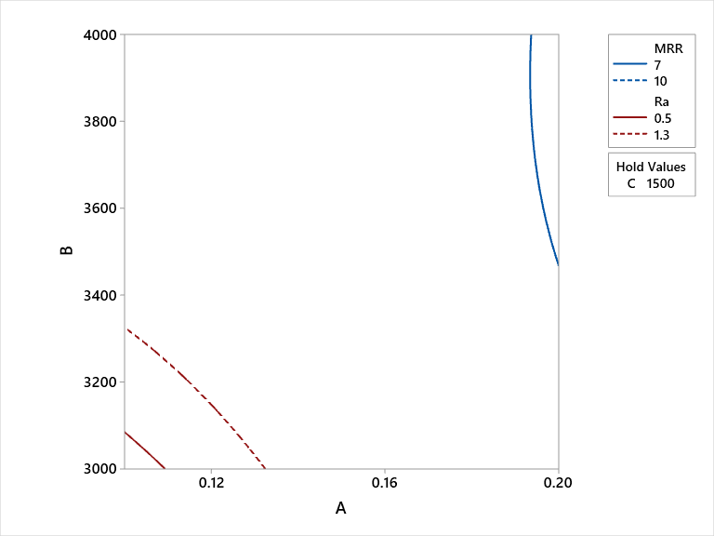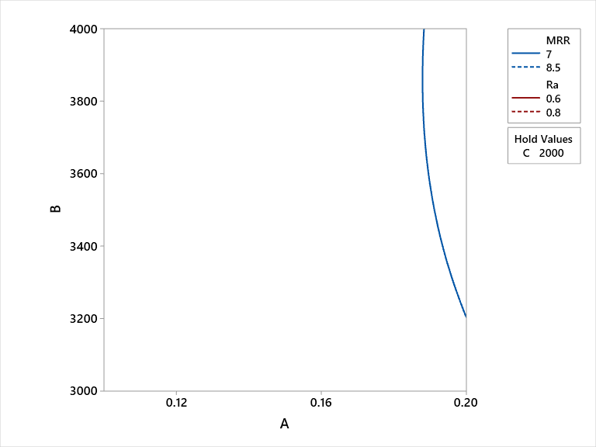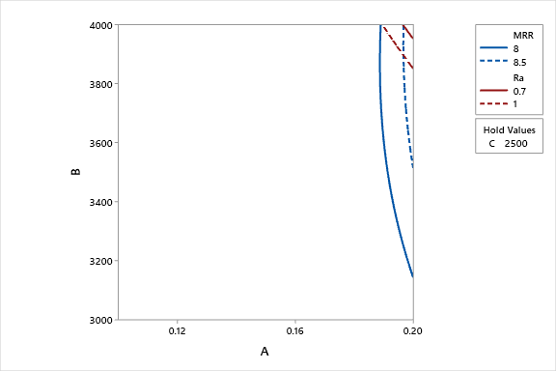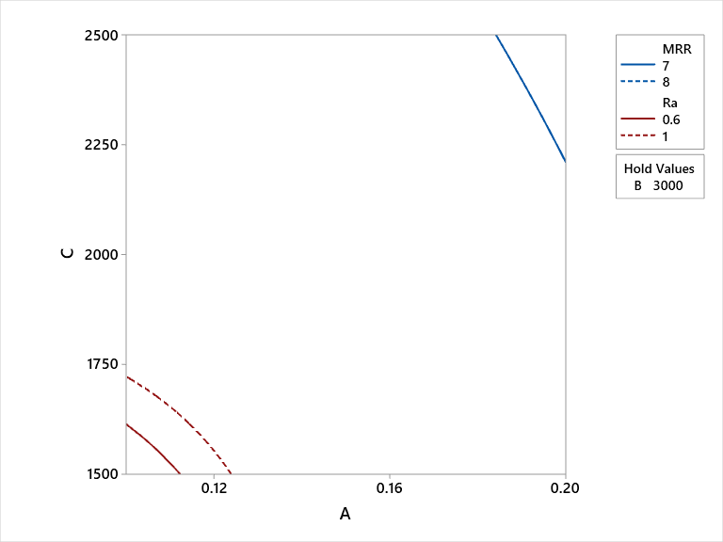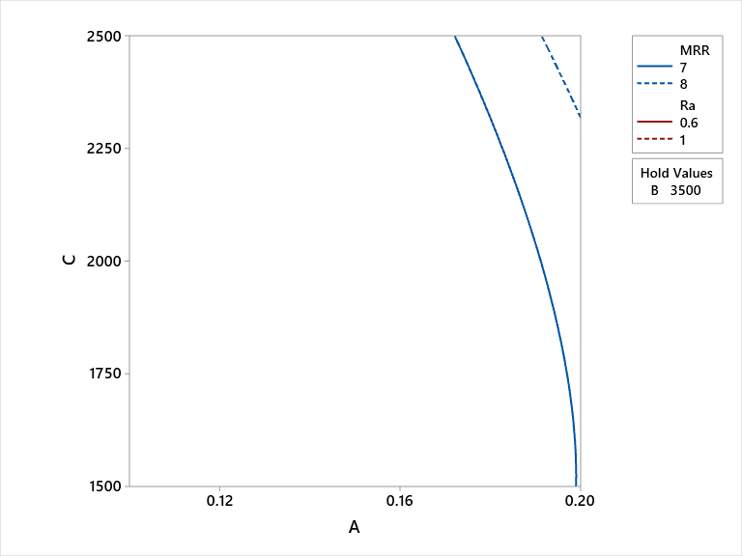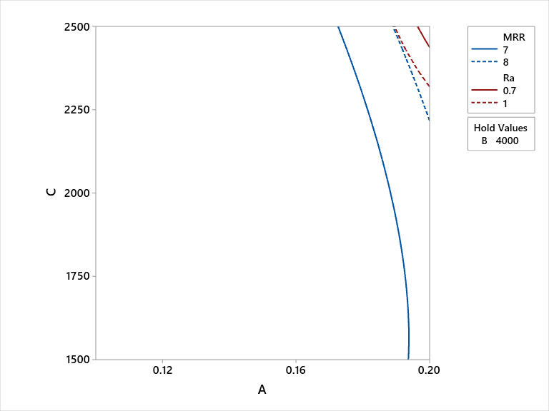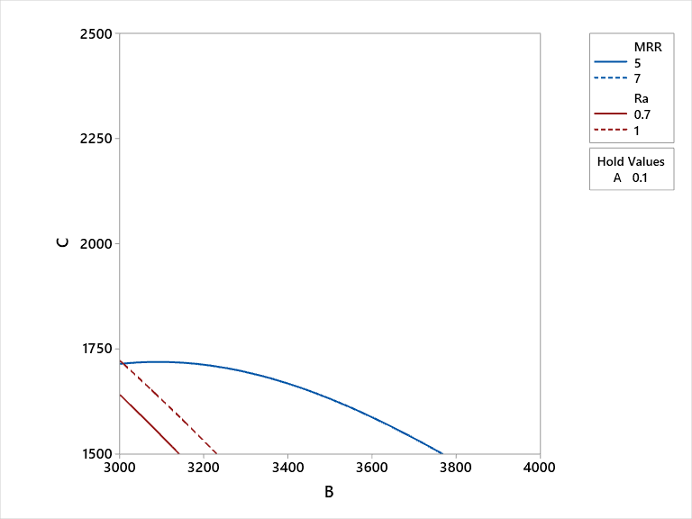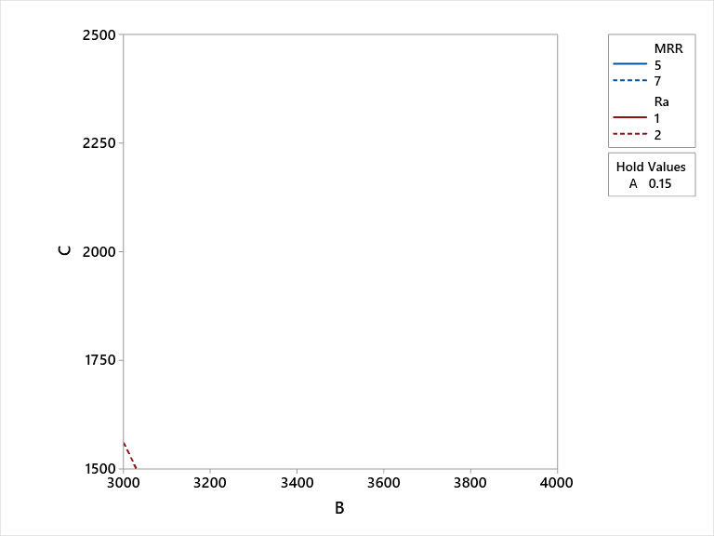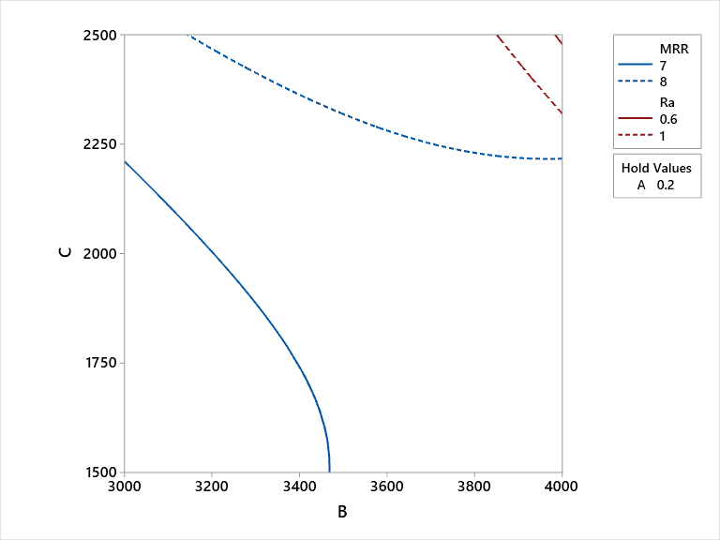
Multi-objective overlaid contour plot for D3 steel showing variations of R_{a} and MRR at a) level 1, b) level 2 and c) level 3.

CONFIRMATORY EXPERIMENTS & CONCLUSIONS

Experimental tests are performed to verify the predicted milling combination to optimize both the response measures of VMC five axis machined D3 steel. Confirmatory results revels that predicted setting is good agreement with the initial experimental tests as shown in Table 2.
The followings are the conclusions drawn from the present study of prediction of multi-responses: surface roughness and MRR in VMC-5-axis machining of D3 steel material using integrated RSM and MTLBO:
- The experiments are conducted on VMC-5-axis machining of D3 steels using Box-Behnken design method of RSM and responses are measured
- Analysis of variance (ANOVA) is used to examine the influences of milling variables on output performance measures
- From the ANOVA results of surface roughness, it is found that feed, interaction effects of all input milling parameters have significant effect on Ra
- ANOVA results of MRR, reveals that depth of cut, square combinations of depth of cut*depth of cut, feed *feed and interactions of depth of cut*speed, speed*feed are influential for MRR
- Mathematical model is developed between milling parameters and output responses by RSM
- Contour graphs are made by RSM application to depict the response variations with varying milling parameters
- Contour plots shows that milling conditions are most significant for both the responses (Ra and MRR)
- Parametric setting is obtained by MTLBO for simultaneous optimization of surface roughness and MRR
- Confirmatory tests show good correlation between predicted condition and initial test runs
From the study, it is mentioned that RSM along with MTLBO is useful for analyzing, modeling, and predicting multi-performance characteristics in VMC five axis machining if D3 tool steel.

REFERENCES

- Kar BC, Panda A, Kumar R, Sahoo AK, Mishra RR. Research trends in high speed milling of metal alloys: A short review. Mater Today Proc 2019;26:2657–62. https://doi.org/10.1016/j.matpr.2020.02.559.
- Rudrapati R, Patil A. Optimization of Cutting Conditions for Surface Roughness in VMC 5-Axis 2019;969:631–6. https://doi.org/10.4028/www.scientific.net/MSF.969.631.
- Singh G, Singh MP, Singh G. Optimization of the machining parameters for surface roughness during turning of Al/SiC/Gr Hybrid MMC. 2013;2:1613–7. https://doi.org/10.13140/RG.2.2.27109.86247.
- Singh G, Mangat H., Sodhi H. Optimization of End Milling Process for D2 ( Die Steel ) By Using. J Mater Process Technol 2014;2:1–17.
- Karthik Pandiyan G, Prabaharan T. Optimization of machining parameters on AA6351 alloy steel using Response Surface Methodology (RSM). Mater Today Proc 2020:1–4. https://doi.org/10.1016/j.matpr.2020.01.369.
- Sharma N, Ahuja N, Goyal R, Rohilla V. Parametric optimization of EDD using RSM-Grey-TLBO-based MCDM approach for commercially pure titanium. Grey Syst Theory Appl 2020;10:231–45. https://doi.org/10.1108/gs-01-2020-0008.
- Moi SC, Rudrapati R, Bandyopadhyay A, Pal PK. Parametric studies on tig welding of 316l stainless steel by rsm and tlbo. Mater Sci Forum 2019;969 MSF:744–9. https://doi.org/10.4028/www.scientific.net/MSF.969.744.
- Malvade N V, Nipanikar SR. Optimization of Cutting Parameters of End. J Eng Res Stud 2014;v:14–7.
- Bharathi Raja S, Baskar N. Application of Particle Swarm Optimization technique for achieving desired milled surface roughness in minimum machining time. Expert Syst Appl 2012;39:5982–9. https://doi.org/10.1016/j.eswa.2011.11.110.
- Lu HS, Chang CK, Hwang NC, Chung CT. Grey relational analysis coupled with principal component analysis for optimization design of the cutting parameters in high-speed end milling. J Mater Process Technol 2009;209:3808–17. https://doi.org/10.1016/j.jmatprotec.2008.08.030.
- Patel TC, Systems AM, Patel LS, Patel BC. Analysis and Prediction of Milling Process on Vertical Milling Centre ( VMC ) by using Response Surface Methodology ( RSM ) 2014;1:205–12.
- Rudrapati R, Sahoo P, Bandyopadhyay A. Optimization of process parameters in CNC turning of aluminium alloy using hybrid RSM cum TLBO approach. IOP Conf. Ser. Mater. Sci. Eng., vol. 149, 2016. https://doi.org/10.1088/1757-899X/149/1/012039.
- Rudrapati R, Rathod L, Patil A, Santosh C, Dega N. Parametric optimization for turning of GFRP composites using elitist teaching learning based optimization ( ETLBO ) 2016:25–30.
- Raghavendra S, Sathyanarayana PS, S S, Vs T, Kn M. High speed machining of titanium Ti 6Al4V alloy components: study and optimisation of cutting parameters using RSM. Adv Mater Process Technol 2020:1–14. https://doi.org/10.1080/2374068X.2020.1806684. [15] Rathod L, Poonawala NS, Rudrapati R. Multi response optimization in WEDM of H13 steel using hybrid optimization approach. IOP Conf Ser Mater Sci Eng 2020;814. https://doi.org/10.1088/1757-899X/814/1/012015.
- Rao RV, Patel V. Multi-objective optimization of heat exchangers using a modified teaching-learning-based optimization algorithm. Appl Math Model 2013;37:1147–62. https://doi.org/10.1016/j.apm.2012.03.043.

