Hybridization of Internet of Things and Cloud Computing

Author 1:
S.B.S.Younus,
Assistant Professor,
Department of Information Technology,
Sadakathullah Appa College,
Tirunelveli-627 011,
Tamilnadu, India.

Author 2:
A.MOHAMMED ASIK ALI,
Assistant Professor,
Department of Computer Science,
Sadakathullah Appa College,
Tirunelveli-627 011,
Tamilnadu, India.

Introduction
The internet of things (IoT) represents a ground-breaking idea that has become a part of modern society and is creating tremendous eagerness among both the business and academic communities. IoT, as the next-generation technology, has enormous impact for many industries. According to analyst predictions, the IoT could reach 64 billion gadgets by 2025, representing one of the major sources of "Big Data," distinguished by volume, value, variety, velocity, and accuracy. The IoT is mainly concerned with the progress of an infrastructure that supports fully interoperable protocols and software for interconnection and hybridization.
A system that is implanted with a combination of software, electronic parts, actuators, sensors, detectors, and wireless connectivity, which activates them to collect data from these objects can be defined as the IoT. An IoT system has the following important characteristics:
- IoT is a technological improvement that enables things to be connected to the internet through wired or wireless networks so that they can share information with each another.
- A variety of wireless sensor networks are available for IoT devices, including near-field communication (NFC), Zigbee, radio frequency identification (RFID), Bluetooth, and Wi-Fi.
- The sensors can be linked to various technologies, including long-term evolution (LTE), general packet radio service (GPRS), third generation of mobile telephony (3G), and global system for mobile communication (GSM).
- The efficiency of an IoT system is mostly determined by three primary aspects, each of which is crucial to its operation.
- Perception
- Middle-ware (Edge, Fog, and Cloud)
- Application
Cloud technology offers virtually unlimited storage and system capabilities to address a wide range of challenges related to IoT. In consequence, the phrase "cloud of things" (CoT) is used to explain the hybridization of IoT and cloud computing. The "CoT" is a model for increasing productivity and enhancing system performance that is mostly used by many industries and manufacturers. Several researchers discussed in their research regarding the use of cloud as a platform to analyze Big Data when data storage and processing are required. A recent empirical study identified many challenges for energy efficient technology that will need to be addressed in the future.
With the advent of the IoT, huge amounts of data are generated in real-time, and this poses a major concern for traditional cloud computing network topologies. A traditional cloud infrastructure condenses all processing, storage, and networking into a limited set of data centers, and the distance between remote devices and remote data centers is relatively wide. This challenge could be addressed by edge computing since it provides access to computing resources that are closer to IoT edge devices and may lead to a new ecosystem for IoT innovation.
Internet of Things (IoT)
Kevin Ashton, a British technology pioneer, created the phrase "IoT" in 1999 to represent a model in which physical objects are connected to the internet using sensors. A "thing" can refer to any physical entity on the surface of the earth, whether it is a communication device or not. Despite the widespread acceptance of the IoT concept, no standard definition has been adopted. There are several definitions in existence: "The IoT refers to the prospect of devices that can create, exchange, and utilize data without the use of a central computing device, where the connectivity of networks and computing capability can be applied to objects, sensors, and everyday objects, not to personal computers.
It is mentioned in the Oxford Dictionary . ―An Internet-based architecture provides connectivity between electronic devices embedded in real-world objects, enabling them to exchange information‖. According to the RFID group, ―It is a global network of interconnected objects with standardized communication protocols that allow them to be accessed by a single entity.
Three-layered architecture of IoT
IoT architecture comprises mainly three layers, namely ―perception laye, ―middleware layer, and ―application layer, as demonstrated in Figure 1. The middle layer of this architecture exists on the edge, fog, and cloud computing.
Perception layer
Perception layer senses data from the surrounding via actuators and sensors. It identifies, gathers, and processes data and sends it to the network layer. It detects other physical parameter in the physical environment or recognize intelligent objects. It also collaborates on local and small-scale networks with the IoT node.
Middleware
As the 'processing layer', the middleware is responsible for the analysis, processing, and storage of a large amount of data obtained from the perception layer. It can perform a variety of tasks and providing services to the lower layer. Various technologies are employed, including high- performance computing tools, cloud computing, and database management systems. Additionally, it introduces a level of abstraction for developers as well as users.
Application layer
It is the responsibility of this layer to provide specialized application services to the client. As a result, it includes a variety of applications, including air quality monitoring, smart buildings, precision farming, intelligent cities, and innovative health care, as well as data integrity, authenticity, and security. This layer is intended to enable designing an intelligent environment.
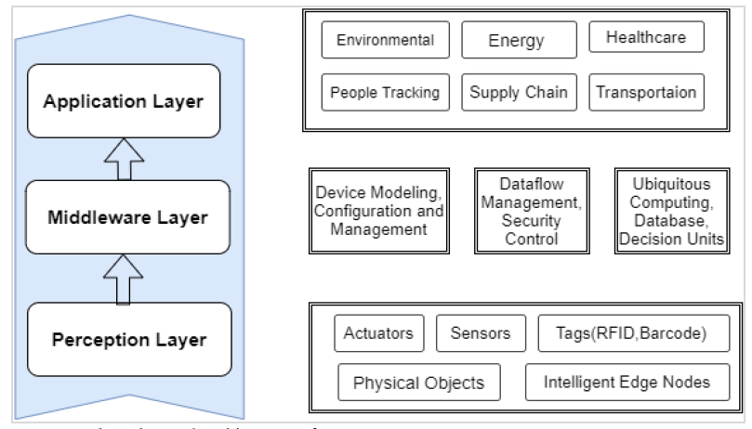
Figure 1: Three Layered Architecture of IoT
Cloud Computing
During the last few decades, cloud computing has taken on several definitions. As per National Institute of Standards and Technology (NIST): "Cloud computing is a service delivery model that facilitates easy, on-demand access to a shared pool of flexible computing resources that can be accessed and delivered on time with a minimum of effort or management". As utility-based computing progresses, it is anticipated that it will move to cloud computing, which has the potential to be a more intelligent in-service provisioning process. Another key advantage of cloud computing is that it reduces information technology (IT's) dependence on fundamental infrastructure settings. The implementation and execution of scientific workflows involving Big Data requires a synergistic model, according to recent studies. Cloud computing has suggested the following functionality: measured services, rapid elasticity, scalability, multi- tenancy, resource pooling, extensive network access with on-demand service. The cloud computing characteristics are shown in Figure 2.
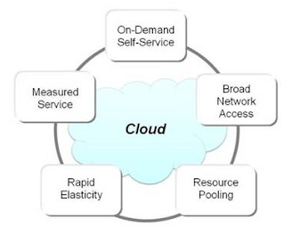
Figure 2: Cloud Computing Characteristics
On-demand self-service
Numerous cloud-based services may be delivered without involving human involvement on the part of the service provider. Most of these services comprise storage capacity, database instances, and virtual machine instances. Accessing cloud accounts and monitoring services can be done using a self-service web interface provided by production organisations. An end-user can provide computing resources independently, such as database setting and shared storage when required, without any interference from the IT manager of the provider.
Extensive Network Access
Cloud services may be accessed by a variety of user applications on the network. A local area network (LAN) or the internet in the setting of a private cloud are both viable choices, even though the enterprise prefers robust, wide-bandwidth networks. The quality of service (QoS) of cloud computing is heavily dependent on network capacity and latency. It has been conventional to use a variety of network- accessible technologies to make thin and dense heterogeneous business solutions more accessible (such as smart-phones, laptops, workstations, and personal computers).
Multi-tenancy and resource pooling
Multi-tenant environments can be accommodated by cloud computing resources. With numerous tenancies, a single software or physical infrastructure can be used by a variety of clients, all while ensuring the privacy and confidentiality of their data. In multitenant systems, different services, for instance memory, processing capability, storage space, and network resources, are allocated to several users in accordance with their individual needs (virtual resources are assigned or moved dynamically in response to the requirements of each user). The word "resource pooling" refers to the sharing of physical assets among multiple clients.
The provider's resource pool should be sufficiently large and diverse to serve a variety of consumer needs while maintaining economic spectrum. As a result of resource pooling, the performance of mission-critical industrial applications should not be adversely affected. Scheduling resources is a critical part of cloud computing. According to the study, the present state of task scheduling methodologies is based on a host of different scheduling parameters.
Ease of elasticity and scalability
It is feasible to scale cloud computing services to meet the demands of a business. It is an essential aspect of cloud computing. There are no penalties associated with customizing costs, efficiency, or availability. It enables manufacturing companies to rapidly produce and deliver any cloud computing resource. This functionality can be used for storage, virtualization software, or marketing assistance. Scalability is more liberal and pragmatic. Scalability dynamically adds or removes resources to meet changing application requirements within the network's constraints.
Measured service
Cloud computing applications are quantified, and producing businesses pay for what they use. The authors of the study highlighted the difficulties faced by experts working in bioinformatics in terms of planning their research efficiently and effectively utilizing cloud computing. In cloud technologies, resource consumption is effectively managed and optimized automatically by utilizing measurements at many levels of abstraction, such as network bandwidth, computing power, storage, and the number of active users. Both the supplier and the consumer's resource requirements may be monitored, quantified, and communicated openly.
Edge computing technology
Edge computing is a data networking model that stresses minimizing latency and bandwidth consumption by processing as near to the data source as feasible . Edge computing is a distributed computing model that brings computation and data storage nearer to the place where it is needed, to get better response times and save bandwidth.
Role of edge computing in IoT technology
In IoT technology, edge computing transforms the data that is managed, processed, and distributed by millions of IoT devices. With the explosive growth of internet-enabled technologies, the IoT and emerging technologies requiring real-time cloud services tend to support sophisticated computing systems, the IoT and emerging technologies requiring real-time cloud services tend to support sophisticated computing systems. With edge computing, data is evaluated on the edge of the local network before reaching the fog and the cloud for rapid, reliable, connectivity-independent, and scalable IoT Edge processing. Figure 3 describes the IoT, edge, fog, and cloud computing architecture.
Fusion of IoT and Cloud Technology
The IoT comprises of a network of physical artifacts that are linked to the internet and are equipped with the ability to collect, exchange, and use data. In cloud computing, resources are delivered via the internet as a service. With the hybridization of IoT and cloud computing, novel applications have been developed that have the potential to revolutionize the way we live and work. In addition, the hybridization of the IoT into the cloud is a natural progess of the technology. The cloud offers the perfect platform for storing and analyzing the huge amounts of data produced by IoT devices. In addition, it provides real-time data processing and analytics, which is necessary for applications like predictive maintenance and energy management. In the last decade, the IoT and cloud-based technologies have emerged significantly. Because of their unique characteristics, these technologies are attractive to researchers and have multiple applications. The integrated model does not have a well-known terminology in the research community.
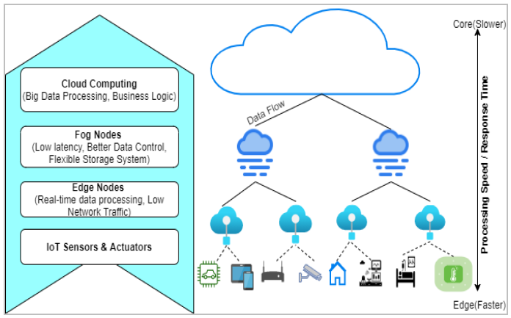
Figure 3: IoT, Edge, Fog and Cloud Architecture
A key part of the IoT is its capacity to utilize virtually limitless amounts of cloud computing resources and ability (such as computation, storage and energy efficiency abilities) to help beat technological limits. A cloud-based computing strategy is an efficient tool for protect data as well as for use in a diversity of applications As a contrast, cloud computing could influence the IoT by initiate new applications that address distributed real-world problems and by allowing new installations that can be applied to diverse real-world scenarios.
Because of its restricted and strong capabilities, the IoT have devices with least processing power and storage capacity in comparison with the different complex tasks that need to be completed. These equipments may serve as data providers and transfer data for processing and storage directly to the cloud .
In the cloud computing, applications and objects communicate over an intermediary layer that hides the functionality and complexity required to implement them. This strategy will considerably impact applications that mentions present difficulties with collecting data, incorporation, and sharing in a multi-cloud context.
Present research on the hybridization of IoT with cloud computing focuses on allowing real-world applications including sustainable buildings, smart cities, smart vehicles and industrial automation. The use of IoT equipments and sensors in connection with cloud-based analytics and decision-making paradigm provide the promise of important enhancement in efficiency, safety, and quality of life.
The future way of research on IoT and cloud computing hybridization will be driven by the need to mention difficulties including data privacy, security, scalability, energy efficiency, and interoperability. In addition, there is a need for additional research into how best to exploit the distinct capabilities offered by this technology hybridization to create novel applications that deliver real value to user.
Architecture for cloud-based IoT
A cloud-based IoT architecture should be achieved of supporting a broad range of devices and sensors, as well as the data they obtain. It must be able to handle the data created by the devices in real-time and give the needed processing and analysis. The architecture must also be able to carry the security and privacy necessities of the IoT applications. An IoT-based cloud model is comprises of three layers: the physical layer, the networking layer, and the application layer. The bottom layer (the physical layer) is accountable for collecting the data needed by the successive layer, that is, the network layer, from their surroundings. A diversity of interesting services are used by the network layer from the physical layer. Figure 4 demonstrates the cloud-based IoT infrastructure.
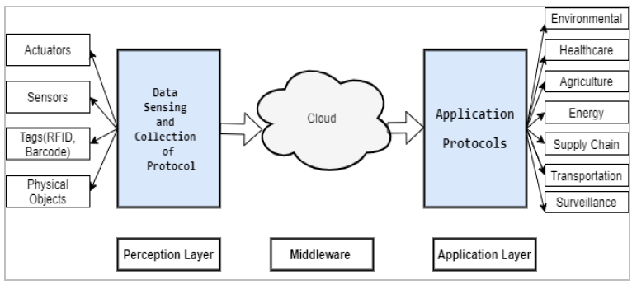
Figure 4: Cloud of things Architecture

IoT-Cloud Applications in various Sectors

Healthcare

Healthcare IoT applications are cloud-based applications that facilitate healthcare providers to distantly observe and supervise the health of their patients. These applications use sensors and other devices to collect data from patients, and then use cloud computing to examine and store the data. Healthcare providers can use these applications to follow the health of their patients and to provide them with timely information and advice. A cloud-based IoT architecture may lead to more refined healthcare applications. In hospitals, sensor networks are used to collect information about the health of patients.

Environment monitoring

IoT devices may generate vast amounts of data, which can be difficult to store and analyse. The data gathered from the sensors can be stored in the cloud and analyzed for use in monitoring environmental circumstances, such as air quality or water levels. By giving feedback on how IoT devices are used, such data can also be utilized to enhance their efficiency. As a smartphone can do various activities, the smart home is based on an novel mobile phone model. A network system connects the devices to carry out activities automatically based on the user's favorite through the IoT.

Agriculture

Agriculture is a quickly growing use of the IoT these days. Cell phones are being used by farmers to check their fields and take required actions against unnecessary pest, such as irrigation, insect screening and fungicide applications in the field. Furthermore, smart objects offered by the IoT are widely used in the diverse poultry and agri industries.

Smart city

A smart city IoT-cloud application can assist to manage a city's infrastructure and resources more efficiently. Some IoT-driven smart city initiatives are showing to deliver tangible benefits to all people. Several ecosystems helps to the progression of smart cities. Many important innovations that help to the foundation of smart cities such as energy management and transportation management.

Industrial

Industrial IoT (IIoT) is a new intelligent industrial management method that controls intelligent devices, sensors, and computer systems. IIoT enables ventures to get real-time data on their inventories and manufacturing units, as well as a sensor attached alarms system that aware staff. Sensor data is recorded and evaluated to decide the sensors' future and direction.

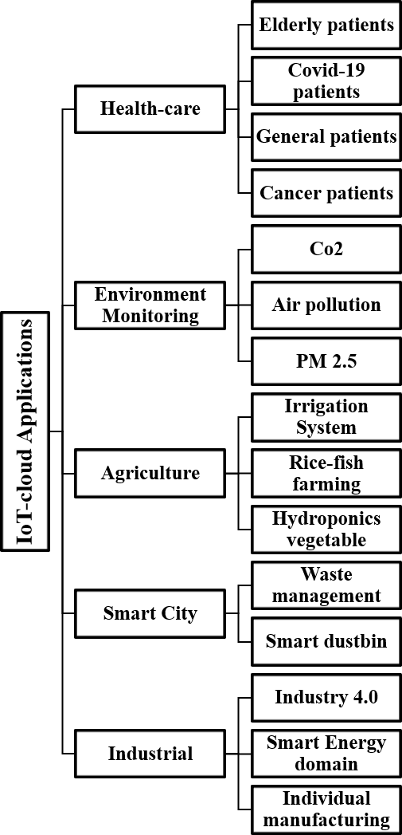
Figure 8: Taxonomy of IoT-cloud applications

Benefits of Hybridization of IoT and cloud

IoT-activated services include a wide variety of equipments such as embedded devices, sensor devices, communication devices, and mobile devices. In the lack of adequate storage and processing resources, the IoT-based system cannot preserve and process large volumes of sensor-driven data. As a consequence, the IoT system will need assistance in overcoming these constraints.

Cloud computing offers an limitless storage capacity, massive computational power, and network bandwidth, among other capabilities which may assist the IoT system in addressing the obstacles explained prior. Cloud computing resources are flexible, allowing them to grow and contract in response to the IoT environment's necessities. Sensor data analysis may also be aided by cloud- based Big Data analytics. Cloud computing hybridization with IoT paradigm enhances the efficiency and trustworthiness of IoT-based applications. A collection of benefits can be done by combining the IoT with cloud computing are explained below.

Data transmission

Cloud-based IoT model allow proficient communication. IoT applications offer low-cost data transmission between systems. Cloud computing enables the cost-effective and efficient connection, control, and exchange of data through the use of hybridized applications.

Storage

The IoT ecosystem is comprises of a number of associated gadgets and sensors that cause vast amounts of real-time data. Local storage on the IoT is not enough to hold this quantity of data. Moreover, a more number of IoT gadgets generate both structured and unstructured data. Conventional databases are unable to hold such a various set of data. Cloud computing enables IoT devices to conquer this data storage challenge. Cloud computing is consist of a group of computers attached with a large quantity of inbuilt storage. Cloud-based IoT systems permit users to store data and use it from everywhere via the internet. Furthermore, this massive data storage may be leveraged to address the heterogeneity of devices by enabling analytics and system improvements.

Processing

IoT devices have basic computing power. As a result, they are unable to process huge volume of data created by millions of connected, intelligent gadgets. Cloud computing provides computational ability for IoT devices by separating the real physical computer into several virtual ones. A virtual computer may be borrowed via Internet-enabled devices on a pay-per-use basis. Because of an hybridization of IoT technology into cloud services, end users can benefit from low-cost computing power while producing vast income.

Modern capacities

Numerous operational gadgets are interconnected through IoT-enabled devices. These devices communicate using a variety of protocols and methods. Hence a coordination among these different devices is difficult. Additionally, Getting highest dependability and efficiency might be challenge. Cloud computing is described by its scalability and ease of usage. By combining cloud computing with IoT, users can be guaranteed that their applications are more reliable, scalable, secure, and efficient.

Models for the cloud of things

Software as a Service, Infrastructure as a Service, and Platform as a Service are the three main deployment methods for cloud computing. With the hybridization of cloud and IoT, novel deployment methods have been produced, including the following:
- Sensing as a Service (SaaS) provides services for getting access to the information collected by IoT sensors.
- Integration Platform as a Servic (IPaaS) permits identifying devices connected to the network and setting up access control policies.
- The Database as a Service (DBaaS) is incurred in both database administration and storage services.
- Ethernet as a Service (EaaS) enables IoT-enabled gadgets to connect to the internet.
- The Sensor and Actuation as a Service (SAaaS) make sure an automatic control of sensors and devices.

The Integration of the IoT with cloud technology is challenging and a number of troubles remain unresolved. A number of valid concerns have been mentioned below:

Privacy and security
In creatin IoT-based cloud services, privacy and security are the primary concerns. The IoT-based Cloud enables the relocate of real-world data to the cloud. In order to make sure only authorized customers have access to data, it is important to decide how efficiently authorization techniques and regulations must be followed. As a precaution, crucial information should be protected from unnecessary access. Cloud- based IoT devices create so many challenges, such as the lack of transparency in service-level agreement (SLAs), data privacy, and the remote-access of the system. Additionally, multi-tenancy may result in the limitation of sensitive data using public key cryptography. In comparison, severe problems, such as user takeover and virtual machine rescue, are also a source of concern. The researchers make an assault on the system and provide a suggestion. Using Artificial neural networks (ANN) and cloud trace back (CTB) technologies, they suggest a method to spot the cause of attacks.

Ipv6 addressing strategies
It is widely identified that the Internet is a main component of the IoT. IPv4 has a profound influence on the IoT. The CoAP (Constrained Application Protocol) technology permits devices and servers to communicate directly via the internet. As part of the future improvement of these technologies, network address translation (NAT) operations will be removed in order to give a specific IP address to the increasing IoT model. IPv6 is developed to defeat IPv4's boundaries by providing a 128-bit Internet Protocol address. There are many benefits to RESTful interfaces, including the availability of an almost unlimited number of Internet-connected devices, cross-platform compatibility, and compliance with REST protocol agreements. The IP protocol 6LoWPAN and ZigBee can be applied to integrated IoT devices to implement IPv6, however, some platforms are yet to implement these protocols. IPv6 is used by the IoT network, which originates from human-initiated networks.
Interoperability
Because of the various and autonomous nature of IoT devices, interoperability is a serious challenge in cloud-based IoT models. Several forms of work have been conducted in this area during the past several years to mention this issue. Due to the diversity of cloud platforms and applications, the presented methodologies give different solutions. Additionally, lack of compatibility may result in the challenge to form cross-platform and cross- domain applications.

Intelligent analytics

Intelligent analytics can offer insights into massive amount of data gathered from interconnected gadgets. This data can be used to identify patterns and trends, uncover anomalies, and provide predictive analytics to make useful decisions. Intelligent analytics can also be used to build automated control systems, allowing for more efficient operations, enhanced safety, and enhanced energy management. Additionally, intelligent analytics can help to enhance customer experience by giving personalized services and targeted suggestions.

Integration methodology
By integrating present and future intelligent cyber- physical paradigms into fully real IoT, the demand for interoperability cannot be ignored. There are no existing IoT standards or approaches for integrating IoT systems because of their dissimilar nature and interoperability. The diversity problem might be when end users utilize multi-Cloud solutions, since applications depend on a multitude of suppliers to support scalability and efficiency.

Heterogeneity
IoT and cloud computing are delayed by the complications of legacy systems, platforms, operating systems, and services. Hence the heterogeneity problem may worsen significantly as end users adopt multi-cloud solutions, where applications become highly dependent on the capabilities provided by numerous providers.

Standardizations
Many Professionals have accepted that the lack of standards is one of the primary challenges facing Cloud-IoT paradigms. IoT-based Cloud models need standardized protocols, interfaces, and APIs to connect diverse intelligent objects and provide exclusive services. Many IoT and cloud deployment methods have been suggested by the experts community.

Edge/Fog computing
Computing can be applied at the edge of giving cloud-based services. To help clients with their cloud computing needs, Fog offers application services. As a generalization, fog is an extension of the cloud system that links the cloud to the network's edge. To accomplish latency constraints, extra nodes are need for services that are latency-sensitive. Although Cloud and Fog are highly dependent on processing, networking, and computing.

Cloud capabilities
An IoT architecture based on the cloud poses a important security risk to every networked system. There are additional attack vectors on both the IoT and cloud sides. An IoT setting can benefit from encryption for data privacy, confidentiality, and authentication. On the other hand, internal threats cannot be defeated, and operating IoT gadgets with restricted functionality is evenly challenging.

Service Level Agreement (S.L.A.) implementation

Cloud-based IoT applications activate the transmission and storage of data generated within the confines of application-specific boundaries, which might be cumbersome in certain cases.

A single provider may not always be enough to assure a specified level of QoS. As a result, it is likely to need the support of several cloud service providers to address SLA breaches.

Big Data

The pervasiveness of mobile devices and sensors demands the use of modular systems. Hence several Cloud service providers may be needed to evade violations of S.L.A. files. However, the adaptability of the most regularly come up of cloud services is still an unsolved issue due to the time, cost, and maintenance of QoS complexity.

Power and energy efficiency

During the past decade, IoT-enabled applications have enabled regular data flow between IoT devices and the cloud, which has resulted in fast power utilization on the nodes. Therefore, the data processing and transmission industries keep on to prioritize energy efficiency.

Performance

Several cloud computing and IoT models (such as networking, processing, and storage) are complex to standardize because of their scale-dependent performance requirements.

Reliability

Cloud computing and IoT union generally initiate dependability concerns in mission-critical applications. For instance, in the domain of intelligent mobility, vehicles are frequently in movement, and automotive networking and connection are often uneven and inefficient. In a resource- constrained setting, an array of problems relating to system crash or systems that are not always approachable are highlighted.

Monitoring

In cloud models, monitoring is a vital for batch processing, resource management, S.L.A.s, dependability and security, and troubleshooting. The cloud-based IoT model adheres to all the same necessities as a usual cloud monitoring system, despite the IoT's inherent challenges associated with speed, volume, and diversity.

Key Points Discussion

In an effort to improve the yield of IoT and cloud hybridization, experts from around the world have investigate a variety of technological solutions. IoT and cloud computing are two buzzword-rich digital revolution topics that have been the focus of a lot of attention in recent years. Here we explores numerous aspects of IoT-based cloud applications (i.e., health-care, environment, agriculture, smart city, and industry). There are following potential impacts of methods and platforms for IoT cloud hybridization which include:
- Improved efficiency and productivity: By automating tasks and monitoring gadgets and systems remotely, businesses can enhance operational efficiency and productivity.
- Enhanced decision making: With real-time data and analytics, IoT- ativated cloud applications can make better informed decisions about their operations.
- Improved customer experience: IoT-activated businesses can offer better customer experiences by customizing products and services to meet customer requirements.
- Decreased costs: Automation and remote monitoring can assist businesses reduce costs related with labour, energy, and other resources.
- Augment security: Cloud-based IoT models can provide improved security features such as data encryption and user authentication. This can assist organizations to safe their data and prevent unauthorized access.
- Enhanced scalability: Cloud-based IoT models provide improved scalability, which perrmits organizations to simply add or remove devices and users as per their need.

Limitations of Hybridization of IoT and Cloud:
- Security problems: It is essential to note that security is one of the key concerns with the IoT. There is a potential for hackers to get access to IoT gadgets which are continuously linked to the internet.
- Privacy concerns: Another concern is the privacy of data. IoT gadgets may have a plenty of information about individuals and their activities. There is a chance that this information could be used to track individuals or compromise their privacy.
- Reliability: One of the most toughest aspects of IoT network is the reliability of data. IoT devices can break down or lose data. This data may not be backed up and could be lost forever.
- Lack of standardizations: The major constraint of IoT cloud hybridization is the lack of standardization. No such standard protocol that fits to all solution for hybridizing IoT gadgets and data into the cloud. Each cloud provider has their own proprietary solution, which makes it difficult to combine multiple IoT devices and platforms. Moreover, numerous IoT devices are not suited with standard cloud technologies, which further complicates hybridization.
- Dependence on internet: IoT gadgets are dependent on the internet for data broadcast. Without proper internet connection, the gadgets will not be able to function properly.
- Cost: The IoT and cloud computing hybridization can be costly, as organizations require to spend money in hardware, software, and services.
- Complexity: The union of IoT with cloud computing might be complex since it needs for the deployment of a diversity of various technologies.

Conclusion and Future Guidelines

As the IoT continues to grow in popularity, so does the need for efficient and reliable cloud hybridization solutions. The hybridization of IoT devices with cloud- based applications has evolved as an attractive approach. Despite the potential of cloud hybridization for IoT, there are still many considerable problems to be overcome. First, the development of IoT cloud hybridization models is still in its premature stages, and there is a lack of mature and strongest tools and platforms. Second, the use of IoT cloud hybridization models often need a considerable amount of manual effort, which can be time-consuming and error-prone. The IoT boost up by the cloud is providing the way for new business openings and research opportunities.

In the future, the IoT cloud hybridization models will become more mature and strongest and that they will be increasingly used to combine IoT devices with cloud-based applications.

The future of IoT cloud hybridization is looking promising with the invent of new technologies, including edge computing, Big Data, Blockchain, industrial 5.0, 5G, and Artificial Intelligence, the possibilities for IoT applications are nonstop. In the near future, we can expect to see more IoT gadgets and applications being hybridized into the cloud. This will enable more data to be collected and processed, resulting in enhanced decision-making and more efficient operations. It can be noted that the hybridization of these technologies could lead to new opportunities for practitioners and researchers.

