Study on the Ethnobotanical Practice Performed by Tribal Communities in Surajpur Forest area, Chhattisgarh
Sudhir Ranjan Choudhury*, Khilesh Kumar Tekam, Ajay Kumar Singh
Department of Forestry, Wildlife and Environmental Science,
Guru Ghasidas Vishwavidyalaya, Bilaspur, Chhattisgarh
*Corresponding author, Email: sudhirranjanchoudhury@gmail.com

Abstract

The study of local (indigenous) plant uses by humans in a particular culture and region is known as ethnobotany. A pre-scientific medical system with bodies of medical knowledge that are passed down from one Vaidya to another through generations is referred to as traditional medicine. The practices for treating illnesses and ailments are related to the tribal people's beliefs, justifications, and ways of making herbal medicine. This paper presents the ethnomedical wealth of the Surajpur district. In various villages throughout Surajpur district, an ethnobotanical study was conducted. In order to treat a variety of illnesses among the various tribes, the paper focuses on the traditional phytotherapy practiced by the current investigations in the Surajpur district of Chhattisgarh, 62 species of plant or plant part have been identified which are used for ethnobotanical purpose by tribal groups. In the list of plant, there were 29 species of trees, 21 Species of herbs, 8 species of shrubs, and 4 species climber. The current study objective was to emphasize the crucial role that local knowledge and culture can play in resource management, to concentrate on the variety of ethnobotanical plants for future use, and to provide a framework for teaching people how to use plants to solve various types of problems.

Keywords: Ethnobotany, Medicinal plant, Traditional knowledge, Ethnomedicine, Ethnic group, Tribal community

INTRODUCTION
Chhattisgarh (C.G) is referred to as the “Herbal State” due to its abundant biodiversity and the reliance of its native tribal population on traditional medical practices. Ethno-botany accounts for the study of relationship between people and plants for their use as medicines, food, shelter, clothing, fuel, fodder, and other household Purposes (Jangdey et. al 2016). It deals with the Interaction of indigenous plants and the local Inhabitants of the area.
The main aim of the present study is to collect information on plants used for ethnobotanical practices by some selected local tribes of the Surajpur Forest area, Chhattisgarh. Various plants have been used in traditional Medicine for several thousand years. India is a repository of medicinal plants. The herbal treasure of the nation is rich in its floristic wealth. Ethnobotany is a fascinating field that explores the intricate relationship between plants and human cultures. It focuses on the traditional knowledge and practices of different ethnic groups, particularly those by living in forest areas (Painkara et. al, 2015). Tribal communities, in particular, have a deep understanding of the local flora and have developed unique ethnobotanical practices over generations. In forest areas, tribal people have a profound connection with their natural surroundings. They have acquired a wealth of knowledge about the diverse plant species found in their environment and have learned to utilize them for various purposes. These practices are deeply rooted in their cultural traditions and play a significant role in their daily lives (Kala, 2009).
The study of ethnobotany not only provides valuable Insights into the traditional knowledge of tribal communities but also offers potential contributions to modern science. Many plant species used by indigenous people have been found to possess medicinal properties or other valuable attributes. Ethnobotanical research can help identify new compounds, uncover unique uses for plants, and contribute to the development of sustainable practices for resource management (Kujur and Ahirwar, 2015). Ethnobotany practices by tribal people offer a unique perspective on the intricate relationships between humans and plants. They provide valuable insights into the sustainable use of natural resources and hold the potential for discovering new medicinal compounds (Kujur and Ahirwar,2015). Furthermore, these practices underscore the importance of cultural diversity and the need to protect indigenous knowledge systems for the benefit of future generations and the well-being of our planet. Ethnobotanical practices have been carried out by societies throughout history and across different geographical regions. They are deeply rooted in the cultural and ecological
OBJECTIVE
- Data collection on ethnobotanical usage of floral species, by tribal community in the Surajpur forest area, in Chhattisgarh.
- To document the traditional knowledge of plants used in ethnobotanical practices.
- To document the method of drug preparation used by the tribal community in the Surajpur forest area of Chhattisgarh.
MATERIAL AND METHOD:
Study Area
Chhattisgarh is situated in the central region of India. It is surrounded by states like Orissa, Maharashtra, Madhya Pradesh, Jharkhand, Uttar Pradesh, Telangana and Andhra Pradesh. Also, there are 5 different river basins that lie in the states which are Brahmani, Mahanadi, Ganga, Godavari, and Narmada. Furthermore, the soils found here are Black Soil, Laterite, Red Soil, Loamy Soil, Black Soil, and others. The southern and northern part of the state is covered with hilly areas, and the central area is plain land.
The current study was conducted in the selected site of Surajpur Forest Area of Chhattisgarh (Lat: 23.2136011°N , Long: 82.8679549°E). Around 2,787 km2 area of the Surajpur District is under forest cover. Surajpur has a humid subtropical, dry winter climate and at 553.09 metres (1814.6 feet) above sea level. Tribes in the Surajpur district eat a variety of wild fruits as part of their diet, particularly during times of food scarcity, due to the area’s dense forests and rich flora. Surajpur generally experiences 35.81 rainy days (9.81%) per year and averages about 51.59 millimeters (2.03 inches) of precipitation yearly. The Gond, Oraon, Kanwar, and other hill tribes and indigenous people of the Surajpur district.

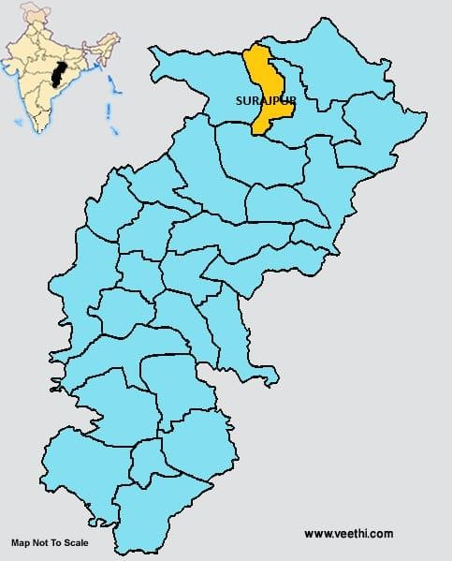
Map 1: study area map Source: internet
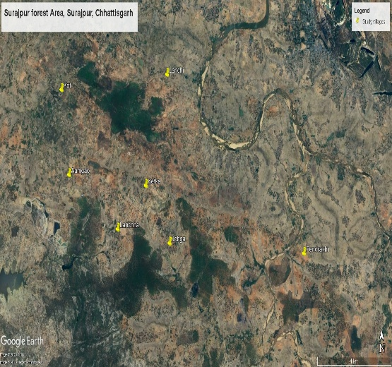
Map 2: Study area Village (Source – Google Earth)
Ethnobotanical exploration
According to literature review on the ethnobotanical investigations, there have not been any research done in the Surajpur region, although there have been a few research done in neighboring districts. As a result, from April to July 2023, field surveys were conducted in the tribal villages of Surajpur district, including Aamgao, Jobaga, Ketka, Kot Lachaa, and Lanchhi Pendrakhi, to collect information on the uses of various plant species. Semi-structured questionnaires on plant components used for food, medicine, vegetables, fibres, colours, gums, agricultural instruments, and other types of illnesses were also utilised to collect data during the survey period. Group conversations among tribal villagers of various ages, representing both genders in the community, were used to cross-check the data.He participant observation method was also used to comprehend the approaches and procedures used by tribe members when using plants and plant components. With the help of informed elders and local youth, the surrounding forested region and agricultural land of the villages were also surveyed for the identification of several ethnobotanical species and their traditional applications.
Method used:
Ethno-botanical survey is conduct in different tribal inhibited areas of Surajpur Forest Area, District- Surajpur Chhattisgarh during (April-July). Extensive field Trips were organized for collecting the plant Species and data. The method adopted for the Collection of data is based on medicinal uses of plants in the treatment of various diseases. Several visits has been done with these resource persons who helped to identify the plants, local/tribal names of the Plants, and the medicinal uses which need to confirm through many resource person as far as possible in other localities of the State. Information like medicinal use of Plant, plant parts used, diseases treated, modes of drug Preparation and administration has been recorded.
Participant Selection: Indentation of members of the community who are having knowledgeable about plants, such as traditional healers, elders, herbalists, and community leaders. Seeked permission and built trust within the community before initiating data collection activities.
Plant Identification References: Various field guide used for floras, or botanical keys specific to the study area. These references aid in plant identification based on botanical features such as leaves, flowers, fruits, and other characteristics.
Identification- Species were identified on the basis of morphology and taxonomic characters. The identities of several plants were confirmed by experts from various institutions. Anatomical sections were also taken to confirm species identity.
Ethnomedicinal practices documentation: An essential method of preserving traditional knowledge about the medicinal plants and cures utilised by many cultures is by documenting ethnomedical practises. It includes keeping a record of the plants’ characteristics, cooking techniques, and uses in curing particular diseases.

RESULT AND DISCUSSIONS:
During the current investigations in the Surajpur district of Chhattisgarh,62 species of plant or plant part have been identified which are used for ethnobotanical purpose by tribal groups. In the list of plant, there were 29 species of trees, 21 Species of herbs, 8 species of shrubs, 4 species climber. Although 62 plant families are represented in the research region, Fabaceae was the most prevalent family in terms of the number of ethnobotanical species. These ethnobotanical plants were used for a variety of things, including food, medicine, drinks, vegetables, tonics, fish poison, insect repellent, and clothing dye.
Medicinal Plants: The 34 families that make up the overall number of known medicinal plant that are used in ethnobotanical practices in Surajpur forest area. For ethnomedicinal usage whole plant or various parts, including the root, tuber, leaf, fruit, bark, resin, seed, and latex, were all employed as medicines. The most common plant part used to make medicine was the root (12 species), which was then followed by fruit (6 species), bark (7 species), leaves (18 species), and seeds (8 species). One species of tuber and three species of stem whole plant (5 species). These plant species have been used to treat a variety of conditions, including indigestion, a cough, body aches, diarrhea, cut wounds, scorpion bites, snake bites, and muscular pain.
The specific results obtained from such a survey can vary depending on the objectives and scope of the study. However, here are some potential outcomes that may arise from an ethno botanical survey:
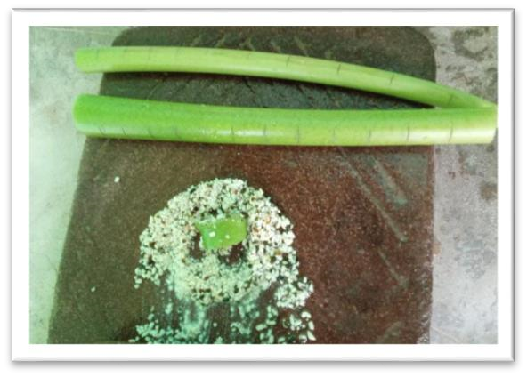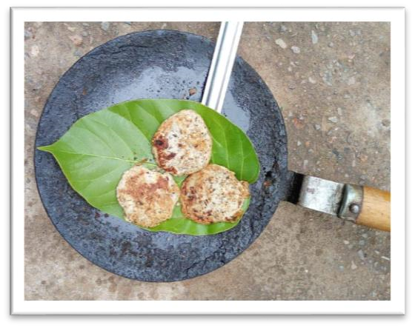

Figure 1- This figure shows the paste made Fig 2- Showing prepared mixture that is turned
after grinding the stem of Curcuma in ball shaped
aromatic.

Figure 3- Variation in Population of Study Area

Aamga
o
Jobga
Ke
tka
Kot
Lachh
a
Lanchi
Pendrakhi
Male
914
592
1
268
1532
509
847
913
Female
890
583
1
363
1557
538
812
850
0
200
400
600
800
1000
1200
1400
1600
1800
TOtal Frequency
Frequency Distribution of Male and
Female
Fig 4- Frequency Distribution of Male and Female in different villages
Medicinal Plant Uses: The performed survey provides detailed information about the traditional medicinal uses of plants in the treatment of various diseases. This includes information about specific plant parts used, modes of drug preparation, and administration methods. Here are the list: -

Table 1: Drug preparation procedure documented from the tribal community

S.N. | Common Name | Scientific Name | Family | Parts use | Disease Uses | Method of preparation | Dose
1 | Dabi | Cadaba fruticosa | Capparaceae | Seed | Heart disease | seed is processed into paste and then drink it with water. | 3-6 Dose
2 | Jangli haldi | Curcuma aromatica | Zingiberaceae | Stem | Pain | blackgram is soaked in water overninght or for 6hrs, then the prepared mixture is turned in ball shaped | 20-25 Dose
3 | Doob | Cynodon dactylon | Poaceae | Leaves | Small injury | grinds with grinding stone, apply the paste to injuries | 4-5 Dose
4 | Mahua | Madhuca longifolia | Sapotaceae | Bark | Helps in reducing gum pain | twig is used to brush teeth. | 4-5 Dose
5 | Aam | Mangifera indica | Myrtaceae | Bark | Fever | Collection of bark,then grinding with help of grinding stone, then ready to drink. | 5-7 Dose
6 | Charota | Senna tora | Caesalpiniaceae | Seed | Itching. | processed into paste and applied into exposed area. | 4-5 Dose
7 | Sal | Shorea robusta | Dipterocarpaceae | Seed | Dysentery | seed is used in powered form through grinding boil the seed | 4-5 Dose
8 | Kateli | Solanum virginianum | Solanaceae | Seed | Teeth pain | tranform it into paste form, then applied to hairs directlt | 3-5 Dose
9 | Rohina | Soymida febrifuga | Meliaceae | Bark | Body pain | bark is boiled and the remains liquid is drinked | 4-6 Dose
10 | Baheda | Terminalia bellirica | Combretaceae | Fruit | Cough | roasted in pan, some people turns it into small pieces which further ready to eat directly | 3-5 Dose
11 | Saja | Terminalia elliptica | Combretaceae | Bark | Diarrhea | processed into powered, consumable with water

Conservation and Sustainable Use: The survey may highlight plant species of conservation concern or those that are at risk due to over-harvesting or habitat loss. This information can contribute to the development of conservation strategies and sustainable use practices.

Comparative Ethnobotanical Study by Tribal Community
As per this study, the indigenous communities living within the forest of Sarjapur have long been a source of admiration as they possess a unique understanding of, and ability to utilize, the plants around them. The four largest tribal communities (Gond, Pando, Kanwar, Raon) were investigated and data on their use of plants were obtained by discussion with tribal informants. Data on ethnobotanical practices which are mostly used to cure body pain, dysentery, gum pain, blood pressure, itching, fractures, etc. The study reveals too little commonality in usage of herbal remedies for the selected villages. The difference in usage of plants by same tribes occupying different localities and different tribes of the same or nearby localities was observed.
.
Fig 26: Distribution of Ethnobotanical species across life forms in the Study area
S.No. | Local Name | Scientific Name | Family | Plant parts | Disease Uses | Use by community | Area
1 | Koilar | Bauhinia variegata | Caesalpiniaceae | Leaves | vegitable | Gond | Kot
2 | Bach | Acorus calamus | Araceae | Tuber | Asthma | Gond | Pendrakhi
3 | Arusa | Adhatoda vasica | Acanthaceae | Root and leaves | Asthma and cough | Pando | Ketka
4 | Bael | Aegle marmelos | Rutaceae | Fruit | Dysentery, Fever | Gond | Lanchi
5 | Ghritkumari | Aloe vera | Asphodelaceae | Leaves | Asthma | Pando | Aamgao
6 | Kalmegh | Andrographis paniculata | Acanthaceae | Whole plant | Fever | Gond | Pendrakhi
7 | Sitaphal | Annona squamosa | Annonaceae | Leaves | prevents hair lice | Oraon | Kot
8 | Satavar | Asparagus racemosus | Asparagaceae | Tuber | Immunity booster | Gond | Jobga
9 | Leem | Azadirachta indica | Meliaceae | Bark | Fever | Gond | Lanchi
10 | Brahmi | Bacopa monnieri | Plantaginaceae | Whole plant | Increase memory power | Gond | Pendrakhi
11 | Char | Buchanania lanzan | Anacardiaceae | Leaves | Small injury | Gond | Kot
12 | Parsa | Butea monosperma | Fabaceae | Root | Paralysis | Gond | Kot
13 | Katkarej | Cadaba fruticosa | Capparaceae | Seed | Heart disease | Oraon | Jobga
14 | Mandar | Calotropis gigantea | Apocynaceae | Root | Asthma | Gond | Kot
15 | Aak | Calotropis procera | Apocynaceae | Root | Asthma | Gond | Ketka
16 | Bhalmushree | Cassia fistula | Fabaceae | Whole plant | Body swelling | Gond | Lanchi
17 | Safed musli | Chlorophytum tuberrosum | Asparagaceae | Root | Weeknesss | Gond | Ketka
18 | Harajora | Cissus quadrangularis | Vitaceae | Whole plant | Bone fracture | Gond | Jobga
19 | Aparajita | Clitoria ternatea | Fabaceae | Root | Asthma | Pando | Ketka
20 | Jangli haldi | Curcuma aromatica | Zingiberaceae | Stem | Pain | Gond | Ketka
21 | Doobi Ghash | Cynodon dactylon | Poaceae | Leaves | Small injury | Kanwar | Jobga
22 | Bhringaraj | Eclipta prostrata | Asteraceae | Leaves | Reduces hair fall | Pando | Ketka
23 | Dudhi | Euphoria hirta | Euphorbiaceae | Leaves | Pain | Pando | Ketka
24 | Bargad | Ficus benghalensis | Moraceae | Root | Diabetes | Gond | Pendrakhi
25 | Domer | Ficus racemosa | Moraceae | Fruit | Blood increase | Gond | Lanchi
26 | Piper | Ficus religiosa | Moraceae | Leaves | Paralysis | Pando | Aamgao
27 | Mulhatti | Glycyrrhiza glabra | Fabaceae | Root | Cold-cough , Asthma | Kanwar | Jobga
28 | Gudmar | Gymnema sylvestre | Apocynaceae | Root and leaves | Fever, Cough and Diabetes | Gond | Ketka
29 | Gurhal | Hibiscus rosa sinensis | Malvaceae | Leaves | Swelling | Gond | Ketka
30 | Kutuj | Holorrhena antidysenterica | Apocynaceae | Seed | Pain | Gond | Ketka
31 | Arusa | Justicia adhatoda | Acanthaceae | Leaves | Asthma | Gond | Pendrakhi
32 | Bhui Champa | Kaemperia rotunda | Zingiberaceae | Bark | Injury | Kanwar | Jobga
33 | Patharbhaji | Kalanchoe pinnata | Crassulaceae | Leaves | Kidney stones | Gond | Pendrakhi
34 | Mahua | Madhuca longifolia | Sapotaceae | Bark | Helps in reducing gum pain | Gond | Lanchi
35 | Aam | Mangifera indica | Myrtaceae | Bark | Fever | Gond | Kot
36 | Pudina | Mentha piperita | Lamiaceae | Leaves | Cough | Gond | Ketka
37 | Baukla | Mimusops elengi | Sapotaceae | Stem | Helps in reducing gum pain | Pando | Aamgao
38 | Senjana | Moringa oleifera | Moringaceae | Leaves | Stomachache problem | Gond | Aamgao
39 | Kevanch | Mucuna pruriens | Fabaceae | Leaves | Asthma | Pando | Aamgao
40 | Kalijiri | Nigella sativa | Ranunculaceae | Seed | Immunity booster Respiration system | Oraon | Kot
41 | Tulsi | Ocimum sanctum | Lamiaceae | Leaves | Cold cough and fever | Gond | Pendrakhi
42 | Bhui aonla | Phyllanthus amarus | Phyllanthaceae | Whole plant | Diarrhoea, Dysentery | Gond | Aamgao
43 | Aonla | Phyllanthus embelica | Phyllanthaceae | Fruit | Immunity booster | Gond | Ketka
44 | Karanj | Pongamia pinnata | Fabaceae | Seed | Itching | Gond | Pendrakhi
45 | Anar | Punica granatum | Lythraceae | Leaves | Diarrhoea | Gond | Aamgao
46 | Sarpgandha | Rauvolfia serpentina | Apocynaceae | Root | Blood pressure | Gond | Ketka
47 | Kattha | Senegalia catechu | Mimosaceae | Latex | Mouths ulcer | Pando | Aamgao
48 | Charota | Senna tora | Caesalpiniaceae | Seed | Itching. | Kanwar | Jobga
49 | Sarai | Shorea robusta | Dipterocarpaceae | Seed | Dysentery | Gond | Lanchi
50 | Kateri | Solanum virginianum | Solanaceae | Seed | Teeth pain | Oraon | Jobga
51 | Rohina | Soymida febrifuga | Meliaceae | Bark | Body pain | Gond | Kot
52 | Sugarleaf | Stevia rebaudiana | Asteraceae | Leaves | Diabetes | Gond | Ketka
53 | Jaam | Syzygium cumini | Myrtaceae | Fruit | Body swelling | Gond | Kot
54 | Amli | Tamarindus indica | Fabaceae | Seed | Skin problems | Gond | Lanchi
55 | Kauha | Terminalia arjuna | Combretaceae | Root | Teeth pain | Gond | Lanchi
56 | Bahera | Terminalia bellirica | Combretaceae | Fruit | Cough | Oraon | Kot
57 | Harra | Terminalia chebula | Combretaceae | Fruit | Fever, Heart disease | Oraon | Kot
58 | Saja | Terminalia elliptica | Combretaceae | Bark | Diarrhea | Gond | Ketka
59 | Giloy | Tinospora cordifolia | Menispermaceae | Stem | Immunity booster | Gond | Pendrakhi
60 | Sindvar | Vitex negudo | Verbenaceae | Leaves | Fever | Oraon | Kot
61 | Ashwagandha | Withania Somnifera | Solanaceae | Root | Blood pressure | Gond | Ketka
62 | Dhawai | Woodfordia fruticosa | Lythraceae | Bark | Stop bleeding | Gond | Ketka

Conclusion:
These ethnobotanical practices and knowledge of plants, their use and associated rituals, ceremonies were passed done from generation to generation contributing in preservation of tribal identity, culture and wisdom. Tribal also possess deep knowledge and understanding about plant and its properties and their practices help in development of herbal remedies and also in new medicinal plants. The understanding of growth pattern, way of harvesting and utilization of plant resources ensures the availability of important plant species for future generations promoting the sustainable management of resources. Also, the rituals, beliefs and taboos include in tribal practices promotes a sence of responsibility towards environmental conservation.
The traditional medical system in India is crucial for providing rural people with comprehensive healthcare for a variety of illnesses. The study, in the forest area of Surajpur, Chhattisgarh, India, to learn more about the customs and traditional remedies of the residents of the surrounding villages. This ethnomedical research aimed to properly document the significant plants for ethnomedicinal that were flourishing in the village. In the village, 106 different species of medicinal plants from 49 different families were counted. The research concluded that this location is home to the medicinal plants with the greatest therapeutic utility, and further documentation is required. This study is the first to list and collect medicinal plants in the Surajpur forest area, and it offers the first analysis of the species’ ethnomedical and cultural significance.
The ethnobotanical practices of tribal people in forest areas provide a rich tapestry of knowledge, culture, and sustainability. These practices represent an intricate relationship between humans and plants, encompassing medicinal uses, spiritual and ritual significance, food and nutrition, economic sustainability, and cultural preservation. By studying and understanding ethnobotanical practices, we gain valuable insights into traditional knowledge systems and the sustainable use of natural resources. Indigenous communities have developed a deep understanding of the diverse plant species in their environment and have honed their practices over generations, ensuring the preservation of valuable resources for future generations.
Moreover, ethnobotanical research holds significant potential for modern science. Many plant species used by indigenous people have been found to possess medicinal properties or offer unique attributes. By exploring these traditional practices, we can identify new compounds, uncover novel uses for plants, and contribute to the development of sustainable resource management strategies Furthermore, ethnobotanical practices underscore the importance of cultural diversity and the need to protect indigenous knowledge systems. Preserving and respecting ethnobotanical practices not only benefits indigenous communities but also contributes to the well-being of our planet. These practices offer lessons in sustainable harvesting, conservation, and the importance of cultural heritage. By integrating traditional wisdom with modern approaches, we can foster a more sustainable and holistic relationship with nature. In essence, the ethnobotanical practices of tribal people in forest areas serve as a reminder of the profound connection between humans and plants. They offer a wealth of knowledge, cultural richness, and potential contributions to various fields. By valuing and preserving these practices, we can foster a more sustainable future that embraces the intricate relationships between people and plants.

REFERENCES
- Kujur, M., & Ahirwar, R. K. (2015). Folklore claims on some ethno medicinal plants used by various tribes of district Jashpur, Chhattisgarh, India. Intern J Curr Microbiol Appl Sci, 4(9), 860-867.
- Painkra, V. K., Jhariya, M. K., & Raj, A. (2015). Assessment of knowledge of medicinal plants and their use in tribal region of Jashpur district of Chhattisgarh, India. Journal of Applied and Natural Science, 7(1), 434-442.
- Jangdey, M. S., Gupta, A., Kaur, C. D., & Saraf, S. (2016). Assessment of Utilization, Value addition and characterization of Tamarind: A Natural Gum of Chhattisgarh. International Journal of Pharmaceutical Research & Allied Sciences, 5(2).
- Kala, C. P. (2009). Aboriginal uses and management of ethnobotanical species in deciduous forests of Chhattisgarh state in India. Journal of Ethnobiology and Ethnomedicine, 5, 1-9.

