**ENVIRONMENTAL INNOVATION AND SUSTAINABLE DEVELOPMENT THROUGH GREEN TECHNOLOGY**

Dr. Sanjay Kumar Narang, Dr. Monika Panchani1, Dr. Kiran Chauhan2,Dr. Manoj Thakur3,Dr. Radhika Jamwal4

**INTRODUCTION**

The only way to ease strain on environmental quality while sustaining economic growth is through environmental innovation. Environmental deterioration has compelled the society to the idea of sustainable development through green technology. Diverse green projects are being implemented to preserve and enhance the quality of the environment. Green technology is the creation and use of tools, and systems that limit the damaging impacts of human activity on the environment and natural resources. The depletion of natural resources and the growth in pollution brought on by the extensive use of non-renewable resources created the need for green technology. The identification of green sources of growth, the development of new green industries, and the creation of new job possibilities are all components of green technology that supports sustainable development. Stronger investment and innovation, which are the cornerstones of sustainable development and open up new economic avenues, are necessary for achieving green growth. Therefore, in-depth study on the conditions of formation, system-forming variables, and effects of sustainable development is necessary for the promotion of the green economy. Businesses (focused on the financial gains), governments (defining environmental goals for sustainable development), and the general public (representing the interests of the social community) are all parties with an interest in the growth of the green economy. For sustainable development objectives to be met, innovation is required. In order to influence green technology, environmental advances, and the socioeconomic aspects of sustainable development, it is important to have a thorough understanding of green knowledge management. This is especially true when it comes to the creation, acquisition, interchange, and application of knowledge.

**THE NEED FOR GREEN ENERGY:** Green energy comes from renewable resources and has very little of an influence on the environment. We should begin employing green energy for both industrial and home applications in order to preserve mother nature from contamination and guarantee a steady supply of electricity. As temperatures rise, agricultural production will decline, damage from floods and storms will increase, diseases will become more prevalent, and access to water will become a problem for more and more people. To slow global warming and protect ecosystems, CO2 emissions must be reduced through energy efficiency and renewable energy. The loss is irreparable and comes at a higher cost to our ecosystem. Higher temperatures will directly harm Earth's plants and animals, while harm to their ecosystems would indirectly harm them. Ecosystems will vanish, and even a slight temperature increase will cause coral bleaching and put some amphibians in risk. Global mass extinctions will occur if temperatures rise by 3 or 4 degrees Celsius or higher. Restoring the earth's environment is essential for a sustainable way of life. The least harmful forms of energy include solar, hydro, and wind because they don't raise carbon dioxide emissions or promote global warming in any manner. 

Figure-1: Green Energy

**SOLAR ENERGY**

All life on Earth is powered by the sun, which is a significant source of solar energy. It generates almost 10,000 times as much energy as the earth and is a clean, renewable source. Since solar energy is the best renewable energy source, we may use it as green energy. Due to cost-saving technology advancements and government initiatives promoting the use of renewable energy, solar energy has seen tremendous growth in recent years. According to legend, India is one of the few nations possessing a surplus of sun energy. There is a ton of room for expansion in the Indian solar market. The market penetration of inferior products and customers' inadequate awareness of solar energy technology, however, are two problems affecting the growth. Solar cells and photovoltaic cells are both types of electrical components that use light to generate electricity. In 1839, French physicist Edmond Becquerel made the initial discovery of photovoltaic energy. Charles Fritts made the first functional solar cell in a successful manufacturing process in 1882. It was constructed from thin gold-coated sheets of selenium. Although the use of solar panels to produce heat and electricity seems to be a relatively recent discovery, it has been utilized to produce energy on a large scale since the early 20th century. Solar energy has seen a significant technological advancement. Solar panels are good at generating renewable energy, but the technology has limitations, such as gloomy skies and dusk, which can render them worthless. However, thanks to infrared technology, a team of researchers from UNSW Sydney and the ARC Centre discovered a way for solar PV cells to perform even at night. They employed a thermos-radiative diode to convert accumulated infrared heat into electricity, similar to how night-vision goggles work. The same principles apply to solar power, the Sun serves as the hot source, and a relatively cool solar panel on Earth's surface serves as the cold absorber, this enables the generation of power. Solar energy typically has many advantages over fossil coal and oil because it reduces carbon emissions, cleans the air, and can be regenerated during our lifetime. As the world's consumption of electricity has increased, researchers have focused on developing solar energy technologies to achieve high efficiency levels with minimal investment costs and less environmental pollution.

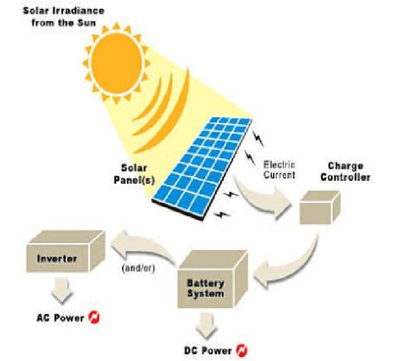 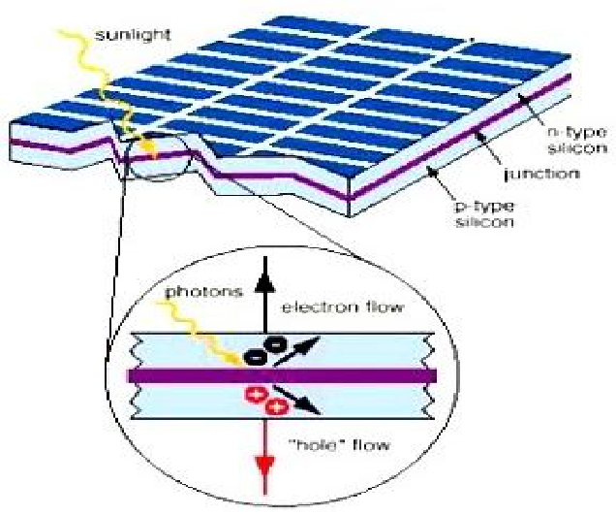

Figure-2. A: Working of solar energy B: Internal reaction of solar energy

**HYDROPOWER**

Hydropower is one of the oldest and greatest sources of renewable energy, generating electricity from the natural flow of moving water. Water flow, head, and density all affect hydropower. Hydroelectric power plants (HPP) are classed based on their capacity. Power plants are classified as "large hydro" (10 MW or more) or "small hydro" (up to 10 MW). Small scale systems are classed as "mini hydro" (up to 1 MW), "micro hydro" (up to 100 kW), and "pico hydro" (up to 5 kW). It is estimated that power plants with a capacity of less than 10 megawatts account for around 10% of the world's power plant capacity. Overall, hydropower is regarded as one of the most efficient renewable energy sources. When scaled up, a hydroelectric power plant is expensive to build, but it provides us with a lot of energy in the long term. Hydroelectric power facilities may achieve an efficiency of around 90%, which no other renewable energy source can match. Solar energy powers the worldwide water cycle, hence hydropower is considered renewable. This is the power generated by the hydrologic cycle, a continuous process in which falling water and high-velocity currents generate electricity. Hydropower is a renewable energy source that now serves as the primary source of electricity, accounting for around 19% of global electricity production. The majority of the hydropower utilized in the world today is generated by large projects. Furthermore, there is more room for the development of small-scale hydropower plants.

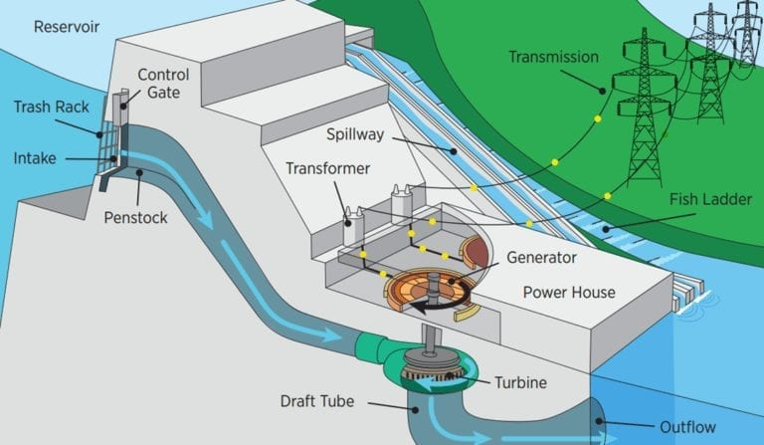 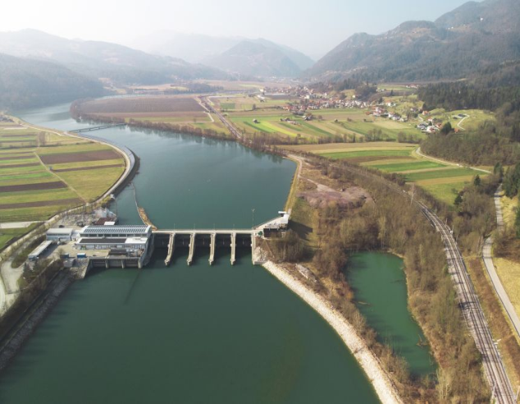

A B

Figure-3: Hydropower generation

**GREEN BUILDING**

Green building technology is still relatively new in comparison to conventional architecture, however recent studies demonstrate that green buildings become more cost-effective over time than conventional buildings. Green buildings use a variety of technologies and materials to reduce environmental effect and energy expenses. Green construction technologies utilize natural resources such as natural light from windows, solar cells mounted on building roofs, rainwater harvesting systems to minimize water use, and trash reduction through the use of recycled products. It refers to the approaches employed in the built environment to guarantee that the building can fulfill the function for which it was designed, that it is comfortable, productive its environmental impact is minimized. Buildings consume more than 40% of global energy and release more than one-third of global greenhouse gas emissions. Therefore, making buildings more energy efficient and decreasing their influence on global warming is critical. Earth has already experienced global warming, green building solutions require not just mitigation (lowering carbon emissions), but also adaptation (enabling structures to react to climate change in projects). Green buildings are important because they help to secure the long-term growth of the environment and provide a healthier environment for humans. It is critical to find and support the advancement of green building technology, which is critical to environmental protection and ecological growth.

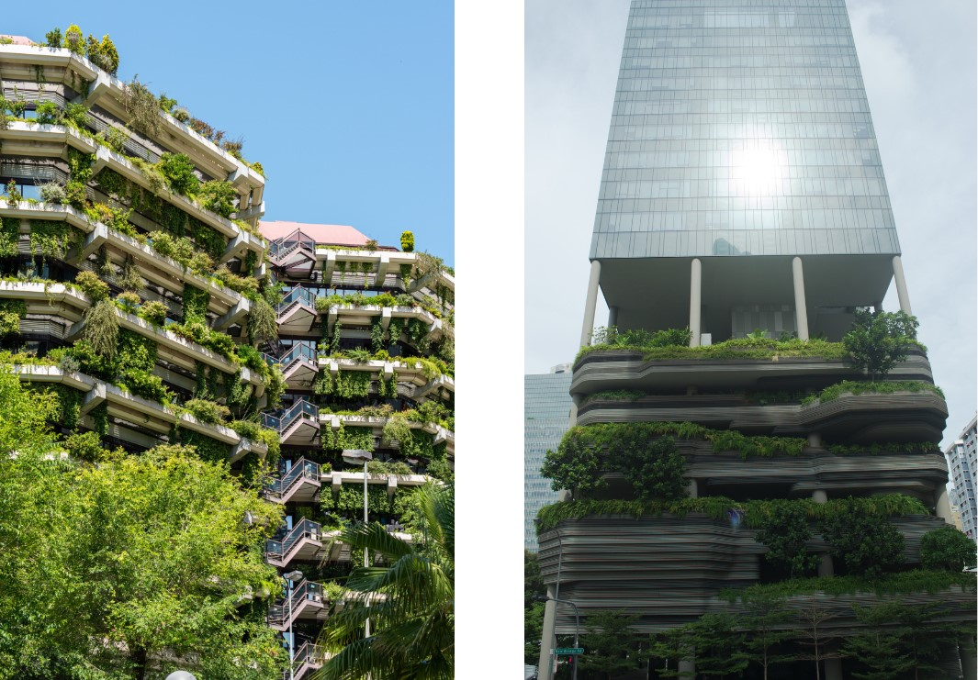

A B

Figure-4: Green Buildings

**WIND ENERGY**

Wind is a plentiful source of energy that may be harnessed to produce clean electricity using wind turbines. Wind power is generated by transferring wind kinetic energy to rotors. The rotating turbine blades' mechanical energy subsequently powers an electrical generator. A wind turbine's power is determined by its size and the speed of the wind passing through the rotor blades. These blades range in diameter from 30 to 90 meters, and the support towers are around the same height. Utility-scale turbines provide power ranging from 100 kilowatts to seven megawatts. Wind farms are made up of larger turbines that give bulk energy to the electrical grid, which is then distributed to homes and offices via transmission and distribution lines. In terms of green technology and commercial preparedness, wind energy is one of the most promising and advanced sources of sustainable energy. In fact, wind power is expected to develop at the quickest rate of any renewable energy source.

Problems and difficulties of wind power

**1.**Correct design: One of the most significant challenges is the correct design of a wind turbine. Wind turbine design should include blade loading (if the blades are light) and aerodynamic stability. Wind turbines are subject to inertia, gravity, and aerodynamic forces.

**2.**Location issues**:** Building a wind farm necessitates a big area, and the developer must own/secure the property. Wind generating stations are typically built in rural locations where land is available besides for various uses such as agriculture and animal husbandry. Wind turbine power is mostly determined by wind speed. Wind speed is mostly influenced by impediments such as buildings and topography. Wind power facilities should be located at a sufficient height in the countryside to ensure full use of wind energy. Wind energy can have both beneficial and harmful environmental effects. Wind turbine energy does not emit pollutants like carbon dioxide, nitrogen oxides, or sulfur dioxide.

3.Wildlife effects: There are two types of wildlife effects: direct and indirect. The immediate repercussions of wind turbine collisions include mortality, while the indirect effects include habitat destruction, etc. However, as compared to other energy sources, the impact of wind turbines on animals is small.

4. Noise pollution: One of the most serious environmental concerns when implementing wind energy is noise pollution. Noise pollution can reduce property value within a given radius of a building, and it is also (to some extent) dangerous to humans. As a result, prior to construction, it is critical to assess the sort of noise produced by the wind turbine.

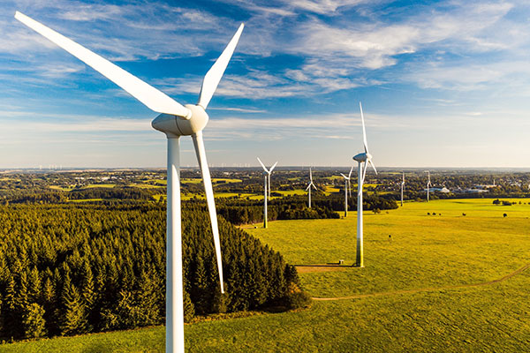 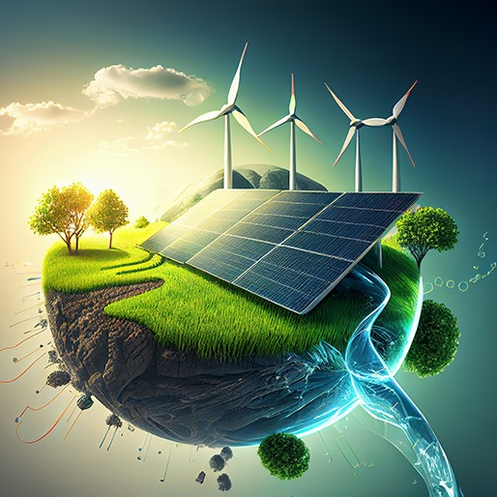

A B

Figure-5: Wind Energy

**GREEN TECHNOLOGY'S FLAWS AND INADEQUACIES**

Green technologies have been used in various industries however, they have not been fully utilized and are still used as alternative energy sources in the energy sector. The initial investment and installation expenses are quite costly; the maximum cost of constructing a 1 MW solar power plant in India is roughly Rs 300-350 crore (without government incentives). In comparison, the cost of constructing a sub-critical coal power plant (Ultra Mega Power Plant 4000 MW) is approximately 184,736 crores. That works out to 46184000 rupees per MW. The gap is enormous, and many developing countries cannot afford it. The government's massive investment in green technologies will effectively limit cash flow in other critical areas such as industry, health, and infrastructure. Technology is continually evolving, and many items are still in the research and developmental stage. As a result, people are unaware of the performance outcomes. Solar panel disposal is still a research management issue since solar panels contain hazardous substances.

**SUMMARY**

This chapter emphasizes the necessity of green energy technologies through sustainable energy. Solar energy would assist to stabilize energy prices while also providing a variety of social, environmental, and economic benefits. Given the current situation of fossil fuel supplies, which are considered decreasing sources of energy, developing a novel strategy for deploying clean energy technologies is both necessary and expected. Despite the fact that solar energy has not yet reached maturity in development. Wind energy has huge potential and requires more attention, particularly in large systems. Wind power's good effects on climate change mitigation and the possibility to reduce energy dependency are evident. Apart from lowering carbon emissions and energy constraint, it also plays an important role in expanding employment prospects in developing countries like India. Hydropower is one of the cleanest, most reliable, and least expensive energy sources. It does not contribute to global warming or climate change in the same way that fossil fuels like as oil do. Hydroelectric power plants offer a steady and consistent supply of electricity, which is not the case with other renewable energy sources such as solar and wind power. Green building technologies have a significant initial investment but have a low environmental impact and are energy efficient. Because business and residential buildings utilize a significant amount of energy in any country. Green buildings will have major advantages over conventional buildings in the future because they reduce energy consumption and waste, and they can return their costs in a reasonable amount of time. Such structures have shown to be economical and ecological in the long run, benefiting both people and society as a whole. All green technologies are required to develop energy systems that protect and promote the environment and human health. Green technologies are unquestionably necessary since they best meet our current global needs.

**AUTHORS CREDENTIALS:**

**Lead and Corresponding Author:**

Dr. Sanjay Narang, Associate Professor (Zoology), Vallabh Govt. College (VGC), Mandi, Himachal Pradesh, India-175001 Email: sanjaynarang76@gmail.com Mobile: 9418480595

**Co-authors:**

1. Dr. Monika Panchani, Associate Professor (Zoology), Vallabh Govt. College (VGC), Mandi, Himachal Pradesh, India-175001

Email: monikapanchani11@gmail.com Mobile: 9418263032

2. Dr. Kiran Chauhan, Assistant Professor, Department of Biosciences, MLSM College Sundernagar, Mandi,H.P. Pin-175018

Email:kiran.cng@gmail.com Mobile:8219166427

3. Dr. Manoj Thakur, Assistant Professor (Environment Science), Vallabh Degree College (VGC), Mandi, Himachal Pradesh, India-175001

Email: [manojthakur0083@gmail.com](mailto:manojthakur0083@gmail.com)

4. Dr. Radhika Jamwal, Assistant Professor (Zoology), Vallabh Degree College (VGC), Mandi, Himachal Pradesh, India-175001

Email : radhika_mnd@yahoo.co.in Mobile: 9418080991