Durability Evaluation of Self-Compacting Concrete with Controlled Permeable Formwork Liner
S. Kandasamy^{1*}, N. Pannirselvam ², S. Syed Ibrahim ³, J. Vanjinathan⁴, S. Sundararaman⁵
¹Professor, Department of Civil Engineering, Vel Tech Rangarajan Dr. Sagunthala R&D Institute of Science and Technology, Chennai-600062, Tamil Nadu, India
²Professor, Department of Civil Engineering, SRM Institute of Science and Technology, Chennai, Tamil Nadu, India
³Associate Professor, Department of Civil Engineering, Ilahia College of Engineering and Technology, Ernakulam, Kerala, India
⁴Assistant Professor, Department of Civil Engineering, Sathyabama Institute of Sciences and Technology, Chennai, Tamil Nadu, India
⁵Professor, Department of Civil Engineering, Sri Manakula Vinayagar Engineering College, Puducherry, India
*Corresponding author E-mail: skandasamyisha@gmail.com
Abstract: Corrosion in reinforced concrete structures is a pervasive global issue, incurring substantial costs for repair and retrofitting. Aggressive agents infiltrate concrete through its surface, triggering rebar corrosion. Controlled Permeability Formwork (CPF) represents an active approach to enhancing the surface area of the concrete's quality. Using this technique, the cement and fine particles are retained while the excess water and trapped air are successfully removed from the fresh concrete's near surface. As a result, the concrete's cover zone's surface porosity decreases, cement content rises, and the water-to-cement (w/c) ratio is decreased. CPF operations yield a smooth surface devoid of pinholes and defects. The purpose of this paper is to report the findings of an experimental investigation that looked at the impact of CPF liner application on the durability properties of self-compacting concrete (SCC). Both CPF liners and impermeable steel formwork (IMF) were used to prepare the samples and subjected to various tests at different ages. These tests encompassed sulfate resistance, hydrochloric acid resistance, sorptivity, and water absorption. The outcomes demonstrated that CPF concretes shown impressive sorptivity (resistance to water absorption) properties, ranging from 22 to 67%. Additionally, CPF concrete displayed a superior residual compressive strength, surpassing IMF concrete by 14 to 143%, particularly when subjected to an environment with hydrochloric acid.
Keywords: Controlled permeability formwork, Hydrochloric acid resistance, Sulfate resistance, Sorptivity, Water absorption.

INTRODUCTION
The corrosion of reinforced concrete structures represents a significant global challenge, resulting in substantial expenses for repair and retrofitting. Aggressive agents infiltrate concrete through its surface, initiating rebar corrosion. The durability of concrete structures is greatly influenced by the quality of the concrete's surface or cover zone. This surface zone serves as the initial line of defense against both physical and chemical deterioration, profoundly influencing the overall structural longevity.
A crucial economic factor for extending the service life of reinforced concrete structures is to make the concrete cover zone more durable. Traditionally, efforts to improve concrete durability have focused on increasing cement content, reducing the water-cement ratio, and incorporating various admixtures. However, these approaches primarily impact rather than focusing on surface-level issues, consider the bulk qualities of concrete.
In practical terms, the concrete's surface layer is in direct contact with atmospheric conditions. Aggressive agents, whether in gaseous or liquid form, particularly chlorides or carbon dioxide, permeate the concrete through its surface layer, threatening the integrity of the concrete structures. Notably, the choice of formwork employed during construction significantly influences the performance of this surface layer [1].
Commonly used formwork materials, such as Plywood or steel that has been impregnated is air and water-tight. When compaction is taking place, any excess water and trapped air tend to migrate towards the formwork. However, since conventional steel or wood is impermeable (referred to as an Impermeable Formwork or IMF), this migration halts when the concrete reaches the interface with the formwork. This phenomenon becomes visually evident on concrete surfaces upon formwork removal, manifesting as the presence of blowholes and pinholes [2].
In terms of structural composition, the core of any given structural element typically displays higher density and superior quality compared to the surface, primarily attributable to the compaction process. Conversely, compared to the inner core of the concrete, the concrete surface is more vulnerable to inadequate curing and compaction [3]. Hence, to ensure robust durability, it becomes imperative to establish a well-compacted, resilient concrete surface zone characterized by low permeability, minimal diffusion, and an absence of surface porosity.

CPF is an active method used to improve the surface layer's quality in concrete. The CPF system comprises a textile liner affixed to conventional formwork, as depicted in Figure 1. The CPF liner helps the near-surface concrete to drain excess mix water and trapped air while holding cement and other fine particles inside of it [5-16]. This mechanism serves to reduce the w/c ratio, reduce surface porosity and increase cement content within the concrete's cover zone. Consequently, this process yields a uniform surface devoid of blowholes, pinholes, and surface imperfections.
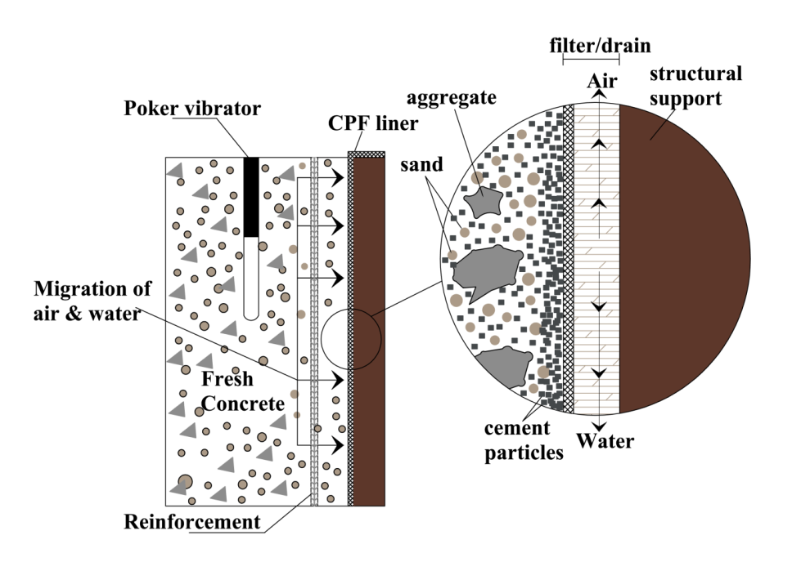
Fig. 1 Function of CPF liner [4]
Many researchers have repeatedly noted that the vibration caused by the compaction process causes a precise amount of mix water and trapped air to be directed towards the formwork. However, evaluating CPF liner performance and efficiency in the context of SCC remains relatively scarce.
In the current experimental study, our goal is to evaluate the CPF liner's performance in relation to self-compacting concrete, where traditional vibration for compaction is unnecessary.
EXPERIMENTAL WORK
Materials
Throughout this investigation, OPC (Ordinary Portland Cement) of grade 43, adhering to IS: 8112-1989 [17] standards and possessing a specific gravity of 3.15 was used. Locally sourced natural river sand that conformed with IS: 383-2016 zone II was used as the fine aggregate [18] standards, having a 2.6 specific gravity and a 2.54 fineness modulus. Crushed natural rock stone that conformed with IS: 383-2016 requirements and had a specific gravity of 2.79 and a fineness modulus of 7.8 was used as the coarse aggregate [18].

For the mixing and preparing of concrete, normal tap water, meeting the requirements stipulated in IS: 456-2000 [19], was employed. Additionally, Fly ash from Chennai's Ennore Thermal Power Station was added to the mixture. A polycarboxylate ether polymer-based superplasticizer (SP) by IS: 9103-1999 was used in this work [20] standards, was utilized to enhance workability. A viscosity-modifying admixture (VMA) was also added to stop segregation.
In this research, a Type II CPF liner was employed, characterized by a single-layer design. This CPF liner operates with its inner face, facing the concrete, functioning as a filter, while the outer face, oriented towards the formwork, serves as a drainage layer, as illustrated in Figure 1. The manufacturer-provided specifications for the CPF liner are detailed in Table 1.
Table 1 Specifications of CPF liner [21]
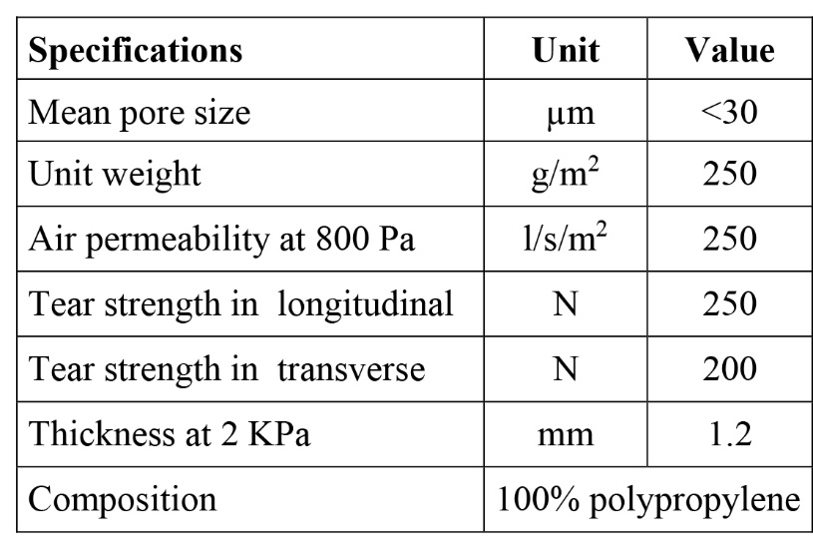
Concrete mixture proportions

Table 2 lists the SCC's concrete mixture proportions and characteristics..

Table 2 Mix proportions and properties of SCC

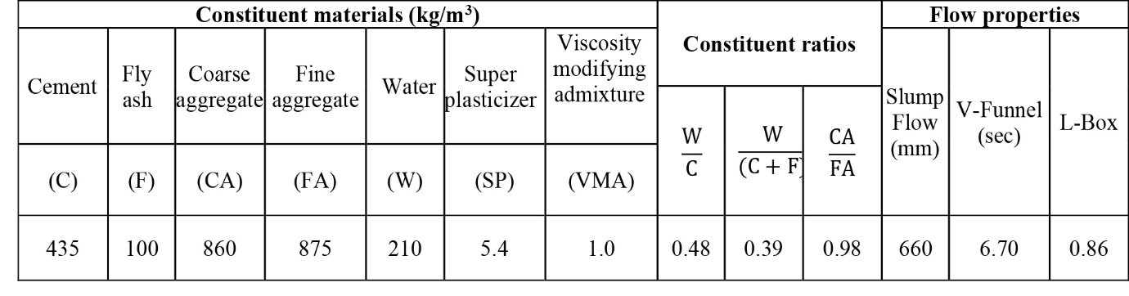

Preparation and curing of specimens

To create the reference test specimens, steel molds were employed. CPF liners were securely attached to the side plates of these molds, and the specimens were subsequently cast, as illustrated in Figure 2. The concrete specimens known as "IMF" specimens have been manufactured using steel molds, while those crafted using steel molds with CPF liners were labeled as "CPF" specimens. A 55-liter drum mixer was used to carefully prepare the concrete mixes. The molds were filled with concrete, and when 24 hours were up, they were removed. The resulting specimens then underwent water curing until the testing date.
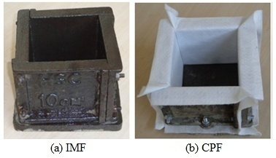
Fig. 2 preparing the mold to cast the cube specimens.

TEST PROGRAMME
Water absorption
A cube specimen measuring 100 mm in dimensions was employed for the test. The testing was conducted at 7, 14, 28, 60, and 90 days, following the guidelines outlined in ASTM C 642 [22]. Prior to the test, the samples were dried for 24 hours in an oven with a temperature of 105°C. Subsequently, the samples were cooled and weighed (W1). Following this, the specimens were submerged in water for 72 hours. The samples were taken out of the water bath, allowed to dry on the surface, and then weighed (W2).
Sorptivity
A cube specimen with dimensions of 100 mm on each side was used for the test. The testing was carried out at 7, 14, 28, 60, and 90 days, following the procedures outlined in ASTM C 1585 [23]. After removing the curing tank, the samples were dried in an oven for three days at 50°C. Subsequently, the samples were allowed to cool to room temperature, except for the suction face (the side in contact with water), which was coated with epoxy. The initial weight of each specimen was recorded.

As depicted in Figure 3, the samples were placed on a tray supported by a platform and submerged in water to a depth of approximately 3 mm. After blotting away any excess water, the samples were removed and weighed.
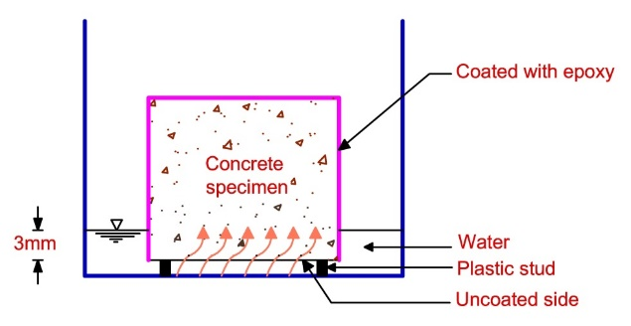
Fig. 3 Layout for sorptivity test.

Hydrochloric acid resistance
A cube specimen measuring 100 mm on each side was employed for this test. After being removed from the curing chamber following a 28-day curing period, the specimens were allowed to air dry for one day, and their original weights were recorded. Hydrochloric acid (HCl) solution with a 5% concentration was prepared. The specimens were subsequently submerged in the acidic solution for 60, 90, 120, and 180 days, respectively, while the concentration of the solution remained constant. The specimens were removed from the acid solution after each designated time period. Following a thorough cleaning of their surfaces and the recording of their weights, they were tested in a 3000 kN compression testing machine at a constant loading rate of 140 kg/cm2/min. Each test duration included the use of three specimens. The concrete specimens' weight loss and remaining compressive strength were the subject of the analysis.
Sulfate resistance
A cube specimen measuring 100 mm on each side was employed for this test. After a curing period of 28 days, the specimens' original weights were noted after they were taken out of the curing chamber. A solution was prepared using a 5% concentration of sodium sulfate (Na2SO4) and magnesium sulfate (MgSO4) relative to the weight of water. The specimens were subsequently submerged for 60, 90, 120, and 180 days, respectively, in solutions of sodium sulfate and magnesium sulfate, while preserving the concentration of the solutions. After each specified time interval, the specimens were removed from the sulfate solutions. Their surfaces were thoroughly cleaned, their weights were recorded, and subsequently, they were subjected to testing in a 3000 kN compression testing machine at a consistent loading rate of 140 kg/cm²/min. For each category and test duration, three specimens were utilized. The analysis focused on the weight loss and residual compressive strength of the concrete specimens.
RESULTS AND DISCUSSION
Water absorption
Figure 4 displays the results of the water absorption. Notably, the CPF concrete samples exhibited a substantial reduction in water absorption, ranging from 22 to 30%, which was considerably lower than that observed in the IMF specimens. This observation underscores the effective barrier created by the CPF liner, which serves as a robust and impermeable cover, effectively minimizing water ingress. Similar studies [8,11] have reported a reduction in water absorption ranging from 29 to 50% in CPF samples.
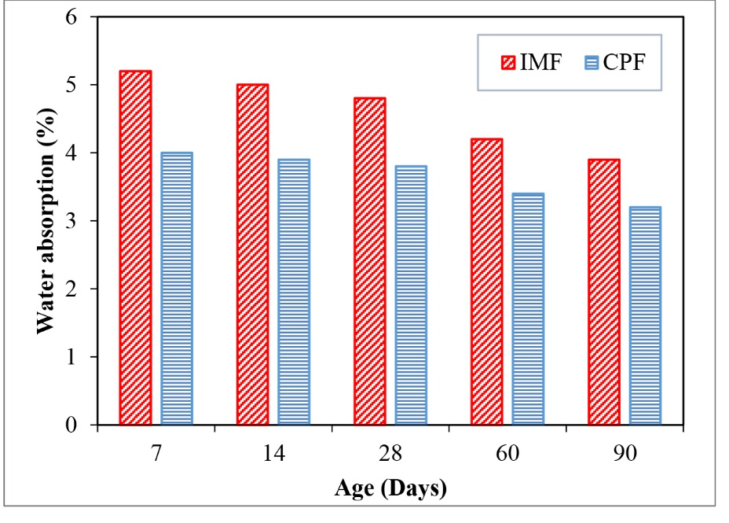
Fig. 4 Water absorption vs age.
Sorptivity
Figure 5 shows how water sorptivity affects the results. It is clear from comparing CPF specimens to IMF specimens at all testing ages that the CPF specimens have significantly less water sorptivity. The enhancement in water sorptivity achieved with the CPF liner is particularly notable, with reductions of 67% at 7 days and 51% at 90 days, respectively.
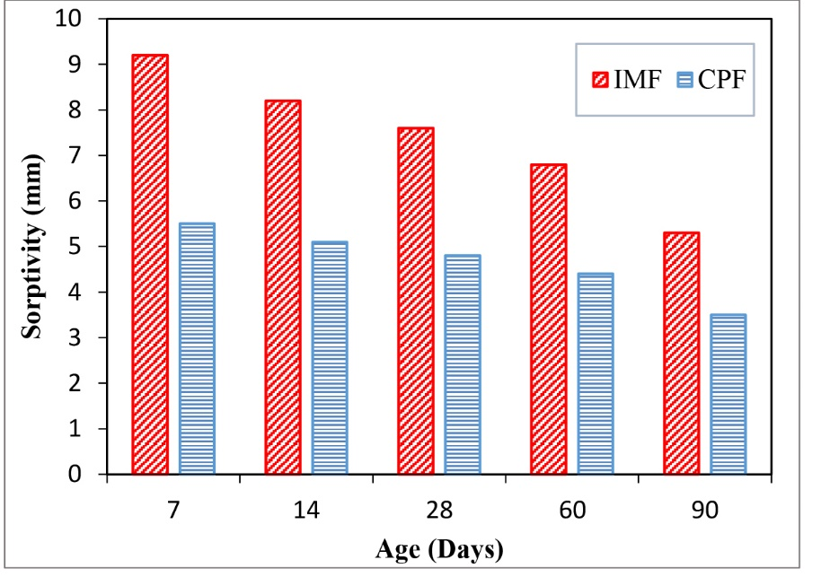
Fig. 5 Sorptivity vs age.
Hydrochloric acid resistance
Figure 6 displays the weight loss of both IMF and CPF concrete specimens when subjected to HCl solution. The outcomes clearly indicate that IMF specimens experienced greater weight loss when compared to CPF specimens across all age intervals. The reduction in weight loss observed in CPF specimens ranged from 42% to 48%. Figure 7 shows the residual compressive strength of the IMF and CPF specimens in the presence of HCl solution. These findings show that across all age groups, IMF specimens had lower residual compressive strength than CPF specimens. The improvement brought about by the CPF liner ranged from 14% to 143%. It's worth noting that the weight loss of concrete specimens is reflected in the residual compressive strength of the concrete.

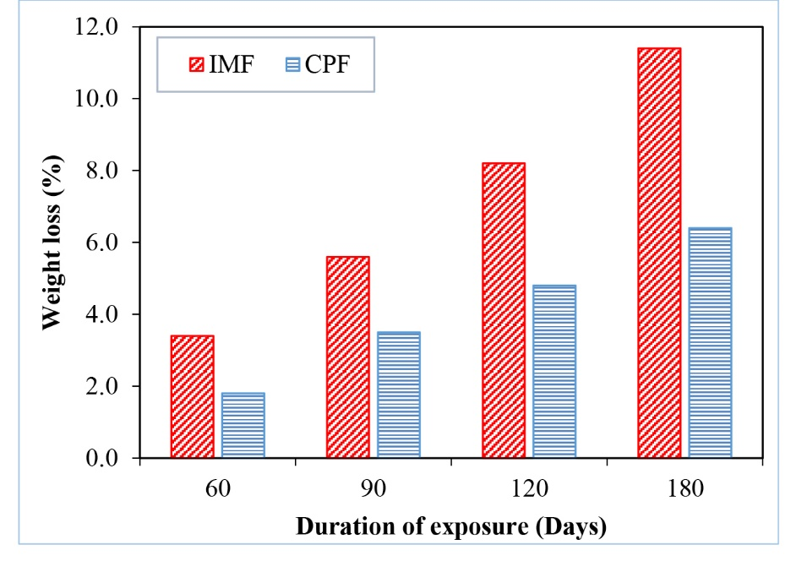
Fig. 6. Weight loss vs duration of exposure.
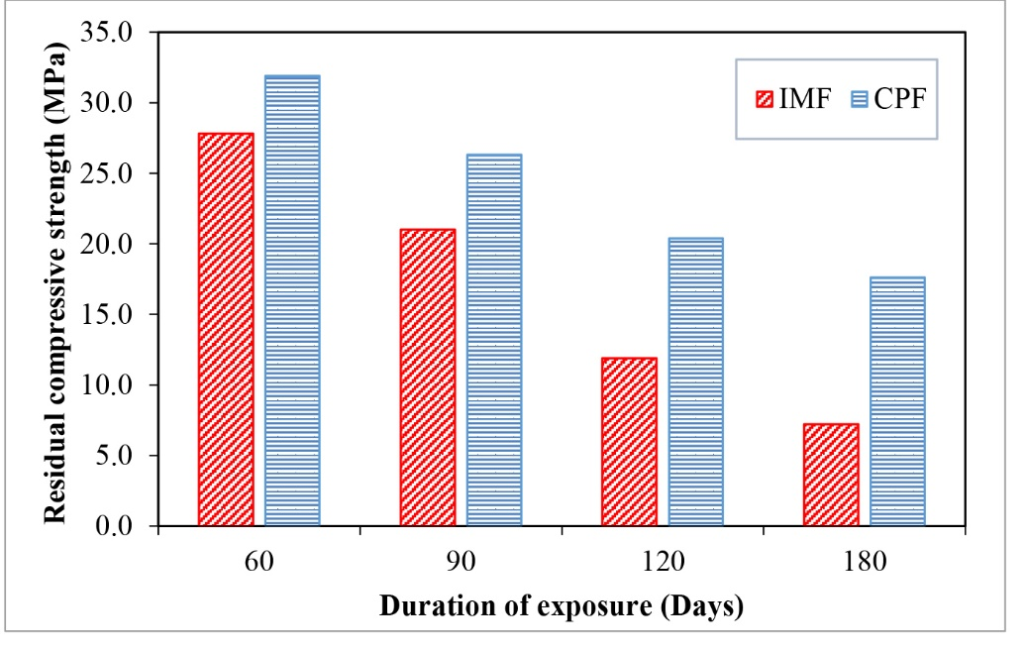
Fig. 7. Residual compressive strength vs duration of exposure.
Sulfate resistance
Figure 8 shows the weight loss of concrete specimens made of IMF and CPF after being subjected to a sulfate solution. The test results clearly indicate that IMF specimens experienced more significant weight loss compared to CPF specimens. The reduction in weight loss observed in CPF specimens ranged from 37% to 43%. Notably, the weight loss was lower when compared to specimens exposed to HCl solution, both for IMF and CPF specimens.

The residual compressive strength of both IMF and CPF specimens in sulfate solution is shown in Figure 9. The results show that when compared to CPF concrete specimens, IMF concrete specimens showed lower residual compressive strength. But there wasn't much of a difference in the residual compressive strength between IMF and CPF specimens. The CPF liner showed an improvement of between 8% and 28%.
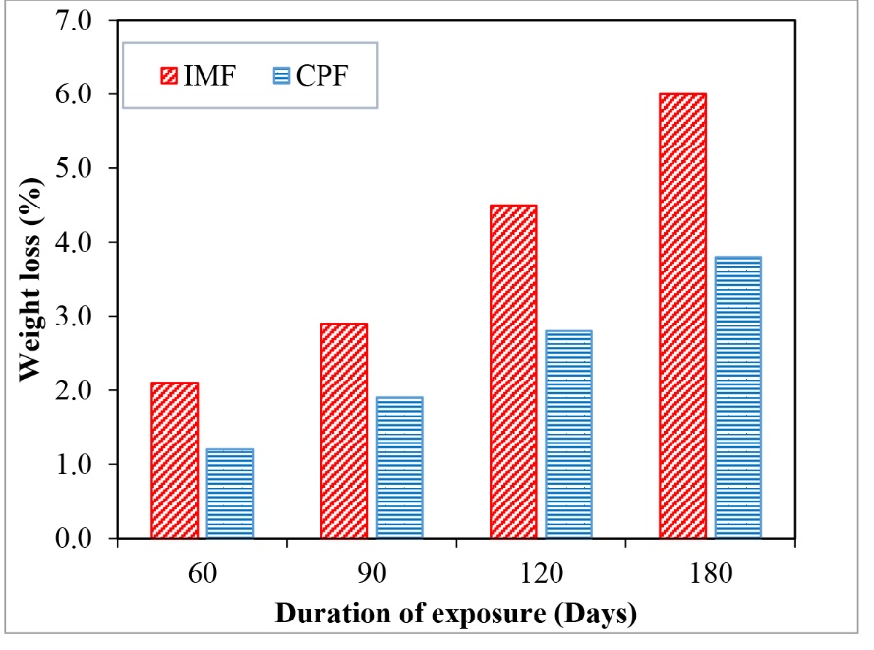
Fig. 8. Weight loss vs duration of exposure.
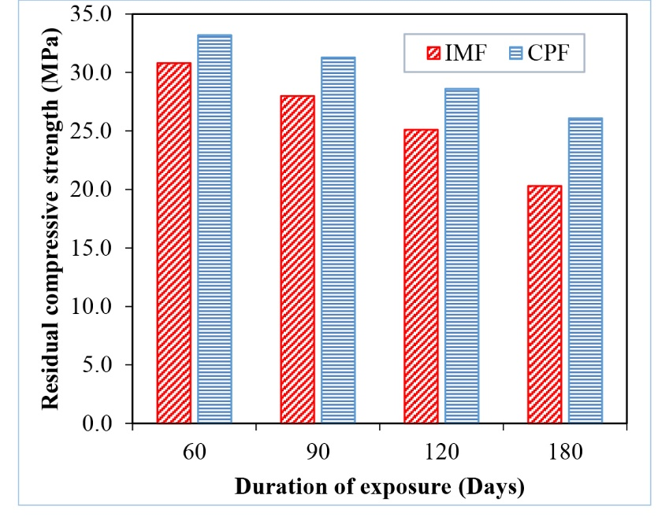
Fig. 9. Residual compressive strength vs duration of exposure.

CONCLUSIONS
The following conclusions were derived as a result of the current experimental investigation:
- Compared to IMF concrete specimens, CPF concrete specimens have a low water absorption value. The improvement ranges from roughly 22% to 30%. Similar to the way CPF samples had considerably lower rates of sorptivity (water absorption) than samples made of impermeable formwork. The increase was between 51% and 67%.
- The weight loss of the CPF concrete samples is observed to be lower in both hydrochloric acid and sulfate environments when compared to samples with impermeable formwork. The range of improvement is within the interval of 37 to 48%.
- Outstanding performance was shown by CPF concretes in a chemical environment. When exposed to hydrochloric acid, CPF concrete's residual compressive strength outperformed IMF concretes by 14% to 143%. The improvement in a sulfate environment ranged from 8% to 28%.
References
[1] A. Ajdukiewicz, On durability aspects of concrete members formed against permeable formwork, Foundation of Civil and Environmental Engineering 7 (2006) 007-016.
[2] W.F. Price, S.J. Widdows, The effect of permeable formwork on the surface properties of concrete, Magazine of Concrete Research 43 (1991) 93-104.
[3] J. Cairns, Enhancements in surface quality of concrete through use of controlled permeability formwork liners, Magazine of Concrete Research 51 (2) (1999) 73-86.
[4] J.S. Coutinho, Effect of controlled permeability formwork (CPF) on white concrete, ACI Materials Journal 98 (2) 2001 148-169.
[5] W.F. Price, Controlled permeability formwork, CIRIA Report, C 511, 2000.
[6] J.S. Coutinho, The combined benefits of CPF and RHA in improving the durability of concrete structure, Cement& Concrete Composites 25 (2003) 51-59.
[7] E. Nolan, P.A.M. Basheer and A.E. Long, Effects of three durability enhancing products on some physical properties of near surface concrete, Construction and Building Materials, 9 (1995) 267-272.
[8] F. Helena, N. Sandra, S. Joana and F. Joaquim, Combined effect of two sustainable technologies: self compacting concrete and controlled permeability formwork, Construction and Building Materials 23 (2009) 2518-2526.
[9] A.A. Adam, D.W. Law, T. Molyneaux, I. Patnaikuni and T. Aly, The effect of using controlled permeability formwork on the durability of concrete containing OPC and PFA, Australian Journal of Civil Engineering 6 (1) 2010 1-12.
[10] McKenna, P., The effect of controlled permeability formwork on carbonation-induced corrosion, 3rd FIB International Congress, Scotland, 2010.
[11] L. Basheer, S.V. Nanukuttan and P.A.M. Basheer, The influence of reusing ‘Formtex’ controlled permeability formwork on strength and durability of concrete, Materials and Structures 41 (2008) 1363-1375.
[12] P.J. Schubel, N.A. Warrior, K.S. Elliott and M. Jones, An Investigation into the critical factors affecting the performance of composite controlled permeability formwork liners, Construction and Building Materials 22 (2008) 1551-1559.
[13] M.J. McCarthy, A. Giannakou and M.R. Jones, Specifying concrete for chloride environments using controlled permeability formwork, Materials and Structures 34 (2001) 566-576.
[14] M.J. McCarthy, A. Giannakou, In-situ performance of CPF concrete in a coastal environment, Cement and Concrete Research 32 (2002) 451-457.
[15] A.K. Suryavanshi, R.N. Swamy, An evaluation of controlled permeability formwork for long- term durability of structural concrete elements, Cement and Concrete Research 27 (1997) 1047-1060.
[16] A Metin, The effects of permeable formworks with sucker liners on the physical properties of concrete surfaces, Construction and Building Materials 15 (2001) 149-156.
[17] IS 8112-1989, Specification for 43 grade ordinary portland cement, Bureau of Indian Standards, New Delhi, 1989.
[18] IS 383-1987, Specification for coarse and fine aggregates from natural source for concrete, Bureau of Indian Standards, New Delhi, 1987.
[19] IS 456-2000, Plain and reinforced concrete, Code of Practice, Bureau of Indian Standards, New Delhi, 2000.
[20] IS 9103-1999, Specification for concrete admixtures, Bureau of Indian Standards, New Delhi, 1999.
[21] Fibertex A/S, Denmark, BBA Agreement Certificate 03/4038, 2009.
[22] ASTM C 642: 1997. Standard test method for density, absorption and voids in hardened concrete, American Society for Testing Materials, 1997.
[23] ASTM C 1585: 2004. Standard test method for measurement of rate of absorption of water by hydraulic cement concrete, American Society for Testing Materials, 2004.

