Environment Sustainability Approaches
Saloni Sahal^{1*}, Harlal Singh and Sarita Khaturia¹
¹Department of Chemistry, School of Liberal Arts and Sciences,
Mody University of Science and Technology, Lakshmangarh, Sikar 332311, Rajasthan, India.
salonisahal03@gmail.com
hlsingh9@gmail.com
saritarajkhatri@gmail.com

Table of contents

1. | Abstract
2. | Introduction
3. | Need of sustainability
4. | The three pillars of sustainability
5. | Importance of environmental sustainability
6. | Examples of environmental sustainability
7. | Environmental, Social, and Governance (ESG)
8. | The advantages of ESG
9. | Conclusion

1. Abstract
Environmental sustainability is the responsibility to conserve natural resources and protect global ecosystems to support health and wellbeing, now and in the future. Because so many decisions that impact the environment are not felt immediately, a key element of environmental sustainability is its forward-looking nature. Environmental protections save lives by reducing world hunger, global warming, natural disasters, polluted water and soil, and pesticides. An ideal, sustainable economy achieves the greatest level of general well-being while using the fewest resources and causing the least amount of environmental harm. To be fully sustainable economically, the overall demand for natural resources must be smaller than the renewable supply of resources available in nature.
Keywords: Environmental sustainability, global ecosystems, Environmental protections, sustainable economy

2. Introduction:
The most crucial thing to keep in mind when referring to sustainable [1] practices is that they strive to maintain a balance with nature. In terms of agriculture, this entails figuring out how to make the plants and animals we raise less damaging to the environment and to people's health. Profitable sustainable practices are a requirement. Sustainable [2, 3] business strategies are worth investing in because they go beyond simple environmental awareness. Sustainable business practices enable organizations differentiate themselves from rivals, which boosts revenue and profitability. Investing in sustainable business practices might create new growth prospects for businesses who want to expand their operations. Businesses may find expanding markets, productive farms, and appealing products with the aid of sustainability [4, 5]. This implies that adopting sustainable business methods can result in a significant rise in sales and profits. Environmental sustainability is the capacity to preserve natural resources for the benefit of both the present and the future generations while preserving the ecological balance of our planet. We must stop more harm as the world's population rises and the long-term effects of unsustainable energy use and industrial expansion become more apparent. It is our responsibility to protect the biodiverse ecosystems of the planet and provide a healthy environment for the next generation. Sustainability [6] in the context of business refers to operating a company in a way that minimizes environmental impact while securing possibility for future growth. Ecological equilibrium is key to environmental sustainability. Humans have been carbonizing our planet for about two millennia, which has influenced the global climate [7]. It is without dispute that human activities have had an impact on the globe, leading to the warming of the atmosphere, oceans, and land, according to the Intergovernmental Panel on Climate Change (IPCC), the United Nations agency charged with evaluating the science connected to climate change. More governments, companies, and people are embracing and advocating environmental sustainability as we continue to witness the detrimental effects of climate change. These diverse organizations are working toward the aspirational objective of decarbonizing our planet in order to safeguard our global ecosystems for the benefit of coming generations.

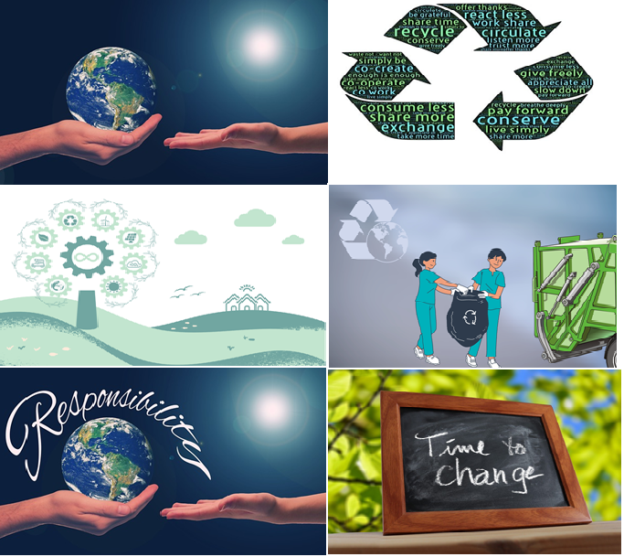

Figure 1: Environmental Sustainability

3. Need of sustainability
Environmental sustainability's ultimate objective is to achieve equality. As we have shown, environmental sustainability has a significant positive impact on human health as well as the health of all other species. It lessens our dependence on fossil fuels [8] and other destructive energy practices, as well as our global carbon impact. By promoting healthier living conditions and improved healthcare, sustainability can lengthen life expectancy and narrow the wealth and poverty gap. In order to address the industrial aspect of waste and pollution, sustainable development [9] promotes more ethical manufacturing and production. Additionally, it encourages businesses, industries, and governments to consider long-term effects before choosing the simplest or least expensive course of action.
4. The three pillars of sustainability
Meeting present-day demands without compromising the potential of future generations to do the same is what sustainability is all about. Many firms attempt to accomplish the following three sustainability [10,11] pillars:
Social sustainability
Social sustainability for organizations involves crucial workplace and employee issues like health and safety, inclusivity, empowerment, opportunity for professional development, and work-life balance.
Economic sustainability
Economic sustainability [12] isn't simply about money, despite the fact that it may appear that this pillar is concentrated on an organization's ability to remain profitable over the course of its existence. An organization that can generate income and maintain long-term business growth without having a detrimental effect on the neighborhood, the environment, or the health and wellbeing of its workers is said to be economically sustainable.
Environmental sustainability
The main focus of this pillar is safeguarding the environment for future generations. Environmentally responsible businesses increase productivity, cut down on resource use and waste, and track and measure carbon emissions along the entire supply chain. Many businesses nowadays are stepping up their environmental initiatives by implementing cutting-edge technology, such as cloud and IoT sustainability solutions that enable them to monitor and lessen their environmental effect [13].

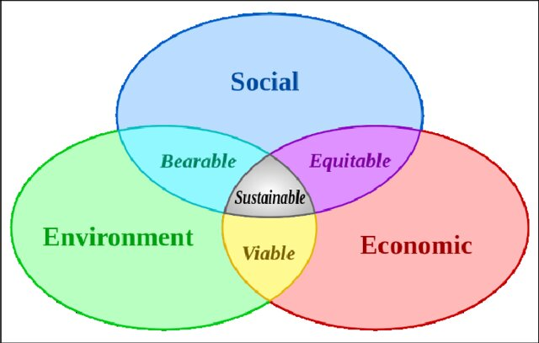

Figure 2: Three pillars of sustainability

5. Importance of environmental sustainability
For the sake of both present and future generations, the environment must be sustainably managed. For nations all across the world, climate change poses a wide range of complicated environmental, social, and economic challenges [14]. The effects of climate change have been more clearly visible in recent decades, including increased global temperatures, more severe droughts, stronger tropical storms, deadly wildfires, and devastating floods. Many people, communities, and organizations throughout the world are embracing environmental sustainability and making this crucial because a priority as humanity and ecosystems all over the planet suffer from the detrimental effects of climate change. By making these efforts, we will be able to reduce the amount of carbon dioxide in the atmosphere and protect natural resources for the benefit of present and future generations. For organizations, environmental sustainability [14] isn’t just good for the environment—it’s also good for business. By advocating for sustainability and launching programs that support a healthier environment, organizations across all industries can build brand trust, boost customer loyalty, and enhance employee satisfaction. Environmental sustainability is no longer a luxury for organizations—it’s now a corporate social responsibility [15].
6. Examples of environmental sustainability: six techniques to lessen your impact
While businesses all around the world desire to step up their sustainability initiatives, many are unsure of where to start. Here are a few environmental sustainability examples and pointers to get you started if you're looking for strategies to lessen the environmental effect of your company:
(i) Use renewable energy sources.
Many companies are switching to renewable energy [16,17] sources including solar, hydro, geothermal, and wind in an effort to lessen their environmental impact. According to projections, renewable energy sources, primarily wind, solar, and hydroelectricity, will produce 50% of all electricity after 2035.
(ii). Commit to a future with no waste.
Only 8.6% of the 100 billion tons of materials that people used in 2020 were recycled back into the economy after being used. Some businesses are adopting a more circular approach to material management in an effort to cut waste [18]. This entails not only using more recycled material but also procuring materials for operations, goods, and packaging in a responsible manner.
(iii). Reduce the carbon emissions from your organization.
Organizations are now able to measure, record, and report carbon emissions throughout their supply chains thanks to innovative environmental sustainability solutions. Organizations can do this to lessen their impact, increase efficiency, and achieve long-lasting reforms.
(iv). Protect ecosystems
A healthy planet requires healthy ecosystems. The state of the world's ecosystems is degrading more quickly than we previously thought, according to study by the United Nations. Because of this, organizations that care about the environment are trying to minimize their negative effects on ecosystems [19] and doing their part to protect natural resources for a future with stable climate.
(v). Use less water.
Many businesses that care about the environment are making efforts to lower their overall water usage [20], and some have even set targets to become water positive within the next ten years. There is an increase in water demand worldwide as a result of population growth, economic progress, and ever-increasing consumption. By 2030, there would be a 56 percent shortfall between water supply and demand, according to predictions, if we do nothing.
(vi). Encourage the use of sustainable policies
Promoting legislation that advances the cause is another method for groups to step up their sustainability efforts. This includes measures intended to support the advancement of zero-carbon energy, the management of ecosystems, and improvements in water access, availability, and quality. Your organization may significantly impact sustainability by advocating for increased sustainability action in your neighborhood, nation, and world.

7. Environmental, Social, and Governance (ESG)
Organizations that want to be more socially conscious adhere to a set of principles known as ESG, which stands for environmental, social, and governance. ESG [21] is significant because investors consider this factor when deciding whether or not to invest in a firm.Concerns about governance, social issues, and the environment are directly impacted by every organization. As environmental and social responsibility has become a concern for a wide range of stakeholders, from communities and customers to shareholders and suppliers, the way firms tackle ESG is more crucial than ever. Furthermore, adhering to strict ESG standards might aid a firm in luring and keeping top people. This is due to the fact that more and more workers are drawn to organizations that care about issues that go beyond profitability and take action to address challenges related to governance, social issues, and the environment.

E = Environmental concerns
This focuses on how a company handles environmental sustainability issues, such as waste management, the use of renewable energy sources, carbon emissions, deforestation, water consumption, air or water pollution, management of natural resources, as well as the company's general attitudes towards climate change and sustainability.

S = Social concerns
The social factors used in the ESG formula provide special emphasis on how a company affects its clients, staff, local community, and the entire planet. This covers crucial employee concerns like labor relations, diversity and inclusion, health and safety at work, a minimum wage or salary, employee training and education initiatives, employee engagement and attrition, and work-life balance. Important client issues like customer service quality, customer interactions, and consumer protection are also covered in this section. In addition, stakeholders may take into account if a company supports social reasons, supports human rights, and provides time and money to charity organizations.

G = Governance concerns
Corporate governance in the context of ESG [22] refers to how effectively a company controls or manages itself. This covers topics including board diversity and structure, accounting transparency, financial reporting, tax tactics, corporate donations, bribery or corruption, political lobbying, environmental compliance, and executive remuneration.

8. The advantages of ESG
Organizations that prioritize environmental, social and governance issues reap a number of worthwhile advantages. An organization [23] can benefit from a compelling ESG offer, for instance:
• Encourage business expansion by luring more clients with environmentally [24] friendly goods.
• Lower energy and water usage to lower operational costs.
• Boost productivity and employee satisfaction to cut down on staff turnover.
• Increase customer and employee recruitment by building brand recognition and social credibility [25].
• Minimize the possibility of regulation and government interference and obtain quick government assistance.

9. Conclusion:
Exponential population growth has led to increased farming, which leads to greater greenhouse gas emissions and deforestation. Industrial and technological growth means we need more power than ever. Yet our planet is reaching a breaking point. We are beginning to see the consequences of global warming on ecosystems and communities. That’s why now more than ever businesses need to invest in environmentally sustainable and socially responsible practices, like using clean energy and paying living wages, to secure a livable future. Companies that adhere to sound environmental, social and governance principles are the focus of ESG investing. ESG is an exciting sector of growth that also has good consequences on society and the environment, as investors are becoming keener to align their portfolios with ESG-related companies and fund providers. Sustainable development can be done by putting solar or wind power generation systems on factory grounds, employing geothermal heating methods, or even taking part in cap and trade agreements. The largest critique of sustainable development is that it doesn't do enough to safeguard the environment now and is predicated on the idea that environmental protections may be established in one region of the world to make up for harm done in another.

References
- Debiagi, P., Rocha, R. C., Scholtissek, A., Janicka, J., & Hasse, C. (2022). Iron as a sustainable chemical carrier of renewable energy: Analysis of opportunities and challenges for retrofitting coal-fired power plants. Renewable and Sustainable Energy Reviews, 165, 112579.
- Alcántara, A. R., Dominguez de Maria, P., Littlechild, J. A., Schürmann, M., Sheldon, R. A., & Wohlgemuth, R. (2022). Biocatalysis as key to sustainable industrial chemistry. ChemSusChem, 15(9), e202102709.
- Pawar, S. A., Chand, A. N., & Kumar, A. V. (2019). Polydopamine: an amine oxidase mimicking sustainable catalyst for the synthesis of nitrogen heterocycles under aqueous conditions. ACS Sustainable Chemistry & Engineering, 7(9), 8274-8286.
- Di Vaio, A., Boccia, F., Landriani, L., & Palladino, R. (2020). Artificial intelligence in the agri-food system: Rethinking sustainable business models in the COVID-19 scenario. Sustainability, 12(12), 4851.
- Khan, I. S., Ahmad, M. O., & Majava, J. (2021). Industry 4.0 and sustainable development: A systematic mapping of triple bottom line, Circular Economy and Sustainable Business Models perspectives. Journal of Cleaner Production, 297, 126655.
- Haseeb, M., Hussain, H. I., Kot, S., Androniceanu, A., & Jermsittiparsert, K. (2019). Role of social and technological challenges in achieving a sustainable competitive advantage and sustainable business performance. Sustainability, 11(14), 3811.
- Amankwah-Amoah, J. (2020). Stepping up and stepping out of COVID-19: New challenges for environmental sustainability policies in the global airline industry. Journal of Cleaner Production, 271, 123000.
- Mat Aron, N. S., Khoo, K. S., Chew, K. W., Show, P. L., Chen, W. H., & Nguyen, T. H. P. (2020). Sustainability of the four generations of biofuels–a review. International Journal of Energy Research, 44(12), 9266-9282.
- Hazaea, S. A., Zhu, J., Khatib, S. F., Bazhair, A. H., & Elamer, A. A. (2022). Sustainability assurance practices: A systematic review and future research agenda. Environmental Science and Pollution Research, 29(4), 4843-4864.
- Safdar, S., Khan, A., & Andlib, Z. (2022). Impact of good governance and natural resource rent on economic and environmental sustainability: an empirical analysis for South Asian economies. Environmental Science and Pollution Research, 29(55), 82948-82965.
- Souto, J. E. (2022). Organizational creativity and sustainability-oriented innovation as drivers of sustainable development: overcoming firms' economic, environmental and social sustainability challenges. Journal of Manufacturing Technology Management, 33(4), 805-826.
- Amalina, F., Abd Razak, A. S., Krishnan, S., Zularisam, A. W., & Nasrullah, M. (2022). A comprehensive assessment of the method for producing biochar, its characterization, stability, and potential applications in regenerative economic sustainability–a review. Cleaner Materials, 3, 100045.
- Khan, H., Weili, L., & Khan, I. (2022). Environmental innovation, trade openness and quality institutions: an integrated investigation about environmental sustainability. Environment, Development and Sustainability, 1-31.
- Khan, S., Murshed, M., Ozturk, I., & Khudoykulov, K. (2022). The roles of energy efficiency improvement, renewable electricity production, and financial inclusion in stimulating environmental sustainability in the Next Eleven countries. Renewable Energy, 193, 1164-1176.
- Lee, C. C., Li, X., Yu, C. H., & Zhao, J. (2022). The contribution of climate finance toward environmental sustainability: New global evidence. Energy Economics, 111, 106072.
- Ramzan, M., Abbasi, K. R., Iqbal, H. A., & Adebayo, T. S. (2023). What's at Stake? The empirical importance of government revenue and debt and renewable energy for environmental neutrality in the US economy. Renewable Energy, 205, 475-489.
- Abbasi, K. R., Shahbaz, M., Zhang, J., Irfan, M., & Alvarado, R. (2022). Analyze the environmental sustainability factors of China: The role of fossil fuel energy and renewable energy. Renewable Energy, 187, 390-402.
- Agyabeng-Mensah, Y., Afum, E., Baah, C., & Essel, D. (2022). Exploring the role of external pressure, environmental sustainability commitment, engagement, alliance and circular supply chain capability in circular economy performance. International Journal of Physical Distribution & Logistics Management, 52(5/6), 431-455.
- Azam, W., Khan, I., & Ali, S. A. (2023). Alternative energy and natural resources in determining environmental sustainability: a look at the role of government final consumption expenditures in France. Environmental Science and Pollution Research, 30(1), 1949-1965.
- Azam, W., Khan, I., & Ali, S. A. (2023). Alternative energy and natural resources in determining environmental sustainability: a look at the role of government final consumption expenditures in France. Environmental Science and Pollution Research, 30(1), 1949-1965.
- Tsang, A., Frost, T., & Cao, H. (2022). Environmental, social, and governance (ESG) disclosure: A literature review. The British Accounting Review, 101149.
- Landi, G. C., Iandolo, F., Renzi, A., & Rey, A. (2022). Embedding sustainability in risk management: The impact of environmental, social, and governance ratings on corporate financial risk. Corporate Social Responsibility and Environmental Management, 29(4), 1096-1107.
- Bhandari, K. R., Ranta, M., & Salo, J. (2022). The resource‐based view, stakeholder capitalism, ESG, and sustainable competitive advantage: The firm's embeddedness into ecology, society, and governance. Business Strategy and the Environment, 31(4), 1525-153
- Niu, S., Park, B. I., & Jung, J. S. (2022). The effects of digital leadership and ESG management on organizational innovation and sustainability. Sustainability, 14(23), 15639.
- Saini, M., Aggarwal, V., Dhingra, B., Kumar, P., & Yadav, M. (2023). ESG and financial variables: a systematic review. International Journal of Law and Management.

