EFFECT OF RECYCLED AGGREGATE ON NORMAL STRENGTH CONCRETE
Lovely Sabat^{1,*}, Binaya Kumar Panigrahi², Harish Sagar M³ and Minakshi Mishra⁴
¹Assistant Professor, REVA University, Bangalore, India, lovelysabat2000@gmail.com
²Associate Professor, Gandhi Institute for Technology, Bhubaneswar, India, panigrahibk1111@gmail.com
³Assistant Professor, REVA University, Bangalore, India, harishsagar.m@reva.edu.in
⁴Assistant Professor, REVA University, Bangalore, India, minakshi@reva.edu.in

*lovely Sabat. Tel: +91 8117026900, E-mail:lovelysabat2000@gmail.com

Abstract: Recycled coarse aggregate (RCA) concrete construction technique can be called as ‘green concrete’, as it minimizes the environmental hazard of the concrete waste disposal. Coarse aggregate plays a vital role for formation of concrete as the amount is more than that of fine aggregate. In the present experimental study is carried out to determine the strength characteristic of recycled aggregate in structural concrete as an alternative material for coarse aggregates. For a particular mix design, coarse aggregate is replaced with recycled bricks by 0%, 10% and 20%. A mix of M35 grade concrete was designed. Firstly the casting and testing of specimens for M35 grade concrete was carried out. In Phase-II, the test results are compared with different code values. Fresh concrete was tested for its workability properties through slump test, compaction factor test and Vee-Bee test. Compressive, flexural and split tensile strength test for recycled coarse aggregate concrete was carried out for hardened concrete. Results of the present study are compared with similar results available in literature associated with normal coarse aggregate. The obtained values of strength were compared with the IS-456-2000, ACI-1985, ACI-1992 and ACI-1995 results. Compressive strength, flexural strength and split tensile strength reduces with increase in percentage of recycled aggregate but the reduction is not prominent up to 20%. The experimental results were well in agreement with IS-456-2000 predicted results. ACI-1985 and ACI-1992 overestimates while predicted values by ACI-1995 underestimates.
Keywords: Recycled wastes, compressive strength, flexural strength.

INTRODUCTION

Scarcity of natural aggregates, ignited civil engineers mind to innovate alternatives for the above said item. Through disciplined and continuous research, civil engineering society opinioned that increased service loads, agency of structure, manmade havocs, natural calamities and stringent updates in the code have necessitated many concrete structures to be demolished. It has been accepted that there is significance possibility of reclaiming and recycling of demolished debris for use in value added application to maximize economic and environment benefit. To save the environment from the pollution of dumped waste, demolished concrete structure and to meet scarcity of row material in the construction field to fulfill human desire of having home, the demolished concrete structure should be crushed and used as a substitute for coarse or fine aggregates in the construction field. In India, a huge quantity of construction and demolition waste produced every year. These waste materials need a large place to be dumped. The solid wastes being a major threat for the environment, the disposal of wastes has become a severe social and environmental problem. Sami W. Tabsh (2008) concluded the importance of recycling concrete wastes as this can help in reducing landfill spaces and saving natural resources and carbon load in the environment. On the other hand, use of natural resources like stones is another major problem which results in increasing natural calamities like land sliding and also changes in climatic condition. Hence it becomes necessary to protect and preserve the natural resources. Therefore the possibility of recycling debris in the construction industry is unavoidable. The amount of fine aggregate for making of concrete is less in comparison to coarse aggregate. So, here an attempt is made to find the effect of recycled aggregates on strength of concrete. The application of recycled aggregate in the construction area is very wide. There are many testing based on the recycled aggregate have been carried out all around the world. The research on recycled aggregate had been carried out in many countries. Some of the literature reviews on recycled aggregate are given below. From the literature review, it is opined that reduction of compressive strength is very less when substitution of recycle aggregates is up to 30%. Beyond 30% the strength is reducing. The cause of decreasing strength may be due to reuse of aggregate. Sherif Yehia (2015) showed that the long term performance and tests for creep and shrinkage is important to study for better assessment of concrete with recycled aggregate. Moreover the toughness and soundness test for such concrete are also very important. S. S. Hasan (2018) carried out all fresh concrete and strength properties of recycled concrete aggregate and it showed that the gradual reduction of tensile strength and compressive strength as the replacement.

MATERIALS USED IN THE WORK

Cement

The binding material which is very much necessary for the preparation of concrete is cement. In this investigation Pozzolana cement was used. The physical properties for the cement were tested conforming to the requirements of IS 12269: 2013. The values obtained are stated in table 1 below.

Table 1: Tested Properties of cement used
Type | Portland Pozzolana Cement
Brand | Ultratech
Specific Gravity(G) | 3.15
IST | 55 mins
FST | 450 mins
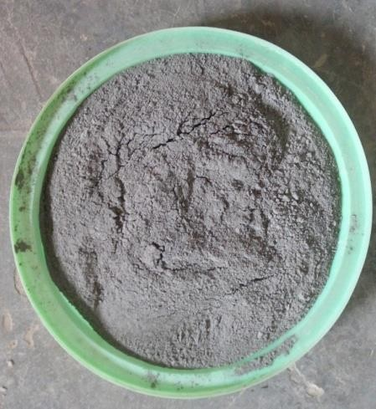

Figure 1: Pozollana Portland Cement (PPC 43)

Water and Chemical Admixture

Clean water was used for the making of all concrete mixes. The chemical admixture used in the work is super plasticizer SIKA VISCOCRETE 2004NS confirming to IS 9103:1999.
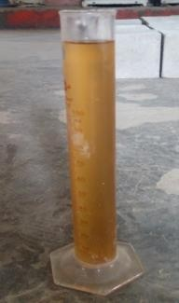
Figure 2: Chemical admixture (SIKA VISCOCRETE 2000NS)

Fine Aggregate

Sand confirming to Zone-II specifications after gradation was used as fine aggregate. The specific Gravity and water absorption of sand was obtained as 2.64 and 1.317% respectively. The bulk density of 1622 Kg/m³ was obtained. The fineness modulus is 3.05.
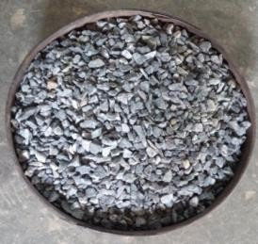
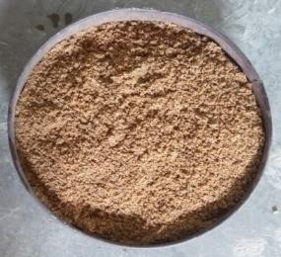
Figure 3: Fine aggregate (Sand) Figure 4: Coarse aggregate (20, 10 mm size)

Coarse Aggregate

Two different kinds of coarse particles were employed in this experiment to make concrete.
• Coarse Natural Aggregate (N.C.A)
• Coarse Aggregate Recycled (R.C.A)
According to IS 383-1970, crushed stones with a nominal size of 10 mm was utilized for coarse aggregate. The result of the sieving was the fineness modulus of 2.87. The aggregate has a bulk density of 1650 kg/m³ and water absorption of 0.503 percent.
- Natural and Recycled Coarse Aggregate.
These aggregates are typically extracted from quarries by rock-cutting or from sand and gravel that has been naturally deposited. the gravel-based natural aggregates, which have been sized down by elements of nature including water, wind, and snow. The quarried rock that has been sized down into the necessary graded particles by blasting, crushing, and screening is the source of natural aggregate. The sources of recycled aggregate are as follows:
- Aggregate from the demolition construction are used for recycled aggregate.
- Structural elements: The structural elements are demolished by following methods.
- Mechanical by Hydraulic Crusher with long boom are
- Wrecking Ball.
- Impulsion, i.e. the placement of explosives and the building collapse in a safe manner
After demolition, the debris is to send to recycling plants for processing. The process of producing the construction and demolition debris into recycled aggregate begins with crushing of whole debris. The concrete debris is crushed into pieces in this process. Generally the equipment used for crushing process are either jaw or impacted mill crusher. After finishing the crushing process, the materials are sent to the screening plant. Screening is the process of separation of crushed aggregates into particular zones. The screening plant is made of a series of large sieves that separates the materials into the size required. The size of screen used to separate the coarse recycled aggregate can be under and over 20 mm sieve. In this investigation the size of sieve used were 20mm, 10mm, 4.75mm respectively. After screening process, the recycled aggregate are washed before used for concrete. After all the recycling process, recycled aggregate are stored in the stackable according to the different size of aggregate.
Table 2: Properties of natural and recycled aggregate.
Properties | NCA | RCA
 |  | 10 % | 20%
Bulk Density(Kg/m³) | 1.46 | 1.45 | 1.44
Specific Gravity (G) | 2.77 | 2.75 | 2.72
Fineness Modulus | 7.2 | 7.12 | 7.13
Water Absorption (%) | 1.0 | 1.81 | 2.1

MIX PROPORTIONING AND EXPERIMENTAL DETAILS

Before the concrete mixing, the selection of mix materials and the required quantities for the mixes has to be done through the Mix Design. As per IS code- 10262-2009, M35 grade concrete was designed. In this investigation, a mix of M35 grade concrete was designed. For this water cement ratio was taken 0.4. The control mix was 100% natural coarse aggregate and other mix was prepared with 90% natural aggregated and 10 % recycled aggregate. Another mix was with 80% natural aggregate and 20% recycled aggregate. The mix proportion for M35 grade concrete is 1 : 1.05 : 2.50. Table 3 denotes the details of the quantity of mix design of the concrete mix.

The workability for the prepared mixes were tested by adopting the slump cone test, Vee–Bee test and compaction factor test following the specifications of IS 1199: 1959. After conducting the workability test, the casted cubes, cylinders and beam samples were casted and kept for curing and the strength properties was tested later. Concrete molds were oiled for the ease of concrete specimen stripping. Three cube samples(150 mm x 150 mm x 150 mm), three cylinder samples (150 mm x 300 mm) and three prism samples (100 mm x 100 mm x 400mm) were casted for the strength tests.

Natural Aggregate proportion | M1 (Control Mix)  100% | M2  90% | M3  80%
Recycled Aggregate proportion | 0% | 10% | 20%
Table 3: Aggregate percentages used in 3 mixes.

Table 4: Initial data for mix design for M35 grade concrete.
Parameter | Values
Target mean strength | 46 N/mm²
W/C Ratio | 0.4
Sand Zone | 2
Maximum Size of aggregate | 20 mm
Correction for | Water Sand  +3 -4
Corrected Water | 191.6 Ltr.
Corrected Sand | 31%
Final Water cement ratio | 0.4
Cement | 479 Kg/m³

Table 5: Proportion and weight of materials by weight.
Batch | 1 | 2 | 3
Cement | 26 | 26 | 26
Sand | 27.3 | 27.3 | 27.3
Water | 10.4 | 10.4 | 10.4
Natural Aggregate | 65 Kg | 58.5 Kg | 52 Kg
20 mm – 10mm | 39 Kg | 35.1 Kg | 31.2Kg
10mm- 4.75mm | 26 Kg | 23.4 Kg | 20.8 Kg.
Recycled Aggregate | 0 | 6.5 Kg | 13 Kg
20 mm – 10mm | 0 | 3.9 Kg | 7.8 Kg
10mm- 4.75mm | 0 | 2.6 Kg. | 5.2 Kg.

The workability test was performed in this inquiry on new concrete mixes. Concrete's workability has an impact on the concrete's placement rate and degree of compaction. There are two ways to test workability.
    - Slump Test.
    - Compaction Factor Test.
    - Vee-Bee.

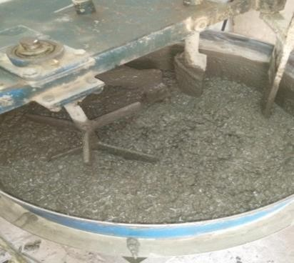

Figure 5: Mixing of all the constituents

RESULTS OBTAINED AND DISCUSSIONS
The fresh concrete and hardened concrete test results were tabulated in different sections and the experimental values were compared with values obtained from various codes. The test results such as compressive strength, split tensile strength and flexural strength with different proportion of recycled aggregate are discussed below in the section.

Workability of concrete mixes:
The obtained values of slump and workability values of concrete are mentioned in table 6 below,
Table 6: Test results of Workability
% of aggregate | Slump value (mm) | Compaction Factor | Vee-Bee (sec)
100% NCA | 20 | 0.9 | 5
10 % Recycled Aggregate | 18 | 0.89 | 4
20 % Recycled Aggregate | 18 | 0.89 | 4

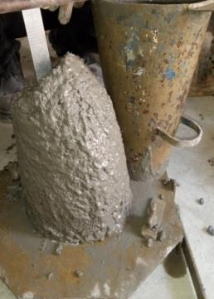
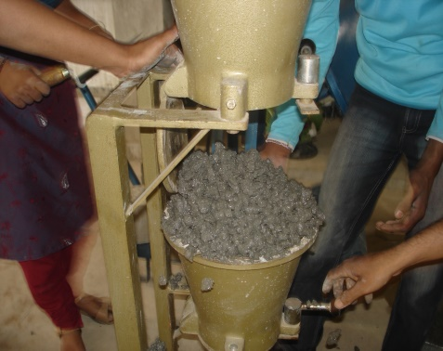
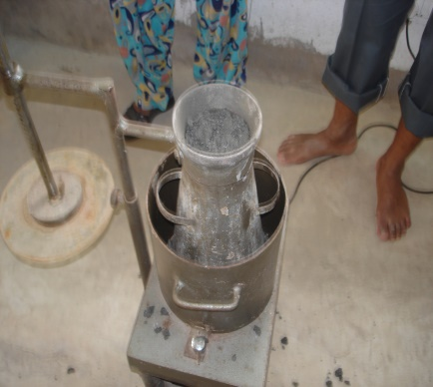
Figure 7: Workability measurement of all concrete mixes

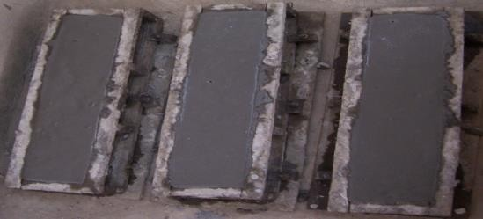
After the workability test, beams, cylinders and cubes were casted and cured for the respective strength tests.
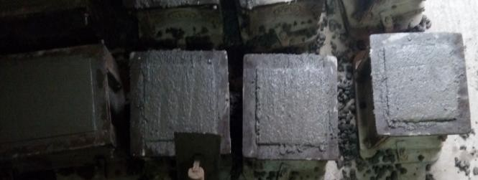
Figure 6: Casted cubes and beam specimens for strength test

Compressive Strength Test Results
Compressive strength is the major strength property to be observed. Compressive strength of concrete mix M1 which is the control concrete was found to be 51.94 MPa. The mixture made with a 10% substitution of RCA for NCA was found to be 50.94 MPa, and the mixture made with a 20% substitution of RCA for NCA was found to be 50.14 MPa.
Table 7: Compressive Strength test values
Mix Type | 100% N.C.A. | 90% NCA + 10% R.C.A. | 90% NCA + 20% .C.A.
Average 7 Days results (N/mm²) | 37.62 | 36.35 | 35.27
Average 28 Days results (N/mm²) | 51.95 | 50.94 | 50.14

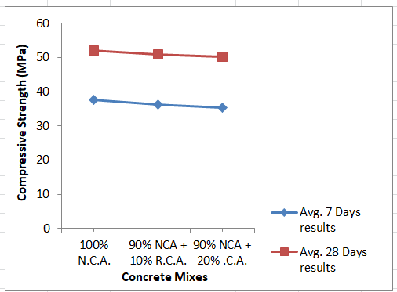
Figure 8: Compressive Strength test results comparison
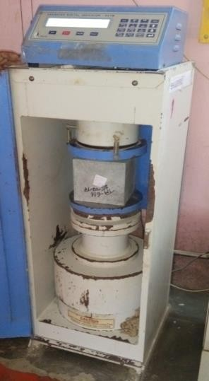
From the above obtained experimental results and graphs, it can be said that when natural coarse aggregate is substituted with RCA, the compressive strength is found to be reducing which was observed from the literature study. This behavior is because of the fact that the failure of normal concrete is caused by mortar (sand + cement) failure. The bond between mortar and recycled coarse aggregates is weaker than that of natural coarse aggregates. The high strength Concrete failure is due to aggregate crushing. The RCA possess lesser crushing value than that of NCA. Compressive strength with 0%, 10% and 20% RCA were plotted in Fig-8. The decrease in compressive strength of 10% and 20% RCA with respect to 0% RCA can be observed from the graph plotted. The decrease in strength was found to be very less and the variation was linear. From the previous research carried out, it was observed that there was decrease of compressive strength with increase of % of RCA and this decrease is not marginal up to 30%.The same was observed in this investigation.
Figure 9: Compressive Strength test of the sample cubes
- Split Tensile Strength of concrete
The concrete specimen's split tensile strength with natural coarse aggregate was found to be 3.19 MPa. The mixture prepared by replacing 10% of the NCA with RCA was measured at 3.09 MPa, while the mixture prepared by replacing 20% of the NCA with RCA was measured at 2.92 MPa. Based on ACI-1985, ACI-1992, and ACI-1995, the theoretical values of split tensile strength were computed. Figure 11 shows the percentage loss in split tensile strength with 10% and 20% RCA. With an increase in RCA, it was discovered that the split tensile strength was decreasing. But up to 20%, this reduction was barely noticeable. Compared to the test findings, the projected outcomes are higher. The percentages of overestimation for 0%, 10%, and 20% RCA were determined to be 11.29, 10%, and 20%, respectively, by ACI-1985.
Table 8: Test results of Split Tensile Strength test
Mix Type | 100% N.C.A. | 90% NCA + 10% R.C.A. | 90% NCA + 20% .C.A.
Average 7 Days results(N/mm²) | 2.79 | 2.34 | 1.68
Average 28 Days results(N/mm²) | 3.19 | 3.09 | 2.92

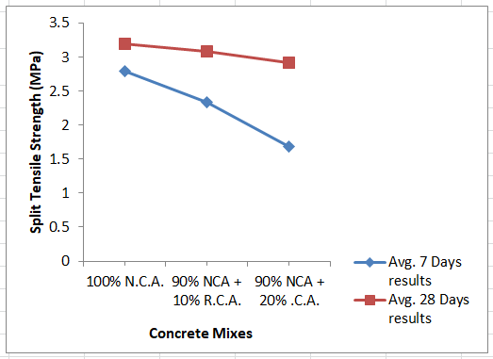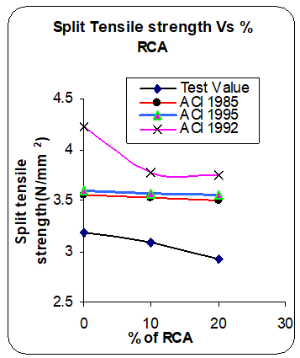
Figure 11. Split Tensile test results comparison
- Flexural Strength of Concrete
Concrete specimens with natural coarse aggregate, 10% RCA, and 20% RCA were found to have flexural strengths of 5.07 MPa, 4.87 MPa, and 4.73 MPa, respectively. Theoretical flexural strength values were determined using the IS-456-2000 standard as well as ACI-1985, ACI-1992, and ACI-1995.
Table 9: Test results of Flexural Strength test
Mix Type | 100% N.C.A. | 90% NCA + 10% R.C.A. | 90% NCA + 20% .C.A.
Average 7 Days results(N/mm²) | 3.79 | 2.34 | 2.23
Average 28 Days results(N/mm²) | 5.07 | 4.87 | 4.73

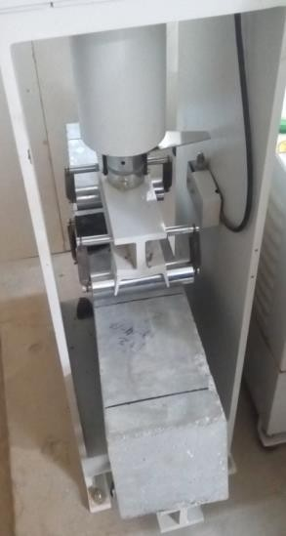

Figure 12: Flexural Strength test of beam specimen
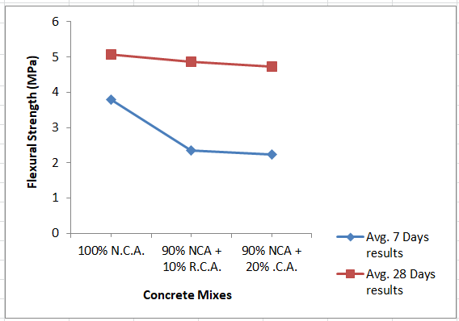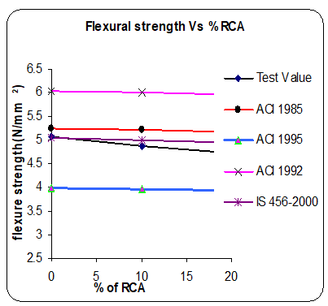
Figure 13: Flexural strength test results comparison

- CONCLUSIONS

The following findings were reached as a result of the test results.
- As the percentage of recycled aggregate increases, compressive strength decreases. Up to 20%, the decline is barely noticeable.
- Split tensile strength is overestimated by ACI-1985 and 1995. As RCA percentages rise, so do the overestimation percentages.
- The split tensile strength is significantly overstated by ACI-1992.
- As the percentage of recycled aggregates increases, flexural strength diminishes. Up to 20%, the decline is barely noticeable.
- While ACI-1985 and 1992 overestimate the flexural strength, IS-456-2000 accurately anticipates it. As RCA percentages rise, so do the overestimation percentages.
- The flexural strength is significantly understated by ACI-1995.
The future scope of the present work includes:
- The Utility of recycled aggregate concrete in load bearing concrete structural elements like slabs, beams and columns.
- To study the long term behavior of such concrete and the microstructural analysis adopting the X-ray diffraction analysis and Scanning electron microscopy test.

References:
[1] S.M.S. Kazmi, M.J. Munir, Y.F. Wu, “10 - Recycled aggregate concrete: mechanical and durability performance”, Handbook of Sustainable Concrete and Industrial Waste Management, pp. 211-227, 2022.
[2] S. Hasan, “Effects of recycled concrete aggregate on some mechanical properties of high strength concrete”, IOP Conference Series: Materials Science and Engineering. vol. 433, 2018.
[3] M. Kang, L. Weibin, "Effect of the Aggregate Size on Strength Properties of Recycled Aggregate Concrete", Advances in Materials Science and Engineering, vol. 2018, Article ID 2428576, 2018.
[4] D. Jiaxin. “Properties of Recycled Aggregate Concrete”, Journal of Civil & Environmental Engineering, Vol. 12, 2022.
[5] M. Malešev , V. Radonjanin , G. Broćeta, “Properties of recycled aggregate concrete, Contemporary Materials”, vol. 2, pp. 240 – 249, 2014.
[6] S. Yehia, K. Helal, A. Abusharkh, A. Zaher, and H. Istaitiyeh, “Strength and Durability Evaluation of Recycled Aggregate Concrete”, International Journal of Concrete Structures and Materials, Vol.9, No.2, pp.219–239, 2015.
[7] S. W. Tabsh, A. S. Abdelfatah, “Influence of recycled concrete aggregates on strength properties of concrete, Construction and Building Materials”, vol.23, pp. 1163–1167, 2009.
[8] A. Patel, V.K.S. Chandrakar, P.S. Tomar, “Comparative Experimental Study of Physical Properties of Concrete Made by used Aggregate with and without Superplasticizer”, International Journal for Research in Applied Science & Engineering Technology, vol. 6 Issue I, 2018.
[9] J. Xiao, W. Li, and C. Poon, “Recent studies on mechanical properties of recycled aggregate concrete in China—a review”, Science China Technological Sciences, vol. 55, no. 6, pp. 1463– 1480, 2012.
[10] J. Xiao, L. Li, V.W. Tam, H. Li, “The state of the art regarding the long-term properties of recycled aggregate concrete”, Structural Concrete, vol. 15(1), pp. 3–12, 2014.
[11] C.M. Vyas, & D.R. Bhatt, (2013). “Evaluation of modulus of elasticity for recycled coarse aggregate concrete”. International Journal of Engineering Science and Innovative Technology, vol. 2(1), pp. 26-35.
[12] J. Xiao, L. Y. Fana, & X. Huang, (2012). “An overview of study on recycled aggregate concrete in China (1996–2011)”, Construction and Building Materials, vol.31, pp. 364–383.
[13] A.M. Neville, (1995). Properties of concrete. Harlow, NY: Pearson.
[14] K.S. Crentsil, T. Brown, & A.H. Taylor, “Performance of concrete made with commercially produced coarse recycled concrete aggregate”. Cement and Concrete Research, vol. 31(5), pp. 707–712, 2001.
[15] G. Fathifazl, & A.G. Razaqpur, “Creep rheological models for recycled aggregate concrete”, ACI Materials Journal, vol. 110(2), pp. 115–126, 2013.
[16] A. Eisa, “Properties of concrete incorporating recycled post-consumer environmental wastes”, International Journal of Concrete Structures and Materials, vol. 8(3), pp. 251–258,2014.

