STUDY ANALYSIS OF PERVIOUS CONCRETE WITH ADMIXTURES
DR.S. BHAGAVATHIPERUMAL¹, SREEJITHA G V², THAILA DHARANI S ³

¹Head of Department, Department of Civil Engineering, Sairam Engineering College, Chennai – 600044, T.N., India.
^{2,3} Research scholars, Department of Civil Engineering, Sri Sairam Engineering College, Chennai-600044, T.N., India.
Correspondence should be addressed to Dr.S.Bhagavathi Perumal
ABSTRACT

Pervious concrete is a special type of concrete with high porosity used for concrete flat work applications that allow water from precipitation and other sources to pass directly through, thereby reducing the runoff from a site and allowing ground water recharge.
This porosity is attained by a highly interconnected void content. Typically, pervious concrete has little or no fine aggregate and has just enough cementing paste to coat the coarse aggregate particles while preserving the interconnectivity of the voids.
Pervious concrete is traditionally used in Parking areas, areas with high traffic, walk ways in parks and gardens, Residential streets, Pedestrian walkways and Green houses, Basketball and volley ball courts etc. Pervious concrete is an important application for the sustainable construction and is one of many low impact development techniques used by builders to protect water quality.
KEY WORDS: Porosity, void content, sustainable construction.

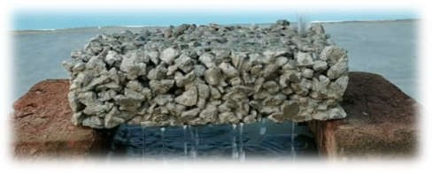

Fig.1 Testing of porous concrete blocks

INTRODUCTION CEMENT:

Cement is a greenish grey coloured powder, made of calcined mixtures of clay and limestone. A cement is a binder, a substance used for construction that sets, hardness, and adheres to other materials to bind them together. Cement is the mixture of calcareous, siliceous, argillaceous and other substance. Cement is used as a binding material in mortar, concrete, etc..
COARSE AGGREGATE:

As coarse aggregate in concrete occupies 35 – 70
% of the volume of the concrete. It may be proper to categories the properties into two groups exterior features (maximum size, particle shape, textures) and interior features (strength, density, porosity, hardness, etc..). Smaller sized aggregates produce higher concrete strength. Particle shape and texture affect the workability of fresh concrete. The transition zone between cement paste and coarse

Aggregate itself. Usually an aggregate with specific gravity more than 2.55 and absorption less than 1.5% can be regarded as being of good quality. Where aggregate strength is higher, concrete strength is also higher.

WATER:

Water is the most essential ingredient in concrete. It should be good free enough organic matter and excessive chemicals and/or minerals. The strength and other properties of concrete are highly dependent on the amount of water and the water-cement ratio.
COCONUT SHELL:
Coconut shells can be used as aggregates in concrete. The characteristics properties of coconut shell concrete such as workability, bulk density, compressive strength, flexural tensile, water absorption and thermal performance.
SILICA FUMES:
Silica fumes, a by-product of the ferrosilicon industry, is a highly pozzolanic material that is used to enhance mechanical and durability properties of concrete. It may be added directly to concrete as an individual ingredient or in a blend of Portland cement and silica fumes.

Fig.2 Pervious concrete

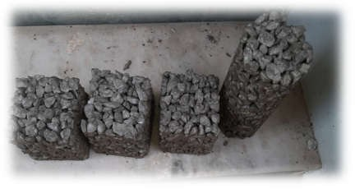
METHODOLOGY:
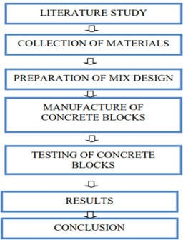

Fig 3. Methodology

ADVANTAGESOF NORMAL PERVIOUS CONCRETE :
- It does reduce stormwater runoff replenishes water tables and aquifers.
- It eliminates detention ponds that are costly for stormwater management practices.
- Also permits for extra environment-friendly land growth.
- It also prevents warm and polluted water from
getting into streams.
- It minimizes flash flooding and standing water. 6.Skidding is lowered.
7.Light reflectivity is greater than asphalt surface. Therefore, reduce the heat island effect. 8.Glare from the wet pavement is virtually eliminated.
ADVANTAGE OF PERVIOUS CONCRETE WITH ADMIXTURES:

- As semi crushed coconut shell are added to pervious concrete, the amount of cement is reduced and also it makes concrete more cost efficient.
- As silica fumes are added, the strength and durability of concrete is increased.
- Also the compressive strength,
bond strength and abrasion resistance is increased which makes the concrete strong enough to resist.

MATERIAL TESTING:
The materials such as cement, coarse aggregate, coconut shell and silica fumes which is used in concrete mix is tested. The test taken for cement is consistency and setting time of cement, for fine

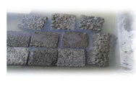
aggregate is specific gravity and fineness modulus test.

MIX DESIGN:

The procedure of mixing the concrete mat
erial is
that first the materials are taken with the correct proportion calculated from the mix design. After collecting all the materials, first mix the cement without any lumps and then coarse aggregate is added and mixed properly. All the materials are properly mixed then the water is added into it and mix it thoroughly without any lumps with the proper workability condition.
CASTING:

When the concrete mixing is done simultaneously the mould is prepared (i.e.) fixing the bolts and nuts, oiling the mould, then the mixed concrete is poured by three layers for compaction using tamping rod in the readily prepared structured
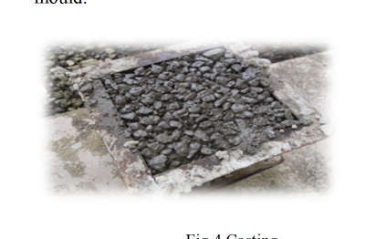
mould.
Fig 4.Casting

CURING:

After the final setting time of concrete is completed, then the mould which is casted is demoulded. After the removal of mould, the concrete specimen is immersed in the curing tank attaining the strength.

Fig 5. Curing

TESTING OF SPECIMENS:

The test for concrete is classified as two types are fresh concrete test and hardened concrete test. The hardened concrete tests are compressive strength test and tensile strength test. This hardened concrete test shall be taken for 7 days, 14 days and 28 days curing respectively

PROPERTIES OF CEMENT:

Cement is a fine powder used for bonding between components of concrete. In this project the cement would be Ordinary Portland cement (OPC) of 53 grade. Cement should be stored in proper place to avoid formation of floc.
The cement used was subjected to various field tests like:
  - The cement used had no floc.
  - After throwing in water, it floated on water for some time before sinking.
  - After immersing our hand in cement, it gave us cool feeling.
  - The cement was easily passing through 90-micron sieve.

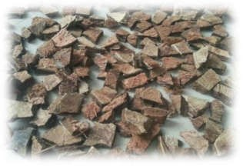

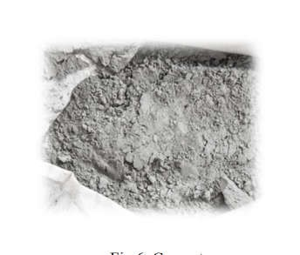
Fig.6. Cement

PROPERTIES OF COARSE AGGREGATE:

- Coarse aggregates are irregular broken stones or naturally occurring round gravels that are used to make concrete, coarse aggregates for structural concrete consist of broken stones of hard rock like granite and limestone (angular aggregates) or river gravels (round aggregates).
- Aggregates larger than 4.75 mm in size are termed as coarse aggregates
- These aggregates are obtained from stone quarries and stone crushers, the size
between 4.75 mm to 80 mm.

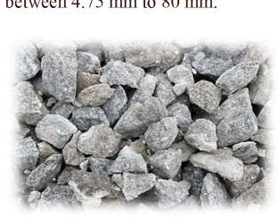

Fig 7. Coarse aggregate

PROPERTIES OF COCONUT SHELLS:

  - Coconut shell has better workability because of the smooth surface on one side of the shells.
  - The impact resistance of coconut shell concrete is high when compared with conventional concrete.
  - Moisture retaining and water absorbing capacity of coconut shell are more compared to conventional aggregates.
Fig 8. Crushed Coconut shell

PROPERTIES OF SILICA FUMES:

- Silica fumes are used in concrete to improve its properties.
- It had been found that silica fume improves compressive strength, bond strength and abrasion resistance.
- It reduces permeability and therefore helps in protecting reinforced steel from corrosion.

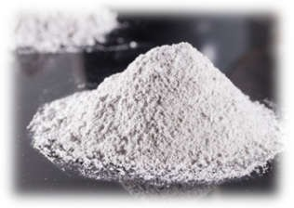

Fig 9.Silica fumes

RESULT OF THE EXPERIMENT: 1.COMPRESSIVE STRENGTH
In 10mm Coarse Aggregate specimen Initialize the cube is cleaned and washed.
•Fix them and slightly apply the grease inside the cube.
- To do concrete, the needs are coarse aggregate.

Before making concrete clean the surface and pour a little amount of the water.

•Add coarse aggregate, cement, mix them with a trowel, and add water.
•Finally pour the concrete in a cube with the dimension of 150mmX150mmX150mm
•Leave it for 24 hours.

After 24 hours remove the mould and leave it for sometimes and place the cube in the curing process.
•After the curing process place the cube in a compressive testing machine on the 7th day, 14th day, and 28th day.
- While checking compressive strength the cube will
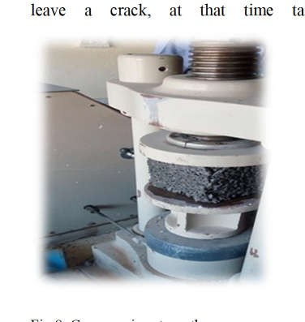
ke readings.
leave a crack, at that time ta

Fig 8. Compressive strength

DAYS | SPECIMEN 1  N/mm² | SPECIMEN 2  N/mm² | SPECIMEN 3  N/mm²
7 | 15.66 | 17.81 | 16.19
14 | 18.82 | 20.43 | 21.13
28 | 24.79 | 23.54 | 25.89

Fig 9. Compressive strength in 20mm coarse aggregate specimen (N/mm²)

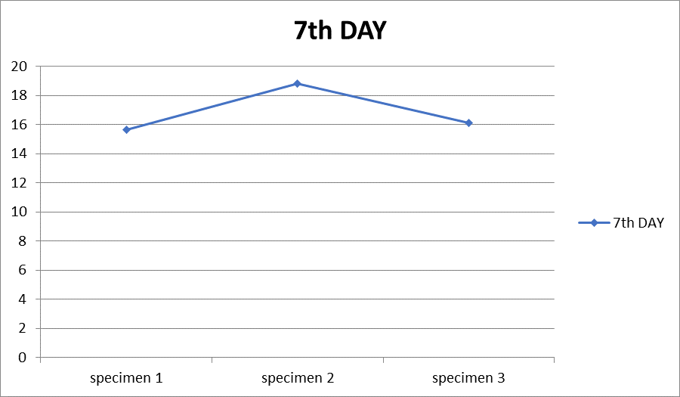

Fig 10. Compressive strength on 7th day
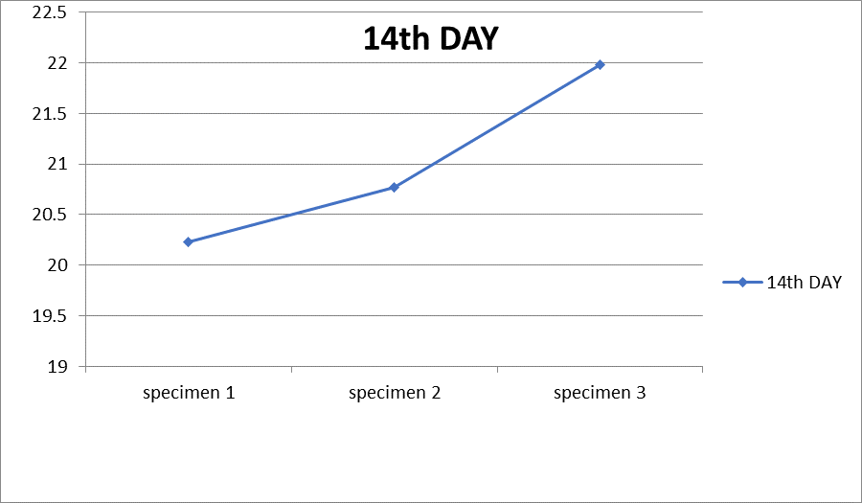

Fig 11. Compressive strength on 14th day
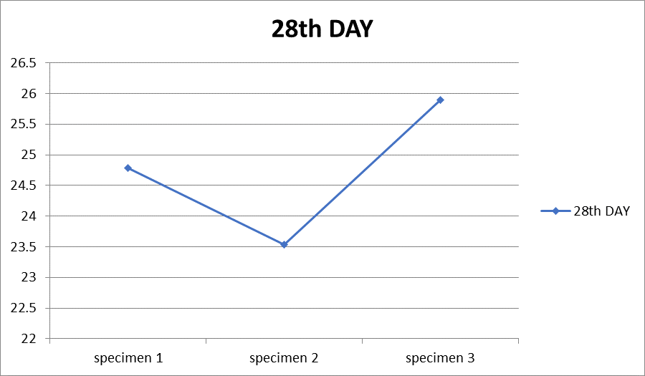

Fig 12. Compressive strength on 28th day
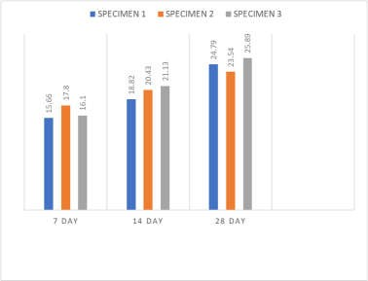

Fig 13. Bar graph representation of 20mm coarse aggregate

DAYS | SPECIMEN 1  N/mm² | SPECIMEN 2  N/mm² | SPECIMEN 3  N/mm²
7 | 18.31 | 18.54 | 19.17
14 | 19.29 | 19.88 | 20.14
28 | 24.84 | 25.57 | 26.24
Fig 14. Compressive strength with admixtures in 20mm coarse aggregate specimen(N/mm²)
specimen 1 specimen 2
specimen 3
7 TH DAY 14 TH 28 TH
DAY DAY
18.31
18.54
19.17
19.29
19.88
20.14
24.84
25.57
26.24

Fig 15. Compressive strength with admixtures on 7th day

Fig 16. Compressive strength with admixtures on 14th day

Fig 17. Compressive strength with admixtures on 28th day
Fig 18. Bar graph representation of 20mm coarse aggregate with admixtures

REFERENCES:

Linkedin

https://www.linkedin.com/in/dr-bhagavathi-perumal- 38079668
Publon Profile URL Link

https://publons.com/researcher/3225383/bhagavathiperu mal-s/
Web of Science ResearcherID https://publons.com/researcher/AAF=3416-2019/ ORCID Author Link https://orcid.org/0000=0002-7868-7901
ORCID ID

0000-0002-7868-7901

Scopus Author Link

https://www.scopus.com/authid/detail.uri?authorID=368 06710000

