Rural entrepreneurship in India: A case of 2022
1. Introduction
The process of entrepreneurship of creating an organization or a company by organizing the several factors of production in an effective way while providing creative and innovative products in a market. Rural entrepreneurship also provides support to the country to have regional development. It also moulds the rural young generation for Undertaking self-Reliability as well as also supporting in effectively utilizing the resources for improving the economy in rural areas. There are several factors of the rural entrepreneurs like forest-based, agro, based on engineering, based textile, handicrafts, and minerals. It is essential for creating employment improving living standards as well as promoting the entire prosperity among the rural people. This case study is going to be based on rural entrepreneurship and rural entrepreneurs who faced a lot of problems living a better life.
2. Objectives of the study
- To know about rural entrepreneurship.
- To discuss the problems faced by rural entrepreneurs in rural entrepreneurship.
- To provide remedial measures in the development of rural entrepreneurship.
3. Rural entrepreneurship in India
India can be stated as a country having a large number of villages, the majority of the population of the entire country lives in the rural areas. The people who are living in rural areas also suffer from poverty, unemployment, and the facilities because of poor infrastructure, which can only be solved by the development of rural entrepreneurs. The organization for economic cooperation as well as the opportunity when the industry, as well as the aging population, can also result in the Migration of a young population from the rural areas to urban areas for the searching of employment opportunities. It also gets discouraged. The Migration of the rural area population to the urban areas as well as reducing the congestion in the cities. The “entrepreneurship” word is taken from the language French and “Entreprendre” represents “Undertake” the person who is always in the search of changes responded within it as well as exploring it like an opportunity. The entrepreneur is the economic person who also concentrates on maximizing profits through innovations Entrepreneurship can be the activities of such an entrepreneur who also starts the startup or venture by taking the initiative and risk while creating a useful asset for providing valuable opportunities to its customers (Newbery et. al., 2017).
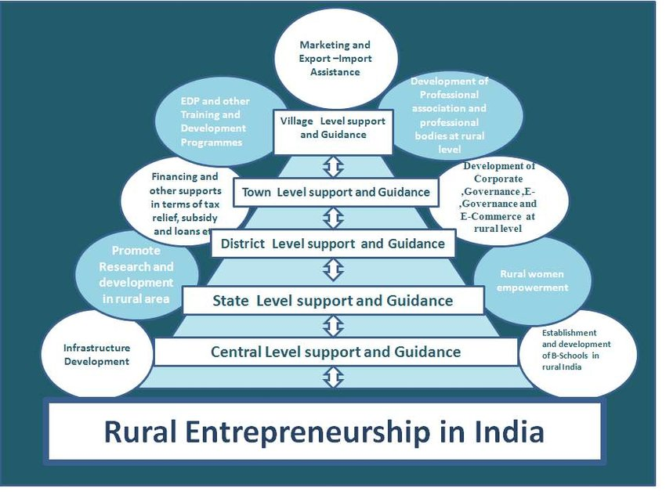
(Source: www.researchgate.net, 2023)
4. Rural entrepreneurship and development of villages
Entrepreneurship plays a significant role in the development of rural areas, if entrepreneurship gets encouraged within the rural areas, it can stimulate the conversions of the complete rural areas by solving the poverty issues, economic disparity, employment, and low-level standard living. Rural entrepreneurs also play a necessary part in the entire economic development of the country, the enlargement and amplifications of rural Industries also facilitate self-employment that also provides support in a large number of utilisations of locally provided raw materials as well as labor.
In India, around 65% of people live in villages and a big percentage of the population of the entire country lives in slums and poverty in rural areas. For eradicating all these things, and bringing prosperity as well as rural development, the concept of rural entrepreneurship plays a significant role. Rural entrepreneurs also provide support in awakening the youth as well as exposing them youth for various opportunities in improving their living standards. The government also provides support in promoting entrepreneurship among the people of the village, for enhancing rural entrepreneurship in the districts of India. It is also necessary to identify the problems faced by entrepreneurs in rural areas (Kulkarni et. al., 2016).
5. Problems in rural entrepreneurship
5.1 Competition with the urban markets
The main issue faced by rural entrepreneurs is competition from the urban markets. In the current situation, people like to buy products from supermarkets as it provides various types of categories of products which fulfill the demands of the customer and it also provides good appearances of the products, the large organizations also invest a lot of money in promoting their products, the advertisements are used for advertising the products and making the mass production successful while the rural entrepreneurs conduct the business with the utilization of local resources and the Limited capitals. Moreover, they are unable in utilizing advanced technology for creating products more innovative because of these things they always become less in competing with the urban markets (Jayadatta, 2017).
5.2 Difficulty in receiving grants from the government
The rural entrepreneurs also run the businesses by utilizing their Limited capital, they also require the proper assistance from the government, and the government also tries to give grants under various types of schemes like single point registration, venture capital, extramural funding research, high-risk reward, etc. All these schemes are beneficial for the entrepreneurs but they are also still not aware of these schemes as well as how they avail the facility of these schemes. As time passes by, these schemes got wasted as they are not utilized by rural entrepreneurs. To survive in a business, the customer also demands the complete fulfillment of their requirements and it needs to be feasible with the smooth flow of production that also depends only on the funds. Getting delayed while providing the products and excessing the formalities or the conditions as well as not following the proper procedure of the production can also create a big challenge for rural entrepreneurs. Difficulty in utilizing grants from the government is also stated as a big challenge for rural entrepreneurs (Sathya, 2019).
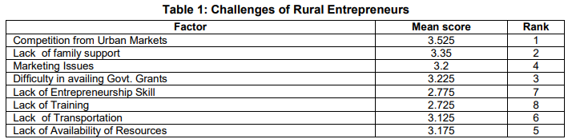
The table represents the major problems faced by the rural entrepreneurs
(Source: inspirajournals.com, 2023)
5.3 Issues of marketing
Rural entrepreneurs also face issues of marketing such as a shortage of information regarding the market, tough competition from the big Industries, exploitation of the intermediators as well as the shortage of outlets to sell the products. The customers' fashion, choices, and tastes also change on daily basis. Rural entrepreneurs also find it difficult in analysing the complete market Trends that may also create a big loss in the market and the customers the entrepreneurs and the marketing issue is also a big challenge for rural entrepreneurs (Pandey & Sahay, 2022).
5.4 Lack of resources
Rural entrepreneurs also depend on local resources for products that may also be scarce and Limited for them. The resources comprise financial funds, labor as well as the raw material to do the production. Several rural entrepreneurships is based on agro, artistic, traditional, and handicraft. The young generation is also interested to do work in the IT sector as well as the technical field. In this situation, rural entrepreneurs also get fail to achieve skilled labor for doing business. The rural entrepreneurs are conducting their business by utilizing the Limited funds as they don't have any alternative solution to avail as well as borrowing funds from the banks or the other type of finance and grants which are provided by the government. The shortage of resources also falls on the list of challenges that are faced by rural entrepreneurs (Hota et. al., 2019).
5.5 Lack of support
If the entrepreneur is having family support that can be more successful. The factors of the family can also affect entrepreneurship as the relationship, culture, beliefs, different roles, family income, and the type of family. People are usually born in the family business which is having the talent to function the business as well as also get learned from their childhood. Moreover, entrepreneurs are also engaged with work so they also cannot spend suitable and adequate time at the time of interacting with the family as well as maintaining relationships with family. The complete Profitability of a business is also uncertain and it also includes various types of elements of uncertainty and risk because of all these reasons entrepreneurs also face a lot of challenges because of the lack of support from family (Vedanthadesikan & Pathmanathan, 2016).
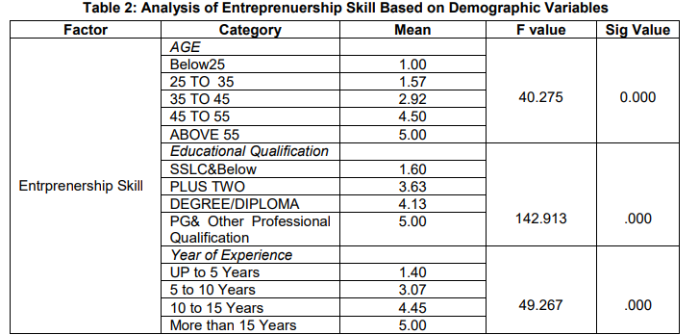
(Source: inspirajournals.com, 2023)
5.6 No proper training
No proper training or the shortage of training can be another main problem faced by rural entrepreneurs. The low productivity, poor performance, enhancing expenses, specialization shortage, machinery breakdown, wastage, difficulty in utilizing the advanced technology, dissatisfaction, and Labour. These are the major cons because of the lack of proper training in the business.
5.7 Shortage of skills
Shortage of skills in entrepreneurship an entrepreneur is also the problem, the person should be multi-talented to perform various types of tasks. The rural entrepreneur also possesses various types of skills such as information technology, technical, communication, problem solving, decision making, and leadership. The successive utilization of entire resources mainly depends on the management skills of the entrepreneur, the shortage of managing the skills while dealing with poor management, and ultimately also affects the entire functioning of a business. This type of problem is also faced by rural entrepreneurs (Hazarika, 2016).
5.8 Shortage of transportation facility
Transportation also provides support in the movement of services and goods from the production line to its distribution centers while ensuring the accessing on the basis of customer demands as well as the acts which are linked among the customers and producers. The existence of complete rural entrepreneurship is actually based on the fraction of the customers that will apply on product availability and the services should be on time all this complete concept is based on transportation. Transportation provides support in the major role of the procurement of raw materials from various types of scattering places as well as the supply of the good to the location of the customer. The transportation challenge involves the lack of road maintenance, logistics, increment in fuel prices, and the services of vehicles. The facilities shortage in transportation is also a major challenge faced by rural entrepreneurs (Prasad & Naveena, 2021).
6. Remedial measures to solve the problems faced by rural entrepreneurs
- The government should provide more amount of financial assistance as well as it also ensures that the entrepreneurs are availing of this facility as well as providing the facilities to showcase their items in a market and the products should be bought at a reasonable price.
- The industries centre of a district can also give frequent programs of training, offer a scholarship, award innovative ideas as well as they can also conduct entrepreneur's meetings (Jayadatta, 2017).
- For developing entrepreneurship talent among the young generation, several NGOs, as well as an educational institution, needs to be conducted various fest or exhibition such as craft Mela, cum sale, seminars, invited talks as well as workshops and meetings for the betterment of rural entrepreneurs on behalf of entrepreneurship programs, etc and create them as the employers instead of the employees.
7. Conclusion
It is concluded that rural entrepreneurship provides support in the development of industries by which the nation can also be developed. While commencing entrepreneurship, people require to get aware of the problems, non-availability, or challenges that may create obstacles in the entire journey of entrepreneurship. The complete study also reveals the problems faced by rural entrepreneurs which involve competition from the outside markets which are also followed by several factors like the difficulties in receiving the grants provided by the government, shortage of family support, shortage of all the available resources, shortage of skills of entrepreneurship, shortage of training, shortage of transportation and the marketing issues. All these rural entrepreneurship developments can be achieved successfully by getting focused on the various problems which also helps in improving the living standard and literacy rate. It is also analyzed that it is a significant difference among the educational qualification, age as well as experience of rural entrepreneurs and related to the skills of rural entrepreneurship.

References
- Hazarika, S. (2016). Skill development for rural entrepreneurship: A study on state institute of rural development (SIRD), Assam. International Journal of Research and Analytical Reviews, 3(3), 61-66. http://ijrar.com/upload_issue/ijrar_issue_316.pdf
- Hota, P. K., Mitra, S., & Qureshi, I. (2019). Adopting bricolage to overcome resource constraints: The case of social enterprises in rural India. Management and Organization Review, 15(2), 371-402. https://www.researchgate.net/profile/Israr-Qureshi/publication/334199130_Adopting_Bricolage_to_Overcome_Resource_Constraints_The_Case_of_Social_Enterprises_in_Rural_India/links/5f0a7abc4585155050a016d7/Adopting-Bricolage-to-Overcome-Resource-Constraints-The-Case-of-Social-Enterprises-in-Rural-India.pdf
- Jayadatta, S. (2017). Major challenges and problems of rural entrepreneurship in India. IOSR Journal of Business and Management, 19(9), 35-44. https://krishi.icar.gov.in/jspui/bitstream/123456789/32945/1/Problems%20and%20prospects%20for%20rural%20enterprises%20Enterprises%20and%20technologies%20for%20rural%20development.pdf
- Kulkarni, S. M., Narkhede, P. A., & Jalgaon, J. (2016). Entrepreneurship and Rural development. Rural Development: Trends, Opportunities and Challenges in 21st Century, 23-30. https://www.researchgate.net/profile/Shubhada-Kulkarni/publication/313798944_Entrepreneurship_and_Rural_development/links/58a6c463aca27206d9a83a7d/Entrepreneurship-and-Rural-development.pdf
- Newbery, R., Siwale, J., & Henley, A. (2017). Rural entrepreneurship theory in the developing and developed world. The International Journal of Entrepreneurship and Innovation, 18(1), 3-4. https://nrl.northumbria.ac.uk/id/eprint/43037/1/Rural%20entrepreneurship%20theory%20in%20the%20developing%20and%20developed%20world.pdf
- Pandey, N., & Sahay, A. (2022). Social entrepreneurship in India. In Indigenous Indian Management: Conceptualization, Practical Applications and Pedagogical Initiatives (pp. 347-383). Cham: Springer International Publishing. https://www.researchgate.net/profile/Arunaditya-Sahay/publication/360608683_Social_Entrepreneurship_in_India/links/62cff9e3f819dc50eaaf75a3/Social-Entrepreneurship-in-India.pdf
- Prasad, B. V., & Naveena, L. (2021). A study on problems and challenges of rural entrepreneurs in India. Journal of Management, 8(S1), 13-20. https://pdfs.semanticscholar.org/7216/d964721245cb208d58f459b86eefb60d2230.pdf
- Sathya, I. (2019). Rural entrepreneurship in India. Research Explorer-A Blind Review and Refereed Quarterly International Journal, 7(2). https://iaraindia.com/wp-content/uploads/2019/03/2-RURAL-ENTREPRENEURSHIP-IN-INDIA.pdf
- Vedanthadesikan, G., & Pathmanathan, P. (2016). Rural Entrepreneurship–An Indian Scenario. International Journal of Humanities & Social Science Studies, 3(2), 88-95. https://www.ijhsss.com/old/files/9.-P.Pathma.pdf
- www.inspirajournals.com, (2023). Challenges faced by rural entrepreneurs. [Online] www.inspirajournals.com. Available at: https://www.inspirajournals.com/uploads/Issues/1740274313.pdf. [Accessed at: 13 March 2023].
- www.researchgate.net, (2023). A-framework-for-the-development-of-rural-entrepreneurship-in-India. [Online] www.researchgate.net. Available at: https://www.researchgate.net/figure/A-framework-for-the-development-of-rural-entrepreneurship-in-India-Source-Mehta-A_fig3_349040854. [Accessed at: 13 March 2023].

