Role of a Teacher in Communicative Language Teaching (CLT) Classroom
Dr. Archana Srinath
Associate Professor
Department of English
East Point College of Higher Education, Bengaluru

Introduction
A teacher assumes several roles in a communicative language teaching (CLT) class. The teacher is the organiser, a guide, a means of support who through one’s experience chooses and provides a proper channel to the students wherein they learn the concepts practically. The teacher becomes just the observer wherein he/she guides the students by giving an idea of the concept. The rest is purely student-oriented.
The teacher responds to the needs of the CLT students by giving personal attention through series of sessions focusing on the students’ receptivity, their learning styles and the aid they use during the process of learning. The teaching also motivates the students by testing them time and again through assessments. This will help them to boost their self-confidence.
Apart from this, a teacher creates an atmosphere wherein the classroom becomes solely a student-oriented one. He/she organises a group discussion/ role play or any such activity where the contribution of the students is more. The teacher gives an outline, organises, create the settings, encourages and guides them whenever needed. The teacher creates a setting, a platform for the students and it is the duty of the student to run the show. They perform each activity according to their thinking and understanding capabilities. Such activities that have less involvement of teachers when the activity is taking place encourages the students to develop their behaviour, attitude, cognitive thinking capabilities, team work and how to face a critical situation. At the end a teacher tells them their setbacks and measures to improve them. A teacher also counsels the students by giving extra attention to the area in which a student is lagging behind in. it may be reading or writing. It is the duty of a teacher to accept the students warmly and solve their problems by talking to them, getting feedback from them. A teacher should also check the students’ time and again whether they have understood the concepts. These are some of the roles played by a CLT teacher that will be beneficial for the effective usage of the communicative methodologies and activities wherein the students gain knowledge and become proficient in communicative language.
The teacher is the need analyst, resource allocator, and facilitator, group process manager. The class is more students centric where the students take part in the interactive activities thereby making the students proficient in the target sentence structures.
Principles of CLT
Communicative Language Teaching works on certain principles like:
Diversity of learning practices
Curricular integration
Lerner autonomy
Teachers as co-learners
Focus on meaning rather than definitions
Alternative assessment practices
High order thinking skills
Role of a student in CLT different from that in the Audio-lingual method
Audio-lingual student needs to be an expert in the language unlike a CLT student who needs language only for communicative purpose. A student in CLT method learns from the environment of his class, along with his group members. There is constant scope for individual thinking, freedom of expression of thoughts and it is much of student-oriented, there is less interference of the teacher. Even though a student commits mistake, it is taken casually and it is the combined responsibility of the entire group for a successful communication. There is no steadfast rules in a CLT class. It comprises of various communicative activities wherein there is direct involvement and participation of the students who enjoy learning as there is no one particular text or rules for learning.
The students have to interact with each other, express their opinions, share their views and participate in the sessions. The teacher assumes the role of a spectator in CLT class. Unlike a CLT class, students in audio-lingual class have to follow certain rules and regulations. They have to imitate the teacher by listening, and then performing certain tasks wherein there is the interference of the teacher. Basically, it is teacher-centered class. The teacher controls and monitors the entire class and makes the students listen or do the activity as per the instructions given by him/her. There is no scope for interaction by the students with their fellow mates, nor the freedom to express their views. They should abide by the rules and order of the teacher. They have to follow a certain text and be precise in grammar and cannot afford to commit any errors in language. Hence a student of audio-lingual method is confined to the norms set by the teacher whereas a student of CLT method goes beyond the horizons by breaking the shackles of the four walls thereby learning language practically though their own experience.
ALM is more based on rote learning and learning through repetition. CLT provides more leverage to the students to take part in the target sentence structures and thereby activating the schema of the students related to the topic.
Methodology to teach communicative skills to a group of teenagers in an EFL class
One would prefer to adopt Communicative Language Teaching (CLT) methodology to teach a group of teenagers as it involves the students’ participation in various activities wherein they learn to interact with people, how to behave, take independent decisions, involve in team work, time management and problem solving measures.
It concentrates and gives exposure on how to face practical and real –life situation. By being engaged in such activities, the students do not get distracted and feel enthusiastic to learn the language. The students involve themselves in role play, group discussions, JAM sessions (Just a Minute) which creates a lively and jovial atmosphere for learning. It gives practical exposure to the students which improves their cognitive thinking, capacity to tackle and handle critical situations, consult their fellow mates, work together to get to a conclusion, handle stress, anxiety, difference of opinions, how to communicate fluently.
This method doesn’t focus on the accuracy of the structure of the sentence or it’s syntax but it gives emphasis on the communicative aspect of the student. If the student is able to convey the meaning to the entire class, the grammatical structure, pronunciation is ignored. Communication plays a vital role wherein students are given an opportunity to learn by themselves despite creating errors, they are encouraged to continue and not stopped abruptly in the middle of the discussion. The teacher at the end conducts the feedback session where he/she explains their shortcomings and guides them in the area of improvement. The teacher has the freedom to plan the activities and games based on the syllabus. He/she has to plan in such a way that it is both educative and entertaining. A teacher should also keep in mind the mood, fluctuation, mentality, their age i.e., teenage, their way of receptivity while planning and executing a communicative activity. It should be interesting as well as students have to learn the language. Such activities not only teach them the language but also prepares them to face the global world- to face the challenges, to solve problems, interact with people, team spirit and responsibility. Overall, this method moulds the entire personality of the students and strives them to be capable enough to face the real competent world.
Hence, CLT method of teaching is very useful to teach communicative skills to the teenager.
Planning, preparing and administering a test.
Tests formally assess the students understanding of the subject as well as their overall performance and the areas that need attention. It is usually in the form of multiple choice, one word, 2 to 3 sentences, true or false, match the following, and essay type questions. In order to conduct a smooth test, proper planning, preparing and administering of a test is very vital.
Planning for a test should be based on the completion of the syllabus. Tests should be conducted on topics which are clearly explained and taught in the class may be oral or practical. It should have an objective – that is to test the specific knowledge, skills and attitude of a student after the end of each session. It can be both objective and subjective.
Objective- Multiple choice questions, true or false encourage students to read the entire text line by line, and there is scope for guess too.
Subjective- Students are given a topic and asked to write an essay on it. This helps them to express their thoughts and use their creativity, flair for language, fluency, logical development of thought process etc.
A test paper should focus on those topics which give more weightage – there should be a balance of questions- i.e., it should contain both easy and difficult questions.
Preparing- Refer to other text books, previous question papers or other sources from various colleges. Provide proper reading space, see whether it is legible and the questions are understood by the students. While preparing a test paper distribute marks based on the importance for the particular topic.
Is the space provided in the question paper itself to write the answers for subjective section or the students given answer booklets? Check whether the questions are framed properly? Proof-read the test paper and check for sentence structure, spellings and grammatical errors.
Administering- Proper administration of the test helps a peaceful environment wherein the students are free of anxiety, stress and fear. Proper guidelines, instructions need to be given to the students to avoid tension. Tell the time allotted for the test, to write their names on the papers and check for any missing pages. Inform the students to write appropriate question numbers while answering. Give instructions as to consult the invigilator for any queries/doubts in question paper and not to discuss with the class. Asking for time, water and other things should be done to invigilator.
Instruct the students to be seated in the places allotted to them till the end of the test until the teacher collects answer papers from entire class. Monitor the class for any malpractice and discourage any movements. Finally, the teacher evaluates the test paper, gives marks and points out the areas of improvement of each student. Thus, planning, preparing and administration are the three methods for successfully conducting and executing a test.

Factors one must keep in mind before evaluating a text book
The factors that one must keep in mind before evaluating a text book is one should have a thorough knowledge of the syllabus, select an appropriate text suitable to the needs of the learner for which one should be aware of the age and level of the learner. One should choose the appropriate text that covers almost entire syllabus- number of chapters, sections, length of a text, price, title, publisher, and target audience, CDs available.
- Does the text book fulfil the objectives of the curriculum? Is it efficient in providing information? Does it serve the purpose of learning? A text book should be full- fledged with information about the subject.
- Is the text book easily available in the market for the students to purchase or should you contact the publisher for sample copies and then order in bulk. Availability of text book plays a vital role. One can order the text book after having a thorough look at the sample copy and judge the text based on its content, syllabus coverage and readability.
- Is the text book bulky or can be handled by the students, one should consider the type face- is it legible for students to read properly? How the text cover- is attractive, is the font of readable size, is the spacing accurate? Is there any glossary, index, section headings which makes the students easily comprehend the text?
- Is there a logical development, sequence from one topic to another? Is the text in appropriate order in the form of topics on particular subject? Are summaries provided?
- Is the text free of grammatical errors, missing pages, and typographical errors? These act as constraints and cause hindrance for easy reading. So, a text book should be clear, precise, error free and with correct spellings.
- Does the book contain accurate information about the subject? Is it realistic? Has the book been updated according to the recent facts- is the book upgraded with the happenings till date? Is it the latest edition?
- Is the book independent in itself? Can one depend on it for learning the prescribed syllabus? Will it suffice if the students read the text alone or are any other additional material is required?
- Does the book contain sufficient practise exercises?
- Is there any additional information, tips provided for the teachers regarding the projects or are the answer keys provided for the exercises given?
- Are some model question papers attached at the end of the text book along with solved papers? This will help the students to familiarize themselves with the question paper pattern in the examination and boost their confidence levels.
- Can the teacher rely on the text book for successful teaching, completing or covering the entire syllabus emphasising on each topic?
- Is there any student discount so as to encourage all students to purchase their own copy and not relying on others? This will help them to make notes, do markings and read and refer whenever they need a text. Having a own text is an added advantage for the students to increase their concentration levels and focusing on the subject during the class.
- The book should be age and level appropriate. If the content of the books are overwhelming then it would fail to appeal to the readers
These are some of the factors that will help in judging and choosing the right text for a study.

A. LESSON PLAN FOR READING A NOVEL

NAME OF TOPIC | READING A NOVEL
TIME DURATION | 40 MIN
OBJECTIVE | Students learn how to read a novel in depth. They also come to know about the thematic scheme, settings and how to analyse and grasp the gist of the story.
AGE | Intermediate
LEVEL | Beginning
WARMER | Ask the students to volunteer themselves to tell about their adventures as a child. What mischief or things they explored? Had they travelled to places? What did they experience? Write the word “adventure” on blackboard. Ask them what comes to their mind and write the words associated with adventure.
PRE-READING | Place the flashcards of the settings, characters, themes and ask them what they think about it. For eg: if the novel is Huckleberry Finn then show the placard of sea, voyage, adventure etc and let them think about it.
WHILE READING | Ask them to identify the theme, story setting. For eg: Is it an adventure or magic? What is the author telling? What would you do if you were in his situation? Do you like adventure? Explain the outline and identify the main idea of the story.
POST-READING | Give the summary of 2 more stories on adventure. Divide the class into groups. Use some props that are used in these novels. Ask each group to find these props. Once all of them have collected the props ask them to create their own story on adventure.  Let each group read their stories aloud and identify if the themes, settings and characters are same.  One group reads a chapter and other group should explain that chapter to the class. This will help the students in involving themselves more in the reading activity. This also will give them time to think and understand the lesson on their own.  Give some unscrambled words on the theme, settings, ask the students to identify the words and tell few sentences on it.
Sample Lesson Plan

MIND-MAPPING

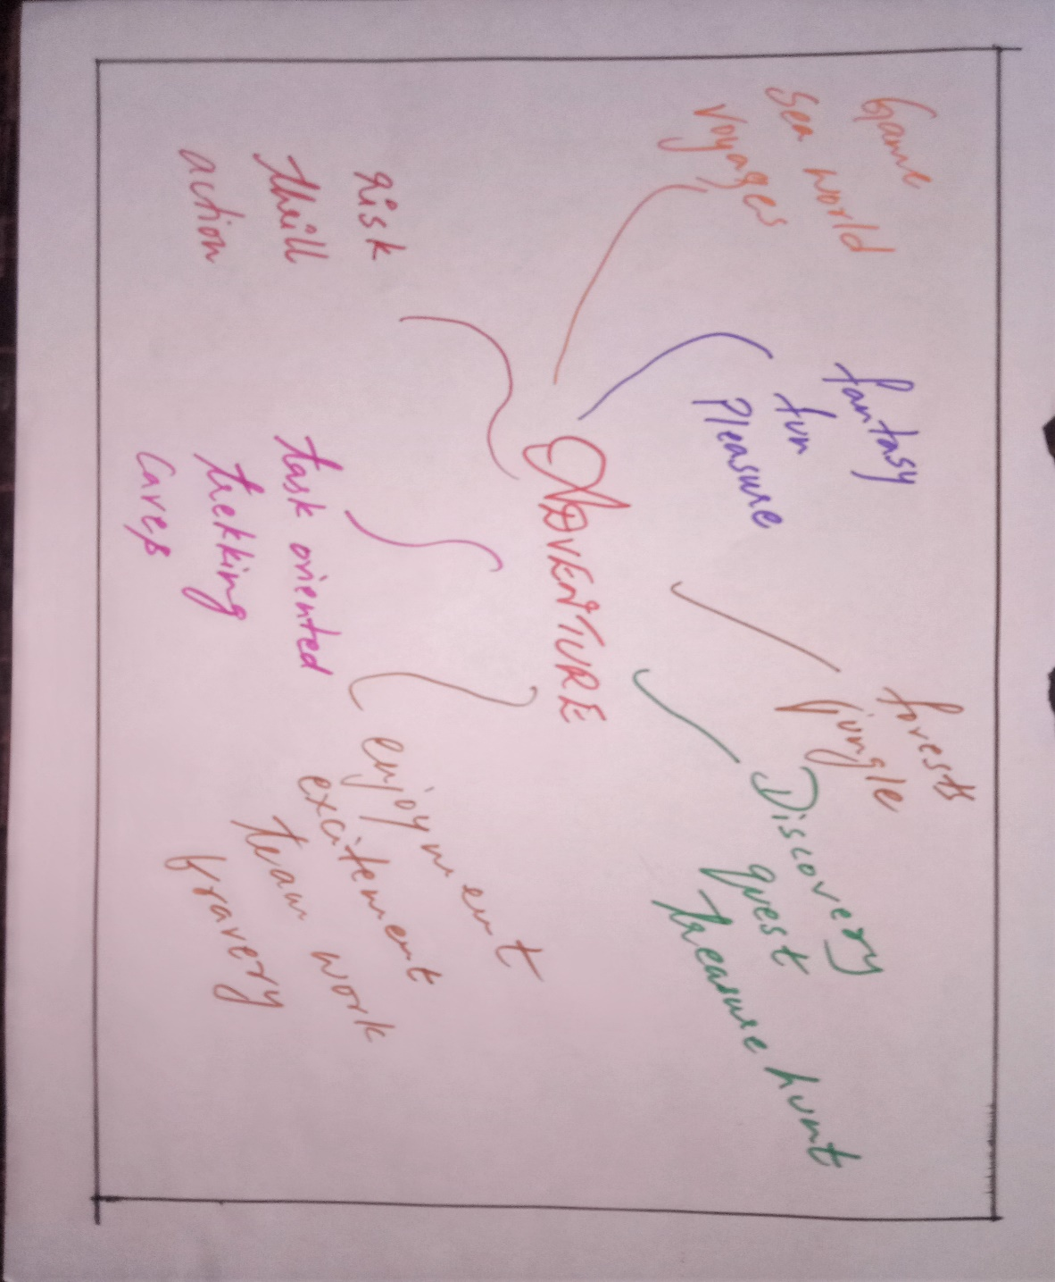

EXCERPT FROM HUCKLEBERRY FINN

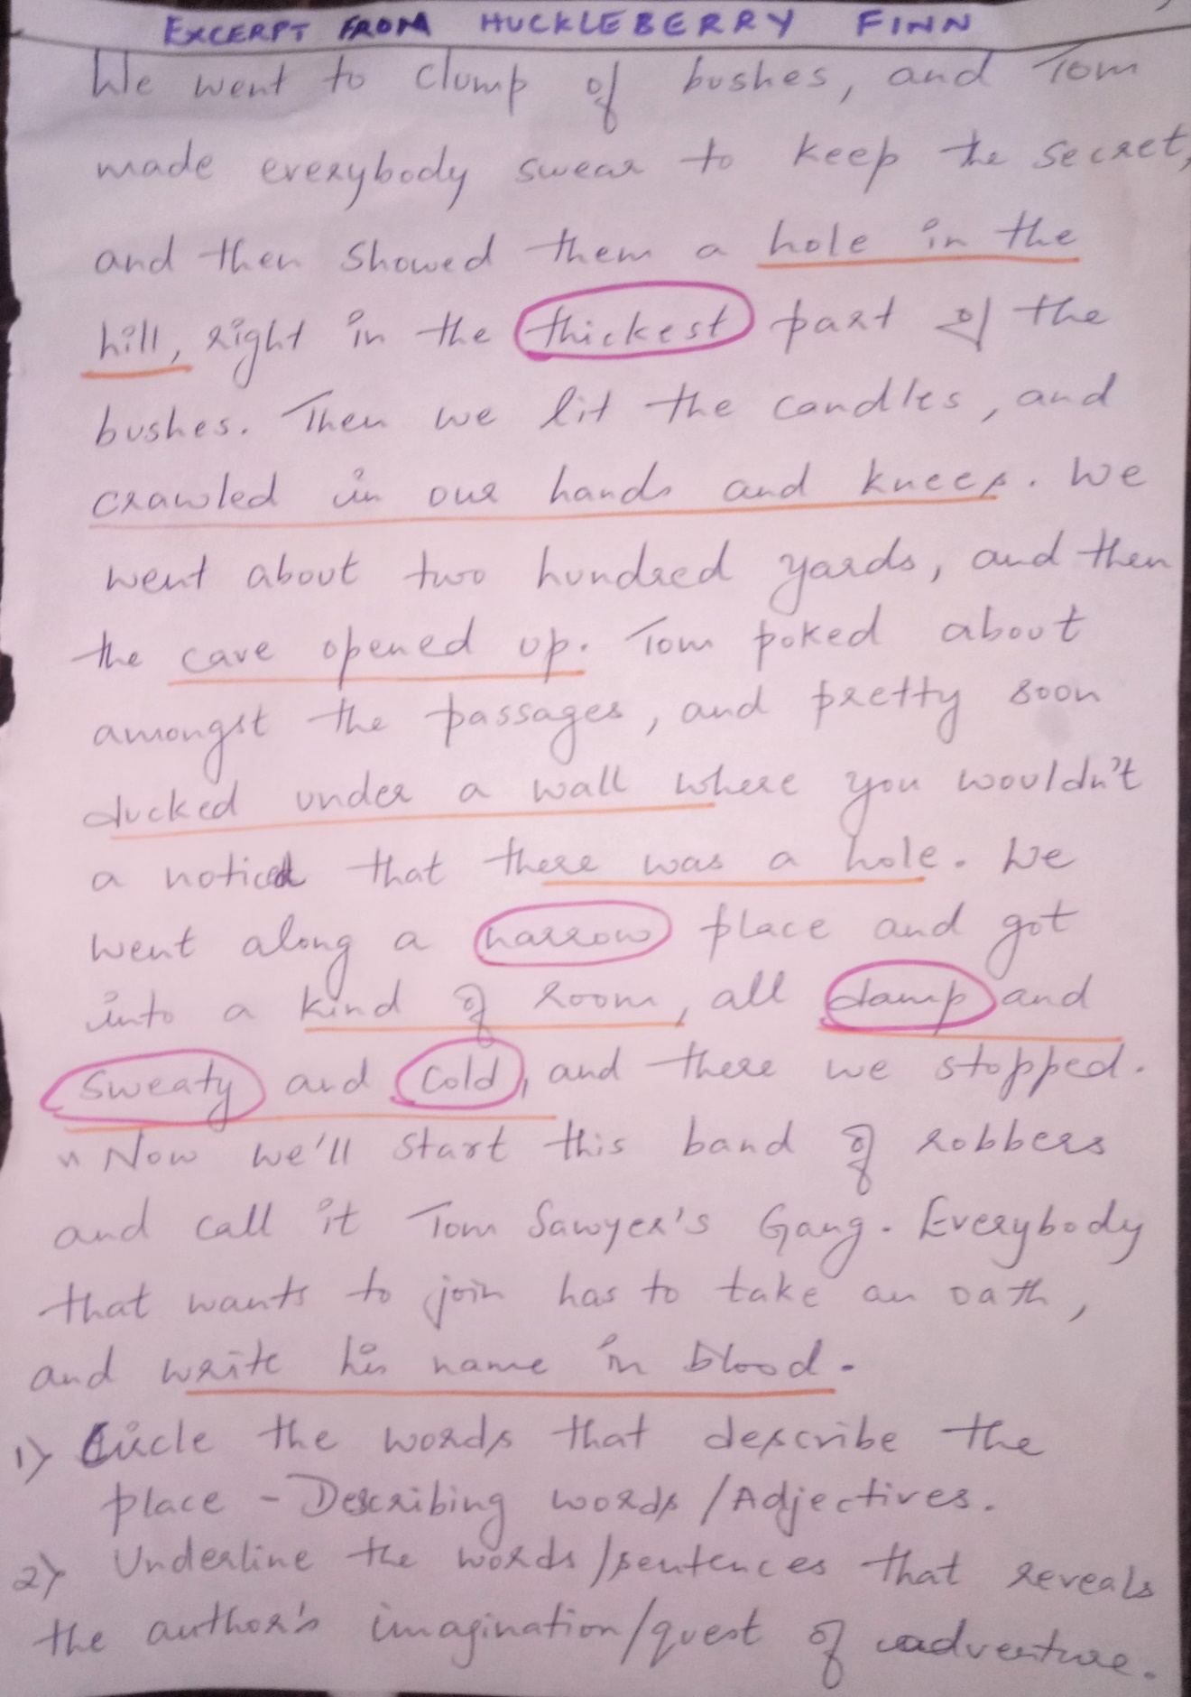
B. LESSON PLAN FOR READING A POEM

NAME OF TOPIC | READING A POEM
TIME DURATION | 40 MIN
OBJECTIVE | Students learn how to read a poem in depth. They also come to know how a poem is to be seen and read with structural analysis.
AGE | Intermediate
LEVEL | Beginning
WARMER | Ask the students to volunteer themselves to sing a song or shayari. This will create an atmosphere of melody.
PRE-READING | Tell words about that object/person. For example the poem taken here is The Daffodils by William Wordsworth. Give words such as Nature, flower, Daffodils, happy, sad, solitude, tranquillity. Ask them what they feel about these words. Let them relate to their personal life.
WHILE READING | Ask them to identify the rhyming lines, stress on words. Explain the intonation, emotions seen in the poem. For example, what action is going on in this poem? How is the mood of the poet? Do you also face the same situation? What do you do when you feel lonely?
POST-READING | Give 2 or 3 random poems on Nature. Divide the class into groups. Ask one group to identify the similarities in the poems. For example, Themes.  Another group has to search for any new or repeated words in the poems.  Another group has to identify the tone, rhyming pattern, imagery, structure in the poems.  Using the theme of Nature and few words from the poems ask the students to create their own poem on Nature.

MIND-MAPPING

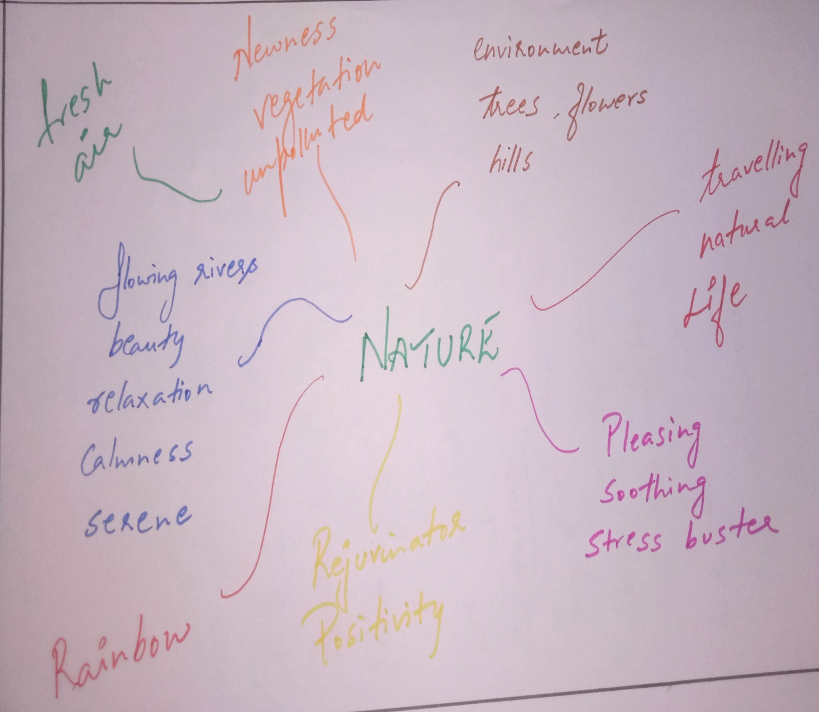

FEW STANZAS FROM THE DAFFODILS -WILLIAM WORDSWORTH
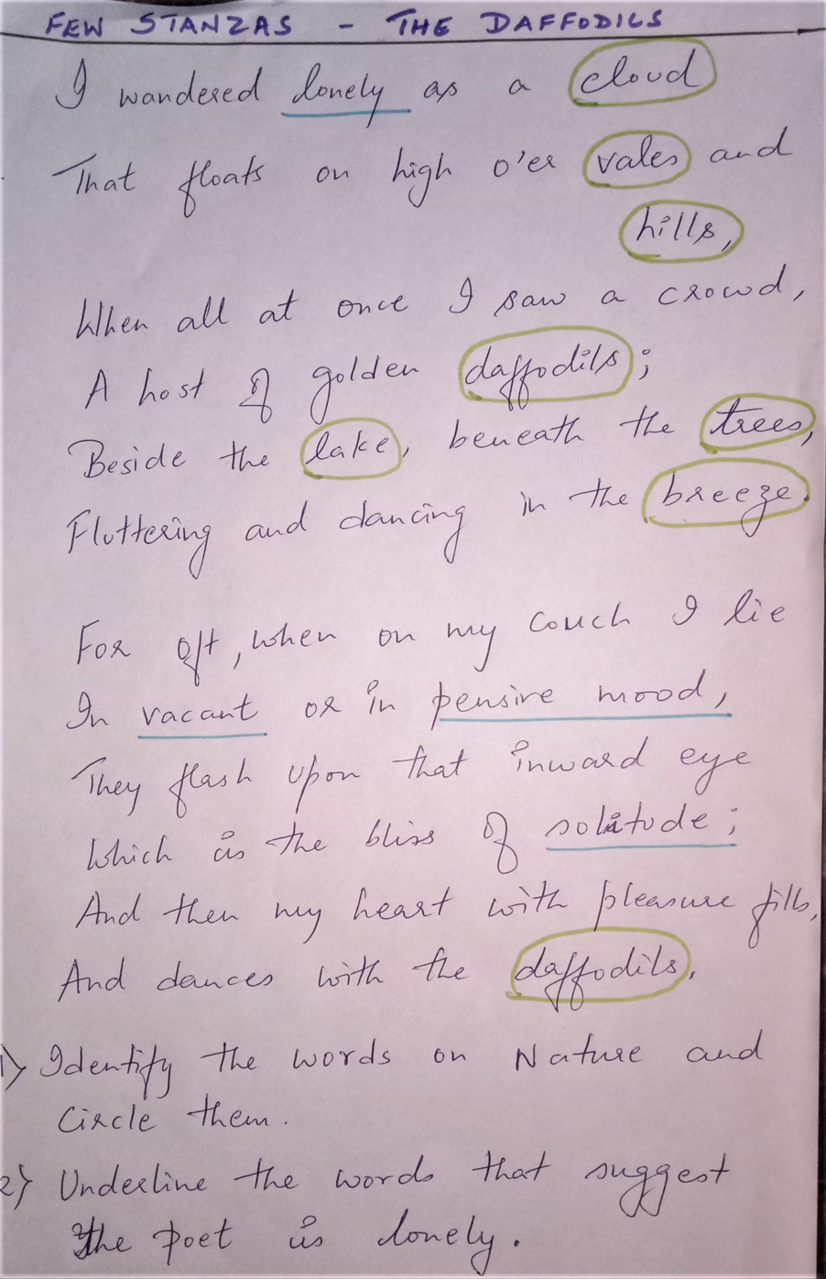
Solutions to few situations the teacher faces in CLT Classroom
Situation 1: If a group of students come to class after the lesson has begun.
Allow them to attend the class and stop teaching the lesson and do some sort of revision so that the students who came late will also understand the concept. It can be in the form of some activity or game. So that other students do not get left out or bored.
Also make them do extra exercises on that particular topic so that they realize the value of time that is punctuality and they do not repeat.
Finally, advice and guide them about being regular and in time to the class.
Situation 2: You have assigned a task, some students have already completed it, but others are still working.
Those who have completed can help the others in completing their task. This will in turn show their intimacy towards their peers.
Also ask the students who have completed to come to the blackboard and give clues so that it will be easy for others to get the answers quickly and in turn complete their task.
Encourage them by praising or applauding those students who complete quickly by giving them some incentives.
Situation 3: One student is causing disruption (acting out).
Give that student importance, let him take the role of the teacher, explain the concepts through exercise or activity. In that way he will be attentive as he has to run the show. There will be no room for his mischief or disruption as he has been given a responsibility.
He can also be made the class monitor, so that he will be busy and is given a responsible job. He should be kept busy with activities and exercises and certain amount of counselling must be done to understand the reason for his restlessness.

Conclusion
The CLT approach of teaching has led to many changes in the way language is taught and learnt. It aims to make “communicative competence” the goal of language teaching and to develop the procedures for teaching the four skills- listening, speaking,reading and writing. The entire idea of communicative language teaching reflects the urgency of practical learning and the outcomes that arise out of such procedures. CLT methodology has made a paradigm shift in the roles of both the learner and the teacher alike. Learners now have to work cooperatively and learn from their peers instead of individual learning from the teacher as highlighted in traditional approaches. They are now engaged in designing classroom activities and encouraged to develop a sense of “autonomous and life-long learning” (Richards,2006, P.5.) A teacher also acts as a need analyst, a counsellor and a group process manager. (Richards & Rodgers,2001, P.169.)

References
Richards,J.C. (2006). Communicative Language Teaching Today. Cambridge University Press. New York,USA
Richards,J.C & Rodgers, T.S. (2001). Approaches and Methods in Language Teaching. Cambridge,UK.Cambridge University Press.
Zouhaiyr Ezzahouani(Author). The Role of Teacher in the Communicative Approach. Munich,GRIN Verlag, https://www.grin.com/document/907293

