CHAPTER TITLE: BIOSEPARATION: TECHNIQUES AND APPLICATIONS FOR PURIFICATION AND ANALYSIS IN BIOTECHNOLOGY
Vandana D Prabhu¹, Keren Shona Simlai¹, Sanyukta Rai¹, Sharada Devi J N²
¹Authors, Jyoti Nivas College, Autonomous, Bengaluru, Karnataka 560095.
²Corresponding author: Sharada Devi J N
Assistant Professor In Zoology
Nrupathunga University, Nrupathunga Road, Bengaluru, Karnataka 560001
sharada.gfgc@gmail.com

Introduction:
The method of purifying biological products on a massive scale utilizing basic scientific and engineering concepts is known as bioseparation. The ultimate goal of this technique is to purify biological substances, cells and molecules. Based on their size, shape, polarity, density, solubility, diffusivity and electrostatic charge, biological products can be separated and purified. High selectivity and high productivity are extremely necessary for bioseparation. Despite having a foundation in conventional chemical separation techniques, bioseparation has certain key distinctions. This is due to the fact that, biological substances as opposed to synthetic chemicals utilized in conventional methods, are used to purify and separate the components in bioseparation. Polysaccharides, nucleic acids and proteins are therefore not appropriate for the demanding conditions of conventional procedures like adsorption and evaporation. Often, the beginning material from which they are processed only contains extremely small amounts of the desired final result. As a result, massive amounts of diluted product streams must be processed in order to produce a tiny quantity of pure product. The beginning substance frequently contains undesirable contaminants whose genetic makeup is comparable to that of the desired result, making these separation techniques highly challenging.
Principles of Bioseparation:
  - Selectivity and Specificity:
Selectivity necessitates that every component in a mixture be present, much like specificity does.Specificity is the ability to objectively evaluate an analyte in the presence of elements that one could reasonably expect to be present.(Source: ) One can use "specificity" or "selectivity" interchangeably. This is bad since specificity can't be assessed because it's considered an absolute idea. A selective reaction or test can also occur when other chemicals are present but exhibit some preference for the substance of interest, whereas a specific reaction or test can only occur when the substance of interest is present. Few reactions are specific, despite the fact that many exhibit selectivity. Enabling the target biomolecules to be separated from complex biological matrices is the aim of bioseparation techniques. A frequent basis for metal identification techniques (such atomic emission spectrometry) is selectivity from the detecting apparatus, or detection selectivity. Methods such as chromatography, electrophoresis, and membrane separations for a wide range of species often depend on separation selectivity, or selectivity in the separation process. Hyphenated techniques, such as liquid chromatography-mass spectrometry (LC-MS), which combine selectivities with respect to separation and detection, can be utilized when there is an especially high demand for selectivity.Tandem mass spectrometry, such as liquid chromatography-mass spectrometry-mass spectrometry (LC-MS-MS), yields a selectivity that is rarely compromised when positive and unbiased identification is required in legal circumstances. In recent times, arrays have been employed to integrate sensors with different kinds and degrees of selectivity. The reactions provide what has been called "computational selectivity" because they are predicated on interactions that are normally evaluated in a mathematical domain (chemometrics). Actually, selectivity is increased by analyzing the spectral data using chemometric techniques and employing a full spectrum encompassing multiple wavelengths as opposed to a single wavelength. This approach to managing near-infrared spectra serves as an excellent example of the idea. There have also been descriptions of single sensors with different incorporated selectivities; these sensors, including spectroelectrochemical detectors that use charge location, electrolysis potential, and spectral wavelength, have a multimode selectivity feature that was designed to reduce interferences. [2]

1.2. Affinity-based Interactions:
Many bioseparation approaches, such as antigen-antibody, ligand-receptor, or enzyme-substrate interactions, rely on specific interactions to achieve selective binding and separations. It is based on extremely precise biological interactions between two molecules, such as those that occur between an enzyme and a substrate, a receptor and a ligand, or an antibody and an antigen. Understanding the interactions between the target molecule and the ligand is critical for efficient affinity purification because it influences the selection of a suitable affinity ligand and purification procedure. Because of the growing popularity of affinity purification, many of the commonly used ligands coupled to affinity matrices are now widely available on the market. In other cases, however, it may be essential to manufacture fresh affinity chromatographic material by fusing the ligand to the matrix. To separate one or more of the required biomolecules from their impurities, affinity-based bioseparations use a biological recognition phenomena that is reversible and specific. These processes call for steps like precipitation, chromatography, two phase extractions and membrane-based purifications. These can alternatively be categorized as
affinity chromatographic and non-chromatographic methods.Even while affinity bioseparations have been heavily sought after for the isolation of medicinal proteins, nothing is known about how they might be used to recover polymer-protein conjugates. Because of its high-resolution capabilities, chromatography will continue to be the favored approach for the purification of biopharmaceuticals, hence the shift in affinity qualities has primarily been addressed in chromatographic procedures. Even while affinity bioseparations have been heavily sought after for the isolation of medicinal proteins, nothing is known about how they might be used to recover polymer-protein conjugates. No matter the type of operation, the fundamental steps in a protein affinity-based bioseparation are(1) trapping of the protein using the ligand (which can be free or coupled to a specific matrix), (2) washing or extraction of the mixture's impurities, and (3) elution or extraction of the target protein. A highly precise biological contact between a target and a ligand underpins the selective and effective purification method known as affinity chromatography (AC). AC advantages include high sample concentration, high sample selectivity, high level of purification (more than 1,000-fold), scalability, preservation of biological activity using gentle procedures, and time savings.
Affinity chromatography has not been widely used for the purification of PEGylated proteins following a PEGylation procedure. The purification of PEGylated proteins following a PEGylation procedure has not yet seen many applications of affinity chromatography. [4]

  - Physical Properties:
A quality of matter which is known as a physical property is one that is unrelated to a change in its chemical makeup. Density, color, hardness, electrical conductivity and melting and boiling points, are a few common examples of physical qualities. Different physical characteristics including size, hydrophobicity, charge, and solubility are used in bioseparation procedures to make it easier to isolate biomolecules.[5] Important properties for bioseparation purposes include thermal stability, diffusivity, charge, solubility, and isoelectric pH. The ability or lability to change of most bio products is used extensively in process design.[6]

Bioseparation Techniques:

2.1 Chromatography:
Chromatography is a crucial biophysical method that makes it possible to distinguish, separate, and purify mixture's constituent parts for both quantitative and qualitative study. Based on certain traits like size and structure, overall charge, the presence of hydrophobic groups on the surface, and the binding ability to the stationary phase, proteins can be purified. This methodology bases the chromatography process on three elements. A "solid" phase always makes up the stationary phase. A mobile phase is frequently composed of a "liquid" or "gaseous component." The technique is known as liquid chromatography (LC) if the mobile phase is liquid, and gas chromatography (GC) if the mobile phase is gas. Gas chromatography is a technique that is used to evaluate gases, volatile liquid mixtures, and solid materials. For thermally unstable and non-volatile compounds, liquid chromatography is very beneficial. A variety of chromatographic procedures have been developed to produce this type of biological separation. Gel filtration chromatography, Ion exchange chromatography, and affinity based chromatography are a few examples.. [7]
2.1.1. Gel Filtration Chromatography:
Gel filtration chromatography or molecular-sieve chromatography depends on the capacity of the molecules to pass through the pores of the gel-filtration matrix, because the molecules in the sample have different molecular sizes. The stationary phase in this approach is made up of molecularly sized pores with a narrow range of sizes. These are referred to as'molecular sieves'. When an aqueous solution containing molecules of various sizes is pumped through the column, particles larger than the pores of the filtration matrix flow quickly through it. Smaller molecules move slowly through the column gel's molecular sieves. The elusion of molecules occurs in the decreasing order of molecular weight. The ‘exclusion limit’ of a particular gel is the molecular weight of the lightest molecule that cannot pass through its pores. [8]

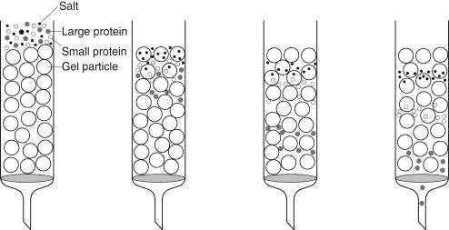

2.1.2. Ion Exchange Chromatography:
Based on their affinity for ion exchangers, ions and polar compounds can be separated using ion exchange chromatography (also known as ion chromatography). Thus, the reversible transfer of ions across the desired ions in the original solution and the ions on the ion exchangers constitutes the separation principle. It is possible to use both cationic and anionic exchangers in this process. Positively charged cations will be drawn to cationic exchangers containing negatively charged groups. These are also known as Acidic ion exchangers. Positively charged anions will be drawn to negatively charged anions by anionic exchangers, also known as Basic ion exchangers.. The charged groups that make up the ion exchangers are essentially covalently linked to the uppermost layer of an insoluble matrix. Groups in the matrix that are positively or negatively charged can be detected. When the matrix dissolves in an aqueous solution, ions with the opposite charge will surround its charged groups. In this "ion cloud," ions can be swapped back and forth without changing the features or characteristics of the matrix. The most used technique for ion exchange chromatography is column chromatography. Nonetheless, there are also thin-layer chromatographic techniques that essentially operate on the ion exchange principle.This type of chromatography depends on the attraction between an analyte and an oppositely charged stationary phase, or ion exchanger. [7]

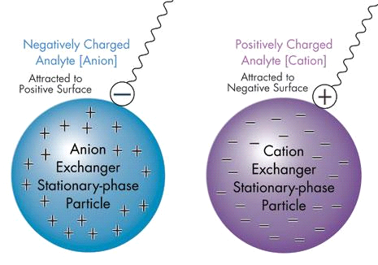.
2.1.3. Affinity Chromatography:
Affinity chromatography is widely utilized for biomolecule purification. As with antibody-antigen binding, the approach relies on the extremely unique interaction between an analyte and its counterpart. The counterpart gets stuck on the stationary phase, forming the affinity column. While the intended analyte, along with a variety of other chemicals, goes through the column, only the analyte retains; everything else passes through. The analyte is then released as a pointed band using an eluent, capable of eliminating the analyte from its homologue. While affinity purification is simple in theory, developing an agent that binds the analyte specifically and with high affinity, followed by developing another agent that discharges the analyte without denaturation, is not always a simple task.

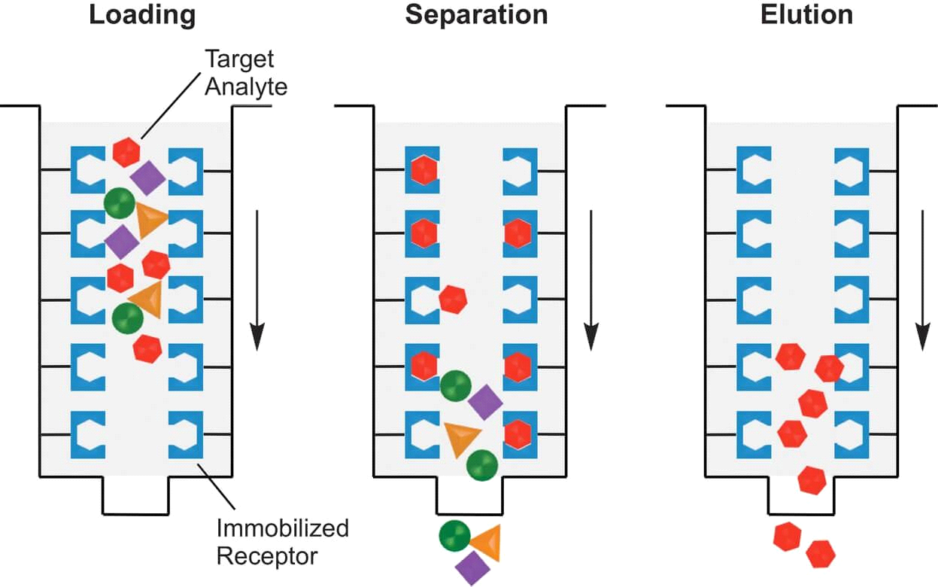

2.2. Electrophoresis:
A laboratory procedure called electrophoresis is used to divide nucleic acids and protein molecules according to their electrical charge as well as their size. The molecules are moved using an electric current through a gel or a similar matrix. Smaller molecules can flow more quickly than larger molecules as a result of the pores in the matrix that act as a sieve. Standards whose sizes have been identified are separated on the same gel and compared to the sample to ascertain the size of the molecules in the sample. Because molecules are electrically charged, they are subject to a force when they are in an electric field. Higher-charged molecules experience greater force from the electrical field, which leads them to move through support medium at a mass-proportionate distance. Agarose gel serves as the electrolyte matrix in DNA electrophoresis, which is widely used. Its large pore size makes it easier for larger molecules to get through, but it is not suitable for filtering smaller molecules. Polyacrylamide gel electrophoresis (PAGE) has a greater resolution than agarose gel, which makes it more appropriate for quantitative analysis. As a result, interactions between proteins and DNA can be detected. It can also be used to learn more about how bacteria become resistant to antibiotics using plasmid analysis.

2.2.1. SDS-PAGE (Sodium dodecyl sulfate-polyacrylamide gel electrophoresis separates):
Proteins are separated analytically using SDS-PAGE based on their molecular weight. Smaller proteins move faster during electrophoresis because the gel matrix provides less resistance. Protein structure and charge are two more parameters that influence how quickly molecules move across the gel matrix. Polymerized acrylamide (polyacrylamide) creates a matrix with the appearance of a mesh for the separation of proteins with specific sizes. Because of its strength, the gel may be easily handled. Using polyacrylamide gel electrophoresis of SDS-treated proteins, researchers may simply, cheaply, and precisely separate proteins based on their length. In response to the electric field, the proteins move through the gel like sand through a sieve. Because proteins have a net positive or negative charge, they can flow in the direction of the isoelectric point, where they have no net charge. Proteins that are uniformly negatively charged and denaturized can be sorted depending on size as they travel towards the positive electrode. This is the most often used technology for high resolution analytical separation of protein mixtures, and it works well in applications where the natural features of protein structure or function are not required. SDS-PAGE is thus employed in a variety of procedures, including immunochemical protein identification and quantification (western blotting), protein expression analysis, and protein sample purification. SDS-PAGE has a distinct disadvantage in that proteins are purposefully denaturated before electrophoresis. In general, proteins recovered by SDS-PAGE cannot be tested for rotein binding interactions, enzymatic activity, and so on. [9(i)]
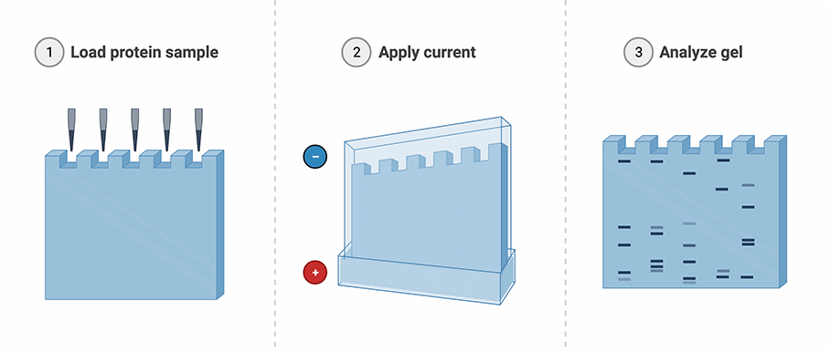
2.2.2. Capillary Electrophoresis:
This separation method divides molecules into groups based on their size and charge in an electric field. It is carried out in an electrolyte solution-filled capillary (a tiny glass tube). Due to changes in electrophoretic range of motion, which varies with size, charge, viscosity, and solvent, analytes are separated. The voltage range that can be used in traditional gel electrophoresis procedures, is constrained because the technique and gel can be destroyed due to heating effects caused by work done by the voltage. Because of their high surface-to-volume ratio, capillaries are better at dissipating heat. As a result, the applied voltages for a capillary electrophoresis study are typically between 10,000 and 20,000 V. High-performance separations are carried out by capillary electrophoresis. Most of the time, CE separations are quicker and more effective than liquid chromatography. Liquid chromatography can separate charged molecules, but capillary electrophoresis does it more effectively. Compared to high-performance liquid chromatography (HPLC), CE has a higher peak capacity, which makes separations more effective and allows for the detection of more peaks. Instrumentation may be rather basic. HPLC is more adaptable, and a variety of stationary and mobile phases have been created for various kinds of molecules. [9(ii)]
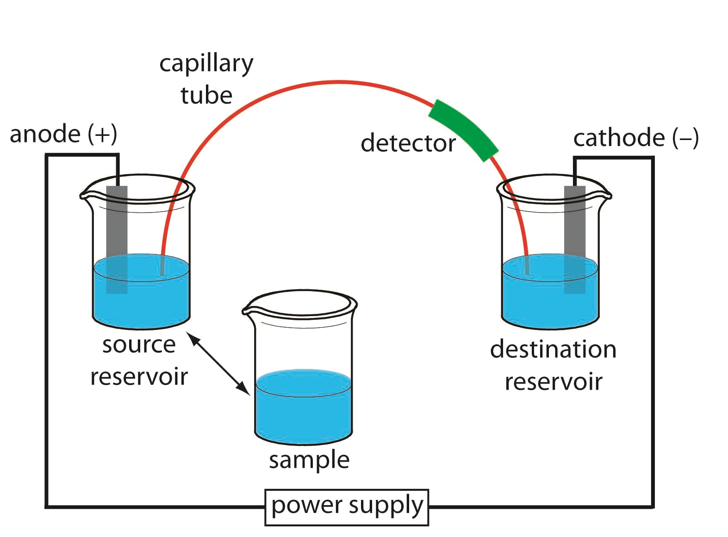

2.3. Filtration: Filtration is a process used to separate solids from liquids or gases using a filter medium. The fluid that passes through the filter is called the filtrate.

2.4. Centrifugation:
Centrifugation is a process that uses centrifugal force to separate particles from a solution based on their density, medium viscosity, size, shape, and rotor speed. In this procedure, a centrifuge is used. A centrifuge operates on the sedimentation principle, which states that substances segregate according to density under the impact of gravitational force. Particles will settle and form a pellet at the bottom of the tube or container during rapid centrifugation. After centrifugation, this pellet is made of heavy and dense particles suspended in the sample and can be readily separated for immediate analysis. Buoyancy, which is influenced by the liquid in which the particles are suspended, is another principle at action during centrifugation. The speed and length of centrifugation are also important elements to take into account in the planning of experiments, as increasing the duration and speed of centrifugation increases the degree of separation. These variables can be determined in order to get the best separation of desired particles of interest. The size and diameter of the rotors can also have an impact on efficiency and performance. Ultra centrifugation, Density gradient centrifugation and differential centrifugation are a few types of centrifugation procedures. Yeast fermentation, cheese making, biological sample separation, milk separation are a few applications of centrifugation. [9(iii)]
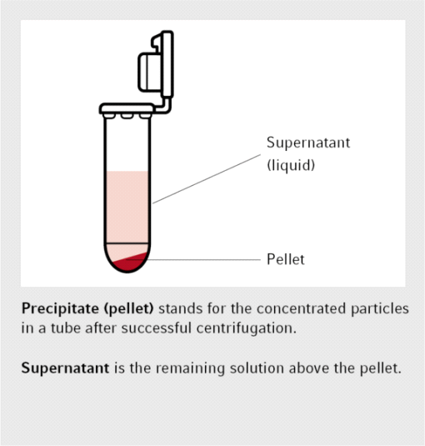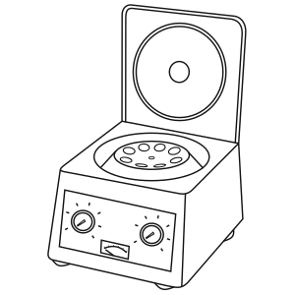

Applications of Bioseparation:
3.1. Biopharmaceutical Production:
Bioseparation is crucial in the production of therapeutic proteins, vaccines, and monoclonal antibodies, where high purity and activity are essential. Biopharmaceuticals are complex drugs synthesized from living tissues or organisms, frequently employing modern and advanced biotechnological techniques. They include blood and its components, somatic cells, gene therapies, vaccinations, recombinant therapeutic proteins, and live drugs used in cell therapy, which are distinct from pharmaceuticals that are entirely produced.[10] Since low-volume, high-purity products are desired, production costs and microbiological contamination (by bacteria, viruses, and mycoplasma) are significant challenges worth being concerned about. Hence, the expense of making such a medicine or biological product ready for commercial consumption includes a significant portion of Bioseparation and downstream processing equipment costs.[11] The high-dose demand for several Monoclonal Antibodies used to treat various types of cancer, rheumatoid arthritis, severe asthma, macular degeneration, multiple sclerosis, and other diseases, translates into annual production requirements for purified products in the metric ton range. The vast majority of the contaminant proteins are removed using a Protein-A affinity chromatography column, purifying a batch of material in four cycles. In the large-scale manufacture of recombinant protein products, the costs of purification and recovery can make up nearly 80% of the overall cost of production. For instance, items may need to be 99.9% pure during processing with virtually no DNA, viruses, or endotoxins remaining.[12] The biopharmaceutical market Bioseparation systems are dominated by chromatography systems, centrifuges, and membranes/filters because these are the most often used products. Although there are many different approaches or systems available for Bioseparation, there are not many options that can equal the yield and purity standards of chromatography, which is the principal technology utilized in the downstream purification of biopharmaceuticals and continues to be the industry standard. From establishing a list of possible drug candidates (using High Performance Liquid Chromatography) to assuring the quality of drug formulations, analyzing the efficacy and release time of innovative drug formulations to developing manufacturing processes, chromatography is employed throughout the drug development process. The global yearly market for downstream processing equipment is anticipated to have developed at a high rate of about 20% per year.[11] Because the key to lowering production costs is stressing advances in Bioseparation-downstream processing equipment, it is worthwhile to make an effort to better evaluate and comprehend the various aspects involved in downstream processing.

3.2. Biorefineries:
Bioseparation plays a vital role in the processing of biomass-derived feedstocks for the production of biofuels, biochemicals, and bio-based materials. Nature stores Solar energy as Biomass which is thought of as a renewable substitute for fossil fuels. In biorefineries, bioresources are sustainably processed to supply an array of commercial goods and energy. Surprisingly, nature is perfectly capable of functioning well with a mixture of reactants leading to a mixture of products. Nature, thus, does not provide mankind with pure chemicals. In contrast, the chemical industry has evolved along the lines of incorporating almost pure raw materials (derived through pre-treatment stages) that are transformed into a mix of products and then separated into pure components. Thus, purity is the most important factor to control these processes. In addition to the production of energy, fuels, and chemicals, a biorefinery may also produce bioproducts such as food and livestock. It is important to highlight that all separation technologies used in biorefineries involve a biomass pre-treatment step (mostly phase separations, but also size reduction, dirt/sand removal, and so on) that results in conditioned biomass which is then used on dedicated technological platforms where it is converted into products. For example; the production of ethanol fuel involves lignocellulosic biomass such as herbaceous crops (e.g. switchgrass), Agricultural residues (e.g., crop straws, sugar cane bagasse, maize residues), forestry wastes, wastepaper, wood, and municipal wastes, which are the most potential feedstock for ethanol. The fundamental process for converting cellulosic biomass to fuel ethanol consists of a few important steps like pretreatment and detoxification of feedstock, co-fermentation, product separation and purification, wastewater treatment, etc, which involve fluid mixture separation employing various methods (e.g., reactive separations, affinity chromatography, trigger-enhanced charge separations).[13] These are some of the separation technologies that can significantly improve biorefineries by streamlining operations with fewer equipment and minimizing operating costs with lower energy requirements, increasing the competitiveness of the biorefineries even in the absence of incentives. Since separations make up the bulk of total costs in biorefineries, any significant improvements in separations have the potential to make or break a business.

3.3. Environmental Remediation:
Bioseparation techniques are used in environmental cleanup processes to remove contaminants from water, soil, and air. Growing industrialization and technologies have increased the usage of chemicals and their discharge into the environment, jeopardizing ecosystems. Since biological treatment procedures like bioremediation, provide a practical and environmentally conscious alternative to traditional chemical treatments, they are currently gaining popularity for removing harmful pollutants from the environment. Treatment of oily waste has grown to be a major problem in today's world. Oily waste is hence, utilized as bases for the synthesis of industrially significant biosurfactants, which help in eliminating waste and mitigate the long-lastingly harmful environmental effects. In contrast, chemical surfactants, due to their badly controlled environmental discharge, constitute a serious hazardous threat. Through their interactions with cell membranes and disruption of cell structure, chemical surfactants have a negative impact on the microorganisms. Fish, which absorb chemicals via their skin, and other animals and people that consume meat begin to exhibit detrimental effects once the levels are high enough. As a result, in order to manufacture biosurfactants, affordable feedstock, competent microorganisms, and suitable bioengineering procedures like bioremediation are used. This allows them to compete economically with the harmful synthetic chemical surfactants. Although it has been challenging to generate these compounds at a competitive price due to inefficient bioprocessing and bioengineering. There is a dearth of research on creating ideal bioprocess approaches, and the potential for cost-effective biosurfactant synthesis, despite substantial investigation in this area. [14] In terms of air pollution, in order to gain a greater understanding on how the harmful particles present in air interact with it, scientists are using Gas chromatography to extract them from a mixture of polluted air. Researchers use various types of chromatography to study airborne particle matter and pinpoint the source of air pollution. Because authorities could target the sources of the particles if they knew their chemical makeup, researchers try to determine the nature of the particles. The researchers then try to understand the risks associated with these particles. Particle matter 10 micrometers, or PM10, is one sort of particle matter being examined by chromatography and is linked to diesel engines. PM10 also originates from industrial sources, lowering air quality.[15] A total of 3.3 billion tonnes of carbon dioxide releases into the atmosphere, and food waste is estimated to have a carbon footprint that makes up around 8% of those emissions. In order to reduce greenhouse gas emissions, the concepts of net-zero (carbon neutrality) are used. The balance between carbon released into the atmosphere and carbon absorbed from the environment through carbon sinks is referred to as carbon neutrality. Both refineries and the food processing sector generate substantial amounts of oily waste which promotes CO emission.[14] A higher carbon economy coupled with the breakdown of waste greatly increases greenhouse gas emissions and contributes to climate change. As a result, waste reduction, reuse, and recycling can support the production of novel, economical, and safe biosurfactants. To replace the prevailing "take, create, and discard" economic development narrative and implement environmental sustainability, the idea and principles of bio-economy have been established as a system model. In terms of water and soil pollution, the present soil remediation technologies, such as pump and treat systems and soil incineration, are either impractically expensive or difficult to implement. Using certain plants to absorb Poly- and perfluoroalkyl substances (PFASs) in situ followed by eliminating them through the process of incineration is a treatment method for PFAS-contaminated soil and groundwater, but it takes a lot of time.[16] The concepts of gas-liquid and high-performance liquid chromatography have been put together and critically analyzed and employed in water and soil research, environmental preservation, and so on. One such use has been in extraction of Herbicide residues from various matrices. Thus, all these chromatography Bioseparation techniques are extensively being researched by the scientists across the globe and used for extraction of pollutants from the ecosystem and to analyze their hazardous nature and the extent of danger they pose to the environment followed by creating new methods to get rid of these from the ecosystem.

3.4.Diagnostic and Analytical Applications:
Bioseparation is employed in diagnostic tests, immunoassays, and proteomics to isolate and analyze biomarkers and proteins. The need for bio-separation has increased due to the industry's enormous advances in life science and biotechnology. In order to meet new testing issues, it is constantly necessary to enhance the performance of the available diagnostic tests. The application of nanoparticles has the potential to advance in vitro diagnostics to a new level of effectiveness. For the purpose of detecting target biomolecules, these nanoparticles are coupled with recognition molecules like oligonucleotides or antibodies. Nanoparticles have been used in cellular imaging, DNA diagnostics, and bioseparation of particular cell cultures and immunoassays.[17] Based on mass spectrometry and magnetic nanoparticles, many brand-new and incredibly sensitive immunoassay techniques have been designed. These techniques have excellent potential for use in bio-separation and immunoassay. For instance, magnetic Fe2O3/Au core/shell nanoparticles are being used in bioseparation due to the simplicity of use and high separation efficiency of this efficient technology. Practically, nearly all of the antigens in the test solution are separated biologically using magnetic Fe2O3/Au core/shell nanoparticles. Through in vitro procedures and MRI tests, another type of nanoparticle, magnetite nanoparticles, were found to be harmless in clinical quantities. These nanoparticles are readily internalized by cancer cells due to their exceedingly small sizes and positively charged surfaces. These functional nanoparticles hence form a potential platform for future in vitro and in vivo tests because of all these advantageous characteristics.[18,19] A similar kind of approach is carried out where the antigen-antibody response that is incubated in a homogenous manner, tests large-molecular-weight antigens with sensitivities comparable to those of other non-isotopic heterogeneous immunoassays. For instance, the thermally precipitating synthetic polymer, poly-N-isopropylacrylamide (polyNIPAAm) which is soluble in water is combined with a monoclonal antibody (MAb) and used in a unique separation procedure for an immunoassay. Above a threshold temperature of 31°C, it precipitates out of water, allowing a polymer bound immune complex to be extracted from the solution. In addition to immunoassays, this basic technique is applied to a wide range of bioseparation procedures when a particular component in a body of water, biological fluid or industrial process stream needs to be isolated for analysis, recovery, or disposal.[20] This technology makes it feasible to remove pollutants or toxins as well as recover products. The present-day chromatographic and associated separation methods have thus advanced to the point that they can effectively separate complicated samples in the proteomics, pharmaceutical, and food industries. Enzymes are proteins that perform crucial biological reactions through their activity. The majority of enterprises use column chromatography, salt and solvent precipitation, electrophoresis, and other traditional procedures to treat distinct extracellular enzymes downstream. Thus, the development of an effective and affordable downstream processing technology is required in order to attain utmost enzyme purity, activity, and recovery levels. Hydrophilic interaction liquid chromatography (HILIC) is one such chromatographic technique which has its own advantages in facilitating the separation of hydrophilic or strongly polar molecules (such as glycopeptides, metabolites, etc.) due to the robust hydrophilic interactions. In the disciplines of proteomics, metabolomics, food science, and medicine, the combination of HILIC with various other separation techniques, presents great separation efficiency towards complicated samples.[21] The reverse micellar extraction (RME) technology is another technique which is being explored as an alternative to the other typical downstream processing procedures. The most exciting potential of reverse micelles is the separation and/or purification of proteins/enzymes in two quick and easy processes with a high degree of activity. Affinity based separations currently include membrane based purification, precipitation, and phase extractions. Besides affinity ligands that have a biological link (in vivo) with the target protein, a wide range of additional ligands are currently used in affinity-based separations. Chelated metal ions, dyes, and peptides are examples of them.[22] Enzymes catalyze all processes in living systems because of their biological affinity for their substrates. Drugs, like hormones, work by chemically recognizing receptors. Thus, the original concept of biological affinity was based on the in vivo connection of molecules. A single volume book cannot adequately cover the constantly growing body of research on affinity-based separations. It has actually taken on a variety of facets. The invention of next-generation medicines with decreased immunogenicity, enhanced safety, and increased efficacy is changing the biotech and pharmaceutical industries owing to the development of protein and peptide therapies. The most common application of modified proteins and monoclonal antibodies is in oncology. The study of gene and cellular functions at the protein level is called proteomics. Determining protein expression phases, post-translational changes, protein localisation, and protein-protein interactions are the objectives of proteomics. The development and detection of protein biomarkers for disease states is one of the significant objectives of proteomics that needs specific consideration in this context. Proteins pose the most challenges in bioseparations out of all the biomolecules.[23]
Emerging Trends and Future Perspectives:
4.1. Continuous Bioseparation:
The development of continuous bioseparation processes reduces processing times, simplifies operations, and enhances productivity in biomanufacturing. The development of continuous bioseparation processes reduces processing times, simplifies operations, and enhances productivity in biomanufacturing. The value of continuous downstream bioprocessing is becoming clear, but connecting multiple processes and integrating upstream is still difficult. Facilities for downstream bioprocessing are subject to taxes like never before. Greater quantities of smaller batches and more product to purify due to rising monoclonal antibody (mAb) demand, expanding biosimilar research, and upstream yield advancements. Public uproar over medicine prices and the movement to lower the cost of goods are further drivers for ongoing bioseparation. The cost of downstream batch bioprocessing is substantially influenced by the use of multistep procedures, huge buffer volumes, and equipment like Protein A resins. Process intensification, which involves processing smaller volumes of material semi-continuously or constantly, is how suppliers and producers are resolving these issues. Chromatography systems and associated purification stages are being evaluated and scaled up to manufacturing scales.[24] To lessen the overall number of downstream processing steps required, biopharmaceutical producers and technology suppliers are examining continuous processes and merging various solutions. To make the continuous capture phase easier, numerous multi-column process technologies have been developed. It has been tried to use several smaller columns to achieve Static Binding Capacity (SBC) from Dynamic Binding Capacity (DBC) at a specific flow rate. Aqueous micellar two-phase systems (AMTPS) and functional magnetic particles are used in conjunction with continuous magnetic extraction (CME), a novel process idea, to continuously purify proteins. CME has been effectively used for protein purification in the past, and it has recently been suggested that it be used for enzymatic conversion processes. The ability of AMTPS to form two phases above the so-called lower critical solution temperature (LCST), which enables switching the system between a single phase and a two-phase regime employing a minor temperature shift, is a key property for the CME process. CME in conjunction with enzymatic conversion procedures guards against enzyme contamination of the product. The reaction can be easily regulated by removing the enzyme from the suspension quickly. The immobilized enzyme is more stable with respect to temperature, pH, and other factors and can be reused repeatedly by continuously recovering the immobilisates, maximizing their lifetime. Further investigation is necessary, nevertheless, to compare the smaller multiple columns' effectiveness with that of a single standard column.[25] In another research, a continuous magnetophoretic bioseparation chip is used for isolating cells from the peripheral blood, such as circulating tumor cells. The chip is made up of a continuous-flow microfluidic platform with gradients of magnetic fields that were specifically tailored locally. Since the magnets' high-gradient magnetic field is spatially irregular, magnetic particles moving through a fluidic channel are attracted to it.[26] Key forces like the magnetic and fluidic forces and their impact on design parameters for an efficient separation are taken into consideration by the computational model. Most scientific advancements use semi-continuous chromatography. The control strategy in place is insufficient to guarantee process robustness for continuous operations. Fundamental models based on thermodynamics and kinetics will be needed for continuous processes in the future in order to better understand the process and develop superior control strategies for online process monitoring.

REFERENCES
[1]https://mpl.loesungsfabrik.de/en/english-blog/method-validation/specificity-selectivity
[2]Selectivity in Analytical Chemistry (IUPAC Recommendations 2001)" Chemistry International -- Newsmagazine for IUPAC, vol. 24, no. 1, 2002, pp. 21-22.
[3]Urh M, Simpson D, Zhao K. Affinity chromatography: general methods. Methods Enzymol. 2009
[4]Luis Alberto Mejía-Manzano, Patricia Vázquez-Villegas, José González-Valdez, "Perspectives, Tendencies, and Guidelines in Affinity-Based Strategies for the Recovery and Purification of PEGylated Proteins", Advances in Polymer Technology, vol. 2020
[5]https://tricliniclabs.com/page-directory/materials-analysis-services/physchem-materials-characterization-techniques-services-from-triclinic-labs.html
[6]https://www.aiche.org/sites/default/files/cep/20141036a.pdf
[7]Separation techniques: Chromatography
Ozlem Coskun Published online 2016 Nov 11. Doi: 10.14744/nci.2016.32757
[8] Recovery of metabolites S.G. Prapulla, N.G. Karanth, in Encyclopedia of Food Microbiology (Second Edition), 2014
[9(i)] Native SDS-PAGE: High Resolution Electrophoretic Separation of Proteins With Retention of Native Properties Including Bound Metal Ions Andrew B. Nowakowski, William J. Wobig, and David H. Petering
[9(ii)] https://www.jove.com/v/10226/capillary-electrophoresis-principle-procedure-and-applications
[9(iii)] https://www.akadeum.com/centrifugation/?cn-reloaded=1
[10]https://en.wikipedia.org/wiki/Biopharmaceutical
[11]https://www.europeanpharmaceuticalreview.com/news/172719/biopharmaceutical-bioseparation-systems-market-to-value-20bn/
[12]https://www.sciencedirect.com/sdfe/pdf/download/eid/1-s2.0-S0149639598800366/first-page-pdf Applications and economics of Bioseparation.
[13]https://pure.manchester.ac.uk/ws/portalfiles/portal/65100431/BiomassBioenergy_2016_95_296_309_Separation_technology_Making_a_difference_in_biorefineries.pdf Separation technology–Making a difference in biorefineries.
[14] Krishna Gautam, Poonam Sharma, Vivek Kumar Gaur, Pallavi Gupta, Upasana Pandey, Sunita Varjani, Ashok Pandey, Jonathan W.C. Wong, Jo-Shu Chang, Oily waste to biosurfactant: A path towards carbon neutrality and environmental sustainability, Environmental Technology & Innovation, Volume 30, 2023
[15]https://gentechscientific.com/chromatography-in-environmental-analysis/#:~:text=Chromatography%20is%20used%20to%20characterize,which%20the%20biodegrading%20is%20occurring. Applications of chromatography in environmental analysis.
[16] Mattias Sörengård, Dan B. Kleja, Lutz Ahrens, Stabilization and solidification remediation of soil contaminated with poly- and perfluoroalkyl substances (PFASs), Journal of Hazardous Materials, Volume 367, 2019
[17]Hassan M.E. Azzazy, Mai M.H. Mansour, In vitro diagnostic prospects of nanoparticles, Clinica Chimica Acta, Volume 403, Issues 1–2, 2009
[18] Fang Bao, Jian-Lin Yao, and Ren-Ao Gu, Synthesis of Magnetic Fe₂O₃/Au Core/Shell Nanoparticles for Bioseparation and Immunoassay Based on Surface-Enhanced Raman Spectroscopy, Langmuir, 2009, 25 (18), 10782-10787; DOI: 10.1021/la901337r
[19] Manasmita Das et al 2010 Nanotechnology 21 125103; DOI 10.1088/0957-4484/21/12/125103.
[20] Monji, N., Hoffman, A.S. A novel immunoassay system and bioseparation process based on thermal phase separating polymers. Appl Biochem Biotechnol 14, 107–120 (1987). https://doi.org/10.1007/BF02798429
[21] Qianying Sheng, Meiyan Liu, Minbo Lan, Guangyan Qing, Hydrophilic interaction liquid chromatography promotes the development of bio-separation and bio-analytical chemistry, TrAC Trends in Analytical Chemistry, Volume 165, 2023
[22]Kalyani Mondal, Munishwar N. Gupta, The affinity concept in bioseparation: Evolving paradigms and expanding range of applications, Biomolecular Engineering, Volume 23, Issues 2–3, 2006.
[23] David E. Garfin, Satinder Ahuja Bioseparations, Separation Methods in Proteomics, 2007; https://doi.org/10.1002/0471238961.biosahuj.a01
[24] A. Shanley, Continuous Bioseparations: Fitting the Pieces Together, BioPharm International 30 (5) 2017.
Golozar, M., Molki, M. & Darabi, J. Computational and performance analysis of a continuous magnetophoretic bioseparation chip with alternating magnetic fields. Microfluid Nanofluid 21, 73 (2017).
[25] Anja Paulus, Naomi Till, Matthias Franzreb, Controlling the partitioning behavior of magnetic micro-particles via hydrophobization with alkylamines: Tailored adsorbents for continuous bioseparation, Applied Surface Science,Volume 332,2015
[26] Golozar, M., Molki, M. & Darabi, J. Computational and performance analysis of a continuous magnetophoretic bioseparation chip with alternating magnetic fields. Microfluid Nanofluid 21, 73 (2017).

