Bioengineering strategies that bridge medicine and technology

Ms. Cynthia Irene kasi Dr Sharangouda J Patil
Department of lifesciences-genetics Department of Zoology
Indian Academy Degree College NMKRV College
Bengaluru,India Bengaluru,India

ABSTRACT

Biomedical engineering is growing as an integrating medium for two evolving professions, medicine and engineering, and has aided in the fight against diseases and illnesses through the development of tools such as biosensors, biomaterials, computational imaging, and artificial intelligence that medical professionals can use for research, diagnosis, and treatment. This chapter assists in identifying the significant role that technological developments in the field of medicine have played in the development of the modern health-care system. It establishes the term "biomedical engineering" as the roles that biomedical engineers play in the health-care delivery system.

Keywords- bioengineering, bionanotechnology,Biomimetic nanomaterials, bioprinting

- A HISTORICAL PERSPECTIVE

Diseases were viewed by prehistoric people as ''visits,'' the arbitrary actions of offended gods or spirits paved way to witch doctors, medicine men, and women, who used their natural instincts and learned from experience to develop a primitive science based on empirical laws, were the ones who practiced medicine. For instance, the arts of herb doctoring, bone setting, surgery, and midwifery were advanced through the acquisition and coding of certain reliable practices. Healing practitioners and shamans observed the nature of specific illnesses and then shared their experiences with subsequent generations, just as prehistoric humans learned from observation that certain plants and grains were good to eat and could be grown.
In actuality, the twentieth century saw the start of modern medicine. The basic sciences (chemistry, physiology, pharmacology, etc.) started to advance much more quickly in the 20th century. There was a lot of interdisciplinary collaboration during that time. Physical science advancements allowed medical research to advance significantly. For instance, William Einthoven created the first electrocardiograph in 1903 and recorded the electrical changes that took place while the heart was beating. In the process, Einthoven ushered in a new era for both electrical measurement methods and cardiovascular medicine.[1]
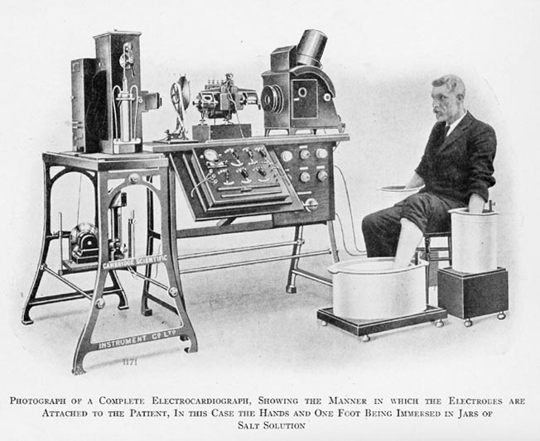
An early ECG machine (circa. 1911)
FIGURE 1: Photograph depicting an early electrocardiograph machine

The main risk of hospitalization—cross infection among patients—was greatly diminished by the introduction of sulfanilamide in the middle of the 1930s and penicillin in the early 1940s. With these new medications at their disposal, surgeons could perform their procedures without having to worry about infection-related morbidity and mortality being too high.
The use of the technology that was accessible aided in the development of sophisticated surgical techniques. The Drinker respirator and the first heart-lung bypass were both introduced in 1927 and 1939, accordingly Cardiovascular catheterization and angiography were created in the 1940s. Using a cannula inserted into the heart through an arm vein and radiopaque dye, these procedures allow for the visualization of the heart's vessels and valves on x-rays. Accurate congenital and acquired heart disease diagnoses (primarily rheumatic fever-related valve disorders) also became possible, ushering in a new era of cardiac and vascular surgery.
Throughout recorded history, technological and scientific developments have continually advanced.
Our society is now completely dominated by computers, much like the ones that managed the Apollo capsules' flight plans. These electronic brains have been used by medical researchers since the 1970s to carry out intricate calculations, maintain records (using artificial intelligence), and even command the very machinery that supports life. A constantly improving computer technology was completely necessary for the development of new medical imaging procedures like computerized tomography (CT) and magnetic resonance imaging (MRI).
Technology has recently hit medicine like a torpedo in recent years. The Human Genome Project was arguably the most significant technological and scientific endeavor of the 1990s. Robotic liquid handlers, automatic sequencers, and software for databasing and sequence assemblage were some of the engineering products that were essential to the effort. This led to a significant shift in biomedical engineering's emphasis from the organ system level to the cellular and molecular level.New horizons have opened up as a result of the genome project's success (for example, it is now possible to develop customized medications using a person's DNA). Science fiction will undoubtedly continue to become reality, as evidenced by developments in tissue engineering, nanotechnology, and artificial organs. [2]
These are merely a few of the scenarios that show how technology has the potential to develop a system of medical services that will be available, of the highest caliber, and affordable to all.

II. BIOENGINEERING

Bioengineering is typically described as a basic-research-focused activity closely related to biotechnology and genetic engineering,typical pursuits of biomedical engineers include:
- Invention of new medical diagnostic tests for diseases & Production of synthetic vaccines from clone cells
- Bioenvironmental engineering to protect human, animal, and plant life from toxicants and pollutants
- Study of protein-surface interactions & Modeling of the growth kinetics of hybridoma cells
- Research in immobilized enzyme technology & Development of therapeutic proteins and monoclonal antibodies
The phrase "biomedical engineering" appears to have the broadest definition. Electrical, chemical, optical, mechanical, and other engineering concepts are used by biomedical engineers to comprehend, alter, or regulate biological (i.e., human and animal) systems.

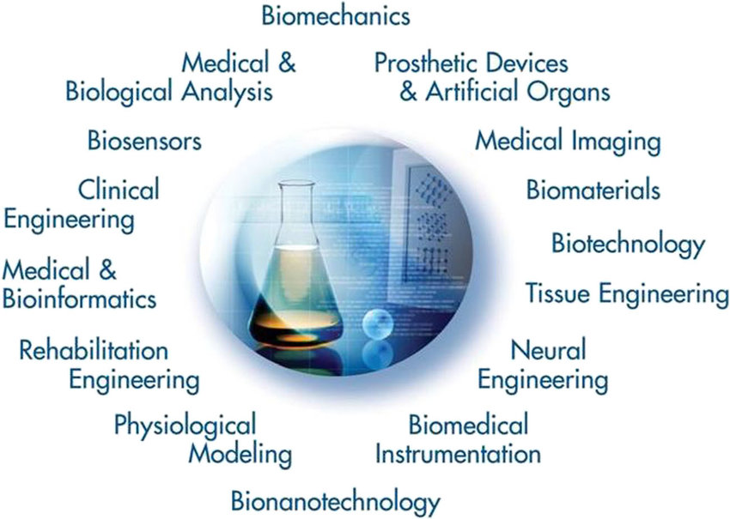
FIGURE 2: The world of biomedical engineering

As illustrated in Figure 2, the field of biomedical engineering now includes many new career areas. These areas include:
- Application of engineering system analysis such as physiologic modeling, simulation, and control to biological problems.
- Detection, measurement, and monitoring of physiologic signals i.e., biosensors and biomedical instrumentation.
- Diagnostic interpretation via signal-processing techniques of bioelectric data.
- Therapeutic and rehabilitation procedures and devices.
- Devices for replacement or augmentation of bodily functions.
- Computer analysis of patient-related data and clinical decision making i.e., medical informatics and artificial intelligence.
- Medical imaging; that is, the graphical display of anatomic detail or physiologic function.
- The creation of new biologic products i.e., biotechnology and tissue engineering.
As a result, biomedical engineering is a branch of engineering that crosses many disciplinary boundaries and is heavily influenced by both engineering and the life sciences. It includes everything from theoretical, non-experimental projects to cutting-edge applications. It might include all four—research, development, application, and operation. Therefore, it is unlikely that any one person can develop expertise that covers the entire field, much like medical practice itself.[3]
The identification of issues and requirements of our current healthcare delivery system that can be resolved using current engineering technology and systems methodology may be a greater potential benefit of using biomedical engineers. As a result, there is hope in the field of biomedical engineering for the ongoing struggle to provide high-quality healthcare at an affordable price. Biomedical engineers can offer the tools and procedures to improve the effectiveness and efficiency of our healthcare system if they are properly focused on finding solutions to issues relating to ambulatory care services, ambulatory medical approaches, and similar issues.

III. ADVANCEMENTS IN BIONANOTECHNOLOGY

The potential of synthetic polymers as biomaterials for use in the production of biomedical devices and artificial organs that can function as real organs has been explored. When the materials come into contact with flowing blood or internal organs, the majority of polymers are not suitable for long-term implantation because the material surface cannot prevent the start of the thrombosis-causing process. For this reason, the creation of materials that consistently demonstrate stable biocompatibility over extended use is desired for advanced medical devices.
The use of nanotechnology in the life sciences opens up the possibility of studying biological systems with unprecedented nanoscale resolution and of resolving medical issues that are experienced by millions of patients worldwide. Over the past two to three decades, significant progress has been made, resulting, for instance, in the approval of nanotechnologies for delivering medications to tumors and other diseased sites[4]. In addition to therapeutic nanoparticles for drug delivery, important topics include:
- For tissue engineering and regenerative medical applications, there are biomimetic nano- or micro-structured materials.
- Specifically, lab-on-chip-based systems for disease diagnosis at the point of care using nanobiosensors.
- Nano-probes for tracking cells, disease pathogenesis, and therapy monitoring in vivo.
- Nanotechnology-based instruments that hasten scientific discovery and clarify basic biology

Biomimetic micro/nano structures:

The extracellular matrix (ECM), which is made up of various micro/nanostructures, plays a significant role in the dynamic microenvironment that surrounds cells and affects how they behave. Many micro/nano-structures have been created to resemble the ECM's structure, but these structures are essentially static and fall short of simulating the ECM's dynamic nature and functionality in vivo. Notably, due to the distinctive spatiotemporal variations, certain micro/nano-structures based on shape-memory polymers (SMPs), such as patterns, fibers, porous scaffolds, and microspheres, have drawn growing interest. These biomimetic micro/nano-structures dynamically shift due to the shape-memory effect, giving the materials special abilities like controlling cell behavior and stimulating tissue growth.
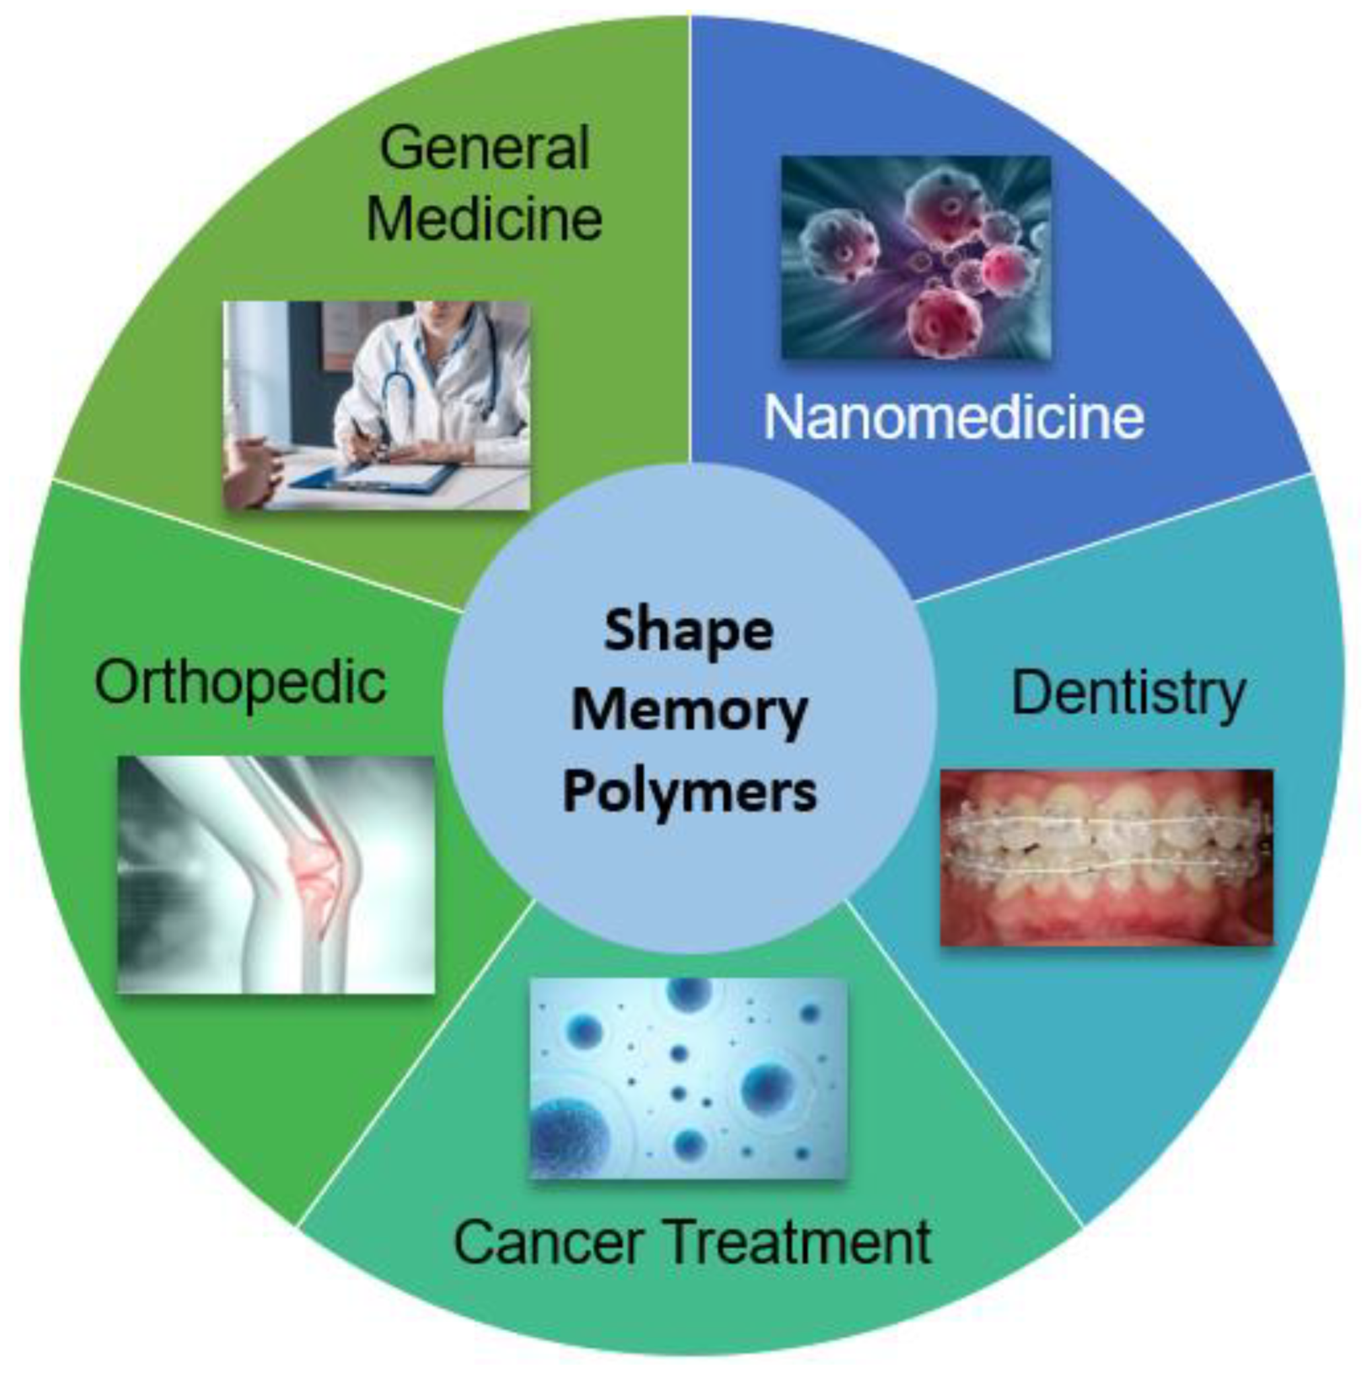
Figure 3: Application of Biomimetic nanomaterials in medicine

Biomimetic nanomaterials (BNMs) are functional materials containing nanoscale components and having structural and technological similarities to natural (biogenic) prototypes.BNMs with organic and porcelain structural elements that are magnetic, metal, or metal oxide, as well as their various combinations, were examined separately. The declared areas of application for the BNMs under consideration were examined, and they included bioimaging, magnetic and infrared hyperthermia, chemo- and immunotherapy, the creation of new drugs for specialized treatment, antibacterial and anti-inflammatory therapy, and tooth and bone reconstruction.[5]
A general classification of BNMs based on the purposes of reproduced BNMs and defined as materials with biomimetic structural elements for example, liposomes incorporating cell wall proteins, materials produced using biomimetic methods, for example, NPs grown using magnetosome-associated proteins, and materials containing biogenic components, i.e., so-called nanobio hydrides e.g., polymeric NPs coated with erythrocyte cell membranes.[6]

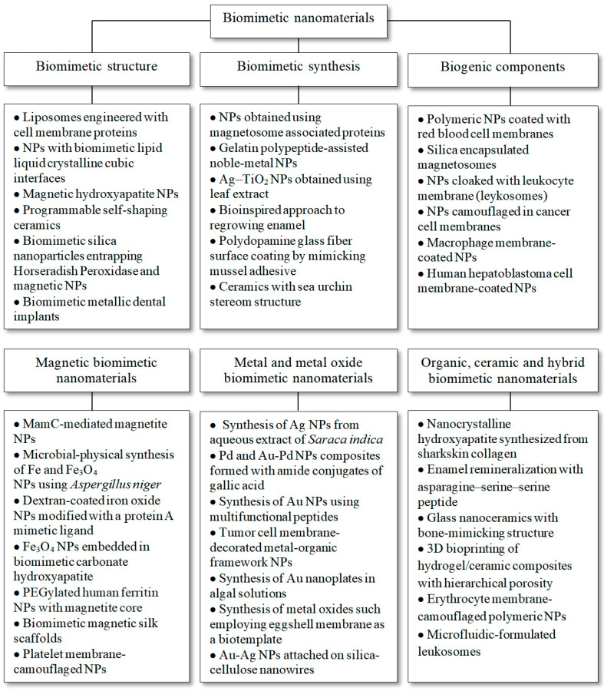
Figure 4: Classification of Biomimetic nanomaterials based on its structure,synthesis and biogenic components.[5]

Cutting-Edge Methods for Non-Invasive Disease Diagnosis Using Biomimetic Nanomaterials:

A. Dentistry:
- The topographical or chemical properties of conventional implant surfaces have been altered in recent years using a variety of techniques to enhance the implant material's adhesion to bone cells. By altering the surface of a titanium implant, it is possible to stimulate bone tissue, reduce the time it takes for osseointegration, and ensure that the implant and bone are properly transmitting occlusal mechanical loads. A titanium base with a nanostructured calcium phosphate coating obtained by introducing HAP ceramic particles into a plasma jet directed at the treated Ti surface can be used in dentures.[8]

B. Bioimaging for Diagnosis:
- Surface-enhanced Raman scattering nanoparticles, which generate a distinct "fingerprint" spectrum, can be used as contrast agents to demonstrate the precise locations of targeted cells in the body for cancer diagnosis.used a related brain tumor mouse model to image deep-seated glioblastoma multiforme tumors by combining surface-enhanced spatially offset resonance Raman spectroscopy (SERRS) with spatially offset Raman spectroscopy (SORS). The creation of SERRS nanostars from AuNPs is the foundation of this novel OI method. The cyclic RGDyK peptide, which can bind to integrin receptors on tumor cell surfaces to target integrins and detect glioblastoma, was used to functionalize the nanostars and encase them in a thin silicon shell. The limitations of conventional Raman spectroscopy-based imaging, which cannot detect tissues at depths greater than a few millimeters, are overcome by this imaging technique.[9]
- GSPIONs were made by mixing glycine with super-paramagnetic iron oxide nanoparticles (SPIONs) for non-invasive imaging and lung immune cell targeting. By neutrophils and alveolar macrophages only, the GSPIONs were taken up. The biodistribution of GSPIONs in the lung was then determined using three-dimensional ultrashort echo time MRI to identify disease. The GSPIONs have a hydrodynamic diameter of 84.19 18 nm, a particle size of 12.5 nm, and are simple to synthesize. These GSPIONs might offer a precise lung cancer diagnostic tool.[10]
- For the specific non-invasive diagnosis of prostate cancer with Prostate-specific membrane antigen (PSMA) receptor using MRI, a reversed-phase microemulsion technique is used to dope silicon with gadopentetic acid. Silica nanotube surfaces were modified with amino and carboxyl groups, and a monoclonal antibody to PSMA was subsequently conjugated using the carbodiimide method.[11]
- Hybrid metal oxide-peptide amphiphile micelles (HMO-Ms) through self-assembly for the MRI of thrombosis in atherosclerotic plaques by combining an inorganic magnetized iron oxide or manganese oxide core with an organic fibrin-targeted amphiphilic peptide. The vulnerable plaques could be found by the novel HMO-Ms. When compared to non-targeted HMO-Ms (NT-Fe-Ms and NT-Mn-Ms), the CREKA peptide functionalized hybrid nanoparticles' targeting ability to target blood clots was tested using MR signal enhancement and signal brightness intensities.[12]
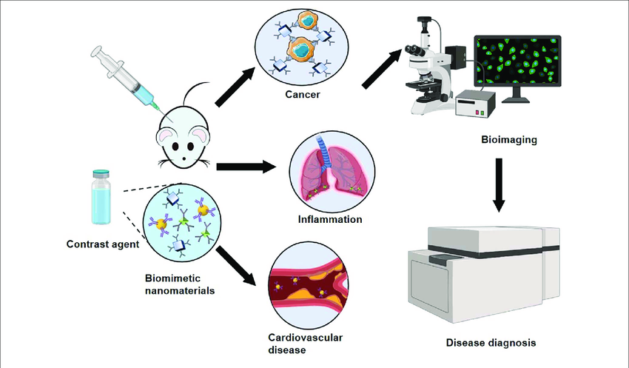

Figure 5: Schematic diagram of biomimetic nanomaterials applied to bioimaging
C. Biosensors:

- Malondialdehyde (MDA) is a biomarker for tissue damage hence, electrochemically polymerized dopamine can be obtained via the electrodeposition of the polymer chitosan (CS) onto the polymer dopamine (DA) on the surface of a glassy carbon electrode. Silver nanoparticle (AgNPs) covalently bound to POLY(DA-CS) membranes bind MDA biomarkers. The electrochemical signal was enhanced by AgNPs, and the excellent biocompatibility and stability of CS resulted in good electrode durability. The dynamic range of the electrochemical sensor was 1.45–7.9 μm, and the lower limit of quantification was 1.45 μm. The sensor could quickly and sensitively detect MDA in exhaled breath condensate (EBC) samples. This platform has the potential to be used to diagnose lung diseases.[13]
- A significant component of the outer membrane of Gram-negative bacteria is lipopolysaccharide (LPS). As a result, sepsis and urinary tract infections caused by Gram-negative bacteria can be detected using LPS as a biomarker. [14]
- A crucial neurotransmitter in the human body, dopamine is connected to Parkinson's disease. As a result, determining the body's dopamine content is crucial for making a Parkinson's disease diagnosis.a novel method based on surface-enhanced resonance Raman spectroscopy (SERRS) for the detection of dopamine levels. Using this technique, biomarkers at femtomolar concentrations could be determined. This method involves functionalizing AgNPs with iron-nitrilotriacetic acid, a common organic chelate that forms catechins with Fe, to capture dopamine which is then detected by SERRS.[15]
- The morbidity associated with cardiovascular diseases increases when cholesterol levels are excessively high. Therefore, non-invasive techniques for measuring cholesterol are important for the early detection and treatment of cardiovascular diseases.an enzyme-based electrochemical biosensor that uses platinum nanoclusters to immobilize the right amount of cholesterol oxidase in order to detect low cholesterol levels in saliva. Chronoamperometry was then used to calculate the cholesterol level. The biosensor had a linear range of 2-486 m, a detection limit of about 2 m, and a sensitivity of 132 A mm-1cm-2.[16]
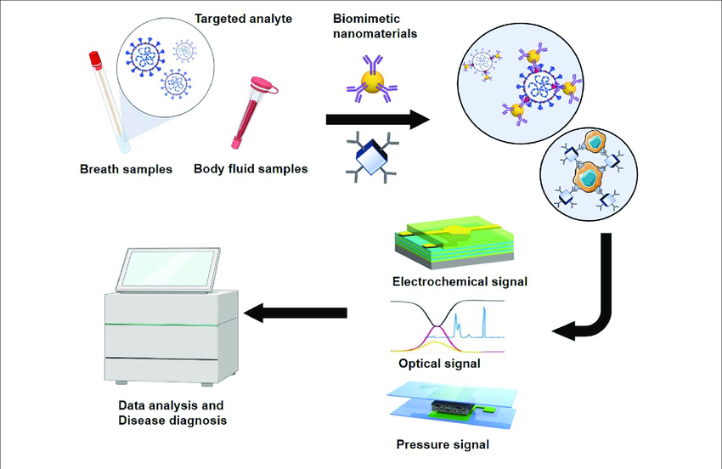
Figure 6: Schematic diagram of biomimetic nanomaterials applied to biosensors

D. Nanovaccines Using Biomimetic Immunomodulatory Materials

Biomimetic nanovaccines are developed by the simulation of the synthetic NPs with biologically derived materials, and the combination of both the synthetic and biological properties is the key factor to improve the therapeutic efficacy of the treatment. Biomimetic nanovaccines come in several varieties, such as liposomes, proteins, cell-membrane-coated NPs, and VLPs modified with antigens and adjuvants (shown in Figure) for the stimulation of immune responses in our body. Due to the presence of various cell membrane proteins and antibodies on the surface of nanovaccines, it is possible to quickly evade the immune system. Biomimetic surface engineering is an unusual approach towards developing current therapeutic actions.

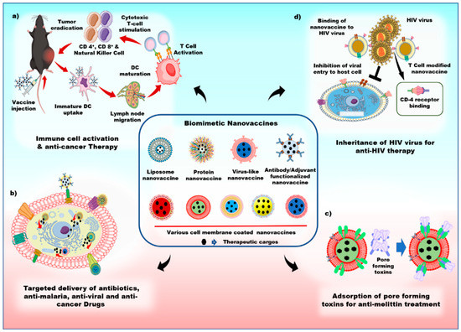
Figure 7: Schematics of the various applications of biomimetic nanovaccines

a) Biomimetic nanovaccines with adjuvants, antigens, and antibodies can trigger dendritic cell maturation and stimulate cytotoxic T-cell to induce a strong immune response against tumor.
b) biomimetic nanovaccines can actively target the cancer cell, and effectively deliver the therapeutic drugs.
c) biomimetic nanovaccines act as a natural substrate for the adsorption of pore-forming toxins, and
d) biomimetic nanovaccines can bind to human immunodeficiency virus (HIV) viruses with CD-4 receptors, and prevent the host cell from HIV virus infections.

Antibacterial Therapy: Due to the presence of immunogenic adjuvants and antigens, which express numerous pathogens associated with molecular patterns (PAMPs), bacterial membranes stimulate innate and adaptive immunity within the human body. NPs with bacterial membrane coatings are therefore thought of as potential vaccines for antibacterial therapy. For instance, a Neisseria meningitis vaccine that demonstrated a successful immune response against pathogens. [18]
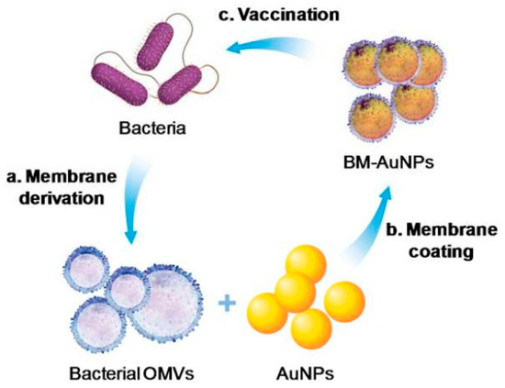
Figure 8: Schematic of antibacterial modulation via bacterial membrane-coated nanoparticles (NPs)[18]

Anti-Tumor Immunity: immunogenicity was triggered by the antigens contained in the liposomes. Antigens that were encapsulated or had their surface altered changed how T-cells responded and prompted CD4+ and CD8+ T-cells to attack the tumor. Effective vaccines, phosphatidylserine conjugated liposomes are largely taken up by antigen-presenting cells and are in charge of Th-cell proliferation.Cytosine-phosphorothioate-guanine (CpG)oligodeoxynucleotide- loaded Poly Lactic-co-Glycolic Acid (PLGA NP) coated with melanoma cancer cell membrane enhanced anti-tumor immunity and could be used as an antigen/adjuvant vaccination. The immune response was boosted by the cancer cell membrane's function as a tumor antigen. By altering the immune responses to cancer cells, this biomimetic nanovaccine stimulated the maturation of antigen-presenting cells and proinflammatory cytokines, such as interleukin-6 and interleukin-12 (IL-12).[19]

IV. ADVANCES IN REGENERATIVE MEDICINE AND TISSUE ENGINEERING:

A significant public health issue is the lack of available organs and tissue, which prevents many deserving patients from receiving transplants. Regenerative medicine holds great promise because of its potential to repair and replace organs and tissues that have been damaged. With the potential to even treat some congenital defects, regenerative biology has shown promising results for both the regeneration and replacement of a variety of tissues and organs, including skin, heart, kidney, and liver. The traditional practise of using donated tissues and organs for transplants has the drawback of a lack of available donors and the potential for immune system rejection of the donated body parts.
3D printing has been one of the most impressive technological developments of recent years. The printing of biological material directly onto cell-seeded scaffolds is of utmost importance. The process is known as 3D bioprinting. Tissue engineering, cell biology, and material science are just a few of the disciplines involved in 3D bioprinting. The correct placement of biological components, cells, and biomolecules like growth factors is necessary for successful bioprinting.The extracellular matrix (ECM) and the various cells found in various tissues must be accurately captured by 3D bioprinting in order to mimic human tissue. Additionally, each required tissue's blood vessels and nervous systems must be recapitulated by bioprinting.

- 3D Bioprinting:

The mixing of scaffolds and cells has been revolutionized by 3D bioprinting, which produces structures with some control over the placement of material and cells in grafts and constructs. Currently, inkjet, microextrusion, and laser-assisted printing techniques are used in 3D bioprinting. [20]
Understanding the composition and spatial organization of the components that make up the tissue or organ is necessary to mimic the complex nature of tissues and organs. Designing complex tissues and organs requires the use of information that is provided by noninvasive imaging technologies like MRI, CAD, and CT. The true volume of the tissue and organ under study can be seen using computed tomography, which displays slices of the tissue architecture. Nuclear magnetic resonance is used in MRIs, which are more effective at displaying improved contrast resolution. Using mathematical modeling techniques and computer-aided design and manufacturing (CAM-CAD), it is possible to create 3D models of tissue and organs. Computer-based models can also be used to predict significant properties like mechanical and biochemical characteristics. Today, it is also possible to create a simulation and structural design of a patient's own organ. Materials with biological origins can be printed using three main technologies. These include inkjet printing, also known as drop-on-demand printing, microextrusion printing, where a robot uses a microextrusion head to print onto the scaffold, and laser-assisted printing, in which bubbles are created under pressure by laser pulses and then sprayed onto the scaffold.[21]

1.Inkjet Bioprinting:
Inkjet printers, also known as drop-on-demand printers, have uses in both biological and nonbiological fields and have so far been utilized to regenerate healthy skin and cartilage.
Process: Liquid biological material is sprayed in large volumes with increased resolution, accuracy, and speed onto defined surfaces. Thermal or acoustic forces are used to eject liquids from the printer onto a scaffold or substrate, which is typically a component of the graft that will be implanted onto the tissue.
Types:
- Thermal inkjet printers release biological material onto the scaffold through heated print heads.[22]
- Acoustic waves are produced by piezoelectric crystals in acoustic printers. By changing the wave's amplitude and duration in the printer head, the size of the biological material droplet can be altered.
Advantages: Thermal inkjet printers are the cheapest of the three bioprinting techniques and are used widely. Inkjet printers are also compatible with many biological materials. It is very easy to control the size of the biological material droplet as well as the direction of ejection using acoustic inkjet printers
Disadvantages: The requirement to maintain a specific viscosity of the biological material being printed is one disadvantage of using inkjet printers. The printer head may become clogged above a certain viscosity. The total amount of cells included and printed is typically reduced to keep biological materials as liquids. High cell concentrations increase the likelihood of printer head clogging and endanger droplet formation. [24]

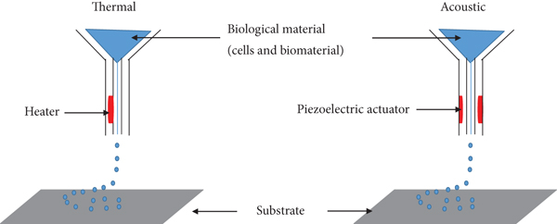
Figure 9 : Components for inkjet bioprinting. [22]

2.Microextrusion Bioprinting
A robot uses a microextrusion head to extrude biological material onto a scaffold or substrate. Here, biological material is continuously deposited onto the scaffold as instructed by CAM-CAD software in the form of tiny beads. Hydrogels and cellular spheroids are two biological materials that can be used with microextrusion printing.Several tissues have been fabricated using this technique including heart valves, vascular networks, and tumor models.
Process: Semi-solid extrusion (SSE) or fused deposition modeling (FDM) based 3D printing are the two mechanisms used in extrusion-based 3D bioprinting to achieve the desired outcome.
Pressurized air or rotating screw gears are used in SSE-based 3D bioprinting to extrude a continuous stream of semi-solid materials through a nozzle. These materials are then deposited one layer at a time to create a 3D structure.But in the FDM 3D bioprinting method, thermoplastic filaments are melted at high temperatures and then extruded through a nozzle to deposit in a layer-by-layer manner to create a 3D structure.
Types:
- In the pneumatic system, the biological material is forced out of a nozzle by compressed air at a rate predetermined.
- In the mechanical system, biological material is dispensed using a screw or piston.[24]
Advantages: Microextrusion bioprinters, as opposed to inkjet bioprinters, can successfully print complex polymers, cell spheroids, and substrates made of clay.The capability to print extremely high cell densities for tissue formation is another significant benefit of this method.
Disadvantages: The distortion of cellular structure and loss of cellular viability that result from the pressure used to expel the bioink are two of the main drawbacks of microextrusion bioprinting.

. 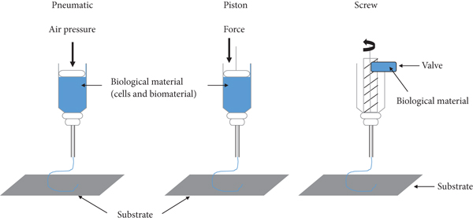
Figure 10: Pneumatic and mechanical (piston and screw) systems are used in microextrusion printers[25]
3.Laser-Assisted Bioprinting:
The process of depositing biomaterials onto a surface while using a laser as an energy source is known as laser-assisted bioprinting.A layer of biological material prepared in a liquid solution with a receiving substrate facing the projector, along with a ribbon with donor transport support, make up a laser-assisted bioprinter.The bioprinters move at a medium speed, and about 95% of the cells are still viable after the process.Laser-assisted bioprinting can be used to create human dermal fibroblasts, pulmonary artery endothelial cells, and breast cancer cells.
Process: The underlying concept behind laser-assisted bioprinting is to use a laser to force biomaterials forward onto a solid surface. The ribbon is exposed to laser light from the printer, which causes the liquid biomaterial to evaporate and droplets of it to travel to the receiving substrate. Biopolymers or a cell culture medium make up the receiving substrate, which promotes cellular adhesion and long-term growth of the biomaterial.[26]
Advantages: With its high level of accuracy and resolution, LAB is able to print bioinks with high viscosities (10-100 m) and densities up to 108 cells per milliliter without subjecting the cells to mechanical stress.
Disadvantages: A significant drawback of the method is the generation of metallic residues during printing that are present in the final bioprinted material. In addition, this approach is very expensive, though it is hoped that over time these costs will decline.[24]

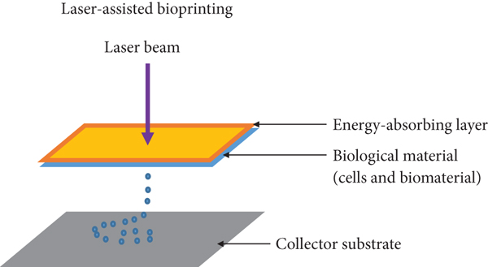
Figure 11: Laser-assisted printers are made up of a pulse laser beam which is focused on an absorbing substrate resulting in the generation of a pressure bubble that forces biological material onto the collector substrate.[26]

4.Stereolithography
The photopolymerization technique is used in the stereolithography (SLA) method of bioprinting. During this process, a UV light or laser is directed over a path of photopolymerizable liquid polymeric material, cross-linking the polymers to form a layer that is hardened.
Process:The foundation of stereolithography technology is the liquid photosensitive polymer's solidification in response to illumination.Light-sensitive polymer materials are polymerized using the technology, which regulates the light intensity using digital micromirror arrays. Layers are created as a result of the photochemical solidification of biopolymers, and these layers combine to create a 3D object.
Advantages:The most accurate fabrication method is stereolithography, which also allows for a wide range of material choices.This technique has a very quick speed (around 40,000 mm/s) and a cell viability of more than 90%.
Disadvantages: Instead of creating a smooth surface, layers sometimes create stair stepping. Moisture, heat, and chemicals all have an impact on tissue components and are finally limited to photosensitive resin.

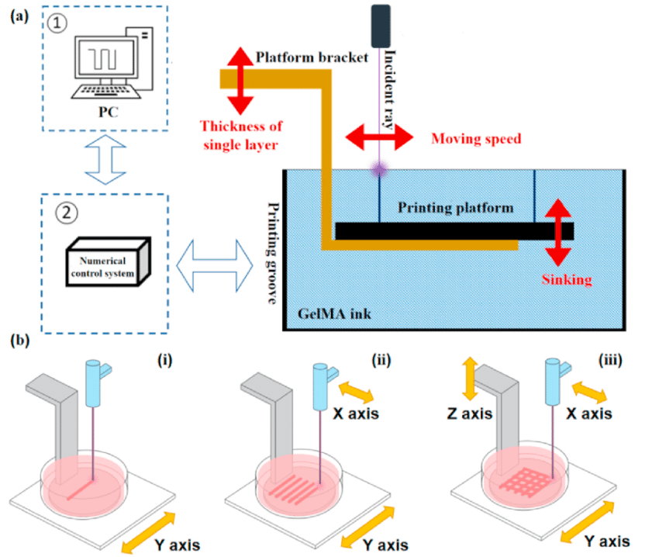

Figure 12: Design of the stereolithography bioprinting system.

(a) Diagram of the stereolithography bioprinting system. The photocrosslinkable hydrogel structure is formed by controlling the motion of the visible laser emitter and the printing platform;

(b) Fabrication of the stereolithography bioprinting system: (i) line forming, (ii) surface forming, and (iii) 3D structure forming[27].

Since its inception, 3D bioprinting has come a long way towards the objective of printing functional tissues. Despite obstacles, it has become abundantly clear from this early stage of research that bioprinting merits further study. The clinical potential of this technology will require more time, work, and multidisciplinary expertise, but the future is promising. The field of personalized regenerative medicine is poised to benefit greatly from bioprinting.

REFERENCES
- John D. Enderle,Susan M. Blanchard,Susan M. Blanchard,Joseph D. Bronzino(2005) “Introduction to biomedical engineering” 2nd ed.,Vol 1. Trinity College—Hartford, Connecticut,ISBN 0-12-238662-0.
- Frederik Nebeker,(2002)”Golden accomplishments in biomedical engineering”3rd ed.,doi: 10.1109/memb.2002.1016851.
- Bronzino, J.D.”,(2005) Biomedical Engineering Handbook”, 2nd Ed., CRC Press, Boca Raton, FL.
- Hobson D.W. Intracellular Delivery III,”The commercialization of medical nanotechnology for medical applications”pp. 405–449, 2016,Springer; Berlin/Heidelberg, Germany.
- Kamil G. Gareev, Denis S. Grouzdev,Veronika V. Koziaeva,Nikita O. Sitkov,Huile Gao,Tatiana M. Zimina,and Maxim Shevtsov(2022),”Biomimetic Nanomaterials: Diversity, Technology, and Biomedical Application”, Jul 20. doi: 10.3390/nano12142485.
- Sushnitha, M.Evangelopoulos, M.Tasciotti, E, Taraballi, F (2020). “Cell Membrane-Based Biomimetic Nanoparticles and the Immune System: Immunomodulatory Interactions to Therapeutic Applications'' Front. Bioeng. Biotechnol., 8, 627.
- Jin, K.; Luo, Z.; Zhang, B.; Pang, Z (2018).”Biomimetic nanoparticles for inflammation targeting”, Acta Pharm. Sin. B, 8, 23–33
- Le Guéhennec, L.; Soueidan, A.; Layrolle, P.; Amouriq, Y(2007)” Surface treatments of titanium dental implants for rapid osseointegration”, Dent. Mater., 23, 844–854.
- Nicolson, F., Andreiuk, B., Andreou, C., Hsu, H. T., Rudder, S., and Kircher, M. F. (2019 “ Non-invasive in vivo imaging of cancer using surface-enhanced spatially offset Raman spectroscopy (SESORS)” Theranostics 9, 5899–5913. doi: 10.7150/thno.36321
- Chakraborty, A., Royce, S. G., Selomulya, C., and Plebanski, M. (2020). “A novel approach for non-invasive lung imaging and targeting lung immune cells”. Int. J. Mol. Sci. 21:1613. doi: 10.3390/ijms21051613.
- Jiang, W., He, X., Fang, H., Zhou, X., Ran, H., and Guo, D. (2018) “Novel gadopentetic acid-doped silica nanoparticles conjugated with YPSMA-1 targeting prostate cancer for MR imaging: an in vitro study”. Biochem. Biophys. Res. Commun. 499, 202–208. doi: 10.1016/j.bbrc.2018.03.124.
- Poon, C., Gallo, J., Joo, J., Chang, T., Bañobre-López, M., and Chung, E. J. (2018). “Hybrid, metal oxide-peptide amphiphile micelles for molecular magnetic resonance imaging of atherosclerosis”. J. Nanobiotechnol. 16:92. doi: 10.1186/s12951-018-0420-8
- Hasanzadeh, M., Nahar, A. S., Hassanpour, S., Shadjou, N., Mokhtarzadeh, A., and Mohammadi, J. (2017). “Proline dehydrogenase-entrapped mesoporous magnetic silica nanomaterial for electrochemical biosensing of L-proline in biological fluids” Enzyme Microb. Technol. 105, 64–76. doi: 10.1016/j.enzmictec.2017.05.007
- Liu, T., Gao, L., Zhao, J., Cao, Y., Tang, Y., and Miao, P. (2018).” A polymyxin B-silver nanoparticle colloidal system and the application of lipopolysaccharide analysis”. Analyst 143, 1053–1058. doi: 10.1039/c7an01788j.
- Kaya, M., and Volkan, M. (2012). “New approach for the surface enhanced resonance Raman scattering (SERRS) detection of dopamine at picomolar (pM) levels in the presence of ascorbic acid”. Anal. Chem. 84, 7729–7735. doi: 10.1021/ac3010428.
- Eom, K. S., Lee, Y. J., Seo, H. W., Kang, J. Y., Shim, J. S., and Lee, S. H. (2020). Sensitive and non-invasive cholesterol determination in saliva via optimization of enzyme loading and platinum nano-cluster composition. Analyst 145, 908–916. doi: 10.1039/c9an01679a
- Veena vijayan,adithyanarayan mohanpatra,saji uthaman, In-kyu park(2019), “Recent Advances in Nanovaccines Using Biomimetic Immunomodulatory Materials”Pharmaceutics, 11(10), 534; https://doi.org/10.3390/pharmaceutics11100534
- Gao, W.; Fang, R.H.; Thamphiwatana, S.; Luk, B.T.; Li, J.; Angsantikul, P.; Zhang, Q.; Hu, C.M.J.; Zhang, L(2015) “Modulating antibacterial immunity via bacterial membrane-coated nanoparticles” Nano Lett., 15, 1403–1409.
- Kroll, A.V.; Fang, R.H.; Jiang, Y.; Zhou, J.; Wei, X.; Yu, C.L.; Gao, J.; Luk, B.T.; Dehaini, D.; Gao, W (2017) “Nanoparticulate delivery of cancer cell membrane elicits multiantigenic antitumor immunity.” Adv. Mater., 29, 1703969.
- Fan LiU,Xiaohong Wang,(2020) ”Synthetic Polymers for Organ 3D Printing“ Aug; 12(8): 1765, doi: 10.3390/polym12081765.
- Dey, Madhuri, and Ibrahim T Ozbolat.(2020) “3D bioprinting of cells, tissues and organs.” Scientific reports vol. 10,1 14023. 18 Aug. 2020, doi:10.1038/s41598-020-70086-y
- X. Cui, G. Gao, T. Yonezawa, and G. Dai,(2014) “Human cartilage tissue fabrication using three-dimensional inkjet printing technology,”Journal of Visualized Experiments, no. 88, article e51294,
- R. Jeurissen, A. van der Bos, H. Reinten et al.(2009), “Acoustic measurement of bubble size in an inkjet printhead,”The Journal of the Acoustical Society of America, vol. 126, no. 5,pp. 2184–2190,
- S. V. Murphy and A. Atala,(2014) “3D bioprinting of tissues and organs,”Nature Biotechnology, vol. 32, no. 8, pp. 773–785,.
- N. Hong, G. H. Yang, J. Lee, and G. Kim,(2018) “3D bioprinting and its in vivo applications,”Journal of Biomedical Materials Research Part B: Applied Biomaterials, vol. 106, no. 1,pp. 444–459,
- B. Hopp, T. Smausz, N. Kresz et al.(2005), “Survival and proliferative ability of various living cell types after laser-induced forward transfer,”Tissue Engineering, vol. 11, no. 11-12,pp. 1817–1823,
- Peng Zhang,Haoxuan Wang,Peng Wang,Yating Zheng,(2021) ”Lightweight 3D bioprinting with point by point photocuring”May 2021 Bioactive Materials 6(5):1402-1412,DOI:10.1016/j.bioactmat.2020.10.023

