SURFCAE MODIFICATIONS AIR COOLED FINS

Sreedhar Vulloju P.S Kishore
Vardhaman College of Engineering, Mechanical Enginnering, College of Engineering , Andhra University
Hyderabad,India Mechanical Engineering
Visakhapatnam,India
sreedharvulloju@gmail.com pskishore@gmail.com

ABSTRACT
One of the major problems which are being faced by two-wheeled automobiles is Engine overheating but this can be reduced by providing effective cooling. The purpose of this work is to improve the efficiency of the fins by bringing up some surface modifications on the existing fin. The modification is about, coating pure copper on the existing aluminium fin as the thermal conductivity of pure copper is much higher than aluminium. The process used to coat pure copper on aluminium is Thermal Spray Process. Three different specimen were manufactured with different copper coating thicknesses. Later they were analysed in Pin-Fin apparatus to evaluate their efficiency. The results obtained were satisfactory with a raise in efficiency of 5%.
Keywords: Aluminium fin, coated with Copper, Thermal Spray Coating, Fin efficiency.

I.INTRODUCTION

Being a mechanical engineer, continuous thrive in the field of Automobiles has been our primary concern. Two-wheeler motorbikes are being used as the major transportation in India which faces extreme heating conditions due to the engine combustion and scalding atmospheric conditions. Fins are used to cool the engine which is being made up with Aluminium with obscure usage of copper in it. Before we took up this work inchoate work has been done on copper coating on Aluminium. Our pragmatic application of this concept on fins was idealized in our minds during our heat transfer laboratory sessions. When it was arduous to acquire the information regarding this, “HEAT TRANSFER” textbook by J.P Holman and Souvik Battacharya was helpful to understand the basic principles related to this and “Heat and Mass Transfer Data Book” by CP Kothandaraman and S Subranamyan placed a vital role in making our thoughts profound into the concepts. Finally, an ASME journal of “Thermal resistance analysis of High power LED using Aluminium Nitride Thin film­ coated copper substrates as Heat Sink” and research article on “Air cooling effect of fins on a Honda shine bike” were like a key to get our project objective accomplished. We ameliorated the efficiency of the fin using copper coating on Aluminium fin which will have a massive impact on fins application. We anticipate future automobile companies using our sophisticated approach of coating on fins which was never existed before.
.

II.DESIGN OF FIN

Design Considerations:

    - Thread of the fin has been designed with the 1.5 mm of pitch to get it fitted with pin fin apparatus.
    - Dimensions of the fin are closely designed with the actual fins which are been used for two wheeler motorbikes.
    - Three holes are designed at equal distances for the placement of thermocouples.

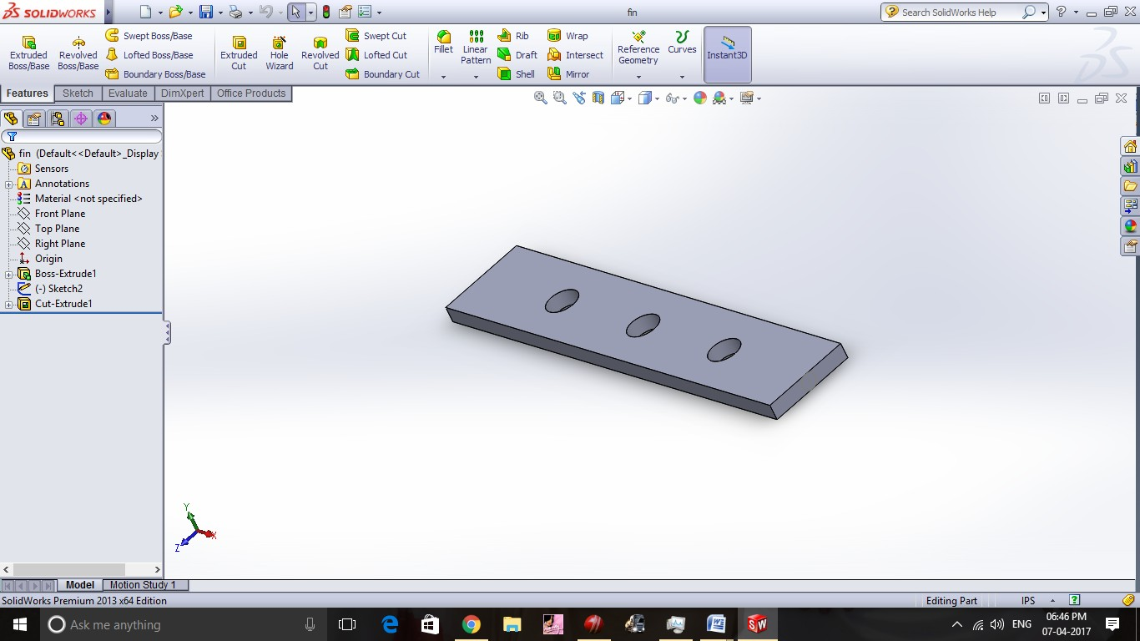

Figure 1: Creating fin using SOLIDWORKS
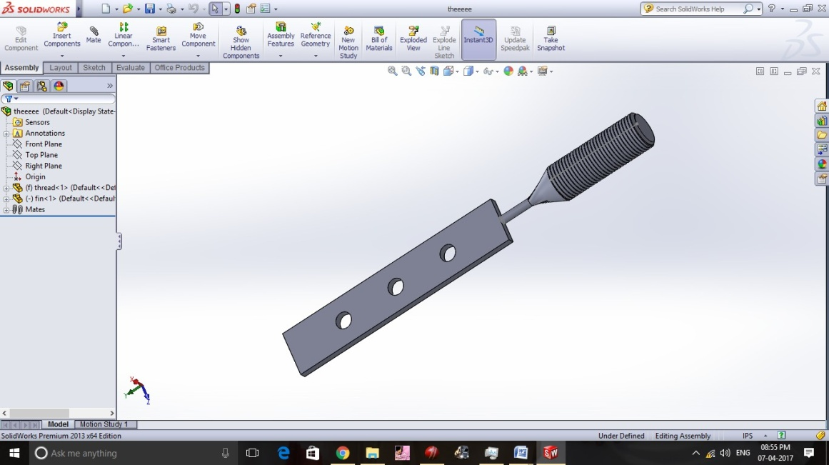

Figure 2. Fin isometric view

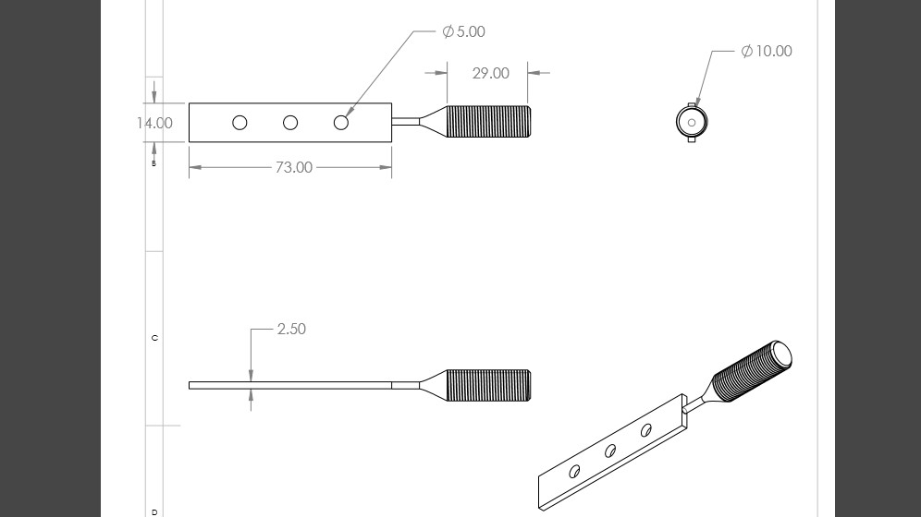

Figure 3:.Draft Sheet of Fin

A. Applications of Fins
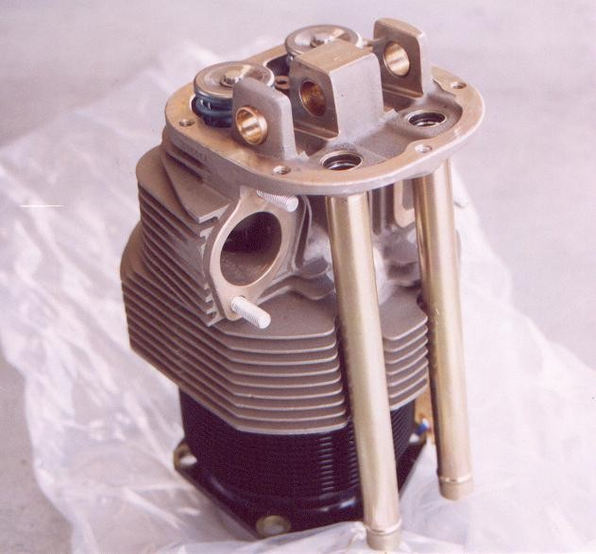
Figure. 4: Air cooled aviation engines

Figure 5:.Heavy weight two wheelers

MANUFACTURING

Step 1:

Fin Manufacturing Procedure

Plain turning:

    - We have taken a square aluminium block of length 107mm and sides 14mm.
    - In plain turning we have utilized 4 jaw chuck to hold the aluminium block.
    - And performed plain turning operation for length 29mm.
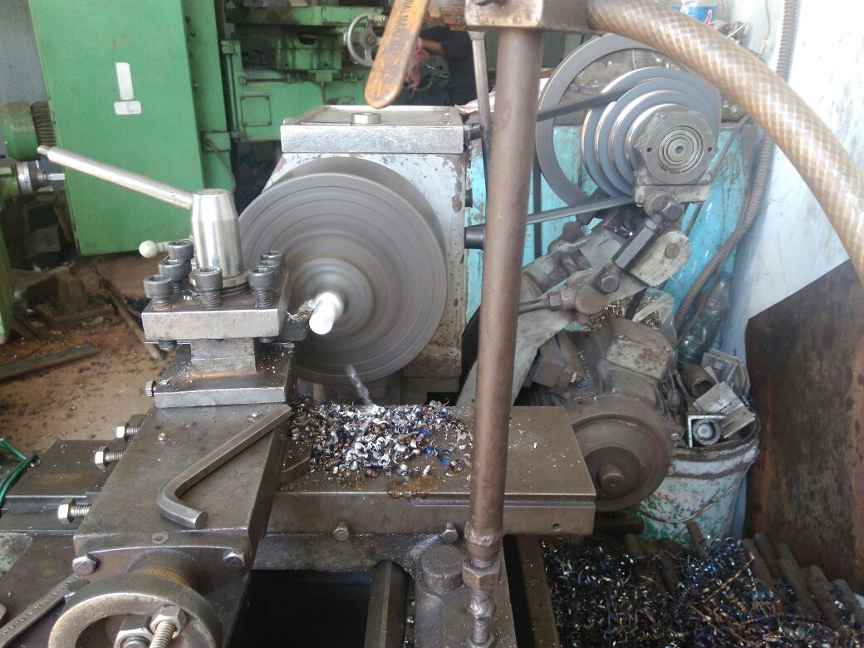

Figure 6:Threading on Lathe

Step 2:

Threading:

- We have performed threading operation on the cylindrical surface.
- And we have achieved threading of pitch 1.5mm.
- This threading portion is inserted into the jig of pin­fin apparatus.
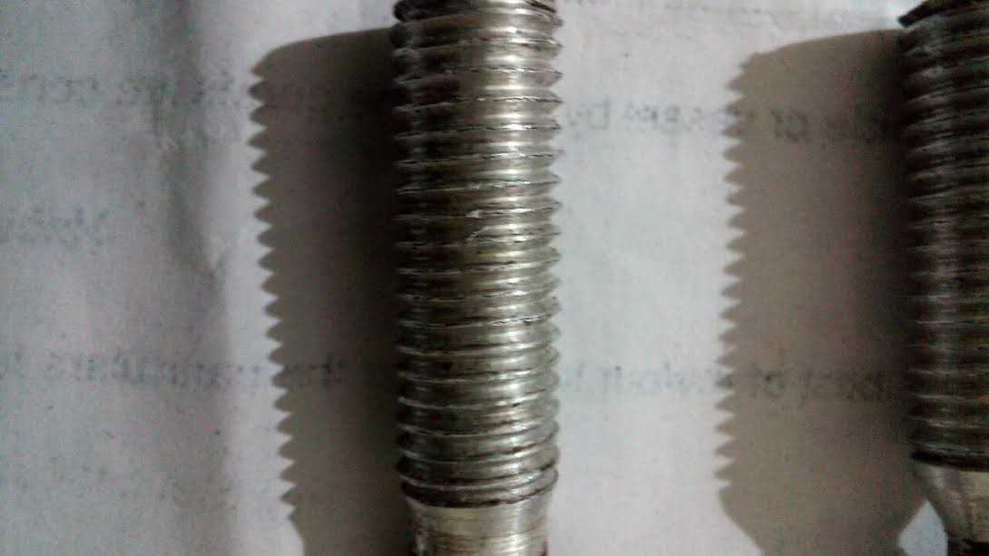
Figure 7: After Threading

Step 3:

Face milling:

- We have utilized face milling operation to produce 2.5mm thick surface.
- We have performed face milling operation for length 73mm.
- As we have to produce 2.5mm thick surface we have utilized face milling as it removes very small layers. And have good surface finish .
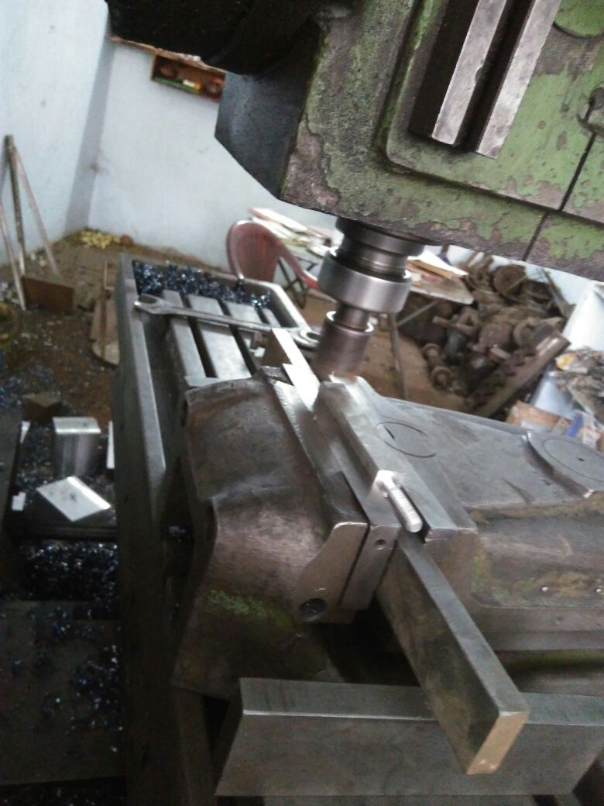
Figure 8:.Face Milling Process

Step 4:

Tapping
- We have produced 3 holes (equally spaced) on 73mm plain surface using drill bit.
- And we have done tapping to that hole of 5mm diameter and pitch 1.5mm.
- The reason for doing this holes is to hold thermocouples which are utilized in pin­fin apparatus.
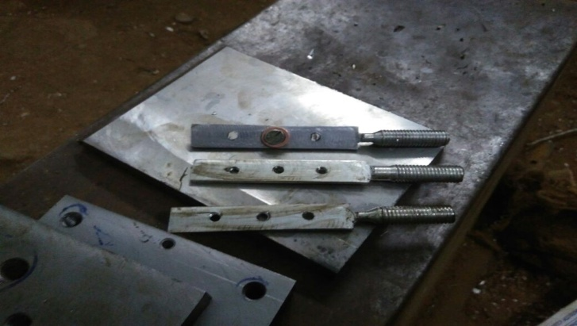
Figure 9:.Aluminum Fins after Tapping

IV. THERMAL SPRAY PROCESS

Thermal spraying process is a coating technique where the substrate is heated and then coated onto the material.
Copper can be coated on to Aluminum using many ways .Out of which thermal spraying process is one of the effective method to coat pure copper onto aluminum.
Thermal spray is defined as “...applying these coatings takes place by means of special devices / systems through which melted or molten spray material is propelled at high speed onto a cleaned and prepared component surface...” This definition does not sufficiently describe the thermal spray process.
The coating feedstock material is melted by a heat source. This liquid or molten material is then propelled by process gases and sprayed onto a base material, where it solidifies and forms a solid layer.
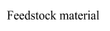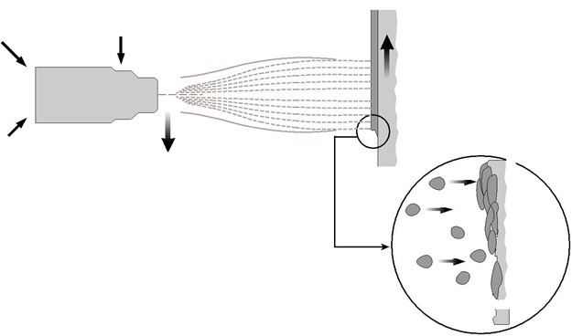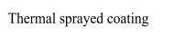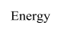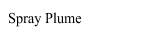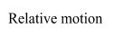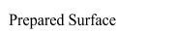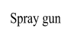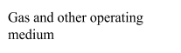

Figure 10:Principle of thermal spraying

A. Substrate Materials
Suitable substrate materials are those that can withstand blasting procedures to roughen the surface, generally having a surface hardness of about 55 HRC or lower. Special processing techniques are required to prepare substrates with higher hardness. Because the adhesion of the coating to the substrate predominantly consists of mechanical bonding, careful cleaning and pretreatment of the surface to be coated is extremely important.
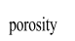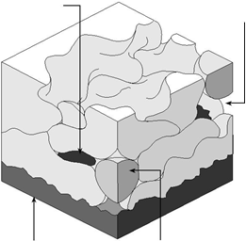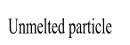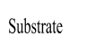After the removal of surface impurities by chemical or mechanical methods, the surface is usually roughened using a blasting procedure. This activates the surface by increasing the free surface energy and also offers the benefit of increased surface area for bonding of the sprayed particles. The liquid or molten coating particles impact the surface at high speed. Adhesion of the coating is therefore based on mechanical “hooking”.Surface roughening usually takes place via grit blasting with dry corundum.

oxide particle

Figure 11: Schematic diagram of a thermal sprayed coating

B. Coating Material

In principle, any material that does not decompose as it is melted can be used as a thermal spray coating material. Depending on the thermal spray process, the coating material can be in wire or powder form.In below table, some of the most frequently used classes of materials are listed, along with a typical example, characteristics and sample applications. Choosing a coating material that is suitable for a specific application requires special knowledge about the service environment as well as knowledge about the materials.
Table 1: Common classes of thermal spray powder materials
Material Class | Typical Alloy | Characteristics | Example Application
Pure metals | Zn | Corrosion protection | Bridge construction
Self­fluxing alloys | FeNiBSi | High hardness, fused minimal porosity | Shafts, bearings
Steel | Fe 13Cr | Economical, wear resistance | Repair
MCrAlY | NiCrAlY | High temperature corrosion resistance | Gas turbine blades
Nickel­graphite | Ni 25C | Anti­fretting | Compressor inlet ducts
Oxides | Al2O3 | Oxidation resistance, high hardness | Textile industry
Carbides | WC 12Co | Wear resistance | Shafts

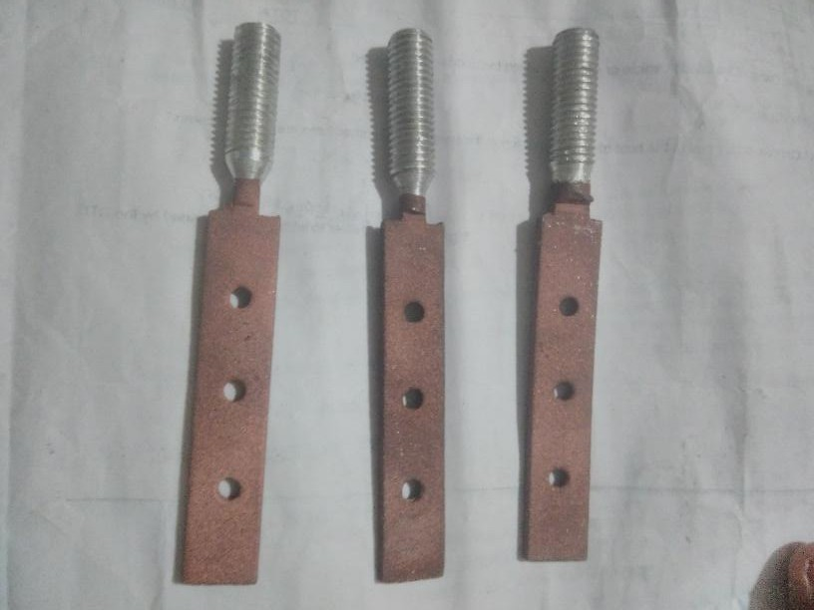
Figure 12: Aluminum fins after coating

V. PIN-FIN APPARATUS

A. Description of apparatus:

    - The apparatus consists of M.S fin of circular cross­sectional fitted across one end of a long rectangular duct. The other end of duct is conducted to suction side of blower and the air flow pass the perpendicular to its axis.
    - The temperature of five thermocouples connected along the length of fin is measured by digital temperature indicator. The airflow is measured by an orifice meter fitted on the delivery side of blower.

B. Specifications:

    - Duct size =150mm*100mm*700mm with bell mouth entry.
    - Diameter of fin =12.7mm.
    - Diameter of orifice =14mm.
    - Diameter of delivery pipe ID =28mm.
    - Coefficient of discharge C_{d} =0.64.
    - Number of thermocouples on fin =3.
    - Air blower: 0.24 HP, 2800 rpm, 180 watts.
    - Digital temperature indicator­ Range: 0­200ºC.
    - Digital voltmeter­ Range: 0­200 V AC.
    - Digital ammeter –Range: 0­2 Amp AC.
    - Dimmerstat : open type ­0­2 Amp, 0­230 V, wire wound.
    - Heater: size 38mm Diameter* 50mm length, Capacity­ 250 Watt.
    - Number of pin provided = 4
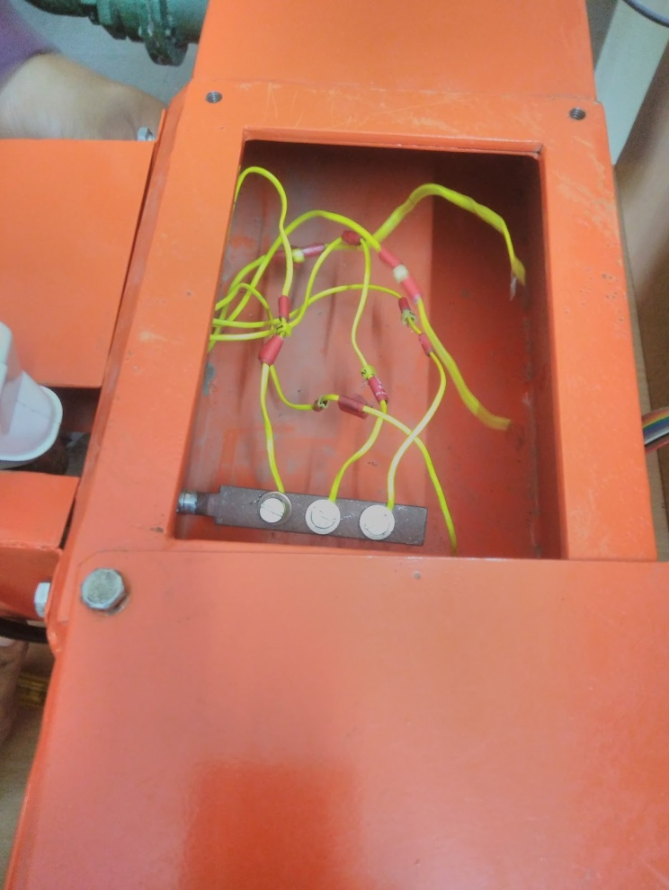

Figure 13: Installing fin onto Pin­Fin Apparatus
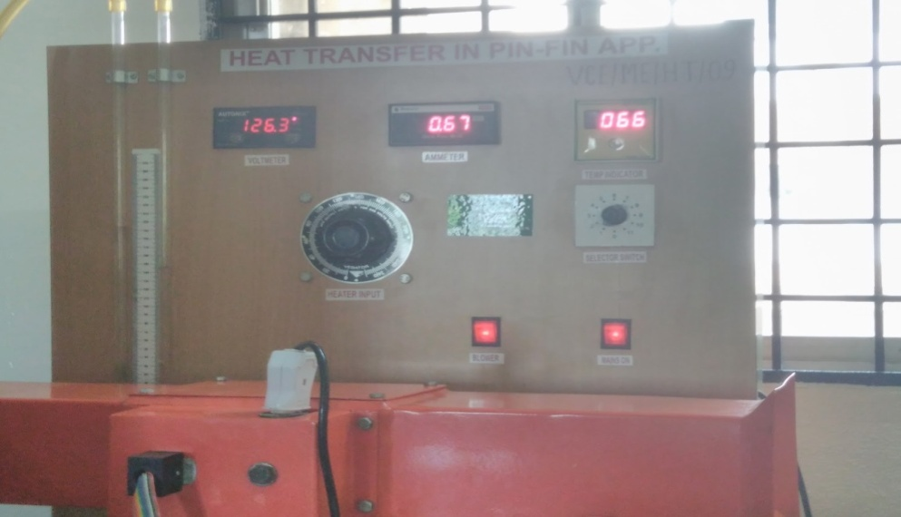
Figure 14:. Pin­Fin Apparatus

VI. RESULTS AND DISCUSSIONS

A. Thermal Conductivity of Copper:

The thermal conductivity of copper varies with temperatures. The highest value of thermal conductivity for copper is 24900 W/m­K which occurs at 9K and lowest is 339 W/m­K, occurs at 1500K. But the operating conditions in Pin­Fin apparatus are around one atm,
Thermal conductivity(W/m­K) | Temperature(K)
406 | 350
401 | 300
396 | 350

From Lagrange’s interpolation formula

K(T) =
(T −T 1 )(T −T 2 ) (T 0 −T 1 )(T 0 −T 2 )
× K0 +
(T −T 0 )(T −T 2 ) (T 1 −T 0 )(T 1 −T 2 )
× K1 +
(T −T 0 )(T −T 1 ) (T 2 −T 0 )(T 2 −T 1 )
× K2

⇒ K(333) = ­ 33×17 × 406 +
5000
2500
83×17 × 401 +
83×17
5000
× 396

⇒ K(333) = 398 W/m­K

B.Analyzing pure Aluminum alloy Fin:

Specifications:
Material: Aluminum 6063 alloy Dimensions: 73mm × 14mm × 2.6mm Thermal Conductivity: 200 W/m­K
When this Aluminum Fin was analysed in Pin­Fin Apparatus under steady state conditions, the following readings were obtained…
Table 2: Aluminum Fin without Coating
S.No | Voltage (V) | Current (Amps) | Manometer reading ( h1 − h2 ) (mm) | T 1 | T 2 | T 3 | Duct Temperature ( T 6 )
1 | 120 | 0.63 | 194­147=47 | 51 | 50 | 48 | 33
2 | 120 | 0.63 | 47 | 52 | 51 | 49 | 33
3 | 120 | 0.63 | 47 | 55 | 53 | 51 | 34
4 | 120 | 0.63 | 47 | 55 | 53 | 51 | 34

C. Analyzing Aluminium Fin (copper coating 150µm)

Specifications:

Material: Aluminum 6063 alloy with copper coating. Coating thickness: 150µm
Dimensions: 73mm × 14mm × 2.75mm

When the aluminium fin with 150 microns as copper coating was analysed in Pin­Fin apparatus, the temperature readings obtained were higher than that of pure aluminium fin. This may be due to the effect of copper coating that increased the heat flow from the heater to the fin’s surface. The table in the next page shows the readings of the current fin.

Table 3: Aluminum Fin with Coating(150 Micron)
S.No | Voltage (V) | Current (Amps) | Manometer reading ( h1 − h2 ) (mm) | T 1 | T 2 | T 3 | Duct Temperature ( T 6 )
1 | 120 | 0.63 | 194­147=47 | 59 | 56 | 54 | 35
2 | 120 | 0.63 | 47 | 63 | 50 | 57 | 35
3 | 120 | 0.63 | 47 | 66 | 63 | 59 | 35
4 | 120 | 0.63 | 47 | 68 | 65 | 62 | 36
5 | 120 | 0.63 | 47 | 69 | 65 | 62 | 36
6 | 120 | 0.63 | 47 | 70 | 66 | 63 | 37
7 | 120 | 0.63 | 47 | 70 | 66 | 63 | 37

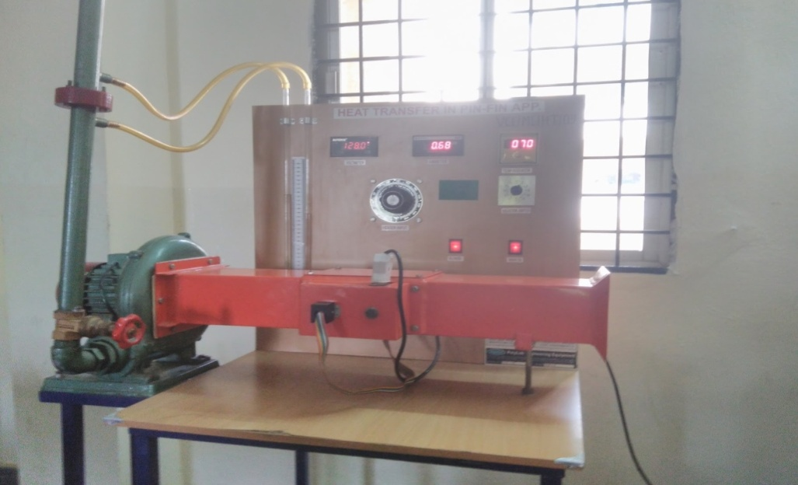
Figure 15:. Steady state condition of modified aluminium fin (150 microns)
D. Analyzing Aluminium Fin (copper coating of 350µm)

Specifications:

Material: Aluminum 6063 alloy with copper coating. Coating thickness: 350µm
Dimensions: 73mm × 14mm × 3.1mm

When this Aluminum fin was analysed in Pin­Fin Apparatus under steady state conditions, the following readings were obtained…
Table 4: Aluminum Fin with Coating(350 Micron)
S.No | Voltage (V) | Current (Amps) | Manometer reading ( h1 − h2 ) (mm) | T 1 | T 2 | T 3 | Duct Temperature ( T 6 )
1 | 120 | 0.63 | 194­147=47 | 60 | 57 | 55 | 36
2 | 120 | 0.63 | 47 | 32 | 59 | 57 | 37
3 | 120 | 0.63 | 47 | 64 | 61 | 58 | 37
4 | 120 | 0.63 | 47 | 64 | 61 | 59 | 38
5 | 120 | 0.63 | 47 | 64 | 61 | 59 | 38

E. Analyzing Aluminium Fin (copper coating of 550µm)

Specifications:

Material: Aluminum 6063 alloy with copper coating. Coating thickness: 550µm
Dimensions: 73mm × 14mm × 3.35mm

When this Aluminum Fin (550 microns copper coat) was analysed in Pin­Fin Apparatus under steady state conditions, the following readings were obtained.
Table 5: Aluminum Fin with Coating(550 Micron)
S.No | Voltage (V) | Current (Amps) | Manometer reading ( h1 − h2 ) (mm) | T 1 | T 2 | T 3 | Duct Temperature ( T 6 )
1 | 120 | 0.63 | 194­147=47 | 62 | 57 | 55 | 36
2 | 120 | 0.63 | 47 | 65 | 59 | 57 | 36
3 | 120 | 0.63 | 47 | 66 | 60 | 58 | 37
4 | 120 | 0.63 | 47 | 67 | 61 | 59 | 37
5 | 120 | 0.63 | 47 | 68 | 32 | 60 | 38
6 | 120 | 0.63 | 47 | 60 | 56 | 54 | 39
7 | 120 | 0.63 | 47 | 60 | 56 | 55 | 39

Table 6:Result Table
Aluminium fin with different coating thickness and without coating were considered as sample fin on which experiments were conducted at different heat inputs aid of Fin Pin apparatus and noted necessary inputs and calculated fin efficiency and effectiveness as shown in the below table.
S.No | Fin material | Coating Thickness | Efficiency of Fin | Effectiveness
1 | Aluminium | Without Coating | 88.2% | 13.9
2 | Aluminium coated with Cu | 150 microns | 89.7% | 14.4
3 | Aluminium coated with Cu | 350 microns | 91.3% | 15.4
4 | Aluminium coated with Cu | 550 microns | 93% | 16

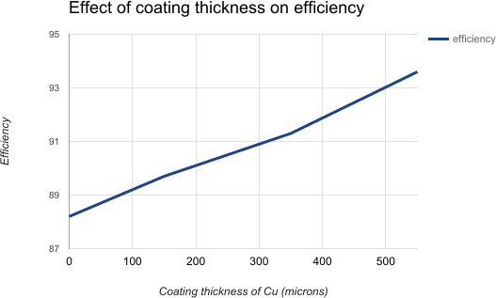

Figure16:. Plot between efficiency and coating thickness
We observed that fin efficiency of Aluminium fin without coating is obtained as 88.2% and its effectiveness as 13.2. Result table and graph shows that fin efficiency and effectiveness are depended on coating thickness.
The Copper coating on Aluminum has recommendable remark with compared without coating on efficiency as shown in the fig.

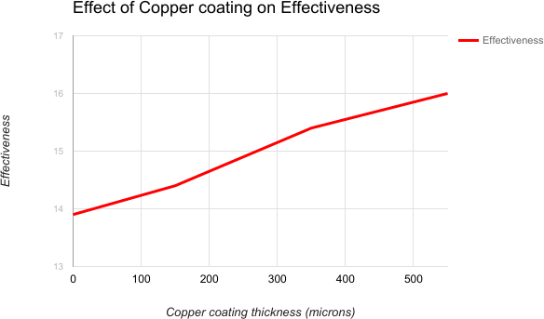

Figure 17: Plot between effectiveness and coating thickness

It is said that the effectiveness of fin without coating is low compared with copper coating as shown in the fig. Effectiveness is obtained as 13.9 in case of without coating and its value increases with increasing coating thickness. Maximum effectiveness is observed as 16 in case of Aluminum fin coated with Copper and with thickness of 550 micron.

When these four fins are analysed under steady state conditions in Pin­Fin apparatus, there is considerable raise in efficiency and effectiveness from the fin with no copper coating to the fin with with copper coating of thickness 550 microns. So, coating the existing fin with copper has shown a positive effect in air­cooling system.

The parameter which is crucial for increasing efficiency is ‘m’. As ‘m’ is inversely proportional to efficiency, the reduction in ‘m’ value with coating thickness made to obtain increasing efficiencies of the fins. The other main parameter which brought changes from modified fin to existing fin is the effective thermal conductivity. The effective thermal conductivity is higher for fin with maximum copper thickness i.e., 550 microns.

VIII. CONCLUSIONS

The aluminum fin with 550 microns copper coating produced efficiency of 93%. But the existing pure aluminum alloy fin has efficiency of only 88%. Hence this type of surface modification can be applied in areas like where effective cooling is required especially in heavy duty motor vehicles, aviation engines as our analysed specimen were close to the real time dimensions of fins. There is a difference of about 5% in the efficiency of existing and modified fin, but this can cause greater impact when more number of fins are used. Because no single fin is used for cooling purpose. The other advantage of using this modification is the production and operating costs for Thermal Spray Process are reasonable.

REFERENCES

[1].“HEAT TRANSFER” textbook by J.P Holman and Souvik Battacharya.
[2].ASME journal “Thermal resistance analysis of High power LED using Aluminum Nitride Thin film­ coated copper substrates as Heat Sink.”
[3].“HEAT AND MASS TRANSFER DATA BOOK” by CP Kothandaraman and Subranamyan
[4].Research article on “Air cooling effect of fins on a Honda shine bike”
[5].http://www.ijera.com/papers/Vol5_issue5/Part%20­%203/O505038292.pdf
[6].Altas Steels Aluminum 6063 Data sheet
[7].Textbook “Heat and Mass Transfer” by Yunus A. Cengel.

