Synthesis, spectral characterization, Insilco molecular docking and in-vitro antimicrobial studies of 5-(4-substituted phenyl)-3-(thiophen-2-yl)-4, 5-dihydropyrazole-1-carbothoamide derivatives
¹A. A. Jafeena , ^{1*}M.R.Ezhilarasi and ²M.Suganthi
1. PG Student, Dr.N.G.P.Arts and Science College, Coimbatore -641 048, Tamil Nadu, India
1* & 2. Assistant Professor, Dr.N.G.P.Arts and Science College, Coimbatore -641 048, Tamil Nadu, India
Email id: mrezhilarasi@gmail.com & skaamindan@gmail.com

Abstract:
A new series of pyrimidines were synthesized and characterized by melting point, FT-IR, one-dimensional ¹H and ¹³C NMR spectroscopic data. All the synthesized compounds were tested for their in vitro antibacterial and antifungal activities. The zone of inhibition tested for the same compound against the set of bacterial and fungal strains shows that the compound 2a against S.Aureus, S.Pyogenes, E.Coli, 4b against P.Aeruginosa has excellent antibacterial activity. Compound 2c shows inhibition against C.albicans. Also in-silico molecular docking predictions were carried for all the compounds. The docking studies were examined by proteins like Bacterial protein 1UAG. The results of the compounds have good docking score compared with the standard drug.
Keywords: Substituted acetophenone, thiphene-2-carbaldehyde, antimicrobial activity, molecular docking, 1UAG.
1. INTRODUCTION:
In the present days a wide range of microorganisms including bacteria, viruses, protozoa and fungi are becoming resistant to drugs that are used to treat infections. This resistance is a major hurdle to treatment of infectious diseases worldwide [1].Microbial infections are a growing problem in contemporary medicine and the use of antibiotics is common across the world. Accordingly, there is an urgent need to widen antimicrobial agents, which have a broad spectrum of activity against the resistant microorganism [2].Therefore it is necessary to have microbial agents with improved potency. There has been a growing pertaining to synthesis of bioactive compounds in the field of organic chemistry. Among nitrogen containing heterocyclic compounds; pyrimidines apparently gained considerable importance owing to their varied biological properties and therapeutically importance. Pyrimidines are the basic nucleus in nucleic acids and have been associated with a number of biological activities. Substituted aminopyrimidine nuclei are common in marketed drugs such as anti-atheroscletic aronixil , anti-histaminic thonzylamine, antianxielytic buspirone, antihypertensive minoxidil and prazosin, anti-psoriatic enazadrem,and other medically relevant compounds. Some notable biological activity of Pyrimidine derivatives includes adenosine receptor antagonists[3], kinase inhibitors[4], analgesic[5], anti-inflammatory[5],inhibitors of cyclin-dependent kinase 1 and 2[6],calcium channel antagonist[7], anti-histaminic[8] and antitubercular[9] activities. Promising diverse pharmacological activities were shown by various N-functionalized morpholines. They were reportedto exert a number of important physiological activities such asantidiabetic[10], antiemetic[11],platelet aggregation inhibitors, anti-hypeelipoproteinemics[10] bronchodilators, growth stimulants [12] and antidepressants’[13]. These were also used in the treatment of inflammatory diseases, pain, migraine and asthma [14].Tridemorph, morpholine derivatives was used as an antifungal agent [15].4-Phenyl morpholine derivatives were reported to possess anti-inflammatory [16] and central nervous system [17] activities. It was known from Scheme 1 that some clinically useful compounds containing pyrimidines moiety exhibit strong tuber-culosis(A) and antimicrobial activity(B). Besides, some of the clinically important drugs contain morpholine moiety in addition to N-heterocycles which are separated one or more carbon atoms. Drugs derived from morpholine incorporated compounds include dextromoramide, (C) a narcotic analgesic and doxapram HCl, (D) a respiratory stimulant. Doxapram used in the treatment of respiratory depression following anaesthesia[18]. Minoxidil[E] was a very good antihypertensive vasodilator and treatment of hair growth for men and women and was marketed under the trade name of Rogaine.

Scheme- 1: Some of the synthetic compounds having the core pyrimidine and morpholine nuclei with therapeutic activities
Structure based drug designing (SBDD) and Ligand based drug designing (LBDD) techniques are employed as important drug discovery tools in rational drug designing process [19]. Molecular docking is the advanced computational used techniques in SBDD to obtain optimized conformation of Ligand-receptor interaction and to study their relative orientation through the minimized energy free system [20]. Computer aided drug designing (CADD) is fast, economical modernized technique that gives valuable, accurate and deep understandings of experimental findings and new suggestions for molecular structures to be synthesized [21]. In continuation of our interest in synthesizing structurally diverse biologically active heterocycles [22-27], we report now the synthesis of pyrimidine derivatives and the biological and insilico studies.
2. EXPERIMENTAL METHOD
2.1. MATERIALS AND METHODS:
All chemical were purchased from sigma Aldrich INDIA. The melting points of the compounds determined using open capillary method. TLC has been checked for formation of compounds regularly and spots were seen by iodine. FT-IR spectra were taken as neat for liquid compounds and as KBr pellets for solids on a Shimadzu spectrum RXI FT-IR.
2.2. PREPARATION OF TLC PLATES& COLUMN CHROMATOGRAPHY:
Analytical TLC was performed on precoated silica gel (Merck, Germany). Silica gel G. 30g was dispersed in 100ml of water. The resulted homogenous solution was applied on glass plates using an applicator. The plates were allowed to dry in air for 3 hours and activated in an oven for one hour before use. Column chromatography was performed on silica gel (60-120 mesh. Merck, India).
2.3. EQUIPMENTS AND ANALYTICAL INSTRUMENTS:
Melting points were determined in open capillary tubes and are uncorrected. FT-IR-8400 instrument is using for IR spectra. The uncorrected IR was recorded on a Shimadzu and Perkin Elmer transform spectrometer. Bruker Avance 400 NMR instrument was using for ¹H NMR spectra and Bruker Avance 400 NMR instrument using for ¹³C NMR spectra.
2.4. PERCENTAGE OF THE PRODUCT:
All the synthesized compounds were purified by recrystallization procedures. The purity of the compound was checked by TLC method. The percentage of yield of the compounds was calculated as follows.
2.5. GENERAL PROCEDURE FOR THE SYNTHESIS OF CHALCONE DERIVATIVES: (1a-1c)
One mole of thiophen-2-carbaldehyde and one mole of various substituted acetophenone were taken in a beaker and to this approximately added 30ml of ethanol containing 2g of NaOH pellets. Then the mixture was stirred well for 30 minutes in an ice cold bath, after it was poured into the crushed ice containing 500ml beaker and this reaction mixture was kept into overnight at room temperature. The chalcones was precipitated out as solid. Then it was filtered, dried and recrystallized from ethanol. The purity of the compound was checked by TLC by using CHCl₃ as a solvent.
2.6. General PROCEDURE FOR THE SYNTHESIS OF 5-(4-SUBSTITUTED PHENYL)-3-(THIOPHEN-2-YL)-4, 5-DIHYDROPYRAZOLE-1-CARBOTHIOAMIDE DERIVATIVES: (2a-2c)
A various mixture of chalcone (0.001mol) in ethanol (40 ml) was added thiosemicarbazide (0.001 mmol) and 2 ml of 2% sodium hydroxide solution was added. Then the reaction mixture was heated under refluxed for 16 hours. After completion of the reaction, then it was poured into crushed ice and kept into overnight at room temperature. Then it was filtered, dried and recrystallized from ethanol. The purity of the compound was checked by TLC and CHCl₃ used as a solvent.
2.7. ANTIMICROBIAL ACTIVITY ASSAY
Synthesized compounds under investigation were individually tested against a panel of Gram-positive and Gram-negative bacteria pathogen, and fungi. Antimicrobial tests were conducted using the agar well-diffusion method [28-30].After the media had cooled and solidified, well (6 mm in diameter) were made in the solidified agar, before microbial inoculums was uniformly spread using a sterile cotton swab on a sterile Petri dish containing agar nutrient (NA) medium, or Sabouraud dextrose agar (SDA) media for bacteria and fungi, respectively. An amount of 100μL of the tested compound solution was prepared by dissolving 1 mg of the compound in 1 mL of dimethylsulfoxide (DMSO). The inoculated plates were then incubated for 24h at 37˚C for bacteria and yeast, and 48h at 28˚C for fungi. Negative controls were prepared using DMSO employed for dissolving the tested compound. Ciprofloxacin (1mg/mL), Clotrimazole(1mg/mL) were used as standards for bacteria and fungi, respectively. After incubation, antimicrobial activity was evaluated by measuring the zone of inhibition against the tested microorganisms. Antimicrobial activity was expressed as inhibition diameter zones in millimeters (mm). By adopting the literature precedent the antimicrobial activity procedure was followed [31].
Computational study
Molecular Docking Study
Molecular docking studies were carried out for 4-(furan-2-yl)-6-(4-morpholinophenyl) pyrimidine-2-amine derivatives 2a-2c using bacterial protein by Auto dock version 4.2.5.1 docking software. The reference method was followed for the docking study [32].
3. RESULT AND DISCUSSION
3.1. Chemistry:
The chemistry of chalcones has generated intensive scientific studies throughout the world. Especially interest has been focused on the synthesis and biodynamic activity of chalcones. In chalcones, two aromatic rings are linked by an aliphatic three carbon chain. Chalcone bears a very good python so that variety of novel heterocyclic with good pharmaceutical profile can be designed. Thiophen chalcone were prepared from various substituted acetophenone reacted with thiophen-2-carbaldehyde in the presence of ethanol containing NaOH solution. The thiophen chalcone were then condensed with hydroxylamine hydrochloride to give carbothioamide derivatives. Claisen-schmidt condensation method for the synthesis of chalcones is very attractive since it specifically generates the trans (E)-isomer.
Scheme - 2: Synthetic route for the target compounds
The IR spectrum supported the data showing the characteristic band for compounds (1a-1c) C=O at 1690-1750 Cm⁻¹, Aromatic C-H stretching around at 3000-3100 Cm⁻¹ and Aliphatic C-H stretching around at 2900-3000 Cm⁻¹. The IR spectrum supported the data showing the characteristic band for compounds (2a-2c) C=N Stretching around at 1600-1650 Cm⁻¹, N-H Stretching around at 3350-3500 Cm⁻¹. Aromatic C-H stretching around at 3000-3100 Cm⁻¹, C=C Stretching around at 1450-1600 Cm⁻¹, Aromatic ring stretching around at 600-800 Cm⁻¹. The ¹H NMR spectrum of the compound 1a showed that the available proton H-5 in the pyrimidine moiety appears as a singlet at 6.16 ppm. A broad singlet at 5.13 ppm is assigned to NH₂ proton of pyrimidine ring. Furthermore, the protons were observed at 6.85and 6.96 ppm is assigned to H-3, H-4 &H-5 respectively. The aromatic protons appeared in the range of 7.08-8.02 ppm.The ¹³C NMR spectrum of compound 1a showed that the ¹³C resonance at 165.30 and 163.22 ppm are due the presence of C=N of pyrimidine moiety. The ¹³C resonance at in the down field region of 152.90 ppm is due to C-N of pyrimidine moiety. The ¹³C resonance at 100.60 ppm is assigned to C-5 carbon of pyrimidine moiety. The ¹³C resonance at in the most down field region of 156.61 ppm is due the presence of C-2 carbon of furan ring. The signal at 108.69, 112.80 and 144.44 ppm is unambiguously assigned to C-3, C-4 and C-5 carbon of furan ring respectively. The aromatic carbons appeared in the range of 113.32-130.87 ppm. From the above spectral characterization of the FT-IR, ¹H NMR, ¹³C NMR spectral data the skeleton of the synthesized compounds were confirmed. The spectral results of the synthesized compounds are given in the Table-1 &2.Physical characterizations of synthesized compounds are given in the Table-3.
Table 1: IR Frequency (E)1-(4-substituted phenyl)-3-(thiophen-2-yl)prop-2- en-1-one derivatives (1a-1c)
Compounds | C=O  Stretching | Ar-CH  Stretching | Aliphatic-CH  Stretching | Ar ring  Stretching | Ar C=C  Stretching
1a | 1653.07 | 3030.30  3058.23 | 2932.89  2963.75 | 691.51,736.84  767.70 | 1449.57
2a | 1655.96 | 3066.85  3180.40 | 2925.17  2962.79 | 687.65,734.91  768.67 | 1410.02
1c | 1676.21 | 3068.27 | 2924.21 | 692.47,758.06  814.21 | 1400.38

Table 2:IR Frequency 5-(4-substituted phenyl)-3-(thiophen-2-yl)-4, 5-dihydropyrazole-1-carbothoamide derivatives(2a-2c)
Compounds | N-H  Stretching | C=N  Stretching | Ar-CH  Stretching | Ar ring  Stretching
2a | 3349.53,3473.95 | 1572.05 | 3048.62 | 694.40,760.79  833.28
2b | 3404.51 | 1588.45,1681.04 | 3029.34  3054.41 | 765.77, 819.78  838.11
2c | 3408.36  3553.03 | 1587.48, 1680.07 | 3030.30, 3058.34  3076.54 | 695.37,765.77  841.96

Table 3: Physical characterizations of the synthesized compounds 2a-2c
Compound | Molecular  Formula | Mol.Wt | Yield  % | Color | Melting  Point⁰C
1a | C₁₄H₁₂O₂S | 244.31 | 83 | Yellow | 112
1b | C₁₃H₉NO₃S | 259.28 | 78 | Brown | 104
1c | C₁₄H₁₂OS | 228.31 | 80 | Yellow | 101
2a | C₁₅H₁₅N₃OS₂ | 317.43 | 75 | Yellow | 179
2b | C₁₄H₁₂N₄O₂S₂ | 332.40 | 68 | Brown | 184
2c | C₁₅H₁₅N₃S₂ | 301.43 | 72 | Yellow | 195

MOLECULAR DOCKING STUDIES:
In silico Activity: The IUAG protein is responsible for the mechanism of cell wall synthesis. The synthesized compounds showed a good docking score and also have good interaction. Especially (compound 2b) showed a good docking score (-6.7 kcal/mol) compared to other 2 compounds. Other compounds docking scores are given by decreasing order -6.3,-6.0 kcal/mol of 2c,2a.The compound 2b interacts with IUAG by forming conventional hydrogen bonding at ARG A: 302, LYS A: 319 and LYS A: 115.Compound 2c forms the conventional hydrogen bond at VAL A: 335, GLY A: 337. Compounds 2a forms conventional hydrogen bonding at ASN A: 421.The compound 2b forms the alkyl,pi-alkyl,and interaction with ALA A: 414. Compound 2c forms alkyl,pi-alkyl interaction at LEU A: 333, LEU A: 330, LEU A: 339, VAL A: 364.Binding score value of the synthesized compounds are given in the Table-4.The2d and 3D images of the synthesized compounds are shown in Table-5.
TABLE-4: Docking Binding Score values of the synthesized compounds 2a-2c
S.No | Compounds structure | Compounds | Binding affinity value  (kcal/mol) | Conventional hydrogen bond interaction | Alkyl and  pi - Alkyl bond interaction | Other bond  interactions
1. |  | 2a | -6.0 | ASN A: 421 | - | SER A: 415,  GLU A: 423
2. |  | 2b | -6.7 | ARG A: 302, LYS A: 319,  LYS A: 115 | ALA A: 414 | SER A : 415
3. |  | 2c | -6.3 | VAL A: 335  GLY A: 337 | LEU A: 333, LEU A: 330, LEU A: 339, VAL A: 364 | ASN A: 363
(‘ - ’) which is indicates that there is no bond interaction
Table-5: The 2d and 3D images of the synthesized compounds 2a-2c
Compounds | 2D Image | 3D Image
2a | 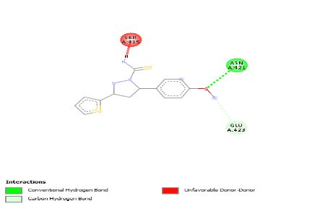 | 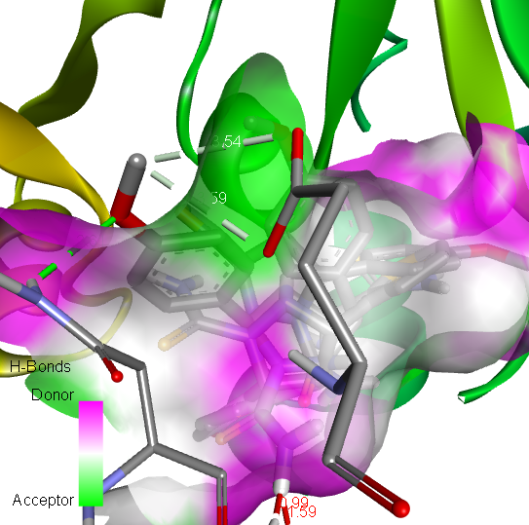
2b | 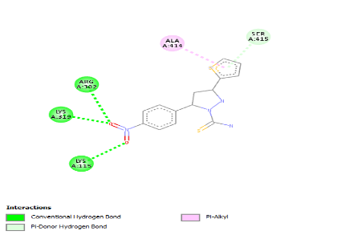 | 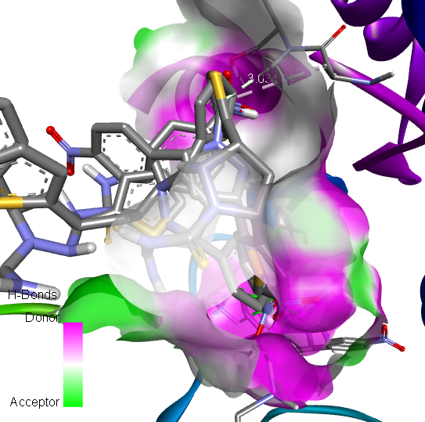
2c | 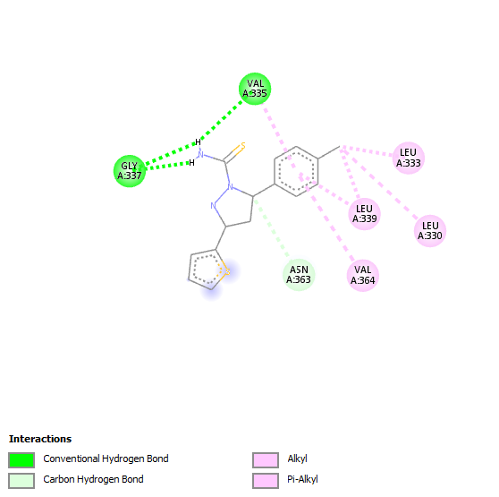 | 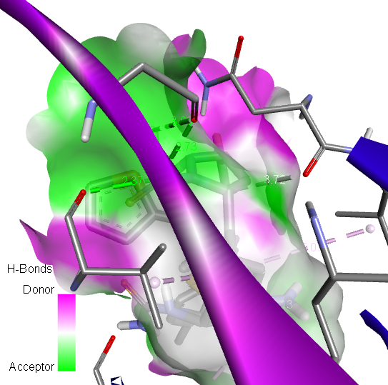

Biology
Antimicrobial study
Novel pyrimidine derivatives 2a-2c were tested for their antibacterial activity by disc diffusion method against tested bacterial and fungal strains and the results are presented in Table-6. The compound 4a shows excellent zone of inhibition against S.Pyogenes and E.Coli and also the good zone of inhibition against S.Aureus and P.Aeruginosa. The compound 4b shows excellent zone of inhibition against E.Coli and P.Aeruginosa and also good zone of inhibition against S.Aureus and S.Pyogenes. The compound 2c exhibits good zone of inhibition against S.Aureus, S.Pyogenes E.Coli and P.Aeruginosa. Among the synthesized compound 2a-2c the 2a exhibits best zone of inhibition when compared with the standard drug ciprofloxacin. In the antifungal studies the 2c exhibits excellent zone of inhibition against C.albicans and also the compound 2a and 2b shows good zone of inhibition when compared with the standard drug Clotrimazole.
Table-6 Antimicrobial activity screening of the compounds (2a-2c) at 10mg/ml
Entry | Bacterial Strain |  |  |  | Fungal Strain
 | S.Aureus | S .Pyogenes | E.Coli | P.aeruginosa | C.albicans
4a | 23 | 21 | 22 | 19 | 15
4b | 18 | 17 | 19 | 24 | 17
4c | 19 | 15 | 13 | 16 | 21
Ciprofloxin/ Clotrimazole | 26 | 19 | 17 | 22 | 24

Figure- 1 in vitro antimicrobial microbial activity of 2a-2c by disc diffusion method
Conclusion:

In summary, new and efficient synthetic route of some amino pyrimidine derivatives were achieved. The structure of the newly prepared compounds was established based on elemental analysis, spectral data and alternative methods wherever possible. The newly prepared compounds were evaluated for their antimicrobial activity against Gram-positive and Gram-negative bacteria as well as fungal stain. The results proved that the prepared compounds 4a-4c showed an adequate inhibitory growth of Gram-Positive and Gram-negative bacteria. Especially, Compound 2a showed excellent zone of inhibition(23mm in diameter) against S.Aureus, and compound 2a exhibit excellent zone of inhibition(21 mm in diameter) against S.Pyogenes and also the compound shows excellent zone of inhibition against E.Coli (22 mm in diameter) when compared with the standard drug Ciprofloxacin. Based on these the compound 2a shows better antibacterial activity against all the compounds. In the fungal study revealed that compound 4c exhibited good zone of inhibition (21 mm in diameter) against the fungal stain C.albican, because of the methyl group substituted in the fifth position of the thophene ring. The molecular docking studies were carried by bacterial protein and Breast cancer protein. All the compounds showed good binding activity scores.
References
1. Desai N C, Rapara.K.M, Joshi .V.V, Vaghani H V,Sadodiya H M. Synthesis, characterizationand antimicrobial screening of hybrid molecules containing quinoline, pyrimidine and morpholine analogues. 2013, J.Chem.sci., Vol.125,No.2,321-333.
2. Humaira Parveen, Raedah Aiyed Suliman Alatawi, nadia Hussein El Sayed, Sadaf Hasan, Sayeed Mukhtar,Asad U Khan. Synthesis,characterization and biological evaluation of some novel nitrogen and sulphur containing organometalic heterocycles.2015, Arabian Journal ofChemistry, http://dx.doi.org/10.1016/j.arabjc.2015.05.002
3.Van veldhoven J p D, Chang l C W, Von Frijtag drabbe Kunzel J K, mulder-krieger t, Struensee-Link R, Beukers M W, Brussee J and Ijermen A P 2008 Bioorg.Med.Chem.16 ,274.
4. Hughes T V, Emanuel S L, Beck A K, Wetter S K, Connolly P J, Karnachi P, Reuman M, Seraj J, Fuentes-Pesquera A R, Gruninger R H, Middleton s A, Lin R, Davis J M and Moddat D F C 2007, Bioorg.Med.Chem.Lett. 17 3266
5. Chhabria M T, bhatt h G, Raval H G and Oza P M 2007 Bioorg.Med.Chem. Lett 17 1022
6. sayle K L, Bentley j, Boyle F T, Calvert A H, Cheng Y, Curtin N J, Endicott J A, Golding B T, Hardcastle I R, Jewsbury P, Mesguiche V, Newell D R, Noble M E M, Parsons R J, Pratt D J, Wang L Z and Griffin R J 2003 Bioorg.Med.Chem. Lett. 13 3079
7. Pastor A, Alajarin R, Vaquero J J, Alvarez- Builla J, Fau de Casa-Juana M, Sunkel C, Priego J G, Fonseca I and Sanz-Aparicio J 1984 Tetrahedron 50 8085
8. Youssuf m S, Kaiser P, Singh G D, Singh S, Bani S, Gupta V K, Satti N K and Suri K A 2008 Int. Immunopharmacol 8 1049
9. Gasse c, Douguet D, Huteau V, Marchal g, munier-Lehmann H and pochet S 2008 Bioorg.Med.Chem. 16 6075
10. Manfred R, Michael m, Robert S, Wolfgang G , Eur. Pat. Appl.Ep 1989 334146:28,Chem.Abstr,112:178999
11. Hale J J, Mills S G, Mac cross M, Dorn C P, Fink P E, Budhu R J, etal , 2000 J. med. Chem, 43 1234-1237
12. Fisher m H, Wyvratt m J, US Patent 1991 5077290:10. Chem.Abstr.116:214513
13. Avramova P, Danchev N, Buyukliev R, Bogoslovova T, 1998 Arch.Pharm, 331, 342-346
14. Dorn C P, Hale J J, MacCross M, Mills S G, US patent 1997 5691336:82. Chem.Abstr.128:48231
15. Parks L W, C R C Crit.Rev.Microbiol,6 1978 301-341
16. Misra v S, Singh, Agarwal R, Chaudhry K C, J.Chem.Soc.Pak. 3 1981 209-211
17. Agarwal R, Chaudhry K C, Misra M S, J.Chem.Soc.Pak 6 (1984)308-310.
18. Kanagaran V, Thanusu J, Gopalakrishnan M. Synthesis and in vitro microbial evaluation of an array of biolabile 2-morpholino-N-(4,6-diarylpyrimidin-2-yl)acetamides. Eur.J.Med.Chem. 2010. 45, 1583-1589 doi:10.1016/j.ejmech.2009.12.068
19. Ferraria L G.;Santos RND.; Oliva G.;Andricopulo. Molecular docking and structure based drug design stratergies. Molecules 2015, 20, 13384-13421.https://doi.org/10.3390/molecules200713384
20. Muchtaridi M.; Dermawan D.;Yusuf M. Molecular docking 3d structure-based pharmacophore modelling and ADME prediction of alpha mangostin and its derivatives against estrogen receptor alpha. J Young Pharm 2018, 10(3), 252-259.https:// DOI: 10.5530/jyp.2018.10.58
21. Liao C.; Sitzmann M.; Pugliese A.; Nicklaus MC.Sofware and resources for computational medicinal chemistry. Future Med Chem 2011, 3(8), 1057-1085. https:// DOI: 10.4155/fmc.11.63
22. Kanagarajan K, Ezhilarasi M R, Gopalakrishnan M.Synthesis and in vitro microbiological evaluation of diethyl 6,6’-(1,4-phenylene)bis(4-aryl-2-oxo-cyclohex-3-enecarboxylates). Journal of Enzyme Inhibition and Medicinal Chemistry ,2011, 26(4),498-505.
23. Senthieel Khumar A B, Ezhilarasi M.R, Prabha B, Raja C. Molecular docking study of the new series of ethyl 6-(furan-2-yl)4-(4-morpholino phenyl)-2-oxo cyclohex-3-ene carboxylates and their bacterial activity.Re.J.Chem Environ.2019, Vol:23(4),70-77.
24. Manju Mathew, Raja Chinamanayakar,Ezhilarasi Muthuvel Ramanathan. Synthesis, invitro antimicrobial evaluation and insilico Molecular docking and ADMEprediction of 4-chlorophenyl furfuran derivatives bearing pyrazole moieties. Asian Journal of Chemistry, 2020, Vol.32.No.6,1482-1490.
25. Senthieel Khumar A B, Naveen Kumar K, Raja C, Ezhilarasi m R. In vitro anticancer activity, antimicrobial and in silico studies of naphthyl pyrazole analogues. Rasayan Journal of Chemistry, 2020, Vol.13,No.2, 1199-1214.
26. Raja Chinnamanayakar.; Ezhilarasi M.R.; Prabha B.; Kulandhaivel M. Synthesis and characterization of cyclohexane-1,3-dione derivatives, and their in-silico and in-vitro studies on antimicrobial and breast cancer activity. Asian J. Pharm and Clinical Research 2019, 12 (3), 311-320. http //dx.doi.org/ 10. 22159/ajpcr. 2019. V12i3. 30481.
27. Rathinamanivannan S.; Megha K,Raja Chinnamanayakar.; Ashok kumar.;Ezhilarasi M R. Synthesis characterization of 2-pyrazoline derivatives and their insilico and invitro studies on microbial and anticancer activity. Asian J Chem 2019, vol-31 No-10, 2191-2196. http://doi.org/10.14233/ajchem.1029.22082.
28.Sharma R, Sharma K, Dixit S . Synthesis characterization, and biological activities of some new arylpyrazoles. Int.J.Chem Tech.Res, 2010, 2, 800-806
29. Studennikova L .Hydrazones of acetaceric ester. Sb Nauch Ref Zh Kim, 1969, 1(7173):46
30. Amir M, Agarwal R. Synthesis and antibacterial activity of 1-thio-carbamoyl-3-methyl-4-(arylhydrazono)-2-pyrazolin-5-one. Indian Chem Soc, 1997, 74(2), 154-155
31.Yasser H Zaki, Marwas S Al Gendey, Abdou O Abdelhamid. A facile synthesis, and antimicrobial and anticancer activities of some pyridines, thioamides, thiazole,urea, quinazolone, β-naphthyl carbamate, and pyrano[2,3-d] thiazole derivatives. Chemistry Central Journal, 2018,12:70 https://doi.org/10.1186/s 13065-018-0439-9
32. Zhuang C, Wen Zhang, Sheng C, Zhang W, Xing C, Miao. Chem Rev, 2017, 117, 7762
https://doi.org/10.1021/acs.chemistry.7b00020

