BIG DATA IN AGRICULTURE
Authors
NANDHINI C.
Assistant Professor (Agricultural Statistics),
Department of Social Sciences,
Kumaraguru Institute of Agriculture, Erode.
nandhini281996@gmail.com

ABINAYARAJAM D.
Research Scholar,
Department of Farm Engineering,
Banaras Hindu University, Varanasi.
abinayarajamd97@gmail.com

PATIL SANTOSH GANAPATHI
Assistant Professor (Agricultural Statistics),
Department of Physical Sciences and Information Technology,
Tamil Nadu Agricultural University, Coimbatore.
san.santoshpatil@gmail.com
Abstract
Agriculture as the backbone of the Indian Economy, the agriculture and allied activities contributes around 19.9% to India's GDP. People towards agriculture have been eventually passed down from one generation to another. Nowadays there are many factors such as climate change, less fertile soil, soil erosion, less land availability, labour scarcity which disturbs most of the agricultural activities. As the population grows faster, we need to produce more food with less land. To overcome this, agricultural technology has become a game changer to the agriculture industry with the adoption of new technology and digitalization in agriculture. The main objective of this chapter is to explain that big data tools and techniques in agriculture have the potential to bring out drastic changes in farming with adoption of technologies to achieve the goal of smart farming.
- Introduction
Big data is the collection of large, complex and unprocessed data which cannot be processed by conventional methods. Traditional data processing cannot manage, analyze or process these datasets due to complexity and too large. Big data requires advanced tools to process and analyze complex data. This dataset has some primary properties such as velocity, volume, variability, variety, veracity and complex.
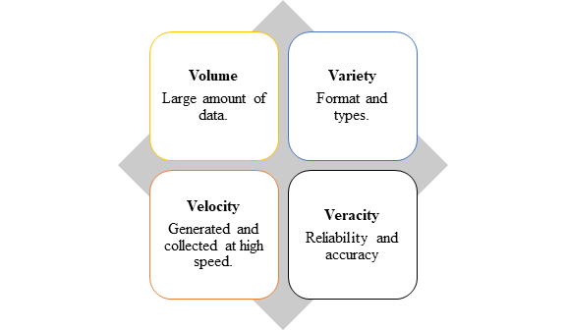
Figure 1. Properties of Big Data
Organization uses advanced analytical techniques like data mining, machine learning, natural language processing and predictive analysis to make sense of big data. These methods aid in the discovery of patterns, trends, correlation, and other significant insights from an enormous amount of data. Big data analytics enables organizations to derive meaningful information and make informed decisions. It has applications in various domains such as business intelligence, health care, finance, marketing, and scientific research. Working with big data, on the other hand, brings with it issues such as data storage, data integration, data privacy, data security, and the requirement for specialized tools and knowledge to handle and interpret massive datasets.
- Role of Big Data in Agriculture:

Big data in agriculture depends entirely on implementing the technology, information, and analytics to provide farmers with meaningful information. Big data plays a significant role in agriculture by transforming how farming operations are managed, leading to increased productivity, efficiency and sustainability. Big data covers acquiring, assembling and processing new data in a timely manner to assist scientists and farmers to make better, wiser decisions. The incorporating the big data analytics in agriculture has enormous potential for sustainable and efficient agricultural practices, enabling farmers to make better decision, reduce the environment impact and improve the overall output of agriculture. There are some key roles of big data in agriculture.
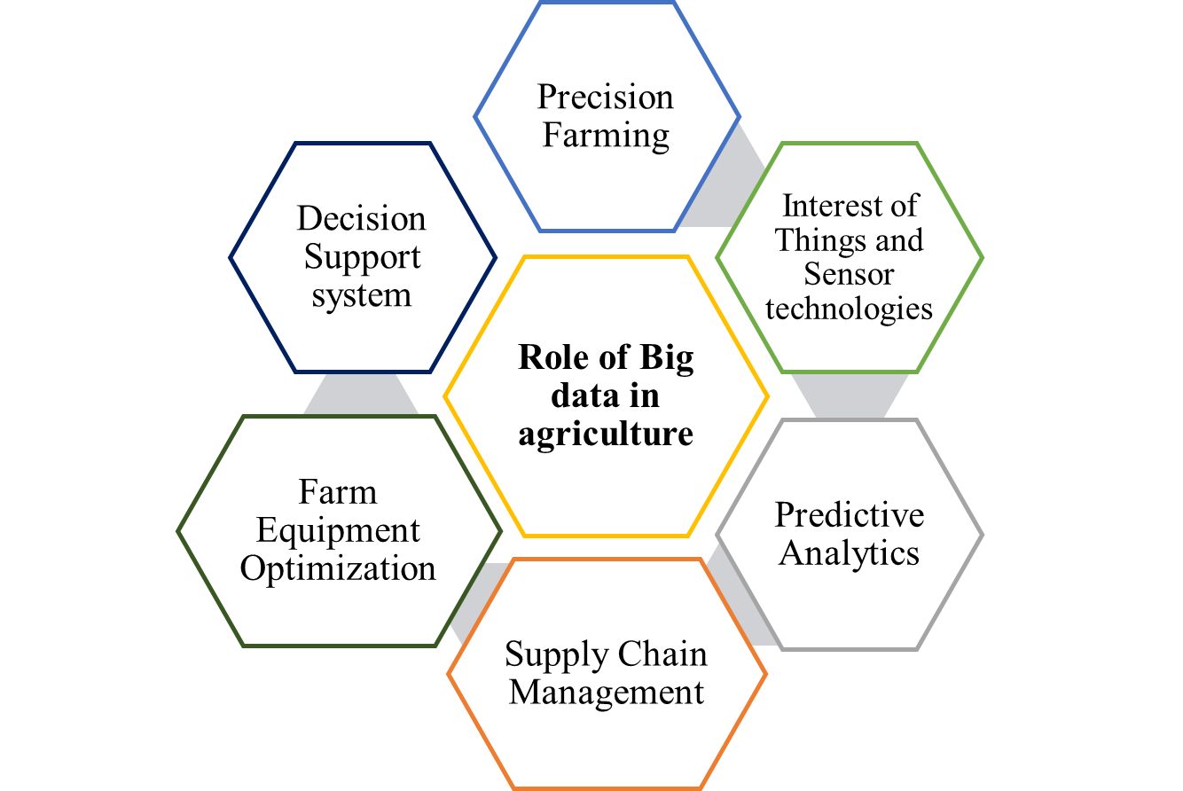

Figure 2. Key roles of big data in Agriculture
2.1 Precision Farming
Farmers can use big data technologies to collect and analyze large amounts of data from a broad range of sources, including weather patterns, soil condition, crop health, and machinery performance. These data assists farmers in making data driven decisions on planting, irrigation, fertilizer management and insect management. Farmers may optimize agricultural yields, eliminate resource waste, and reduce environmental impact by precisely customizing these practices.

2.2 Interest of Things and Sensor Technologies
IoT devices and sensors are being distributed throughout agricultural fields to capture real-time data on temperature, humidity, soil moisture, nutrient levels, and other variables. Massive volumes of data are generated by these sensors, which may be analyzed to gain insights into crop health, disease outbreaks, and resource utilization. This information enables farmers to take proactive measures to reduce crop losses and boost efficiency, such as early pest detection or changing irrigation systems.

2.3 Predictive Analytics
Predictive analytics can anticipate various agricultural outcomes by merging historical data with machine learning algorithms. Farmers can forecast crop disease, optimize planting schedules, and estimate market demand by analyzing patterns such as weather data, market trends, and historical yield data. This enables them to reduce risks, optimize production, and make educated decisions to increase profitability.

2.4. Supply chain Management
Big data analytics enhance supply chain efficiency and transparency of agriculture. Stakeholders can get insights into inventory levels, transportation logistics, quality control, and demand forecasting through monitoring and analyzing data along the supply chain, from farm to fork. This contributes to waste reduction, product loss reduction, food safety, and distribution network optimization.

2.5 Farm equipment Optimization
Big data plays a significant role in monitoring and optimizing the performance and also assists us to improve the quality of agriculture machinery and equipment. Farmers can recognise the inefficiencies of equipment, schedule the maintenance in advance, optimize the utilization of farm equipment and make better decisions pertaining to machinery investment by analyzing the data collected from sensor and telematics systems.

2.6 Decision support system
Big data platforms provide a decision support system for farmers by consolidating and analyzing the large amount of data from various resources. These system offers guidance as well as insights into crop management, Pest and disease control practices, cropping pattern and resources allocation in real time. By implementing these technologies ensure the decision making ability of the farmers and also improve the farm productivity.
- Challenges of implementing Big data in Agriculture
Although the big data possess the potential to revolutionize agriculture, there are various difficulties need to be addressed before deployment can be successful. Here are some of the most important challenges of implementing big data in agriculture:
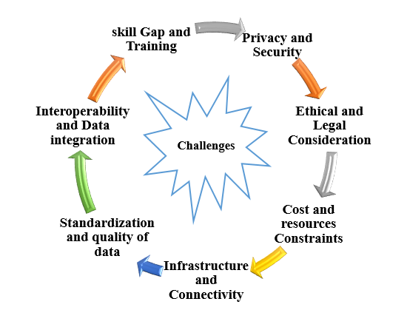
Figure 3. Challenges of Big data Implementation
- Standardization and Quality of Data: Ensuring the quality, accuracy, and consistency of data is critical for reliable analysis and decision-making. Data acquired from diverse sources may contain inconsistencies, inaccuracies, or gaps, making it difficult to combine and analyze properly. To overcome this issue, it is crucial to standardize data formats, ensure data integrity, and develop data validation methods.
- Privacy and Security: Data collected from agriculture are often sensitive data such as crop yield, farm location and financial records. It is vital to protect this data from unauthorized access, breaches, or misuse. Maintaining data privacy and security requires the implementation of effective data security measures, data encryption, access controls, and compliance with data protection rules.
- Ethical and Legal Consideration: The application of big data in agriculture involves ethical and legal challenges, such as data ownership, data sovereignty, and potential data misuse. To address these problems and ensure responsible and ethical use of agricultural data, clear rules, legislation, and ethical frameworks must be established.
- Cost and Resources Constraints: Implementing the big data requires specialized staff, large investment in infrastructure and data storage. Adoption and implementation of big data technology may be difficult for small-scale farmers or those with limited resources. To overcome cost and resource constraints, big data solutions must be affordable and accessible.
- Infrastructure and Connectivity: Agriculture big data collection, transmission and processing require adequate infrastructure and secure connection. Due to insufficient infrastructure and connectivity in rural areas, face challenges in implementation. Building robust infrastructure and ensuring widespread access to reliable connectivity is crucial for leveraging big data technologies in agriculture
- Interoperability and Data Integration: Integrating data from several sources and systems, maintaining interoperability, and distributing data among stakeholders including farmers, consumers suppliers, researcher and policy makers can all be difficult. Developing standardized data formats, protocols, and data-sharing frameworks are important for seamless data integration and collaboration.
- Skill Gap and Training: For collecting and analysing data from various sources require skilled staff. Due to scarce resource people, training programmes can help the farmer to overcome the skill gap and improve data literacy.
- Impact of Big Data on the Agriculture
Technology revolution in agriculture has become possible nowadays due to big data. Modern world without big data is very hard to imagine for a successful agricultural oriented business. In agribusiness, big data plays a major role in smart farming and precision farming which helps the farmers to get more yield with minimum cost. And also big data provides information on changes in weather, rainfall, market prices, soil moisture and other factors that affect crop yield to farmers. Big data has many other uses on agricultural sector such as Pesticides use optimization, Farm equipment management, Supply chain problems management, Yield prediction, Food safety, etc., In pesticide application, big data helps in farmers’ decision making on what pesticide to apply, when, where, and how much to apply. Data collected through sensors are processed and analysed which helps farmers to track their machinery and control the motor system remotely. It saves time for farmers and enhances production. According to the Food and Agriculture Organization of the United Nations (FAO), approximately 1/3 of the food produced for human consumption is wasted or lost every year. In this case, big data provides new opportunities to help farmers in revolutionizing agricultural practices to battle against the food crisis.
- Conclusion
This chapter describes the importance and impact of big data and their roles in agriculture. Digital Transmission network (DTN) provides agricultural information solutions and market intelligence which helps farmers and commodity traders can access up-to-date weather and pricing data to better manage their business. Most crucial thing is the challenge of managing a complex network of data sources, an enterprise resource planning (ERP) system, financial applications, GIS, agronomy packages and sensing applications to render information in real-time for customers. Success in farming has been largely dependent on favourable natural forces, but not anymore. Cloud computing and big data together have ensured that farmers have sufficient data points to make good decisions on farming.

