A brief review on: Different Technique used for preparation of solid lipid nanoparticle.
Pallavi P Sambarkar, Priyanka P Thore.
Sdmvm’s Diploma In Pharmacy Institute, chh. Sambhajinagar
ABSTRACT Solid lipid nanoparticles (SLN) are at the front of the speedily emerging field of nanotechnology with a number of probable applications in targeted drug delivery and explore for new inventions. Different invented nanoparticles and drugs retaining low solubility and reduced pharmacokinetic profiles are major substances widely delivered to specific specific sites. Solid lipid nanoparticles (SLN)has as a several potential applications in site specific drug delivery, because of their characteristic size reliant properties, solid lipid nanoparticles propose to develop new therapeutics. The capacity to combine drugs into nanocarriers deals with new sample in drug delivery that could usage for drug directing. Therefore solid lipid nanoparticles hold excessive capacity for getting the goal of controlled and target specific drug delivery and therefore involved wide consideration of researchers. This review focused on different carriers and different methods of preparations of SLN.

Key words: nanocarriers drug carriers, solid lipid nano[particles, TEM.

INTRODUCTION The decrease in the particle size of material at the nanometer scale increases their surface area by some orders of extent. Particles size of nanoparticles is ranges from 1 nm to 1000 nm. Solid lipid nanoparticles characterize by carrier system to conventional colloidal carriers for instance - emulsions, nanoparticles and liposomes. Nanoparticles prepared from solid lipids are fascinating main attention as novel colloidal drug carrier for intravenous uses as they have been proposed as an another particulate carrier system. SLN offer distinctive properties such as small size, large surface area, high drug loading and the interaction of phases at the edge and are attractive for their potential to improve performance of product .In order to overcome the drawbacks associated with the liquid state of the oil droplets, the liquid was substituted by a solid lipid nanoparticals, which eventually changed into solid lipid nanoparticles. Solid lipid nanoparticles are one of the distinctive latent colloidal carrier systems as alternate materials to polymers which is identical to oil in water emulsion for parenteral preparation, but the liquid lipids of the emulsion has been replaced by a solid lipid nanoparticles shown in Fig. 1.

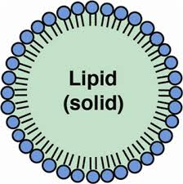

Fig. 1: A pictorial presentation on SLN.

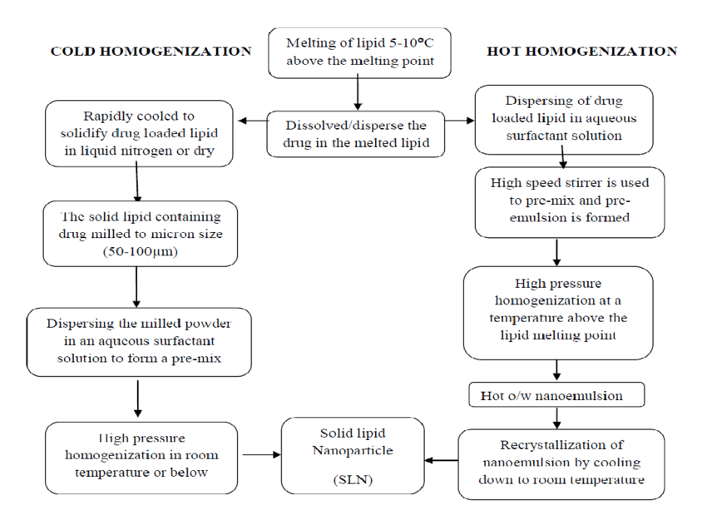The graphical presentation of several drug carriers such as emulsions and liposomes and their advantages.
Advantages of SLN1
• Control and target specific drug release.
• increased biocompatibility5.
• develop stability of pharmaceuticals.
• Increased and improved drug content.
• Simple to scale up and sterilize.
•Enhanced control concluded release of encapsulated compounds.
• Improved bioavailability of bioactive compound.
• It is simple to manufacture.
• No specific solvent is required.
• usual emulsion manufacturing methods applicable.
• Materials required is the similar to emulsions.
• Long-term stability.
• Can be used for commercial sterilization procedures.

Aims of solid lipid nanoparticles6,9
• To deliver drug in controlled manner.
• Improved drug stability.
• Elevated drug content.
• No bio-toxicity of the carrier.
• Expectancy of organic solvents.
• Combination of lipophilic and hydrophilic drugs.

Preparation of solid lipid nanoparticles1- 4,6,43,52,56
SLNs have potential carriers SLNs that are prepared from lipid, emulsifier and water/solvent by using several different methods, some methods are discussed here
Methods of preparation of solid lipid nanoparticles
1. High pressure homogenization
A. Hot homogenization
B. Cold homogenization

2. Ultra sonication/high speed homogenization
A. Probe ultrasonication
B. Bath ultrasonication

3. Solvent evaporation method
4. Solvent emulsification-diffusion method
5. Supercritical fluid method
6. Microemulsion based method
7. Spray drying method
8. Double emulsion method
9. Precipitation technique
10. Film-ultrasound dispersion

1. High pressure homogenization (HPH)
It is a prevailing method,used for the preparation of SLNs. High pressure homogenizers passed a liquid with high pressure (100–2000 bar) accross a narrow gap (in the range of a few microns). The fluid accelerates at high velocity (over 1000 Km/h) over a very short distance. Because of Very highshear stress and force particles distripute down to the submicron range. Normally 5-10% lipidcontent is used but may increase up to 40%.Two general methods of HPH are hot homogenization and cold homogenization.

A. Hot homogenization: this method iscarried out at over the melting point of lipid and can hence it is known as the homogenization of an emulsion. Melting of pre-emulsion of the drugloaded lipid and the aq. emulsifier phase at same temprature is obtained by high-shear mixingdevice. Due to the decreased viscosity of the inner phase and higher temperatures result in lower particle sizes. Because of high temperatures may cause increase the degradation rate of the drug and the carrier. Increasing the number of cycles and homogenization pressure often results in an increase of the particle size due to highkinetic energy of the particles.

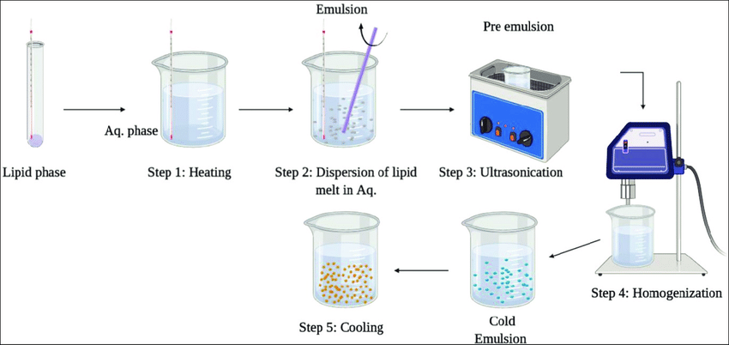

Fig. 3: Graphical presentation of hot homogenization technique

B. Cold homogenization
Cold homogenization method is very useful to overcome the various problems in hothomogenization like Temperature-induced drug degradation, drug distribution into the aqueous phase, Complexion of the crystallization.this is modified method in which drug containing lipid melt is cooled, the solid lipid ground to lipid microparticles and these lipid microparticles are dispersed in a cold surfactant solution yielding a pre-suspension. Then this pre-suspension is homogenized at or lower room temperature, the gravitation force is strong enough to break the lipid microparticles directly to solid lipid nanoparticles.

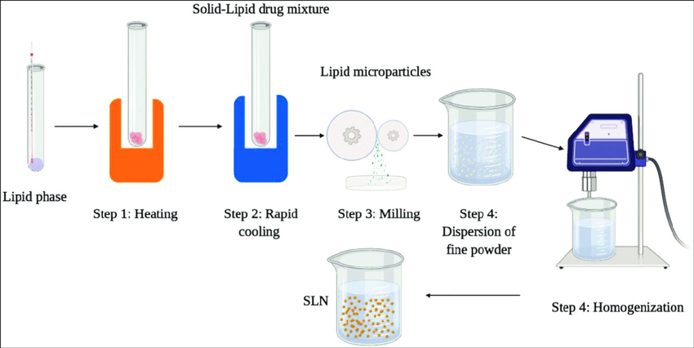

Fig. 4: graphical representation ofcold homogenization process

2. Ultrasonication/high speed homogenization
SLNs are prepared by ultrasonication or high speed homogenization method. To reduced particle size both ultrasonication and high speed homogenization is required. Reduce shear stress is most important advantage.

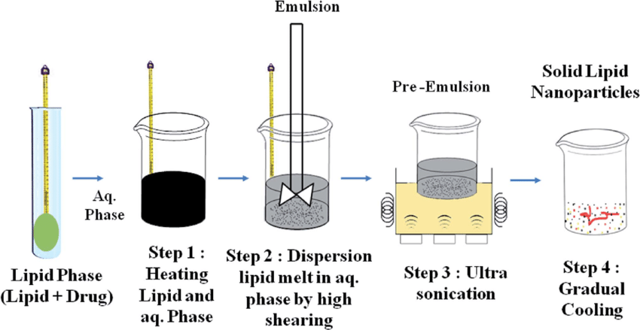

Fig.5: Ultrasonicatio process

3. Solvent evaporation
SLNs are prepared by solvent evaporation technique. The material is dissolve in a water-immiscible organic solvent (e.g. cyclohexane) and is emulsified in an aqueous phase. By the evaporation of the solvent, nanoparticles dispersion is formed by precipitation of the lipid in the aqueous medium by formation of the nanoparticles of 25 nm mean size. The solution was emulsified in an aqueous phaseby high pressure homogenization. The organic solvent was removed from the emulsion by evaporation under reduced pressure (40–60 mbar).solvent evaporation method is scalable constant and commercially established.

4. Solvent emulsification-diffusion method
This method involves the emulsification of organic solution of drug which is miscible with water and it also encloses stabilizers. The particles with normal diameters of 30-100 nm can be acquired by this method. Prevention of heat during the process is the most significant advantage of this technique.

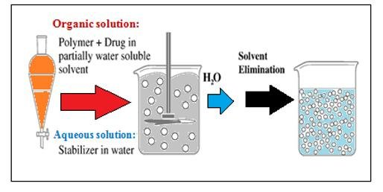

Fig. 5:Graphical representation for emulsification-diffusion method.

5. Supercritical fluid method
This is an alternative method of preparing SLNs by particles from gas saturated solutions (PGSS)this method is very useful for particle of dry powder and mild pressure temp condition this technique is the suitable to minimize the use of solvents. The Particles are obtained in the form of dry powder.

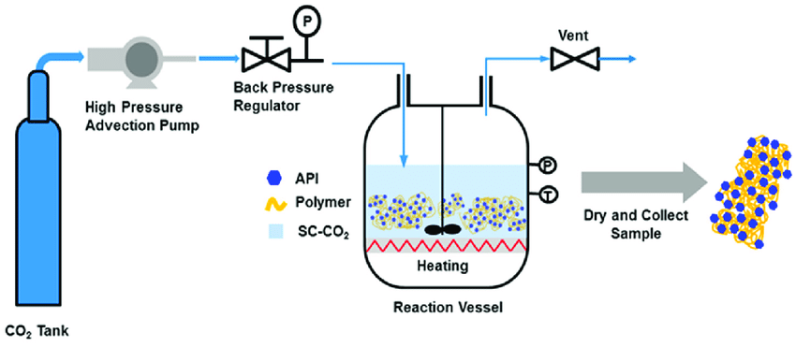

6. Microemulsion based method
This method is conventional on the dilution of microemulsions. This method is composed of micro-emulsions which are of two-phase systems composed of an inner and outer phase (e.g. o/w microemulsions). They are made by stirring an optically translucent mixture at 65-70°C, which typically composed of a low melting fatty acid (e.g. stearic acid),emulsifier (e.g. polysorbate 20), co-emulsifiers (e.g. butanol) and water. With continuous stirring the hot microemulsion is dispersedin cold water (2-3°C) . SLN dispersion method can be used as granulation fluid for shifting in to solid product (tablets, pellets) by granulation method. High-temperature gradient help in rapid lipid crystallization and avoid aggregation.
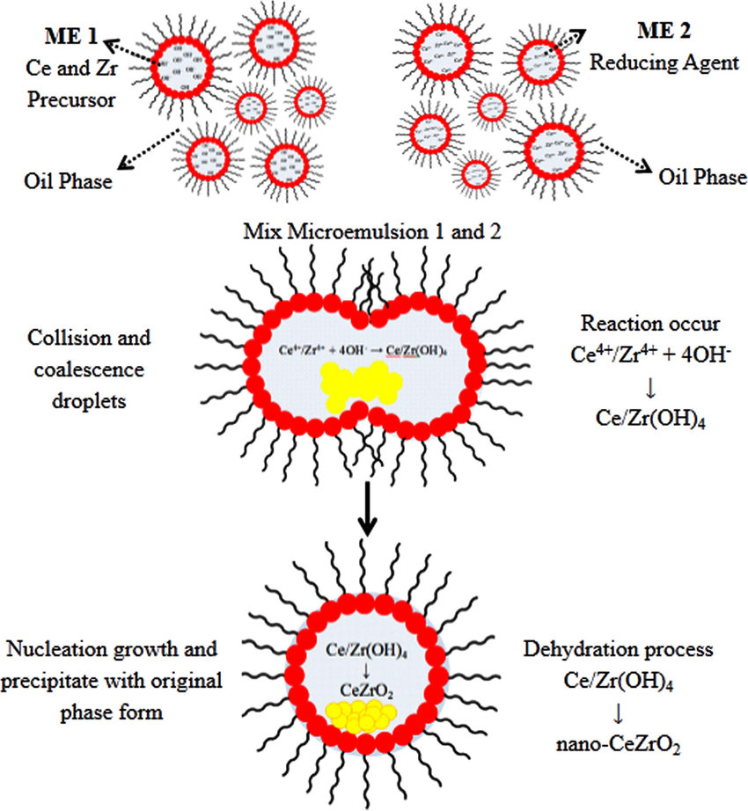

Fig. 6: Microemulsion techniques.

7. Spray drying method
It is substitute technique to the lyophilization method. This comments the use of lipid with melting point more than 70o C. The best results were obtained with SLN concentration of 1% in a solution in water or 20 in ethanol-water mixture.
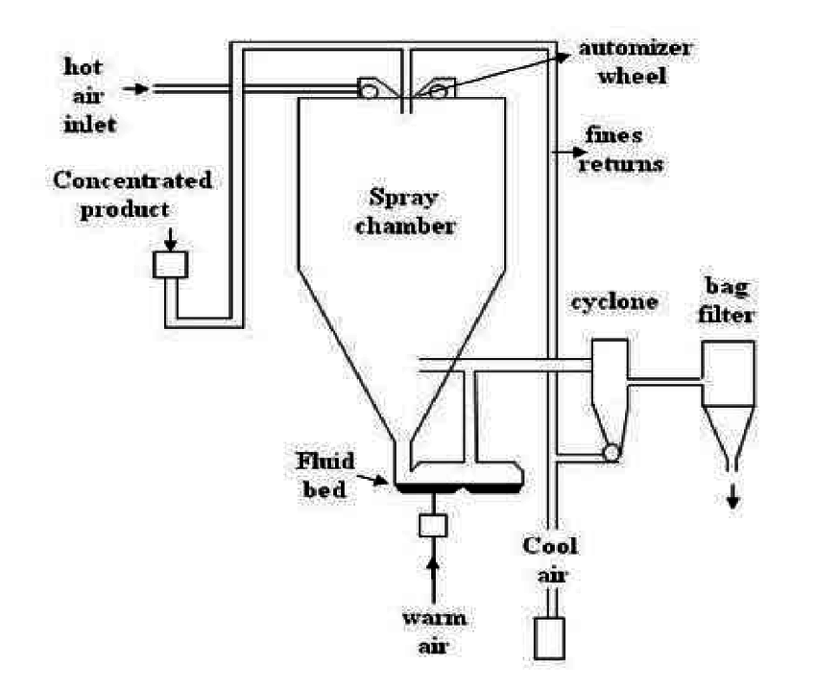

Fig 07-Spray drying method

8. Double emulsion method
In this method the drug is encapsulated among a stabilizer to avoid the separating of drug in to external waterphase during solvent evaporation in the external water phase of w/o/w double emulsion.

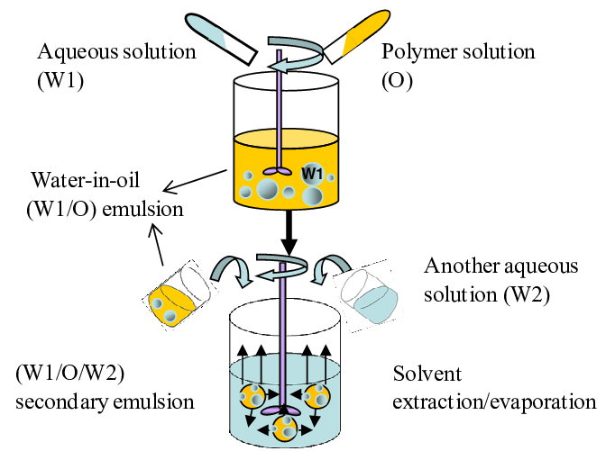

Fig 08-Double emulsion method

9. Precipitation method
The glycerides are liquefied in an organic solvent (e.g. chloroform) and the solution will form an aqueous phase. After evaporation of the organic solvent the lipid will be precipitatedand form nanoparticles.Chemical precipitation is the most common method used in removing dissolved (ionic) metals from solutions, such as process wastewaters containing toxic metals. The ionic metals are altered to an insoluble form (particle) by the chemical reaction between the soluble metal compounds and the precipitating reagent. The particles made by this reaction are removed from solution by settling and/or filtration. The unit operations typically required in this technology includes neutralization, precipitation, coagulation/flocculation, solids/liquid separation, and dewatering.

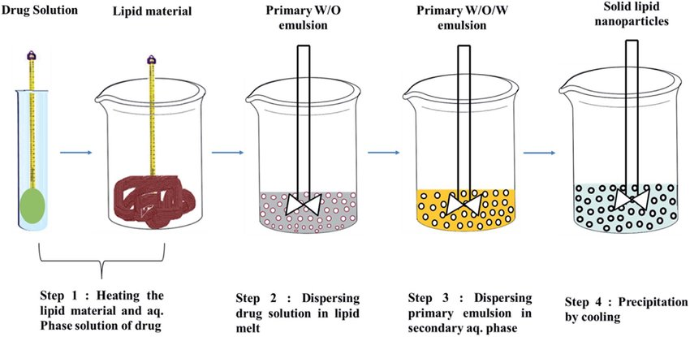

Fig 09-Precipitation method

10. Film-ultrasound dispersion
The solvent and the drug were put into suitable organic solutions, after decompression, rotation andevaporation of the organic solutions, a lipid film is formed, then the aqueous solution which includes theemulsions was added. By the ultrasound with the analysis to diffuser at last, the SLN with the slight andconstant particle size is formed.

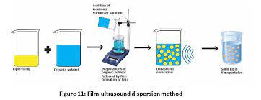
Conclusion-. SLN provide a novel and unique drug-delivery system. The regular objective of controlled drug delivery is aptly achieved with SLNs. Clear advantages of SLN include the composition (physiological compounds), the rapid and effective production process including the possibility of large scale production, the avoidance of organic solvents and the possibility to produce carriers with higher encapsulation efficiency. The suitable categorization of the composite surfactant/lipid dispersions requires several analytical techniques to the determination of the particle size.

References
1.S. Mukherjee, S. Ray and R. S. Thakur, Ind. J. Pharm. Sci., 349-358 (2009).
2. M. R. Mozafari, 41-50 (2006).
3. Rainer H. Muller, Karsten Mader and Sven Gohla, Eur. J. Pharm. Biopharm., 50(1), 161-177 (2000).
4. Wolfgang Mehnart and Karsten Mader, Adv. Drug. Deliv. Rev., 47, 165-196 (2001).

5. Houli Li, Xiaobin Zhao, Yukun Ma and Guangxi Zhai, Ling Bing Li and Hong Xiang, Lou. J. Cont.
Release, 133, 238-244 (2009).

6. Melike Uner, Gulgun Yener, Int. J. Nanomedicine, 2(3), 289-300 (2007).

Indu Pal Kaur, Rohit Bhandari, Swati Bhandari and Kakkur. J. Cont. Rel., 127, 97-109 (2008).

Antonio J. Almeida and Eliana Souto, Adv. Drug Delivery Rev., 59, 478-490 (2007)
S. P. Vyas and R. K. Khar, Controlled Drug Delivery - Concepts and Advances, First Edition, Vallabh
Prakashan (2002) pp. 38-50.
Joseph Robinson and Vincent H. L. Lee, Controlled Drug Delivery - Fundamentals and Applications,
2nd Edition, 4-33.

