ROBOTIC SURGERY: THE FUTURE OF MINIMAL INVASIVE SURGERY
Dr. Manu Saini
Assistant Professor (Physiology), Mahatma Gandhi Medical College and Hospital, Jaipur
Dr. Rajendra Bagree
Sr. Professor (General Surgery), SMS Medical College and Hospitals, Jaipur
Dr. Abhishek Saini
Assistant Professor (Paediatrics), NIMS, Jaipur
ABSTRACT
Robotic surgery is emerging as the latest technique in minimal invasive surgeries. Robotic surgery is performed using a robot-assisted surgery system, the robot being under the operative control of the surgeon. The robotic system currently being used is the leader-follower type, the da Vinci surgical system (intuitive surgery).This chapter describes not only the current state of robotic surgery but also the future development of robotic surgery systems in gastrointestinal, urological and other surgeries.
KEYWORDS- Robotic Surgery, Invasive Surgery, da Vinci surgical system
- INTRODUCTION
Surgery is a large field which requires many minimal invasive surgeries mainly in gastrointestinal and urological surgeries. Laparoscopy has been widely accepted by surgeons world over, the 1990’s having been the so called laparoscopic revolution. Surgeries like laparoscopic cholecystectomy have become the standard operative procedure for cholelethiasis mainly because of shorter hospital stays, reduced post operative morbidity and better cosmetic outcomes for the patients. However, complex procedures like pancreatectomy proved difficult to be performed laparoscopically due to technical issues. Only some new technology could overcome the limitations experienced by the surgeon in laparoscopic surgeries. Since beginning of 21st century, robotic surgery has proved to overcome the limitations of conventional laparoscopic surgeries and lead to future development in surgical field. Presently robotic surgery has been adopted by surgeons all over the world, mainly for urological surgeries, various gastrointestinal cancer surgeries and bariatric surgery.
The da vinci robotic system has been approved in the US since 2000. However, till 2009, not many surgeries were being performed by robotic system. Main fields of concern in using robotic systems was difficulty in operating the system , how useful it was as compared to laparoscopy ,cost factor , and installation and controlling the system. It was observed finally that robotic system operations were beneficial to patients because it required less hospitalization, better recovery and lesser incidences of deaths during operations. When applying criteria of Health Technology Assessment, robotic surgery has proved to be costly especially purchase and maintenance of technology and operating time is also more as compared to conventional approaches of surgery.
Robotic surgery has effectively addressed the limitations of laparoscopic and other minimal invasive procedures, it is expected to grow much more in coming years and ‘almost all surgeries can and will be performed by robotic help in the future’. This will change the existing surgical training pattern, and will also require special training such as use of robotic simulators and telemonitoring .
- WHAT IS ROBOTIC SURGERY?
Surgery is a large field which requires many minimal invasive surgeries mainly in gastrointestinal and urological surgeries. Laparoscopy has been widely accepted by surgeons in the 1990’s, in fact there has been a so called laparoscopic revolution. Surgeries like laparoscopic cholecystectomy have become the standard operative procedure for cholelethiasis mainly because of shorter hospital stays, reduced post operative morbidity and better cosmetic outcomes for the patients. However, complex procedures like pancreatectomy proved difficult to be performed laparoscopically due to technical issues. Only some new technology could overcome the limitations experienced by the surgeon in laparoscopic surgeries. Since beginning of 21st century, robotic surgery has proved to overcome the limitations of conventional laparoscopic surgeries and lead to future development in surgical field.. Presently robotic surgery is being adopted by surgeons all over the world, mainly for urological, cardiac, gynecologic, various gastrointestinal cancer surgeries and bariatric surgery.
The da vinci robotic system has been approved in the US since 2000. However, till 2009, not many surgeries were being performed by robotic system. Main fields of concern in using robotic systems was difficulty in operating the system , how useful it was as compared to laparoscopy, cost factor , and installation and controlling the system. It was observed finally that robotic system operations were beneficial to patients because it required less hospitalization, better recovery and lesser incidences of deaths during operations. When applying criteria of Health Technology Assessment, robotic surgery has proved to be costly especially purchase and maintenance of technology and operating time is also more as compared to conventional approaches of surgery.
Robotic surgery has addressed the limitations of laparoscopic and other minimal invasive procedures to a large extent, and it is expected to expand much more in coming years. Almost all surgeries can and will be performed by robotic help in the future”. This will change the existing surgical training pattern, and will also require special training such as use of robotic simulators and telemonitoring .
- HISTORY OF ROBOTIC SURGERY
The history of robotic surgery started at NASA-National Aeronautics and Space Administration. The concept was developed by Scott Fisher who introduced the first head mounted display. This gave the viewer a three dimensional virtual environment. Engineer Phil Green then developed a system of robotic telemanipulation at Stanford Research Institute. In 2000, the da vinci system became commercially available in United states for use. Presently more than 1700 robotic systems have already been installed worldwide.

- CLINICAL APPLICATIONS OF ROBOTIC SURGERY
Robotic surgery has allowed surgeons to perform complex and advanced surgeries with more precision with minimal invasive procedures. In laparoscopy, surgeon has to stand and remain in specific positions throughout the surgery. Whereas in robotic surgery, surgeon is more comfortable, sitting on control console, thus less exerted physically. Laparoscopic camera gives the surgeon a two dimensional image, robotic surgery gives the surgeon a 3-dimensional view which helps the surgeon have better perception of surgical field , camera is also more steady and convenient. Robotic arm manipulation gives the surgeon a wider range of motion and he is able to carry on more complex surgical movements.
In a relatively short period of time, robotic surgery has taken over a wide spectrum of surgeries especially gastrointestinal and urological surgeries. Till date results have shown lower mortality, morbidity and hospital stay duration as compared to conventional laparoscopic operations. But still there are not enough studies on robotic surgery; more procedure specific trails have to be performed before robotic surgery can be widely accepted in everyday surgical practice.

- LIMITATIONS OF ROBOTIC SURGERY
Limitations of laparoscopy Robotic solutions
- Two- dimensional vision of surgical field -Three dimensional view of field.
- Impaired depth perception -proper depth perception
- Movements in laparoscopy are counterintuitive -movements are intuitive
- Unstable camera held by assistant -surgeon controls the camera
- Uncomfortable position of surgeon -surgeon comfortably seated on consol.
Although robotic surgery is rapidly developing all over the world, it has not yet reached its full potential. The major concern is cost effectiveness. The major part of increased cost is the initial cost of purchasing the robot, estimated at about 25 crore with yearly maintenance of 1 crore. Both these are expected to decrease in coming years as more and more robotic surgeries are taken up by the surgeons. Operating time of robotic surgery and even decreased hospital stay will also ultimately contribute to the cost effectiveness of robotic surgery.
Other limitations include the bulky apparatus of robotic equipment currently being used. A bigger operating room of 24*24 is required for surgery. Additionally, there is lack of tactile feedback to the surgeon. Special training and more technical support is required in robotic surgery.
- ROBOTIC SURGICAL EDUCATION
Surgical training has not much changed for more than a century. Surgeons in training have always gained surgical Training through experience and supervised trial and error on patients. This training has its limitations that it requires more cases and surgical trained is quite prolonged. It also compromises patient’s safety in hands of under training surgeons .Robotic surgery creates a new medium of acquiring surgical skill through simulation of all the surgeries that can be done by a robot. Surgical robots can help the surgical trainers by allowing the surgeons to practice procedure on reconstructions of anatomy of actual patients. Virtual reality visual stimulation and soft tissue models that can recreate the feel of human tissues will help the surgeons in getting ready for the surgery scheduled the next day on real patients. Trainee surgeons can even be guided through tele-monitoring. In tele- monitoring system, tele-robotic surgery can be done by a surgeon who operates the robotic arm from miles away. The surgeons commands are relayed to the surgical unit by fibre optic cables. The first tele-robotic surgery was Cholecystectomy performed by surgeons in NewYork on a patient in Strasbourg, France in 2001. Since then, many tele-robotic surgeries have been performed and many trainee surgeons have been educated all over the world with help of tele-monitoring systems.
- INDIAN SCENERIO IN ROBOTIC SURGERY
According to latest data, till end of October 2021, more than 76 robotic installations have been installed in India in government and private institutions. More than 500 surgeons have been trained to do robotic surgery and many are under training. There are nine systems in government-funded institutions, these include, All India Institute of Medical Sciences New Delhi, SGPGI Lucknow, PGIMER Chandigarh, All India Institute of Medical Sciences Rishikesh, All India Institute of Medical Sciences Jodhpur, Safdarjung Hospital New Delhi, Jawaharlal Institute of Post-Graduate Medical Education and Research and Delhi State Cancer Institute. Apart from government-funded institutions and medical colleges, India boasts a plethora of privately-run training institutes that proffer comprehensive instruction in the domain of robotic surgery, including training courses, fellowships, and observership. In addition to formal training initiatives, junior faculty members and residents may also partake in informal training activities pertaining to robotic-assisted surgeries. At present, the prevailing modus operandi entails consultants embarking upon rigorous training regimens via robotic surgery fellowships, whereby they progressively transition from executing conventional open surgeries to conducting robotic-assisted procedures. Concurrently, as these consultants and faculty members transition their surgical practices, junior faculty, fellows, and residents acquire requisite proficiencies and invaluable hands-on experience through didactic learning and active involvement in such procedures. This trend reflects the widespread acceptance of robotic-assisted surgeries within the broader purview of the general public, as well as the collective endorsement extended by governmental and private entities alike.
Intuitive, the sponsor of the da Vinci robotic system offers a series of training courses that are necessary before using the robot in a clinical setting. These courses are divided into four phases: Phase 1 provides an introduction to da Vinci Technology, Phase 2 focuses on training participants in the technology itself, Phase 3 involves conducting initial case series, and Phase 4 emphasizes ongoing development. In addition to these training modules, Intuitive's platform also includes videos covering different surgical specialties.
India got its first urologic robotic installation at the All India Institute of Medical Sciences, New Delhi, in 2006. The following years have seen exponential growth of robotic surgeries in India.The robotic system being used at present is the da vinci X1,3rd generation. More than 500 surgeons have been trained in robotic surgery in India and more than 14000 surgeries have already been performed throughout India. Growth of robotic surgery in India is expected to be rapid and exponential because of the availability of a large number of cases, rapidly growing economy and expanding healthcare sector. The main concern is to bring down the cost of robotic installation, maintenance and surgery. The focus is on training the younger generations of surgeons in robotic surgery, surgeons are being sent for training to various centres like Cochin.

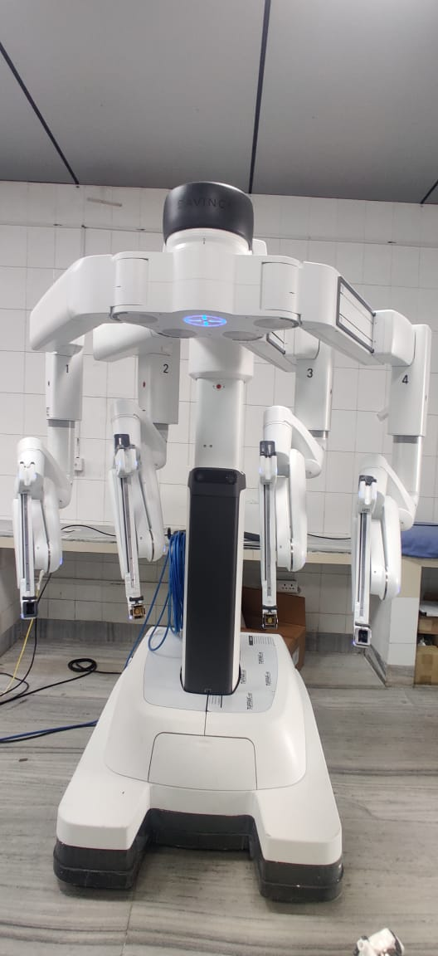
Fig: 1 – Robotic arm
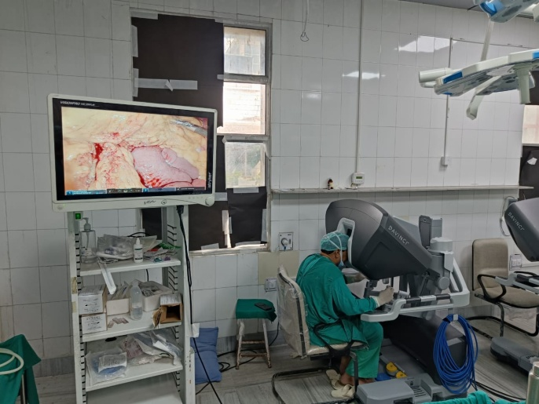
Fig: 2- Surgeon on Robotic Consol
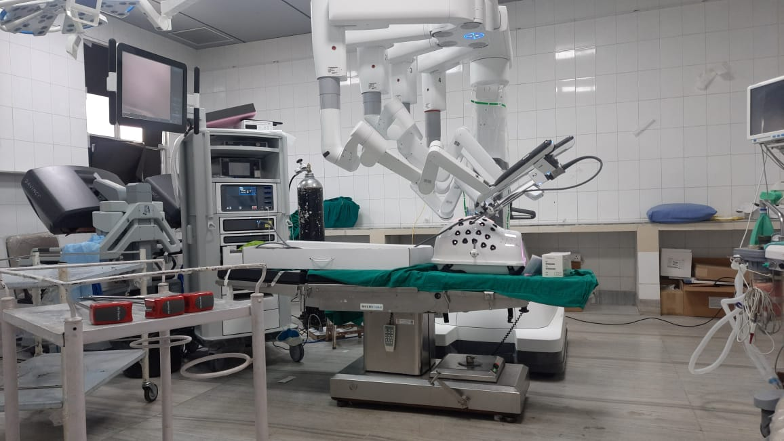
Fig: 3- The da Vinci Robotic Surgical System
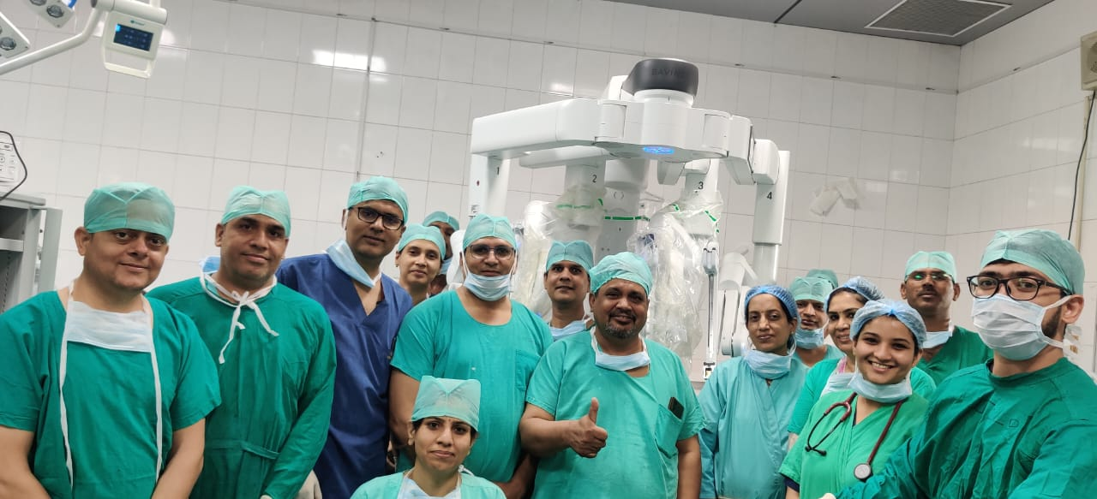
Fig: 4- Operating Robotic Surgical Unit at SMS Medical College and Hospital, Jaipur (Rajasthan) led by Dr. Rajendra Bagree, Sr. Professor.

- CONCLUSION
Robotic surgery is fast developing but still in its infancy stage. Robotic surgery has improved the precision and dexterity of surgeons, allowing them to perform difficult operations that could not have been performed effectively with conventional laparoscopic approach. Robotic surgery has proven not only to be the safer option but also more favourable to the patients in regards to surgical morbidity and hospital stay. The main concern is the cost of equipment and its maintenance and technical training required to operate the robotic system these concerns need to be resolved so that robotic surgery can become mainstream everyday surgical procedure.
REFERENCES
Bora GS, Narain TA, Sharma AP, Mavuduru RS, Devana SK, Singh SK, et al. Robot-assisted surgery in India: A SWOT analysis. Indian J Urol. 2020;36:1–3. [PMC free article] [PubMed] [Google Scholar]
Chowriappa AJ, Shi Y, Raza SJ, Ahmed K, Stegemann A, Wilding G, et al. Development and validation of a composite scoring system for robot-assisted surgical training – The Robotic Skills Assessment Score. J Surg Res. 2013;185:561–9. [PubMed] [Google Scholar]
Davies BL, Hibberd RD, Ng WS, Timoney AG, Wickham JE. The development of a surgeon robot for prostatectomies. Proc Inst Mech Eng H. 1991;205:35–8. [PubMed] [Google Scholar]
Educational Impact of Robot Assisted Surgical Training Program – SAGES Abstract Archives. SAGES. [Lastaccessed on 2021 Jun 28]. Available from: https://www.sages.org/meetings/annual-meeting/abstracts-archive/educational-impact-of-robot-assisted-surgical-training-program/
George EI, Brand CT, LaPorta A, Marescaux J, Satava RM. Origins of robotic surgery: From skepticism to standard of care. JSLS. 2018;22:e2018.00039. [PMC free article] [PubMed] [Google Scholar]
Gamboa AJ, Santos RT, Sargent ER, Louie MK, Box GN, Sohn KH, et al. Long-term impact of a robot assisted laparoscopic prostatectomy mini fellowship training program on postgraduate urological practice patterns. J Urol. 2009;181:778–82. [PubMed] [Google Scholar]
McDougall EM, Corica FA, Chou DS, Abdelshehid CS, Uribe CA, Stoliar G, et al. Short-term impact of a robot-assisted laparoscopic prostatectomy 'mini-residency' experience on postgraduate urologists' practice patterns. Int J Med Robot. 2006;2:70–4. [PubMed] [Google Scholar]
Hung AJ, Jayaratna IS, Teruya K, Desai MM, Gill IS, Goh AC. Comparative assessment of three standardized robotic surgery training methods. BJU Int. 2013;112:864–71. [PubMed] [Google Scholar]
Kwoh YS, Hou J, Jonckheere EA, Hayati S. A robot with improved absolute positioning accuracy for CT guided stereotactic brain surgery. IEEE Trans Biomed Eng. 1988;35:153–60. [PubMed] [Google Scholar]
Lee Jason Y, Phillip M, Sundaram Chandru P, McDougall Elspeth M. Best practices for robotic surgery training and credentialing. J Urol. 2011;185:1191–7. [PubMed] [Google Scholar]
Lee YL, Kilic GS, Phelps JY. Medicolegal review of liability risks for gynecologists stemming from lack of training in robot-assisted surgery. J Minim Invasive Gynecol. 2011;18:512–5. [PubMed] [Google Scholar]
Lane T. A short history of robotic surgery. Ann R Coll Surg Engl. 2018;100:5–7. [PMC free article] [PubMed] [Google Scholar]
McDougall EM, Corica FA, Chou DS, Abdelshehid CS, Uribe CA, Stoliar G, et al. Short-term impact of a robot-assisted laparoscopic prostatectomy 'mini-residency' experience on postgraduate urologists' practice patterns. Int J Med Robot. 2006;2:70–4. [PubMed] [Google Scholar]
Schreuder HW, Wolswijk R, Zweemer RP, Schijven MP, Verheijen RH. Training and learning robotic surgery, time for a more structured approach: A systematic review. BJOG. 2012;119:137–49. [PubMed] [Google Scholar]
Siddiqui NY, Tarr ME, Geller EJ, Advincula AP, Galloway ML, Green IC, et al. Establishing benchmarks for minimum competence with dry lab robotic surgery drills. J Minim Invasive Gynecol. 2016;23:633–8. [PubMed] [Google Scholar]
Satava RM, Stefanidis D, Levy JS, Smith R, Martin JR, Monfared S, et al. Proving the effectiveness of the fundamentals of robotic surgery (FRS) skills curriculum: A single-blinded, multispecialty, multi-institutional randomized control trial. Ann Surg. 2020;272:384–92. [PubMed] [Google Scholar]
Sridhar AN, Briggs TP, Kelly JD, Nathan S. Training in robotic surgery – An overview. Curr Urol Rep. 2017;18:58. [PMC free article] [PubMed] [Google Scholar]
SMTH. Clinical Robotic Surgery Association. Clinical Robotics. [Last accessed on 2021 Jun 27]. Available from: https://clinicalrobotics.com/
Yule S, Flin R, Paterson-Brown S, Maran N. Non-technical skills for surgeons in the operating room: A review of the literature. Surgery. 2006;139:140–9. [PubMed] [Google Scholar]

