CRYPTOCURRENCY IN INDIA: AN OVERVIEW

Nandita Debnath
Assistant Professor, Denning College for Teacher Education, Tezu, Arunachal Pradesh.
Abstract: With the digital & internet revolution, a new concept came into being which is known as Cryptocurrency. Cryptocurrency being a virtual currency is a valuable intangible asset used as a medium of transaction and also trading. It is not available in physical form. The cryptocurrency market has evolved as fast growing market for investment with immense speed over a short time period. The first cryptocurrency Bitcoin was introduced in January 2009, and since then more than many cryptocurrencies have been developed because of its increasing popularity and consumer’s interest. The present study will focus on History ,pros and cons and future prospects of cryptocurrency in India.
Keywords: Cryptocurrency, Bitcoin, Virtual currency, Blockchain.
Introduction: The instruments used as exchange instruments to make the trade transactions as easy as possible according to the market needs have experienced a huge development and change. Those instruments used to intermediate the exchange of goods are known as money. Money as something that serves as a medium of exchange, an unit of accounting, and a store of value. Money is a medium of exchange in the sense that we all agree to accept it in making transactions. Merchants agree to accept money in exchange for their goods; employees agree to accept money in exchange for their labor. As a unit of accounting, money provides a simple device for identifying and communicating value.
Money serves as a store of value in that it allows us to store the rewards of our labor or business in a convenient tool. From the era of barter to commodity money, metal and coins, to gold and silver, continuing by modern monetary systems and checks and ending with the latest global currency developments, such as introduction of cryptocurrencies known as Bitcoin and Ethereum and alike.
The introduction of cryptocurrencies has revolutionized the international payment system in a scale that just few years ago were unimaginable. A cryptocurrency is a digital or virtual currency that uses cryptography for security. In 1983, the American cryptographer DavidChaum conceived an anonymous cryptographic electronic money called e-cash. Later, in 1995, he implemented it through Digicash,an early form of cryptographic electronic payments which required user software in order to withdraw notes from a bank and designate specific encrypted keys before it can be sent to a recipient. This allowed the digital currency to be untraceable by the issuing bank, the government, or any third party. A cryptocurrency is difficult to counterfeit because of its security feature. A defining feature of a cryptocurrency is that it is not issued by any central authority. It is completely decentralized
Objectives: The objectives of this study are as follows:
OBJECTIVES OF THE STUDY
- To understand the concept of cryptocurrency.
- To study the history, types, pros and cons of cryptocurrencies in India.
- To analyse the future prospects of cryptocurrency in india

Review of Literature
Chohan, U. W. (2017) at the center of the economic common sense of cryptocurrencies lies the hassle of surmounting the double-spending hassle, which poses accounting and duty challenges that effective cryptocurrencies have sought to conquer. This discussion paper evaluations the salient literature to be able to better inform academic and practitioner inquiry on the double-spending issues in cryptocurrencies.
Francis, J. C (2019) The U.S. Has approximately 1,600 cryptocurrencies. No cryptocurrency is certified to be known as money due to the fact none has been specified via the U.S. Government as being felony tender. Cryptocurrencies are called virtual currencies because they possess some of the traits of cash. In this text, three issues related to cryptocurrencies are analyzed. First, bitcoins are considered, because they are the primary Cryptocurrency. Second, an evaluation of the processes the Federal Reserve and the principal financial institution of Sweden are going thru to evaluate the possibility of issuing a few no longer-but-fully-described new form of electronic forex. Third, an examination of the
Viability of block chain, which became brought as an inner aspect of bitcoin, as successful stand-alone technology.
Ogorevc, M (2019) this paper is prompted by using a speculation that the lengthy-time period Value of a cryptocurrency is determined with the aid of its future use as cash. For a cryptocurrency to be used as a medium of price, it has to fulfill three impartial functions: medium of change, a unit of account, and store of value. Currently, cryptocurrencies are held for funding purposes in place of being used for transactions and for that reason as a medium of change. For cryptocurrency to emerge as extensively adopted as a method of price, it first needs to go through a very volatile duration due to the fact speculative investors see long-run destiny cost within the cryptocurrency.
Li, X., and Whinston, A. B (2019) Cryptocurrencies, along with Bitcoin, were an essential component in some monetary activities. For instance, Bitcoin is the main payment approach for ransom ware attackers and retailers on the Darknet. It is therefore beneficial to understand the functions of cryptocurrencies and their monetary implications. In this studies, we use bitcoin, Ether, and XRP, the three cryptocurrencies with the highest marketplace values as of this writing, in addition to Libra, that is impending and topical, as examples to investigate their functions. Specifically, we argue that these cryptocurrencies are basically extraordinary due to variations in the following elements: the identity management of their ledger writers, their consensus algorithms, and their coin supply. We discuss how these elements determine cryptocurrency performance, which include safety, privacy, and economic influence.
We also talk capacity studies subjects round those cryptocurrencies that can be still open.
Liu, Y et al., (2020) this paper researches the position of technological sophistication in Initial Coin Offering (ICO) successes and valuations. Using diverse system learning techniques, we construct technology indexes from ICO whitepapers to seize technological sophistication for all cryptocurrencies. We discover that the cryptocurrencies with high technology indexes are more likely to succeed and less likely to be delisted ultimately. Moreover, the era indexes strongly and undoubtedly are expecting the lengthy-run performances of the ICOs. Overall, the effects propose that technological sophistication is an essential determinant of cryptocurrency valuations. Harit, P (2020) a democratic form
of Govt. Is constantly defined as “by using the
Public, for the Public and to the Public.” The primary characteristic of a government is to supply public services to its citizens for which it calls for assets to finance its expenditure. Among others, taxation works as a primary supply to fund public expenditure. Developments and Advancements in technologies, has enabled the Govt. To perceive new ways and opened new systems to collect taxes. Among them, comes the curious state of affairs of taxation of Cryptocurrency. Unlike the fiat foreign money, Cryptocurrencies are +decentralized, relying on a peer-to-peer community that operates with none third-celebration intervention just like the Central Bank.
Kishore Jain, D (2020) the effect of the creation of cryptocurrencies in all economies is discussed right here. The benefits of the usage of cryptocurrencies as well as the drawbacks of conventional digital payments are included. Cryptocurrency goals to revolutionize the virtual bills marketplace; but, it does supply upward push to many questions as to its fee, reliability, and destiny opposition amongst the cryptocurrencies as nicely.

Research methodology:
This paper is purely based on secondary data referring to various sources such as journals, newspaper articles, websites and statutory report

Cryptocurrency :a brief overview
Cryptocurrency is decentralized digital cash, based on blockchain technology. One may be familiar with the most popular versions, Bitcoin and Ethereum, but there are greater than 5,000 different cryptocurrencies in movement, in keeping with CoinLore. One can use crypto to shop for ordinary goods and services, although many humans put money into cryptocurrencies as they could in different belongings, like shares or precious metals. While cryptocurrency is a singular and interesting asset elegance, buying it may be volatile as you must take on an honest amount of studies to absolutely recognize how every system works. (Kate Ashford and John Schmidt,2020)
Figure 1: Cryptocurrency Work
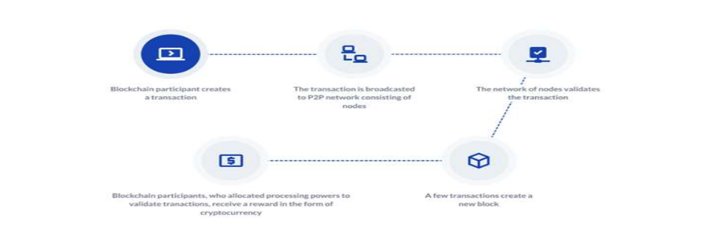
Cryptocurrency is a digital or virtual currency that uses cryptography for security. A cryptocurrency is difficult to counterfeit because of this security feature. Cryptocurrencies are decentralized and not subject to government or financial institution control.
- And the decentralized control of each cryptocurrency works through distributed ledger technology, typically a blockchain that serves as a public financial transaction database.
- The most famous cryptocurrency is Bitcoin, which was created in 2009.
- Cryptocurrencies are designed through mining, which uses computing power to solve complex math problems that verify transactions on the blockchain, the public ledger of all cryptocurrency transactions. And miners are rewarded with cryptocurrency for their efforts.
Cryptocurrency trading is speculative and complex, and it involves significant risks. Prices can fluctuate on any given day. Given the price volatility, cryptocurrency is only suitable for some investors. Therefore, cryptocurrency should be considered a high-risk investment. Before investing, understand the risks involved and consult a financial advisor.

Cryptocurrency Ecosystem:
The current growth inside the blockchain-based cryptocurrency environment has been attracting researchers, developers, investors, regulators, and speculators to expand new economic and enterprise models for change, funding, and taxation. Currently, the cryptocurrency atmosphere is immature with multifaceted agree with issues in any respect degrees from technology providers to customers and governments. (Rehman, et al.2020)
Figure 2: Cryptocurrency Ecosystem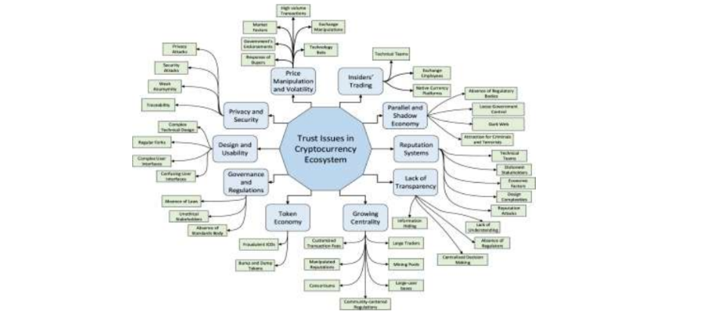

Brief History of Cryptocurrency
In the caveman era, people used the barter system, in which goods and services are exchanged among two or more people. For instance, someone might exchange seven apples for seven oranges. The barter system fell out of popular use because it had some glaring flaws:
- People’s requirements have to coincide—if you have something to trade, someone else has to want it, and you have to want what the other person is offering.
- There’s no common measure of value—you have to decide how many of your items you are willing to trade for other items, and not all items can be divided. For example, you cannot divide a live animal into smaller units.
- The goods cannot be transported easily, unlike our modern currency, which fits in a wallet or is stored on a mobile phone.
After people realized the barter system didn’t work very well, the currency went through a few iterations: In 110 B.C., an official currency was minted; in A.D. 1250, gold-plated florins were introduced and used across Europe; and from 1600 to 1900, the paper currency gained widespread popularity and ended up being used around the world. This is how modern currency as we know it came into existence.
Modern currency includes paper currency, coins, credit cards, and digital wallets—for example, Apple Pay, Amazon Pay, Paytm, PayPal, and so on. All of it is controlled by banks and governments, meaning that there is a centralized regulatory authority that limits how paper currency and credit cards work.

Types of Cryptocurrency
The first type of crypto currency was Bitcoin, which to this day remains the most-used, valuable and popular. Along with Bitcoin, other alternative cryptocurrencies with varying degrees of functions and specifications have been created. Some are iterations of bitcoin while others have been created from the ground up
Bitcoin was launched in 2009 by an individual or group known by the pseudonym “Satoshi Nakamoto. As of March 2021, there were over 18.6 million bitcoins in circulation with a total market cap of around $927 billion.
The competing cryptocurrencies that were created as a result of Bitcoin’s success are known as altcoins. Some of the well known altcoins are as follows:
- Litecoin
- Peercoin
- Namecoin
- Ethereum
- Cardana
Today, the aggregate value of all the cryptocurrencies in existence is around $1.5 trillion—Bitcoin currently represents more than 60% of the total value.

Pros associated with Cryptocurrency are as follows:
a) Protection Against Inflation: Inflation has led several currencies to lose value over time. The amount of any coin is specified in the source code. As demand grows, its value rises, keeping pace with the market and, in the long term, preventing inflation.
b) Privacy: Cryptocurrency privacy and security have long been key concerns. The blockchain ledger is built on many mathematical problems that are difficult to decode. As a result, bitcoin transactions are more secure than standard electronic transactions. To improve security and privacy, cryptocurrency uses pseudonyms that are unrelated to any user, account, or stored data that may be traced to a profile.
c) Self-Governed: The governance and upkeep of any currency are critical to its development. Developers/miners hold cryptocurrency transactions on their hardware and receive the transaction fee as a reward. Since miners are compensated for their efforts, they keep transaction records accurate and up to date, preserving the cryptocurrency's integrity and keeping records decentralized.
d) Decentralization: One important advantage of cryptocurrency is that it is mostly decentralized. Many cryptocurrencies are controlled by the developers who use them and people who own a large amount of the coin or by a firm that develops it before it is given to the market. Decentralization serves to keep the currency monopoly free and in check by ensuring that no single entity determines the flow and value of the coin, which, in turn, keeps it stable and secure, not like fiat currencies, which are controlled by the government.
e) Easy Transfer: Cryptocurrencies have traditionally been seen as the best option for transactions. Cryptocurrency transactions, whether international or domestic, are lightning fast. Because there are minimal barriers to overcome, the verification takes extremely little time to complete.
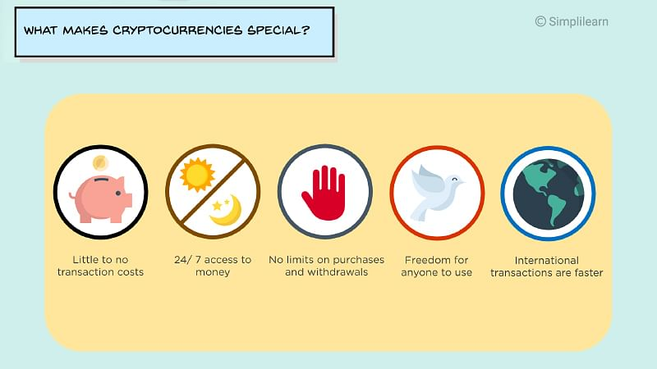

Cons associated with Cryptocurrency are as follows:

a) Some coins cannot be obtained in other fiat currencies: Some cryptocurrencies are only available in a single or a few fiat currencies. This forces the user to first convert these currencies into one of the major currencies, such as Bitcoin or Ethereum, and then to their desired currency via other exchanges. This only applies to a few cryptocurrencies. This results in the addition of superfluous transaction fees to the process.
b) Hacks: Although cryptocurrencies are extremely secure, exchanges are not. Most exchanges save user wallet info in order to correctly operate their user ID. Hackers can steal this information and get access to a large number of accounts. These hackers can quickly move funds from those accounts once they have gained access.
Some exchanges, including Bitfinex and Mt Gox, have been hacked in recent years, and Bitcoin worth thousands and millions of dollars has been stolen. Most exchanges are now highly secure, but there is always the possibility of another hack.
c) No refunds or Cancels: If there is a disagreement between the parties involved or if funds are sent to the wrong wallet address by mistake, the sender cannot retrieve the coin. Many people can utilize this to defraud others for their money. Because there are no refunds, one can simply be formed for a transaction for which they never received the product or services.
d) Security threats: Hackers and malicious users can create as much as they want from virtual currency if they break the system and know the method of virtual currency creations. This will lead to the ability to create fake virtual currency or steal virtual currency by just changing the accounts balances. For example, selling in-game virtual items and virtual currency is against World of Warcraft (WoW) game policies. Therefore, many users log into WoW gold selling websites to buy virtual gold in order to pay for virtual items that they need. Many of WoW gold selling websites are not reliable and they are vulnerable to hacking and many users are complaining about paying real money for nothing or for fake virtual currency.

e) Collapse concerns in cryptocurrency systems: Unlimited issuing of virtual currency in the variety virtual communities will lead to economic problems since its issuing is not based on the demand and supply. It is possible for some providers such as Second Life to issue unlimited Linden Dollars and increase their virtual items prices in order to gain more real revenues. On the other hand, it will suffer from inflation and economic issues leading to collapse in the virtual currency system.
f) Impact on real monetary systems: Since some virtual currency systems are connected with real world monetary systems, they may affect the demands and supply facilities of real world money. For example, enabling users to purchase virtual and real goods and services with virtual currency in some platforms may reduce the demands on real money. Users will no longer depend on real money to buy what they want and they will use virtual money instead. On the other hand, some platforms enable users to exchange their virtual currency with real currency and this will increase the demands on real world currency. This fluctuation will affect on the real monetary systems.
g) Gold farming risks: Gold farming term is very popular in China and developing countries. Gold farmers are players who play in social games such as World of Warcraft in order to gain gold, which is virtual currency of the game, and then sell it for real money. The targeted buyers are the players who do not have enough time to play and compete for gaining virtual currency. In fact, huge cash flow is generated from gold farming process and it is not controlled and regulated. This will increase fraud and financial risks where virtual currency is exchanged with real money in unreliable environment.
h) Fluctuation in virtual currency value: According to Chow and Guo study, it is observed that when the popularity of a virtual community drops, the value of its virtual currency will be devalued. For example, users who own 1000 units of virtual currency can buy from variety of 100 items. In case the provider of that virtual currency drops, users can only buy from 10 items with their 1000 units since dropping will be reflected in fewer goods and services especially in closed virtual communities.
i) Money laundering: Money laundering is one risk that is very likely to rise with the use of VC especially with platforms that enable users to exchange virtual currency with real money. In practical case occurred in Korea in 2008, the police arrested a group of 14 persons for laundering $38 million obtained from selling virtual currency. The group converted the amount of $38 million, which is generated by gold farming, from Korea to a paper company in China as payments for purchases.
j) Unknown identity risks: Since creating an account in most of virtual currency platforms such as social games and social networks is not authenticated, financial transactions cannot be monitored very well. Gamers and users can create more than one account with unknown identities and use them for illegal transactions. There is no way to recognize the source of creating or cashing out the virtual currencies. This leads to inability to track the transactions in case of money laundering suspicion. Moreover, unknown identity will enable criminals to get paid with virtual currency for their crimes.

Prospects of Cryptocurrencies in India
The Union Government has recently discussed a ban on private cryptocurrencies in a new bill, "Cryptocurrency and Official Digital Currency Bill Regulations, 2021(Cryptocurrency Bill 2021) ". All private cryptocurrencies, including Bitcoin, will be banned in India if this bill is implemented. The Government of India talked about the development of cryptocurrencies under the bill. If India produces its systematic blockchain, India has many advantages. For example, transactions are more secure. Since India controls its cryptocurrency, there is no further change in the value of the cryptocurrency. India enforces its cryptocurrency legislation. This may include explicit legal provisions regarding the abuse of cryptocurrency mechanisms. Since cryptocurrencies are implemented via the blockchain, their verification methods are also transparent. However, India also faces some challenges related to cryptocurrencies, such as identifying illegal transactions. This information remains sensitive in other cryptocurrencies such as Bitcoin. Currently, the number of trades executed over cryptocurrencies is increasing. With its growing popularity in India, cryptocurrencies can bring many benefits to India with a better legal environment and regulations. Here are some use cases: Cryptocurrencies create an alternative business environment for Indian entrepreneurs. Indian engineers are allowed to develop new technologies that can create new jobs by paying customers. You will find tactics. The brokerage cost is low, and the transaction can be made relatively cheap.
Conclusion: Crypto-currency is such an invention which has become a global phenomenon. Earlier RBI warned the Indians from using cryptocurrency that to be associated with money laundering and terrorist financing. However, cryptocurrency is a modern technology and a tool which needs to look forward for. Even though there has been no regulatory response from the Indian government, the number of investors in cryptocurrency is increasing rather swiftly over the last few years. Indian government should take responsible steps now to regulate such currency as its user in India is rapidly growing. Future of cryptocurrency in India looks promising and there is ray of hope
References
[1] Akhtar et al (2019) “Potential of Blockchain Technology in Digital
Currency: A Review," 2019 16th International Computer Conference on Wavelet Active Media Technology and Information Processing, 2019, pp. 85-91, doi: 10.1109/ICCWAMTIP47768.2019.9067546.
[2] Alzahrani and T. U. Daim, (2019) "Analysis of the Cryptocurrency
Adoption Decision: Literature Review," 2019 Portland International Conference on Management of Engineering and Technology (PICMET) pp. 1-11, doi: 10.23919/PICMET.2019.8893819.
[3]AdamBaron(2019)https://www.investopedia.com/articles/forex/091013/future-cryptocurrency.asp
[4]BilalJafar(2021)https://www.financemagnates.com/cryptocurrency/news/top-5-
cryptocurrencies-of-2021/
[5] Bradley Dunseith (2017) https://www.india-
briefing.com/news/cryptocurrency-bitcoin-india-usage-regulation-
15343. Html/
[6] Chan, Q., Ding, W., Lin, C., & Rossi, A. G. (2021, January 08). An Inside Look into Cryptocurrency Exchanges. Retrieved from https://papers.ssrn.com/sol3/papers.cfm?abstract_id=3759062
[7] Chohan, U. W. (2017, December 23). The Double Spending Problem and Cryptocurrencies. Retrieved from https://papers.ssrn.com/sol3/papers.cfm?abstract_id=3090174
[8] Crypto Regulations in India. (2021, March 25). Retrieved from
https://complyadvantage.com/knowledgebase/crypto-regulations/cryptocurrency-
regulations-India/
[9] Does Cryptocurrency Attract Tax in India? Here's What We Know. (2021, July
20). Retrieved from https://www.india-briefing.com/news/what-are-the-tax-
Implications-for-cryptocurrency-assets-in-india-22610.html/
[10] Francis, J. C. (2019, April 12). Bitcoins, Cryptocurrencies and BlockChains. Retrieved from
https://papers.ssrn.com/sol3/papers.cfm?abstract_id=3371051
[11] Giudici, G., Milne, A., & Vinogradov, D. (2019, September 17). Cryptocurrencies: Market analysis and perspectives.
Retrieved from https://link.springer.com/article/10.1007/s40812-019-00138-6
[12] Harit, P. (2020, June 24). Cryptocurrency and Social Justice: A Study of Indian Taxation Laws on Emerging Virtual Challenges. Retrieved from
https://papers.ssrn.com/sol3/papers.cfm?abstract_id=3615059
[13] Härdle, W. K., Harvey, C. R., & Reule, R. C. (2019, April 29). Understanding Cryptocurrencies. Retrieved from https://papers.ssrn.com/sol3/papers.cfm?abstract_id=3360304

