Preparation of Mixed Metal Oxide (Zn and CuO) nanoparticles doped Polymer (PMMA) composite films using solution cast method
Jyoti, Manu Faujdar*

Vivekananda Global University, Jaipur

ABSTRACT

We developed mixed zinc-copper oxide, pure copper oxide, and pure zinc oxide (ZnO, CuO) polymer composite films in five different ratios by Sol-Gel: 2-10gm, 4-10gm, 6-10gm, 8-10gm, and 10-10gm. We created pure PMMA and made weight-percentage doped PMMA films with pure ZnO, pure CuO, and mixed Zinc-Copper oxide. Composite films made of prepared materials and PMMA Using the solution-casting method, films up to 100 millimetres thickness.
- Introduction
By the middle of the twenty-first century, nanotechnology is most likely going to have a big impact on our economy and society. Science and innovation research in this field ensures advancements in fields like energy, biotechnology, information technology, materials and assembly, nano gadgets, medicine and medical services, and national security. There is a general consensus that nanotechnology will lead the next technological revolution. [1-3] Polymer nano composites are special because they are lightweight, highly flexible, and skillfully made at low cost and temperature. In many areas of life, polymers are replacing metals and are of great interest to society. They can also be further modified for use in modern applications. In industries like packaging, construction, and medical applications, they are preferred over conventional materials. In order to process polymeric materials, pressure and heat must be applied.[1] A material is essentially a combination of at least two different materials, each of which has unique properties. Typically, the term "composite" refers to materials that are created mechanically by joining at least two distinct materials. Although the polymer has amazing optical qualities, it is poorly scratch resistant. The rigid polymer chains give it a tolerable level of dimensional stability. [7] It is resistant to the elements and stable against corrosive and soluble bases. It is attacked by a few natural solvents and has a greater effect strength than polystyrene or glass. It has the most simple, straightforward optical properties of any thermoplastic that is commercially available.[8] PMMA is a transparent plastic that transmits light nearly perfectly (92%), making it suitable to serve as a conduit for light. Dichloromethane, a chemical compound, PMMA dissolvent is considered because it has the highest soluble limit for PMMA, the best evaporation rates, and the lowest chemical hazard due to its lower viscosity than alternative solvents. [4-6,9] Due to their numerous uses in superconductors, optical, electrical, catalytic, photocatalytic degradation, gas sensors, and biosensors, oxide (CuO) nanoparticles are widely used.[10] The authors have previously studied the synthesis of potassium chromate, [10] potassium permanganate (KMnO4), [11] tin chloride (SnCl2), and [12] doped poly (methylmethacrylate) (PMMA) composite films. The authors have stated in all of these publications that all dopant material significantly alters the optical parameters. We were intrigued by the results and inspired to look further, which is why we reported here. In this article, we describe how to make ZnO and CuO nanoparticles and ZnCuO/PMMA nanocomposite films.

2.1 Materials
During the entire research work the chemicals used are listed in the below table:
S. No. | Name of Chemical | Chemical Formula | Structure | Firm | Physical Properties
1 | Zinc Chloride | ZnCl₂ | 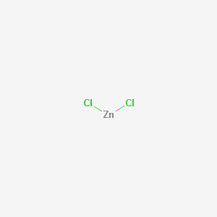 | Merck Life Science Private Limited, Mumbai | Soluble in ethanol, glycerol and acetone  Density-2.907 g/cm³  White crystalline solid
2 | Copper (II) Chloride | CuCl₂ | 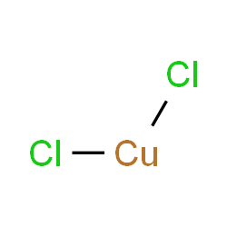 | Merch Specialties Private Limited, Mumbai | Blue-green solid (dehydrate)  Soluble in methanol ,ethanol,  Acetone.  Density-2.51g/cm³ (dehydrate)
3 | Lead(II)Chloride Anhydrous pure 98% | PbCl₂ | 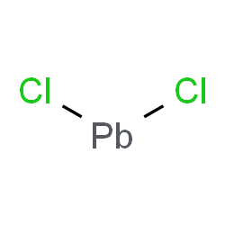 | Loba Chemie Pvt. Ltd., Mumbai | white odorless solid  Slightly Soluble in dilute HCl, ammonia;  Density- 5.85 g/cm³
4 | Hydrochloric Acid Pure 35% | HCl | H-Cl | Himedia Laboratories | Liquid, colourless- light yellow  Soluble in cold water, hot water.
5 | Ethyl Alcohol | C₂H₅OH | 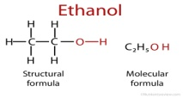 | Himedia Laboratories | Colorless liquid easily soluble in water and is itself a good solvent.
6 | Dichloromethane purity of 99.8% | CH₂Cl₂ | 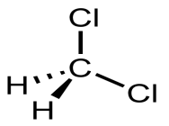 | Merch Specialties Private Limited, Mumbai | Colorless liquid Miscible in ethyl Acetate, Alcohol, Hexanes, Benzene, CCl₄, diethyl Ether, CHCl₃ .
7 | Poly (methylmethacrylate) | (C₅O₂H₈) _{n} | 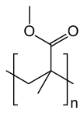 | M/s Gadara Chemicals, Bharuch. | Density- 1.18 g/cm³

2.2.1 Synthesis of Zinc Oxide Nanoparticles using Solution Casting:
For the creation of zinc oxide particles, zinc chloride (ZnCl2) and sodium hydroxide (NaOH) were the two initial ingredients. We used a magnetic stirrer to stir 5g of NaOH in distilled water at 50 degrees Celsius in a beaker. Then, we added 8.5 gm of zinc chloride to distilled water in a beaker and continued to stir it with a different magnetic stirrer. ZnCl2 solution was continuously and dropwise poured into NaOH solution while being stirred. When ZnCl2 is added to an aqueous alkaline solution, ZnO precipitates immediately, changing the solution's colour from transparent to white. For the complete removal of residues from the suspension, precipitated was washed five times with distilled water. The final precipitates were then achieved after drying.
2.2.2 Synthesis of Copper Oxide Nanoparticles using Solution Casting:
sodium and copper chloride (CuCl2) the two initial ingredients for the production of copper oxide nanoparticles were sodium hydroxide (NaOH). We used a 1.5.gm of NaOH in 40 ml of ethanol and stirred it at room temperature in a beaker being stirred by a magnet. Afterwards, we used a beaker to hold 1 g of copper chloride in ethanol used a different magnetic stirrer to stir it. added NaOH solution Drop by drop, continuously, and allowed to in CuCl2 solution thirty minutes of stirring. The NaOH solution was dropped reaction happens in a copper chloride solution, and Dark blue turns to black in colour. Paper filters are used for sample was permitted after the gel was filtered and washed with water and dry at room temperature.
2.2.3 Synthesis of Zinc-Copper Oxide Nano Material Using Sol-Gel Technique in Different Composition
The precursors Copper Chloride CuCl₂ and Zinc Chloride ZnCl₂ were made to react with hydrochloric acid and ethanol in presence of dry ether at 60°C to produce the mixed metal as explained in the reaction stated below: -

CuCl₂+ZnCl₂+2HCl+C₂H₅OH $\frac{ZnCl2(anhy.)}{Dry ether or Hcl}$ [Cu-O-Zn] + 3C₂H₆ + 6Cl
-------------- (1)

The ZnCl₂ in the above reaction is anhydrous in nature and is the Lucas reagent that acts like a basic reactia. Obtained compound [Cu-O-Zn]’s IUPAC name is 1-Copper, 2-Zinc superoxide. These MMO or mixed metal oxides have been prepared for different ratio of precursor salts viz 2:5 and 4:5 as explained in subsequent sections.
2.2.4 Synthesis of Zinc-Copper Oxide in Ratio of 2:5
For above preparation we took 10gm copper chloride and 4gm zinc chloride to obtain Zn-CuO ratio 2:5. This will be referred as sample COZ1. The white colored Zinc chloride anhydrous powder and blue colored copper chloride powder in their mentioned fixed ratios were made to react with 20 ml of hydrochloric acid in a beaker kept over a magnetic stirrer for almost an hour.
After this we added ethanol (w/v 99%) in to this solution which was of yellowish color with a tinge of blue and allowed it to keep stirring for another four hours at room temperature till the solution turn into a denser gel of blue color. In this process the precursors react with the OH functional group of ethanol. When stirring was stopped and evaporation of solution was allowed to occur at room temperature, a reaction occurred within several minutes, followed by a rapid formation of a rigid bluish green colored gel form of Zinc-Copper oxide which is shown in figure 2.1 Then for purpose of characterization we heat this gel at 60°C in an oven to obtain the dry powder.
This prepared MMO gels will be referred to as COZ1.
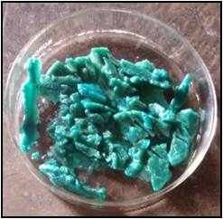
Figure 2.1: Picture of Xerogels of Zn-CuO in ratio 2:5

2.2.2 Synthesis of Zinc-Copper oxide in 4:5 ratios:
For synthesis of zinc-copper oxide in ratio 4:5 we adopted the same procedure as explained in 2.2.1 except that the amount of precursor were taken in the following ratio ; we took 10gm of copper chloride and 8gm of zinc chloride to react this with hydrochloric acid and later ethanol. This prepared Zn-CuO gels will be referred to as COZ2.
One can see the difference in colour, texture and homogeneity on change of composition.
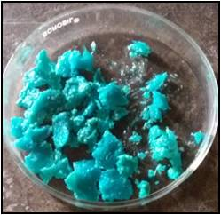
Figure 2.2: Pictures of xerogels of zinc-copper oxide in 4:5 ratios

2.3 Development of Pure PMMA Polymer Film
The thin film of pure PMMA is prepared using solution cast method. The procedure undertaken is explained below:

We took a calculated fixed amount of granular PMMA and dissolved it in solution of dichloromethane and ethanol using a ultrasonicator. The process of stirring in ultrasonicator continued for 6 hours at room temperature to assure the uniform dispersion of polymeric chains to provide homogeneous solution. After this we pour the solution into flat bottom glass Petri dish of 9cm diameter. The petri dish is made to be placed over another petri dish of larger diameter containing mercury so that the smaller Petri dish flouts over mercury providing uniform leveling for preparation of film. We leave this for 24 hours so that the solvent disappears slowly at pervasive temperatures at atmospheric pressure. And the sample is obtained in form of dry film of 120 micro meters PMMA. This dried film is taken out from petri dish using tweeze clamp.

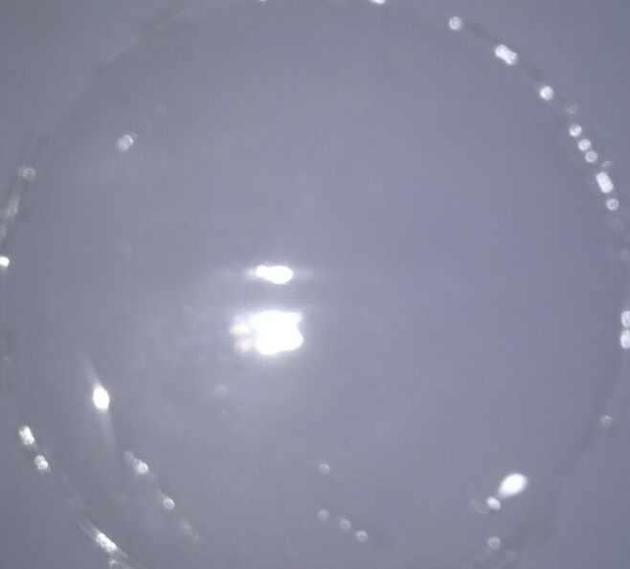
Figure 2.2: Film of Pure PMMA Polymers

    - Development of Zinc-Copper Oxide doped PMMA Composites
2.3.1.1 Development of Zinc-Copper Oxide of ratio in 2:5 Doped PMMA Films
A foresee amount of paplour PMMA is measured and dissolved in (20ml) dichloromethane with sprit which perform as a solvent. The molten PMMA is stirred uniformly on an ultra sonicator for 6 hours to assure the homogenous dispersion of polymer particles without concentricity throughout the solvent to obtain a homogeneous solution. The solution was stirred at room temperature. After that we took this solution in a 100ml beaker and added (.1) gm. of COZ1 and allowed this on a magnetic stirrer for overnight. Then was poured this into a glass flat bottom Petri dish floated over mercury for 24 hours, and the solvent was allowed to disappear slowly at pervasive temperature under atmospheric pressure for almost twenty-four hours. The dried samples were then peeled off by tweezers clamp. The sample film of PCOZ1 thickness 120micrometer is shown below.

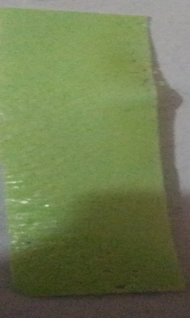

Figure 2.3: (a) Developed Zn-CuO-PMMA for 2:5 ratio solution (b) Zn-CuO of 2:5 doped PMMA Polymer Composite Film

2.3.1.2 Development of Zinc-Copper Oxide of Ratio in 4:5 Doped PMMA Films
For synthesis of Zn-CuO doped PMMA composite film for another composition we adopted the same procedure as explained in 2.3.1, the developed MMO doped PMMA composite film in figure 2.4.
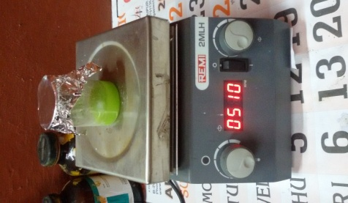

Figure 2.4: (a) Developed Zn-CuO-PMMA for 4:5 solutions (b) Zn-CuO of 4:5 doped PMMA Composite Film

2.4 Synthesis of Lead-Copper Oxide Nano Compound Using Sol-Gel Technique
For this purpose we used the respective metals and precursor; reacted them with hydrochloric acid and ethyl alcohol to obtain the respective mixed metal oxides. The preparation of each mixed metal oxide is explained below: -

These mixed metal oxides have been prepared for different ratio of precursor salts viz 2:5 and 4:5. The sol–gel process is a method for producing gel from solid materials to small molecules. The method is used for the formation of MO, MMO, and M-O-M’. It can be obtained by hydrolysis and partial summarization of precursors such as metal chlorides, metal aloxides, metal nitrates. The further summarization of sol particles in to a gel material. The gel is a dysphasic material in which the solids encapsulate the solvent. And for knowing these structural properties we have characterized by X- ray diffraction, Raman spectroscopy, FTIR spectroscopy, and FESEM technique.
2.4.1 Synthesis of Lead-Copper Oxide in ratio of 2:5
For this Synthesis we took the metal chlorides starting precursor reacted them with hydrochloric acid and ethanol to obtain the respective metal-oxide-metal. The preparation of metal-oxide-metal is explained below: -

PbCl₂ + CuCl₂ + 2HCl + 2C₂H₅OH $\frac{ZnCl2(anhy.)}{Dry ether or HCl}$ [Pb-O-Cu] + 3C₂H₆ + 6Cl

These mixed/metal oxides or metal-oxide-metal have been prepared for different ratio of precursor salts viz 2:5. For preparation of Lead-Copper Oxide in different ratios of constituent’s metals we took - 4gm lead chloride in 10gm copper chloride to obtain Lead-Copper oxide ratio 2:5.
After this lead chloride and copper chloride made them to react with 20ml of hydrochloric acid and kept it over magnetic stirrer for 1 hour, after this we added ethyl alcohol in to this solution and kept stirring it for four hour at room temperature during this time solution reacts with OH group. A reaction occurred within several minutes, followed by a rapid formation of a rigid gel. Then we heat this solution at 60 degree centigrade temperature. So that the solvents evaporates leaving behind green colored gel form of lead-copper oxide (i.e. metal-oxide-metal). And this gel dried in oven 60 degree temperature, then gel solvent changes in to hydrous form . we could not perform the calcinations process of M-O-M because higher than 60 degree above temperature its changes their properties and colour became green to black.
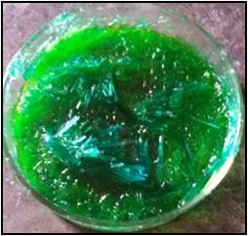
Figure 2.5: Picture of Prepared [Pb-CuO]

2.4.2 Synthesis of Lead-Copper Oxide in Ratio of 4:5:
For this Synthesis we took the metal chlorides as starting precursor reacted them with hydrochloric acid and ethanol to obtain the respective metal-oxide-metal. The preparation of metal-oxide-metal is explained below:-
These mixed/metal oxide compound or metal-oxide-metal compound have been prepared for different ratio of precursor salts viz 4:5. For preparation of 1-copper,2-lead superoxide in different ratios of constituents metals we took - 8gm lead chloride in 10gm copper chloride to obtain lead-copper oxide ratio 4:5.
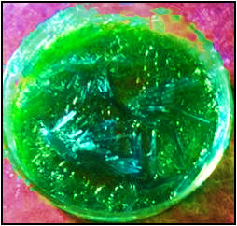
Figure 2.6: Picture of prepared Pb-CuO

After this lead chloride and copper chloride made them to react with 20ml of hydrochloric acid and kept it over magnetic stirrer for 1 hour, after this we added ethyl alcohol in to this solution and kept stirring it for four hour at room temperature during this time solution reacts with OH group. A reaction occurred within several minutes, followed by a rapid formation of a rigid gel. Then we heat this solution at 60 degree centigrade temperature. So that the solvents evaporate leaving behind green colored gel form of lead-copper oxide (i.e. mixed metal oxide). And this gel dried in oven 60 degree temperature, then gel solvent changes in to hydrous form .we couldn’t perform the calcinations process of M-O-M compound because higher than 60 degree above temperature its changes their properties and color became green to black.

2.5 Development of Lead-Copper Oxide Nano Compound Doped PMMA Composites
2.5.1 Synthesis of Lead-Copper Oxide of Ratio in 2:5 doped PMMA Films
A foresee amount of paplour PMMA is measured and decomposed in dichloromethane with sprit which perform as a solvent. The diffluent (molted) PMMA is stirred uniformly on a magnetic stirrer for 6 hours to assure the dispersion of polymer particles without concentricity throughout the solvent to get a specious (homogeneous) solution. The solution was stirred at room temperature. After that we have added lead-copper oxide which is obtained from sol-gel process, in the ratios of 2:5 in (.1) gm quantity and stirred for overnight. Then poured into a glass flat bottom Petri dish floated over mercury for 24 hours, and the solvent was allowed to disappear slowly at pervasive temperature under atmospheric pressure for almost twenty four hours. The dried samples were then peeled off by tweezers clamp. The pure PMMA films were made by solution casting method, following the same procedure.

Figure 2.6: Picture of Prepared Pb-CuO of 2:5 Ratio Film

2.5.2 Synthesis of Lead-Copper Oxide of ratio in 4:5 doped PMMA Films
A foresee amount of paplour PMMA is measured and decomposed in dichloromethane with sprit which works as a solvent. The diffluent (molted) PMMA is stirred uniformly on a magnetic stirrer for 6 hrs to assure the dispersion of polymer particles without concentricity throughout the solvent to get a specious (homogeneous) solution. The solution was stirred at room temperature. After that we have added lead-copper oxide which is obtained from sol-gel process, in the ratios of 4:5 in (.1) gm. quantity and stirred for overnight . Then poured into a glass flat bottom Petri dish floated over mercury for 24 hours, and the solvent was allowed to disappear slowly at pervasive temperature under atmospheric pressure for almost twenty four hours. The dried samples were then peeled off by tweezers clamp. The pure PMMA films were made by solution casting method by following the same procedure.
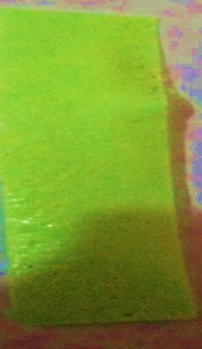
Figure 2.7: Picture of Prepared Pb-CuO of 4:5 Ratio Films

We have used for synthesized Zn-Cu oxide and Pb-Cu oxide nano-particles and their doped PMMA films are studied using “X-ray” diffractometer “XRD” (PANalytical unit using software X'Pert°Pro3) equipped “with Cu-K_{α} radiation” of wavelength ƛ = “1.5406A°” at accelerating voltage 30 kV in Malviya National Instiute of Technology. The surface structure of the composite samples was investigated using S-3700N FESEM field emission scanning electron microscope in material research Centre (MNIT, Jaipur). The composition of functional groups of our powdered samples and prepared films were examined by FTIR Perkin Elmer Spectrum Version 10.4.00 FTIR Spectrophotometer in the region 400-4000 cm⁻¹ in material research center (MNIT, Jaipur). The Raman spectrum of the samples was measured using a STR5050 (400 nm-3000 nm) confocal micro Raman spectrometer. The diode pumped solid state (DPSS) laser of wavelength 532 nm was used as a source of excitation in material research center (MNIT, Jaipur). The FL spectra were obtained using fluorescence emission spectroscopy in material research center (MNIT, Jaipur).
References:
1. Kalotra P, Singh N, Dadhich A, Shrivastava S, Soni G and Vijay Y K 2019 Adv. Sc. Eng. and Med. 101.
2. Bafna M, Gupta A K, Khanna R K 2019Mater. Today:Proc. MATPR7592
3. Bafna M, Gupta A K, Khanna R K, Vijay Y K 2018 Bull. of Mat. Sc. 41 160
4. Khodair Z T, Saeed M H and Abdul-Allah M H 2014 Iraqi J of Phy 12(24) 47
5. Najeeb H N, Dahash G A, Haddawi S F, and Jassim S M 2014 Chem and Mater Eng 2(6) 145
6. Bafna M and Garg N 2017J of Sc. and Tech. 6(1) 27
7. Ramesan T M and Bijudas K 2016 J. of Chem. & Pharm. Sc. 1 52
8. Roaaramadan, Ramajaj E K, and Hasan A A 2014 Int. J of Elec. Eng. 2(3) 6
9. Choudhary S 2017 Ind J of Chem tech, 24 311
10. Bafna M, Gupta A K, Khanna R K 2018 J. of Emer Tech. and Inno. Res. 5(2) 433
11. Vijay S, Vijayavargiya J K, Sharma A and Vijay Y K 2013 Amer. Sc Pub 5 1
12. Bafna M, Garg N, Gupta A K 2018 J. of Emer Tech. and Inno. Res. 5(1) 494
13. Abdulallah M. H., Chiad S. S., Habubi N. F, DiyalaJournal for Pure Science, 6 (2) (2010) 161-169.
14. Najeeb H. N., Balakit A.A., Wahab G. A. Kodeary A. K, Acadmic Research Institute, (2014) 48-56.
15. Abdullah O G, Shujahadeen B A and Rasheed M A 2016 Results in physics (Elsevier Publication) vol 6, p 1103.
16. Kittel C 2005 Introduction to solid state physics (USA: John Wiley & Sons) 8th edn
17. Ali B R and Kadhem F N 2013 Int. J. Appl. Innov. Eng. Manag. 2114
18. Abdullah O G, Shujahadeen B A and Rasheed M A 2016 Results in physics (ElsevierPublication) vol 6, p 1103
19. Khodair Z T, Saeed M H and Abdulallah M H 2014 Iraqi J. Phys. 1247
20. K. Hedayati, 2015, journal of nanostructures,395-401
21. A. Radhakrishnan, B. Beena,Indian Journal of Advances in Chemical Science 2014, 158-161

