Concept and Evolution of Evidence-Based Practice in Nursing
Assia Haleema
Tutor research scholar college of nursing GMC, Srinagar
assiahaleema@gmail.com
Abstract:
The concept of evidence based practice from a historical point as it is related to educational and practice domain. The concept of EBP is defined as similarities and dissimilarities’ towards the evidence based medicine .it is necessary to have proactive role of registered nurses to search for research knowledge in order to reduce gap between theory and practice. Therefore it is the process of locating, apprasing and applying research based evidence and taking advantage of technological advances in which nursing can move forward as a well informed discipline.
Key words: Education , Evidence based practice, Practice ,education,nursing.
INTRODUCTION;
It is a process of locating, appraising, and applying the best evidence available from the nursing and medical literature to improve quality of clinical nursing practice.
It is using best research available along with clinical expertise and patient.
It is a method of problem solving that identify clinical problem and find out the best appropriate solution based on research literature.
EBP improves the delivery of health care, strengths outcomes, diminishes geographical differences in care and cuts costs. Employing EBP has been found to increase overall job satisfaction.
Evidence-based practice has gained increasing popularity since its introduction and is the accepted standards of practice, policy, management and education within health services across the world .Health care professionals are encouraged to use current research in their practice to deliver the highest quality of care, achieve optimal outcomes, promote cost-effective client care and ensure accountability and transparency in decision-making.

Evidence based practice is thus a process that involves : 5As, which stands; Ask, Acess Appraise , Apply, Audit.
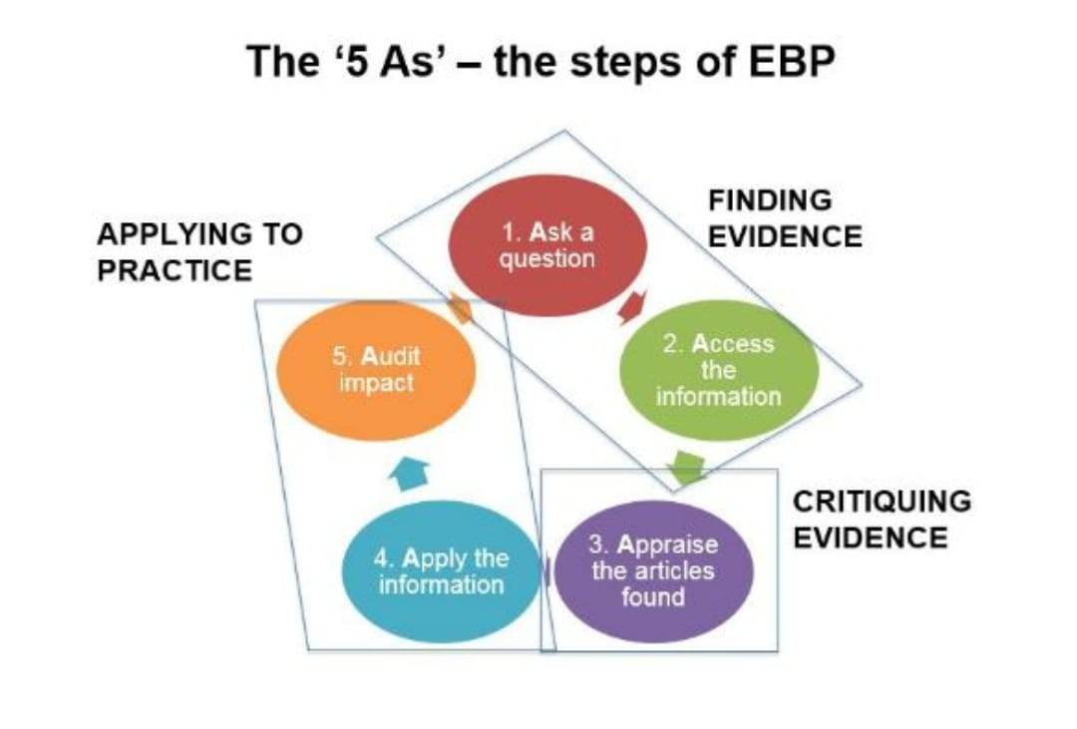

TERMINOLOGY:
- Evidence: It is something that furnishes proof or something legally submitted to ascertain in the truth of matter.
- Practice: The actual application or use of an idea, belief or method as opposed to theories relating to it.
- Evidence based practice: It is systemic interconnecting of scientifically generated evidence with the exact knowledge of expert practitioner to achieve a change in a particular practice for the benefit of a well define client/patient group(French 1999).
- Evidence based nursing: It is a process by which nurses make clinical decisions using the best available research evidence, their clinical expertise and patient preferences (Mulhall 1998).

EVOLUTION OF EVIDENCE BASED PRACTICE:
In 1972, Archie Cochrane pointed out the importance of properly testing the effectiveness of health care strategies, and stressed the role of randomized controlled studies to provide evidence on which health care is based. The term "evidence-based medicine" was introduced by Guyatt- et al in 1992 to shift the emphasis in clinical decision making from "intuition, unsystematic clinical experience, and pathophysiologic rationale" to scientific, clinically relevant research.
In 1996, Sackett -et al explained evidence-based clinical decision making as a combination of not only research evidence but also clinical expertise, taking into account the patient’s preferences. Clinical expertise was defined as the “proficiency and judgment that individual clinicians acquire through clinical experience and clinical practice”.
Although EBP has only recently found widespread integration in modern nursing practice ,starting in 1990s, its roots run deep in nursing history.
.some nurse researchers trace it back to Florence NightingaleIn the 1800s, her effort to improve patient outcomes in the face of unsanitary conditions by employing accurate observation and analysis is often considered the first example of EBP.
While supervising the barrack hospital in Scutari, Turkey, during the Crimean war, Nightingale applied critical thinking skills, evidence and experimentation to improve patient health. She also used statistics to better anticipate morbidity and mortality in her patients. Although she lacked the wealth of research we have today, she was nevertheless a trailblazer for EBP in nursing.
Nurses employing EBP are able to standardize care, decrease medical errors, and bring positive change to their patients, their communities and the world around. Ultimately, EBP gives nurses the opportunity to take a more active role in shaping the practice of nursing with other healthcare professionals and clinicians. It means living up to the example that Nightingale set and creating a better healthcare system from the inside.
Healthcare is changing, and those who are able to navigate the demands of EBP will be positioned to facilitate that change in their own practice.
Beginning with Florence Nightingale in the 1800s and evolving again within the medical community, evidence-based practice continues to advance along with the nursing discipline.
Evidence-based practice is foundational to undergraduate and graduate nursing education and is a way for the nursing discipline to minimize the theory to practice gap.
It is crucial that registered nurses be proactive in their quest for research knowledge, so that the gap between theory and practice continues to close. Utilizing nursing best practice guidelines, reviewing and implementing applicable research evidence, and taking advantage of technological advances are all ways in which nursing can move forward as a well-informed discipline.
In addition to caring for fallen soldiers in the 1800s, Florence Nightingale, iconic founder of modern nursing, was also recognized for being an outspoken social reformer and steadfast statistician.
The “Lady with the Lamp” kept careful record of health status connecting illnesses to injuries. From this record, Nightingale was able to draw conclusions that would have a profound effect on modern medicine, such as linking unsanitary conditions and poorly ventilated spaces to a patient’s poor health. Her efforts thus comprise a prime example of evidence-based practice .She used the systematic process of collecting, processing, and implementing research findings to improve clinical practice and patient outcomes. The ultimate goal of the evidence-based nursing, is to help nurses provide the highest -quality, most cost-efficient care possible. Today, evidence-based nursing practice is part of the curriculum for most nursing degrees.
Practice | Evidence
Critical care
Reduction of VAP by oral care | - Ventilator – associated pneumonia is defines as pneumonia that occurs 48 hours or more after intubation.  - oral hygiene has been identified as one important weapon in the defense against VAP.
Care of CVP with Chlorohexidine | - Chlorohexidine (effective skin disinfect) bathing was associated with significant reductions in central venous catheter – associated bloodstream infections.  - To prevent infection, the site of cannula insertion should be cleaned for a minimum of 30 seconds with equivalent skin cleansing solution(0.5% chlorohexidine in 70% alcohol)
Music therapy – a complementary treatment for mechanically ventilated intensive care patients. | - A significant fall in systolic and diastolic blood pressure was seen during the music therapy session and a corresponding rise after cessation of treatment.
Hyperbaric oxygen therapy for the adjunctive treatment of traumatic brain injury | - HBOT may reduce the risk of death and improve the final GCS and may reduce patient death and disability.  - HBOT can improve oxygen supply to the injured brain, reduce swelling associated with low oxygen levels and reduce the volume of brain that will ultimately perish.
Miking and stripping is no longer recommended to maintain patency | - This practice causes increased intra pleural pressure and damages the pleural tissue.  - New tube contains a non – thrombogenic coating, thus decreases the potential for clotting.  - It is necessary to help the drainage move to the tubing, apply a gentle squeeze – release motion to small segments of the chest tube between the fingers.
Deep breathing and coughing exercises for post – surgical patients. | - Deep breathing and coughing exercises can decrease the risk of lung complications following surgery, deep breathing helps to get more oxygen to the body’s cells.  - Coughing and deep breathing work to clear mucus and allow moist air to enter the airways.
EXAMPLES OF EVIDENCE BASED PRACTICE IN NURSING:

SUMMARY:
To sum up, evidence-based-practice nursing involves continuous professional development and a commitment to lifelong learning nursing must keep abreast of the latest research and clinical practice guidelines to ensure that their practice is informed by the latest research. This requires a commitment, ongoing learning and professional development, including attending conferences, reading scholarly articles, and participating in continuous education programs.

References
- American Association of Colleges of Nursing. (2013). Evidence-based practice. Retrieved from http://www.aacn.nche.edu/qsen/workshop-details/new-orleans/KD-EBP.pdf
- Aravind, M., & Chung, K.C. (2009). Evidence-based medicine and hospital reform: Tracing origins back to Florence Nightingale. Plastic and Reconstructive Surgery, 125(1), 403
  - 409. Retrieved from http://www.ncbi.nlm.nih.gov/pubmed/19910854
- BBC History. (n.d.). Florence Nightingale (1820-1910). Retrieved from http://www.bbc.co.uk/history/historic_figures/nightingale_florence.shtml
- Beyea, S.C., & Slattery, M.J. (2013). Historical perspectives on evidence-based nursing. Nursing Science Quarterly, 26(2), 152-155. Retrieved from http://nsq.sagepub.com/content/26/2/152.abstract
- Brady, N., & Lewin, L. (2007). Evidence-based practice in nursing: Bridging the gap between research and practice. Journal of Pediatric Health Care, 21, 53-56. Retrieved from http://www.researchgate.net/publication/6601749_Evidence-based_practice_in_nursing_bridging_the_gap_between_research_and_practice
- Canadian Nurses Association. (n.d.). Strategies to promote evidence-based practice/evidence informed decision-making nurses. Retrieved from http://www.nurseone.ca/Default.aspx?portlet=StaticHtmlViewerPortlet&plang=1&ptnme=Strategies%20to%20promote%20evidence-based%20practice
- Canadian Nurses Association. (2010). Evidence-informed decision making and nursing practice. Retrieved from http://www.nanb.nb.ca/PDF/CNA-Evidence_Informed_Decision_Making_and_Nursing_Practice_E.pdf
- Carper, B. (1978). Fundamental patterns of knowing in nursing. Advances in Nursing Science, 1(1), 13-24. Retrieved from http://journals.lww.com/advancesinnursingscience/Citation/1978/10000/Fundamental_Patterns_of_Knowing_in_Nursing_.4.aspx
- Cochrane Collection. (2013). Background of Cochrane. Retrieved from http://www.cochrane.org/about-us/history/.

