Chapter name -Biomass
Ajay Kumar
Assistant professor(Guest)
9319603208
scienceaware01@gmail.com

Abstract
Fossil fuels have been crucial for human civilizations, influencing technology, society, economy, and international development. Today, the majority of energy comes from coal, natural gas, and other fossil fuels. These non-renewable energy sources pose significant threats to human life and the environment, including air and water pollution and global warming. Biomass, an essential part of energy, can be used as a renewable energy source and can be used to produce biofuels for electricity and transportation. Biofuels are derived from biological carbon fixation and can be produced using various techniques and processes. Biomass is the fourth-largest energy source globally, and its main types include wood and agricultural products. Biomass can be transformed into fuels, chemicals, or electric energy through both the thermochemical and biochemical processes. Thermochemical processes involve heat and catalysts while biochemical processes use enzymes and microorganisms. Nanotechnology and nanomaterials have emerged as promising tools for biomass conversion. Nanoparticles (NPs) offer numerous advantages over other sources for biofuel synthesis due to their size, unique properties, and stability. Biomass conversion techniques for renewable energy production face challenges, including proper chemical characterization of feedstocks using methods like FT-ICR MS, GPC, and NMR can enhance performance in biomass conversion reactions. Impurities in biomass-derived feedstocks can reduce catalyst activity, making it necessary to design more active, selective, and stable catalysts and selecting the right solvent can enhance the reaction rates, selectivity, stability, and raw material solubility.

Chapter 06
6.1 Introduction
During the course of human civilizations energy regimes played fundamental role in urbanization and industrial development. Fossil fuels have been a key factor in the advancement of technology, society, the economy, and international development. Fossil fuels continue to dominate the world's energy systems. The majority of the energy used today originates from coal, natural gas, and other fossil fuels.(Wang et al. 2021)
The use of these high-carbon fuels in power plants, boilers, and combustion engines Coal, petroleum ions, and liquid petroleum gases (LPG) are examples of fossil fuels that are limited in quantity in nature since they are nonrenewable energy sources.
However, there are number of drawbacks associated with the applications of fossil fuels such as toxic carbon dioxide and greenhouse gas emissions are raising the earth's temperature and threatening a previously unprecedented change in the planet's chemistry and climate, with catastrophic consequences for the future of human civilization and ecosystems.(Perera 2018)
The consumption of fossil fuels poses a serious threat to the human beings and the environment, producing issues from air and water pollution to global warming.
Considering various alternative energy sources, biomass has been an indispensable part of energy. Every organic substance deriving directly or indirectly from the photosynthesis process is considered as biomass that can be a combination of naturally derived materials, originating from plants as well as all the materials composed of organic matrix except for plastics originating from petrochemical and fossil materials(Tursi 2019). Biomass could play a significant role as a source of renewable energy with enormous potential as a source of renewable energy, and can be used to make biofuels for electricity, transportation, etc. (Saleem 2022). Power generated from fuels derived from biomass is known as bioenergy. Using biomass to produce biofuels offers a solution to achieve a low-carbon environment and a sustainable circular economy. Biofuel is a type of fuel whose energy is derived from biological carbon fixation, it include fuels derived from biomass conversion, as well as solid biomass, liquid fuels and various biogases. Biofuels, which are produced by converting biomass using a various techniques and processes, can be one of the sources used to meet the world's energy needs. it has been taken into consideration as a substitute feedstock for the production of sustainable energy in the future. There are several conversion technologies and process options are available for biomass energy conversion such as physical conversion (mechanical pressing, briquetting, distillation of crops with high oil content ), Thermochemical conversion (combustion, gasification, and pyrolysis), chemical conversion (combustion, carbonation, gasification, thermal decomposition) and Biochemical conversion technologies (biological pre-treatments , selection of different microorganisms or enzymes). The process provides a platform to obtain fuels and chemicals such as biogas, hydrogen, ethanol, butanol, acetone and a wide range of organic acids. Biomass forms the fourth-largest energy source worldwide after coal, oil and natural gas. The main types of biomass include wood and agricultural products, such as crop waste, bagasse, solid waste, landfill gas and alcohol fuels. The use of nanotechnology and nanomaterials for biomass pretreatment, saccharification, fermentation process, lipid extraction, transesterification, anaerobic digestion has risen as a promising tool in providing cost-effective techniques to improve production quality. There are multiple advantages to using nanoparticles (NPs) over other sources for biofuel synthesis due to their size and unique properties such as the high surface area to volume ratio and special attributes such as a significant extent of crystallinity, catalytic activity, adsorption capacity, and stability(Arya et al. 2021)
6.2. Biomass
Biomass can be regarded as any organic material that originated from plants or animals. Thus, the United Nations Framework Convention on Climate Change UNFCCC in 2005 defined the biomass as follows “A non-fossilized and biodegradable organic material originating from plants, animals and micro-organisms. This shall also include products, by-products, residues and waste from agriculture, forestry and related industries as well as the non-fossilized and biodegradable organic fractions of industrial and municipal wastes” The definition of biomass varies depending on heterogeneity of the materials, the usage, and the source. However, in a broader sense, biomass is a collection of organically derived materials, including all products made of organic matrix and materials obtained from plants, such as crops, trees, shrubs, and algae, with the exception of plastics made from petrochemical and fossil elements.(Garba 2021)
6.2.1. Biomass Resources
Agricultural and forestry wastes (waste from the wood-processing industry), animal waste (from livestock farms), sewage, algae, and aquatic crops are the most significant biomass sources (as shown in Fig. 1). If municipal solid waste (MSW) and waste products from anthropogenic activities cannot be recycled during further processing, they are also included in the biomass category (Ben-Iwo, Manovic, and Longhurst 2016).Biomass resources that are available on a renewable basis and are used either directly as a fuel or converted to another form or energy product are commonly referred to as “feedstocks.”
(Fig. 1 different sources of biomass)
6.2.3 Classification of biomass
Biomasses can be classified into different categories based on quality, composition, products, origin, application and nature of their existence as well as the functionality biomass.
6.2.3 a. Classification based on biomass feedstock
Dedicated energy crops, crop wastes, forest residues, purpose-grown grasses, woody energy crops, algae, industrial wastes, sorted municipal solid waste, urban wood waste, and food waste are all examples of biomass feedstocks(as shown in fig.2). They also include algae, wood processing residues, municipal waste, and wet waste.
First-generation biomasses
First-generation(1st gen.) biomasses are edible biomass such as sugars and triglycerides etc.
Second-generation biomass
Second-generation (2nd Gen.)biomass consists of non-edible oils, municipal organic waste, and non-edible lignocellulose biomass, such as cereal straw, sugar cane bagasse, forestry crops, and kitchen vegetable waste.
Third-generation biomass
Third-generation(3rd Gen.) biomass consists of algal biomass the algal source gives high yields with lower resources and in less time than lignocellulose biomass. Algal species are grown in sea water, open ponds, and in photobioreactors thus, algal products do not compete with food. different species of algae can have varying compositions of nutrients such minerals, vitamins, amino acids, lipids, proteins, pigments, and carbohydrates as well as hemicellulose and lignin etc. Algae contain significant levels of lipids, hence the majority of microalgal species can be used to produce biodiesel.
Fourth-generation biomass
Fourth-generation(4th Gen.) biomass is associated with the genetically modified first, second, and third-generation biomass feedstocks(Singh et al. 2021).
At the present time, the majority of research being conducted in this field is concentrated on genetically modified microalgal biomass. Current research efforts are currently underway to modify the plants/ microorganisms in order to produce a high content of lipids and carbohydrates. The application of Biotechnology promises to improve photosynthetic efficiency for faster growth leading to enhanced utilization of CO2 and minimization of carbon emission in the atmosphere(Parakh et al. 2023)
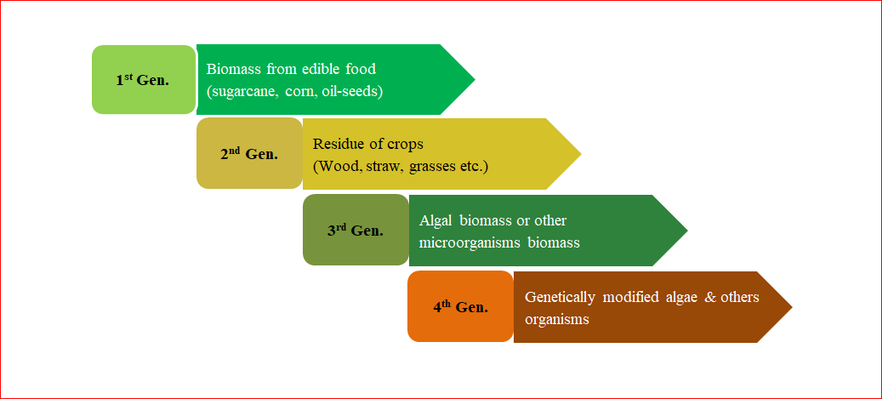
(Fig. 2 classification of biomass)
6.2.3.b. Classification of biomass based on chemical composition
Biomass can be classified into many categories based on its chemical composition, comprising carbohydrates, lignin, essential oils, vegetable and animal fats, and natural resins (gums). The biomass of carbohydrates is composed of cellulose, hemicellulose, and starch. Depending on the type of linkage and/or the sugars used, these biopolymers exhibit different structural variations.
Starch
Starch (C₆ H₁₀O₅)n is a polymeric non-reducing carbohydrate made up of two polyglucans: 10%–20% water soluble amylose and 80%–90% water insoluble amylopectin. It is made up of numerous glucose units linked together via α-O-4 glycosidic linkages. Amylose has a straight chain structure with 250–300 units of α-D-glucose that are linked together by a single sugar unit, giving it the appearance of a helix. In addition to being bound to α-(1→6) bonded glucose monomers, amylopectin is also linked with α-(1→4) bonding glucose monomers. Cereals, tubers, and vegetables contain a high amount of starch. (Tursi 2019)
. 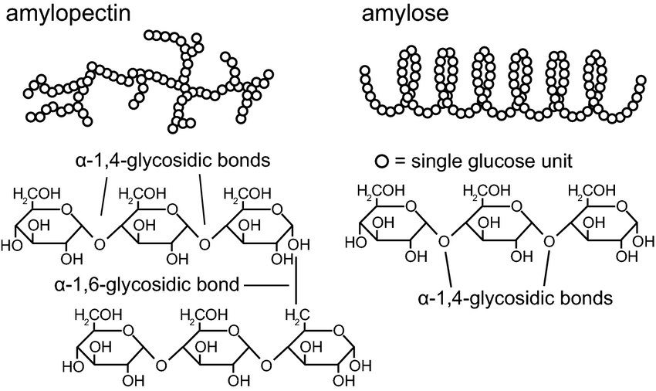
(Fig.3 structure of starch biopolymer (Willfahrt et al. 2019)
Cellulose
The most commonly found organic substance in nature is cellulose, which has a structural role in plant cell walls and contributes 90% and 50%, respectively, of the structure of cotton and wood. It also makes up 30% to 50% of the lignocellulose biomass, which is another important component. As a linear polymer, cellulose is made up of unbranched anhydro β-glucose rings that have oxygen covalently bound to the C1 of one glucose ring and the C4 of an adjacent glucose.

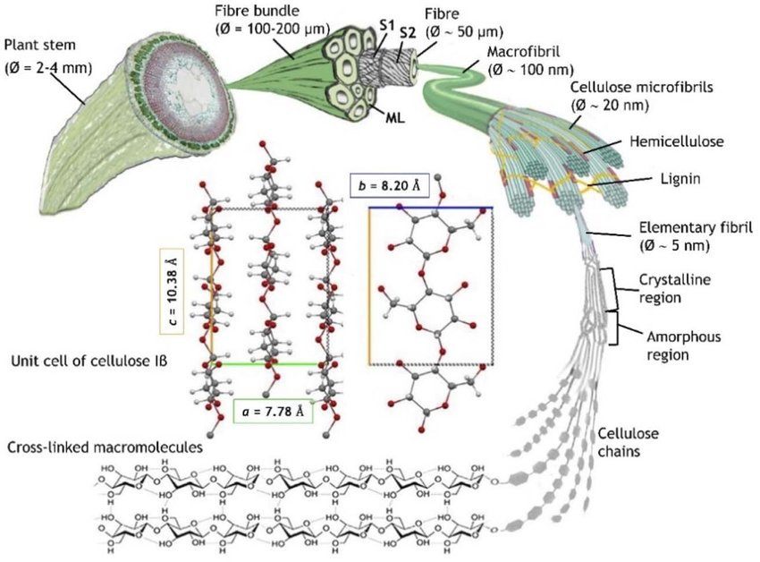
(Fig.4 cellulose biopolymer (Dal Fovo et al. 2022))

Hemicellulose
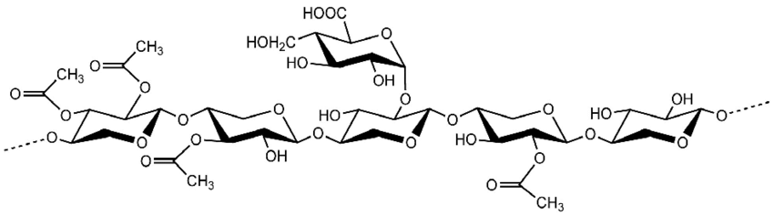
(Fig.5 structure of hemicellulose biopolymer (Hu et al. 2020))
One of the main components of plant cell walls, hemicellulose is made up of heterogeneous branching polysaccharides. It has a strong link to the cellulose microfibrils' surface. hemicellulose is composed of shorter (500–3000 units per polymer) and highly branched groups of pentose (D-xylose, L-arabinose), hexose (D-mannose, D-glucose, and -D-galactose), hexuronic acids (4–O-methyl-D-glucuronic acid, galacturonic acid.
Hemicellulose in plants with a hardwood root system is primarily made up of 4-O-methylglucuronoxylan with acetyl substituents. The majority of the hemicellulose in softwood-based plants is made up of O-acetyl-galactoglucomannan units, which are made of mannose and glucose.(Tursi 2019)
Xylans
The basic backbone of xylans is composed of d-xylose units and its associated branches, which are connected by β -1.4 linkage. Although the primary chain of xylan is identical to that of cellulose, it contains D-xylose as a monomeric unit instead of D-glucose and traces of L-arabinose. The nature of the ramification of the main chain is variable: branches consisting of L-arabinofuranose linked to the 0–3 positions of D-xylose residues and of D-glucuronic acid, acetyl esters or 4-O-methyl-D-glucuronic acid linked to the 0–2 positions. Other groups could be linked to other substituents such as ferulate groups.(Tursi 2019)
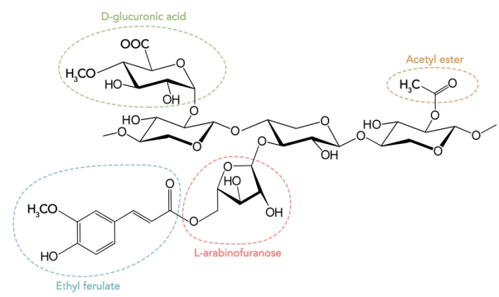
(Fig.6 structure of xylan)

Mannans
Hemicellulose is mainly made up of mannans. The mannan compounds include mannan, galactomannan, glucomannan, glucuronic acid mannan, etc. Mannans are composed of mannose residues connected by β-(1-O-4) linkage while the galactomannans consist of galactose units linked with a β- (1-O-6) bonds(Tursi 2019).
Galactans and arabinogalactans
The backbone of galactans is composed of galactose residues connected by β-(1-O-4) bonds while galactose residues, as side chain, are attached to the O-6. Galactans exists in the form of arabinogalactans, appears generally in larch trees and not commonly found in all kind of plants as compared to polysaccharides molecules in the groups. This polymeric chain includes long straight chain in which 4-α-galactopyranosyl and 3-β-D-galactopyranosyl have attached alternatively with each other. The most common arabinogalactan include galactose residues (which may also be terminal) linked to O-3 or O-6 positions of the main chain and arabinofuranose residues linked to O-3 or O-5 positions.
Lignin
Lignin is the second-largest heterogeneous natural organic biopolymer and one of the constituents of lignocellulose biomass, comprising 10%-35% by weight and 40% by energy. In the paper, sugar, ethanol, and other bio-based production industries, lignin is regarded as a waste product or by-product. The three main monoolignols coumaryl alcohol, coniferyl alcohol, and sinapyl alcohol,(as shown in fig.7) which are joined by strong C-O and C-C bonds, to make the foundation of its three-dimensional complex cross-linking
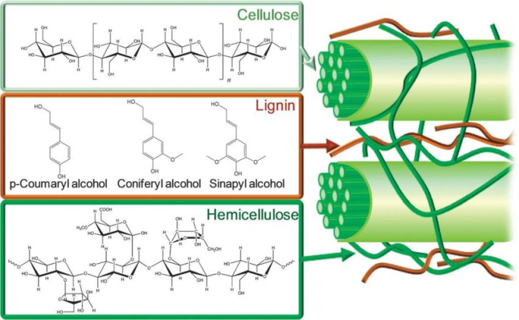
. (Fig.7 structure of lignin biopolymer complex(Wen 2019) )
Essential oil
Essential oils are natural volatile complex liquids (mostly colourless at room temperature) comprising of terpenes (monoterpenes, sesquiterpenes) and treated as secondary metabolites of the plants.
such as alcohols, ethers, carbonyl compounds, amines, phenols, acid and its derivatives, and heterocyclics The extraction of these oils are followed by methods including mechanical pressing,
Essential oils are regarded as secondary metabolites of the plants and are naturally occurring volatile complex liquids (usually colorless at room temperature) made up of terpenes (monoterpenes, sesquiterpenes as shown in fig.8a,8b). Essential oils have been classified based on its chemical classes such as alcohols, ethers, carbonyl compounds, amines, phenols, acids and their derivatives, and heterocyclics. These oils are extracted using techniques like mechanical pressing,
a. 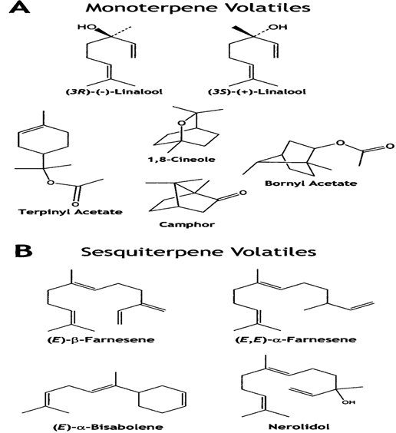 b.
(fig.8a & 8b Monoterpenes and Sesquiterpenes)
Vegetable oils and animal fats
Triacylglycerols (also known as triglycerides) are the structurally comparable term for animal and vegetable fats that are derived from both plant and animal sources. Lipids are a general term for oils and fats. On compared to other biomass sources, a lot of work has gone into producing valuable compounds from oils and fats, which have been shown to be useful in a variety of industrial processes. A biofuel, biodiesel is produced on an industrial scale from oils obtained from oily plants, plant seeds, and animal fats. Through the transesterification (chemical conversion) process
Lignocellulosic biomass
Lignocellulosic biomass is a composite of several chemical and biological substances, such as cellulose, hemicelluloses, lignin, fat, starch, water-soluble sugar, amino acids, and other complicated substances. Lignin (C81H92O28) (the outer surface of lignocellulosic biomass), hemicelluloses [(C5H8O4)m] (below lignin), and cellulose [(C6H10O5)n] (the core) make up the three primary portions. Lignin has a composition of around 40% and serves as a significant source for the manufacture of biofuel
Chitin and Peptidoglycan
Chitin and Peptidoglycan are the polysaccharide chain made up of many monomeric units of N-acetyl glucosamine which are attached by the help of β-1, 4 bonds. chitin has acetyl amine group at C2 position whereas cellulose molecule has a hydroxyl group at this position . Peptidoglycan polymer consists of many N-acetylmuramic and N-acetyl glucosamine units which are linked together to form glycan.

6.3. Biomass processing, conversion technologies
As biomass production rises steadily, it is necessary to create more efficient and effective waste management strategies that can support environmental sustainability. One advantageous use of biomass is in the energy industry, as well as in the manufacturing of biofertilizers, water purification systems, cement, thermal insulators, and building materials.
Biomass serves as the processing input (feedstock) for the biorefinery system, which produces a variety of bio-based products. The production of biofuel and a variety of chemicals from biomass is the basic principle of the biorefinery system.
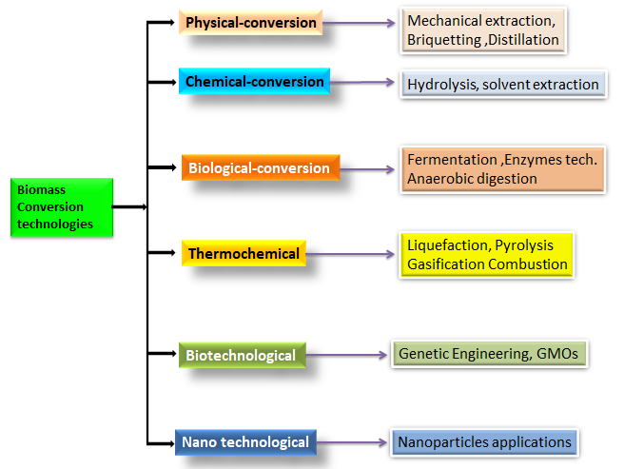
(Fig.9. Biomass conversion technologies)
Innovations in Technologies(as shown in Fig.9) for Biofuel Processing broadly covers current technologies in alternate fuels and chemical production, such as biomass-to-liquid technologies (liquefaction, pyrolysis, and trans esterification), biomass-to-gas technologies (gasification), gas-to-liquid technologies (syngas fermentation and Fischer-Tropsch synthesis), co-processing technologies, fuel upgrading technologies (hydro treating and reforming), and novel catalyst development for biofuels. As a result of biomass processing, bioenergy can be produced through thermochemical or biochemical processes as heat, electricity, or biofuels (gaseous, liquid, or solid).
Biomass or biomass waste can be converted into several useful products for energy generation and chemicals(as shown in fig.10). The selection of particular conversion technique to use for biomass depends on a number of criteria such as type and amount of biomass used as a feedstock, availability, the selection of final products, process economics, and environmental concerns.

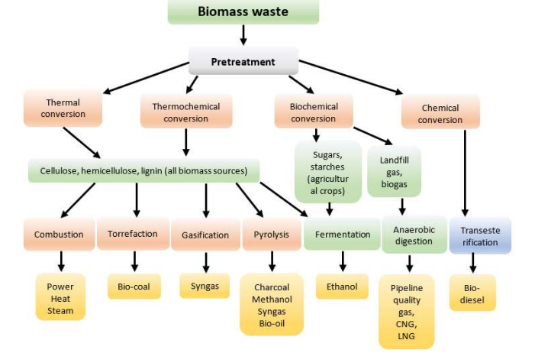
(Fig.10 Products from Biomass conversion technologies(Kalak 2023))
The most common method for converting biomass into useful energy is direct combustion. All biomass can be incinerated directly to heat buildings and water, supply process heat for industry, and produce power in steam turbines. Thermochemical conversion of biomass includes pyrolysis and gasification. Both processes include the thermal decomposition of biomass feedstock materials, which undergo heating to high temperatures in sealed, pressured tanks known as gassifiers. The key differences between the processes are the conversion temperatures and the quantity of oxygen present. Pyrolysis involves heating organic compounds to temperatures between 400° C and 500° C (800° F and 900° F) with almost no free oxygen present. Fuels including charcoal, bio-oil, sustainable diesel, methane, and hydrogen are produced during the pyrolysis of biomass. Hydrotreating is used to produce renewable diesel, renewable gasoline, and renewable jet fuel, bio-oil (made by fast pyrolysis) is processed with hydrogen at high temperatures and pressures in the presence of a catalyst. Gasification entails heating organic materials to between 1,400° F and 1,700 F (800° C and 900° C) with injections of controlled amounts of free oxygen or steam into the vessel to produce a carbon monoxide- and hydrogen-rich gas called synthesis gas or syngas. The process of gasification involves heating organic materials to temperatures between 800°C and 1,700°C (or 1,400°F and 1,700°F), while injecting controlled amounts of free oxygen or steam into the reactor to obtain synthesis gas or syngas, which is rich in hydrogen and carbon monoxide. Syngas is a fuel that can be used for gas turbines that provide electricity, heating, and diesel engines. The hydrogen can then be burned or utilized in fuel cells after being processed to separate it from the gas. The Fischer-Tropsch process can be used to further process the syngas to create liquid fuels. A chemical conversion process known as trans esterification used to converts vegetable oils, animal fats, and greases into fatty acid methyl esters, which are then utilized to make biodiesel. The biological conversion of biomass involves the production of ethanol through fermentation and biogas through anaerobic digestion.
6.4. Challenges associated with biomass conversion technologies
In order to produce a renewable source of energy through biomass there are various conversion technique used yet some challenges are associated with some techniques that need to improve the efficiency of conversion techniques
Realistic biomass feedstocks should be properly chemically characterized using methods like Fourier-transform ion cyclotron resonance mass spectrometry (FT-ICR MS), GPC, and NMR because some biomasses are chemically complex. if compared to conversion in water alone, it has been found that mixtures of water and organic co solvents (i.e., mixed solvent environments) not only facilitate but also enhance the performance of some significant biomass conversion reactions. As a result, the criteria used to select a solvent have an impact on everything from the rates and selectivity of chemical reactions to the stability of liquid phase-products and the solubility of raw materials. One of the most challenging factors related to the catalytic conversion of biomass, and even the upgrading of the derived chemical intermediates, is that biomass-derived feedstocks often contain impurities that can reduce the activity or lifetime of catalysts. Consequently, it is necessary to design more active, selective, and stable catalysts.(Walker et al. 2019)

6.5. Summary
Fossil fuels, such as coal and natural gas, have significantly impacted human civilizations, posing significant environmental challenges such as toxic emissions and climate change. Biomass, derived from organic substances from photosynthesis, is a crucial alternative energy source that can be used to produce biofuels for electricity and transportation. Biofuels, including solid biomass, liquid fuels, and biogases, contribute to a low-carbon environment and a sustainable circular economy. Biomass can be converted into various energy sources, including wood and agricultural products, using various conversion technologies and processes. There are four types of biomass: first-generation (edible), second-generation (non-edible oils), and third-generation (algal biomass)and fourth generation (genetically modified biomass ). Algal species offer high yields with lower resources and in less time than lignocellulose biomass, making them suitable for biodiesel production. Among several bioconversion techniques the Hydrotreating and gasification processes produce renewable fuels. However, biomass feedstocks often contain impurities, requiring more active, selective, and stable catalysts. Innovations in biofuel processing encompass various technologies for alternate fuels and chemical production, including biomass-to-liquid, biomass-to-gas, gas-to-liquid, co-processing, fuel upgrading, and novel catalyst development. Bioenergy can be produced through thermochemical or biochemical processes, and biomass waste can be converted into various energy and chemical products. The choice of conversion technique depends on feedstock type, availability, final product selection, process economics, and environmental concerns. Biomass conversion techniques for renewable energy production face challenges, including proper chemical characterization of feedstocks using methods like FT-ICR MS, GPC, and NMR. Mixed solvent environments enhance performance in biomass conversion reactions. Selecting the right solvent impacts reaction rates, selectivity, stability, and raw material solubility. Biomass feedstocks often contain impurities, requiring more active, selective, and stable catalysts to improve efficiency.

References
Arya, Indrajeet et al. 2021. “Current Trends and Future Prospects of Nanotechnology in Biofuel Production.” Catalysts 11(11).
Ben-Iwo, Juliet, Vasilije Manovic, and Philip Longhurst. 2016. “Biomass Resources and Biofuels Potential for the Production of Transportation Fuels in Nigeria.” Renewable and Sustainable Energy Reviews 63.
Dal Fovo, Alice et al. 2022. “Nonlinear Imaging and Vibrational Spectroscopic Analysis of Cellulosic Fibres Treated with COEX® Flame-Retardant for Tapestry Preservation.” RSC Advances 12(41).
Garba, Abdurrahman. 2021. “Biomass Conversion Technologies for Bioenergy Generation: An Introduction.” In Biotechnological Applications of Biomass,.
Hu, Lisong et al. 2020. “Hemicellulose-Based Polymers Processing and Application.” American Journal of Plant Sciences 11(12).
Kalak, Tomasz. 2023. “Potential Use of Industrial Biomass Waste as a Sustainable Energy Source in the Future.” Energies 16(4).
Parakh, Sheetal Kishor, Zinong Tian, Jonathan Zhi En Wong, and Yen Wah Tong. 2023. “From Microalgae to Bioenergy: Recent Advances in Biochemical Conversion Processes.” Fermentation 9(6).
Perera, Frederica. 2018. “Pollution from Fossil-Fuel Combustion Is the Leading Environmental Threat to Global Pediatric Health and Equity: Solutions Exist.” International Journal of Environmental Research and Public Health 15(1).
Saleem, Muhammad. 2022. “Possibility of Utilizing Agriculture Biomass as a Renewable and Sustainable Future Energy Source.” Heliyon 8(2).
Singh, Veer et al. 2021. “Microbiological Aspects of Bioenergy Production: Recent Update and Future Directions.”
Tursi, Antonio. 2019. “A Review on Biomass: Importance, Chemistry, Classification, and Conversion.” Biofuel Research Journal 6(2).
Walker, Theodore W., Ali Hussain Motagamwala, James A. Dumesic, and George W. Huber. 2019. “Fundamental Catalytic Challenges to Design Improved Biomass Conversion Technologies.” Journal of Catalysis 369.
Wang, Fang et al. 2021. “Technologies and Perspectives for Achieving Carbon Neutrality.” Innovation 2(4).
Wen, Yuming. 2019. Degree Project in Materials Science and Engineering, Second Cycle, 30 Credits Stockholm, Study of the Performance of Peat Moss Pyrolysis.
Willfahrt, Andreas, Erich Steiner, Jonas Hötzel, and Xavier Crispin. 2019. “Printable Acid-Modified Corn Starch as Non-Toxic, Disposable Hydrogel-Polymer Electrolyte in Supercapacitors.” Applied Physics A: Materials Science and Processing 125(7).

.

