SAMPLING IN NURSING RESEARCH

The sampling component is an indispensable part of the research process that is required to be cautiously selected. To acquire this, you need to apprehend various types of sampling methods. Knowledge of sampling designs is fundamental for growing a research plan.
What is sampling?
Sampling is defined as a procedure of selecting a sample from individual or from a large group of population for certain kind of research purpose.
Sampling involves selecting a group of people, events, behaviors or other elements with which to conduct a study.
A sampling plan defines the process of making the sample selections.
Sample is a subset of the population, selected so as to be representative of the larger population
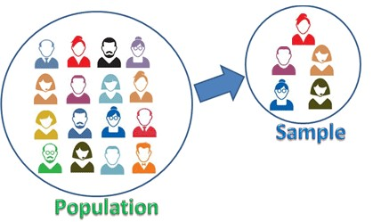
Source: https://sixsigmastudyguide.com/wp-c content/uploads/2020/12/ds1.png
Source: https://sixsigmastudyguide.com/wp-content/uploads/2020/12/ds1.png

Advantages and disadvantages of sampling
- Sampling saves time and money and offers quicker effects as the sample size is smaller than the entire population.
- Sampling gives greater accurate effects as it is carried out by means of skilled and skilled investigators.
- Sampling allows to estimate the sampling errors
- Study of samples requires less area and tools as they are small in size.
The essential drawback of sampling is probabilities of bias.
But there are so many benefits of sampling, so it is the best way to proceed with research.
Types of Sampling
There are basically two kinds of sampling.
- Probability Sampling
- Non Probability Sampling
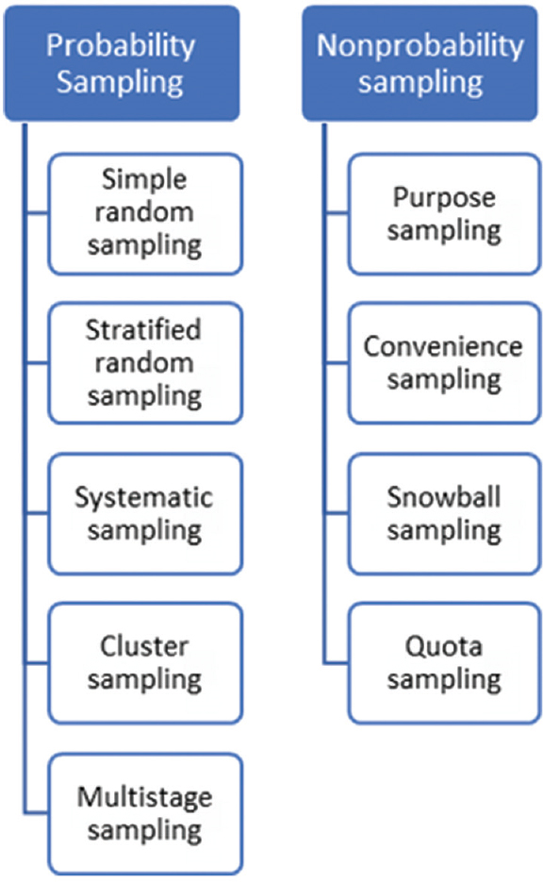
Source: Kandola D, Banner D, O’Keefe-McCarthy S, Jassal D. Sampling Methods in Cardiovascular Nursing Research: An Overview. Canadian Journal of Cardiovascular Nursing. 2014 Aug 1;24(3).

Probability Sampling:
- It is also known as random sampling.
- It is a scientific method of selecting a sample according to some laws of chance in which sampling unit in the population has some definite pre-assigned probability of being selected in the sample.
- Probability sampling is considered as the gold standard approach of sampling.
- When population is homogenous there are high probabilities of each member of being chosen in the sample
- Eg: In a pot full of cooked rice, we want to check if the rice is cooked or not, we will pick some rice in the spoon and check whether it is cooked or not, this spoon of rice will symbolize the whole population of rice in the pot and eavh and every rice grain has an equal chance of being selected.
- It is further divided into following subtypes:
- Simple random sampling
- Stratified random sampling
- Systematic sampling
- Cluster sampling
- Multistage sampling

- Simple Random Sampling
- In this method of sampling each member of the population has an equal chance of being chosen in the sample.
- The members of sample are selected randomly and simply by chance.
- This type of sampling is first-class method of sampling for the homogenous population.
- Example- Let us say there are 200 participants in a conference and we would like to select 50 participants by simple random sampling. The list of all the 200 participants would be available which constitutes the sampling frame. The 50 participants can now be selected by either using random number table or by lottery method.
- There are 2 ways to carry out simple random sampling:
- Lottery method.
- Random Number Table Method
Advantages of simple random sampling:
- Ease of assembling the sample. It is also considered as the fair way of selecting the sample because each member of the population has equal chance of being selected in the sample.
- Sample selected via this approach is the representative of the total population.
- It is an unbiased method of choosing the sample.
Disdavantages of simple random sampling:
- Due to large population complete list of all the members of population is not available.

- Stratified Random Sampling
- In this technique of sampling, the total population is divided into homogenous sub groups called as strata.
- Then, sample is selected by means of simple random sampling from these homogenous strata.
Example- In studying the prevalence of hypertension in an adult population, it would be possible to stratify the population according to gender and then having equal number of subjects from both males and females. This would yield sex-wise prevalence of hypertension. The sample could also be stratified by place of residence such as urban, rural which would give us area-wise prevalence of hypertension with equal representation from each group
Advantages of stratified random sampling:
This sampling method gives higher accuracy in results as compared to the other methods
- Even smaller sample sizes can also give good results using strata
- Reduces the potential for human bias in the selection of cases to be included in the sample.
- Sample chosen through this approach is highly representative of population being studied
- This approach of sampling allows to make generalizations form the sample to population
Disadvantages of stratified sampling:
- This approach is no longer relevant in the population which can’t be divided into subgroups.

When to use stratified random sampling
- It can be used when we favor to focus on a specific strata from the given population data
- When we desire to establish relationship between two strata
- When it is challenging to contact the sample population.

- Systematic Sampling:
- In this method of sampling the selection of participants is carried out in a predetermined, orderly sequence.
- In this, member is selected after a constant interval.
Steps in systematic sampling:
- First develop a well-defined structural population to start on sampling aspect
- Figure out the ideal sample size
- After deciding sample size, assign number to every member of sample
- Then , the interval of sample is selected
Example: First sample is randomly selected the, every 10th person presenting to an OPD is included in the study.
Advantages of systematic sampling:
- It is very easy to create, conduct and analyze the sample
- Risk factor is minimal
- As there is even distribution of individuals to form a sample, systematic sampling is recommended when there are diverse participants of population.

Disadvantages of systematic sampling:
- The process of selection can have interaction with hidden periodic trait within the population. If the sampling approach coincides with the periodicity of the trait, sampling technique will no longer be random and representativeness of pattern is compromised.
- Cluster Sampling:
- In cluster sampling, a number of segments of population are treated as cluster, and participants from every cluster are chosen randomly.
- It is distinct from other probability sampling as in different methods population is divided into subgroups on the foundation of age, sex, career etc.
- But in this method, we are selecting randomly form already exisiting or naturally occurring groups/ cluster Eg: towns within a district, schools in a town
- Example; In a metropolis if we want to comprehend the list of individuals suffering from hypertension, here it is tough to find, but if we search area wise, we might also get higher results. Here, the region acts as cluster and individuals will be treated as sampling unit.
Advantages of cluster sampling:
- This sampling technique is especially inexpensive as prices of travelling and list are significantly reduced through this method.
- It is very feasible method of sample selection from a large population.

Disdavantages of cluster sampling:
- Biased sampling: if the group in populace that is chosen as a cluster sample has biased opinion then the complete population is inferred to have similar opinion.
- Sampling errors: This other method has high chances of error as compared to the other methods of probability sampling

- Multi Stage Sampling:
- As the name suggests, here sample is selected in many stages, hence called as multistage sampling.
- Example: In a national survey, a random number of districts are chosen in all the states followed by random number of tehsils and villages. In the third stage, houses will be selected.
Advantages of multi stage sampling:
- It is applicable for primary data collection for large populations that are geographically dispersed.
- Reduces the costs and time associated with data collection.
- Provides flexibility, as researchers can break down the population as often as necessary to create the sample population they need.
- Allows each stage to use its own sampling method, whether it be stratified sampling, cluster sampling or simple random sampling.
- Typically more accurate than using cluster sampling with the same sample size.

Disadvantages of multi stage sampling:
- It introduces a considerable degree of subjectivity
- the sample will not be representative of the entire population, and there are high chances of bias

Non Probability Sampling:
- In non probability sampling each member of the population does not have known probability of being selected in the sample.
- It is used in both quantitative and qualitative research designs.
- This type of sampling is less expensive but chances of selection bias are more as compared to probability sampling
- Sample selected by this method is not representative of the whole population.
- It is of following subtypes:
- Convenience Sampling
- Quota sampling
- Purposive sampling
- Snow ball sampling

- Convenience Sampling:
- In this type of sampling members of a sample are selected on the basis of their convenient and accessibility.
- In this only those members are selected who are easily accessible to researcher
- This method is most commonly used in pilot study
- Example- Patients coming to the out-patient department of a hospital.
Advantages of convenience sampling:
- Sample selection by this method is very easy and inexpensive.
- This method is commonly used for pilot studies and for hypothesis generation
- It is a quick method of sample selection
Disadvantages of convenience sampling:
- This method involves high chances of sampling error
- Purposive Sampling:
- It is also known as judgmental, selective or subjective sampling.
- In this method members of sample are selected according to the purpose of study.
- This method can be used in following situations:
- When number of people is less in the population and the researcher knows that the target population fulfill his/her demands
- When there is need to filter the samples chosen by other methods.
Advantages of purposive sampling:
- It provides researchers with the justification to make generalizations from the sample that is being studied.
- It is useful because it provides a wide range of non- probability sampling techniques for researcher to draw on.
Disadvantages of purposive sampling:
- This method is highly prone to researcher bias
- Representativeness of the sample is not maintained

- Quota Sampling
- In this method of sampling, members are selected on the basis of some specific characteristics chosen by the researcher.
- These specific characteristics serve as a quota for selection of the members of the sample.
- It is similar to stratified random sampling, the only difference between both is that in stratified random sampling, elements of sample are chosen randomly, but in quota sampling it is not so.
- Number of participants is taken in specific category in well planned manner.
- Example: In a sample of 100, the researcher need 40% men & 60% women in the sample. He would continue selecting the sample until his quota for men is complete i.e 40%
Advantages of quota sampling:
- It is useful when it is not possible to obtain a probability sample, but still representative sample of the population is required
- Quota sampling is much quicker and easier to carry out because it does not require a sampling frame and strict use of random sampling techniques
- Quota sampling improves the representations of particular strata within the population, as well as ensuring that these data are not over presented.
- Use of quota sample, which leads to stratification of a sample, allows us to more easily compare these groups.
Disadvantages of quota sampling:
- Sampling error can’t be determined as in this method sample has not been chosen by random selection.
- This method can cause sample bias
- Generalization from the sample to population is not possible
- Can lead to overall increase in sample size which would increase costs of the research and time duration.
- Snow Ball Sampling:
- It is also called as chain sampling or sequential sampling
- Here in this method existing study subjects helps in recruitment of other subjects from their acquaintances.
- Thus, the sample group grows like a rolling snow ball.
- This method is applied where it is difficult to identify the members in a sample.
- Example: In case of drug addicts or in case of prostitutes
Advantages of snow ball sampling:
- It is an quick and easy method of sampling
- It is cost-effective
Disadvantages of snow ball sampling:
- In this method chances of sample bias and sample error can be high
- It is difficult method of sample collection if the target population is ununcooperative

Important Points:
- The sampling method chosen depends on the population of interest.
- Careful planning is the key for generating reliable results.
- Probability samples are the gold standard in sampling methodology.
- Probability sampling means one can generalise to the population defined by the sampling frame.
- Non-probability sampling means one cannot generalise beyond the sample

REFERENCES
- Sharma G. Pros and cons of different sampling techniques. International journal of applied research. 2017 Nov 26;3(7):749-52.
- Bhardwaj P. Types of sampling in research. Journal of the Practice of Cardiovascular Sciences. 2019 Sep 1;5(3):157.
- Kandola D, Banner D, O’Keefe-McCarthy S, Jassal D. Sampling Methods in Cardiovascular Nursing Research: An Overview. Canadian Journal of Cardiovascular Nursing. 2014 Aug 1;24(3).
- Curtis AC, Keeler C. Sampling design in nursing research. AJN The American Journal of Nursing. 2021 Mar 1;121(3):53-7.
- Gray JR, et al. Sampling. In: Burns and Grove’s the practice of nursing research: appraisal, synthesis, and generation of evi - dence. 8th ed. St. Louis: Elsevier; 2017. p. 329-62.
- Elfil M, Negida A. Sampling methods in clinical research; an educational review. Emergency. 2017;5(1).
- Acharya AS, Prakash A, Saxena P, Nigam A. Sampling: Why and how of it. Indian Journal of Medical Specialties. 2013 Jul 7;4(2):330-3.
- https://sixsigmastudyguide.com/wp-c content/uploads/2020/12/ds1.png

