Hazardous chemicals induced Acute Lung Injury: Molecular mechanism and treatment approach with novel therapy

Alok K Soni*, Puja Kumari, Souravh Bais
Institute of Pharmaceutical sciences SAGE University Indore, Madhya Pradesh

Abstract.
Pulmonary toxicants are substances that can cause damage to the respiratory system, including the lungs and airways. These toxicants can come from various sources, such as smoking, pollution, and industrial chemicals. Understanding the effects of pulmonary toxicants is crucial in protecting human health and preventing respiratory diseases. Exposure to these substances may lead to oxidative and inflammatory cascades, that can damage the lungs and cause respiratory problems including lung cancer, asthma, chronic obstructive pulmonary disease (COPD), and emphysema. Exposure may be associated with addictions, during occupational, or drug therapy, accidentally or intentionally as an act of war. The most common pulmonary toxicant is Cigarette smoke and second-hand smoke which are causing 7 million death per year and other significant health risk to the public. Ricin and abrin are highly lethal plant-derived toxins that can cause severe respiratory distress and even death if inhaled. These toxins can be used as bioterrorism agents, making it essential to understand their effects and develop treatment strategies. On the other hand, bleomycin and cyclophosphamide are medications used to treat several types of cancer. Several studies reported that cyclophosphamide and bleomycin cause pulmonary toxicity in human patients and animals. Similarly, 2.5-micron particles, Diesel exhaust and naphthalene, which common air pollutants, have also been linked to respiratory problems. Paraquat, an herbicide, has been shown to exacerbate lung injury and inflammation. In the present chapter, we have summarized the variety of pulmonary toxicants their way of exposure and the mechanism of toxicity that will help in understanding toxic effects and developing effective preventive and treatment strategies for protecting public health.

Keywords: - Abrin, Bleomycin, Cyclophosphamide, Diesel-exhaust, E-cigarettes, Lipopolysaccharide, Naphthalene, Paraquat, Pulmonary toxicants, Ricin, Smoking.

Introduction: -
The lungs are complex organs that perform a variety of essential functions related to respiration, acid-base regulation, and immune defense. The bronchial tree refers to the branching airways that started from the trachea and end-up to the alveoli. Alveoli are the small, air sac-like structures where gas exchange take place. The blood vessels within the lungs are responsible for transporting oxygen and carbon dioxide between the lungs and the rest of the body. The lungs' connective tissue also offers structural support and contributes to stabilizing the lungs' position and form within the thoracic cavity.
The process of exchanging gases between the atmosphere and the body's tissues is known as respiration. The main organs in charge of this process are the lungs, which absorb oxygen from the air we breathe and exhale carbon dioxide, a waste product of cellular activity. This exchange occurs at the level of the alveoli, that are surrounded by a dense network of blood capillaries. The walls of the alveoli and capillaries are extremely thin, In addition to gas exchange, the lungs play a crucial role in regulating the body's acid-base balance. The production of carbon dioxide, which is rapidly converted to carbonic acid in the bloodstream, can alter the pH of the blood if not removed efficiently. The lungs help to maintain a stable pH by removing excess carbon dioxide from the blood through exhalation. (1)
The lungs are also play an important role component of the body's immune system. The respiratory tract is exposed to a wide variety of potentially harmful particles, chemicals and microorganisms. The lining of the airways is coated with mucus, which traps these particles and prevents them from reaching the alveoli. Additionally, specialized immune cells in the lungs, such as macrophages and lymphocytes, help to identify and eliminate any pathogens that do make it into the alveoli. The lungs are a remarkable example of the body's ability to adapt to its environment and maintain homeostasis. The intricate interplay between the respiratory, cardiovascular, and immune systems ensures that the body's oxygen needs are met, waste products are removed, and harmful pathogens are kept at bay. (2)

Structure and Anatomy.
The anatomy of the lungs includes number of structural features that coordinate together to facilitate the process of respiration and exchange of gases between the body and the environment. The lungs are a pair of cone-shaped soft organs located in the thoracic cavity and surrounded by the rib cage. The lungs are composed of several structures, including the bronchial tree, alveoli, respiratory membrane pleura.

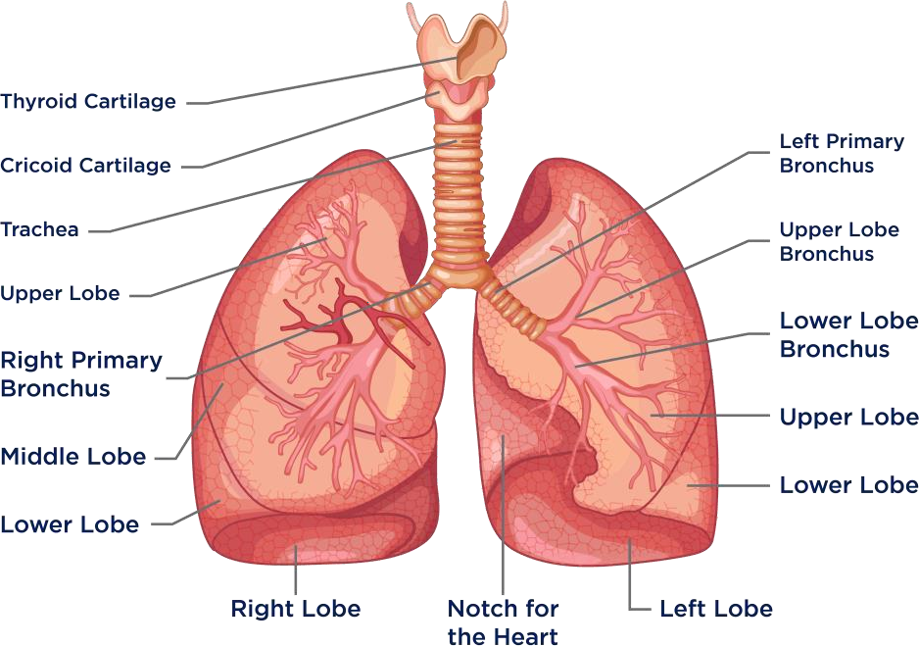
Fig.1 Anatomy Human Lungs
Bronchial tree:
The bronchial tree is a series of branching tubes that lead from the trachea to the alveoli. The trachea is a large tube with ring that begins at the larynx and splits into the right and left bronchi. Further, they divide into smaller bronchioles and even smaller structures called terminal bronchioles, which eventually end up to the air sac like structure called alveoli.
Alveoli:
The alveoli are small, thin-walled air sacs that are the main sites of gas exchange in the lungs. Alveoli are surrounded by a dense capillaries network that facilitate the exchange of oxygen and carbon dioxide between the lungs and the body. The respiratory membrane is the ultra-thin layer of tissue that separates the alveoli from the surrounding blood capillary. This membrane is made up of two layers of cells and a thin layer of basement membrane, which together form a barrier that allows for the diffusion of gases between the alveoli and the blood.
Diaphragm
A vital component of breathing is the diaphragm, a dome-shaped muscle that divides the thoracic and abdominal chambers. The diaphragm contracts and descends during inhalation, expanding the thoracic cavity and allowing air to enter into the lungs. The diaphragm relaxes and travels upward during exhalation, reducing the size of the thoracic cavity and allowing air to exit the lungs.
Pleura: The double-layered membrane known as the pleura covers the lungs and aids in decreasing friction when breathing. The visceral pleura, or inner layer, covers the surface of the lungs, whereas the parietal pleura, or outer layer, lines the thoracic cavity. A thin layer of fluid lies between these two layers; this fluid serves as a lubricant and enables the smooth movement of the lungs during respiration. (3)

Lobes and bronchopulmonary segments^{[5]}
Right lung | Left lung
Upper  - Apical  - Posterior  - Anterior  Middle  - Lateral  - Medial  Lower  - Superior  - Medial  - Anterior  - Lateral  - Posterior | Upper  - Apicoposterior  - Anterior  Lingula  - Superior  - Inferior  Lower  - Superior  - Anteriomedial  - Lateral  - Posterior

Lung Injury.
Any substance that is breathed in affects the lungs, and many of these substances can be dangerous and leads to lungs function improperly. Acute and chronic inflammatory lung diseases, such as lung fibrosis, allergic asthma, acute lung injury (ALI)/acute respiratory distress syndrome (ARDS), and chronic obstructive pulmonary disease, are caused by occupational and environmental exposures to mineral dusts, airborne pollutants, cigarette smoke, pharmaceutical therapy with anticancer drugs, and radiotherapy.
- Acute Lung Injury and Repair:
A condition that can be caused by a variety of factors including infection, trauma, and exposure to environmental toxins. (4)

Chronic Lung Injury:
Chronic lung injury refers to long-term damage or dysfunction of the lungs that can lead to breathing difficulties and reduced lung function over time. It can be caused by various factors such as exposure to toxins, infections, autoimmune disorders, and genetic predisposition. (5)

Pulmonary Toxicants.
A pulmonary toxicant is any substance that, when inhaled, can cause damage to the lungs and respiratory system. These toxicants can come from a variety of sources, including industrial chemicals, environmental pollutants, tobacco smoke, and even certain types of medication. Exposure to these substances can result in a various type of respiratory symptoms, including coughing, wheezing, shortness of breath, and chest pain and improper lung functions.
Pulmonary toxicants work by damaging the delicate tissues of the lungs and interfering with the normal processes of respiration. Some toxicants can cause inflammation and scarring in the lungs, while others can damage the cells and structures that are responsible for gas exchange. Long-term exposure to pulmonary toxicants can lead to chronic respiratory conditions such as asthma, emphysema, and lung cancer.
Governmental organizations control several lung toxicants by makings rules and regulations. These organizations establish guidelines for allowable exposure levels and demand that businesses take precautions to safeguard employees and the environment from harmful toxins.
Research into the effects of pulmonary toxicants on human health is ongoing, and new toxicants continue to be identified. It is important for individuals to be aware of the potential dangers of exposure to these substances and to take steps to protect themselves from exposure. This may include wearing protective gear when working with hazardous materials, avoiding areas with high levels of pollution, and quitting smoking. (6)

Pathogenesis.
The pathogenesis of pulmonary toxicants can vary depending on the specific agent and mechanism of toxicity involved. However, in general, pulmonary toxicants can cause damage to the respiratory system by directly or indirectly injuring lung tissue, altering lung function, and triggering an inflammatory response. For example, some pulmonary toxicants may directly damage lung tissue through oxidative stress or other mechanisms, leading to cell death, inflammation, and fibrosis. Other toxicants may cause lung injury indirectly by triggering an immune response, leading to inflammation and damage to lung tissue. The authors describe the various ways in which pulmonary toxicants can damage lung tissue, alter lung function, and trigger inflammation, as well as the potential long-term health effects of such exposures. the pathogenesis of pulmonary toxicants is complex and can involve multiple mechanisms of toxicity. Understanding these mechanisms is important for identifying and mitigating the risks associated with exposure to these agents.
Pulmonary toxicants can cause damage to the respiratory system through a variety of mechanisms. Direct toxicity to lung tissue is a common mechanism by which many pulmonary toxicants cause harm. This can occur through oxidative stress, DNA damage, or other cellular damage that leads to cell death, inflammation, and fibrosis. The degree of direct toxicity can vary depending on the specific agent and dose, as well as the duration and route of exposure.

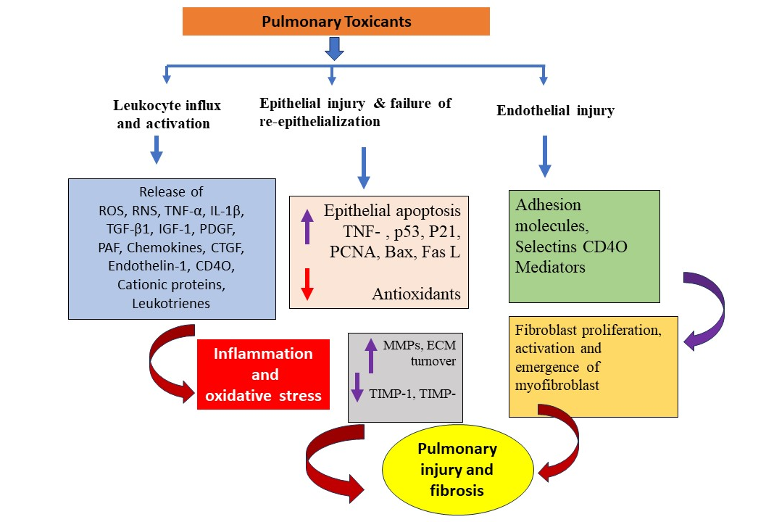
Figure 2 Molecular Mechanism of pulmonary toxicity by toxicants

Indirect mechanisms of toxicity can also contribute to lung injury caused by pulmonary toxicants. For example, some toxicants can cause immune-mediated lung injury by triggering an inflammatory response in the lungs. This can lead to the production of cytokines and chemokines, which can further damage lung tissue and cause inflammation. Other indirect mechanisms of toxicity can include changes in lung function, such as decreased lung capacity or increased airway resistance. These changes can occur as a result of inflammation, airway obstruction, or other factors that interfere with normal lung function. (7)
The long-term health effects of pulmonary toxicants can also be significant. Chronic exposure to certain toxicants, such as asbestos or tobacco smoke, can increase the risk of lung cancer and other respiratory diseases. Additionally, exposure to some pulmonary toxicants can increase the risk of cardiovascular disease, due in part to the role of the lungs in oxygenation and gas exchange. In order to fully understand the pathogenesis of pulmonary toxicants, it is important to consider both the direct and indirect mechanisms of toxicity involved, as well as the potential long-term health effects of such exposures. (8)

Histopathological evidences
Histopathology is the study of changes in tissues or organs caused by disease or injury. In the case of pulmonary toxicants, histopathology is a valuable tool for understanding the mechanisms of lung injury caused by these agents. It involves examining lung tissue samples under a microscope to identify the specific histopathological changes that are indicative of lung injury. One of the key features of histopathology associated with lung injury caused by pulmonary toxicants is inflammation. Inflammatory cells, such as neutrophils and macrophages, can accumulate in lung tissue in response to exposure to toxicants, causing cellular damage and tissue injury. The accumulation of inflammatory cells can also lead to the production of cytokines and chemokines, which can further exacerbate lung injury. Another important feature of histopathology in lung injury caused by pulmonary toxicants is the presence of fibrosis. Fibrosis refers to the formation of scar tissue in the lungs, which can occur in response to repeated exposure to toxicants. Fibrosis can lead to a reduction in lung function and breathing difficulties. Histopathological study can provide valuable information about the specific histopathological changes associated with lung injury caused by specific agents, which can aid in the development of effective prevention and treatment strategies.
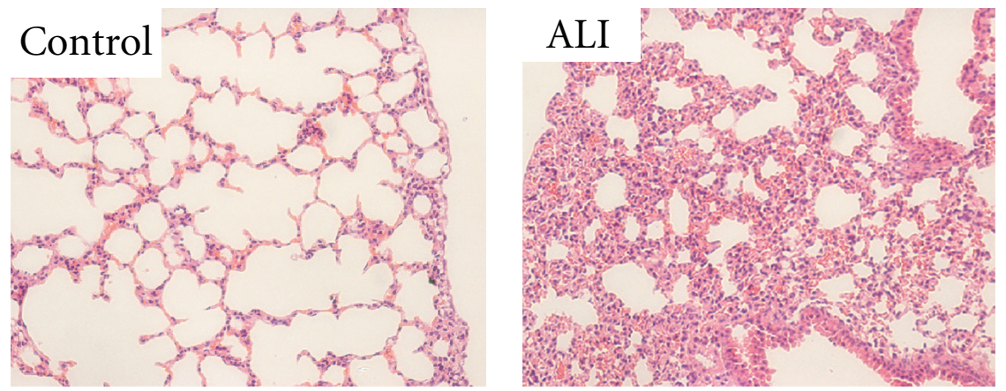
Figure 3 Guo, Zhongliang, et al. acute lung injury in mice." Mediators of inflammation 2012 (2012).

Pulmonary toxicants can cause various histopathological changes in the lungs, which can vary depending on the specific agent and mechanism of toxicity involved. In general, pulmonary toxicants can cause cellular and tissue damage, inflammation, and fibrosis, which can be reflected in histopathological changes. A study published in the Journal of Occupational Health in 2016 provides a comprehensive review of the histopathological changes associated with lung injury caused by various pulmonary toxicants. The authors describe the histopathological features of lung injury caused by specific agents, such as asbestos, silica, and carbon nanotubes, among others. For example, asbestos exposure can cause the formation of asbestos bodies, which are characteristic of asbestos-related diseases such as asbestosis and mesothelioma. Silica exposure can lead to the formation of nodules and fibrosis, as well as other inflammatory changes in the lungs. Carbon nanotubes can cause granuloma formation and fibrosis, as well as other inflammatory changes. Apart from that, pulmonary toxicants, such as certain drugs and chemicals, can also cause histopathological changes in the lungs. For example, bleomycin, which is used in chemotherapy, can cause diffuse alveolar damage and fibrosis. the histopathological changes associated with lung injury caused by pulmonary toxicants can be varied and complex, reflecting the diverse mechanisms of toxicity involved. Histopathological evaluation is an important tool for identifying and diagnosing lung injury caused by pulmonary toxicants. (9)

Smoking.
Smoking is a significant contributor to respiratory illnesses and lung damage. The chemicals in tobacco smoke can irritate and inflame the airways, leading to chronic bronchitis and emphysema. The toxicants in tobacco smoke can also cause oxidative stress and inflammation in the lungs, which can lead to the development of lung cancer.
Tobacco smoke contains more than 70 recognized carcinogens, including benzene, nitrosamines, and polycyclic aromatic hydrocarbons (PAHs), which are all known to alter DNA and cause mutation. In addition, smoking causes oxidative stress, which can lead to inflammation and tissue damage in the lungs. This can contribute to the development of chronic obstructive pulmonary disease (COPD).(10)
Smoking can also impair the function of the cilia, hair-like structures that line the airways and help to clear mucus and other debris from the lungs. These damaged cilia cannot perform their function effectively, which can lead to an accumulation of mucus and a higher risk of infections. Overall, smoking is one of the most significant causes of pulmonary toxicants, and it is responsible for a high proportion of lung disease and lung cancer cases worldwide. (11)

Electronic cigarettes.
Electronic cigarettes (e-cigarettes) are a relatively new product that have gained popularity in recent years as an alternative to traditional cigarettes. While e-cigarettes are often marketed as a safer alternative to smoking, there is still much debate about their potential health effects, including their impact on the respiratory system. (12)
One study found that e-cigarette vapor contains a number of toxic chemicals, including formaldehyde, acrolein, and diacetyl, which are known to be harmful to the respiratory system. Another study reported that e-cigarette use can lead to an increase in airway resistance and inflammation in the lungs, which may increase the risk of respiratory problems. the respiratory effects of e-cigarette use are still being studied, and more research is needed to fully understand the potential risks associated with these devices. However, the evidence suggests that e-cigarettes may have negative effects on lung function and respiratory health, and caution should be taken when using these devices. (13)
Tobacco corporations are advertising new tobacco products in reaction to the decline in cigarette use, such as flavored electronic cigarettes (e-cigs), which are frequently promoted as safer substitutes for regular cigarettes. The experience of smoking and the desired nicotine impact are achieved through the inhalation of e-cigarette aerosols, also known as e-cigarette vapor, without the use of tobacco. E-cigarettes have rapidly gained popularity since they were first used in 2007, especially among teenagers and young people. (14)(15)
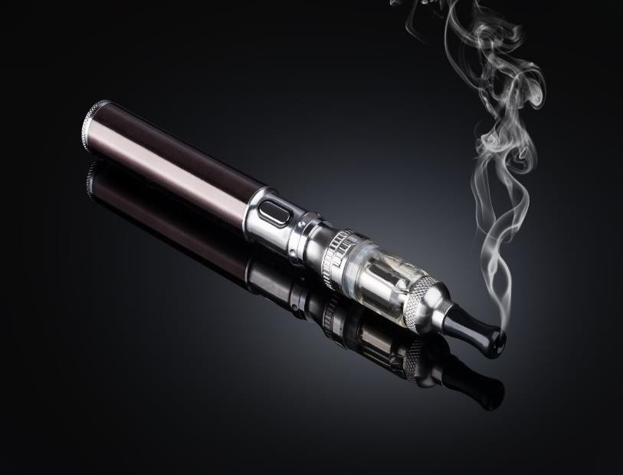

Fig. 4 Electronic cigarettes

Ricin.
Ricin is a ribosome-inactivating protein that is present in the beans of the castor plant Ricinus communis and is reasonably easy to purify. The US National Institutes of Health's biodefense strategy plan lists ricin as a category B priority disease and a biological select agent by the Centers for Disease Control. In order to specifically target and eliminate cancer cells, ricin is also being developed as a component of immunotoxins. Ricin is a highly toxic protein found in the seeds of the castor oil plant (Ricinus communis). Exposure to even a small amount of ricin can be lethal. The toxin acts by inhibiting protein synthesis within cells, leading to cell death.
Ricin is considered a potent pulmonary toxicant, and inhalation of the toxin is a significant concern in the event of a ricin exposure incident. It is important to note that exposure to ricin is rare, and most cases of ricin poisoning occur through ingestion or skin contact with the toxin rather than inhalation. However, in cases where ricin is released into the air as an aerosol, such as in a bioterrorism attack, inhalation of the toxin can be a significant concern. ricin is a highly toxic substance that can cause severe respiratory symptoms and potentially life-threatening lung damage if it is inhaled. In severe cases, exposure to ricin can lead to acute respiratory distress syndrome (ARDS), a life-threatening condition that can cause severe lung damage and fluid buildup in the lungs. It is important to take precautions to avoid exposure to ricin, and to seek medical attention immediately if you suspect that you have been exposed to the toxin. (16, 17)

Fig.5 Ricin and abrin (Felder E et al. Simultaneous Detection of Ricin and Abrin DNA by Real-Time PCR (qPCR). Toxins. 2012)

Abrin.
Abrin is a naturally occurring protein toxin found in the seeds of the rosary pea (Abrus precatorius) plant. It is a type II ribosome-inactivating protein (RIP) that can irreversibly inactivate ribosomes. This plant is native to regions of Asia and Africa, and the toxin is known for its high potency and ability to cause severe illness or death in humans and animals Similar to ricin, another potent protein toxin found in castor beans, abrin works by inhibiting the production of proteins within cells, ultimately leading to cell death and tissue damage. Due to its extreme toxicity, abrin has been studied as a potential biological weapon, and is subject to regulation by many countries and international organizations. Exposure to abrin can occur through ingestion, inhalation, or injection, and even very small amounts can be lethal. Therefore, it is crucial that abrin is only handled by trained professionals in highly controlled laboratory environments. (18)
Abrin can be inhaled into the lungs and cause severe damage to the respiratory system. According to a study published in the Journal of Applied Toxicology, inhalation of aerosolized abrin can lead to acute lung injury, respiratory failure, and death in humans and animals.
When abrin is inhaled, it enters the lungs and can cause damage to the delicate tissues that line the respiratory system. The toxic effects of abrin on the lungs are due to its ability to interfere with protein synthesis within cells, which leads to cell death and tissue damage. This can result in inflammation of the lungs, fluid accumulation, and impaired oxygen exchange, which can ultimately lead to respiratory failure. Therefore, it is crucial that abrin is handled only by trained professionals in controlled laboratory environments, and that appropriate safety precautions are taken to prevent accidental exposure. (19).
The exact mechanism of abrin-induced pulmonary toxicity is not well understood. However, it is believed that abrin can enter the lungs and cause damage to the alveolar-capillary membrane, leading to pulmonary edema, hemorrhage, and inflammation. Additionally, abrin may also stimulate the release of inflammatory mediators such as cytokines and chemokines, which can further exacerbate lung damage and inflammation. Inhalation of abrin can cause a range of respiratory symptoms, including cough, chest pain, and shortness of breath, and can ultimately result in respiratory failure and death., leading to cell death. Inhalation of abrin can cause severe pulmonary toxicity, which can be life-threatening.
Abrin can also cause damage to the blood vessels in the lungs, leading to pulmonary hemorrhage. Pulmonary hemorrhage is a condition where blood leaks into the lungs, and it can cause symptoms such as coughing up blood and shortness of breath. In addition to causing damage to the alveolar-capillary membrane and blood vessels, abrin can also stimulate the release of inflammatory mediators such as cytokines and chemokines. These mediators can further exacerbate lung damage and inflammation, leading to respiratory distress and ultimately, respiratory failure. Overall, inhalation of abrin can cause a range of respiratory symptoms and can be life-threatening. It is important to take precautions to avoid exposure to abrin, as there is no specific antidote or treatment for abrin poisoning. (20)

Naphthalene.
Naphthalene is a commonly used industrial chemical and is also found in some household products, such as mothballs and deodorizers. Inhalation of naphthalene can cause damage to the respiratory system, as it is a known pulmonary toxicant. Inhalation of naphthalene can cause irritation of the nose and throat, coughing, shortness of breath, and chest tightness.

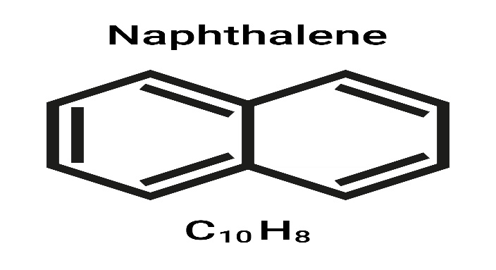
Fig: 5 Napthalene and its common use as mothball

In addition, prolonged or repeated exposure to naphthalene may cause damage to the lungs and can lead to the development of disease conditions such as asthma, bronchitis, and emphysema. One of the primary mechanisms of naphthalene toxicity in the respiratory system is through the formation of reactive metabolites in the liver, which are then transported to the lungs and can damage lung tissue. (21)

Bleomycin.
Bleomycin is a bacterial derived glycopeptide antibiotic that has been used as anticancer drug clinically since 1970. Bleomycin primarily used in Hodgkin's lymphoma, testicular cancer, and squamous cell carcinoma of the head and neck. It works by binding to DNA and causing strand breaks, which triggers apoptosis in cancer cells. Bleomycin is administered intravenously and the dose is based on the patient's body weight and the type of cancer being treated. Its use is limited by its potential for pulmonary toxicity. (22)
bleomycin is known to be a pulmonary toxicant, meaning that it can cause damage to the lungs. The risk of pulmonary toxicity is one of the major limitations of bleomycin therapy and can limit its use in some patients. The exact mechanism of bleomycin-induced pulmonary toxicity is not fully understood, but it is reported that it has ability to generate free radicals and other reactive oxygen species (ROS) and cause oxidative stress in the lungs. This can lead to inflammation, fibrosis, and other types of lung damage. (23,24)
The risk of pulmonary toxicity from bleomycin can be attributed by a variety of factors, such as dose and duration of treatment, the patient's age and underlying lung function, and the presence of other lung diseases or risk factors such as smoking. Patients receiving bleomycin should be closely monitored for signs of pulmonary toxicity, which may include cough, shortness of breath, fever, and chest pain. If pulmonary toxicity is suspected, treatment with bleomycin may need to be discontinued or adjusted, and supportive care may be necessary to manage the symptoms of lung damage. (25).

Diesel Exhaust.
Diesel exhaust is a well-known pulmonary toxicant that can cause lung injury and respiratory diseases. Diesel exhaust contain a complex mixture of gases and particles include nitrogen oxides, sulfur oxides, carbon monoxide, volatile organic compounds, and particulate matter. These components can irritate the lungs and cause inflammation, leading to lung injury and respiratory diseases such as asthma, chronic bronchitis, and lung cancer. One mechanism of toxicity of diesel exhaust is the production of reactive oxygen species (ROS) and oxidative stress. Diesel exhaust particles can activate immune cells in the lungs, leading to the production of ROS and inflammation. This can cause damage to lung tissue and DNA, increasing the risk of respiratory diseases and cancer. There are several strategies for preventing or reducing the effects of diesel exhaust as a pulmonary toxicant. These include reducing exposure to diesel exhaust by using cleaner fuels or electric vehicles, implementing proper ventilation systems, and using personal protective equipment. Additionally, treatments for lung injury caused by diesel exhaust may include the use of anti- inflammatory medications, oxygen therapy, and pulmonary rehabilitation.
Diesel exhaust is a complex mixture of gases and particles that is produced by the combustion of diesel fuel. It is a major source of air pollution in urban areas and is known to be a significant contributor to respiratory diseases and lung cancer. The main components of diesel exhaust include nitrogen oxides (NOx), sulfur oxides (SOx), carbon monoxide (CO), volatile organic compounds (VOCs), and particulate matter (PM). Diesel particulate matter (DPM) is a major component of diesel exhaust that can penetrate deep into the lungs and cause irritation, inflammation, and damage to lung tissue. There is growing evidence that exposure to diesel exhaust is associated with a wide range of adverse health effects, including asthma, chronic bronchitis, emphysema, lung cancer, and cardiovascular disease. One of the mechanisms of toxicity of diesel exhaust is the production of reactive oxygen species (ROS) and oxidative stress. Diesel exhaust particles can activate immune cells in the lungs, leading to the production of ROS and inflammation. This can cause damage to lung tissue and DNA, increasing the risk of respiratory diseases and cancer. Preventing or reducing the effects of diesel exhaust as a pulmonary toxicant can be done by reducing exposure to diesel exhaust. This can be achieved by using cleaner fuels or electric vehicles, implementing proper ventilation systems, and using personal protective equipment (PPE). Additionally, treatments for lung injury caused by diesel exhaust may include the use of anti-inflammatory medications, oxygen therapy, and pulmonary rehabilitation. (26)
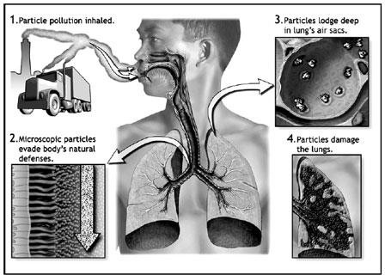
Fig. 6 Diesel Exhaust

Lipopolysaccharide.
Lipopolysaccharide (LPS), a substance found in gram-negative bacteria's outer membrane, is a powerful inflammatory agent. LPS can be found in many environments, including contaminated water and food, and can also be present in the air as a result of bacterial aerosolization. LPS-induced lung injury is associated with an acute inflammatory response in the lungs, leading to increased permeability of the alveolar-capillary barrier and accumulation of fluid and inflammatory cells in the lungs. This can cause impaired gas exchange and respiratory failure. Mechanism of LPS toxicity is also attributed to activation of toll-like receptor 4 (TLR4) on immune cells in the lungs, leading to the production of pro-inflammatory cytokines and chemokines. These mediators can cause damage to lung tissue, increase vascular permeability, and recruit inflammatory cells to the lungs.
There are several strategies for preventing or reducing the effects of LPS as a pulmonary toxicant. These include using antibiotics to treat bacterial infections, using potent anti-inflammatory medications to reduce the inflammatory response, and using mechanical ventilation or extracorporeal membrane oxygenation (ECMO) to support respiratory function. Additionally, there are several potential treatments for LPS-induced lung injury, including anti- inflammatory agents, antioxidants, and therapies targeting the TLR4 signaling pathway. However, further research is needed to fully understand the mechanisms of LPS toxicity and develop effective treatments (27)

Cyclophosphamide.
Cyclophosphamide is an alkylating agent commonly used in chemotherapy to treat various types of cancers, including lymphoma, leukemia, and breast cancer. The drug works by damaging DNA in rapidly dividing cells, thereby preventing the growth and division of cancer cells. However, cyclophosphamide can also damage healthy cells, particularly those in the bone marrow, hair follicles, and digestive tract, leading to side effects such as hair loss, nausea, and immunosuppression. Another potential side effect of cyclophosphamide is pulmonary toxicity, which can manifest as acute respiratory distress syndrome (ARDS) or interstitial pneumonitis. Several studies have reported the cyclophosphamide-induced pulmonary toxicity. One study published in the European Respiratory Journal in 2001 reported that patients treated with high-dose cyclophosphamide for systemic lupus erythematosus (SLE) develop interstitial pneumonitis. Another study published in the Journal of Oncology Pharmacy Practice in 2012 reported that patient suffered with ARDS after receiving cyclophosphamide as part of a chemotherapy regimen for breast cancer. The mechanism of cyclophosphamide-induced pulmonary toxicity is not fully understood, but it is thought to be related to the accumulation of toxic metabolites in the lung tissue. The toxicity may also be exacerbated by other factors, such as underlying lung disease or concomitant use of other drugs with pulmonary toxicity. Overall, while cyclophosphamide is an effective chemotherapy agent, healthcare providers should be aware of the potential for pulmonary toxicity in patients receiving this medication. Close monitoring and prompt recognition of any respiratory symptoms may help to mitigate the risk of severe pulmonary complications. (28)
The diagnosis of cyclophosphamide-induced pulmonary toxicity can be challenging, as there is no specific diagnostic test for this condition. The diagnosis is typically made based on a combination of clinical symptoms, radiological findings, and laboratory tests. Chest x-rays and computed tomography (CT) scans can reveal diffuse infiltrates or ground-glass opacities in the lung tissue, while pulmonary function tests may show a restrictive or obstructive pattern. Treatment for cyclophosphamide-induced lung toxicity depends on the severity of the symptoms and may include supportive care, such as oxygen therapy and mechanical ventilation, as well as discontinuation of the drug. In some cases, corticosteroids or other immunosuppressive agents may be used to reduce inflammation in the lung tissue. (29)

2.5 PM Pollution.
Recently, with modernization and accelerated urban development, air pollution is worsening and became a risk to people's health. Large-scale haze pollution poses a health risk to residents of most cities. The primary contributor to atmospheric haze pollution is PM2.5, or tiny particulate matter with a diameter of less than or equal to 2.5 m. Coal combustion, the disposal of industrial waste, and excessive automobile emissions are the main causes of PM2.5 pollution. It is a mixture of solid and liquid particles that are suspended in the air and most commonly measured sizes are PM2.5 and PM10. Recent research has shown that respirable particles are intimately linked to the prevalence of human diseases and mortality rate in the disciplines of toxicology, epidemiology, and other relevant sciences. These PM can enter into deep tissue of lungs leads to several respiratory problems such as asthma, chronic obstructive pulmonary disease (COPD), and even lung cancer.
The mechanisms of the PM2.5 induced pulmonary toxicity is generation of oxidative stress. PM2.5 contain free radicals, metal and the other organic components which can induce free radical production into the lung cells. In addition, that the PM2.5 surface was rich in iron, copper, zinc, manganese, and other transition elements, as well as polycyclic aromatic hydrocarbons and lipopolysaccharide, etc. additionally, excessive formation of free radicals or ROS caused by PM2.5 lowers cellular antioxidant defenses, oxidizes lipids on cell membranes, and raises intracellular Ca2+ concentrations. Furthermore, elevated intracellular Ca2+ levels may further boost the generation of free radicals or ROS.
Furthermore, It has been widely established that PM2.5 is associated with release of inflammatory cytokines, whereby it promotes the overexpression of certain transcription factor genes and accumulations of inflammatory cells into lungs. The migration of neutrophils, T cells, and eosinophils to the lungs exhibit higher cell activity, release more inflammatory cytokines and chemokines, leads to lung tissue damage. (30)

Paraquat.
Paraquat was first manufactured and sold by Imperial Chemical Industries (ICI, England) in early 1962 under the trade name Gramoxone, and is today among the most commonly used herbicides. The most common use of paraquat in agriculture is to control weed growth. It is a non-selective herbicide, meaning it can kill most plants it comes into contact with, including crops. However, paraquat is also dangerous to humans and animals. It is classified as a pulmonary toxicant because it primarily affects the respiratory system, specifically the lungs. Exposure to paraquat can occur through inhalation, ingestion, or skin contact. When inhaled, paraquat can cause damage to the lungs, leading to a condition called paraquat lung or paraquat poisoning. This condition is characterized by inflammation and terrific damage of the lungs, which can lead to shortness of breath, coughing, chest pain, and fever. In severe cases, it can cause respiratory failure and death. The toxic effects of paraquat are not reversible, and there is no known antidote. Therefore, it is important to take precautions to avoid exposure to paraquat, such as wearing protective clothing and respiratory equipment when working with the chemical. Additionally, it is essential to follow the proper handling and disposal procedures for paraquat to prevent environmental contamination and accidental exposure.[31]

Choking Agents.
Choking agent poisoning happens when you are exposed to a harmful chemical, such as phosgene or chlorine. Chlorine is the most frequently manufactured industrial chemical, which is used in a variety of processes to make bleached paper, polymers, solvents, medicines, and other compounds. It is also used to purify drinking water. Due to its extreme toxicity, unintentional releases of chlorine from industrial facilities and during transportation could result in a significant number of fatalities. (32). Exposure of chlorine gas leads to reaction of both Cl₂ and HOCl with airway lining lead Production of reactive oxygen species (superoxide (O2 - ), hydrogen peroxide (H2O2 ) and hydroxy radicals ( .OH) and nitrogen species (peroxynitrite (ONOO- ) leads to oxidative stress in the lungs.
Phosgene is a highly valued and significant industrial building block, particularly for the creation of polyurethane and polycarbonate plastic precursors. it is colorless gas with a musty smell is phosphorus. It has a density that is almost four times that of air (4.25 kg/m3). Phosgene is a highly toxic chemical that was employed as a weapon during World War I and caused 85,000 fatalities. It is a thick gas that quickly filled enemy trenches and is a very severe lung irritant. It is under the Chemical Weapons Convention's Schedule 3 classification. Small amounts also come via the breakdown and combustion of organochlorine chemicals, such chloroform, in addition to its industrial production.[34]. Phosgene quickly hydrolyzes in water to produce hydrochloric acid and carbon dioxide, which irritate the eyes, nasopharynx, and central airways. Phosgene's carbonyl group (C=O) can interact with hydroxyl (-OH), sulfhydryl (-SH), and amino (-NH2) groups in acylation processes. The main pathophysiological effects of phosgene (severe dyspnea and clinically obvious lung edema) are accounted for by these reactions. Exposure to phosgene mostly harms the respiratory system. Acute lung injury caused by phosgene (P-ALI) is frequently brought on by brief exposure to the gas.[35][36]. Long-term exposure can result in acute respiratory distress syndrome (ARDS), chronic hypoventilation, refractory pulmonary edema, and other lung damage. [37][38]

Prevention and Treatment.
Prevention and treatment of lung injury caused by pulmonary toxicants involve various strategies, including avoiding exposure to the toxicants, reducing or eliminating exposure, and managing the symptoms and complications of lung injury. Here are some preventive and treatment strategies for lung injury caused by pulmonary toxicants:
Avoidance and reduction of exposure: One of the most effective ways to prevent lung injury caused by pulmonary toxicants is to avoid exposure to the toxicants. This can involve taking appropriate measures such as using protective equipment, implementing proper ventilation, and following safe handling procedures. Reducing exposure to the toxicant can also be effective in preventing lung injury. Avoiding exposure to pulmonary toxicants is the most effective way to prevent lung injury. This can involve using personal protective equipment (PPE) such as respirators, gloves, and protective clothing. It can also involve implementing proper ventilation and following safe handling procedures. For example, asbestos exposure can be reduced by implementing proper work practices, wetting down the material, and using appropriate PPE.
Symptomatic management: If lung injury has already occurred, symptomatic management can help reduce the severity of symptoms and improve lung function. This can involve using medications to reduce inflammation, such as corticosteroids, or to manage breathing difficulties, such as bronchodilators. If lung injury has already occurred, symptomatic management can help reduce the severity of symptoms and improve lung function. This can involve using medications to reduce inflammation, such as corticosteroids. In some cases, antibiotics may be prescribed to treat infections that can occur as a result of lung injury.
Oxygen therapy: In some cases, lung injury caused by pulmonary toxicants can result in low oxygen levels in the blood. Oxygen therapy can help improve oxygen levels and reduce the risk of complications. If lung injury has led to low oxygen levels in the blood, oxygen therapy can help improve oxygen levels and reduce the risk of complications. Oxygen can be administered through a mask or nasal cannula, or in severe cases, through a mechanical ventilator.

Pulmonary rehabilitation: Pulmonary rehabilitation can help improve lung function and reduce symptoms of lung injury. This can involve exercises to improve lung capacity, breathing techniques, and education about managing lung injury. Pulmonary rehabilitation is a comprehensive program that involves exercises to improve lung capacity, breathing techniques, and education about managing lung injury. It is often used for individuals with chronic lung conditions, but may also be beneficial for those with lung injury caused by pulmonary toxicants.

Summary.
Pulmonary toxicants are substances that can cause damage to the lungs and respiratory system. These can come from various sources including smoking, environmental pollution, and occupational exposure to chemicals such as asbestos and silica. Cigarette smoke, which contains tar, carbon monoxide, paraquat, and phosgene, is a well-known pulmonary toxicant and can cause inflammation, damage to airways, and increased risk of lung cancer. Environmental pollution, such as particulate matter, naphthalene, and carbon monoxide, can also cause respiratory problems and increase the risk of lung cancer. Occupational exposure to toxic substances can cause pulmonary fibrosis, a scarring of lung tissue resulting in respiratory complications. Exposure to chlorine gas can cause severe respiratory distress, and some drugs such as chemotherapy agents can also have pulmonary toxicity as a side effect. Reducing exposure to these toxicants is crucial for protecting respiratory health and can involve measures such as reducing environmental pollution, promoting smoking cessation, and implementing workplace safety measures.

Conclusion.
Pulmonary toxicants are substances that can cause harm to the lungs and respiratory system, and can range from particulate matter and gases to volatile organic compounds, paraquat, naphthalene, and tobacco smoke. Exposure to these toxicants can lead to short-term irritation, chronic respiratory conditions, and even cancer. To minimize exposure, individuals can wear protective equipment and avoid smoking and exposure to secondhand smoke, while policymakers can consider regulations to reduce the emission of these toxicants in the environment.

Reference:
  - Rhoades, R. A., & Bell, D. R. (2012). Medical Physiology: Principles for Clinical Medicine. Lippincott Williams & Wilkins. (Pages 471-486)
  - Schnapp, L. M., & Farver, C. F. (Eds.). (2010). Acute Lung Injury and Repair: Scientific Fundamentals and Methods. CRC Press.

  - Mason RJ, Broaddus VC, Martin TR, et al. (eds.). (2021). Murray and Nadel's Textbook of Respiratory Medicine (7th ed.). Elsevier.

  - Lenfant, C., Reynolds, S. D., & Barnes, P. J. (Eds.). (2014). The Lung: Development, Aging and the Environment. Elsevier.

  - West, J. B. (2015). Pulmonary Pathophysiology: The Essentials. Lippincott Williams & Wilkins.

  - Parrillo, J. E., & Dellinger, R. P. (Eds.). (2019). Critical Care Medicine: Principles of Diagnosis and Management in the Adult. Elsevier.

  - Harkema, J. R., Hotchkiss, J. A., & Vanden Heuvel, J. P. (2012). Toxicology of pulmonary toxicants. Environmental health perspectives, 120(3), 345-352.

  - Kim, H. R., & Yu, I. J. (2016). Histopathological approach for the detection of pulmonary toxicity induced by occupational and environmental chemical substances. Journal of Occupational Health, 58(2), 125-139.

  - Elaine N. Marieb and Katja Hoehn, "Human Anatomy & Physiology" the lungs are composed of the following structures:
  - Garry P. Ginsberg "Toxicology: The Basic Science of Poisons" including scientific journals and textbooks on toxicology and environmental health ‘pulmonary toxicants.

  - Kumar, V., Abbas, A. K., & Aster, J. C. (2014). Robbins basic pathology (9th ed.). Elsevier Saunders.)

  - Goniewicz, M. L., et al. (2014). Levels of selected carcinogens and toxicants in vapor from electronic cigarettes. Tobacco Control, 23(2), 133-139.

  - Lrner, C. A., et al. (2015). Vapors produced by electronic cigarettes and e-juices with flavorings induce toxicity, oxidative stress, and inflammatory response in lung epithelial cells and in mouse lung.

  - Besaratinia A, Tommasi S. Electronic cigarettes: the road ahead. . 2014.

  - Anand V, McGinty KL, O’Brien K, Guenthner G, Hahn E, Martin CA. E-cigarette use and beliefs among urban public high school students in North Carolina. J Adolesc Health. 2015

  - Franck, R. W., & Huang, Y. (2019).

  - Karaman MW, Herrgard S, Treiber DK, et al. A quantitative analysis of kinase inhibitor selectivity. Nat Biotechnol. 2008;26(1):127–132.

  - Girish, V., & Satyamoorthy, K. (2015). Abrin: A concise review. Journal of toxicology, 2015, 1-13.

  - Breyer, M. G., & Mantis, N. J. (2012). The type 2 ribosome-inactivating protein abrin induces respiratory failure and death in mice following inhalation exposure. Journal of applied toxicology, 32(12), 998-1007.
  - Gupta, R. C. (Ed.). (2015). Handbook of Toxicology of Chemical Warfare Agents. Academic Press.

  - Luch, A. (Ed.). (2012). Molecular, clinical and environmental toxicology: Volume 1: Molecular toxicology. Springer Science & Business Media.

  - Katzung, B. G. (2017). Basic and Clinical Pharmacology, 14th Edition. New York: McGraw-Hill Education.

  - D.S. Alberts, H.S. Chen, R. Liu, et al Bleomycin pharmacokinetics in man
I. Intravenous administration. Cancer Chemother Pharmacol, 1 (1978), pp. 177-181.

  - M.L. Samuels, D.E. Johnson, P.Y. Holoye Continuous intravenous bleomycin (NSC- 125066) therapy with vinblastine (NSC-49842) in stage III testicular neoplasia
Cancer Chemother Rep, 59 (1975), pp. 563-570.

  - Charlene A. McQueen, Timothy C. Marrs, Bryan Ballantyne Comprehensive Toxicology Elsevier Publication date: 2010.

  - Bosson, J. A., & Pourazar, J. (2020). Diesel exhaust as a pulmonary toxicant: mechanistic considerations. Journal of Internal Medicine, 287(6), 597-609

  - Javadi-Paydar, M., Ghasemi, H., Mashayekhi, S., Esmaeili, M., Rezaei, N., & Ghaffari,
H. (2019). Lipopolysaccharide-induced acute lung injury: Role of oxidative stress and platelet-activating factor. Journal of Cellular Physiology, 234(7), 10244-10253.

  - Willems LM, Jacquet JM, Dequeker J. Cyclophosphamide-induced pulmonary toxicity in systemic lupus erythematosus. Eur Respir J. 2001;18(4):748-752.

  - Gouda HM, Taha H, El-Shafey MA, Abd El Aziz AM. Acute respiratory distress syndrome following cyclophosphamide therapy: a case report. J Oncol Pharm Pract. 2012;18(4):459-462.

  - Xing, Y. F., Xu, Y. H., Shi, M. H., & Lian, Y. X. (2016). The impact of PM2.5 on the human respiratory system. Journal of thoracic disease, 8(1), E69–E74. https://doi.org/10.3978/j.issn.2072-1439.2016.01.19)

  - Brook, R. D., Rajagopalan, S., Pope, C. A., Brook, J. R., Bhatnagar, A., Diez-Roux, A. V., ... & Kaufman, J. D. (2010). Particulate matter air pollution and cardiovascular disease: An update to the scientific statement from the American Heart Association. Circulation, 121(21), 2331-2378.

31 . Bond, J. A. (2021). Pulmonary toxicity of paraquat. Annals of translational medicine, 9(5), 458. doi: 10.21037/atm-20-6206.

- S Jonasson, B Koch, A Bucht - Toxicology, 2013 – Elsevier.

- CBRNE - Lung-Damaging Agents, Phosgene May 27, 2009.

- Wolfgang Schneider; Werner Diller. "Phosgene". Ullmann's Encyclopedia of
Industrial Chemistry. Weinheim: Wiley-VCH. doi:10.1002/14356007.a19_411.
- 6. Xu N, Shao Y, Ye K, Qu Y, Memet O, He D, et al.. Mesenchymal stem cell-derived exosomes attenuate phosgene-induced acute lung injury in rats. Inhal Toxicol (2019) 31(2):52–60.

- 7. Filipczak PT, Senft AP, Seagrave J, Weber W, Kuehl PJ, Fredenburgh LE, et al.. NOS-2 inhibition in phosgene-induced acute lung injury. Toxicol Sci (2015) 146(1):89–100. doi: 10.1093/toxsci/kfv072.

- . Aggarwal S, Lam A, Bolisetty S, Carlisle MA, Traylor A, Agarwal A, et al.. Heme attenuation ameliorates irritant gas inhalation-induced acute lung injury. Antioxid Redox Signal (2016) 24(2):99–11doi: 10.1089/ars.2015.6347.

- Aggarwal S, Ahmad I, Lam A, Carlisle MA, Li C, Wells JM, et al.. Heme scavenging reduces pulmonary endoplasmic reticulum stress, fibrosis, and emphysema. JCI Insight (2018) 3(21):e12069 doi: 10.1172/jci.insight.120694.

