“SMART BUS TRACKING AND MANAGEMENT SYSTEM”

Introduction
Bus tracking is an application that tracks a bus and gathers the distance to each station along its route. Tracking System involves the installation of an electronic device in a bus, with an installed Android App on any SMART phone to enable the Administrator/User to track the bus location. Based on IoT this project is implemented as android application. There are two applications onefor server and the other for the client. Buses carry GPS devices to track their positions. By this positions to server are periodically updated. Client application displays map showing the position of bus. It shows where buses are on a map and provide students and staffs the updated information at different time interval using RTC. The server will monitor location and will store its data in the database. It is a real-time system as this method automatically sends the information on the GPS system to a system/SMART phone. The students/staffs can get flexibility of planning travel using the app, to decide when to catch the bus. Arduino UNO microcontroller is used to programming for software and hardware module. And it is connected to the cloud and following through the android app. The waiting time of the user can be reduced. Simple mode of communication is the key feature of the Bus Tracking system. This application can be easily extended for central tracking system to keep track of all the buses. The different queries and efficient route management can be easily done through central server system. Abstract Bus tracking is an application that tracks a bus and gathers the distance to each station along its route. Tracking System involves the installation of an electronic device in a bus, withan installed Android App on any SMART phone to enable the Administrator/User to track the bus location.
The general objective of the development of this system is to help people track things in more efficient way and effective way resulting in greater reliability. In real life, when a freight service provider wants to track his/ her shipment service which is been carried by a vehicle. It’s really difficult to man- age all those fleet of vehicles which is in movement in whereas corners of the city. There are buses made available for passengers travelling distances, but not many passengers have complete information about these buses. Complete information namely the number of buses that go to the required destination, bus numbers, bus timings, the routes through which the bus wouldpass, time taken for the bus to reach, maps that would guide the passenger with his/her route and most importantly, track the current location of the bus and give the correct time for the bus to reach its bus stop. The proposed system deals with overcoming the problems stated above. The system is an Android application that gives necessary information about all the buses travelling in Pune. This information overcomes the problems faced in the previously built application “Pune Bus Guide”. The platform chosen for this kind of system is android, reason being Android Operating System has come up on a very large scale and is owned by almost every second person.Also, Android is a user friendly platform, thereby enabling ease of access for all the users. A number of applications made for the Android Operating System is increasing on a large scale eversince its advent. Android is an open source mobile software environment.
Brought up by Google, the operating system has been made Linux based and uses Java programming language. It has a virtual machine that is used to optimize memory usage as well as resources. This application has been developed using IDE (Android Studio 1.6) with ADT (Android Development Tools) and Android SDK (Software Development Kit). There are a number of constraints that need to be satisfied.
Vehicle Tracking System (VTS) is the technology used to determine the location of a vehicle using different methods like GPS and other radio navigation systems operating through satellites and ground based stations. This system is an important tool for tracking each vehicle at a given period of time and now it is becoming increasingly popular for people having expensive cars and hence as a theft prevention and retrieval device.

Vehicle Security using VTS:-
Vehicle Security is a primary concern for all vehicle owners. Owners as well as researchers are always on the lookout for new and improved security systems for their vehicles. One has to be thankful for the upcoming technologies, like GPS systems, which enables the owner to closely monitor and track his vehicle in real-time and also check the history of vehicles movements. This new technology, popularly called Vehicle Tracking Systems has done wonders in maintaining the security of the vehicle tracking system is one of the biggest technological advancements to track the activities of the vehicle. The security system uses Global Positioning System GPS, to find the location of the monitored or tracked vehicle and then uses satellite or radio systems to send to send the coordinates and the location data to the monitoring center. Due to real-time tracking facility, vehicle tracking systems are becoming increasingly popular among owners of expensive vehicles.
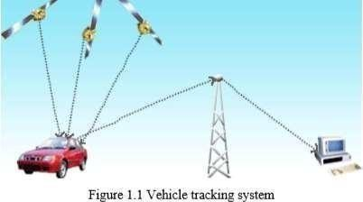

EXISTING SYSTEM
The existing system has many disadvantages related to cost, performance etc. The proposed system is going to reduce all the defects of existing system. The proposed system uses the Arduino Uno kit which provides power of microcontroller as well as microprocessor which is going to increase the performance of the system with less energy consumption.

PROPOSED SYSTEM
The system has two sub systems namely the school bus sub system and remote server sub system. The school bus subsystem is associated with student identification using RFID and location tracking using GPS. Each entry and exit in bus involves activation of RFID reader and acquisition of student ID. This is used to determine student status which is transmitted to server via Wi-Fi module. The location is transmitted at regular intervals to server to track the bus.
The server subsystem involves remote database that stores the student status as well as GPS co- ordinates along with student details. This is used to display relevant information to parents after login. Server subsystem is used to update the data and relay the same to application. Each student has a passive RFID tag which stores unique data for identification. When the tag is in vicinity of reader, internal inductive current produced by the tag in response to the wireless signal transmitted by reader allows the tag to provide the data to the reader. It can work without manual intervention at all making the process automatic.

PROBLEM STATEMENT
The objective of this proposed system is to develop an application which will help to provide security for school going children’s. This allows parents and management to check the status of secure smart school bus by using Iota. The proposed system will provide various facilities like speed control, check drunk and drive, missing children’s, accident emergencies, inappropriate drop, panic button, logistic management etc. which are helpful for child security.

Key Features
The most important features of IoT include artificial intelligence, connectivity, sensors, active engagement, and small device use. A brief review of these features is given below −
- AI − IoT essentially makes virtually anything “smart”, meaning it enhances every aspect of life with the power of data collection, artificial intelligence algorithms, and networks. This can mean something as simple as enhancing your refrigerator and cabinets to detect when milk and your favorite cereal run low, and to then place an order with your preferred grocer.
- Connectivity − New enabling technologies for networking, and specifically IoT networking, mean networks are no longer exclusively tied to major providers. Networks can exist on a much smaller and cheaper scale while still being practical. IoT creates these small networks between its system devices.
- Sensors − IoT loses its distinction without sensors. They act as defining instruments which transform IoT from a standard passive network of devices into an active system capable of real- world integration.
- Active Engagement − Much of today's interaction with connected technology happens through
passive engagement. IoT introduces a new paradigm for active content, product, or service engagement.
- Small Devices − Devices, as predicted, have become smaller, cheaper, and more powerful over time. IoT exploits purpose-built small devices to deliver its precision, scalability, and versatility.

Internet of Things - Technology and Protocols
IoT primarily exploits standard protocols and networking technologies. However, the major enabling technologies and protocols of IoT are RFID, NFC, low-energy Bluetooth, low-energy wireless, low-energy radio protocols, LTE-A, and WiFi-Direct. These technologies support the specific networking functionality needed in an IoT system in contrast to a standard uniform network of common systems.

RFID
RFID (radio-frequency identification) and NFC (near-field communication) provide simple, lowenergy, and versatile options for identity and access tokens, connection bootstrapping, and payments.
- RFID technology employs 2-way radio transmitter-receivers to identify and track tags associated with objects.

Low-Energy Wireless
This technology replaces the most power hungry aspect of an IoT system. Though sensors and other elements can power down over long periods, communication links (i.e., wireless) must remain in listening mode. Low-energy wireless not only reduces consumption, but also extends the life of the device through less use.

Internet of Things - Hardware
The hardware utilized in IoT systems includes devices for a remote dashboard, devices for control, servers, a routing or bridge device, and sensors. These devices manage key tasks and functions such as system activation, action specifications, security, communication, and detection to support-specific goals and actions.

IoT − Sensors
The most important hardware in IoT might be its sensors. These devices consist of energy modules, power management modules, RF modules, and sensing modules. RF modules manage communications through their signal processing, WiFi, ZigBee, Bluetooth, radio transceiver, duplexer, and BAW.

Standard Devices
The desktop, tablet, and cellphone remain integral parts of IoT as the command center and remotes.
  - The desktop provides the user with the highest level of control over the system and its settings.

  - The tablet provides access to the key features of the system in a way resembling the desktop, and also acts as a remote.
  - The cellphone allows some essential settings modification and also provides remote functionality.

Other key connected devices include standard network devices like routers and switches.

Internet of Things - Software
IoT software addresses its key areas of networking and action through platforms, embedded systems, partner systems, and middleware. These individual and master applications are responsible for data collection, device integration, real-time analytics, and application and process extension within the IoT network. They exploit integration with critical business systems (e.g., ordering systems, robotics, scheduling, and more) in the execution of related tasks.

Data Collection
This software manages sensing, measurements, light data filtering, light data security, and aggregation of data. It uses certain protocols to aid sensors in connecting with real-time, machine- to-machine networks. Then it collects data from multiple devices and distributes it in accordance with settings. It also works in reverse by distributing data over devices. The system eventually transmits all collected data to a central server.

Device Integration
Software supporting integration binds (dependent relationships) all system devices to create the body of the IoT system. It ensures the necessary cooperation and stable networking between devices. These applications are the defining software technology of the IoT network because without them, it is not an IoT system. They manage the various applications, protocols, and limitations of each device to allow communication.

Real-Time Analytics
These applications take data or input from various devices and convert it into viable actions or clear patterns for human analysis. They analyze information based on various settings and designs in order to perform automation-related tasks or provide the data required by industry.

Application and Process Extension
These applications extend the reach of existing systems and software to allow a wider, more effective system. They integrate predefined devices for specific purposes such as allowing certain mobile devices or engineering instruments access. It supports improved productivity and more accurate data collection.

Arduino programming:

The Arduino/Genuino Uno can be programmed with the (Arduino Software (IDE)).Select "Arduino/Genuino Uno from the Tools > Board menu (according to the microcontroler on your board). The ATmega328 on the Arduino/Genuino Uno comes preprogrammed with a boot loader that alows us to upload new code to it without the use of an external hardware programmer. It communicates using the original STK500 protocol (reference, C header files).
We can also bypass the boot loader and program the microcontroler through the ICSP (In-Circuit Serial Programming) header using Arduino ISP or similar. The ATmega16U2/8U2 is loaded with a DFU boot loader, which can be activated by:

  - On Rev1 boards: connecting the solder jumperon the back of the board (near the map of Italy) and then rese ingthe 8U2.
  - On Rev2or later boards: there is a resistor that puling the 8U2/16U2 HWB lineto ground,makingit easier to put into DFU mode. [1]

Warnings:
The Arduino/Genuino Uno has a resettable polyfuse that protects your computer's USB ports from shorts and overcurrent. Although most computers provide theirown internalprotection, thefuseprovides an extra layer of protection. If more than 500 mA isapplied to theUSB port, the fusewilautomatically break the connection until the short or overload is removed.

Differences with other boards:
The Uno differs from al preceding boards in that it does not use the FTDI USB-to-serial driver chip. Instead, it features the Atmega16U2 (Atmega8U2 up to version R2) programmed as a USB-to-serial converter.

Power:
The Arduino/Genuino Uno board can be powered via the USB connection or with an external power supply. The power source is selected automatically.
External(non-USB) power can come either from an AC-to-DC adapter (wall-wart) or battery. The adapter can be connected by plugging a 2.1mm center-positive plug into the board's power jack. Leads from a batterycan be inserted in the GND and VIN pinheaders of the POWER connector.
Theboard can operate on an external supply from 6 to 20 volts. If supplied withless than 7V, however, the 5V pin may supply less than five volts and the board may become unstable. If using more than 12V, the voltage regulator may overheat and damage the board. The recommended range is 7 to 12 volts.
The power pins are as follows:

  - VIN. The input voltage to the Arduino/Genuino board when it's using an external power source (as opposed to 5 volts from the USB connection or other regulated power source). One can supply voltage through this pin, or, if supplying voltageviathe power jack, access itthrough this pin.
  - 5V.This pin outputs a regulated 5V from the regulator on the board. The board can be supplied with power either from the DC power jack (7 - 12V), the USB connector (5V), or the VIN pin of the board (7-12V). Supplying voltage via the 5V or 3.3V pins bypasses the regulator, and can damage your board. We don't advise it.
  - 3V3. A 3.3 volt supply generated by the on-board regulator. Maximum current draw is 50 mA.
  - GND. Groundpins.

  - IOREF. This pin on the Arduino/Genuino board provides the voltage reference with which the microcontroler operates. A properly configured shield can read the IOREF pin voltage and select the appropriate power source or enable voltagetranslators on theoutputs to work withthe 5V or 3.3V.

Memory:
The ATmega328 has 32 KB (with 0.5 KB occupied by the boot loader). It also has 2 KB of SRAM and 1 KB of EEPROM (whichcan be read and written withthe EEPROM library).

Communication:

Arduino/Genuino Uno has a number of facilities for communicating with a computer, another Arduino/Genuino board, or other microcontrollers. The ATmega328 provides UART TTL (5V) serial communication, which is available on digital pins 0 (RX) and 1 (TX). An ATmega16U2 on the board channels this serial communication over USB and appears as a virtual com port to software on the computer. The 16U2 firmware uses the standard USB COM drivers, and no external driver isneeded. However, on Windows, an
.inf file is required. The Arduino Software (IDE) includes a serial monitor which alows simple textual data to be sent to and fromthe board. The RX and TX LEDs on the board wil flash whendata is being transmitted via the USB-to-serial chip and USB connection to the computer (but not for serialcommunication on pins 0 and 1).
A Software serial library alows serial communication on any of the Uno's digital pins. The ATmega328 also supports I2C (TWI) and SPI communication. The Arduino Software (IDE)includesa Wire libraryto simplifyuse of the I2C bus; see the documentation for details. For SPIcommunicatio n, use the SPI library.

Automatic (Software) Reset:
Rather than requiring a physical press of the reset button before an upload, the Arduino/Genuino Uno board is designed in a way that alows it to be reset by software running on a connected computer. One of the hardware flowcontrol lines(DTR) of the ATmega8U2/16U2 is connected to the reset line ofthe ATmega328 viaa 100 nano farad capacitor. When this line is asserted (taken low), the resetline drops long enough to reset the chip. TheArduino Software (IDE) uses this capability to alow you to upload code by simply pressing the upload button in the interface toolbar. This means that the boot loader can have a shorter timeout, as the lowering of DTR can be well-coordinated with the start of the upload. This setup has other implications. When the Uno is connected to either a computer running Mac OS X or Linux, it resets each time a connection is made to it from software (via USB). For the folowing half-second or so, the boot loader is running on the Uno. While it is programmed to ignore malformed data (i.e. anything besides an upload of new code), it wil intercept the first few bytes of data sent to the board after a connection is opened. If a sketch running on the board receives one- time configuration or other data when it first starts, make sure that the software with which it communicates waits a second afteropeningthe connection and before sendingthis data.
The Uno board contains a trace that can be cut to disable the auto-reset. The pads on either side of the trace can be soldered together to re-enable it. It's labeled "RESET-EN". You may also be able to disable the auto-reset by connecting a 110 ohm resistor from 5V to thereset line.

Regulated power supply:

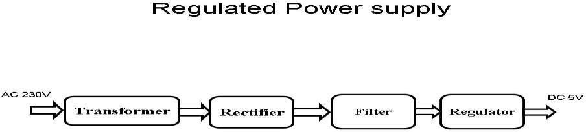

Fig 4.1

Transformer:
A transformer is a device that transfers electrical energy from one circuit to another through inductively coupled conductors without changing its frequency. A varying current in the first or primary winding creates a varying magnetic flux in the transformer's core, and thus a varying magnetic field through the secondary winding. This varying magnetic field induces a varying electromotive force (EMF) or "voltage" in the secondary winding. This effect is called mutual induction. If a load is connected to the secondary, an electric current will flow in the secondary winding and electrical energy will be transferred from the primary circuit through the transformer to the load. This field is made up from lines of force and has the same shape as a bar magnet. If the current is increased, the lines of force move outwards from the coil. If the current is reduced, the lines of force move inwards. If another coil is placed adjacent to the first coil then, as the field moves out or in, the moving lines of force will "cut" the turns of the second coil. As it does this, a voltage is induced in the second coil. With the 50 Hz AC mains supply, this will happen 50 times a second. This is called MUTUAL INDUCTION and forms the basis of the transformer.

Rectifier:
A rectifier is an electrical device that converts alternating current (AC) to direct current (DC), a process known as rectification. Rectifiers have many uses including as components of power supplies and as detectors of radio signals. Rectifiers may be made of solid-state diodes, vacuum tube diodes, mercury arc valves, and other components. A device that it can perform the oppositefunction (converting DC to AC) is known as an inverter. When only one diode is used to rectify AC (by blocking the negative or positive portion of the waveform), the difference between the term diode and the term rectifier is merely one of usage, i.e., the term rectifier describes a diode that is being used to convert AC to DC. Almost all rectifiers comprise a number of diodes in a specific arrangement for more efficiently converting AC to DC than is possible with only one diode. Before the development of silicon semiconductor rectifiers, vacuum tube diodes and copper
(I) oxide or selenium rectifier stacks were used.

Filter:
The process of converting a pulsating direct current to a pure direct current using filters is called as filtration. Electronic filters are electronic circuits, which perform signal-processing functions, specifically to remove unwanted frequency components from the signal, to enhance wanted ones.

Regulator:
A voltage regulator (also called a ‗regulator‘) with only three terminals appears to be a simple device, but it is in fact a very complex integrated circuit. It converts a varying input voltage into a constant
‗regulated ‘output voltage. Voltage Regulators are available in a variety of outputs like5V, 6V, 9V, 12V and 15V. The LM78XX series of voltage regulators are designed for positive input. For applications requiring negative input, the LM79XX series is used. Using a pair of
‗voltage-divider‘ resistors can increase the output voltage of a regulator circuit. It is not possible to obtain a voltage lower than the stated rating. You cannot use a 12V regulator to make a 5Vpower supply. Voltage regulators are very robust. These can withstand over-current draw due toshort circuits and also over-heating. In both cases, the regulator will cut off before any damageoccurs. The only way to destroy a regulator is to apply reverse voltage to its input. Reverse polaritydestroys the regulator almost instantly.

LCD DISPLAY
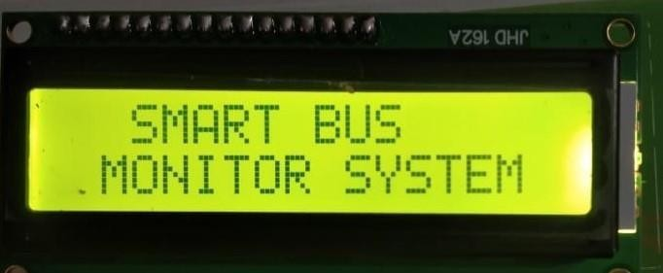

Fig 16*2 LCD display

A liquid-crystal display (LCD) is a flat-panel display or other electronically modulated optical device that uses the light-modulating properties of liquid crystals. Liquid crystals do not emit light directly, instead using a backlight or reflector to produce images in color or monochrome. LCDs are available to display arbitrary images (as in a general-purpose computer display) or fixed images with low information content, which can be displayed or hidden, such as preset words, digits, and 7-segment displays, as in a digital clock. They use the same basic technology, except that arbitrary images are made up of a large number of small pixels, while other displays have larger elements.
LCD is used in wide range application including computer monitors, televisions, instrument panels, aircraft cockpit displays, and indoor and outdoor signage. Small LCD screens are common in portable consumer devices such as digital cameras, watches, calculators, and mobile telephones, including smartphones. LCD screens are also used on consumer electronics products such as DVD players, video game devices and clocks. LCD screens have replaced heavy, bulky cathode ray tube (CRT) displays in nearly all applications. LCD screens are available in a wider range of screen sizes than CRT and plasma displays, with LCD screens available in sizes ranging from tiny digital watches to huge, big- screen television sets.

Since LCD screens do not use phosphors, they do not suffer image burn-in when a static image is displayed on a screen for a long time (e.g., the table frame for an aircraft schedule on an indoor sign). LCDs are, however, susceptible to image persistence.

The name and functions of each pin of the 16×2 LCD module is given below. Pin1 (Vss): Groundpin of the LCD module.
Pin2 (Vcc): Power to LCD module (+5V supply is given to this pin)

Pin3 (VEE): Contrast adjustment pin. This is done by connecting the ends of a 10K potentimeter to +5V and ground and then connecting the slider pin to the VEE pin. The voltage at the VEE pin defines the contrast. The normal setting is between 0.4 and 0.9V.
Pin4(RS): Register select pin. Logic HIGH at RS pin selects data register and logic LOW atRS pin selects command register. If we make the RS pin HIGH and feed an input to the data lines(DB0 to DB7), this input will be treated as data to display on LCD screen. If we make the RS pin LOW and feed an input to the data lines, then this will be treated as a command ( a command to be written to LCD controller – like positioning cursor or clear screen or scroll).
Pin5 (R/W): Read/Write modes. This pin is used for selecting between read and write modes. Logic HIGH at this pin activates read mode and logic LOW at this pin activates write mode.
Pin6 (E): This pin is meant for enabling the LCD module. A HIGH to LOW signal at this pin will enable the module.
Pin7 (DB0) to Pin14(DB7): These are data pins. The commands and data are fed to the LCD module though these pins.
Pin15 (LED+): Anode of the back light LED. When operated on 5V, a 560 ohm resistor should be connected in series to this pin. In Arduino based projects the back light LED can be powered from the 3.3V source on the Arduino board.
Pin16 (LED-): Cathode of the back light LED.

RS pin of the LCD module is connected to digital pin 12 of the Arduino. R/W pin of the LCD is grounded. Enable pin of the LCD module is connected to digital pin 11 of the Arduino. This method is very simple, requires less connections and we can almost utilize the full potential of the LCD module. Digital lines DB4, DB5, DB6 and DB7 are interfaced to digital pins 5, 4, 3 and 2 of the Arduino. The 10K potentiometer is used for adjusting the contrast of the display. The Arduino can be powered through the external power jack provided on the board. +5V required insome other parts of the circuit can be tapped from the 5V source on the Arduino board. The Arduino can be also powered from the PC through the USB port.

LCD OUTPUTS:
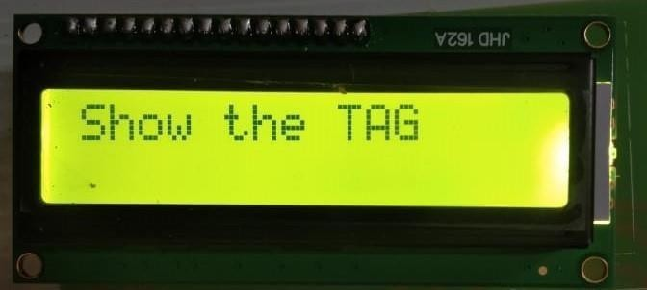
LCD outputs
A liquid-crystal display (LCD) is a flat panel display, electronic visual display, or video display that uses the light modulatingproperties of liquid crystals. Liquid crystals do not emit light directly.
LCDs are available to display arbitrary images (as in a general-purpose computer display) or fixed images which can be displayed or hidden, such as preset words, digits, and 7-segment displays as in a digital clock. They use the same basic technology, except that arbitrary images are made up of a large number of small pixels, while other displays have larger elements.
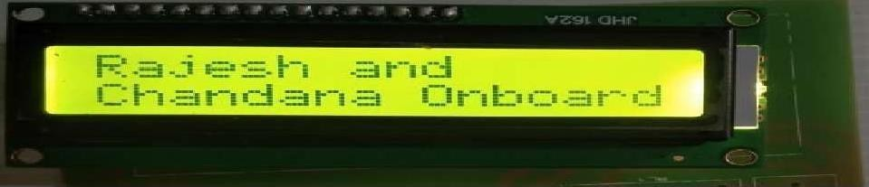
Here we need to show our RFID Tag or RFID Card . Hence it reads the RFID number and displays the output.and displays

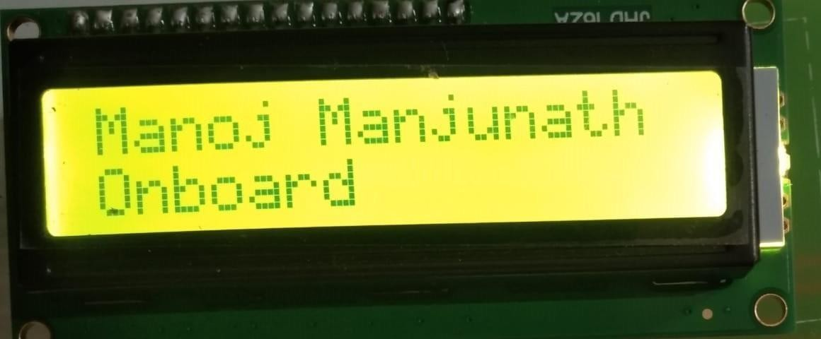

Jumper Wires

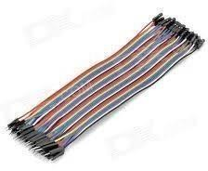

Fig Jumper wires

A jump wire (also known as jumper, jumper wire, jumper cable, DuPont wire, or DuPont cable) is an electrical wire or group of them in a cable with a connector or pin at each end (or sometimes without them – simply "tinned"), which is normally used to interconnect the components of a breadboard or other prototype or test circuit, internally or with other equipment or components, without soldering.

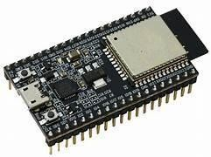
Individual jump wires are fitted by inserting their "end connectors" into the slots provided in a breadboard, the header connector of a circuit board, or a piece of test equipment.

ESP 32

This is ESP WROOM 32 MCU Module. ESP WROOM 32 is a powerful, generic WiFi-BT-BLE MCU module that targets a wide variety of applications, ranging from low-power sensor networks to the most demanding tasks, such asvoice encoding, music streaming, and MP3 decoding.
At the core of this module is the ESP32S chip, which is designed to be scalable and adaptive. There are 2 CPU coresthat can be individually controlled or powered, and the clock frequency is adjustable from 80 MHz to 240 MHz.
The user may also power off the CPU and make use of the low-power coprocessor to constantly monitor the peripherals for changes or crossing of thresholds. ESP32S integrates a rich set of peripherals, ranging from capacitive touch sensors, Hall sensors, low-noise sense amplifiers, SD card interface, Ethernet, high- speed SDIO/SPI, UART, and I²C.
Using Bluetooth, users can connect to their phone or broadcast low energy beacons for its detection. The use of Wi- Fi enables a large physical range, as well as a direct connection to the internet via a Wi-Fi router. Perfect for wearable electronic or battery- powered applications, the ESP32 chip uses less than 5µA.
In addition, this module can support data rates of up to 150 Mbps and 22 dBm output power at the PA in order to allow for the widest physical range.
To learn how to run the “Hello world” program using ESP 32 Application :

- Universal low power IoT sensor hub.
- Home automation.
- Universal low power IoT recorder.
- Mesh network.
- Video streaming of the camera.
- Industrial wireless control.
- OTT TV box / set-top box device.
- Baby monitor.
- Smart Socket.
- Sensor networks.
- Wi-Fi toys: Counters, toys, Anti-lost device.
- Wearable electronic products.
- Wi-Fi speech recognition device.
- Wi-Fi location-aware devices.

Features :

- Integrated 520 KB SRAM.
- Hybrid Wi-FI & Bluetooth.
- High level of integration.
- Ultra-low-power management.
- 4 MB Flash.
- On-board PCB antenna.

PIN CONFIGURATION of ESP8266
- VCC: to provide voltage up to 3.6 V at maximum
- GND: to provide ground to the module
- RX: serial data receiving
- TX: serial data transmission
- CH_PD (power down of the chip)
- RST: reset pin
- General purpose input output pins are 16

RFID

RFID History
In 1946, a Russian invented an espionage tool called the Covert Listening Device. This device retransmitted incident radio waves with audio information. Sound waves vibrated a diaphragm which slightly altered the shape of the resonator, which modulated the reflected radio frequency. This passive device was attributed to be the first known device and a predecessor of the RFID technology. The British invented a similar system during the World War II to identify enemy aircraft. It was called the Identification of Friend or Foe (IFF). Initial application was during World War II-The United Kingdom used RFID devices to distinguish returning English airplanes from inbound German ones. RADAR was only able to signal the presence of a plane, not the kind of plane it was. It was invented in 1948 by Harry Stockman. In 1971, an RFID device that was passive, powered by the interrogating signal, with a 16-bit memory transponder was invented. This device was the true ancestor to modern RFID and was patented in 1973 in the USAthat had demonstrated its uses in:
- Transportation (automotive vehicle identification, automatic toll system, electronic license plate, electronic manifest, vehicle routing, vehicle performance monitoring)
- Banking (electronic check book, electronic credit card), security (personnel identification,automatic gates, surveillance)
- Medical (identification, patient history)

It came into commercial use only in 1990s.
Radio frequency identification (RFID) technology is a wireless communication technology that enables users to uniquely identify tagged objects or people. RFID is rapidly becoming a cost-effective technology. This is in large part due to the efforts of Wal-Mart and the Department of Defense (DoD) to incorporate RFID technology into their supply chains. Although the foundation of the Radio Frequency Identification (RFID) technology was laid by past generations, only recent advances opened an expanding application range to its practical implementation.

RFID is only one of numerous technologies grouped under the term Automatic Identification (Auto ID), such as bar code, magnetic inks, optical character recognition, voice recognition,touch memory, smart cards, biometrics etc. AutoID technologies are a new way of controlling information and material flow, especially suitable for large production networks.

RFID Concept

The RFID technology is a means of gathering data about a certain item without the need of touching or seeing the data carrier, through the use of inductive coupling or electromagneticwaves. The data carrier is a microchip attached to an antenna (together called transponder ortag), the latter enabling the chip to transmit information to a reader (or transceiver) within agiven range, which can forward the information to a host computer. The middleware (software for reading and writing tags) and the tag can be enhanced by data encryption for security-critical application at an extra cost, and anti- collision algorithms may be implemented for the tags if several of them are to be read simultaneously.
One important feature enabling RFID for tracking objects is its capability to provide unique identification. One possible approach to item identification is the EPC (Electronic Product Code), providing a standardized number in the EPC global Network, with an Object Name Service (ONS) providing the adequate Internet addresses to access or update instance- specific data. However, currently, ONS cannot be used in a global environment, and since it is a proprietary service, its use is relatively expensive, especially for participants with limitedresources such as SMEs. As an alternative, researchers from the Helsinki University have proposed the notation ID@URI, where ID stands for an identity code, and URI stands for a corresponding Internet address. This allows several partners to use the system and still
guarantee unique identification. The project ‘Identity-Based Tracking and Web-Services for SMEs’ (http://www.traser- project.eu) is currently working on further development of this concept.
RFID tags or radio-frequency identification tags are helping streamline distribution, logistics and asset tracking and rapidly replacing traditional barcode technology as the solution of choice for company's in nearly every industry sector globally. With the increasing success and popularity of RFID more demands are being placed on its performance.
Additional capabilities are required for RFID tag design and functionality including the ability to package and encapsulate tags and incorporate sensor based technology. RFID tags are being used increasingly in extreme environments requiring exposure to harsh chemicals,high moisture and high heat.

The FOUR CORE Components of an RFID SystemAn RFID system has fourbasic components: A tag which is composed of a semiconductor chip and an antenna.
An interrogator (sometimes called a read/write device), which is composed of anAntenna, a RF electronicsmodule, and a control electronics module.
A controller (sometimes called a host), which most often takes the form of a PC ora workstation running database and control (often called middleware) software.
An antenna, which converts electrical power to RF power.

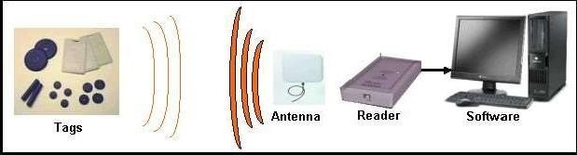
Fig Basic Building blocks of an RFID system

RFID TAGS
The basic function of an RFID tag is to store data and transmit data to the interrogator. At its most basic, a tag consists of an electronics chip and an antenna encapsulated in a packageto form a usable tag, such as a packing labelthat might be attached to a box.
Generally, the chip contains memory where data may be stored and read from and sometimes written, too, in addition to other important circuitry. Some tags also contain batteries, and this is what differentiates active tags frompassive tags. In our project we use passive tag.

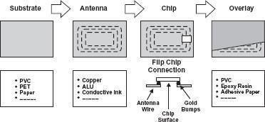

Fig 4.7: RFID Tag components

TYPES OF TAGS AND READERS
RFID tags and readers can be grouped under a number of categories. Their classificationis presented. Classification of RFID tags

Passive
- Also called ‘pure passive’, ‘reflective’ or ‘beam powered’.

- Obtains operating power from the reader.

- The reader sends electromagnetic waves that induce current in the tag’s antenna, the tag reflects the

- RF signal transmitted and adds information by modulating thereflected signal.
- Semi-passive uses a battery to maintain memory in the tag or power the electronicsthat enable the tag tomodulate the reflected signal communicates in the same method, as the other passive tag.
Active
- Powered by an internal battery, used to run the microchip’s circuitry and tobroadcast a signal to the reader.
- Generally ensures a longer read range than passive tags.

  - More expensive than passive tags (especial because usually are read/write)

  - The batteries must be replaced periodically bythe tag’s memory type

  - Read only - The memory is factory programmed, cannot be modified after itsmanufacture
  - Its data is static.

  - Very limited quantity of data can be stored, usually 96 bits of information can beeasily integrated with data collection systems.

  - Typically are cheaper than read-write tags.

  - Its data can be dynamically altered.

  - Can store a larger amount of data, typically ranging from 32 Kbytes to 128 Kbytes
  - Being more expensive than read-only chips, is impractical for tracking inexpensiveitems by the method of wireless signal used for communication between the tag and reader Induction.
  - Close proximity electromagnetic or inductive coupling - near field

  - Generally use LF and HF frequency bands

RC522 RFID Card Reader Module
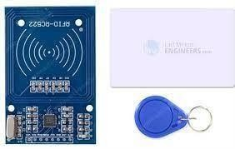
Fig 4.8 RFID
This RC522 RFID Card Reader Module 13.56MHz is a low-cost MFRC522 based RFID Reader Module is easy touse and can beused in a wide range of applications.

This RC522 RFID Card Reader Module 13.56MHz is a low-cost MFRC522 based RFID Reader Module is easy touse and can beused in a wide range of applications.
The MFRC522 is a highly integrated reader/writer IC for contactless communication at 13.56MHz. RC522 is the highly integrated RFID card reader which works on non-contact 13.56mhz communication, is designed by NXP as low power consumption, low cost and compact size read and write chip, is the best choice in the development of smart meters and portable hand-held devices.
MF RC522 use the advanced modulation system, fully integrated at 13.56MHz with all kinds of positive non-contact communication protocols. Support 14443A compatible answer signal. DSP dealwith ISO14443A frames and error correction. Furthermore, it also supports rapid CRYPTO1 encryption to validate Mifare series products. MFRC522 support Mifare series higher speed non- contact communication, duplex communication speed up to 424 kb/s. As a new family member in 13.56MHz RFID family, MF RC522 has many similarities to MF RC5200 and MF RC530 and also has more new features.
This module can fit directly in handheld devices for mass production. The module uses the 3.3V power supply and can communicate directly with any CPU board by connecting through SPI protocol, which ensures reliable work, high reading distance.

NEO-6M GPS Chip
At the heart of the module is a GPS chip from U-blox – NEO-6M. The chip measures less than a postage stamp but packs a surprising amount of features into its tiny frame. It can track up to 22 satellites over 50 channels and achieve the industry’s highest level of tracking sensitivity i.e. -161 dB, while consuming only 45 mA current.

Unlike other GPS modules, it can perform 5 location updates in a second with 2.5m horizontal position accuracy. The U-blox 6 positioning engine also has a Time-To-First-Fix (TTFF) of less than 1 second.

One of the best features offered by the chip is Power Save Mode (PSM). This allows a reduction in system power consumption by selectively switching certain parts of the receiver on and off. This dramatically reduces the power consumption of the module to just 11mA making it suitable for power sensitive applications such as GPS wristwatches.
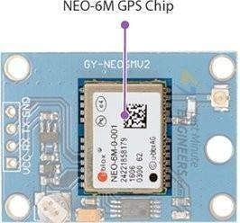

The required data pins of the NEO-6M GPS chip are broken out to a 0.1″ pitch headers. It contains the pins needed for communication with the microcontroller over the UART. The module supports baud rates from 4800bps to 230400bps with a default baud of 9600.

Here are the specifications:
Receiver Type -50 channels,
GPS L1(1575.42Mhz)Horizontal Position Accuracy 2.5m
Navigation Update Rate 1HZ (5Hz maximum)
Cool start: 27sHot start: -1s
Navigation Sensitivity -161dBm
Communication Protocol NMEA, UBX Binary, RTCM
Serial Baud Rate 4800-230400 (default 9600)
Operating Temperature -40°C ~ 85°C
Operating Voltage 2.7V ~ 3.6V

Software:

  - Arduino IDE
  - Embedded C

Arduino IDE
Arduino is a prototype platform (open-source) based on an easy-to-use hardware and software. It consists of a circuit board, which can be programed (referred to as a microcontroller) and a ready- made software called Arduino IDE (Integrated Development Environment), which is used to writeand upload the computer code to the physical board.
Arduino provides a standard form factor that breaks the functions of the micro-controller into a more accessible package.
A program for Arduino may be written in any programming language for a compiler that produces binary machine code for the target processor. Atmel provides a development environment for their microcontrollers, AVR Studio and the newer Atmel Studio.
The Arduino project provides the Arduino integrated development environment (IDE), which isa cross-platform application written in the programming language Java. It originated from the IDEfor the languages Processing and Wiring. It includes a code editor with features such as text cutting and pasting, searching and replacing text, automatic indenting, brace matching, and syntaxhighlighting, and provides simple one-click mechanisms to compile and upload programs to aArduino board. It also contains a message area, a text console, a toolbar with buttons for common functions and a hierarchy of operation menus.
A program written with the IDE for Arduino is called a sketch. Sketches are saved on the development computer as text files with the file extension .ino. Arduino Software (IDE) pre-1.0 saved sketches with the extension .pde.
The Arduino IDE supports the languages C and C++ using special rules of code structuring. The Arduino IDE supplies a software library from the Wiring project, which provides many common input and output procedures. User-written code only requires two basic functions, for starting the sketch and the main program loop, that are compiled and linked with a program stub main() into an executable cyclic executive program with the GNU toolchain, also included with the IDE distribution. A minimal Arduino C/C++ sketch, as seen by the Arduino IDE programmer, consist of only twofunctions:
- setup(): This function is called once when a sketch starts after power-upor reset. Itis used toinitialize variables, input and output pin modes, and other libraries needed inthe sketch.
- loop(): After setup() has been called, function loop() is executed repeatedly in themain program.It controls the board until the board ispowered off or is reset.

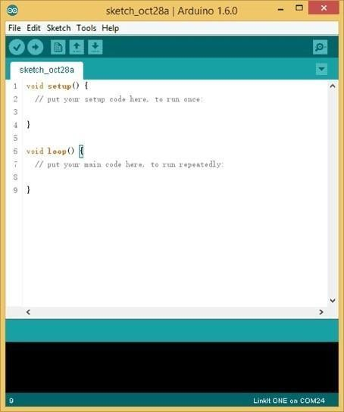

Embedded C:

Embedded C is one of the most popular and most commonly used Programming Languages in the development of Embedded Systems.
Embedded C is perhaps the most popular languages among Embedded Programmers for programming Embedded Systems. There are many popular programming languages like Assembly, BASIC, C++ etc.thatare often used for developing Embedded Systems but Embedded C remains popular due to its efficiency, less development time and portability.

What is an Embedded System?
An Embedded System can be best described as a system which has both the hardware and software and is designed to do a specific task. A good example for an Embedded System, which manyhouseholds have, isa Washing Machine.

SYSTEM DESIGN
Design is a meaningful engineering representation of something that is to be built. It is the most crucial phase in the developments of a system. Software design is a process through which the requirements are translated into a representation of software. Design is a place where design is fostered in software Engineering. Based on the user requirements and the detailed analysis of the existing system, the new system must be designed. This is the phase of system designing. Design is the perfect way to accurately translate a customer’s requirement in the finished software product. Design creates a representation or model, provides details about software data structure, architecture, interfaces and components that are necessary to implement a system. The logical system design arrived at as a result of systems analysis is converted into physical system design.

System development methodology
System development method is a process through which a product will get completed or a product gets rid from any problem. Software development process is described as a number of phases, procedures and steps that gives the complete software. It follows series of steps which is used for product progress. The development method followed in this project is waterfall model.

Model phases
The waterfall model is a sequential software development process, in which progress is seen as flowing steadily downwards (like a waterfall) through the phases of Requirement initiation, Analysis, Design, Implementation, Testing and maintenance.

Requirement Analysis: This phase is concerned about collection of requirement of the system. This process involves generating document and requirement review.
System Design: Keeping the requirements in mind the system specifications are translated in to a software representation. In this phase the designer emphasizes on:-algorithm, data structure, software architecture etc.
Coding: In this phase programmer starts his coding in order to give a full sketch of product. In other words system specifications are only converted in to machine readable compute code.

Implementation: The implementation phase involves the actual coding or programming of the software. The output of this phase is typically the library, executables, user manuals and additionalsoftware documentation

Testing: In this phase all programs (models) are integrated and tested to ensure that the completesystem meets the software requirements. The testing is concerned with verification and validation.

Maintenance: The maintenance phase is the longest phase in which the software is updated to fulfill the changing customer need, adapt to accommodate change in the external environment, correct errors and oversights previously undetected in the testing phase, enhance the efficiency of the software.

System Architecture
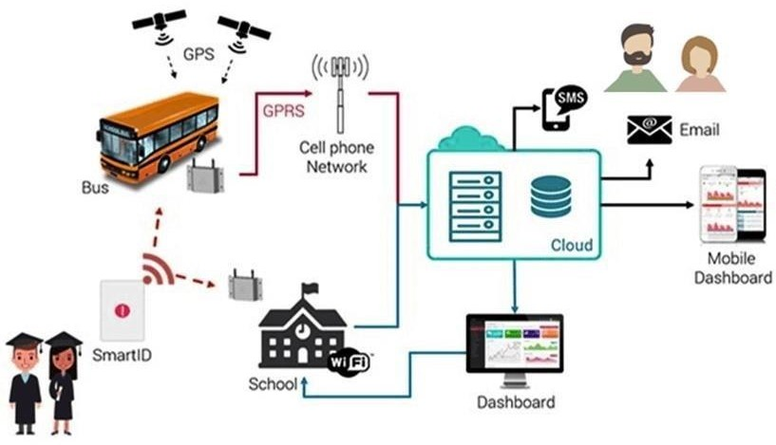

The proposed embedded system consists of hardware block as well as software part. The hardware components for implementation require a microcontroller, RFID reader , RFID cards, GPS module, Wi-Fi module, LCD module. Moreover the development of mobile application requires corresponding android studio for software development.
  - Microcontroller: Arduino Mega microcontroller is used as the central part of the school bus sub system. C language program saved in the memory of the controller ensures proper module functionality .The microcontroller has 16 analog inputs, 54 digital input/output pins as well as 4 UARTS. The UARTs are used to connect RFID, GPS and the Wi-Fi module. Arduino IDE is the software used to develop the code.
  - GPS Receiver: SIM 28 ML GPS receiver with low power consumption is used. NMEA format is followed by signals received by the module. It provided co-ordinates of any location on planet Earth with exact Universal Time Coordinated time (UTC). It is used for live tracking with high accuracy and reliability. GPRMC signal contains location information with co-ordinate specification.
  - ESP8266 Wi-Fi module: Wi-Fi module is used to transfer the data to remote server periodically. It follows AT commands and can be connected to the server using TCP protocol. It requires 3.3V power supply and is compact in size. It is easily configurable using Arduino.
RFID module: EM18 RFID reader is used along with passive tags for student identification. It operates at frequency of 125KHz. The module radiates 125KHz through its coils and when 125KHz passive RFID tag is brought into this field it will get energized from this field. These passive RFID tags mostly consist of CMOS IC EM4102 which can get enough power for its working from the field generated by the reader. By changing the modulation current through the coils, tag will send back the information contained in the factory programmed memory array.

and reliability. GPRMC signal contains location information with co-ordinate specification. 3.ESP8266 Wi-Fi module: Wi-Fi module is used to transfer the data to remote server periodically. It follows AT commands and can be connected to the server using TCP protocol. It requires 3.3V power supply and is compact in size. It is easily configurable using Arduino.
  - RFID module: EM18 RFID reader is used along with passive tags for student identification. It operates at frequency of 125KHz. The module radiates 125KHz through its coils and when a125KHz passive RFID tag is brought into this field it will get energized from this field. These passive RFID tags mostly consist of CMOS IC EM4102 which can get enough power for its working from the field generated by the reader. By changing the modulation current through the coils, tag will send back the information contained in the factory programmed memory array.
  - LCD Display: 16x2 LCD display is used to verify student status at the time of entrance as well
as exit. It is compatible with the Hitachi HD44780 driver. It can be easily interfaced with arduino board. It forms part of school bus subsystem.

The main goal of the proposed work is to improve the Bus system by adding the necessary additional features into the application, like accurate bus timings, correct bus numbers and moreover adding a GPS tracker into it. This study accepts input in the form of selection of the source and destination and selection of the bus travelling the distance to display the entire details about the routes and also track the location of the respective bus and give the map for the same. The last two decades have seen growing interest in the development of Android based platform. Our review of this area shows that there have been only few approaches that provide automated tools for the functioning of the application:
    - An application has been implemented in Pune, named “Pune Bus Guide”. This application gives the way to the destination correctly, but the number of drawbacks that it has is greater than the number of advantages. It does not show the passengers current location even if he/she is connected to the GPS. Also, this application has been proven useless as it does not display the bus numbers, so the passengers find it very hard to know the number and time of arrival of the respective buses. It does not have a real time bus tracking service or does not even generate maps for the users ease. This application has never been updated ever since its development. Moreover, this application has bugs which makes it all the more difficult for the user to use it.
    - Another application that was implemented in Mumbai, named “M-Indicator i” has drawbacks like: It displays matter which is the same as what is online. Its latest updates have given issues on every Android mobile supporting even the most recent device version. The “A to B” module of buses has given problems. Whenever an option for the source to destination is selected, the field still remains blank, i.e. no bus routes are displayed.

    - When we show the RFID tag or the card it reads the unique number mentioned and gives the output as student name onborded .

    - Notification goes to the parents as that student is inside the bus hence it stores the data in iot.

The proposed system will provide various facilities like check drunk and drive, children’s entry and exit information, accident emergencies, inappropriate drop, GPS tracking system, logistic management etc., which are helpful for child security.
The various advantages of the proposed system are Transportation Safety, Student Safety andAttendance of ward is a time benefit for school management.

SCOPE
Many cities have found that GPS tracking system not only improve the efficiency of city bus operation, but also encourage commuters to take the advantage of city bus system.
Many city bus system have discovered that GPS tracking system which allows to monitor the location and arrival time of their bus actually increase the number of people using city buses for routine communing.
The application is a user friendly one that anyone can access for free of cost. The basic idea for this project was to guide the bus travelers with the routes, all the possible stops that come on their way to the destination and moreover, display maps and track their locations and show the estimate remaining time required to reach. The aim is to overcome all the drawbacks faced in all the previous applications and generate fast and accurate results. The proposed system has been divided into two modules as follows. Module 1 gives information about all the routes from the source to the destination and give maps for the same. Module 2 give information about all the buses along with the bus numbers that go through the selected stops, track the location of the bus. The proposed system will provide various facilities like check drunk and drive, children’s entry and exit information, accident emergencies, inappropriate drop, GPS tracking system, logistic management etc., which are helpful for child security.
The various advantages of the proposed system are Transportation Safety, Student Safety andAttendance of ward is a time benefit for school management.

SCOPE
Many cities have found that GPS tracking system not only improve the efficiency of city bus operation, but also encourage commuters to take the advantage of city bus system.
Many city bus system have discovered that GPS tracking system which allows to monitor the location and arrival time of their bus actually increase the number of people using city buses for routine communing.
The application is a user friendly one that anyone can access for free of cost. The basic idea for this project was to guide the bus travelers with the routes, all the possible stops that come on their way to the destination and moreover, display maps and track their locations and show the estimate remaining time required to reach. The aim is to overcome all the drawbacks faced in all the previous applications and generate fast and accurate results. The proposed system has been divided into two modules as follows. Module 1 gives information about all the routes from the source to the destination and give maps for the same. Module 2 give information about all the buses along with the bus numbers that go through the selected stops, track the location of the selected bus and send this information to the passenger giving him/her the estimate time required for the bus to reach. This is done using the Client-Server technology.

