THERAPEUTIC PROPERTIES OF “NEELAM SAMBA” - A TAMILNADU TRADITIONAL RICE VARIETY
KALAIVANI. R, BAKIYA LAKSHMI S. V, SUMITHRA D
Department of Biotechnology,
Bon Secours College for Women, Villar, Thanjavur, Tamilnadu, India.
Affiliated with Bharathidasan University, Tiruchirappalli
E. mail: bakiyalakshmi.sv@gmail.com, vanisri05bio@gmail.com, gksumin@gmail.com

Abstract

Brown rice has rich nutrients important for a healthy food regimen even as parboiling rice is rich in nutrition and micronutrients. The knowledge about traditional rice varieties has not reached the public and scientific interference about the traditional varieties. This is the time to highlight the significance of medicinal value and its properties in a scientific manner. To reveal the Bioactive compounds and the medicinal properties of the traditional rice variety Neelam samba, to restore our indigenous knowledge about rice, enhance the nutritional values, with a view the study is designed to examine the Bioactive compounds and the Pharmacological activities of selected rice variety. The GCMS study revealed the Presence of antimicrobial, anti-inflammatory antioxidant, anticancer, and Sex Pheromone compounds. The selected rice variety will be used for the development of functional foods and various other value-added products for a sustainable healthy life.
Keywords: Neelam Samba, Traditional Rice, GCMS, Bioactive Compounds

Introduction

The maximum not unusual rice fed on with the aid of people is polished rice, observed by means of unpolished rice; but purple, red or black colored rice have been cultivated for a long term in Asia (Ahuja et al., 2008). colored rice possesses unique coloration and taste but, because of the problem in the time period of the difficult texture of cooked colored rice, they may be not popular for consumption even though it has been long known approximately the useful results of pigment in those corporations of rice. Neelam Samba is a conventional range that is surprisingly appropriate for cultivation in regions that are vulnerable to water logging.

Altogether, the value of cultivation could be very low. those facts are favorable and worthwhile to the rural farming network. The goal of this look at became to examine the phytochemical and its Pharmacological position of organic traditional rice range Neelam samba. this may facilitate further information of its inherent houses that will assist toward optimizing its usage and make it commercially feasible.

Materials and Methods
The traditional rice variety “Neelam Samba” was collected from a Thanjavur District, Tamilnadu. The paddy samples obtained were stored under -20°C in deep freezer. This paddy was taken out kept in the atmospheric condition for equalization of moisture and after allowing for a week’s exposure the moisture was analyzed and the paddy was shelled in the “Satake” Laboratory model Rubber Role Sheller. After shelling it was pulverized in “Fritze” pulverizer and used for analysis.

Analysis of Bioactive compounds by GC-MS

25g of Neelam Samba rice powder extracted with 95% ethanol for 12 hours, then 2µl of this extract was used for GC/MS analysis.

Results and Discussion
The results relating GC - MS evaluation brought about the identification of variety of compounds from the GC fractions of the ethanolic extract of decided on sample Neelan Samba. The compound prediction is based on Dr.Duke's Phytochemical and ethnobotanical Databases. The medicinal uses of phytocomponents recognized in Neelan samba become tabulated in table 1. The presence of diverse bioactive compounds confirms the application of selected pattern Neelan samba for numerous ailments through conventional practitioners.
Table Components identified in the Neelam samba and its Medicinal Properties [GC MS study]

No. | Name of the compound | Biological Activity
1. | 1,2-Benzenedicarboxylic acid, butyl octyl ester | Anti-inflammatory (Li et al., 2004) and antibacterial interest (Modupe et al.,  2010).
2. | Hexadecanoic acid, ethyl ester (Palmitic acid, ethyl ester) | Antioxidant, Hypocholesterolemic Nematicide, Pesticide,Lubricant, Antiandrogenic, flavor, Hemolytic five- Alpha reductase inhibitor (Rajeswari et al., 2012)
3. | 9,12-Octadecadienoic acid, methyl ester, (E,E)- (Linolelaidic acid, methyl ester) | Antiinflammatory, Hypocholesterolemic, cancer preventive, Hepatoprotective, Nematicide Insectifuge, Antihistaminic, Antieczemic, Antiacne, five-Alpha reductase inhibitor Antiandrogenic,  Antiarthritic, Anticoronary, Insectifuge (Rehana Banu and Nagarajan 2013 )
4. | Oleic Acid | Antitumor effect (Carrillo et al., 2012 )
5. | Didodecyl phthalate | Vasodilator, Angiotensin AT2 receptor antagonist, Uric acid excretion stimulant and Diuretic (Mallikadevi et al., 2012)
6. | 1,2-15,16-Diepoxyhexadecane | Cytotoxicity (Murugesan Amudha and  Shanmugam Rani 2014)
7. | 6,11-Dimethyl-2,6,10-dodecatrien-1-ol | Antimicrobial Activity (Mohan Das et  al., 2013)
8. | cis-Z-à-Bisabolene epoxide | To boom intercourse hormone interest (Amutha Iswarya Devi and Kottai Muthu  2014)
9. | 2H-Pyran, 2-(7-heptadecynyloxy)tetrahydro- | Antimicrobial , Antiinflammatory and  Antioxidant (Anand and Gokulakrishnan 2012)

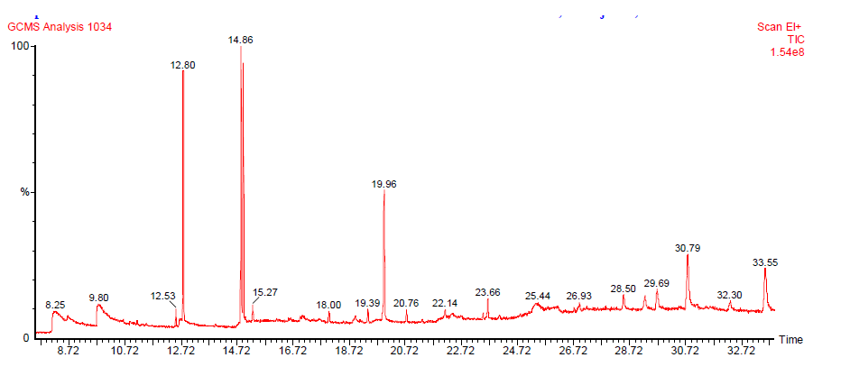
GCMS Chromatogram

Conclusion
Traditional rice possesses extensive allegations to human health not simply in terms of food but also as a medication. It has the capacity to control most cancers and devasting diseases current state of affairs. Therefore the rice used as meals and easy to formulate Nutraceutical can serve as a tool in self-medicine for human diseases. This observation explores the goodness of the pattern Neelan samba which has a phytopharmaceutical significance. Our prime duty is to conserve and cultivate traditional rice varieties for a sustainable healthy life.

References

- Ahujal U, Ahujal S C, Thakrar R & Singh R K, Rice-A Nutraceutical, Asian Agri- History,12(2)(2008) 93-108.
- Amutha Iswarya Devi J and Kottai Muthu A 2014. Gas chromatography-mass spectrometry analysis of bioactive constituents in the ethanolic extract of
Saccharum spontaneum linn. Int J Pharm Pharm Sci, Vol 6, Suppl 2, 755-759.
- Anand T and Gokulakrishnan K 2012. Phytochemical Analysis of Hybanthus enneaspermus using UV, FTIR and GC- MS. IOSR Journal of Pharmacy Vol. 2, Issue 3, PP.520-524.
- Carrillo, del M. Cavia and Alonso-Torre S. R 2012. Antitumor effect of oleic acid; mechanisms of action. A review. Nutr Hosp. 27(5):1860-1865.
- Li EW Leach DN, Myers P, Leach GJ, Lin GD, Brushett DJ, Waterman PG (2004). Anti-inflammatory activity, cytotoxicity and active compounds of TinosporasmilacinaBenth. Phytother. Res. 18:78-83.
- Mallikadevi, T., Paulsamy S. Jamuna S and Karthika K (2012). Analysis for phytoceuticals and bioinformatics approach for the evaluation of therapetic properties of whole plant methanolic extract of Mukia maderaspatana (l.) M.roem. (cucurbitaceae) – a traditional medicinal plant in western districts of tamil nadu, india. Asian Journal of Pharmaceutical and Clinical Research. Vol 5, Issue 4, 163-168.
- Modupe O, Wesley O, Morufu A, Elizabeth AO (2010). Analysis of essential oil from the stem of Chansmanthera dependens. J. Nat. Prod. 3:47-53.
- Mohan Das N, Sivakama Sundari S, Karuppusamy S, Mohan VR, Parthipan B 2014. GC - MS analysis of leaf and stem bark of Cleidion nitidum (muell. – arg.) thw. ex kurz. (euphorbiaceae). Asian J Pharm Clin Res, Vol 7, Issue2, 2014, 41 - 47.
- Murugesan Amudha and Shanmugam Rani 2014. Assessing the bioactive constituents of Cadaba fruticosa (l.) Druce through GC-MS. Int J Pharm Pharm Sci, Vol 6, Issue 2, 383-385.
- Peter Werle, Marcus Morawietz, Stefan Lundmark, Kent Sörensen, Esko Karvinen, Juha Lehtonen “Alcohols, Polyhydric” in Ullmann’s Encyclopedia of Industrial Chemistry, Wiley-VCH, Weinheim, 2008.
- Philip D, Kaleena PK, VAlivittan K (2011). Gc-ms analysis and antibacterial activity of chromatographically separated pure fractions of leaves of Sansevieria roxburghiana. Asian J. Pharm. Clin. Res. 4:130-133.
- Rajeswari G, Murugan M and Mohan VR 2012. GC-MS analysis of bioactive
components of Hugonia mystax L. (Linaceae). Research Journal of Pharmaceutical, Biological and Chemical Sciences. Volume 3 Issue 4 Page 301- 308.
- Rehana Banu H and Nagarajan N 2013. GC-MS determination of bioactive components of Wedelia chinensis (Osbeck) Merrill. Journal of Chemical and Pharmaceutical Research, 2013, 5(4):279-285.
- Senthilkumar G, Madhanraj P, Panneerselvam A (2011). Studies on the Compounds and Its Antifungal Potentiality of Fungi Isolated From Paddy Field Soils of Jenbagapuram Village, Thanjavur District, and South India. Asian J. Pharm. Clin. Res. 1:19-21.
- Shafaghat A, Farshid S, Vahid mani-Hooshyar A (2012). Phytochemical and antimicrobial activities of Lavandula officinalis leave and stems against some pathogenic microorganisms. J. Med. Plants Res. 6:455-460.
- Ushadevi T (2008). Studies on the microfungal in the muthupet mangroves with emphasis on antimicrobial activity. Ph.D. Thesis, Trichirappalli, India: Bharathidasan University.

