**Overview of recent environmental catalytic materials**

V T Vasantha1, C K Madhusudhan2, and R S Praveen Kumar2

1Department of Chemistry, Vemana Institute of Technology, Bangalore-560034, Koramangala, Karnataka, India

2Department of Physics, Vemana Institute of Technology, 560034, Koramangala, Karnataka, Bangalore, India.

***Abstract:***

This chapter comprises of brief introduction on catalytic technology, different features of the present work and a review of the published and patented literature on the modification of acido-basic properties of metal oxides, mixed metal oxides and their anion/cation-treated forms, their characterization by various physico-chemical techniques, and their catalytic activity in different organic reactions. A review on the application of microwave heating for the heterogeneously catalyzed liquid phase organic reactions is also presented.

Keywords: Catalytic technology,microwave chemistry, Honeycomb monolith

***1.1 Introduction***

The past few decades have seen significant improvements in the chemical industry, primarily due to concerns regarding the environment along with the economy on a global level. Emphasis is now on making processes efficient in terms of consumption of both energy and raw materials with minimal waste. This has been proposed that powerful catalytic technologies could achieve this. These catalytic technologies have long been utilized in sectors like the synthesis of chemicals and polymers, energy and petroleum, pollution management, and in the food and pharmaceutical sectors.



J.J. Berzelius first proposed the term "catalyst" in 1836. He described it as a material that alters the rate of chemical reaction, while itself remaining chemically unchanged at the end of the reaction [1,2]. Substances help loosen the bonds that hold atoms together in the reactants together. As a result, he originated the term catalysis. Wilhelm Ostwald proposed its powerful definition as far as the ideas of chemical kinetics. In 1909, Ostwald was granted the Nobel Prize in science for his commitments to catalysis. Recently, the main focus has been on developing novel solid acid catalysts through research and development in order to enhance selectivity and accelerate up the production of the desired product. By changing their surface properties, various new catalysts are being synthesized in this way [3-6]. The primary benefits of solid acids over traditional liquid acid catalysts are their total recovery from the reaction mixture and easy separation from reaction mixture. [7-9].

***1.2 Catalysed processes***

A chemical reaction is referred to as catalytic when, in a thermodynamically sensible reaction, the addition of a small amount of a chemical substance accelerates the rate at which chemical equilibrium is reached without changing the substance chemically. A catalyst is a substance that increases the rate of reaction. Providing an alternate mechanism with a distinct transition state at a lower energy is how catalysts function. Consequently, as Figure 1.1 shows, the catalytic reaction's activation energy is lower than that of the uncatalyzed reaction.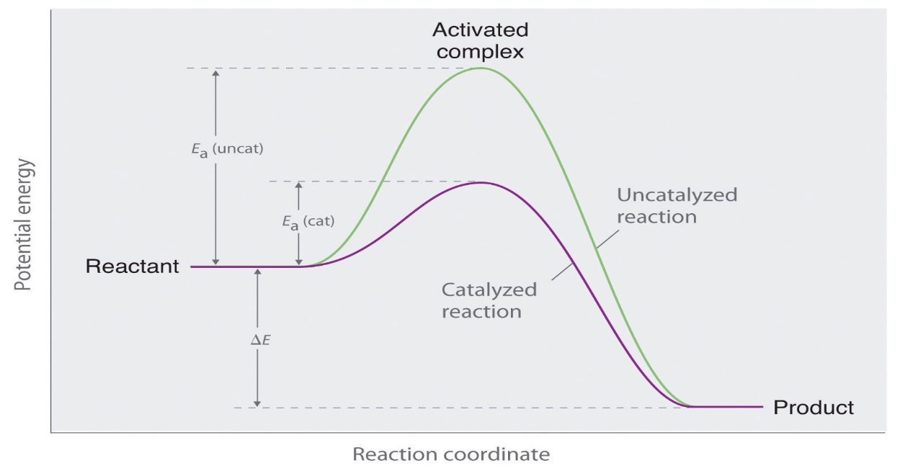

**Figure 1.1Energy diagram showing that the presence of a catalyst reduces activation energy by bringing it up a new reaction path.**

Ea (uncat) = activation energy for uncatalysed reaction

Eac (cat) = activation energy for catalysed reaction

ΔE= Energy change accompanying the reaction

By giving an alternative route for the reaction, a catalyst alters the activation energy E of a reaction. Thermal energy kT, where k is the Boltzmann's constant and T is the temperature, normally provides the activation energy E. Only a portion of all molecule contacts, denoted by the probability factor e-E/kT. Therefore, if the activation energy E is reduced, either by raising the temperature or by employing a catalyst, the reaction rate can be increased [2]. Collision theory suggests that a catalyst initially combine with one of the reactants forming an intermediate compound, this intermediate compound is highly reactive. Hence it react with the second reactant to form the product and there by the catalyst is regenerated.

E.g.: reaction between two reactants A and B in presence of catalyst C

A + C $→$ [AC]

One of the Catalyst Highly reactive intermediate Reactant

[A C] + B $→$ AB + C

Other reactant Product regenerated catalyst

Over all reaction:

A + B + [C] $→$ AB + [C]

***1.2.1 Catalytic reaction types***

In general there are two categories of catalysis:

(a) Homogeneous catalysis

(b) Heterogeneous catalysis

***1.2.1.1 Homogeneous catalysis***

Reactants and catalyst will be in the same phase in a homogeneous catalytic reaction. Usually, there is only one liquid phase or one gas phase containing all of the reactants and catalysts.Hence, reuse, recover and separation of homogeneous catalysts are less possible or more expensive Ex: HCl, H2SO4, H3PO4, AlCl3, TiCl4, FeCl3, p-toluene sulfonic acid, CF3SO3H etc. These are less environment friendly due to the formation of highly toxic waste product during chemical reactions.

***1.2.1.2 Heterogeneous catalysis***

The phases of the reactants and catalysts in a heterogeneous catalytic process will be different. Typical examples are liquid-gas reactions that occur in the presence of solid catalysts. The Contact Process, which produces sulphur trioxide by passing sulphur dioxide and oxygen over a solid Vanadium oxide catalyst, is one example of how sulfuric acid is synthesised. Thus, it can be easy to take out heterogeneous catalysts from the reaction mixture, Since they can be recovered and recycled several times without losing their catalytic activity, they are considered as beneficial to the environment. For example, heteropolyacids, clays, zeolites, metal oxides, mixed metal oxides, etc. Nobel Prizes in heterogeneous catalysis have been awarded on several times: Fritz Haber in 1918, Card Bosch in 1931, Irving Langmuir in 1932, and Gerhard Ertl in 2007. Several significant heterogeneous catalysts can be broadly categorised as follows [10].

1. Transition metals, alloys, and bimetallic clusters (such as Pt-Sn in petrochemical refining, Ti-Zeigler-Natta catalyst in olefin polymerization, and vanadium in the manufacture of sulfuric acid)Metal oxides (TiO2 in automobile exhaust, V2O5 in oxidation of xylene to phthalic acid)

2. Complex oxides (Perovskite type) catalysts (photocatalysis, Pt/Al2O3 catalyst-induced alkane-to-alkene dehydrogenation, and automobiles exhaust)

3. Zeolites (Petrochemical industry and isomerisation of xylenes and toluene’s to p-xylene).

Environmental catalysis, photocatalysis, and electrocatalysis are the three main types of heterogeneous catalysis. Maintaining the environment is the primary goal of environmental catalysis. As examples, consider the reduction of NOx in mass gases using ammonia on V2O5-TiO2 as catalyst, or the removal of CO and hydrocarbons from vehicle exhaust gases using so-called "three-way" catalysts, which are ceramic honey combs layered with Rh-Pt-CeO2-Al2O3. In photocatalysis, light is absorbed during a reaction by either the reactant or the catalysis. Using semiconductor catalysts (iron, zinc, and titanium oxides) for the photochemical breakdown of organic materials on self-cleaning surfaces is one example. Oxidation and reduction through electron transfer are included in electrocatalysis. Examples include fuel cells and the use of catalytically active electrodes in electrolysis procedures like chlor-alkali electrolysis.

***1.3 Solid acid-base catalysts***

When compared with liquid Lewis and Bronsted acid and base catalysts, solid acid-base catalysts have a number of advantages. They are less hazardous to the environment, easily removed from the liquid reaction mixture, and can be used again. In addition, they may be designed to provide better activity, selectivity, and catalyst life. While a solid base has a tendency to take an electron pair or take a proton, a solid acid has a tendency to give an electron pair or receive an electron pair. Bronsted bases are proton acceptors, Lewis bases are electron-pair donors, and Bronsted acids are proton donors. Lewis bases are also electron-pair acceptors. These explanations are useful for providing a clear thinking of solid acid and base catalysis and are suitable for comprehending the acid-base phenomena exhibited by different materials. It should be indicated, nevertheless, that depending on the type of adsorbate in the reaction, the same site could function as both a Lewis and a Brønsted base [11].

***1.3.1 Catalysts for solid acid***

Acidic sites can be found on the surface of zeolites, clays, metal oxides, mixed metal oxides, etc. Modification of these oxides and mixed oxides with sulphate, phosphate, and borate anions and Al3+, Mo6+, and W6+ cations were found to form strongly acidic and super-acidic sites; for this purpose, they are referred to as solid acids. The structure, texture, and surface modification of solid acids significantly affect how strong their acidity is. Table1.1 [12] gives an example list of solid acids along with examples.

**Table 1.1.** Types of solid acid catalysts and examples.

|  |  |  |
| --- | --- | --- |
| **Sl. No.** | **Solid acid catalysts** | **Examples** |
| 1 | Natural clay minerals | Montmorillonite, Kaolinite |
| 2 | Simple metal oxides and sulphides | ZrO2, Al2O3, SiO2, Fe2O3, TiO2, V2O5, MnOx, ZnS, CdS |
| 3 | Metal salts | MgSO4 |
| 4 | Mixed metal oxides | ZrO2-Al2O3, SiO2-Al2O3, ZrO2-SiO2, V2O5- ZrO2, MoO3- ZrO2, WO3- ZrO2 |
| 5 | Sulfated promoted metal oxides | SO42--ZrO2, SO42--Al2O3, SO42--SiO2, SO42-- Fe2O3, SO42--TiO2 |
| 6 | Mounted acids | Porous oxides, graphite, metal salts, combined or treated with H2SO4, SbF5, AlCl3, H3PO4, H3BO3 |
| 7 | Metal phosphates | Alumina phosphates (AlPO4), silicoalumino phosphates (SAPOs) |
| 8 | Carbon | Carbon nanotubes, activated charcoal |
| 9 | Cation exchange resins | Amberlyst-15, nafion-H |
| 10 | Heteropolyacids | H3PW12O40.24H2O, 12-tungstophosphoric acid |

***1.3.2 catalytic solid bases***

Solid acid catalysts have been extensively studied and used in many different types of reactions up to this point due to the tremendous advancements in the oil and petrochemical industries over the past forty years. However, a lot more work has been done to prove solid base catalysts as compared to solid acid catalysts. The numbers 103, 10, and 14 correspond to the categories of solid acid, solid base, and solid acid-base bi-functional catalysts, respectively, according to a quantifiable investigation carried out by Tanabe and Hölderich up until 1999 [13]. It seems like there are a lot less solid acid catalysts overall than there are solid base-related catalysts, as well as solid base and acid-base bi-functional catalysts. Actually, liquid bases catalysts are used in the industrial process of several processes, including addition, condensation, cyclization, isomerization, and alkylation. Table 1.2 provides an example list of solid bases and examples.

**Table 1.2:** Types of solid base catalysts and examples.

|  |  |  |
| --- | --- | --- |
| **Sl. No.** | **Solid base catalysts** | **Examples** |
| 1 | Single metal oxides | MgO, CaO, SrO, BaO, La2O3, ZrO2 |
| 2 | Mixed oxides | ZrO2/MgO, ZrO2/CaO, MgO- Al2O3 MgO-TiO2 |
| 3 | Mesoporous material | MgO/SBA-15  MCM-41 functionalized with amino groups |
| 4 | Zeolite | Cs-occluded zeolite X, Y  Cs-exchanged zeolite X, |
| 5 | Oxinitride | SiON, AlPON, ZrPON |
| 6 | Supported catalyst | KF/Al2O3, Na/NaOH/Al2O3, Na /MgO |
| 7 | Clay and modified clay | Mg-Al hydrotalcites |
| 8 | Other | Calcined NaNO3 |

***1.3.3 Super acids***

The chemistry of super acids, i.e, acids stronger than 100% Bronsted acids such as sulphuric acid or Lewis acids like aluminum trichloride. i.e., (Hammett acidity) H0 ≤ -12 [14]. Acid strength of some solid and liquid acids are shown in Fig. 2. Hall and J.B. Conant proposed the term ‘super acid’ in 1927 [15].

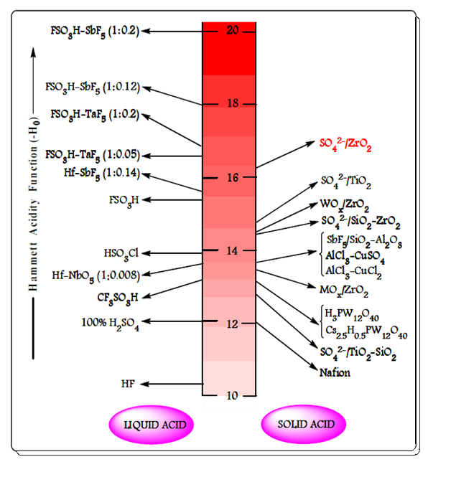

**Figure 1.2.** The acidity of various liquid and solid acids.

***1.3.3 Metal oxides in catalysts***

Metal oxides form an important class of industrial catalysts due to their flexible nature [16]. Metal oxides may be acidic or basic and also exhibit redox properties. The acidic or basic strength of metal oxides depends on the surface with M–OH, M–O–M, M=O or M-( ) functionalities where M is metal and M-( ) represents an oxygen vacancy. Metal oxides such as ZrO2, MoO3, Al2O3, V2O5, TiO2, Fe2O3, WO3, CaO, MgO, etc., are crucial to the field of catalysis used in chemical and petrochemical industries because they act as catalysts as well as catalytic supports [17-20].

***1.3.4 oxides of mixed metals***

Due to their active acidic or basic sites, high thermal stability, and large surface area, which enhance reactant conversion, product yield, and reaction time reduction, mixed metal oxides serve as vital heterogeneous catalysts in both practical and industrial research [21–23]. Mixed metal oxides have wide range of applications such as catalysts in fine chemical synthesis, green chemistry technology and petroleum industry [24]. A schematic representation of applications of mixed metal oxides is shown in Figure 1.3.

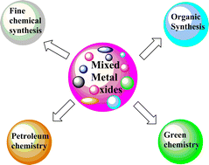

**Figure1.3**. A representation of mixed metal oxide uses.

***1.4 Brief description of materials used as catalysts for the research work presented in this thesis***

***1.4.1 Zirconia (ZrO2) and modified zirconia materials***

Zirconia (ZrO2) has high thermal stability and tensile strength, corrosion resistance and hardness. In the field of heterogeneous catalysis, ZrO2 and its modified forms have been used as catalysts and catalytic supports in reactions that are catalysed by both acids and bases [25–26].The acidic and basic properties of ZrO2 can be altered by the addition of cationic or anionic materials. Drastic improvement in acidic properties can be seen by the addition of sulfate, molybdenum, vanadium and tungsten ions to produce solid “super-acids" [27] and drastic improvement in basic properties can be seen by addition of calcium, magnesium ions, etc.

ZrO2 exists in three different phases or crystal structures such as monoclinic, tetragonal and monoclinic crystalline phases. In the monoclinic phase of ZrO2, the Zr4+ ion has seven-fold coordination (it is surrounded by seven oxygen atoms), and in the tetragonal and monoclinic phases, it has eight-fold coordination.. The size of Zr4+ ion in crystal structure is 0.79 Å, 1.32 Å is the radius of O2- ion and 0.6 is the cation and anion radius ratio. A schematic crystal structure of monoclinic, tetragonal and monoclinic phases showed in Figure 1. 4.

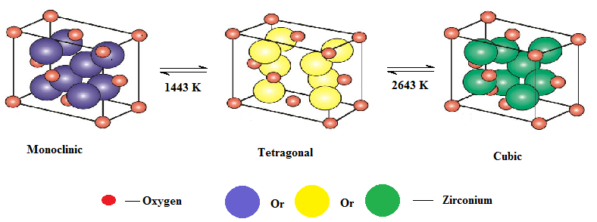

**Figure 1.4.** Schematic crystal structure of monoclinic, tetragonal and monoclinic phases.

It has been found that zirconia's tetragonal phase exhibits catalytic activity. This phase has been successfully stabilised over a number of attempts at various pressures and temperatures. At ambient temperature, the oxide is monoclinic at standard atmospheric pressure. Then, when the temperature rises, it changes into the tetragonal and cubic phases. Due to its theoretical and practical importance, the monoclinic-tetragonal phase change has been extensively examined [28]. The zirconia powder's particle size and preparation method have an impact on the pace of transformation from the monoclinic to the tetragonal phase [29, 30]. The phase transition occurs more rapidly depending on the prepared zirconia's particle size. Phase transformation may also be significantly affected by the addition of sulphate anions. Since it can delay the formation of oxo-bonds between zirconium atoms and oxygen atoms, bridging sulphate ions stabilise the structure of zirconia (Figure.1.5).

**Figure.1.5.** Structure of sulphated zirconia [42]

This will stabilise the surface area and stop rapid phase transformation by avoiding sintering at elevated temperatures [31, 32]. A precursor, pH, and ageing duration are some of the factors which influence the phase transition [32]. The sample showed a rapid change in phase from tetragonal to monoclinic when it precipitated at low pH. An amphoteric oxide with strong acid-base properties is zirconia. The Lewis acidity is created by the bridging cations. Brønsted acid sites are a result from terminal coordinated water molecules. The typical types of acidity at lower and higher temperatures, respectively, are Lewis acid sites and Bronsted acid sites [33]. Numerous studies have been conducted in this area to examine surface modification and zirconia's ability to withstand acidity. The most well-known of these involves adding cationic or anionic materials, such as WO3, SO42-, and MoO3, at the sub-monolayer level to create new acidic sites, and attaching catalytically active metal oxides.

Because these modifications can produce strength of the order of 100% H2SO4, which is exceptional in any heterogeneous catalyst, the results achieved in recent years are really impressive [35]. The highly acidic sites that result from grafting sulphate species onto ZrO2 are referred to be "super acidic" on their surfaces. Arata and co-investigators [36] reported in 1979 that zirconia, when properly treated with sulfuric acid or ammonium sulphate, exhibits extremely strong acidity and is capable of catalysing the isomerization of n-butane to isobutane at room temperature. As a result of this, among the promoted zirconia-based solid acid catalysts, the SO42- /ZrO2 (SZ) catalyst gained greater attraction. Several chemical synthesis and transformation processes, such as multicomponent reactions, isomerization, alkylation, acetylation, esterification, glycosidation, and some other economically important reactions, have been shown to be very active for the SZ catalyst throughout time [37, 38]. However, an important disadvantage of SZ catalyst is its fast deactivation in reducing conditions and at high temperatures due to SOx and H2S production, respectively. Many efforts were made to improve the stability and activity of the SZ catalyst, including carbon molecular sieves, noble metal Pt, and transition metals including Fe, Mn, and Cr [39]. Under specific preparation circumstances, Arata and Hino (1988) claimed that solid super acids may be synthesised by adding WOx or MOx to the Zr- or Ti-hydroxides [40, 41]. Their findings were also supported by our thorough research, and we have investigated a few of these catalysts for different chemical processes.

**1.4.2 Alumina (Al2O3)**

The Alumina (Al2O3) as a catalyst and catalytic support has been widely recognized. Al2O3 has been regarded as an acid-type catalyst and its role has been studied in a number of catalytic applications [43]. As a support or co-catalyst, alumina is used in many catalytic processes of industrial importance such as isomerization, alkylation, catalytic cracking, hydroforming, etc., [43]. Al2O3 is [amphoteric](https://en.wikipedia.org/wiki/Amphoteric) in nature which means that Al2O3 can behaves as both acid and a base. When alumina is heated at different temperatures, alumina transforms into seven forms such as gamma, delta, theta, kappa, chi, eta and rho, and these seven aluminas are called “Transition Aluminas” (Figure 1.6) [44]. Transition aluminas are used as catalysts as well as catalytic supports in heterogeneous catalysis, because they are porous in nature, less expensive, mechanically more stable at high temperature and possesses good physical strength**.** Due to [amphoteric](https://en.wikipedia.org/wiki/Amphoteric) nature, Al2O3 and its modified forms can be used as catalysts in many organic transformations such as dehydrogenation [46], [synthesis of functionalized 1,4-dihydropyridine derivatives](http://www.sciencedirect.com/science/article/pii/S1381116914003185) [47], transesterification reactions [48], esterification reactions [49], synthesis of biodiesel [50], epoxy cleavage reactions [51], hydrodeoxygenation [52], acylation reaction [53], etc.

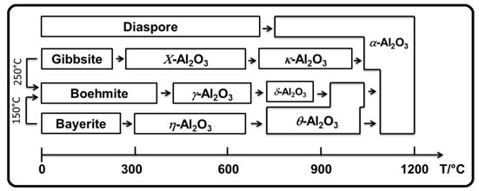

**Figure1.6.** Temperature transformation sequence of the aluminum hydroxides (Al2O3) [45].

***1.5 Introduction to cordierite honeycomb (HM)***

Cordierites (2Al2O3.2MgO.5SiO2) have naturally very low thermal expansion co-efficient over a wide range of temperatures, which contains MgO, SiO2 and Al2O3 in this ratio of 2:5:2. Cordierite honeycomb monolith (HM) can have used as heterogeneous catalyst after the modification [54]. They can be circular shapes with interconnected repeating cells or channels [55]. The catalyst coated honeycomb monoliths have advantages over powder catalysts, such as formation of thin layer of catalyst with high active surface area, less amount of catalyst loaded on the monolith, easy separation and complete recovery of the catalyst from the reaction mixture. Though supported honeycomb monolith catalysts were originally developed for gas phase reactions in automotive emission control systems as a catalytic converters in diesel and gasoline engines, ozone abatement in aircrafts and selective reduction of NOx. [34, 57-61], their use in liquid phase/ vapor phase organic synthesis is least explored [56

**Advantages of honeycomb monoliths**

Monolith catalysts have some common features in most of the applications when compared with pellet packed fixed-bed reactors commonly used in the petroleum refining industry or other multiphase reactors. They have the following advantages.

1. Higher specific external catalyst surface area for mass transfer and reactions.

2. Decrease of external mass transfer when used for multiphase reactors.

3. Elimination of internal diffusion limitations when thin walls are used.

4. Lower pressure drop when under high fluid throughputs.

5. Easy scale up.

6. Easier cleaning of particulates accumulated on the channel walls.

7. Lower axial dispersion and back-mixing and therefore high product selectivity.

8. Reduction of fouling and plugging and thus extended catalysts lifetime.

In reference to ceramic monoliths, the support presents excellent operational properties such as high mechanical strength, high temperature resistance, low thermal expansion coefficients low pressure drop and availability in various sizes or shapes [62]. Different procedures have been performed coating the monoliths walls with support materials called wash coat like gamma Al2O3, TiO2, ZrO2 or zeolites, to obtain a higher surface area and abundant pores, since cordierite itself exhibits negligible porosity and offers little contribution to catalytic action [63].

***1.6 Methodologies***

One of the important features in the catalysis research is generally three interconnected characteristics that are intricate, such as, preparation, characterization and reactivity of the catalysts. A triangular association between these three aspects has been shown by many authors [64-81].

***1.6.1 Catalyst preparation***

The following catalysts were prepared in this investigation:

Metal oxide: ZrO2

Mixed metal oxides: ZrO2-Al2O3, MgO-ZrO2, CaO-ZrO2

Modified oxides: SO42-/ZrO2, Mo(VI)/ZrO2, W(VI)/ZrO2 ,Mg(II)/ZrO2, Ca(II)/ZrO2 and Ba(II)/ZrO2

***1.6.2 Preparation of catalytic materials on honeycomb monoliths***

***1.6.2.1 Coating of ZrO2, 5%Mo(VI)/ZrO2, 5%W(VI)/ZrO2 and SO42-/ZrO2 on honeycomb monoliths***

Catalytic materials were coated on honeycomb monoliths (HM) by using ‘dip and dry’ method [82]. Typically, in order to coat ZrO2 on a bare HM, a dilute solution consisting of known amount of zirconyl nitrate [ZrO(NO3)3. 8H2O] was prepared. The resulting solution was coated on a HM by dipping and drying in a muffle furnace preheated at 400 oC. The ‘dip and dry’ steps were repeated for 6 to 8 times until ~0.02 g of the catalyst (ZrO2) is coated on the HM. Similarly, bare HMs were coated with 5%Mo(VI)/ZrO2 and 5%W(VI)/ZrO2 by using dilute solutions containing known amounts of ZrO(NO3)3. 8H2O and ammonium molybdate [(NH4)6Mo7O24.4H2O]/ ammonium tungstate [(NH4)10H2W12O42. 4H2O].

For coating SO42-/ZrO2 on a bare HM, a slurry consisting of 1.5 g of Zr(OH)4 and 0.75 mL of 3M H2SO4 was made with deionized water. The slurry was mixed well and coated on the HM.

***1.6.2.2 Coating of MgO/ZrO2 and CaO/ZrO2 on honeycomb monolith***

Honeycomb monoliths (HMs) were coated with MgO/ZrO2 or CaO/ZrO2 by ‘dip and dry’ method. In a typical method, known amounts of zirconyl nitrate with magnesium nitrate/calcium nitrate were taken in a 125 ml beaker to which 30 mL of deionized water was added to make a solution. The resulting solution was coated on a bare honeycomb by ‘dip and dry’ method in a muffle furnace which was preheated at 400 oC. ‘Dip and dry’ steps were conducted for 10-12 times till ~0.2 g of the solid base catalyst is coated on the HM.=

***1.6.2.3 Coating of binary oxides on honeycomb monolith***

HMs were coated with different percentage binary oxides like 40%ZrO2-60%Al2O3 and 60%ZrO2-40%Al2O3 using dilute solutions containing known amount of Al(NO3)3 and Zr(NO3)3.

***1.6.2.4Coating of 5%Mg(II)/ZrO2,5%Ca(II)/ZrO2and 5%Ba(II)/ZrO2 on HMs***

Dilute solutions consisting of known amounts of zirconyl nitrate and barium nitrate/calcium nitrate/magnesium nitrate was made. These solutions were coated on HMs by ‘dip & dry’ method in a furnace preheated at 400 0C. The ‘dip & dry’ steps were repeated 6-8 times till ~0.15 g of 5% Mg(II)/ZrO2 or 5%Ca(II)/ZrO2 or 5%Ba(II)ZrO2 were coated on the HMs.

The above HMs coated with catalytic materials were calcined at 550 oC for 5 h in a muffle furnace before using them as catalysts.

***1.7 Catalyst characterization***

All the prepared catalysts used in the present investigation were characterized by using the following techniques:

* Temperature programmed desorption of ammonia (TPD-NH3) and n-butyl amine back titration method for surface acidity
* Temperature programmed desorption of carbon dioxide (TPD-CO2)
* Powder X-ray diffraction (PXRD) for crystallinity
* Fourier Transform Infrared (FTIR) spectroscopy for functional group analysis
* Barunauer-Emmett-Teller (BET**)** method for specific surface area
* Scanning Electron Microscopy (SEM) for surface morphology
* Inductively Coupled Plasma-Optical Emission Spectrometer (ICP-OES) technique for elemental analysis

The brief description of experimental procedures of characterization techniques involved in the work carried out for present thesis is given below.

***1.7.1 Temperature programmed desorption of ammonia (TPD-NH3)***

Temperature programmed desorption (TPD) analyses the type, number and strength of active acid sites available on the surface (surface acidity) of catalytic materials. In this experiment, 0.1 g of the catalyst was degassed under helium stream for 1 h at 100 °C, ammonia (99.99%) gas was injected into the stream until saturation was reached and cooled to 50 °C. The system was maintained at 50 °C for 30 min and then the catalyst surface was flushed with helium for 2 h at 50 °C. The catalyst was heated at the rate of 5 °C min-1 in helium to 700 °C. The change in concentration of the desorbed NH3 was calculated from the peak area of the calibrated thermal conductivity detector signals. The molecules which desorbs at low temperature are weakly held than the molecules desorbed at higher temperature. Hence TPD experiment not only describes the number of acid sites but also the strength of acidity.

Quantitative analysis of model surfaces using temperature-programmed desorption (TPD) techniques was developed in the early 1960. It is one of the versatile techniques for the determination of the total acidity and to determine the strength of acid sites present in the catalyst by using pulse chemisorb instrument Mayura NH3 - TPD unit [83, 84].

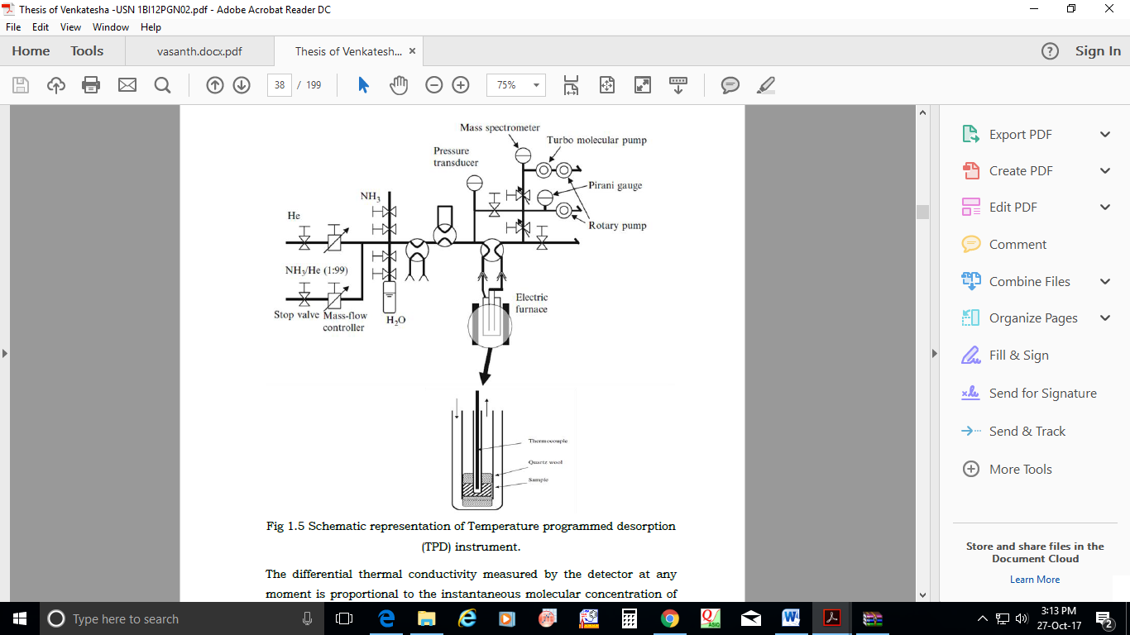

**Figure 1.7**.. Schematic representation of Temperature programmed desorption (TPD) instrument.

***1.7.2 n-butyl amine back titration method***

The total surface acidity of the solid catalytic materials can also be determined by n-butyl amine back titration method. In this method, 0.5 g of the catalyst was suspended in 25 ml of dry benzene solution of 0.05 M n-butyl amine. The mixture was left for 24 hours. During this time period, all the acid sites on the surface of the solid get neutralized. The unreacted n-butyl amine was titrated against 0.05 M HCl and bromothymol blue used as an indicator. The surface acidity of the solid catalyst was calculated from the decrease in concentration of n-butyl amine. The total surface acidity (TSA) was calculated by using a formula:

|  |
| --- |
| $$Total surface acidity of the catalyst=\frac{(x-y) 1000}{W}mmol/g$$ |

Where,

Molarity of n- butyl amine before adding the catalyst = x

Molarity of n- butyl amine after treating with the catalyst = y

Weight of the catalyst = W (g)

***1.7.3 Temperature programmed desorption of carbon dioxide (TPD-CO2)***

Desorption of carbon dioxide is frequently used in order to determine the type, number and strength of active basic sites available on the surface (surface basicity) of catalytic materials. The strength of the basic sites correlated with the desorption temperature. Often qualitative measurements are carried out for different experiments under same conditions. TPD of adsorbed carbon dioxide has been widely used to probe basic materials. For example, rubidium–modified supports have been investigated using stepwise TPD of CO2. The addition of Rb species to supports like MgO, Al2O3, TiO2 and SiO2, via the decomposition of supported rubidium acetate, increases the surface density of adsorbed CO2 over that pure support. The high desorption temperatures required to liberate CO2 from RbO/MgO indicated the formation of very strong basic sites. Hence CO2 -TPD unit is used by Mayura analytical centre. Carbon dioxide temperature programmed desorption has also been used to measure the base strengths of various alkali metals-containing (exchanged and occluded) zeolites [89]. TPD plots of carbon dioxide desorbed from alkaline earth oxides are compared. Before each TPD run, adsorption of carbon dioxide and the following treatment were done under the same conditions [88].

***1.7.4 Powder X-ray diffraction (PXRD)***

The PXRD studies were mainly carried out to know the structural integrity, d-spacing (planar distance) and planar orientation of materials. PXRD patterns of catalytic materials was obtained from X’pert Pro Philips diffractometer equipped with a Ni filtered Cu-Kα radiation with λ=1.5418 Å using a graphite crystal monochromator with a scanning range 5-80° with a scanning rate of 2° min-1. Phase identification is based on the comparison of the corresponding peaks with standard references.

𝑛𝜆 = 2d(ℎ𝑘𝑙) sinθ

According to Bragg’s law, every reflection detected at a 2θ angle in the diffraction pattern of a crystalline sample obtained using X-ray of wavelength (λ) is related to distance between lattice planes (d) with an orientation designated by Millers indices (hkl).

A crystal lattice consists of a regular arrangement of atoms, with layers of high atomic density present through the crystal structure. A plane of high atomic density indicates planes of high electron density. Since scattering happens between impinging X-ray photons and the loosely bound outer orbital electrons, when a monochromatic beam of radiation falls onto the high atomic density layers, scattering will occur. In order to satisfy the requirement for constructive interference, it’s necessary that the scattered waves originating from the individual atoms, the scattering points, be in phase with one another. The geometric conditions for this condition to occur are shown in Figure.1. 8.

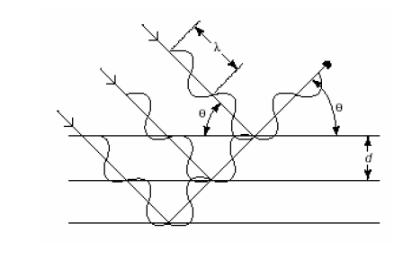

**Figure1.8**. Diffraction from an ordered arrangement of atoms.

***1.7.5 Fourier Transform Infrared (FTIR) spectroscopy***

French mathematician Jean Baptiste Fourier developed the FTIR method in the early 1800s. Practically all compounds having covalent bonds, whether inorganic or organic, absorb various frequencies infra-red radiations in the electromagnetic spectrum region. This spectrum is usually used to study the fundamental vibrations and associated vibrational-rotational levels of the structure. The FT-IR spectrums were recorded on with 4 cm-1 resolution using a Nicolet IR200 FT-IR spectrometer a single beam of IR radiation from the source is sent to a Michelson interferometer, which by the displacement of a mirror produces an interferogram (Figure 1.9). IR Spectroscopy is a very powerful technique which gives fingerprint evidence on the chemical composition of the sample [85].



**Figure 1.9**. Schematic representation of IR- spectrophotometer.

FTIR spectroscopy of adsorbed probe molecules is one of the most important and well advanced methods for studying the composition and structure of the surface functional groups of supported metal catalyst. Numerous species can reside on the support surface: hydroxyl groups of different nature; Lewis acid sites (coordinately unsaturated surface cations); base sites (bridging oxygen atoms or oxygen atoms of OH groups);structures formed by impurity anions that remain after the synthesis (sulphate, ammonia and nitrate groups) or from contact with air (carbonate-carboxylate structures) [86,87].

***1.7.6 Brunauer-Emmett-Teller (BET) method***

Total surface area of catalystic material is vital in catalytic activity because it decides the adsorption of reacting molecules on the catalyst surface with active sites. Selectivity and activity of catalytic materials in organic reactions are strongly related to its surface characteristics. In this method, the amount of N2 adsorbed over the adsorbent at the temperature of liquid nitrogen (77K) is measured as a function of pressure. NOVA 1000 Quanta chrome high-speed gas sorption analyzer instrument was used to measure the specific surface area of all the prepared catalysts.

In this technique, a known quantity of catalytic material in a U- shaped glass tube which is degassed at 523 K for 5 h to remove the pre-adsorbed gas (Figure 1.10). The material present in the U shaped glass tube was then cooled to room temperature and then to 77 K using liquid nitrogen as a coolant. The sample of catalytic material was saturated with nitrogen which gets physically adsorbed on the surface of sample at the temperature at 77 K. The volume of N2 adsorbed was recorded using detector and surface area was calculated by the following equation;

|  |
| --- |
| $$\text{Specific surface area= }\frac{V_{m}\text{ x N}}{22414 x W}xA_{m}{(m}^{2}/g)$$ |

Where,

N is the Avagadro’s number (6.022 x 1023 mole-1), W is the weight of catalyst in grams, Am is the cross section of adsorbed molecule (0.162 nm2 for N2) and Vm is the volume of corresponding monolayer coverage.



**Figure 1.10.** Schematic representation of BET Surface area measurement Instrument.

***1.7.7 Scanning electron microscopy (SEM)***

The catalyst particle morphology was investigated by field-emission scanning electron microscopy using SEM (JEOL JSM-7500F microscope) operating at 20 kV at a working distance of 8 mm). SEM is generally designed for the physical characterization of catalytic materials such as particle size, shape, surface structure, porosity and dispersion of particles. SEM is carried out by projecting a narrow electron beam over the surface and detecting the yield of either secondary or backscattered electrons as a function of position of primary beam. The secondary electrons have mostly low energies (approximately 5-50 eV) and originate from the surface region of the sample. Backscattered electrons come from deeper regions and carry information on the composition. The resolution and magnification of SEM is relatively low compared to TEM.

***1.7.8******Inductively Coupled Plasma-Optical Emission Spectrometer (ICP-OES)***

Inductively coupled plasma (ICP) is the method of optical emission spectroscopy (OES). The amount of metals present in catalyst samples could be estimated using Thermo-iCAP 6000 Series instrument. When the plasma energy is passed in to the samples, elements/atoms in the sample absorb the energy and are excited, then returned to original position by emitting photons. The standard solutions of catalysts in the range 20-140 ppm were prepared using suitable acid solvents such as HNO3 or HF or HCl and the solution was filtered through 0.45 μ (micron) membrane filters and used for further analysis.

***1.8 Catalytic activity studies***

The catalytic activity of the prepared and characterized catalytic materials was evaluated in the following organic reactions.

* Microwave assisted condensation reactions of benzimidazole and bis(indolyl)methane derivatives

* Transesterification of waste cooking oil via microwave irradiation

* Vapor phase synthesis of glycerol carbonate by transesterification method

* Synthesis of Solketal through glycerol acetalisation with Acetone

The above reactions were carried out in a specially designed reactor vessel to accommodate honeycomb monolithic catalyst. Figure 1.11 (a) and 1.11 (b) shows an example of ceramic monolithic structure and specially designed reactor vessel to accommodate honeycomb monolithic catalyst.



**Figure 1. 11(a):** Photograph of (a) Cordierite honeycomb monolith. (b) Reactor with monolithic catalyst.

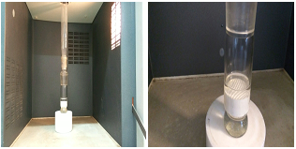

**Figure1.11 (b)**: Microwave reactor and reactor vessel to accommodate HM catalyst.

***1.9 Introduction to microwave chemistry***

Microwave irradiation accelerate both organic as well as inorganic reactions and reduces the time consumption from hours or days to minutes because of selective absorption of microwave energy by the molecules has attracted a considerable amount of attention in recent years. It provides quick results and drastically reduces reaction times. Uniform heating occurs throughout the material, high efficiency of heating, increased product yield with enhanced purity in final product by reducing unwanted side reactions. Environmental heat loss can be avoided compared to conventional heating methods. It is due to the fact that microwave irradiation activates the smallest degree of variance of polar molecules and ions such as alcohol with the continuously changing magnetic field and the changing electric field, which interacts with molecular dipoles and charged ion, causing polar ends of these molecules or ions to have a rapid rotation, heat is generated due to molecular friction between the moving molecules.

Microwave radiation is a form of electromagnetic radiation in the frequency range of 0.3 to 300 GH. The energy of microwave photons corresponding to this frequency is 0.0016 eV. This energy is too low to break any chemical bond and is also lower than the energy of Brownian motion. With change in rotational energy of the molecules but not by molecular structure breaking. This clearly indicates that the microwave irradiation cannot induce chemical reactions. In general, based on the loss factors solvents can be classified as high (tanδ > 0.5), medium (tanδ 0.1–0.5), and low microwave absorbing (tanδ < 0.1). Other common solvents without a permanent dipole moment such as carbon tetrachloride, benzene, and dioxane are more or less microwave transparent. In a microwave heated reaction, these molecules should be used along with other polar reagents or catalysts which are likely to be polar so that the overall dielectric properties of the reaction medium will allow sufficient heating by microwaves [90].

In conventional methods of chemical synthesis, conductive heating is done by an external source. In this heat is first passed to the walls of reactor vessel, then passing through the reaction mixture. Microwave assisted synthesis does not depend on the thermal conductivity of the reactor, and instantaneously heats up the reactant molecules. This is due to the mechanism that microwave directly interacts with reactant molecules. The use of microwaves in a wide variety of chemical reactions develops awareness in the scientific community and assumed that in a few years, most of chemists will probably use microwave energy to heat chemical reactions on a laboratory scale.

***1.10 Conclusion***

* Preparation of environment-friendly solid catalysts such as zirconia and their modified forms supported on cordierite and their characterization.
* Comparison of the catalytic activity of zirconia and their modified forms supported on cordierite in the synthesis of various fine chemicals.
* Comparison of percentage yield of the products obtained by the various organic reactions such as transesterification, acetalisation, and condensation reactions, etc.
* Study of applying microwave technology in the synthesis of fine chemicals.
* Identification of the most suitable catalyst for these reactions.
* Optimization of the reaction conditions over a selected catalyst.
* Ascertain the correlation between the type of acid sites and basic sites required for the reactions and catalytic activity.

**Reference:**

1. B. Lindstrom., L.J. Pettersson, [A brief history of catalysis](http://www.springerlink.com/index/wl51463803777448.pdf), Cattech 7, (2003), 130.
2. G. Ertl. Angew., Reactions at Surfaces: From Atoms to Complexity, Chem. Int. Ed. 47, (2008), 3524.
3. C. Christ. Ed., Production-Integrated Enviornamental Protective and waste management in the chemical industry, Wiley-VCH. Weinheim, (1999).
4. P.T. Anastas, J.C. Warner. Eds., Green Chemistry; theory and practice, Oxford Uni. Press, Oxford. (1998).
5. P.T. Anastas, T.C Williamson. Eds., Green Chemistry; frontiers in Chemical Synthesis and process. Oxford Uni. Press. Oxford. (1998).
6. R.A. Sheldon, H. Bekkum., Fine chemicals through heterogeneous Catalysis, Willey-VCH, New York, (2007).
7. R.A. Sheldon, H. Bekkum., Fine chemicals through heterogeneous Willey-VCH, New York Catalysis, (2007).
8. G. Ertl, H. Knozinger, F. Schuth, J. Weitkamp (Editors)., Handbook of Heterogeneous Catalysis, Second Enlarged Edition, Volume 1, Wiley-VCH Verlag GmbH& Co. KGaA, Weinheim, Germany, (2008).
9. S.M. Auerbach, K.A. Carrado, P.K.Dutta., Handbook of layered materials, Marcel Dekker, Inc. New York, Basel, (2004).
10. J. M. Thomas, W. J. Thomas., Principles and Practice of Heterogeneous Catalysis, VCH Wenhheim and New York, (1997).
11. K. Tanabe, M. Misono, Y. Ono, H. Hattori., New solid acids and base, Kodansha-Elsevier, Tokyo- Amsterdam, (1989).
12. K. Tanabe., “Solid Acids and Bases”, Academic Press, New York, (1990) 136.
13. K. Tanabe, W.F. Hölderich., Industrial application of solid acid–base catalysts, Appl. Catal. A 181 (1999) 399.
14. R. J. Gillespie, T E Peel., Hammett acidity function for some superacid systems. II. Systems sulfuric acid-[fsa], potassium fluorosulfate-[fsa], [fsa]-sulfur trioxide, [fsa]-arsenic pentafluoride, [sfa]-antimony pentafluoride and [fsa]-antimonypentafluoride-sulfur trioxide, J. Am. Chem. Soc. 95, (1973), 5173.
15. N. F. Hall, J. B. Conant., A study of superacid solutions. i. the use of the chloranil electrode in glacial acetic acid and the strength of certain weak bases, J. Am. Chem. Soc. 49(12), 1927, 3047.
16. M.T. Migawa, J.-L. Girardet, J.A. Walker, G.W. Koszalka, S.D. Chamberlain, J.C. Drach, L.B, Townsend., Design, Synthesis and Antiviral Activity of α-Nucleosides:  d- and l-Isomers of Lyxofuranosyl- and (5-Deoxylyxofuranosyl)benzimidazoles, J. Med. Chem. 41 (1998) 1242.
17. [T. M. Miller](http://pubs.acs.org/action/doSearch?ContribStored=Miller%2C+T.+M.), [V. H. Grassian](http://pubs.acs.org/action/doSearch?ContribStored=Grassian%2C+V.+H.)., Environmental Catalysis: Adsorption and Decomposition of Nitrous Oxide on Zirconia, J. Am. Chem. Soc. 117 (44) (1995) 10969.
18. [N. Pernicone](http://www.sciencedirect.com/science/article/pii/0021951769903315), [F. Lazzerin](http://www.sciencedirect.com/science/article/pii/0021951769903315), [G. Liberti](http://www.sciencedirect.com/science/article/pii/0021951769903315), [G. Lanzavecchia](http://www.sciencedirect.com/science/article/pii/0021951769903315)., The oxidation of methanol over pure MoO3 catalyst, J. Catal. 14 (4) (1969) 391.
19. O. Rahmanpour, A Shariati, M. R. K. Nikou., New Method for Synthesis Nano Size γ-Al2O3 Catalyst for Dehydration of Methanol to Dimethyl Ether, International J. Chem. Eng and App. 3 (2) (2012) 125.
20. B. Rosana, D. Valderez, S. Wido, P. Luiz,J. Braz., Synthesis and Structure-Activity Relationship of a WO3 Catalyst for the Total Oxidation of BTX, Chem. Soc. 25 (11) (2014) 2026.
21. A. V. Biradar, S. B. Umbarkar, M. K. Dongare., Transesterification of diethyl oxalate with phenol using MoO3/SiO2 catalyst, Appl. Catal. A. 285 (2005) 190.
22. A. P. Amrute, A. Bordoloi, N. Lucas, K. Palraj, S. B. Halligudi., Sol–Gel Synthesis of MoO3/SiO2 Composite for Catalytic Application in Condensation of Anisole with Paraformaldehyde, Catal. Lett. 126 (2008) 286.
23. S.J.Singh, R.V.Jayaram.,Chemoselective*O*-*tert*-butoxycarbonylation of hydroxy compounds using NaLaTiO4 as a heterogeneous and reusable catalyst, Tetrahedron Lett. 49 (2008) 4249.
24. B. G. Manoj, K. P. Rajesh, V. J. Radha., Role of mixed metal [oxides](javascript:popupOBO('CHEBI:25741','C2CY00490A','http://www.ebi.ac.uk/chebi/searchId.do?chebiId=25741')) in catalysis science—versatile applications in organic synthesis, Catal. Sci. Technol. 2 (2012) 1113.
25. L. E. Davies, N. A. Bonini, S. Locatelli, E. E. Gonzo., Characterization and catalytic activity of zirconium dioxide prepared by sol-gel, Latin Am. Appl. Res. 35 (2005) 23.
26. B. M. Reddy, K. V. R. Chary, B. Rama Rao, V. S. Subrahmanyam, C. S. Sunandanat, Subrahmanyam, C. S. Sunandanat., ESR, oxygen chemisorption and activity studies on MoO3ZrO2 catalysts, Polyhedm. 5 (112) (1986) 191.
27. K. Arata., Solid Superacids, Adv. Catal. 37 (1990) 165.
28. F. Heshmatpour, R. B. Aghakhanpour., Synthesis and characterization of nanocrystalline zirconia powder by simple sol–gel method with glucose and fructose as organic additives, Powder. Technol. 205 (2011) 193.
29. K. Ishid, K. Hirotu, O. Yagamuchi., [Formation of zirconia solid solutions containing alumina prepared by new preparation method](http://onlinelibrary.wiley.com/doi/10.1111/j.1151-2916.1994.tb05425.x/full) J. Am. Ceram. Soc. 77 (1994) 1391.
30. M. Trunec., Effect of grain size on mechanical properties of 3y-tzp, Ceramics – Silikaty. 52 (2008) 165.
31. C. Norman, P. Goulding and I. Mc Alpine., [Role of anions in the surface area stabilisation of zirconia](https://www.sciencedirect.com/science/article/pii/092058619480009X/pdf?md5=c4668015b8f321e2c383abb344e9f889&isDTMRedir=Y&pid=1-s2.0-092058619480009X-main.pdf&_valck=1), Catal. Today, 20 (1994) 313.
32. C. Norman, P. Goulding, P. Moles.Stud., the Role of Sulphate in the Stabilisation of Zirconia, Surf. Sci. Catal. 90 (1994) 269.
33. A. F. Bedilo, M. A. Plotnikov, N.V. Mezentseva, A. M. Volodin, G.M. Zhidomirov, I. M. Rybkina, K. J. Klabundeb., Superoxide radical anions on the surface of zirconia and sulfated zirconia: formation mechanisms, properties and structure, Phys. Chem. Chem. Phys.7 (2005) 3059.
34. Nijhuis T A, Kreutzer M T, Romijn A C J, Kapteijn F & Moulijn J A., Monolithic catalysts as efficient three-phase reactors, J Chem Eng Sci, 56 (2001) 823.
35. K. Tanabe., "Solid Acid and Bases", Academic Press, New York (1990) 136.
36. K. J. Ratnam. R. S. Reddy. N. S. Sekhar, M. L. Kantam, F. Figureuéras., [Sulphated zirconia catalyzed acylation of phenols, alcohols and amines under solvent free conditions](http://www.sciencedirect.com/science/article/pii/S1381116907004116), J. Mol. Catal. A: Chem. 27 (2007) 230.
37. B. M. Reddy, M. K. Patil., Organic Syntheses and Transformations Catalyzed by Sulfated Zirconia, Chem. Rev. 109 (2009) 2185.
38. K. Toshima, K.I- Kasumi, S. Matsumura., Novel Stereocontrolled Glycosidations of 2-Deoxyglucopyranosyl Fluoride Using a Heterogeneous Solid Acid, Sulfated Zirconia (SO4/ZrO2), Synlett, (1999), 813.
39. B. Tyagi, M. K. Mishra, R. V. Jasra., Synthesis of 7-substituted 4-methyl coumarins by Pechmann reaction using nano-crystalline sulfated-zirconia, J. Mol. Catal. A: Chem.,(2007), 276, 47.
40. C. Y. Hsu, C. R. Heimbuch, C. T. Armes, B. C. Gates., A highly active solid superacid catalyst for n-butane isomerization: a sulfated oxide containing iron, manganese and zirconium, J. Chem. Soc. Chem. Commun. (1992) 1645.
41. M. Hino, K. Arata., Synthesis of solid superacid of tungsten oxide supported on zirconia and its catalytic action for reactions of butane and pentane, J. Chem. Soc. Chem. Commun. (1988) 1259.
42. R. Srinivasan, M. Harris, S. Simpson, R. De Angelis, B. Davis., Zirconium oxide crystal phase: The role of the pH and time to attain the final pH for precipitation of the hydrous oxides, J. Mater. Res.3.(1988) 787.
43. H. Pines, W. O. Haag., Catalyst and Support. I. Alumina, its Intrinsic Acidity and Catalytic Activity, J. Am. Chem. Soc. 82 (1960) 2471
44. P. S. Santos, H. S. Santos, S. P. Toledo., Standard transition aluminas. Electron microscopy studies, Mat. Res. 3 (4) (2000) 104.
45. A. J. Leonard, F V. Cauwlaert, J. J. Fripiat., Structure and Properties of Amorphous Silicoaluminas. III. Hydrated Aluminas and Transition Aluminas, J. Phys. Chem. 71 (1967) 435.
46. H. Zhao, H. Song, Z. Miao, L. Chou., Isobutane dehydrogenation over chromia alumina catalysts prepared from MIL-101: Insight into chromium species on activity and selectivity**,** J. Ener. Chem. 23 (6) (2014)708.
47. N. Ahmed, Z. N. Siddiqui., Mesoporous alumina sulphuric acid: A novel and efficient catalyst for on-water synthesis of functionalized 1,4-dihydropyridine derivatives via β-enaminones, J. Mol. Catal. J. Mol. Catal. A: Chem. 394 (2014) 232.
48. A. S, Badday, A. Z. Abdullah, K. T. Lee., Ultrasound-assisted transesterification of crude Jatropha oil using alumina-supported heteropolyacid catalyst, Appl. Energy. 105 (2013) 380.
49. G. Mitran, E. M. A. Redey, I. C. Marcu., Esterification of acetic acid with n-Butanol using vanadium oxides supported on γ-alumina, Comptes Rendus Chimie, 15 (9) (2012) 793.
50. I. Lukic, J. Krstic, D. Jovanovic, D. Skala., Alumina/silica supported K2CO3 as a catalyst for biodiesel synthesis from sunflower oil, Bioresource Tech.100 (20) (2009) 4690.
51. H. Naeimi, M. Moradian., Alumina-supported metal(II) Schiff base complexes as heterogeneous catalysts in the high-regioselective cleavage of epoxides to halohydrins by using elemental halogen, Polyhedron, 27 (18) (2008) 3639.
52. L. Faba, E. Diaz, S. Ordonez., Hydrodeoxygenation of acetone–furfural condensation adducts over alumina-supported noble metal catalysts, Appl. Catal. B: Environ.160–161 (2014) 436.
53. R. Fang, G. Harvey, H. W. Kouwenhoven, R. Prins., Effects of non-framework alumina in the acylation of xylene over USY, Appl. Catal. A: Gen.130 (1) (1995) 67.
54. P.O Thevenin, P.G.Menon and S.G Jaras., Catalytic Total Oxidation of Methane. Part II. Catalytic Processes to Convert Methane: Partial or Total Oxidation, Cattech7 (2003) 10.
55. K. Arata, M. Hino., Synthesis of Solid Superacid of Molybdenum Oxide Supported on Zirconia and Its Catalytic Action, Chem. Lett. (1989) 971.
56. M. A. Subramanian, D.R. Corbin, U. Chowdhry., Better ceramic substrates through zeolites, Bull. Mater. Sci. 16 (6) (1993) 665.
57. R.M. Heck, S. Gulati, R.J. Rarranto., The application of monoliths for gas phase catalytic reactions, J. Chem. Eng. 82 (2001) 149.
58. I.M. Lachmann., Cordierite honeycomb structural bodies, Sprechsaal 119 (1986) 1116.
59. I.M. Lachmann, R.N. McNally. High Temperature Monolithic Supports for Automobile Exhaust Catalyst. Chem. Eng. Progr. 18 (1985) 29.
60. I.M. Lachmann, J.L. Willians., Extruded monolithic catalyst supports, Catal. Today 14 (1992) 317.
61. A.A. Klinghoffer, R.L. Cerro, M.A. Abraham., Catalytic wet oxidation of acetic acid using platinum on alumina monolith catalyst, Catal. Today 40 (1998) 59.
62. T. A. Nijuis, A. E. W. Beers, T. Vergunst, I. Hoek, F. Kaptejin, J.A Moujlin., Preparation of monolithic catalysts, Catal. Rev. Sci. Eng. 43 (2001) 345.
63. O. Öhrman, J. Hedlund, J. Sterte., Synthesis and evaluation of ZSM-5 films on cordierite monoliths, Appl. Catal., A, 270(2004) 193.
64. J. M. Dominguez, J. L. Hernandez, G. Sandoval.,Surface and catalytic properties of Al2O3–ZrO2 solid solutions prepared by sol–gel methods, Appl. Catal. A. 197 (2000) 119.
65. K. V. R. Chary, C. P. Kumar, P. V. R. Rao, V. V. Rao., Dispersion and reactivity of V2O5 catalysts supported on Al2O3–ZrO2,Catal. Commun. 5 (2004) 479.
66. J. L. Lakshmi, T. R. B. Jones, M. Gurgi, J. M. Miller., Synthesis, characterization and activity studies of vanadia catalysts supported on sol–gel derived Al2O3–ZrO2 mixed oxide, J. Mol. Catal. A: Chem. 152 (2000) 99.
67. K. V. R. Chary, C. P. Kumar, D. Naresh, T. Bhaskar, Y. Sakata., Characterization and reactivity of Al2O3–ZrO2 supported vanadium oxide catalysts, J. Mol. Catal. 243 (2006) 149.
68. G. Li, W. Li, M. Zhang, K. Tao., Characterization and catalytic application of homogeneous nano-composite oxides ZrO2–Al2O3, Catal. Today, 93–95 (2004) 595.
69. X. Song, A. Sayari., Sulfated Zirconia-Based Strong Solid-Acid Catalysts: Recent Progress, Catal. Rev. Sci. Eng. 38 (1996) 329.
70. G. D. Yadav, J. J. Nair, Sulfated zirconia and its modified versions as promising catalysts for industrial processes, Micropor. Mesopor. Mater. 33 (1999) 1.
71. S. Sugunan, C. R. K. Seena, T. M. Jyothi., Acid-base, electron donating and catalytic properties of sulfated zirconia, React. Kinet. Catal. Lett. 67(1999) 49.
72. K. Tanabe, H. Hattori, T. Yamaguchi., Crit. Rev. Surf. Chem. 1 (1990) 1.
73. A. Corma, A. I. Juan-Rajadell, J. M. Lopez Nieto., Influence of preparation conditions on the structure and catalytic properties of SO42−/ZrO2 superacid catalysts, Appl. Catal. A 116 (1994) 151.
74. M. R. Gonzalez, J. Kobe, K. B. Fogash, J. A. Dumesic., J, Promotion ofn-Butane Isomerization Activity by Hydration of Sulfated Zirconia, Catal. 160 (1996) 290.
75. A. F. Bedilo, M. A. Plotnikov, N. V. Mezentseva, A. M. Volodin, G. M. Zhidomirov, I. M. Rybkina, K. J. Klabundeb., Superoxide radical anions on the surface of zirconia and sulfated zirconia: formation mechanisms, properties and structure, Phys. Chem. Chem.Phys.7 (2005) 3059.
76. C. Norman, P. Goulding and I. Mc Alpine., Role of anions in the surface area stabilisation of zirconia**,** Catal. Today, 20 (1994) 313.
77. C. Norman, P. Goulding, P. Moles., the Role of Sulphate in the Stabilisation of Zirconia, Stud. Surf. Sci. Catal. 90 (1994) 269.
78. K. Saravanan, B. Thyagi, H. C. Bajaj., Sulfated zirconia: an efficient solid acid [catalyst](javascript:popupOBO('CHEBI:35223','C2CY20462B','http://www.ebi.ac.uk/chebi/searchId.do?chebiId=35223')) for esterification of [myristic acid](http://www.chemspider.com/Chemical-Structure.10539.html) with short chain alcohols, Catal. Sci. Technol. 2 (2012) 2512.
79. A. Clearfield, G. P. D. Serrette, A. H. Khazi-Syed., Nature of hydrous zirconia and sulfated hydrous zirconia, Catal. Today 20 (1994) 295.
80. T. K. Cheung, B. C. Gates., Sulfated zirconia and iron- and manganese-promoted sulfated zirconia: do they protonate alkanes, Top. Catal. 6 (1998) 41.
81. J. A. Melero, J. Iglesias, G. Morales., Heterogeneous acid catalysts for biodiesel production: current status and future challenges, Green Chem. 11 (2009) 1285.
82. M Shyamsundar, SZ Mohamed Shamshuddin, C U Aniz., [Cordierite Honeycomb Monoliths Coated with Zirconia and Its Modified Forms for Biodiesel Synthesis from Pongamia glabra](http://pubag.nal.usda.gov/pubag/article.xhtml?id=1214481&searchText=subject_term%3A%22transesterification%22), J Amer Oil Chem Soc., (2015), 335.
83. D. K. Chakrabarty, B. Vishwanathan., “Heterogeneous catalysis”, New Age International Publishers, (2008).
84. R. J.Cvetnovic, Y. Amenomia., Application of a Temperature-Programmed Desorption Technique to Catalyst Studies, Adv. Catal. 17 (1967) 103
85. G.M. Lampan, D.L. Pavia, G.S. Kriz, J.R. Vyvyan., Spectrscopy, 4thedition, Cengage Learning (2012).
86. O.B. Belskaya, I.G. Danilova, M.O. Kazakov, R.M. Mironenko, A.V. Laverno, V.A. Likholobov., FTIR Spetroscopy of Adsorbed probe molecules for analyzing the surface properties of supported Pt (Pd) catalysis, Chapter-7,intech,open science,(2012).
87. W.H. Chen, H.H. Ko, A. Sakthivel, S.J. Huang, S.H. Liu, A.y. Lo, T.C. Tsai, S.B. Liu., A solid-state NMR,FT-IR and TPD study on acid properties of sulphated and metal promoted zirconia: Influences of promoter and sulphation treatment, Catalysis Today, 116,111-120,(2006)
88. R. J. Cvetnovic, Y. Amenomia., Application of a Temperature-Programmed Desorption Technique to Catalyst Studies, Adv. Catal. 17 (1977) 103.
89. J. A. Schwarz, J. L. Falconer., Temperature-Programmed Desorption and Reaction: Applications to Supported Catalysts, Catal. Rev. 25 (1983) 141.
90. A. Loupy (Ed.)., Microwaves in Organic Synthesis, Wiley–VCH, Weinheim, (2006).