Nanobiotechnology: A tool to ameliorate the antidiabetogenic potential of
Syzygium cumini (Jamun)
Shruti Anand¹, Avni Nayyar¹, Manaal Zahera², Archna Talwar^{1*}
¹Department of Chemistry, Isabella Thoburn College, Lucknow, Uttar Pradesh
²Department of Biotechnology, Era University, Lucknow, Uttar Pradesh
*Correspondence: archna.05talwar@gmail.com

- Abstract
Researchers have been investigating the design of effective drug candidates using natural compounds as our primary strategy against various chronic conditions. Diabetes mellitus, a complex metabolic disorder imposing a substantial global health burden, has driven the search for innovative solutions. This quest has led to the exploration of nanobiotechnology as a transformative tool to harness the antidiabetic potential of natural compounds, with a particular focus on Syzygium cumini, commonly known as Jamun. Jamun, a traditional medicinal plant, harbors various bioactive components such as anthocyanins, polyphenols, and flavonoids, showcasing significant antidiabetogenic potential. The unique properties of black plum such as insulin-mimetic effects, α-glucosidase inhibition, and enhanced insulin secretion from pancreatic β- cells make it a natural and safe remedy for diabetes management. This chapter explores the fascinating connection between Syzygium cumini (Jamun) and its eco-friendly approach to synthesizing nanoparticles with anti-diabetic properties. However, challenges related to delivery and bioavailability have spurred the integration of nanotechnology. The green-synthesized nanoparticles derived from Jamun have demonstrated the capability to amplify the antidiabetogenic potential of their constituents. Integrating nanobiotechnology into the Syzygium cumini (Jamun) study presents a promising avenue for improving diabetes management. This interdisciplinary approach effectively bridges the gap between traditional herbal medicine and cutting-edge nanotechnology, providing efficient, targeted, and sustainable solutions for Diabetes. As research in this field continues to advance, the collaboration between natural remedies and modern technology holds the potential to alleviate the global burden of Diabetes, instilling hope for improved health outcomes among individuals affected by this chronic condition.
Keywords: Diabetes mellitus, Syzygium cumini, Nanobiotechnology, Green-synthesized nanoparticles, Anthocyanins, Polyphenols, Flavonoids, Antidiabetogenic potential
- Introduction
The world has been grappling with the menace of illness, and researchers have consistently investigated to design effective drug candidates to minimize the ill effects of medicines and improve their therapeutic properties. Throughout evolution, natural products have been bolstering our health and treating diseases and injuries—the natural compounds served as our primary arsenal against various chronic conditions. Although plant-based medicines have been widely used in the Orient and the Occident, their exact nomenclature was still being determined in the eighteenth and nineteenth centuries. The work of Serturner marked the beginning of natural product chemistry by isolating morphine from Papaver somniferum. The native people of the Andes and Amazon highlands used the bark of the cinchona tree as an infusion to treat fevers. It was known as 'Jesuit fever bark' by the early sixteenth century, which brought a remarkable and profound change. Carl Koler, a German chemist, isolated cocaine that could function as a local anesthetic in eye surgery. The alkaloid-rich oil extracted from Pilocarpus jaborandi served as a tool to combat glaucoma. The population of American Indians on the island of Guadeloupe cured stomach aches and reduced inflammation in wounds by Ananas comosos [1]. Moreover, the twentieth century highlighted the discovery of several medicines and many compounds, and their structures were identified that alleviated the significance of natural entities. The identification of molecular structures allowed scientists to synthesize rather than isolate these chemical species like emetine from Cephaelis ipecacuanha, quinine from Cinchona ledgeriana, atropine from Atropa belladonna, nicotine from Nicotiana tobacum, caffeine from Coffea arabica and others.
However, the actual medicinal properties of botanical remedies and their intricate blends’ composition remained unexamined and reflected their poor-quality control. Nonetheless, there has been a swift transformation in the evolution of botanical medicines due to several reasons, such as the adverse effects of modern drugs, drug-resistant microorganisms, and others. Additionally, the concepts of traditional medicines have laid the foundation for the development of allopathy or modern drugs and the origin of new drugs by Newmann estimated that about 60% of the commonly used household names like reserpine, artemisinin, penicillin, and paclitaxel are either directly or indirectly derived from plants.
To resolve the issue of identifying new leads in the limited realm of chemical diversity, extensive research on chemistry, pharmacology, clinical therapeutics, and pharmacognosy has been carried out on various medicinal plants. Using combinatorial chemistry techniques to generate molecular diversity has been particularly valuable in testing numerous analogs of lead compounds to optimize their properties. The pharmaceutical industries aim to uncover active agents that can aid in developing novel drugs for ailments like cancer, malaria, Diabetes, and many more.
According to information gained from the World Health Organization (WHO), nearly 80% of the global population is dependent on traditional medicines. Approximately 60% of the pharmaceuticals currently on the market are sourced from natural compounds found in plants [2]. The bioactive agents present in plant extracts possess therapeutic properties. These active agents, such as flavonoids, alkaloids, phenylpropanoids, tannins, saponins, and terpenoids, possess water solubility but exhibit limited absorption capabilities, resulting in reduced bioavailability and subsequently impacting their therapeutic efficacy. Nanotechnology has overcome the challenges of low bioavailability, unpredictable toxicity, reduced stability, and others. The amalgamation of nanotechnology and medicinal plants offers a promising avenue to overcome the limitations through nano-encapsulation by encasing aromatic molecules within customized nanocarriers [3].
Syzygium cumini, commonly known as jamun or black plum, is an herbal medicinal plant in the Unani system of medicine. Jamun is a versatile plant unveiling the presence of a range of vital compounds in its leaf extracts, including alkaloids, flavonoids, steroids, cardiac glycosides, tannins, saponins, phenols, and terpenoids [4]. The essential oils extracted from jamun leaves include transcaryophyllene (11.19%), α-caryophyllene (4.36%), α-pinene (32.32%), β- pinene (12.44%), 1,3,6- octatriene (8.41%), α-limonene (3.42%), and delta-3-carene (5.55%). These bioactive entities are responsible for their medicinal properties like antidiabetic, antioxidant, anticancer, antiallergic, immunomodulatory, etc. [5]. Not only the fruit of the Jamun but also the extracts derived from its leaves, bark, and seeds have demonstrated effectiveness in diabetes treatment [37]. Hence, Jamun is a versatile fruit with various health conditions, like regulating blood sugar levels, managing hyperglycemia, and addressing associated health concerns. The following Table 1 depicts the phytochemicals and active constituents found in the plant parts of black plum.
Table 1: Showing phytochemicals and active constituents found in various plant parts of Syzygium cumini

S. No. | Plant part | Phytochemicals | Active Constituents
1. | Leaves | Mycaminose, crategolic (Maslinic) acid, β-sitosterol, Betulinic acid, heptacosane, n-dotricontanol, quercetin, n-nonacosane, n-hentriacontane, n-octacosanol, ntriacontanol,myricetin, myricitrin and the flavonols glycosides myricetin 3-O- (400-acetyl)-α L-rhamnopyranosides. | Ferrullic acid, catechin, cretegolic acid, n-dotricontanol, myrcetin, mycaminose, quercetin, tannic acid, BHA, Tocopherol.
2. | Flower | Oleanolic acid, Ellagic acids, isoquercetin, quercetin, Kaempferol, and myricetin. | Erategolic acid, isoquercetin, quercetin, Kaempferol Oleanolic acid.
3. | Fruit Pulp | Anthocyanins, delphinidin, petunidin, malvidin-diglucosides. | Petunidin, α-pinene, β- pinene, malvidin, peonidin, XXXyaniding, delphinidin, pelargonidin.
4. | Seeds | Jambosine, gallic acid, ellagic acid, corilagin, 3,6-hexahydroxydiphenoylglucose, 1-galloylglucose, 3-galloylglucose, quercetin, β-sitosterol, 4,6 hexahydroxy diphenoylglucose | Quercetin, Rutin, 3,5,7,4- tetrahydroxy flavones, caffeic acid, ellagic acid, ferullic acid, albumen, fat, jambosine, ellagic acid, lauric, myristic, palmitic, stearic, oleic acid, linoleic, malvalic and vernolic acid and phytosterols such as β-sitosterol.

Figure 1 shows some of the chemical structures of phytoconstituents found in various plant parts of Syzygium cumini.
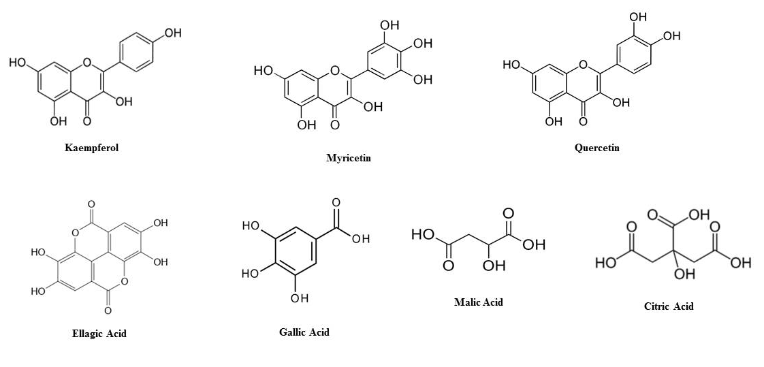

- The Antidiabetogenic Effects of Syzygium cumini (Jamun)
Anomalies in metabolism characterized by high blood sugar levels and decreased tolerance for glucose lead to the medical condition called Diabetes mellitus. Changes in the way hormones are controlled and impaired cellular processes contribute to the elevation of fasting blood glucose levels beyond 110mg/dL (6.1 mmol) and post-meal glucose levels exceeding 200mg/dL (11.1 mmol), thereby triggering the onset of Diabetes [6]. Individuals with Diabetes often exhibit imbalances in the regulation of hormones, causing a surge in blood sugar levels and disrupting the body's normal state of equilibrium. Diabetes primarily arises from pancreas dysfunction, which can hinder insulin secretion, disrupt insulin's normal function, or exhibit a combination of both, resulting in a diabetic condition.
Diabetes is categorized into three main types: type 1, 2, and gestational Diabetes. Among these, type 2 diabetes constitutes the most significant portion of diagnosed cases. Type 1 diabetes results from the body's inability to generate insulin, whereas type 2 diabetes arises when the body struggles to utilize insulin efficiently. Conversely, gestational Diabetes refers to a situation where blood sugar levels are raised, and this takes place while a woman is pregnant [7]. About 10.4% of the adult population in India is thought to experience Diabetes, leading to a mortality rate of one million deaths [8]. Currently, a range of pharmaceutical drugs are designed for treating Diabetes, including sulphonylureas, biguanides, alpha-glucosidase inhibitors, thiazolidinediones, and meglitinides. However, these medications come with diverse side effects, such as hypoglycemia, weight gain, nausea, diarrhea, fluid retention, and abdominal bloating [9]. These complications underscore the necessity for novel antidiabetic medications with fewer side effects. Modern medicine offers a wide range of treatment strategies to effectively manage both Type 1 and type 2 diabetes. However, Ayurveda and nanotechnology offer extensive insights into treating Diabetes using Jamun. This chapter predominantly focuses on the therapeutic potential of Jamun, scientifically identified as Syzygium cumini, in the context of addressing Diabetes.
- The scavenging activity of Jamun
The reduction of blood sugar levels and the alleviation of hyperlipidemia by Jamun might not stem from a singular mechanism. Instead, multiple potential mechanisms appear to collaborate in a synchronized manner to manage Diabetes and hyperlipidemia. Among these mechanisms, the combined effects of various factors play a crucial role. The excess formation of free radicals and reactive oxygen species (ROS) is one of the most critical events in causing Diabetes [10,11]. Thus, the process of neutralizing these free radicals through the use of Jamun appears to play a pivotal role in managing diabetes [12-14]. At the molecular level, the decrease in glucose levels can be attributed to Jamun's ability to activate PPARα, PPARγ, and AKT. This activation, in turn, leads to the downregulation of the expression of various molecules, including ACC1, Foxo-1, PGC1α, Scid 1, SREPB1c, endoplasmic reticulum protein retention receptor (KDEL), and GPR98. These downregulated molecules are responsible for the depletion of G6Pase, ADA, 5’NTase, PEPCK, and Fas activities [15-18], as shown in Figure 2.
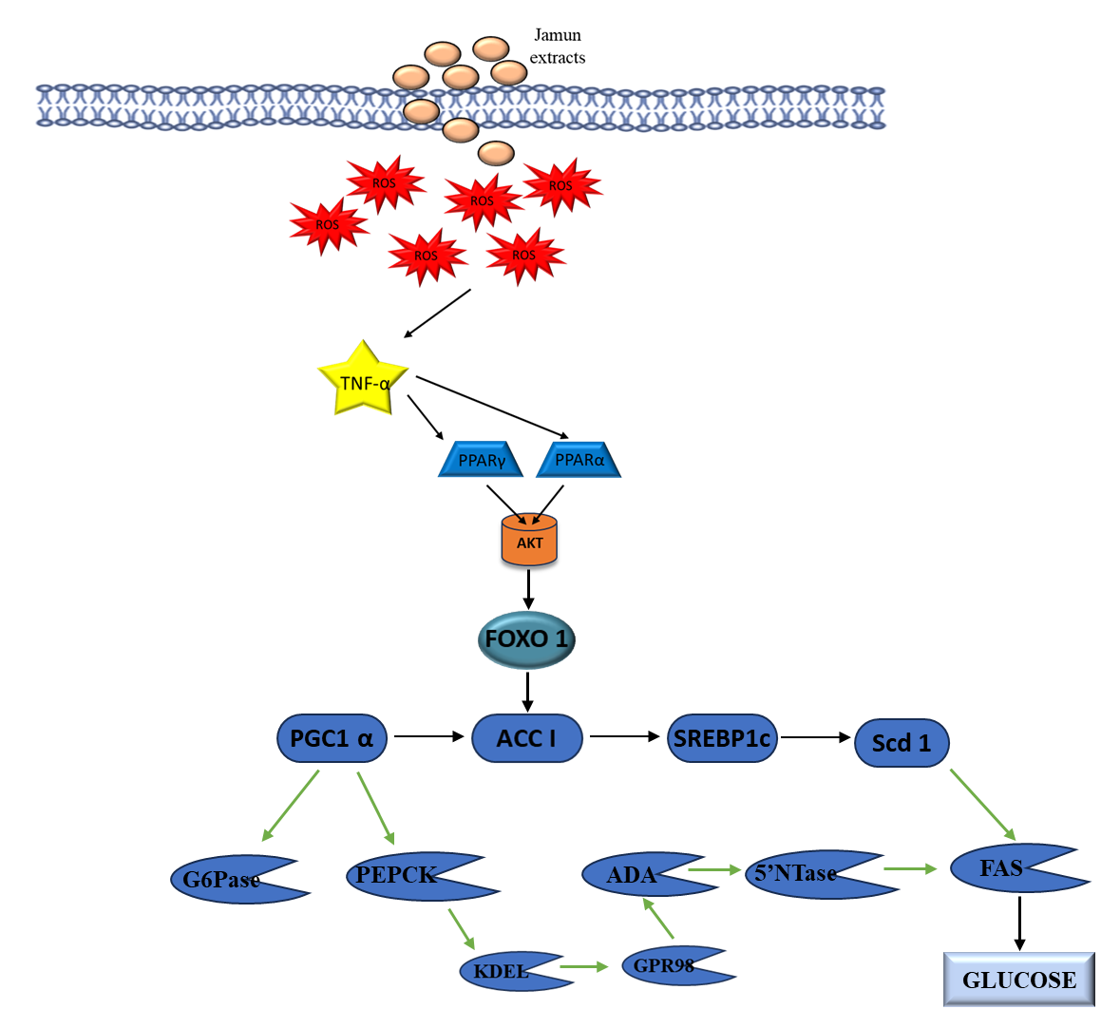

Figure 2(Cited from Ref. 36) Jamun fruit exhibits antioxidant properties by scavenging free radicals, which are reactive oxygen species (ROS). These ROS molecules play a role in modulating the expression of TNF-α and protein kinase (AKT). Furthermore, the fruit positively influences peroxisome proliferator-activated receptor gamma (PPARγ) and PPARα, leading to the downregulation of factors such as Forkhead box protein-1 (Foxo-1), peroxisome proliferator-activated receptor gamma coactivator 1-alpha (PGC1α), sterol regulatory element-binding protein-1c (SREBP1c), Acetyl-CoA carboxylase (ACC1), stearoyl-CoA desaturase-1 (SCD1), endoplasmic reticulum protein retention receptor (KDEL), G protein-coupled receptor (GPR98), fatty acid synthase (FAS), glucose 6-phosphatase (G6Pase), phosphoenolpyruvate carboxykinase (PEPCK), Adenosine deaminase (ADA), and 5’-nucleotidase (5’NTase).

- Mechanism of Action
In Diabetes, there is a noted dysregulation of the Nrf2/Keap1/ARE (Antioxidant Response Element) signalling pathway [19]. Jamun appears to sequester Nrf2/Keap1 and facilitate the translocation of Nrf2 into the nucleus, effectively restoring this pathway to its normal functioning state. The activation of Nrf2 and its translocation into the nucleus trigger the activation of the Antioxidant Response Element (ARE). This, in turn, stimulates the production of heme oxygenase-1 (HO1) and NAD[P]H: quinone oxidoreductase-1 (NQO1). As a consequence, there is an increase in the levels of antioxidants, such as GPx, GSH, glutathione reductase (GR), SOD, catalase, and glutathione-s-transferase (GST) in diabetic conditions, resulting in a reduction of lipid peroxidation [20-22], as explained in Figure 3. In addition to these known mechanisms, Jamun may employ several other unidentified pathways to exert its antidiabetic effects.

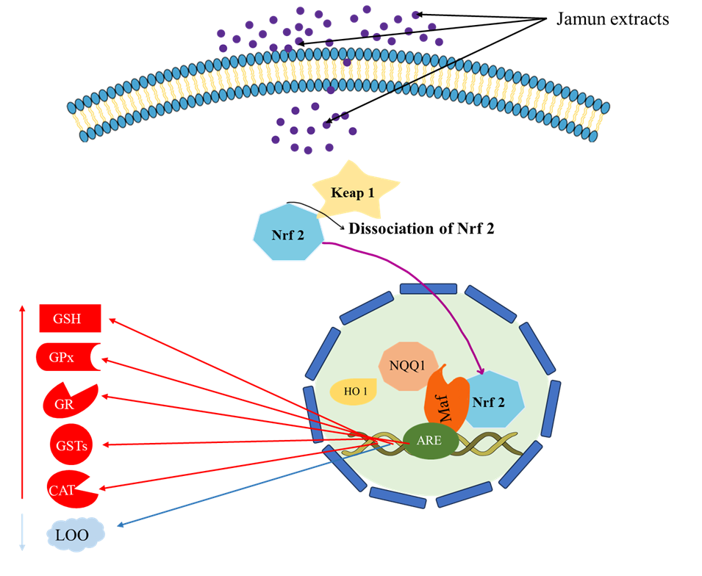

Figure 3 (Cited from Ref. 36) Jamun's efficacy in addressing Diabetes stems from its capacity to disassociate nuclear factor E2-related factor 2 (Nrf2) from Keap1, resulting in the translocation of Nrf2 into the nucleus. Once localized in the nucleus, Nrf2 activates the antioxidant response element (ARE), consequently inducing the expression of heme oxygenase-1 (HO1) and NAD[P]H: quinone oxidoreductase-1 (NQO1). This cascade triggers an augmentation in the levels of glutathione (GSH), glutathione peroxidase (GPx), glutathione reductase (GR), glutathione S-transferase (GST), and catalase (CAT) while concurrently diminishing lipid peroxidation (LOO).

Jamun contains anthocyanins that underlie its antidiabetic effects. However, various disadvantages, like inadequate solubility, limited biological availability, instability, and unpredictable toxicity, hinder their practical applications. To overcome these issues, nanotechnology is crucial in unlocking their full potential for use in pharmaceutical formulations. The convergence of nanotechnology and combinatorial chemistry presents a promising avenue to enhance Jamun’s antidiabetic potential. This method provides a fundamental understanding of the principles employed in designing, characterizing, producing, and applying materials on a nanoscale. As a result, it deals with the constraints linked to anthocyanins.
- Green Synthesis of nanoparticles by using Syzygium cumini (Jamun)
In the context of eco-friendly nanoparticle synthesis, various compounds, including vitamins, microorganisms, sugars, biopolymers, and plant extracts, find applications as both capping and reducing agents. Notably, recent advances have enabled the creation of nanoparticles through the utilization of plant components like tissues and extracts [23]. Among the available methods, plant-based extracts are particularly well-suited for large-scale, environmentally-conscious nanoparticle synthesis.
For instance, the Jamun plant, known for its rich content of beneficial compounds, could play a significant role in this approach. Jamun plants possess molecules such as phenols, nitrogen compounds, terpenoids, and other antioxidants that effectively scavenge free radicals [18]. The presence of phytosterols and polyphenols within these plants further enhances their suitability for application in nanoparticle synthesis.
- Different types of nanoparticles synthesized from Syzygium cumini
- Silver nanoparticles
Polar-soluble components play a pivotal role in synthesizing silver nanoparticles (SNP). Researchers have observed a direct connection between the number of polyphenols and surfactants within the reaction solution and the size of the generated SNP. As a result, the quantity of polyphenols emerges as a potentially critical factor influencing the resulting silver nanoparticles' size and distribution characteristics [32]. The authors also reported the spherical agglomerated silver nanoparticles of the leaf and seed extract, as confirmed by SEM and atomic force microscopy (AFM). Figure 4 shows the morphology and microscopy results of the synthesized silver nanoparticles. The average size of Ag nanoparticles synthesized by leaf extract, leaf water fraction, seed extract, and seed water fraction was 30, 29, 92, and 73 nm, respectively, as shown in Figure 5.

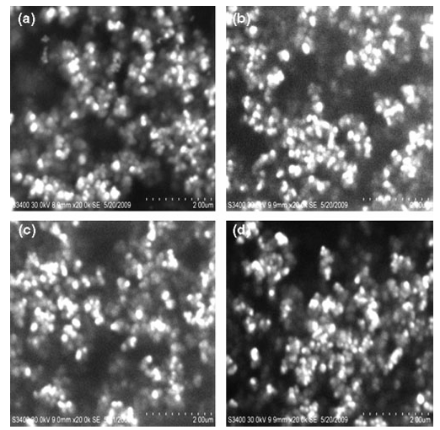
Figure 4. SEM images of SNP synthesized with (a) leaf extract, (b) leaf water fraction, (c) seed extract, and (d) seed water fractions of S.cumini. Adapted from [18]

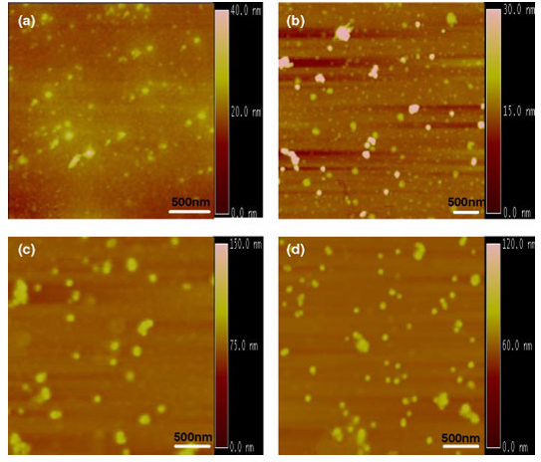

Figure 5. Tapping mode AFM images of SNP synthesized with (a)leaf extract (LE), (b) leaf water fraction, (c) seed extract (SE), and (d) seed water fractions of S. cumini. A scale bar of 500 nm is labelled in each image. Adapted from [18]

- Polymeric Nanoparticles
Paula et al. [28] conducted an antidiabetic study comparing Jamun seeds and Janum-mediated polymeric nanoparticles. They showcased how polymeric nanoparticles carrying an aqueous extract of Syzygium cumini (Jamun) preserved the extract's antioxidant properties and elevated its antifungal efficacy in vitro [27]. Significantly, these polymeric nanoparticles emerged as a valuable alternative due to their adeptness in controlling drug release. Their attributes include biocompatibility, biodegradability, and superior stability compared to other systems. Moreover, they also proved that nanoparticles containing the aqueous extract of S. cumini are more effective than the aqueous extract of S. cumini in reducing glucose (56%), cholesterol (33%), and creatinine (51%). The polymeric nanoparticles also exhibited a substantial impact on serum (16%) and pancreatic (46%) AOPP levels, as well as renal (48%) TBARS levels, when compared with the DMþC (diabetes mellitus plus C. albicans) group, as depicted in Figure 6. In the context of the C. albicans group, both treatments decreased NAG activity, but no reduction in creatinine levels was observed.
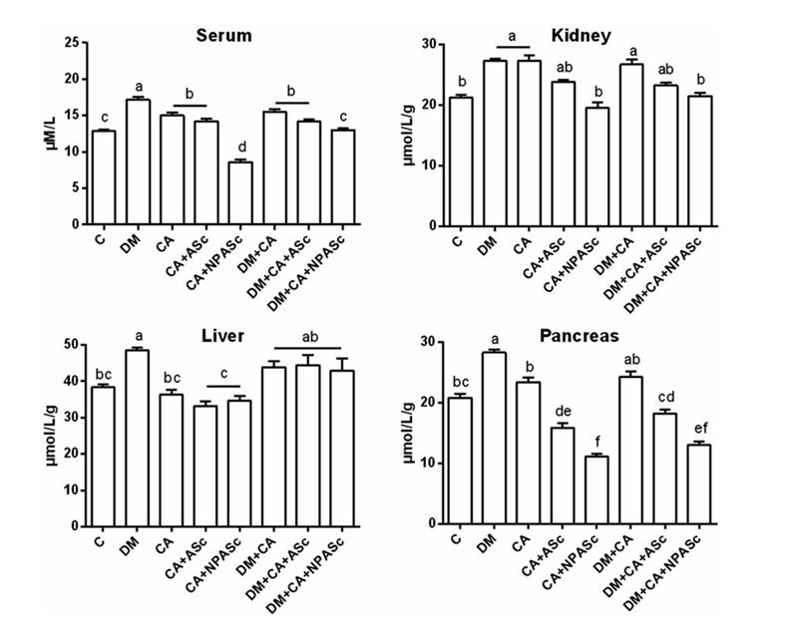

Figure 6. Impact of jamun seed extract and seed extract loaded polymeric nanoparticle treatments on AOPP levels in the serum (μM/L) and tissue (μmol/L/g of protein) of rats. The data is presented as the mean ± SEM (n=6). Significantly different mean values are denoted by distinct letters (p<0.05) according to the Duncan test. The experimental groups include DM - diabetic rats; CA - rats infected with Candida albicans; CA+ seed extract - rats infected with Candida albicans and subjected to seed extract treatment; CA + seed extract loaded polymeric nanoparticle - rats infected with Candida albicans and treated with NP; DM+CA - diabetic rats infected with Candida albicans; DM +CA +seed extract - diabetic rats with Candida albicans infection and seed extract treatment; DM+CA+NP- diabetic rats with Candida albicans infection and NP treatment. Adapted from [28]

- ZnO Nanoparticles
Daniel and coworkers in 2019 [29] synthesized and assessed the antidiabetic impact of Zinc oxide nanoparticles derived from Syzygium cumini. Their findings indicated that the acquired ZnO nanoparticles stabilized through interactions with phenolic compounds in the seed extract, as indicated by FT-IR analysis. Moreover, the XRD pattern analysis verified the crystalline nature of the nanoparticles, shown in Figure 7 (a) and (b), while TEM images unveiled their polygonal structure with dimensions ranging from 16.7 to 22.9 nm, as shown in Figure 8.
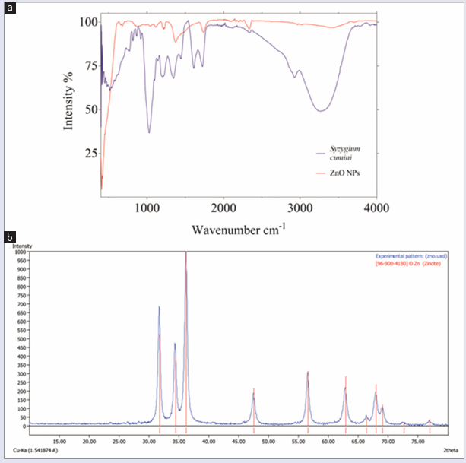

Figure 7. Spectral characterization of zinc oxide nanoparticles (a) Fourier transform-infrared chromatogram of zinc oxide nanoparticles and Syzygium cumini seed extract and (b) X-ray diffraction spectra showing the diffraction pattern of the synthesized zinc oxide nanoparticles. Adapted from [29]

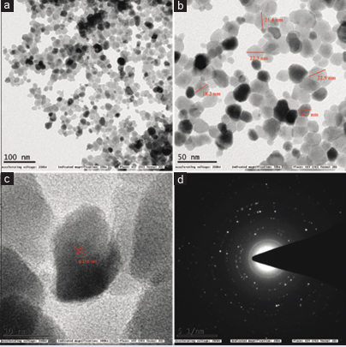

Figure 8. Transmission electron microscopy analysis of the synthesized zinc oxide nanoparticles, (a and b) Morphology and size, (c) d-spacing of the surface and (d) Selected area electron diffraction. Adapted from [29]

In-depth molecular interaction investigations between the phenolic compounds extracted from the Syzygium cumini seeds and α‑amylase and α‑glucosidase revealed a pronounced affinity toward these enzymes, surpassing that of acarbose, as shown in Figure 9.
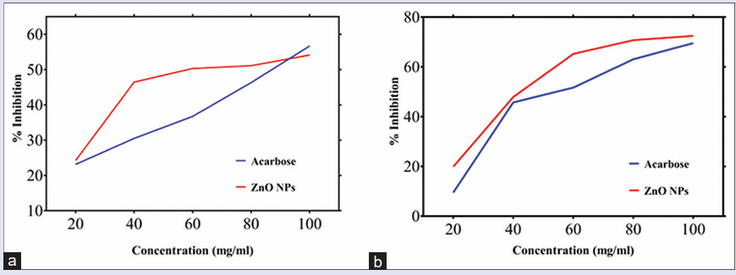
Figure 9. Inhibitory potential of zinc oxide nanoparticles and acarbose against (a) α-amylase and (b) α-glucosidase Adapted from [29]

Additionally, the in vitro inhibitory potential studies of the ZnO nanoparticles demonstrated their capacity to inhibit enzymes similar to acarbose. Studies have indicated that metal oxide nanoparticles can penetrate the plant cell wall, concurrently elevating ROS, RNS, and chlorophyll levels [33]. In a separate investigation conducted by Daniel et al. in 2020 [26], the size of the Zinc oxide nanoparticles (ZnO NPs) produced using jamun-mediated synthesis was determined to be 18.92 nm. Notably, in vitro studies conducted on rat insulinoma (RIN-5F) cells showed that cells treated with the synthesized ZnO NPs displayed a dose-dependent increase in insulin secretion. Furthermore, when administered to streptozotocin-fructose-induced type II diabetic rats, the ZnO nanoparticles showcased significant effects. This encompassed a substantial reduction (p < 0.01) in blood glucose levels and marked decreases in total cholesterol, triglycerides, and low-density lipoprotein levels. Conversely, there was a noticeable increase (p < 0.01) in serum insulin levels and liver antioxidant enzyme levels. These combined findings underscored the nanoparticles' role as hypoglycemic and hypolipidemic agents.
Furthermore, treating ZnO NPs in diabetic rats yielded an augmented number of beta cells, attributed to the heightened insulin levels and reduced glucose levels. In conclusion, the synthesized ZnO NPs demonstrated a compelling hypoglycemic effect in diabetic rats, thereby highlighting their potential as a potent antidiabetic medication. A significant revelation from the study revealed that ZnO nanoparticles (NPs) induced nuclear damage and brought about modifications at the cellular level in the A549 human lung cancer cell line, with the extent of these effects being dependent on the concentration of the nanoparticles. In a separate experiment, ZnO NPs synthesized through a green method were employed as a nutritional source for cultivating sesame plants at various concentrations (1, 3, 5, 7, 9 mg/ml). The research underscored the role of ZnO nanoparticles in nanomedicine and nano-nutrient applications [32]. These findings indicate that nanotechnology has the potential to enhance the beneficial characteristics of plant extracts, like their antioxidant activity, which could have practical applications in addressing complications related to Diabetes. The nanoparticles synthesized from different parts of jamun with their size, and shape using the green approach have been mentioned in Table 2.
Table 2: Nanoparticles synthesized from different parts of Syzygium cumini

PLANT PART | NANOPARTICLE | SIZE (nm) | SHAPE | REFERENCES
SEEDS | ZnO | 16.7–22.9 nm | Polygonal | [29]
LEAVES | ZnO | 11.35 nm | Hexagonal | [34]
LEAVES | α-Fe2O3 | NA | Irregular spherical shaped | [35]
SEEDS | ZnO | 18.92 nm | Hexagonal | [30]
SEEDS | Ag | 92 nm | Spherical | [31]
LEAVES | Ag | 30 nm | Spherical | [31]

- Future Perspective
Recent research advances have highlighted the broad spectrum of applications for plant-derived nanoparticles in regulating disorders and diseases driven by oxidative stress. Accumulating evidence from published literature strongly indicates that plant-derived nanoparticles hold significant promise as innovative and potent therapeutic agents for addressing conditions stemming from oxidative stress-induced damage. Moreover, green synthesis of nanoparticles exhibits a versatile range of medicinal utilities encompassing antioxidative properties and displaying capabilities as antidiabetic, antibacterial, antifungal, anticancer, and antiplasmodial agents. Notably, they can catalytically modulate biomolecular reactions with redox attributes. While these attributes hold significant promise, it is imperative to channel further research efforts toward addressing key challenges inherent in the synthesis and practical integration of plant-derived compounds within pharmacological contexts. The green synthesis of nanoparticles involves the utilization of metals, which pose toxicity risks when consumed in significant amounts by humans. Many reports need more essential information regarding the toxicity profile of the produced nanoparticles and pertinent biological investigations. To tackle these concerns, which encompass the exact mechanisms, distribution, toxicity, and potential negative impacts, it is imperative to conduct thorough and extensive pharmacokinetic studies.
- Conclusion
Natural products are considered to be extremely valuable, encompassing both straightforward and exceedingly intricate chemical structures. The natural metabolites are superior in terms of biochemical and pharmacological activities, and the drug discovery process from natural products is associated with isolation, purification, screening, and the discovery of novel drug candidates. Therefore, the blend of nanotechnology and plant-derived medicinal products represents a promising avenue in pharmaceutical research. By encapsulating or modifying these products at the nanoscale, their bioavailability and therapeutic potential can be significantly improved, leading to more effective treatments and reduced side effects. This interdisciplinary approach leverages the wisdom of traditional medicine. It demands careful consideration of safety, regulatory compliance, and ethical implications to ensure that the resulting therapies are both practical and responsible.

- References

- Steven King, Medicines that changed the world. Pac. Discovery, 1992, 45, 23-31.
- Ekror, The growing use of herbal medicine: issues relating to adverse reactions and challenges in monitoring safety. Front. Pharmacol, 2013, 4, 177_187.
- Ansari S, Sameem M, Islam F. Influence of nanotechnology on herbal drugs: a review. J Adv Pharm Technol Res. 2012 ; 3 (3):142.
- Agarwal P, Gaur PK, Tyagi N, Puri D, Kumar S. An overview of the phytochemical, therapeutic, pharmacological and traditional importance of Syzygium cumini. Asian J Pharmacogn, 2019 ; 3 (1): 5-17
- Shyamala Gowri S, Vasantha K. Phytochemical screening and antibacterial activity of Syzygium cumini (Myrtaceae) leaves extracts. Int. J PharmTech Res. 2010; (2): 1569-1573
- World Health Organization (WHO). Definition and diagnosis of Diabetes mellitus and intermediate hyperglycemia: a WHO/ IDF consultation report. Geneva, Switzerland: World Health Organization; 2006. p. 50.
- WHO: ‘Global report on diabetes’ World Health Organization, Geneva, 2016
- International Diabetes Federation: ‘IDF Diabetes Atlas, 8th edition.’, 2017
- Modi, P.: ‘Diabetes beyond insulin: a review of new drugs for treating diabetes mellitus,' Curr. Drug Discov. Technol., 2007, 4, (1), pp. 39–47
- Dos Santos JM, Tewari S, Mendes RH. The role of oxidative stress in developing Diabetes mellitus and its complications. J Diabetes Res. 2019;2019:4189813.
- Behl T, Kaur I, Sehgal A, et al. Unfolding Nrf2 in Diabetes mellitus. Mol Biol Rep. 2021;48(1):927–939.
- Jagetia GC, Baliga MS. Evaluating nitric oxide scavenging activity of certain Indian medicinal plants in vitro: A preliminary study. J Med Food. 2004;7(3):343–348.
- Jagetia GC, Shetty PC, Vidyasagar MS. Inhibition of radiation–induced DNA damage by jamun, Syzygium cumini, in the cultured splenocytes of mice exposed to different doses of γ–radiation. Integr Cancer Ther. 2012;11(2):141–153.
- Yadav N, Pal A, Sihag S, et al. Antioxidant activity profiling of acetonic extract of jamun (Syzygium cumini L.) seeds in different in–vitro models. Open Food Sci J. 2020;12:3–8.
- Sharma S, Pathak S, Gupta G, et al. Pharmacological evaluation of aqueous extract of Syzigium cumini for its antihyperglycemic and antidyslipidemic properties in diabetic rats fed a high cholesterol diet— Role of PPARγ and PPARα. Biomed Pharmacother. 2017;89:447–453.
- Xu J, Liu T, Li Y, et al. Hypoglycemic and hypolipidemic effects of triterpenoid–enriched Jamun (Eugenia jambolana Lam.) fruit extract in streptozotocin–induced type 1 diabetic mice. Food Funct. 2018;9(6):3330–3337.
- Bopp A, De Bona KS, Bellé LP, et al. Syzygium cumini inhibits adenosine deaminase activity and reduces glucose levels in hyperglycemic patients. Fundam Clin Pharmacol. 2009;23:501–507.
- Ayya N, Nalwade V, Khan TN. Effect of jamun (Syzygium cumini L.) seed powder supplementation on blood glucose level of type–II diabetic subject. Food Sci Res J. 2015;6(2):353–356.
- David JA, Rifkin WJ, Rabbani PSet al. The Nrf2/Keap1/ARE pathway and oxidative stress as a therapeutic target in Type II Diabetes mellitus. J Diabetes Res. 2017;2017:4826724.
- Donepudi AC, Aleksunes LM, Driscoll M V, et al. The traditional ayurvedic medicine, Eugenia jambolana (Jamun fruit), decreases liver inflammation, injury and fibrosis during cholestasis. Liver Int. 2012;32(4):560–573.
- Chanudom L, Tangpong J. Anti–inflammation property of Syzygium cumini (L.) Skeels on indomethacin–induced acute gastric ulceration. Gastroenterol Res Pract. 2015;2015:343642.
- Sutariya B, Taneja N, Saraf M. Betulinic acid, isolated from the leaves of Syzygium cumini (L.) Skeels, ameliorates the proteinuria in experimental membranous nephropathy through regulating Nrf2/NF–κB pathways. Chem Biol Interact. 2017;274:124–137.
- J.G. Parsons, J.R. Peralta-Videa, J.L. Gardea-Torresdey, Use of plants in biotechnology: synthesis of metal nanoparticles by inactivated plant tissues, plant extracts, and living plants, Dev. Environ. Sci. 5 (2007) 463–485.
- M. Nasrollahzadeh, M. Maham, S.M. Sajadi, Green synthesis of CuO nanoparticles by aqueous extract of Gundelia tournefortii and evaluation of their catalytic activity for the synthesis of N-monosubstituted ureas and reduction of 4-nitrophenol, J. Colloid Interface Sci. 455 (2015) 245–253.
- M. Nasrollahzadeh, S.M. Sajadi, M. Maham, Tamarix gallica leaf extract mediated novel route for green synthesis of CuO nanoparticles and their application for N-arylation of nitrogen-containing heterocycles under ligand-free conditions, RSC Adv. 5 (51) (2015) 40628–40635. 76 Colloidal Metal Oxide Nanoparticles
- M. Nasrollahzadeh, S. Mohammad Sajadi, M. Maham, A. Ehsani, Facile and surfactant-free synthesis of Pd nanoparticles by the extract of the fruits of Piper longum and their catalytic performance for the Sonogashira coupling reaction in water under ligand- and copper-free conditions, RSC Adv. 5 (4) (2015) 2562–2567.
- Bitencourt PER, Ferreira LM, Cargnelutti LO, Denardi L, Boligon A, Fleck M, Brandao R, Athayde ML, Cruz L, Zanette RA, et al. 2016. A new bio-degradable polymeric nanoparticle formulation containing Syzygium cumini: phytochemical profile, antioxidant and antifungal activity and in vivo toxicity. Ind Crop Prod. 83:400–407.
- Paula E. R. Bitencourt, Lariane O. Cargnelutti, Carolina S. Stein, Raquel Lautenchleger, Luana M. Ferreira, Manuela Sangoi, Laura Denardi, Raphaela M. Borges, Aline Boligon, Rafael N. Moresco, Letícia Cruz, Régis A. Zanette, Sydney H. Alves & Maria Beatriz Moretto (2017) Nanoparticle formulation increases Syzygium cumini antioxidant activity in Candida albicans-infected diabetic rats, Pharmaceutical Biology, 55:1, 1082-1088, DOI: 10.1080/13880209.2017.1283338
- Daniel, J. Arul, and S. Asha Devi. "Inhibition of Key Digestive Enzymes Involved in Glucose Metabolism by Biosynthesized Zinc Oxide Nanoparticles from Syzygium cumini (L.): An: In vitro: and: in silico: Approach." Pharmacognosy Magazine 15, no. Suppl 3 (2019): S502-S509.
- John AD, Ragavee A, Selvaraj AD. Protective role of biosynthesised zinc oxide nanoparticles on pancreatic beta cells: an in vitro and in vivo approach. IET Nanobiotechnol. 2020 Dec;14(9):756-760. doi: 10.1049/iet-nbt.2020.0084. PMID: 33399105; PMCID: PMC8676548.
- Kumar, Vineet, Subhash C. Yadav, and Sudesh Kumar Yadav. "Syzygium cumini leaf and seed extract mediated biosynthesis of silver nanoparticles and their characterization." Journal of Chemical Technology & Biotechnology 85, no. 10 (2010): 1301-1309.
- Arumugam, Manikandan, Dinesh Babu Manikandan, Elayaraja Dhandapani, Arun Sridhar, Karthiyayini Balakrishnan, Manickavasagam Markandan, and Thirumurugan Ramasamy. "Green synthesis of zinc oxide nanoparticles (ZnO NPs) using Syzygium cumini: Potential multifaceted applications on antioxidants, cytotoxic and as nanonutrient for the growth of Sesamum indicum." Environmental Technology & Innovation 23 (2021): 101653.
- Motyka, O., Chlebíková, L., Mamulová Kutláková, K., Seidlerová, J., 2019. Ti and Zn content in moss shoots after exposure to TiO2 and ZnO nanoparticles: biomonitoring possibilities. Bull. Environ. Contam. Toxicol. 102, 218–223. http://dx.doi.org/10.1007/s00128-020-02787-z.
- Sadiq, Hamad, Farooq Sher, Saba Sehar, Eder C. Lima, Shengfu Zhang, Hafiz MN Iqbal, Fatima Zafar, and Mirza Nuhanović. "Green synthesis of ZnO nanoparticles from Syzygium Cumini leaves extract with robust photocatalysis applications." Journal of Molecular Liquids 335 (2021): 116567.
- Joshi, N. C., A. Chodhary, Y. Prakash, and A. Singh. "Green synthesis and characterization of α-Fe2O3 nanoparticles using Leaf Extract of Syzygium cumini and their suitability for adsorption of Cu (II) and Pb (II) ions." Asian Journal of Pharmaceutical and Clinical Research 31 (2019): 809-1814.
- Dagadkhair, Amol Changdeo, Komal Nivrutti Pakhare, Ashok Dattatray Todmal, and Rajkumar Ramrao Andhale. "Jamun (Syzygium cumini) Skeels: a traditional therapeutic tree and its processed food products." International Journal of Pure & Applied Bioscience 5, no. 5 (2017): 1202-1209.
- Rizvi MK, Rabail R, Munir S, Inam-Ur-Raheem M, Qayyum MMN, Kieliszek M, Hassoun A, Aadil RM. Astounding Health Benefits of Jamun (Syzygium cumini) toward Metabolic Syndrome. Molecules. 2022 Oct 24;27(21):7184. doi: 10.3390/molecules27217184. PMID: 36364010; PMCID: PMC9654918.

