From Glands to Growth: Unveiling the Role of Hormones in the Human Body
Latha Rani R ¹* Imrankhan Jiragal ² Akshaykumar ³ and Uma N. Kulkarni 4
1. Young Professional-II, AICRP on Women in Agriculture, UAS, GKVK, Bangalore
2. Young Professional-II, AICRP on Women in Agriculture, UAS, GKVK, Bangalore
3. Scientist (Animal Science), ICAR-Krishi Vignan Kendra, Bidar
4. Professor and Head, College of Community Science, UAS, Dharwad
latharanjurani@gmail.com +91-9880822375
*Corresponding author: Latha Rani R

Abstract

Hormones play a crucial role in physiological processes in organisms. This chapter provides an overview, covering types, mechanisms of action, and significance across organisms. It explores major hormone-producing glands, spotlighting functions and interactions in the endocrine system. Hormones are categorized based on structure and action, including steroids, peptides, amino acid and fatty acid derivatives. Steroids influence gene expression by binding intracellular receptors. Peptide hormones use cell membrane receptors, initiating signal transduction. Tightly controlled hormone secretion involves feedback loops, circadian rhythms, and neural signals. Negative feedback maintains precise hormone levels. Circadian rhythms impact sleep-wake cycles and metabolism. Hypothalamic neural signals regulate the "master gland" pituitary for hormone release. Hormonal imbalances have profound consequences, causing disorders like diabetes, thyroid disorders, and reproductive issues. Understanding hormone regulation is crucial for accurate diagnosis and effective treatment.
Key words: Hormones,

Introduction

Hormones play a crucial role in regulating various processes and functions in the human body. They are chemical messengers produced by specialized cells or glands called endocrine glands. These hormones are released into the bloodstream and travel to target cells or organs, where they exert their effects by binding to specific receptors.
Classification
Hormones can be classified into different categories based on their chemical structure, function, and the glands that produce them. Here are some common ways to classify hormones:
Chemical Structure:
a. Steroid Hormones: These hormones are derived from cholesterol and include hormones such as cortisol, testosterone, and estrogen. They are lipid-soluble and can easily pass through cell membranes.
b. Peptide or Protein Hormones: These hormones are made up of amino acids and include hormones such as insulin, growth hormone, and oxytocin. They are water-soluble and bind to receptors on the cell surface.
Function:
a. Endocrine Hormones: These hormones are released into the bloodstream by endocrine glands and travel to target cells or tissues to exert their effects. Examples include thyroid hormones and adrenal hormones.
b. Paracrine Hormones: These hormones act on nearby cells without entering the bloodstream. They are produced by various tissues and exert localized effects. Examples include histamine and prostaglandins.
c. Autocrine Hormones: These hormones act on the same cells that produce them. They play a role in regulating the function of the secreting cell itself.
Glandular Origin:
a. Hypothalamic Hormones: These hormones are produced in the hypothalamus and regulate the release of hormones from the pituitary gland. Examples include thyrotropin-releasing hormone (TRH) and gonadotropin-releasing hormone (GnRH).
b. Pituitary Hormones: These hormones are produced by the pituitary gland, which is often referred to as the "master gland." Examples include growth hormone, luteinizing hormone (LH), and adrenocorticotropic hormone (ACTH).
c. Thyroid Hormones: These hormones, including thyroxine (T4) and triiodothyronine (T3), are produced by the thyroid gland and regulate metabolism and growth.
d. Adrenal Hormones: The adrenal glands produce hormones such as cortisol (a glucocorticoid) and adrenaline (epinephrine). They play a role in stress response and regulation of various body functions.
e. Gonadal Hormones: These hormones, including testosterone in males and estrogen and progesterone in females, are produced by the gonads (testes in males and ovaries in females) and are involved in sexual development and reproduction.
Endocrine glands and exocrine glands
Endocrine glands
Exocrine glands are a type of glandular tissue found in the human body that secrete substances onto an epithelial surface through ducts. These glands are responsible for producing and releasing various fluids, such as mucus, enzymes, saliva, sweat, and digestive juices, to aid in the proper functioning of the body. Exocrine glands are widely distributed throughout the body and serve numerous functions.
Examples of exocrine glands:
Salivary glands: These glands produce and secrete saliva into the oral cavity, helping with the initial digestion of food.
Sweat glands: Sweat glands are responsible for producing sweat, which helps regulate body temperature and maintain homeostasis.
Sebaceous glands: These glands secrete an oily substance called sebum, which lubricates the skin and hair, preventing them from drying out.
Mammary glands: Found in the breasts of females, mammary glands produce milk during lactation to nourish newborn babies.
Lacrimal glands: These glands are responsible for producing tears, which help lubricate and protect the eyes.
Gastric glands: Located in the lining of the stomach, gastric glands secrete digestive enzymes and hydrochloric acid to aid in the digestion of food.
Pancreas: The pancreas is a mixed gland with both exocrine and endocrine functions. The exocrine portion of the pancreas produces and releases digestive enzymes into the small intestine to aid in the digestion of carbohydrates, proteins, and fats.
Liver: While the liver is primarily known for its metabolic functions, it also produces bile, which is stored in the gallbladder and released into the small intestine to aid in the digestion and absorption of fats.
Endocrine glands
Endocrine glands are specialized glands in the human body that secrete hormones directly into the bloodstream. These hormones are chemical messengers that regulate various physiological processes and help maintain homeostasis. Here are some of the major endocrine glands in the human body:
Pituitary gland: Located at the base of the brain, the pituitary gland is often called the "master gland" because it controls the functions of many other endocrine glands. It secretes hormones that regulate growth, reproduction, metabolism, and the function of other endocrine glands.
Thyroid gland: Situated in the front of the neck, the thyroid gland produces hormones that regulate metabolism and energy expenditure. The main hormones released by the thyroid gland are thyroxine (T4) and triiodothyronine (T3).
Parathyroid glands: There are four small parathyroid glands located near the thyroid gland. They produce parathyroid hormone (PTH), which helps regulate the level of calcium and phosphorus in the blood and plays a crucial role in bone health.
Adrenal glands: Situated on top of the kidneys, the adrenal glands consist of two parts: the outer adrenal cortex and the inner adrenal medulla. The adrenal cortex produces hormones such as cortisol, aldosterone, and sex hormones, while the adrenal medulla secretes adrenaline (epinephrine) and noradrenaline (norepinephrine), which are involved in the body's response to stress.
Pancreas: While the pancreas is primarily an exocrine gland involved in digestion, it also has endocrine functions. The specialized clusters of cells called the pancreatic islets (or islets of Langerhans) produce hormones such as insulin and glucagon, which regulate blood sugar levels.
Gonads (Testes and Ovaries): In males, the testes produce testosterone, the primary male sex hormone responsible for the development of secondary sexual characteristics and sperm production. In females, the ovaries produce estrogen and progesterone, which regulate the menstrual cycle and are involved in the development of secondary sexual characteristics.
Pineal gland: Located in the brain, the pineal gland produces the hormone melatonin, which helps regulate sleep-wake cycles and is influenced by light and darkness.
Key roles of hormones in the body:
Regulation of Growth and Development: Hormones, such as growth hormone and thyroid hormones, are responsible for promoting normal growth and development in children and adolescents. They influence the development of various tissues and organs, including bones, muscles, and the brain.
Maintenance of Metabolism: Hormones like insulin, glucagon, and thyroid hormones are involved in regulating the body's metabolism. They control the storage, release, and utilization of nutrients, such as glucose, fats, and proteins, to provide energy for various cellular processes.
Reproduction and Sexual Development: Hormones, such as estrogen and progesterone in females, and testosterone in males, are essential for reproductive functions and sexual development. They regulate the menstrual cycle, promote fertility, control secondary sexual characteristics, and contribute to the development of reproductive organs.
Regulation of Stress Responses: The adrenal glands release hormones like cortisol and adrenaline in response to stress. These hormones help the body cope with stressful situations by increasing heart rate, blood pressure, and energy production, while suppressing non-essential functions like digestion.
Control of Fluid and Electrolyte Balance: Hormones like antidiuretic hormone (ADH) and aldosterone play a role in regulating fluid balance and electrolyte concentrations in the body. They influence the reabsorption and excretion of water and electrolytes by the kidneys to maintain proper hydration and electrolyte levels.
Regulation of Blood Sugar Levels: Insulin and glucagon, produced by the pancreas, are vital for maintaining normal blood sugar levels. Insulin lowers blood glucose by promoting its uptake into cells, while glucagon raises blood glucose by stimulating the release of stored glucose from the liver.
Mood and Emotional Regulation: Hormones, including serotonin, dopamine, and oxytocin, play a role in regulating mood, emotions, and behavior. Imbalances in these hormones can contribute to mood disorders like depression and anxiety.
Hypothalamus
The hypothalamus is a small but vital part of the brain located just below the thalamus and above the pituitary gland. It serves as a control center for various essential functions of the body, playing a crucial role in maintaining homeostasis and regulating the autonomic nervous system.
Key functions and features associated with the hypothalamus:
Hormone Regulation: The hypothalamus produces and releases several important hormones that control the functions of the pituitary gland, which is often considered the master gland. These hormones include thyrotropin-releasing hormone (TRH), gonadotropin-releasing hormone (GnRH), corticotropin-releasing hormone (CRH), growth hormone-releasing hormone (GHRH), and others.
Body Temperature Regulation: The hypothalamus plays a vital role in maintaining the body's core temperature. It receives signals from temperature receptors throughout the body and responds by initiating various mechanisms to conserve or dissipate heat, such as shivering or sweating.
Circadian Rhythms: The hypothalamus is involved in regulating the sleep-wake cycle and other circadian rhythms. It receives input from the eyes' optic nerves to help synchronize the body's internal clock with the external environment.
Hunger and Thirst Regulation: The hypothalamus helps regulate feelings of hunger and thirst, monitoring the body's energy and fluid levels. It integrates signals from various sources, including hormones and nutrient levels, to determine when to initiate or suppress these sensations.
Autonomic Nervous System Control: The hypothalamus influences the autonomic nervous system, which controls involuntary bodily functions such as heart rate, blood pressure, digestion, and respiration. It helps maintain the balance between the sympathetic and parasympathetic divisions of the autonomic system.
Emotion and Behavior: The hypothalamus is involved in the expression of emotions and certain behaviors. It interacts with other brain regions, such as the limbic system, to regulate mood, aggression, sexual behavior, and other instinctual responses.
Link to the Pituitary Gland: The hypothalamus is connected to the pituitary gland through a complex network of blood vessels, known as the hypothalamic-pituitary axis. This connection allows the hypothalamus to exert control over the release of hormones from the pituitary gland, which, in turn, influences various other glands and body functions.
The hypothalamus produces and releases specific hormones called releasing hormones and inhibiting hormones that act on the pituitary gland to stimulate or inhibit the secretion of various hormones.
Hormones released by the hypothalamus:
Gonadotropin-Releasing Hormone (GnRH): GnRH stimulates the pituitary gland to release two important gonadotropin hormones, luteinizing hormone (LH) and follicle-stimulating hormone (FSH). These hormones are responsible for the regulation of the reproductive system, including the release of sex hormones from the ovaries in females and testes in males.
Corticotropin-Releasing Hormone (CRH): CRH stimulates the release of adrenocorticotropic hormone (ACTH) from the pituitary gland. ACTH, in turn, stimulates the adrenal glands to release cortisol, a stress hormone that helps regulate metabolism, immune response, and response to stress.
Thyrotropin-Releasing Hormone (TRH): TRH stimulates the pituitary gland to release thyroid-stimulating hormone (TSH). TSH then acts on the thyroid gland to stimulate the synthesis and release of thyroid hormones, which play a vital role in regulating metabolism, growth, and development.
Growth Hormone-Releasing Hormone (GHRH): GHRH stimulates the pituitary gland to release growth hormone (GH). GH is essential for promoting growth and development in childhood and adolescence, as well as regulating metabolism and maintaining healthy body composition in adulthood.
Prolactin-Inhibiting Hormone (PIH) or Dopamine: This hormone inhibits the release of prolactin from the pituitary gland. Prolactin is involved in milk production in breastfeeding women and plays a role in reproductive functions.
Pituitary Gland
The pituitary gland, also known as the hypophysis, is a small, pea-sized gland located at the base of the brain, just below the hypothalamus. It is often referred to as the "master gland" because it plays a crucial role in regulating various bodily functions and controlling the activity of other endocrine glands.
The pituitary gland is divided into two main parts: the anterior pituitary (adenohypophysis) and the posterior pituitary (neurohypophysis). Each part has different functions and releases different hormones.
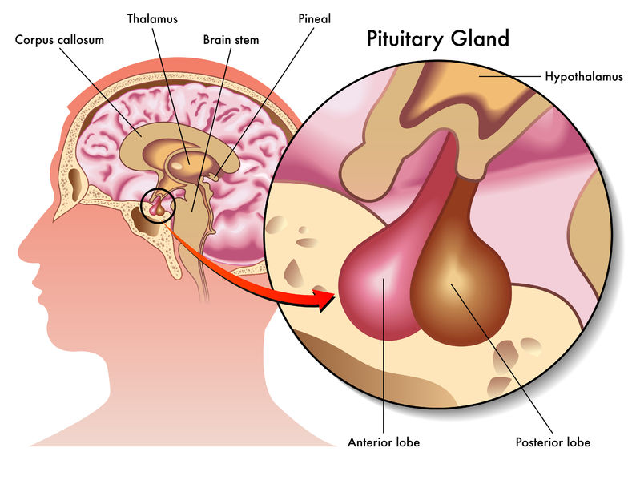

Anterior Pituitary: The anterior pituitary synthesizes and releases several hormones, which include:
Growth Hormone (GH): Stimulates growth and cell reproduction, and plays a role in regulating metabolism.
Adrenocorticotropic Hormone (ACTH): Stimulates the adrenal glands to produce cortisol, a hormone involved in stress response.
Thyroid-Stimulating Hormone (TSH): Regulates the production of hormones by the thyroid gland.
Follicle-Stimulating Hormone (FSH) and Luteinizing Hormone (LH): Control the reproductive functions in males and females.
Prolactin (PRL): Stimulates milk production in breastfeeding women.
Melanocyte-Stimulating Hormones (MSH): Regulate pigmentation in the skin.
Posterior Pituitary: The posterior pituitary does not synthesize hormones but stores and releases two hormones produced by the hypothalamus:
Antidiuretic Hormone (ADH) or Vasopressin: Regulates water balance by controlling the reabsorption of water by the kidneys.
Oxytocin: Stimulates uterine contractions during childbirth and plays a role in lactation and social bonding.
Thyroid gland
The thyroid gland is a small, butterfly-shaped endocrine gland located in the neck, just below the Adam's apple. It is responsible for producing and secreting hormones that regulate various bodily functions, including metabolism, growth, and development. The two main hormones produced by the thyroid gland are thyroxine (T4) and triiodothyronine (T3).
The thyroid gland is controlled by the hypothalamus and the pituitary gland. The hypothalamus releases thyrotropin-releasing hormone (TRH), which signals the pituitary gland to release thyroid-stimulating hormone (TSH). TSH then stimulates the thyroid gland to produce and release T3 and T4 into the bloodstream.
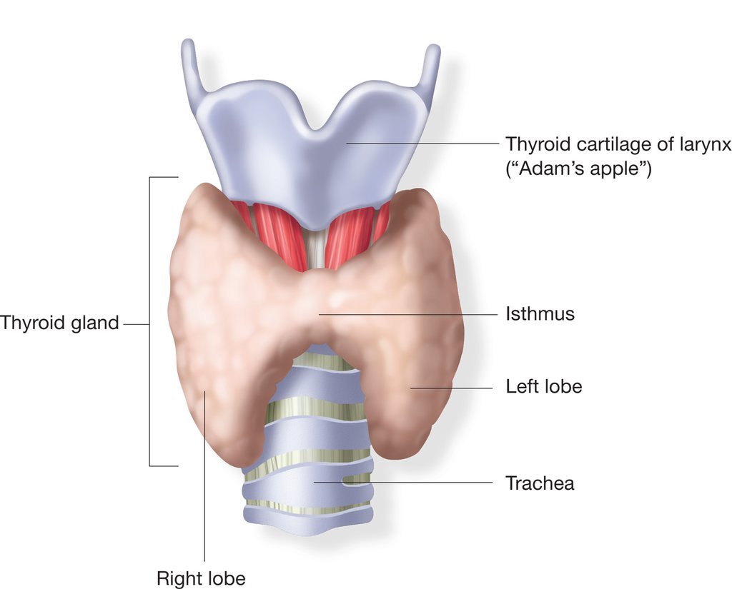

T3 and T4 play a crucial role in maintaining the body's metabolism. They regulate the rate at which cells use energy, influence protein synthesis, and help regulate body temperature. They are also involved in the growth and development of tissues, especially in children.
Thyroid disorders can occur when the thyroid gland produces either too much or too little hormone.
Some common thyroid disorders:
Hyperthyroidism: A condition where the thyroid gland produces an excess amount of thyroid hormones. Symptoms may include weight loss, rapid heartbeat, irritability, anxiety, and difficulty sleeping.
Hypothyroidism: A condition where the thyroid gland does not produce enough thyroid hormones. Symptoms may include fatigue, weight gain, depression, cold intolerance, and dry skin.
Goiter: Enlargement of the thyroid gland, usually caused by iodine deficiency or certain autoimmune conditions.
Thyroid nodules: Abnormal growths or lumps in the thyroid gland. Most nodules are benign, but some can be cancerous.
Pancreas
The pancreas is a glandular organ located in the abdomen, specifically in the upper left side. It plays an important role in the digestive and endocrine systems.
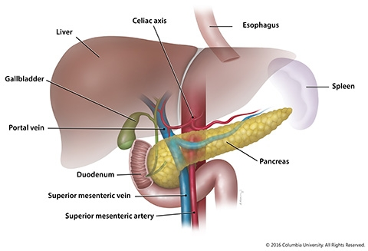

Exocrine Function: The pancreas produces digestive enzymes that help break down carbohydrates, proteins, and fats in the small intestine. These enzymes, including amylase, lipase, and proteases, are released into the pancreatic ducts and eventually reach the small intestine via the common bile duct.
Endocrine Function: The pancreas contains clusters of cells called pancreatic islets or islets of Langerhans, which are responsible for the production and secretion of hormones. These hormones include insulin, glucagon, somatostatin, and pancreatic polypeptide.
Insulin: Produced by beta cells, insulin plays a crucial role in regulating blood sugar levels. It facilitates the uptake of glucose by cells, which helps lower blood sugar levels.
Glucagon: Produced by alpha cells, glucagon acts opposite to insulin by increasing blood sugar levels. It stimulates the liver to convert stored glycogen into glucose, which is released into the bloodstream.
Somatostatin: Produced by delta cells, somatostatin inhibits the release of insulin and glucagon, regulating their balance.
Pancreatic Polypeptide: Produced by F cells, pancreatic polypeptide helps regulate pancreatic secretions and digestive processes.
Imbalances in the production or functioning of these hormones can lead to various conditions. For example, a deficiency of insulin leads to diabetes mellitus, while excess insulin production can cause hypoglycemia.
Adrenal glands

The adrenal glands are small, triangular-shaped glands located on top of each kidney. They are part of the endocrine system and play a crucial role in hormone production and regulation within the body. Each adrenal gland is composed of two distinct parts: the adrenal cortex and the adrenal medulla.
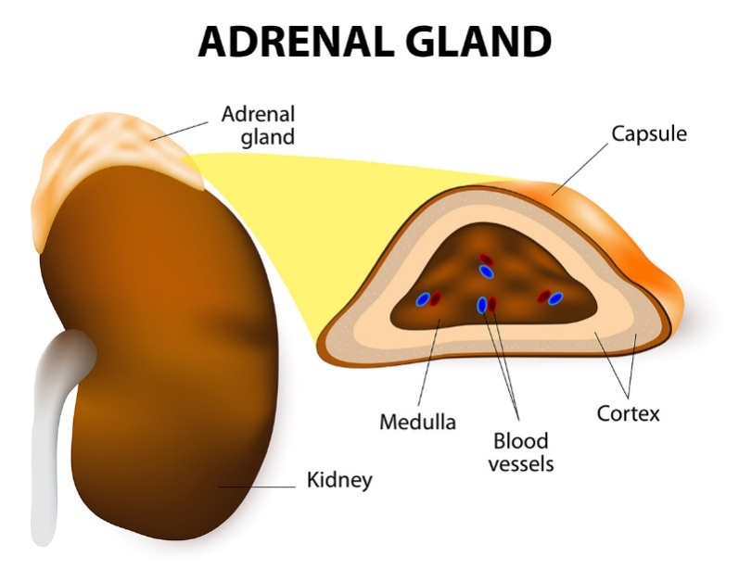

Adrenal Cortex: The outer layer of the adrenal gland is known as the adrenal cortex. It produces several essential hormones, including:
Cortisol: Also known as the "stress hormone," cortisol helps regulate metabolism, immune responses, and the body's response to stress.
Aldosterone: This hormone helps regulate blood pressure and electrolyte balance by controlling the reabsorption of sodium and the excretion of potassium in the kidneys.
Androgens: The adrenal cortex also produces small amounts of male sex hormones (androgens) such as dehydroepiandrosterone (DHEA) and androstenedione.
Adrenal Medulla: The inner part of the adrenal gland is called the adrenal medulla. It is responsible for the production and release of two main hormones:
Epinephrine (adrenaline): This hormone is involved in the body's "fight-or-flight" response, which prepares the body for intense physical activity or stress. It increases heart rate, blood pressure, and energy availability.
Norepinephrine (noradrenaline): Similar to epinephrine, norepinephrine also plays a role in the body's stress response, but it has a more pronounced effect on blood vessel constriction, leading to increased blood pressure.
Conclusion
Hormones are essential chemical messengers that coordinate and regulate numerous physiological processes in living organisms. Their classification, mechanisms of action and interactions within the endocrine system are critical for maintaining homeostasis and overall well-being. Further research in the field of endocrinology is necessary to uncover the complexities of hormone signaling and its implications for human health and disease.

