Nanotechnology in water purification and treatment: current outlook and future perspectives
Fatima Saeed ª, Sridhar Sunder Gopal ª, Nivedita Sahu ª *
a. Membrane separations laboratory, Indian Institute of Chemical Technology
Tarnaka-500007, CSIR-Hyderabad, India
Introduction
The rapid climate change and exponentially increasing population pose serious challenges to fulfilling global water needs. The world’s population is expected to reach 6.4 billion by 2050, which requires growth for water production and availability by then to meet human requirements. Agricultural requirements for freshwater account for 70 % of available water usage [1]. Every year around 65 billion freshwater is consumed to achieve human needs. This presents an urgent need to develop novel techniques for wastewater treatment and water production. Industrialization in all the developed and developing countries is discharging several pollutants like heavy metals, microplastics, pathogens, dyes, organic and inorganic compounds into freshwater bodies [2]. The stringent norms for water discharge to control emerging contaminants enable us to look into new ways for wastewater treatment. The development of nanomaterials for water treatment may help to resolve the global challenges of marine pollution [3].
Various hazardous materials are entering into water bodies due to the global industrial revolution. Several industries including textile, leather, electronics, metal finishing, etc. are discharging large quantities of heavy metals on a continuous basis. The removal of heavy metals is essential as they can enter into the bodies of land and marine animals accumulate and lead to death [4]. Some metals like copper and zinc are essential for the human body but can be dangerous if present in excess amounts. They also disturb the ecosystem and natural cycle of the environment. Therefore, there is an urgent need to remove the heavy metals and prevent its negative impacts on the environment and human health. Recently, various techniques have been developed for the treatment of heavy metals. They include electrochemical treatment, ion exchange, chemical precipitation, coagulation, adsorption, membrane filtration, and reverse osmosis etc [13]. Among the mentioned processes adsorption is the most common method due to its low cost and easy operation and availability/regeneration of various adsorbents. Despite all the benefits it is difficult to operate on a commercial scale.
To overcome the limitations of conventional techniques nanotechnology presents one of the innovative areas to reduce water pollution and its reclamation. Besides, existing technologies give higher efficiencies and lower inputs. Various nanomaterials like nano-membranes, nano-metals, and nano-adsorbents are available along with nano-catalysts. This technique provides economic and sustainable use of the resources to overcome the limitations posed by existing treatment technologies [14]. The nano-materials have sizes between 1-100 nm with diverse size-based characteristics due to their higher surface area. They offer features like more reactivity, strong sorption, rapid dissolution, quantum effect, super-magnetism, and par magnetism, etc. the developed nano-sized materials can be used as membranes, catalysts, coatings, reagents, coatings, and adsorbents. For the nano-based substances, the area/size ratio is very high, due to which they can be employed to improve the existing properties of the materials [15]. The advanced treatment systems employ nanomaterials to remove heavy metals, organic contaminants, and dissolved gases, along with different pathogens. This technique presents new ways to make water treatments pave new heights with the development of advanced next-generation systems.
In this chapter, the properties of nanomaterials for water treatment and production are discussed. The advantages and impacts of using these materials in this field are reported. Nanomaterial classification and its various uses are well discussed. The removal strategies of heavy metals and future directions are also discussed in this chapter.
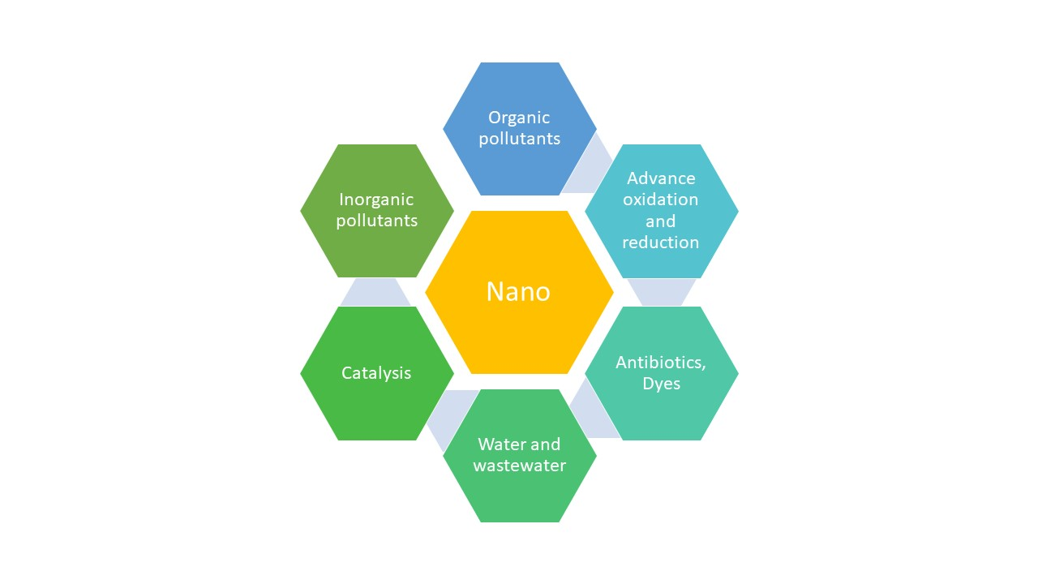
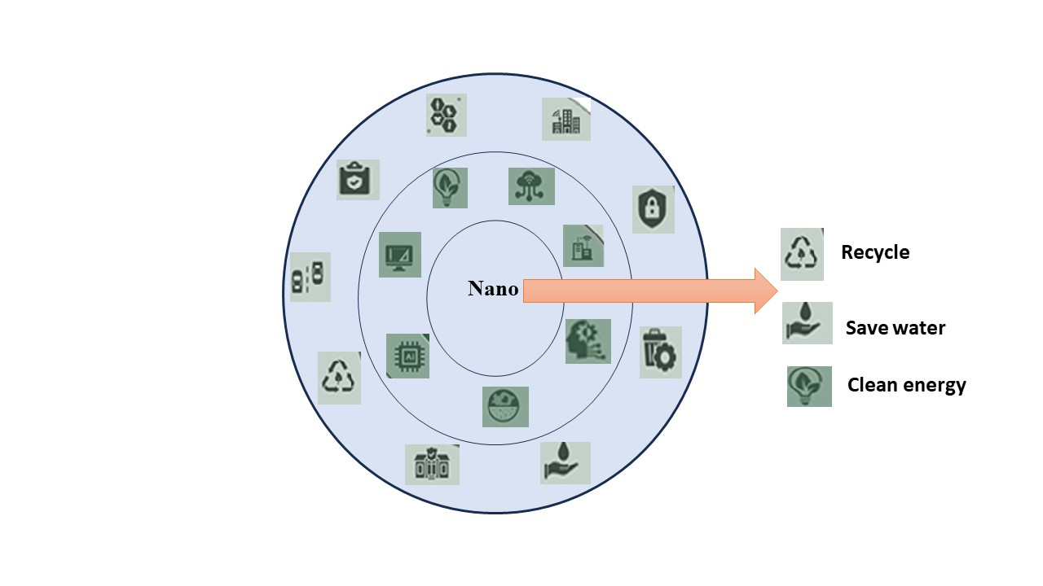

Different types of nanomaterials
Nanometals and metal oxides
The metal oxides are promising alternatives to activated carbon for heavy metal removal from wastewater. The size is small which reduces the diffusion distance and makes them compressible without reducing the surface area. Usually, nano-metals and nano-metal oxides are compressed into porous pellets or used in powders for industrial use. Some of the commonly used metal oxides include FexOy, Al₂O₃, TiO₂, MgO, MnO₂, CeO₂ etc. They have higher levels of reactivity due to the quantization effect and unsaturated metal surface that provides higher active sites for metal binding.
Nanozerovalent iron
Nano-iron with zero valency is one of the most promising materials for adsorption. It has higher reduction potential, good mobility with excellent reactivity and adsorption performance. It can be synthesized by chemical and physical processes like lithography, grinding, and abrasion. Chemical reactions such as hydrogen-molten metal reaction, gas phase thermal decomposition, and reduction of gas-metal can all be used to create it. Due to its ease of usage, it is most frequently synthesized through chemical reduction, and the product obtained has a uniform structure and strong reactivity.
Iron oxides
The nano-sized iron oxides include goethite (α-FeOOH), Haematite (α-Fe₂O₃), maghemite (ϒ-Fe₂O₃), and magnetite (Fe₃O₄). Nano iron oxide like goethite can be used for heavy metals like arsenate, cadmium, cobalt, mercury, chromium, lead, tin, and zinc removal from wastewater [24]. Some researchers studied the performance of goethite for arsenate removal and observed that it is getting adsorbed on iron oxide surface through binuclear complex formation. Also, some researchers employed goethite for As(V) removal with good adsorption performance at neutral pH. It was found that the surface hydroxyl groups are responsible for arsenate removal at acidic pH while at neutral pH electrostatic attraction plays a key role for metal ion removal [25]. The goethite presents good arsenic adsorption capacity which can be improved by adding biodegradable polymeric functional groups.
Magnetite (Fe₃O₄)
This iron-based nanoparticle has higher adsorption characteristics for metal removal of Hg(II), Cu(II), Cr(VI), As(V), Ni(II), Sb(V), and V(V). Due to its magnetic character, it can be easily separated from aqueous solution by applying an external magnetic field. They can be synthesized by hydrothermal or solvothermal methods. Apart from easy synthesis and separation, they have the capability to agglomerate in aqueous systems that reduce their specific surface area and adsorption capacity. Also, they are not stable under acidic conditions so chemical modifications are needed to use them in strong acidic environments. Functional groups like amines, and silanes, can be added to its surface to improve its adsorption capacity under extremely acidic conditions. By adding polymer groups to Fe₃O₄ they can remove Cr (VII) ions by electrostatic interactions.
Aluminium oxide (Al₂O₃)
Al₂O₃ can effectively remove heavy metals like Zn(II), Ni(II), Cr(VI), Cd(II), and Pb(II). Nano-alumina can be used in even harsh chemical environments as it has excellent chemical resistance and regeneration capability [22]. Smaller-sized alumina particles have higher adsorption capacities for Cr (VI). It can also be reduced to Cr (II) and Cr(III), by binding with active sites on the alumina surface. The adsorption capacity of alumina nanoparticles is not altered by the presence of other foreign species in water. However, for groundwater the adsorption capacity is significantly reduced due to the presence of other contaminants. They have regeneration capacities of around 91 % when treated with sodium hydroxide [23].
Silica (SiO₂)
Silica is available in different pore sizes and has a unique shape, large surface area and well-defined pore size. Due to the presence of a large number of hydroxyl groups on its surface, it can be functionalized with silane modifiers to improve its adsorption capacity. It has excellent acid and alkali resistance and many nitrogen-containing functional groups can be added like polyaniline and polypyrrole [16]. Different organic and inorganic functional groups can be conjugated with hydroxyl groups of silica through vander waals forces, hydrogen bonding, and reversible covalent bondings. Also, the functional groups can be combined with heavy metal ions to form a coordination structure [17]. Metals like Pb(II), Cd(II), As(III), Fe(II), and Mn(II) can be removed from drinking water solutions by silica nanoparticles.
Titanium dioxide (TiO₂)
Titanium dioxide being photocatalytic in nature has greater advantages for wastewater remediation. It has low cost and higher chemical stability. Similarly, it has more lifetime compared to other nanomaterials [18]. It can be successfully employed as a disinfectant by activating it under UV rays. Titanium-based nanowires were successfully employed to remove heavy metals like Pb²⁺, Cu²⁺, Fe³⁺, Cd²⁺ and Zn²⁺ from contaminated water with an adsorption efficiency of 97 %. Therefore it can be successfully employed in water filters as a promising alternative for water purification [19]. Apart from this, they have excellent electrical and optical properties and can be employed in coatings, anticorrosives, solar cells etc.
Metal-organic frameworks (MOFs)
These are nano-porous organic-inorganic materials with topological structures in 1D, 2D and 3D. The unique structure is formed by connecting metal clusters with organic ligands. MOFs present one of the leading and promising classes of nanomaterials at present. They have superior applications in gas sensing, liquid separations, gas storage, drug delivery, catalysis, along wastewater treatment [26]. They have unique features of high crystallinity, large porosity and specific surface area which is very high compared to other porous materials. The structure of MOFs is highly flexible and it can be adjusted due to bridging ligands and coordination bonds. Their structures can be reversed or deformed due to the existence of several sigma-bonds. Compared to traditional porous materials like molecular sieves, MOFs are highly flexible. This feature imparts peculiar physiochemical properties with great adsorption/desorption characteristics [27]. The unique feature of reversibility, makes them change their structure through functionalized chemical modification.
ZIFs are a class of MOFs that have emerged as excellent adsorbent materials within the past three decades. They have three-dimensional lattices with metal ions and organic linkers that contain tetrahedral Zn^{II} atoms linked by imidazolate ligands. A large variety of zeolite-like structures can be obtained by modification of the ligands. ZIFs offer high hydrothermal, chemical, and thermal stabilities. Their 3D framework offers accessibility and diffusion of contaminants through the structure. They have the great advantage of modifying their pore size and shape by changing the linkers and metal ions connectivity. To combat the limitations of inorganic membranes they are the building blocks for membrane preparation with high efficiency for water treatment applications [28]. They are used as fillers in mixed matrix membranes due to their hybrid metal-organic nature, allowing the organic ligands to couple with polymers and increase the affinity between the fillers and the polymer matrix. The pore of the ZIFs in MMMs serves as preferential channels for target molecules to obtain high selectivity. They can also improve the permeation properties by regulating the polymer chain packing and enlarging the free volume of the matrix.
Nano adsorbents
Various metal oxides can be used as low-cost adsorbents for heavy metal removals along radionuclides. Some of the nano adsorbent includes carbon-nanotubes-based nano adsorbent, metal oxide nano adsorbent, polymer nano adsorbent, and zeolites. The oxygen metal present in metal oxides like titanium dioxide, iron oxide and alumina is responsible for metal sorption [11]. The nano-sized adsorbents allow fast adsorption of metal ions along with intraparticle diffusion along the micropore walls. It allows faster kinetics because of a higher specific surface area, more number of adsorption sites and shorter diffusion rates. Various heavy metals like arsenic, lead, mercury, copper, cadmium, chromium, and nickel can be used using titanium dioxide nanoparticles [12]. They also have the unique feature of switching to higher valency, lower valency and zero valency. Hexavalent chromium ions can also be removed by some iron-based nanoparticles along with arsenic and lead at acidic pH from water pH. Some nanorods-based magnetic adsorbents can also be used for heavy metal removal as they have good adsorption capacities. Mercury can be removed by super-magnetic nanoparticles with faster and more selective adsorption. Iron-based materials like nano-haematite can remove lead, zinc and cadmium from water. These nano adsorbents offer the advantages of higher adsorption capacities along with limitations of higher toxicity, production cost, bulk volume production handling etc.
Carbon nanotubes (CNT) nano adsorbent
These are the carbon allotropes with cylindrical nano-pores. They are present either as single-walled or multi-walled nanotubes. They have the unique feature of higher active adsorption sites with adjustable surface chemistry and antimicrobial properties. They can be effectively used for the adsorption of emerging contaminants as well as the detection of contaminants [20]. The electrostatic attraction or chemical bonding is responsible for their adsorption. To overcome the disadvantages of ozonation and chlorination without any byproducts this process can be used. They can be simply regenerated through appropriate adjustments of operating conditions, like pH shift. Recently, CNTs were transformed into sponges with a dash of boron that can be used effectively for oil-water separation. If it is scaled up it can be used to remove oil from oil spills. They can be transformed into oxidized CNTs, molecule-modified CNTs, metal-oxide-modified CNTs, and polymer-modified CNTs [21]. Due to their higher production costs, they are still not employed on an industrial scale for municipal water and wastewater treatment. But some effluent like pharma needs smaller quantities of CNTs for the removal of antibiotics and pharmaceuticals from wastewater.
Polymeric nano adsorbent
Dendrimers are a class of polymeric adsorbents that are used for heavy metal removal. The interior hydrophobic shells can adsorb organic compounds and the exterior branches can adsorb the heavy metals. Metals like copper can be removed by using these adsorbents in an ultrafiltration system. The adsorbent can be regenerated easily by a small pH change. Textile water dyes can also be removed by these adsorbents based on chitosan-dendrimer nanostructure. They have the advantages of nontoxicity, biodegradability and biocompatibility.
Water treatment by nanomaterials
Major challenges in water treatment and reclamation include the removal of micro-pollutants, organic dyes, heavy metal uptake, brackish water etc. New water treatment membrane includes MOF-based membranes. They provide various interaction paths along with strong mechanical and chemical strength. They can be synthesized by continuous growth of MOF layers on a polymer substrate [4]. They have excellent controllable porosity, that imparts good permeability and makes them potential candidates for practical water treatment applications. For large-scale, industrial applications the nanoparticle can be formulated into a packed bed to reduce the pressure drop and equipment size or it can be immobilized on an inert carrier. Some researchers have used lithium-ion imprinted adsorbents as short beds to remove lithium from wastewater. They recovered lithium with 98 % purity by using different series-parallel combinations [5]. This technology does not rely on larger infrastructure for wastewater treatment. They have low economic utilization of available water resources and great advantage of increasing water supply.
Membrane separation technology can be employed for water treatment with nanoparticle addition. It represents a greener technology due to its operational simplicity, low area requirements, environmental protection, energy conservation, and higher separation efficiency [6]. The nanoparticles can be embedded into membranes to improve their rejection efficiencies. Some expensive materials like gold, silver, palladium, and ruthenium can be immobilized on the membrane surface and applied for heavy metal removal with greater efficiency. Several nanoparticles like silica, zirconia can be embedded into membrane structures to improve their properties [7]. Nanoparticles can increase the performances of membranes such as permeability, mechanical strength, and so on. Also, the addition of inorganic oxide nanoparticles causes an increase in tensile strength to some extent. Some researchers employed zeolite nanoparticles in polysulfone polymer and removed nickel, and lead ions from water solutions [8].
Membrane techniques like ultrafiltration, nanofiltration can be employed for wastewater remediation with photocatalytic membranes. Materials like titanium dioxide and zinc oxide can be used for such operations. The organic pollutants can be reduced along with heavy metal removal [9]. The nanoparticles have strong oxidative free radicals that can destroy pollutants present in wastewater. The poor reusability of adsorbents can be overcome by membranes that use nanoparticles in immobilized form [10]. The removal of heavy metals from water is a one-step process using membranes without any use of harsh chemicals. The combination of polmer+nanomaterial provides higher adsorption sites along with greater water permeability. Photocatalytic materials like graphitic carbon nitride, graphene quantum dots and titanium dioxide can be used in membranes for simultaneous photocatalysis and membrane filtration.
Future scope and limitations
The nanomaterials are of great value in water treatment applications. Apart from several advantages, there are some limitations to using the materials which include the aggregation of material in the membrane, susceptibility to pathogens and bacteria for real-time applications, immature production methods, uncertain life cycle etc. also, the synthesis of MOFs with controllable shape/size is relatively complex that requires many efforts to develop for industrial applications. Nanotechnology can be very useful for developing countries, which are more prone to water quality degradation regularly. It represents one of the innovative areas to develop and maintain water quality standards. Nanotechnology-based water monitoring, treatment and recycling can be opted for in the near future. However, the loading of nanoparticles onto polymeric membranes has some drawbacks of aggregation and poor dispersion. However, the search continues for membranes with low cost, high reusability, greater selectivity and higher metal ion rejection. Researchers are exploring the possibility of incorporating various types of nanomaterials in a bid to impart the unique characteristics of nanomaterials into membranes. Porous nanomaterials like MOFs can be employed to overcome the problems of pressured drop and leakage along with regeneration.
Nanotechnology can be combined easily with conventional technologies and it holds a huge potential to be developed as a water treatment tool in the near future. It needs still more work done for the complete removal of heavy metal ions from wastewater. Many studies can be done on the development of these nanomaterials for target pollutants. To employ these materials commercially in water treatment it needs lower cost and more reusability. The nanomaterial-based membrane possesses good potential to be used on a commercial scale. Besides, several issues on the uses and toxicity of nanomaterials on the environment and human beings have also started. Subsequently, the stability, antifouling, dispersibility and compatibility of the nanomaterials can be widely studied. Further research can be focused on the use of these materials for large-scale commercial applications. With these limitations, new research should be focused on the use of nanomaterials along with their reuse and biodegradation capability.
Acknowledgement
The author would like to thank KIIMS, CSIR-IICT for providing the manuscript no. ICT….
References:
- Gehrke I, Geiser A, Somborn-Schulz A. Innovations in nanotechnology for water treatment. Nanotechnology, science and applications. 2015 Jan 6:1-7.
- Liu L, Luo XB, Ding L, Luo SL. Application of nanotechnology in the removal of heavy metal from water. InNanomaterials for the removal of pollutants and resource reutilization 2019 Jan 1 (pp. 83-147). Elsevier.
- Subramaniam MN, Goh PS, Lau WJ, Ismail AF. The roles of nanomaterials in conventional and emerging technologies for heavy metal removal: A state-of-the-art review. Nanomaterials. 2019 Apr 17;9(4):625.
- Khan NA, Khan SU, Ahmed S, Farooqi IH, Dhingra A, Hussain A, Changani F. Applications of nanotechnology in water and wastewater treatment: A review. Asian Journal of Water, Environment and Pollution. 2019 Jan 1;16(4):81-6.
- Qu X, Alvarez PJ, Li Q. Applications of nanotechnology in water and wastewater treatment. Water research. 2013 Aug 1;47(12):3931-46.
- Zhu J, Hou J, Zhang Y, Tian M, He T, Liu J, Chen V. Polymeric antimicrobial membranes enabled by nanomaterials for water treatment. Journal of membrane science. 2018 Mar 15;550:173-97.
- Shahrin S, Lau WJ, Kartohardjono S, Gohari RJ, Goh PS, Jaafar J, Ismail AF. Development of adsorptive ultrafiltration membranes for heavy metal removal. InAdvanced Nanomaterials for Membrane Synthesis and its Applications 2019 Jan 1 (pp. 1-22). Elsevier.
- Ahmed SF, Mofijur M, Ahmed B, Mehnaz T, Mehejabin F, Maliat D, Hoang AT, Shafiullah GM. Nanomaterials as a sustainable choice for treating wastewater. Environmental Research. 2022 Nov 1;214:113807.
- Kumari P, Alam M, Siddiqi WA. Usage of nanoparticles as adsorbents for waste water treatment: an emerging trend. Sustainable Materials and Technologies. 2019 Dec 1;22:e00128.
- Khan SH. Green nanotechnology for the environment and sustainable development. Green materials for wastewater treatment. 2020:13-46.
- Sharma M, Singh J, Hazra S, Basu S. Adsorption of heavy metal ions by mesoporous ZnO and TiO2@ ZnO monoliths: adsorption and kinetic studies. Microchemical journal. 2019 Mar 1;145:105-12.

- Aprianti, T.; Miskah, S.; Selpiana; Komala, R.; Hatina, S. Heavy metal ions adsorption from pulp and paper industry wastewater using zeolite/activated carbon-ceramic composite adsorbent. AIP Conf. Proc. 2018, 2014, 020127.
- Saikia J, Gogoi A, Baruah S. Nanotechnology for water remediation. Environmental Nanotechnology: Volume 2. 2019:195-211.
- Al-Rashdi, B.A.M.; Johnson, D.J.; Hilal, N. Removal of heavy metal ions by nanofiltration. Desalination 2013, 315, 2–17.
- Attia, H.; Johnson, D.J.; Wright, C.J.; Hilal, N. Comparison between dual-layer (superhydrophobic–hydrophobic) and single superhydrophobic layer electrospun membranes for heavy metal recovery by air-gap membrane distillation. Desalination 2018, 439, 31–45
- Seaf El-Nasr TA, Gomaa H, Emran MY, Motawea MM, Ismail AR. Recycling of nanosilica from agricultural, electronic, and industrial wastes for wastewater treatment. Waste recycling technologies for nanomaterials manufacturing. 2021:325-62.
- Salami BA, Oyehan TA, Gambo Y, Badmus SO, Tanimu G, Adamu S, Lateef SA, Saleh TA. Technological trends in nanosilica synthesis and utilization in advanced treatment of water and wastewater. Environmental Science and Pollution Research. 2022 Jun;29(28):42560-600.
- Kanakaraju D, Glass BD, Oelgemöller M. Titanium dioxide photocatalysis for pharmaceutical wastewater treatment. Environmental chemistry letters. 2014 Mar;12:27-47.
- Li FB, Li XZ. Photocatalytic properties of gold/gold ion-modified titanium dioxide for wastewater treatment. Applied Catalysis A: General. 2002 Mar 28;228(1-2):15-27.
- Li YH, Zhao YM, Hu WB, Ahmad I, Zhu YQ, Peng XJ, Luan ZK. Carbon nanotubes-the promising adsorbent in wastewater treatment. InJournal of Physics: Conference Series 2007 Mar 1 (Vol. 61, No. 1, p. 698). IOP Publishing.
- Li M, Jia X, Wang L, Gao G, Feng X, Li C. Research on Modified Carbon Nanotubes in Wastewater Treatment. Catalysts. 2022 Sep 24;12(10):1103.
- Islam MA, Morton DW, Johnson BB, Pramanik BK, Mainali B, Angove MJ. Metal ion and contaminant sorption onto aluminium oxide-based materials: A review and future research. Journal of environmental chemical engineering. 2018 Dec 1;6(6):6853-69.
- Holmes AB, Gu FX. Emerging nanomaterials for the application of selenium removal for wastewater treatment. Environmental Science: Nano. 2016;3(5):982-96.
- Chen Z, Wang X, Ge Q, Guo G. Iron oxide red wastewater treatment and recycling of iron-containing sludge. Journal of Cleaner Production. 2015 Jan 15;87:558-66.
- Nassar NN. Iron oxide nanoadsorbents for removal of various pollutants from wastewater: an overview. Application of adsorbents for water pollution control. 2012 Nov 11:81-118.
- Abbasi Z, Cseri L, Zhang X, Ladewig BP, Wang H. Metal–organic frameworks (MOFs) and MOF-derived porous carbon materials for sustainable adsorptive wastewater treatment. InSustainable Nanoscale Engineering 2020 Jan 1 (pp. 163-194). Elsevier.
- Abdi J, Abedini H. MOF-based polymeric nanocomposite beads as an efficient adsorbent for wastewater treatment in batch and continuous systems: Modelling and experiment. Chemical Engineering Journal. 2020 Nov 15;400:125862.
- Bhattacharya S, Bala S, Mondal R. Design of chiral Co (II)-MOFs and their application in environmental remediation and waste water treatment. RSC advances. 2016;6(30):25149-58.
- Saikia J, Gogoi A, Baruah S. Nanotechnology for water remediation. Environmental Nanotechnology: Volume 2. 2019:195-211.
- Hasham A. Selected nanotechnology applications in industrial waste water treatment: a review. International Journal of Environmental Pollution and Environmental Modelling. 2018 Feb 7;1(3):71-6.

