UNDERWEIGHT
Miss.M Neeti Harshitha, Lecturer, capital degree and Pg college, Shapur nagar,chintal
MEANING:
Being underweight implies that you are below the healthy weight range the weight that science has revealed you need to be in order for your body to function normally. Falling outside of this range, whether overweight or underweight, can have major consequences for your health.

SIGNS AND SYMPTOMS :
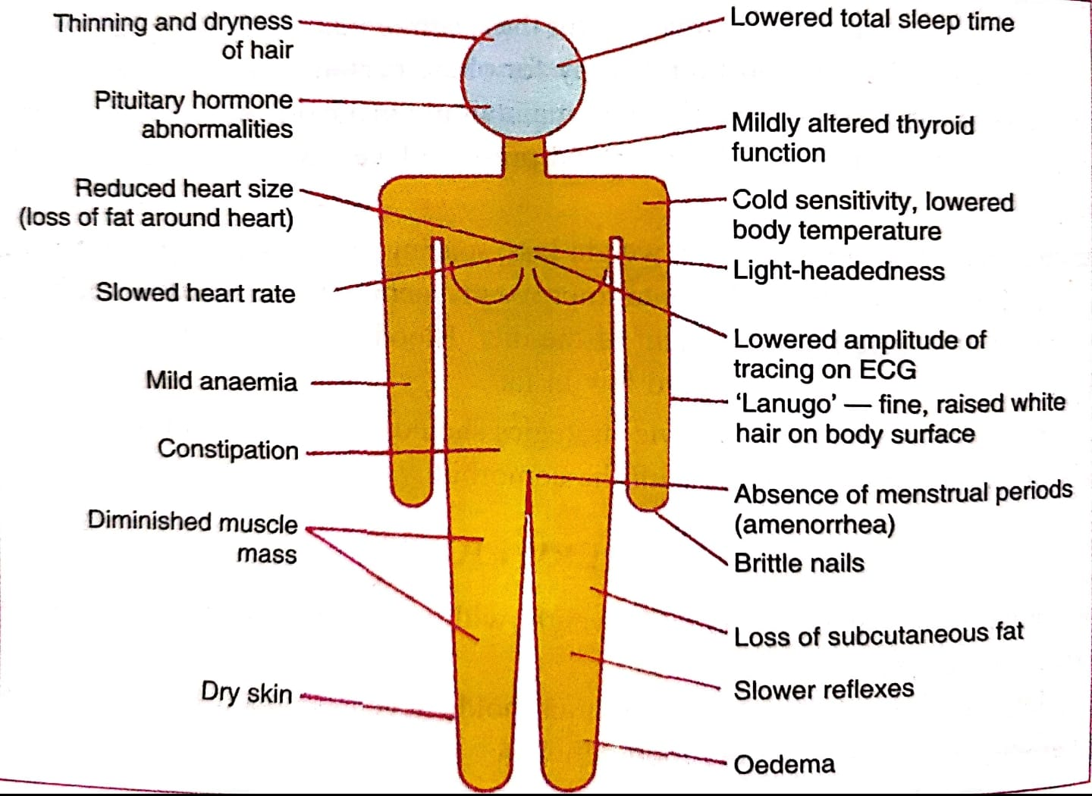
AETIOLOGY
Underweight has a number of reasons, including:
Starvation can result from famine,
A diet lacking in enough proteins, or
An effort to lose weight.
Fatty tissue is destroyed during famine, and the skeletal, cardiac, and small intestinal muscles atrophic, losing their ability to absorb nutrients.
Low blood pressure, pronounced emaciation, hair loss, and inelastic skin are the effects of this.
Since the feeding and unhealthy initially, glucose water, fruit juice, and skim milk powder may be administered as part of a progressive regimen.
Debilitating conditions including cancer, diabetes, malabsorption syndrome, and tb can also cause underweight. For them, infections are frequent. In these circumstances, tonics are ineffective since they only work to enhance hunger and not weight. Spending money on nutritious, high-calorie foods is prudent and required.
Eating extremely little food may be influenced by psychological variables (anorexia nervosa). Some mentally ill people refuse to eat, which causes drastic weight loss. Girls between the ages of 15 and 25 are most commonly affected by anorexia nervosa.
Those who are busy, agitated, nervous, and who never relax have underweight. As it becomes severe, psychological effectiveness as a whole is decreased, and their ability to focus, make decisions, and withstand disasters is very weak. Poor working efficiency results in lower production. He is not able to work nonstop for very long.
It happens under pathological circumstances including fevers, gastrointestinal problems, when the capacity for digestion and absorption is reduced, and in hyperthyroidism.
Being underweight might be a sign of a more serious underlying disease, in which case it is considered secondary. Unexplained weight loss may necessitate a physician's expert medical diagnosis.
In certain cases, being underweight is the major cause of other illnesses. Those who are very underweight may have limited physical stamina and a weakened immune system, leaving them vulnerable to illness. "underweight status... And micronutrient deficiencies also cause decreases in immune and non-immune host defences, and should be classified as underlying causes of death if followed by infectious diseases that are the terminal associated causes," writes Robert e. Black of the johns Hopkins School of public health (jhsph).
Category | Bmi (kg/m2)
Underweight (severe) | 16.0
Underweight (moderate) | 16.0- 16.9
Underweight (mild) | 17.0-18.4
Normal | 18.5-24.9
LIMITATIONS OF UNDERWEIGHT
Individuals with a BMI of less than 18.5 have a lower vo, max, ability for prolonged strenuous labor, and productivity.
Pregnant mothers who are underweight run a higher chance of having underweight children.
When bmi values are below 17 in both men and women, progressively higher percentages of time are lost from work or spent unwell in bed.
The death rate increases gradually and curvilinearly in a group of males with bmis between 18.5 and less than 16.0.
Immunological deficiencies are more prevalent in males who have low bmis and concurrent
There are deficits in micronutrients. Children that are malnourished are smaller and lighter.
In females who are malnourished, the age of menarche is postponed by around one to two years.
EFFECT OF UNDERWEIGHT INFANTS
HOW IS A CHILD'S BMI DETERMINED?
Your physician will measure your child's height and weight when they are wearing no shoes or heavy clothing, and then calculate BMI using the following formula:
THE FORMULA FOR BODY MASS INDEX
1. Multiply their weight in pounds by 703 184 × 703 = (a) 129,352
2. Multiply their height (in inches) by two 69 × 69 = (b) 4,761
3. Divide (a) by (b) 129,352 ÷ 4,761 = 27.2 (BMI score) (BMI score)
WHAT ARE BMI PERCENTILE GROUPS?
The labels underweight, healthy weight, overweight, and obese are used to characterize your child's BMI on the BMI curve. Remember that these terms do not characterize your child.
If the kid or adolescent falls into a high-risk category, such as being underweight, overweight, or obese, your physician may inquire further about their medical history. They may also conduct blood testing and other examinations to rule out any potential health issues.
Category | Bmi percentile range
Underweight | Less than the 5th percentile
Healthy weight | 5th to 84th
Overweight | 85th to 94th
Obesity | Above 95th
What is the meaning of your child's bmi percentile?

Paediatricians’ utilize both the BMI number and the percentile to determine which group a kid belongs to. The BMI percentile ranges and weight status categories are as follows:
Children should ideally fall between the 5th and 85th percentiles. Percentiles outside of this range can put children at risk of health concerns.
Children below the fifth percentile may have a nutritional deficit—either not obtaining enough calories or burning more calories than they are getting, or both. Similarly, children over the 85th percentile may have issues with how their bodies balance energy intake and production. This might be due to a number of causes, including diet, the way their bodies handle calories or other bodily processes, a lack of physical exercise, or a combination of these.
WHAT IS SLOW WEIGHT GAIN?
Delayed weight gain is sometimes known as "failure to thrive." it is not an illness in and of itself, but rather the result of a number of medical, social, and environmental conditions that prevent a kid from obtaining the calories required for proper growth.
A baby's weight typically doubles throughout the first 4 to 6 months of life and triples within the first year. A baby born weighing six pounds, for example, would generally weigh around 12 pounds by 6 months of age and about 18 pounds by the age of one.
Modest weight growth isn't necessarily a cause for concern. Some newborns and youngsters are just smaller than the majority of their peers their age. Yet, between 1% and 10% of children are affected.
When does slow weight gain become an issue?
Slow weight gain is an issue when it interferes with a child's healthy development, especially during their first year of life when their brain is growing.

SLOW WEIGHT GROWTH MAY BE AN ISSUE IF:
- If the child does not regain his or her birth weight within 10 to 14 days of delivery,
- The kid gains less than an ounce every day until he or she is three months old.
- Between the ages of 3 and 6 months, the infant should gain no more than 0.67 ounces every day.
- A child of any age has been developing steadily and then stops.
- Although delayed weight gain should always be discussed with the child’s doctor, it is less of a concern when:
- A newborn wakes up on their own and wants to feed 8 to 12 times a day
- A baby is growing at a steady rate
- A baby has about the same number of wet and dirty diapers as other babies
HOW TO HANDLE SLOWER WEIGHT GAIN?
The growth and nutrition program at boston children's hospital is a multidisciplinary program comprised of doctors, nurses, nutritionists, social workers, behavioural experts, and speech therapists who will collaborate to find the causes and solutions for your child's sluggish weight gain. We collaborate with parents, primary care doctors, and other hospital personnel to build a customized long-term treatment plan for each child and address the issues impacting their growth.
If your kid's height increase, rather than weight gain, is a major concern, we may recommend your child to the specialists at the department of endocrinology.
DELAYED WEIGHT GAIN IN BABIES AND CHILDREN
WHAT ARE THE SIGNS OF SLOW WEIGHT GAIN?
Size is one of the most visible signs of delayed weight gain: your child is substantially smaller than other youngsters his or her age. These may include their weight, height, and head size.
You may notice the following signs if your kid is not getting enough calories:
- They had lost interest in the world around them.
- Extreme drowsiness, frequent weeping and fussiness, and failure to meet physical milestones including rolling over, sitting up, and walking at the same time as other children their age
WHAT FACTORS CONTRIBUTE TO SLOW WEIGHT GAIN?
Slow weight growth can be caused by a variety of circumstances, ranging from a medical condition to social or financial difficulties. Anything that impedes a child's access to food or capacity to digest food will stunt their growth. It is frequently caused by a combination of causes.
MEDICAL REASONS:
- Premature delivery can make it difficult for your infant to eat until their suckling and swallowing muscles fully develop.
- Down syndrome can also make it difficult for a youngster to suck and swallow.
- Hypoglycemia, galactosemia, and phenylketonuria are examples of metabolic diseases that can impair the body's capacity to turn food into energy.
- An infant with cystic fibrosis may have difficulty absorbing calories.
- A food allergy or intolerance may restrict the foods that your kid can consume without becoming unwell.
- A child may vomit regularly as a result of gastroesophageal reflux.
- Anything that causes persistent diarrhea might deprive your infant of adequate nutrients.
CAUSES BOTH SOCIAL AND FINANCIAL:
Parents may not know how to properly mix formula or how frequently their newborn or toddler should consume it.
An infant may stop eating due to household stress caused by divorce, death, or another upheaval.
Poverty may make it difficult for parents to provide adequate meals for their children.
EFFECT OF UNDERWEIGHT IN CHILDREN
Children acquire weight and develop faster throughout infancy and childhood than at any other point in life. Some children, however, do not grow weight at a typical rate, either due to predicted genetic abnormalities, being born prematurely, or undernutrition, which can occur for a variety of causes. Undernutrition is sometimes known as a growth deficit, weight loss, or failing growth.
It is critical to identify and treat children who are not gaining weight regularly since this might be an indication of malnutrition or an underlying medical condition that needs to be treated. Undernutrition can lead to issues such as a weaker immune system, slower linear development, shorter height, or learning impairments.
Low weight gain is characterized as gaining weight more slowly than other children their age and gender. Weight "normal" ranges are based on the weights of thousands of youngsters. The centers for disease control and prevention (cdc) and the world health organization (who) provide standard growth charts for boys and females that are acceptable for all races and ethnicities.
CAUSES OF POOR WEIGHT GAIN
Low weight growth is a symptom of several probable reasons, rather than a disease. The following are some of the causes of poor weight gain:
Not getting enough nutritional energy (measured in calories) or
Not getting the correct balance of protein, fat, and carbs
Not absorbing a sufficient quantity of nutrients requiring a greater than usual quantity of nutritional energy (measured in calories)
DIAGNOSIS OF POOR WEIGHT GAIN
- If a newborn or child's weight gain slows or stops, it is critical to try to identify and address the underlying problem.
- The first step is to conduct a thorough medical history and physical examination.
- Most children will not require blood or imaging tests, however, testing may be advised in specific circumstances.
- If the kid has any of the following conditions, the caregiver(s) should mention them:
- Rumination, vomiting, or diarrhea (swallowing, regurgitating, then re-swallowing food).
- Avoids meals with specific textures (for example, hard or crunchy), which might indicate a chewing/swallowing issue or a food aversion. Avoids certain foods or food categories (for example, milk, and wheat), which may indicate a food allergy or intolerance.
- Drinks a lot of low-calorie beverages, such as low-fat milk or fruit juice. Consuming these beverages may hinder the toddler from eating more calorie-dense solid meals.
- Eats a lot of whole milk, which might cause iron deficiency anemia.
- Eats a limited diet (eg, vegetarian, lactose-free, wheat or gluten-free).
- Feeding limits imposed by oneself due to behavioral rigidity or sensory aversions.
- Caregivers should also explain whether they have removed foods from the child's diet owing to concerns about their impact (eg, abdominal pain, diarrhoea, "hyperactivity").

EFFECT OF UNDERWEIGHT ON ADOLESCENCE
Undernutrition is a global health problem that mostly affects children and adolescents in low- and middle-income nations (lmics). Undernutrition is caused by inadequate macronutrient and micronutrient intakes and presents itself in four ways: wasting underweight, growth stunting, and nutritional deficiencies.
According to world bank research, india has the most undernourished children in the world, which has far-reaching implications for childhood and adolescent morbidity and mortality, as well as the national economy.
According to research being undertaken in eight indian megacities among women with a special focus on slum-non-slum, being underweight was much higher in slum inhabitants, while being overweight was significantly greater in non-slum regions.
Adolescents (13-19 years old) account for one-quarter of the global population. This era of life is significant since it is during this period that teenagers experience fast growth and development, necessitating larger nutritional requirements.
Additionally, during this time, health and dietary behaviors are formed, making teenagers more sensitive to health and nutrition difficulties than other age groups.
More importantly, adolescent girls require sufficient quantities of high-quality nutritive foods to meet the additional nutritional needs associated with
- Maturation, menstruation, and participation in various physical activities as well as to reduce health risks and break the intergenerational cycle of malnutrition.
Some major indicators of underweight teenage females have been missed by researchers in recent studies,
- Sociodemographic socioeconomic factors,
- Parental education, occupation,
- Eating habits and food insecurity.
Being underweight is well acknowledged to be one of the primary public health issues among adolescents, particularly school-aged children in south east asian nations, as it affects health, cognition, and scholastic success.
Furthermore, it is widely understood that the poor health and nutritional welfare of adolescent girls can have far-reaching effects in terms of an intergenerational cycle of malnutrition, productivity, and economic losses.
EFFECT OF UNDERWEIGHT ON PREGNANT WOMEN
Most pregnant women with a low bmi have a healthy pregnancy and infant, although there is an increased risk of:
- Premature labor and delivery,
- Miscarriage (when the baby is born before they are fully developed)
- Foetal growth restriction difficulties with your baby's development that may impair their heart, diaphragm, or stomach if your baby has a low birth weight.
The midwife may provide you with further particular advice and assistance based on the reason for your low bmi. This is so they can effectively help you, depending on the cause.
They will learn that there are several causes for having a low bmi, including:
- Being naturally slender but healthy
- Having a medical explanation for your weight loss, such as an overactive thyroid or a gastrointestinal condition, such as inflammatory bowel disease or celiac disease.
- An eating disorder prevents you from eating enough. A good balanced diet should include roughly 2,000 calories per day.
- Loss of appetite, maybe related to despair, anxiety, or stress over-exercising
EATING PROBLEMS
When pregnant women have an unhealthy relationship with food, they have an eating disorder. This has the potential to take over your life and make you physically and psychologically unwell. If they have an eating problem or have had one in the past, gaining weight may be mentally challenging for the woman.
They should be a designated expert, often a doctor or a midwife, to assist you during your pregnancy and after you give birth.
PSYCHOLOGICAL WELL-BEING
Depression or any other mental health problem can have an impact on your weight. During pregnancy or the first year following childbirth, up to one in every five women has mental health difficulties. Anxiety, sadness, and low mood are all frequent. Yet, help is available.
EXERCISE
It is still necessary to remain active throughout pregnancy, but you should not exceed the suggested amount of 30 minutes, 5 times per week.
Pregnant women should keep in mind that exercise does not have to be difficult in order to help them manage their weight and stay healthy throughout pregnancy. Swimming, strolling, yoga, or pilates are all softer activities that are mostly preferred.
INSUFFICIENT FUNDS
If you don't have enough money for meals, talk to your midwife or doctor. They may be able to put you in touch with organizations that can assist you.
There are other applications, that connect you to stores that offer food at reduced prices as it approaches its expiration date. The apps may contain some unhealthy food, but keep an eye out for vegetable and fruit packs from supermarkets, as well as other healthy alternatives.
EFFECT OF UNDERWEIGHT ON LACTATING MOTHERS
Lactating moms are at a higher risk of malnutrition than the general population due to the additional calories and nutrients necessary to maintain nursing. Lactating moms who are malnourished have been proven to impact both the quantity and quality of breast milk, as well as the nutritional and health status of their children. According to many studies, undernutrition in lactating moms is a severe public health issue.
Several studies have found that an individual's nutritional status is direct/immediately changed by the quality and amount of their food intake, as well as their health condition/disease experience.
To investigate their relationship with undernutrition, three groups of factors were identified:
- Fundamental factors, underlying factors, and immediate factors. Multivariable logistic regression analysis revealed that
- Household income, food security, dietary diversity, frequency of meals, potable water/pipe water accessibility, and toilet use were significantly associated with undernutrition, whereas age, family size, current use of family planning methods, place of delivery, nutrition information/counseling, anc follow-up, and any illness in the previous 2 weeks were not.
Lactating women with an average monthly household income which is less were 3.5 times more likely to be malnourished than those with a higher monthly income.
EFFECT OF UNWEIGHT ON ADULT WOMEN AND ADULT MEN
Being underweight or not getting enough nourishment has several health hazards.
THESE DANGERS CONSIST OF:
Vitamin deficiency, anaemia, or malnutrition
Osteoporosis caused by inadequate calcium and vitamin d intake
Reduced immune response higher risk of postoperative complications
Irregular menstrual cycles that affect reproductive problems growth and development problems, particularly in adolescents and teens
You may not be consuming enough nutritious foods containing essential nutrients to sustain your body if you are underweight. It could result in malnutrition. Malnutrition can have a range of long-term effects on your health, some of which may be apparent to you or people around you.
YOUR SIGNS MIGHT CONSIST OF:
Feeling depleted of vitality or fatigue
Being prone to disease or having difficulty fending it off
Having irregular or missing periods among women who also have problems with their teeth, dry skin, or hair.
REDUCED IMMUNOLOGICAL RESPONSE
The researchers acknowledged their difficulties in figuring out whether this is a result of being underweight or if the underlying reasons for being underweight are more to blame. For instance, malnutrition might result in weakened immunity and underweight individuals. To completely comprehend the relationship between weight and immunological function, more study is required.
INCREASED POTENTIAL FOR SURGICAL COMPLICATIONS
According to one study, those who have total knee replacement surgery when underweight had a higher risk of developing infections than people who are not underweight. Although they were unable to pinpoint the causes, they believe underweight individuals are unable to the same rate of wound healing as persons with a normal bmi. They discovered that the preoperative hemoglobin level was low in the underweight group. The results imply that being underweight may have an impact on your capacity to heal wounds, however, additional study is required.
EFFECT OF UNDERWEIGHT ON GERIATRIC WOMEN AND MEN
healthy aging has been designated as a priority by the world health organization (who) for its work on aging between 2016 and 2030, and a policy framework has been created that highlights the need for action in a variety of sectors. The program's goal is to help older people retain and enhance functional abilities that promote well-being and enable participation in society.
Although there are significant individual variations in these changes, the biology of ageing is understood to be the time-related decline of physiological functions that results in changes in the functional performance of various organ systems as well as decreased resilience to physical, cognitive, and mental stressors. Age-related declines in adaptive and regenerative ability are linked to greater rates of morbidity. The occurrence of age-related illnesses in middle-aged people, on the other hand, has been perceived as a symptom of rapid aging. In order to maintain health and quality of life, one needs happiness as one age, and a modulator of healthy aging, as defined by the who, is maintaining optimal nutritional status and sufficient nutrient consumption.
Older people are particularly vulnerable to disease-related weight loss, loss of muscle mass and strength (i.e., sarcopenia), and ultimately, the frailty syndrome, all of which can significantly affect clinical outcomes and recovery from disease in general age is one of the main risk factors for the development of chronic disease. A typical critical early phenomenon in elderly people is weight loss, a hallmark of macronutrient shortage and/or catabolism. This starts off a catabolic cascade of unfavourable events that results in greater morbidity and death. Although there are many factors that contribute to weight loss as people age, some of them include disease processes including catabolic events, illness, or age-related anorexia (also known as "anorexia of aging") and consequent inadequate nutritional intake.
The damaging and far-reaching effects of starvation have been extensively discussed. Although disease-related malnutrition does not just affect older individuals, it is more common as people age and the effects seem to be more severe in older people due to their reduced ability for regeneration.
Malnutrition as a whole has been recognized as a significant burden on the health care system because of its negative effects on clinical outcomes, healing from illness, trauma, and surgery, and its association with increased morbidity and mortality in both acute and chronic diseases
RELATIONSHIP BETWEEN UNDERWEIGHT AND MALNUTRITION
As underweight reflects both low height for age and low weight for age, it serves as a clear sign of both chronic and acute malnutrition. Contrarily, it is believed that undernutrition, which is the study's major focus, is the primary cause of around half of all child mortality worldwide. Because of this, malnutrition is a significant problem for public health and development both internationally and in underdeveloped countries.
DIETARY MODIFICATIONS FOR AN UNDERWEIGHT PATIENT
For newborns, increasing the number of calories in breast milk by pumping it and adding a set amount of formula powder or liquid concentrate. Fortified human milk is the name given to this combination (see "Patient education: pumping breast milk (beyond the essentials)"). This therapy should be carried out under the guidance of a healthcare professional or a nutritionist for the safety of the infant.
Infant formula calories can be increased by adding less water to powder or liquid concentrate or by adding a calorie supplement, such as maltodextrin or corn oil. As previously stated, for the safety of the newborn, this treatment should be carried out under the supervision of a healthcare professional or nutritionist.
FOOD TIPS
Feed your youngster first during mealtime. Youngsters that drink excessively may not consume as much food. (drinks are more filling and lower in calories.)
Fruit juices should not be given to children under the age of one year. After one year, reduce the amount of fruit juice to 4 ounces (120 millilitres) each day. Any sugary or fizzy drinks should be avoided. Breast milk, formula, or milk (for children over 1-year-old) are the best options.
Don't be concerned if your toddler insists on eating the same food every day. Most importantly, kids must consume adequate calories and protein.
Junk food is not a healthy way to gain weight. Junk foods frequently have a high fat or sugar content but little nutritional value.
TIMING OF MEALS
Children must frequently eat, but not always. To allow for three meals and two to three snacks per day, provide something every two to three hours. After an unfinished dinner, avoid having a snack.
Schedules are easy for kids to follow. Try to provide meals and snacks at the same time every day if at all feasible.
Before a meal, give your child 1 hour to feel hungry by not giving them anything to eat or drink (apart from water).
Keep mealtimes brief for your youngster (15 minutes is probably long enough for a toddler).
EATING HABITS
Try to unwind.
Everyone should enjoy their meals.
Discover your child's behavior at times of hunger or fullness.
Find out what they enjoy eating.
You have a choice of foods.
FEEDING ZONE
Strive to eat as a family or group together. In this approach, people may set an example for healthy eating.
Minimize activities like watching tv that divert your child's attention from eating.
Ensure that the food is within your child's grasp. (Use a booster seat, high chair, or small table.)
DIETARY MANAGEMENT
A person who is underweight needs to have a positive energy balance. It is recommended that calorie intake exceed energy expenditure.
Foods high in energy are essential for weight growth.
A person who is underweight should have frequent meals. He needs to prioritize eating and give each meal the attention it deserves
They ought to have snacks in between their three main meals at the very least.
A person who is underweight should learn to eat more at each meal. One way to increase serving size is by drinking milk from a bigger glass. Supplements to the diet are an option.
Food must be enticing. You can experiment with different dishes and cuisine as well as your diet.
Eating may be done with friends, family, and in a variety of settings and environments. An individual may get hungrier after having a stroll before eating.
BOWELS AND EXERCISE
Frequent outdoor activity might increase hunger. Activity and high-calorie consumption help to build lean body mass rather than merely fat. A healthy appetite is dependent on emotional stability. Constipation can cause a decrease in appetite, so it's important to control it with enough water, exercise, and fruit. Avoid artificial beverages, soft drinks, alcohol, aerated drinks, excessive tea, and coffee as they suppress appetite. On November 26, we observe the anti-obesity day.
NUTRITION AND FOOD

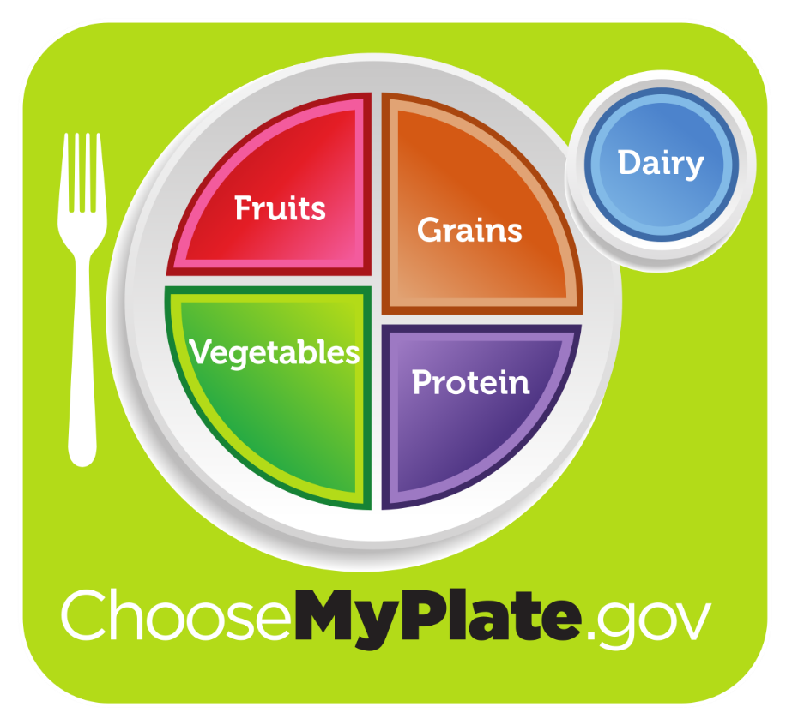

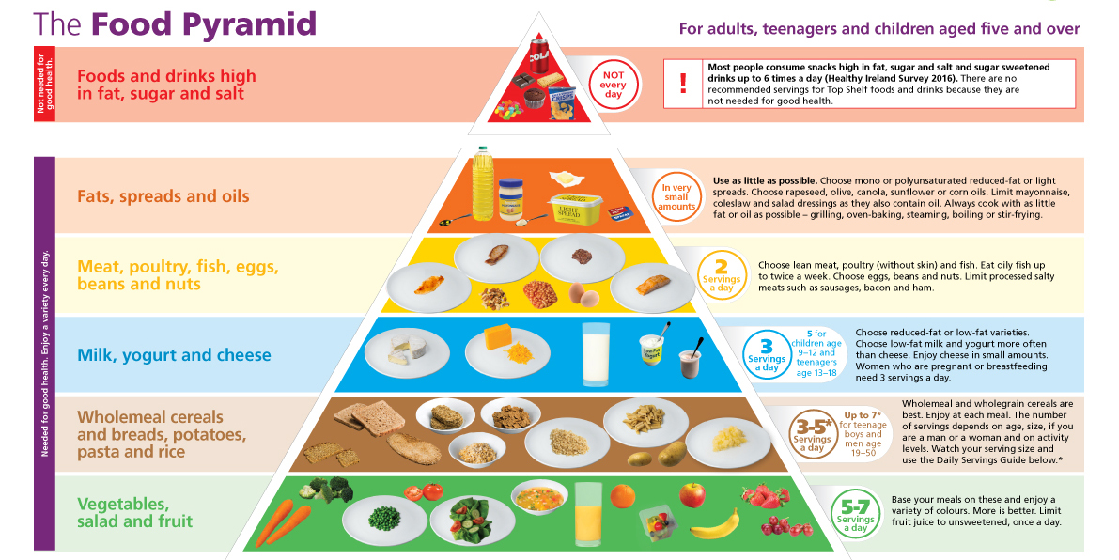It is advised to consume enough of vitamins and eat a diet heavy in calories, protein, and fat.
But the first step is to identify and address the reason for undereating before beginning the diet. Following that, a balanced diet should be created depending on the needs. Fine, raised, lanugo hair on the body's surface. A lack of a menstrual cycle (amenorrhea) broken nails
Energy: the number of calories needed varies based on the activity. The total amount of calories consumed should exceed the amount of energy needed to increase weight. It is advised to consume an additional 500 kcal each day. Increases should be made gradually over a period of one to two weeks to prevent stomach issues.
Proteins: for the purpose of creating tissue, more than 1.2 g of protein per kg is advised. The body fully utilizes high-quality protein, hence the best protein sources should be taken in large quantities at first. Subcutaneous fat loss, slower reactions, oedema
Fat: fat content, it is still important to have readily digested fats. Foods that are fried or greasy should be avoided since they might make you sick. A meal shouldn't start with fatty meals because they suppress appetite. Foods high in calories and fat, such as cream, butter, margarine, and oils, contribute to weight gain.
Carbohydrates: high-carbohydrate sources must be the foundation of the diet. Limit your intake of leafy vegetables and give potato and yam priority. The diet can be generously supplemented with non-vegetarian meals, dried fruits, candies, nuts, desserts, jam, jelly, cereals, and cereal goods, all of which are excellent sources of energy. There should be more meals served.
The nutritional content of the diet is improved by two small meals that include soups, juices, or sweets in between the main meals. Foods that are simple to digest should be offered. You can add foods like porridge, cutlets, sweets, potato chips, and high-protein beverages like milk, malted milk, and badam kheer. Thick soups are very healthy and readily digested foods.
Minerals and vitamins: a balanced diet eliminates the need for additional vitamin and mineral supplements.
Fluids: in order to avoid reducing the amount of food consumed, fluids should only be consumed after a meal. Take in enough liquids to prevent constipation.

REFERENCES:
https://www.ncbi.nlm.nih.gov/pmc/articles/PMC7797319/#:~:text=adolescents%20from%20low,non%2Dslum%20areas
https://www.ncbi.nlm.nih.gov/pmc/articles/PMC7797319/#:~:text=Adolescents%20(10%E2%80%9319,16%2C17
https://www.tommys.org/pregnancy-information/im-pregnant/weight-management/underweight-during-pregnancy#:~:text=Lack%20of%20money,your%20visit%20today%3F
https://www.tommys.org/pregnancy-information/im-pregnant/weight-management/underweight-during-pregnancy#:~:text=Lack%20of%20money,your%20visit%20today%3F
https://en.wikipedia.org/wiki/Underweight#:~:text=A%20person%20may,accelerometry).%5B17%5Dhttps://onlinelibrary.wiley.com/doi/full/10.1002/hsr2.356#:~:text=Lactating%20mothers%20are%20at%20increased%20risk%20of%20being%20underweight%20because%20of%20the%20physiological%20changes%20that%20lead%20to%20disproportionately%20higher%20energy%20and%20nutrient%20requirements%20compared%20to%20their%20non%2Dpregnant%20and%20non%2Dlactating%20counterparts
https://www.healthychildren.org/English/health-issues/conditions/obesity/Pages/Body-Mass-Index-Formula.aspx#:~:text=Body%2DMass%20Index%20Formula,4%2C761%20%3D%2027.2%20(BMI%20Score)
https://www.healthline.com/health/underweight-health-risks#:~:text=There%20are%20certain,children%20and%20teenagers
https://www.ncbi.nlm.nih.gov/pmc/articles/PMC9528949/#:~:text=and%20underweight.%201-,Underweight,-is%20a%20direct
Dietetics by b srilakshmi 7th and 8th series

