REVIEW FOR VERTICAL AXIS MAGLEV WIND TURBINE HAVING VARIOUS DESIGNS

Dr.Harshit Bhavsar¹

- Assistant Professor, Department of Mechanical Engineering, SAL College of Engineering, Ahmedabad, Gujarat, India.

Abstract:-
Renewable energy sources like turbines are gaining additional importance in recent years as apprehension of setting pollution has increased. Several developments have taken place to utilize star and wind energy. Wind is gift all over in the slightest degree time however wind turbines are present in few places to get power. An effort has been created to create use of wind even from tiny regions by developing paradigm of vertical axis wind turbine mistreatment railroading suspension to harness power. A new approach of getting placed the magnets (double finished arrangement) has been experimented during this work. The aim is to use straightforward material as turbine blade and generate power by magnetically levitated system. A brand new means of putting the ND magnet and coils were deployed on the wind turbine plates and experimented during this work. On rotation of the wind turbine the magnetic arrangement would produce axial flux whereas passing over copper coil arrangement.

Key words:- turbine-Blades, Magnetic Levitation, Magnets, Wind Energy.

Introduction:-
Presently a day, we will eventually have to look for inexhaustible or basically limitless fuel hotspots for the human turn of events to proceed. Environmentally friendly power is for the most part power provided from sources, for example, wind power, sunlight based force, geothermal energy, hydropower and some others. The requirement for the environmentally friendly power is high from most recent couple of a long time because of the weariness of regular power age strategies. The utilization of environmentally friendly power is the as it were thing that diminishes the reliance of human on petroleum products. Among the wide range of various environmentally friendly power sources Wind Energy is one of the quickest developing fuel sources which is developing at the pace of 30% yearly diagram.[2]

The breeze speeds in Asian nations is extremely low, particularly in the urban areas, and this much measure of wind speed isn't sufficient to begin the breeze factory. This undertaking presents structure and guideline of the proposed attractive levitation wind turbine for better use of wind energy. In Maglev Wind turbine there is no grating, and subsequently it can deal with low speed. The Maglev wind turbine configuration is a huge take off from customary propeller plans. Its fundamental preferences are that it utilizes frictionless orientation and an attractive levitation plan and it doesn't have to tremendous spaces needed by more regular breeze turbines. It additionally requires nearly nothing if any support. The Maglev wind turbine was first uncovered at the Wind Power Asia display in Beijing 2007. The exceptional working standard behind this plan is through attractive levitation. Attractive levitation is as far as anyone knows an incredibly proficient framework for wind energy. The vertically situated edges of the breeze turbine are suspended noticeable all around supplanting any requirement for metal rollers.( T G Sriganesh, G J Naveen, Vishnu P)

Wind power terminology:

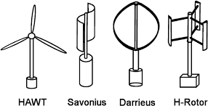

Fig. 1:-Maglev Vertical Axis Wind Turbine

Sujata R. Ingle, Ambikaprasad O. Chaubeyhave shown theeffectiveness of the breeze turbine is subject to wind availability, in the event that the measure of wind is adequate breeze turbine sharp edges are turning continuously.

The wind is hits the cutting edges of the turbine, the force age by the cutting edges can be determined as, Dynamic energy (K.E) = ½ mv2 Measure of Air cruising is given by,
m = ρ AV (1)
Subbing this estimation of the mass in articulation of K.E,
K.E = ρAv3 Watts (2)
To change control over to kilo watt a non-dimensional proportionality steady k is presented where, k = 2.14 X 10-3
Along these lines, Force in KW (P) = 2.14 ρAv3 x10 (3) Where,
m = Mass of air navigating A = Area
Air Density (ρ) = 1.2 kg/m3
Cleared by the sharp edges of the turbine
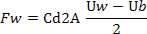
Speed (V) = wind speed with condition over, the force being created can be determined, anyway one should take note of that it is preposterous to expect to change over all the intensity of the breeze into power. The turbine assimilates the breeze energy with their individual edge will move more slow that the breeze speed. The distinctive speed creates a drag power to drive the sharp edges. The drag power for following up on one sharp edge is determined as
Where,
A - Swept territory of the cutting edge
ρ - Air thickness (about 1.225 kg/m3 adrift level) Uw - Wind speed
Cd - The drag coefficient (1.9 for rectangular structure) Ub - The speed on the edge surface.

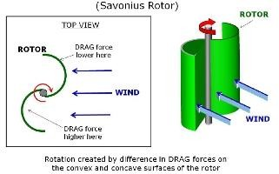

Fig.1:-Drag- Based Wind Turbine Concept

Principle and types of magnetic suspension:
research on Magnetic suspension way that an item is suspended through magnetic enchantment and/or repulsion forces to reap non-touch guide and low-friction in motion.

Due to no mechanical contact in the attractive bearing, it has numerous points of interest, including no wear, no defilement, reasonable for long haul use in vacuum and destructive climate, no mechanical grinding, low commotion, low force misfortune and no need of grease or fixing. In this manner, attractive suspension innovation can be utilized for fast applications to kill mechanical issues identified with oil and force misfortune.
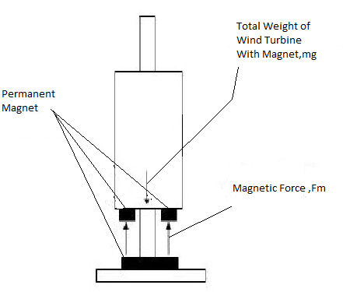

Fig. 2:-Free body diagram of magnetically levitated object

Attractive levitation is a technique wherein an article is suspended with no help other than attractive fields. The attractive power created is utilized to neutralize the impacts of gravitational power and lift up the item. By putting these two magnets on top of one another with like polarities confronting one another, the attractive shock will be solid enough to get both the magnets a good way off far from one another. There are numerous preferences for using attractive levitation that is to limit contact, make power estimation, plan, and engaging gadgets. As of late, this

development innovation is applied into transportation framework in which non-leading vehicle travel securely at extremely rapid while suspended, guided, and moved over a guide path by attractive fields. The idea of attractively suspended vehicle invigorated the turn of events of helpful application in different fields, for example, power age.

Working Principle:
This is the overall schematic graph of attractive levitation vertical hub wind turbine by which the force is created by utilizing Faraday's first law of acceptance which expresses that "Any place a conductor is put in a fluctuating attractive field, emf are instigated which is called incited emf, if the conductor circuit are shut, current are likewise actuated which is called initiated current." The breeze energy turns the breeze turbine cutting edges which are fixed to circle and to which magnets are fixed and attractive motion of these magnets joins with the loop which is put on the base of the maglev wind factory.[3]
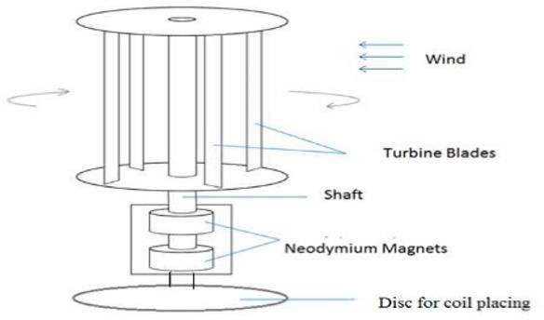
Fig. 4:-Sketch and components of maglev wind turbine

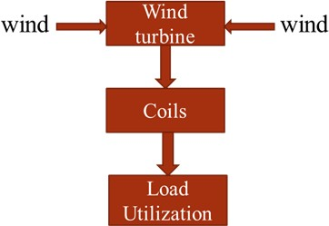

Fig. 5:-Block diagram of maglev wind turbine

Advantages:
- A monstrous pinnacle structure isn't needed, as VAWT's are mounted nearer to the ground.

- These are found nearer to the ground and subsequently simpler to keep up.
- No such oil requirements.
- Capable of creating power from wind speeds as low as 1.5 m/s and answered to work in breezes arriving at 40 m/s.
- Producing 20% more energy than a regular turbine, at onceshrinking operational expenses by half over the customary draft turbine.
- Better response to quickly evolving winds.
- Lighter weight towers

Future Scope:
Future work could involve examination of the impact of following points of view talked about beneath on the presentation of the current rotor.
- By utilizing modernized cutting edges for Savonius rotor, the force of the rotor can be expanded to deliver more force at even low speeds.
- Design identified with self-flexible End Plates can be created to draw in more air to go through the cutting edges via programmed formation of weight differential across gulf and source.
- In this plan we can put Solar Plate and can get multiplied power with a similar spot being use

Conclusion:-
The idea of vertical hub wind turbine utilizing attractive levitation effectively worked. Contrasting with customary even wind turbines, single maglev wind turbine having enormous limit gives more yield. The turbine productivity is improved by usage of magnets assisting with turning with quick speed with insignificant grinding as it offsets the weight on the shaft of the turbine. The standard windmills having set of 1000 windmills powers 5 lakh homes while single maglev wind turbine is fit providing capacity to 7.5 lakh homes. The necessary zone for single maglev windmill is under 100 sections of land while field of 1000 windmills require in excess of 64000 sections of land. From this perception we can say that a solitary maglev wind turbine is conservative contrasted with traditional breeze turbine.

Regarding huge scope power creation, vertical hub wind turbines have not been known to be appropriate for these applications.. A mortgage holder would have the option to separate free clean energy subsequently encountering a decrease in their utility cost and furthermore add to the "Environmentally friendly power Energy" mindfulness that is progressively picking up ubiquity.

References:-
- Santoshkumar Jiledar Chaturvedi, „Maglev Wind Generator‟, 3rd The International Conference on Renewable Energy Technology, eISSN: 2319-1163 | pISSN: 2321-7308,(2014).
- Nitin A. Dhumne, surbhi Shrivastava, “A Novel Method Design of Vertical Axis WindTurbine by using Magnetic Levitation, –International Journal for Innovative Research in Science & Technology| Volume 4 | Issue 1 | June 2017
- Manoj L, Nithesh J, Manjunath T, Gowreesh S “ Power Generation using Magnetic Levitation Vertical Axis Wind Turbine, International Journal of Engineering and Advanced Technology (IJEAT), Volume-9 Issue-2, December, 2019
- Vishal D Dhareppgoal and Maheshwari M Kona-gutti, „Regenedyne Maglev Wind Power Generation‟, SARC- IRAJ International Conference, ISBN: 978-81-92747-8-3. 16th June 2013
- Dinesh N Nagarkarand, Dr. Z. J. Khan, „Wind Power Plant Using Magnetic Levitation Wind Turbine‟, International-Journal of Engineering and Innovative Technology (IJEIT) Volume 3, Issue1, July 2013.
- Baker J R., Features to aid or enable self-starting of fixed pitch low solidity vertical axis wind turbines, (2003) Journal of Wind Engineering and Industrial Aerodynamics; 15:369–80.
- Ponta F L, Seminara J J, Otero A D., on the aerodynamics of Variable-geometry oval-trajectory Darrieus wind turbines. Renewable Energy; 32(2007) 35–56.
- Chaichana T, Chaitep S., Wind power potential and characteristic analysis of Chiang Mai, Thailand, Mechanical Science and Technology; 24(2010) 1475–9.
- Nayana Said, Maya Yeole, PriyankaPatil, P.N.Salunkhe, “Magnetic levitation is used as merit over conventional wind mill” International Journal for Scientific Research and Development (IJSRD), in 2017

- C.M.Vivek, P.Gopalakrishan, R.Murugesh, R.Raja Mohamed, “Increasing the efficiency of wind turbine using wind energy by producing electricity” International Research journal of engineering and Technology(IRJET), in April-2017
- Harshal Vaidya, PoojaChandadkar, Bobby Khobragade, R.K.Kharat, “The implementation of different types of wind turbine for power generation” International Journal of Research in Engineering and Technology (IJRET), in 2016
- ParthRathod, KapilKhalik, Ketul Shah, Het Desai, Jay Shah, “The study of combined vertical axis wind turbine and optimizing combined rotor blades” International Journal of Innovation Research in Science Engineering Technology(IJIRSET), in April-2016
- Ajay L.Parate, Pawan M Kumbhare, Rahul C Patekar, Pravingupta, “The implementation of an alternative configuration of a wind turbine for power generation” International Journal for Scientific Research and Development (IJSRD), in 2015
- D.A.Nikam, S.M.Kherde, “Various stages of design and development of optimizing vertical wind turbine” International Journal of Engineering Research and Application (IJERA), in Nov-2015
- Er.Rahul Jangam, Avinash Barve, Bhagyesh Talekar, Pratik Hajare “Frictionless Wind Turbine Using Magnetic Levitation” Journal of Emerging Technologies and Innovative Research, JETIR18IC051, 2018
- Dr. Dinesh N Nagarkar, Dr. Z. J. Khan,“Wind Power Plant Using Magnetic Levitation Wind Turbine”, International Journal of Engineering and Innovative Technology (IJEIT),Vol. 3, Issue 1, July 2013.
- Dr. Aravind CV, Dr. Rajparthiban, Prof. Rajprasad R,"A Novel Magnetic Levitation Assisted Vertical AxisWind Turbine–Design Procedure and Analysis", 8th International Colloquium on Signal Processing and its Applications, (IEEE) in 2014.
- Nitin Sawarkar, Sumedh Dongre, PG.T.Dhanuskar,Deepak Hajare “ Design and Fabrication of Windmill Using Magnetic Levitation” International Journal of Innovations in Engineering and Science, Vol. 1, No.1, 2016
- Ashwin P. Joseph, Suraj P. Chavhan, Pravesh K. Sahare, Abdul Arif, Tanveer A. Hussain,” Review Paper on Wind Turbine using Magnetic Levitation”, IJRMET Vol. 6, Issue 1, Nov 2015-Apri l 2016
- Huachun Wu Ziyan Wang Yefa Hu,” Study on Magnetic Levitation Wind Turbine forVertical Type and Low Wind Speed”, 2010 IEEE.

