X RAY PRODUCTION IN DIAGNOSTIC RADIOLOGY
AUTHORS
1* VIGNESH. K, DEPARTMENT OF RADIOLOGY AND IMAGING TECHNOLOGY
SCHOOL OF ALLIED HEALTH SCIENCES, VINAYAKA MISSIONS RESEARCH FOUNDATION -DU, CHENNAI, TAMILNADU, INDIA
Vigneshmphy9@gmail.com

2*PREETHI.B, DEPARTMENT OF RADIO DIAGNOSIS
SRM MEDICAL COLLEGE HOSPITAL AND RESEARCH CENTRE
MAHATMA GANDHI RD, POTHERI, SRM NAGAR, KATTANKULATHUR, TAMIL NADU 603211, INDIA.
preethibaskar2406@gmail.com
Abstract
Electromagnetic waves with wavelengths of 0.01 to 10 nanometers are referred to as X-rays. X-rays have been used to image biological tissues and assist in the diagnosis of disease for a very long time in the field of diagnostic radiology. Simply put, X-rays are created when electrons are accelerated by a potential difference, which results in electromagnetic radiation. The fundamental parts of an X-ray production system consist of a generator and an X-ray tube, each of which parts is enclosed in a vacuum.
I. INTRODUCTION
A source of energy is necessary for medical imaging of the human body. The energy used to create the image in radiology's medical imaging procedures must be able to pass through tissues. Most medical imaging outside of the radiology department is done using visible light, which has a limited capacity to penetrate tissues at depth. Skin photography, endoscopy, and light microscopy are all applications of visible light pictures in pathology, gastrointestinal, and obstetrics. Direct visual observation, which also makes use of visible light, is a standard practice across all medical specialties. Mammography, computed tomography, magnetic resonance imaging, and nuclear medicine are examples of diagnostic radiology procedures that utilize electromagnetic spectrum wavelengths outside of the visible light region in addition to X-rays.
II. PRODUCTION OF X RAY
The glass envelope of a conventional X-ray tube is filled with high vacuum. A cathode (negative electrode) and a positive electrode, both hermetically sealed in the tube, are located at either end. Thermionic emission occurs when heat emits an electron from the tungsten plate that serves as the cathode. When extremely energetic electrons contact with materials, they turn their kinetic energy into electromagnetic radiation, producing X-rays.
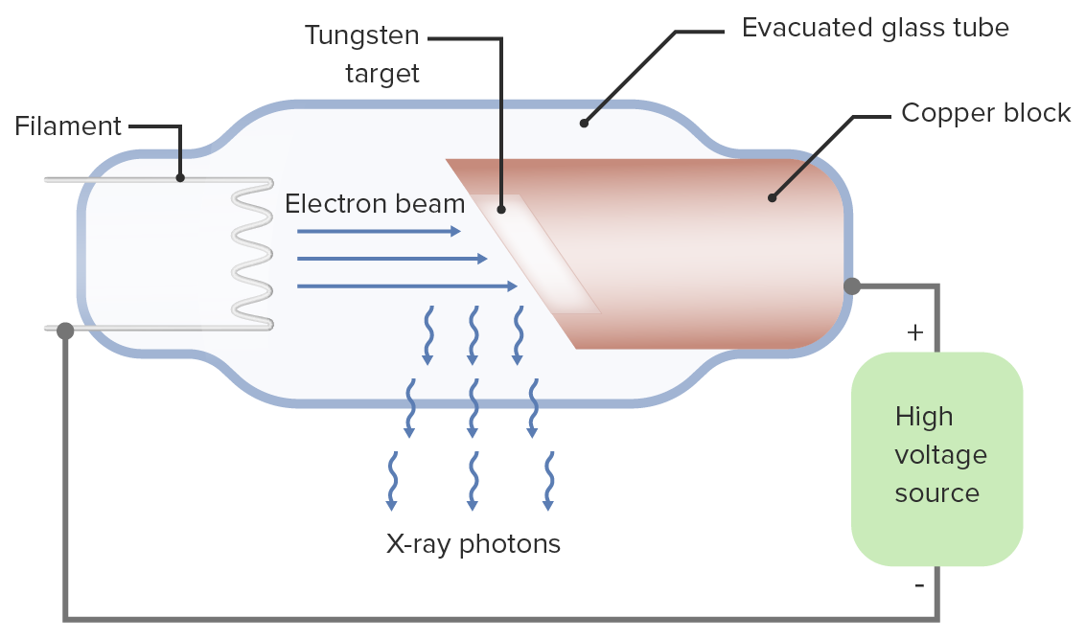

Figure:1 X Ray Production
An evacuated route vacuum for electron acceleration and an electron source makes up the equipment that brings out the above task. Outside supply of energy to speed up that electron
X-Ray Tube
X-Ray Tube
1. Cathode
2. Anode
3. Rotor/Stator
4. Glass or Metal envelope
5. Tube Housing

Cathode:
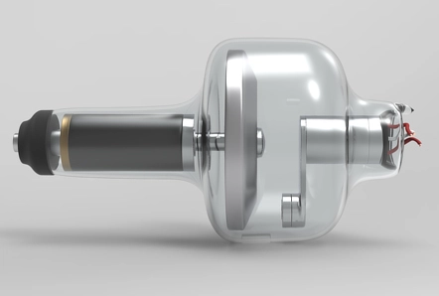
1. A focusing cup surrounds a helical coil of tungsten wire that serves as the cathode.
2. The filament circuits supply a voltage of up to 10 V and up to 7 A of current to the filament.
3. The filaments are heated by electron resistance, which releases electrons.
4.When a positive voltage is given to the anode relative to the cathode, an electron released from the filament flows through the tube's vacuum to the anode.
Focusing cup Figure:2 Cathode
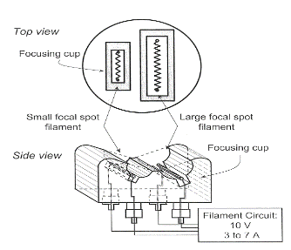
Shapes the electron beam's width and surrounds the filaments.
It is possible to bias an insulated focusing cup with a greater negative voltage (about 100V less) than the filament. intensify the electric field surrounding the filament.
1. Limits the beam's spread
2. Produces a narrow focal spot width
Filament Current
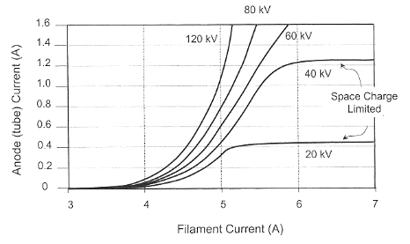
The rate of thermionic electron emission is dependent on filament temperature, which is determined by filament current. A space charge cloud forms around the filament when no voltage is provided between the cathode and the anode.
the use of highly positive The electron is accelerated toward the anode by the cathode-to-anode voltage, which results in tube current. Relatively substantial changes in tube current can result from small changes in the filament current.
Anode Figure: 3 Filament Current
A metal target electrode known as the anode is kept at a positive potential differential with respect to the cathode.
Due to its high atomic number (Z=74) and high melting point (3,370°C), tungsten is the most commonly utilized anode material.
The surface of a tungsten anode can withstand significant heat deposition without cracking or pitting.
Anode arrangements
1. The simplest type of X-ray tube has a fixed or stationary anode.
2. is made up of a block of copper with a tungsten inlay inside.
3. Copper secures the tungsten target and efficiently removes heat from it.
4. A smaller target area slows down heat transfer, which lowers the maximum tube current and, as a result, the x-ray flux.
5. Used in dental X-ray machines, portable X-ray equipment, and portable fluoroscopy systems
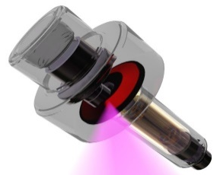
Rotating anode:
1.The most common diagnostic x-ray applications employ rotating anodes.
2. Higher x-ray production capabilities due to increased heat loading
3. Electrons give a rotating target energy, distributing thermal energy across a vast surface and mass.
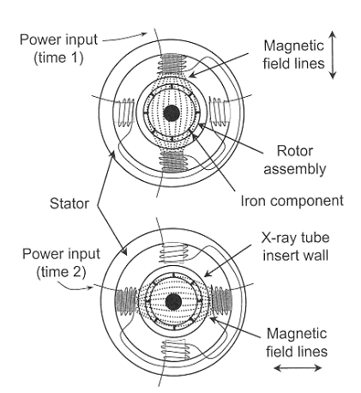
Rotor:
Copper bars are placed around a cylindrical iron core in the rotor. The stator is composed of electromagnets that encircle the rotor outside the x-ray tube. Rotor rotation is caused by alternating current flowing through the stator windings. The range of rotational rates is from low speed rotation at 3,000 to 3,600 rpm to high speed rotation at 9,000 to 10,000 rpm.

Focal spot size
Actual focal spot width and effective focal spot width are equivalent.
Actual focal length times sine of effective focal length
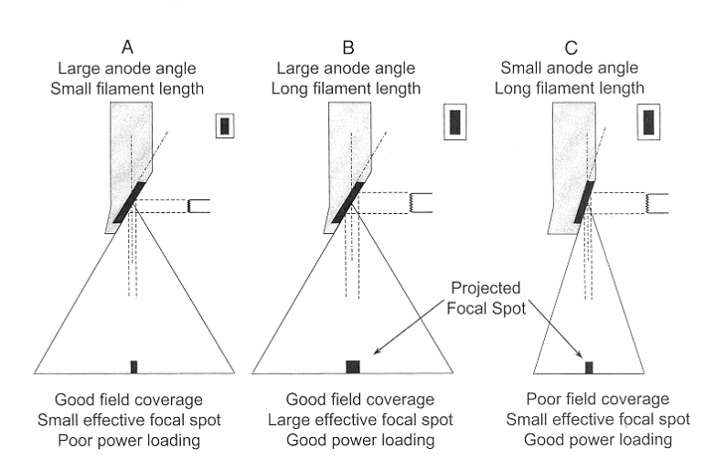
The line focus principle describes the foreshortening of the focal spot length when seen down the center ray.
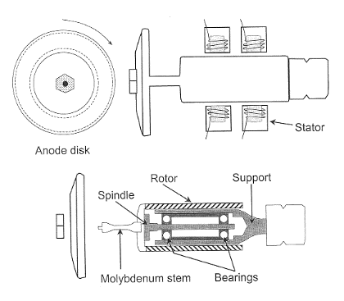

Figure:4 Focal Spot Size
Anode angle
There is a suitable anode angle that depends on the clinical imaging application. A modest anode angle is preferred for small field-of-view image receptors, such as those found in cineangiographic and neuroangiographic equipment, whose field coverage is limited by the diameter of the image intensifier. High anode angles are necessary for standard radiography operations in order to achieve large field area coverage at close focal spot-to-image distances.
Effective focused spot length varies with picture plane position in the anode-cathode direction.Position in the picture plane has no discernible effect on the focus point size in the breadth dimension. Specified nominal size at the beam's center ray

III. Transformers
Perform task of “transforming” alternating input voltage into alternating output voltage using principles of electromagnetic induction Generic transformer has two distinct, electrically insulated wires wrapped about a common iron core
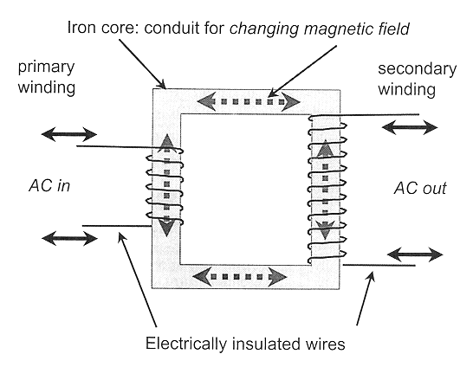

Figure:5 Transformer
Law of Transformers

The ratio of the primary voltage to the secondary voltage is equal to the ratio of the number of coil turns in the primary winding to the number of coil turns in the secondary winding.
VP/VS equals NP/NS
1. A transformer may change the voltage or isolate it is dependent on the ratio of the turns in the two coils.
2.NS > NP: A "step-up" transformer that raises the secondary voltage
3.NS NP: a "step-down" transformer that lowers the secondary voltage
4.NS = NP: "isolation" transformer, primary voltage and secondary voltage are equal.
Autotransformer
consists of an iron core and a single coil of wire. The Transformers Law still holds true. operates on the self-induction, as opposed to mutual induction, premise. secondary voltage changes or climbs more gradually compared with conventional transformers electrically separates the primary circuit from the secondary circuit.

Diodes
Electrical devices that only permit current to flow in one direction and have two terminals The x-ray tube itself is an example of a diode. A semiconductor material crystal that is part of a solid-state diode is "doped" with traces of impurity elements. When voltage was applied in one direction, conductivity increased, but when voltage was applied in the opposite direction, it decreased to very low levels.
DIODES
ONE-WAY FLOW OF ELECTRON

ANODE CATHODE

Vacuum tube diode
(e.g.-Ray Tube)

Solid-State Diode
Figure:6 One Way Flow of E
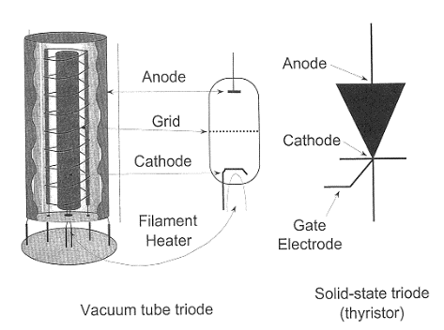
Triodes
A vacuum tube diode with a grid-like third electrode near the cathode
The grid is required for electrons traveling from the cathode to the anode. By applying a tiny negative voltage to the grid, the cathode's electrons are subjected to a strong force that allows on/off switching or current regulation.
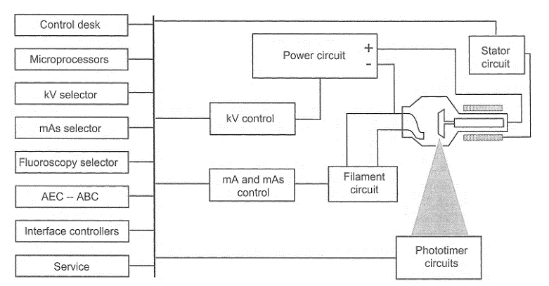

Operator Console
The operator sets the focused spot size, exposure duration, kVp, and mA (which represent the number of x-rays in the beam at a given kVp). Peak kilovoltage (kVp) regulates the x-ray beam's quality (penetrability), which affects subject contrast. The x-ray flux is determined by tube current (mA). The mA setting is typically used to determine the focus spot size. Some generators allow the use of preprogrammed processes.
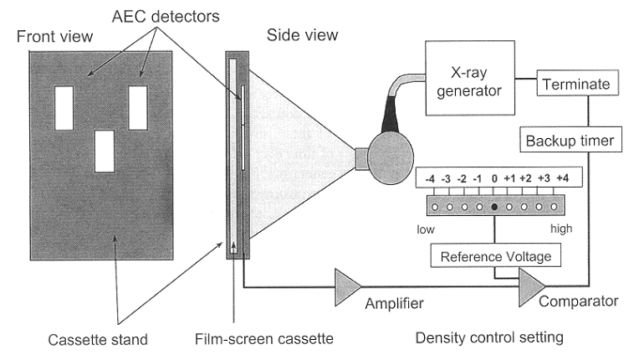
Timing the x-ray exposure
Digital timers have mostly replaced electronic timers due to their excellent repeatability and microsecond precision. Only low-power, single-phase generators employ mechanical switches. High voltage switches used in three-phase and constant potential circuits The high-frequency inverter electrically switches the high-voltage transformer's primary side.

Photo timers
Check the radiation's actual impact on the image receptor. Stop the x-ray operation after an exact amount has been created. provides a continuous exposure to the image receptor while accounting for patient-specific differences in attenuation and thickness.
Generator for Falling Load
It delivers the greatest mA for the selected kVp while taking into consideration the features of the instantaneous heat load on the x-ray tube when used in conjunction with the photo timing (AEC) subsystem. The image receptor (IR) receives the required quantity of radiation in the shortest period of time feasible by continuously reducing the wattage as exposure time progresses.
Factors affecting x-ray emission
An x-ray tube's output is described by its quality, quantity, and exposure.
An x-ray beam's penetrability is characterized by quality
The quantity of the beam's photons is referred to as its size.
Since exposure is nearly proportional to the x-ray beam's energy fluence, it possesses features related to both quality and quantity.

Efficiency, exposure, quality, and amount of X-ray production are influenced by the following factors:
1. X-ray tube target material
2.Voltage
3. Current
4. Exposure
5. Beam Filter
6. Waveform of the generator

Target (anode) material
Have an impact on the creation of bremsstrahlung radiation. Atomic number and output exposure are roughly inversely related. The target material affects the energies of the characteristic x-rays. Target material impacts both the quantity and quality of characteristic radiation and bremsstrahlung radiation.

Tube voltage (kVp)
Determines the maximum energy of the bremsstrahlung spectrum and affects the quality of the output spectrum
The effectiveness of x-ray production is directly influenced by tube voltage. exposure typically equivalent to the cube of the kVp in the diagnostic range
$$\text{Exposure}∝\text{kV}{\text{p}}^{2}$$

To maintain the same exposure, increases in kVp must be balanced off by equal variations in mAs.
The patient's x-ray attenuation characteristics are another factor in procedure modification.
The mAs fluctuates with the fifth power of the kVp ratio in order to ensure equal transmitted exposure across a typical patient:

The rate at which electrons move from the cathode to the anode is known as tube current. The relationship between the beam's exposure and tube current for a given kVp and filtration is linear.

Exposure
The amount of time that x-rays are created is known as the exposure time. The connection between exposure duration (mAs) and the quantity of x-rays generated is simple.

The beam optimizer
By excluding only high-energy photons from the spectrum, beam filtering modifies the quantity and quality of the x-ray beam. The quality is enhanced as a result of an increase in average energy and a decrease in photon number (quantity).

waveform of the power source
The average potential difference between a single-phase generator and a three-phase or high-frequency generator is lower for the same kVp. The resulting x-ray spectrum's quality is impacted by this. Both the quantity of x-rays produced and the quality of the x-ray spectrum are impacted by the kVp ratio's fifth power.

References
[1] Diagnostic Radiology Physics: A Handbook for Teachers and Students
[2] J.T. Bushberg, J.A. Seibert, E.M. Leidtholdt, J.M. Boone, 3rd edn. (Lippincott Williams &
Wilkins, 2011)
[3] W.R. Hendee, E.R. Ritenour, Medical Imaging Physics, 4 edn. (Wiley, New York, NY, USA,
2002)
[4] IAEA. (2010). Clinical Training of Medical Physicists Specializing in Diagnostic Radiology.
Training Course Series, 47, International Atomic Energy Agency
[5] Core Curriculum for medical physicists in Radiology, Recommendations from am EFOMP/ESR working group, 2011
[6] International Commission on Radiological Protection,
the 2007 Recommendations of the international commission on Radiological
Protection, ICRP Publication 103, Elsevier (2008)
[7] United nations, sources and effects of ionizing Radiation, Report 2000, Vol.
1: Sources, Scientific Committee on the Effects of Atomic Radiation (UNSCEAR),un, new York (2000)
[8] H. Jones, J. Cunningham, The Physics of Radiology, Fourth Edition (C. Thomas, 1983)

