INDIVIDUALIZE HEALTH CAUTIOUS AND COMMUNICATION

Dr.Satyasrikanth P  Associate Professor  Department of ECE  Atria Institute of Technology  Bangalore  satyarikanth123@yahoo.in | Nataraja N  Assistant Professor  Department of ECE  Atria Institute of Technology  Bangalore  nataraja.sp85@gmail.com | Dr. Keshavamurthy  Professor  Department of ECE  Atria Institute of Technology  Bangalore  keshavamurthy_s@yahoo.com | Anne Gowda A B  Assistant Professor  Department of ECE  Sri Venkateshwara College of Engineering  Bangalore  annegowda.ece@gmail.com

ABSTRACT
Health monitoring and security for humans in healthcare is an essential element that encompasses the continuous tracking and evaluation of diverse health indicators to identify and mitigate potential health issues. The field has witnessed significant progress with advancements in technology and medical research, leading to the development of advanced monitoring systems that enable real-time data collection and enhance overall health outcomes. The integration of wearables, sensors, and mobile health applications has empowered individuals to monitor their crucial health metrics, such as vital signs, physical activity levels, and sleep patterns, among others. Moreover, these devices possess the capability to notify healthcare providers about potential health concerns, facilitating prompt intervention and treatment.
Keywords: Healthcare, Wearable, sensors, Monitoring, Mobile Health

INTRODUCTION
In recent years, the rapid growth of the internet has led to the emergence of the Internet of Things (IoT), where various devices are connected and communicate with each other. This interconnected network has paved the way for the development of smart technologies and generated a vast amount of data, ushering in a new era of information utilization. The applications of IoT span across different domains, including transport and logistics, healthcare, smart environment, and personal and social aspects. Governments worldwide are focusing on creating smart cities that leverage these emerging technologies to enhance competitiveness on the international stage. With the widespread use of smart devices, individuals are surrounded by technology that connects them to networks, social platforms, and other intelligent systems. The impact of IoT on daily life is substantial, influencing areas such as entertainment, work, and communication.
Individualized health caution and combination refer to the personalized approach of healthcare, where medical treatments and interventions are tailored to the specific needs of each individual. It involves considering various factors such as genetics, lifestyle, environment, and medical history to develop a comprehensive and customized healthcare plan.
In traditional healthcare practices, treatments are often generalized and applied uniformly to a broad population. However, individual differences play a significant role in how individuals respond to different treatments and interventions. This realization has led to a shift towards individualized healthcare, which aims to provide more effective and targeted care for each person.
The concept of individualized health caution encompasses several aspects. Firstly, it recognizes that each individual is unique, with distinct genetic makeup, physiological characteristics, and lifestyle factors. This understanding allows healthcare providers to develop personalized prevention strategies, diagnostic approaches, and treatment plans. By considering an individual's specific risk factors, vulnerabilities, and preferences, healthcare professionals can optimize outcomes and minimize potential side effects.
Combination therapy is an integral part of individualized health caution. It involves the use of multiple treatment modalities or interventions to address the complex nature of certain medical conditions. Rather than relying on a single treatment approach, combination therapy aims to target different aspects of a disease or condition simultaneously, improving efficacy and reducing the likelihood of treatment resistance.
The advancements in technology and the availability of vast amounts of health data have greatly facilitated the implementation of individualized health caution and combination therapy. Genetic testing, biomarker analysis, wearable devices, and electronic health records enable healthcare providers to gather comprehensive information about an individual's health status. This data, combined with sophisticated algorithms and artificial intelligence, can assist in the identification of personalized treatment options and predict optimal therapeutic approaches.
The benefits of individualized health caution and combination therapy are substantial. It allows for earlier detection and prevention of diseases, more precise diagnoses, and the development of targeted treatment plans. By tailoring healthcare interventions to each individual, healthcare providers can achieve better patient outcomes, minimize adverse effects, and improve overall healthcare efficiency. In individualized health caution and combination therapy represent a paradigm shift in healthcare towards personalized and targeted approaches. By considering individual variations and combining multiple treatment modalities, healthcare providers can optimize patient care, enhance treatment efficacy, and improve the overall quality of healthcare delivery.
Among the various domains benefiting from IoT, the field of medical and healthcare stands out as a key enabler. IoT devices play a crucial role in collecting, monitoring, evaluating, and notifying patients about their health information. The penetration of IoT devices in medical and healthcare encompasses health monitoring of medical parameters, diagnostics, medical equipment tracking, secure indoor environment access, smart hospital services, and even entertainment services. However, remote monitoring of patients by doctors remains a challenging task. Analyzing a patient's health condition requires the collection of various medical parameters and transmitting them to the doctor through a reliable networking channel, which poses its own set of challenges.
To address these challenges, several technologies come into play. The Internet of Things (IoT) refers to a system where interconnected computing devices, machines, objects, animals, or people are assigned unique identifiers and can transfer data over a network without human intervention. Cloud computing is another essential technology that allows the delivery of hosted services over the internet. It enables companies to consume computing resources as utilities rather than building and maintaining their own infrastructure. ESP-32, which stands for "Espressif Systems Product 32," is a widely used microcontroller module in building IoT projects. Additionally, the Blynk app provides a platform with iOS and Android applications for controlling devices like ESP-32 and Raspberry Pi over the internet, allowing users to build a graphical interface for their projects easily.
The implementation of health monitoring systems using IoT technology has numerous potential scenarios. For instance, in the case of a patient being introduced to a new drug with an unstable regulatory body system, continuous monitoring and data analysis can help assess the patient's response. Patients prone to heart attacks or those who have suffered one before can benefit from continuous monitoring of vital signs to predict and alert in advance of any indication of a potential cardiac event. Monitoring critical organ situations and detecting conditions that may lead to life-threatening situations are also vital, especially for individuals with advanced age and failing health conditions. Athletes during training can utilize health monitoring systems to determine which training regimens produce the best results.
However, there are challenges to the widespread adoption of health monitoring systems. Some existing systems require wireless detection and transmission of sensor information to a health server, often with subscription fees that may hinder accessibility, particularly in developing countries. Internet connectivity is also an issue, as real-time health connections require reliable and high-quality internet access, which may be lacking in certain regions. Moreover, many of these systems were initially developed in developed countries with well-established infrastructure, making their adaptation to developing countries more complex.
To overcome these challenges, it is crucial to approach health detection in developing countries with a ground-up approach that takes into account the basic minimal conditions presently available. Simplifying the design of patient monitoring systems based on the number of parameters they can detect can be a viable solution. For instance, a single parameter monitoring system focuses on detecting and analyzing a specific parameter, such as an electrocardiogram (ECG) reading, which can provide multiple readings based on the algorithm used. On the other hand, a multi-parameter monitoring system simultaneously tracks multiple parameters, often found in high-dependency units (HDUs), intensive care units (ICUs), or during surgery and post-surgery recovery in hospitals. These systems monitor parameters like ECG, blood pressure, and respiration rate, serving as indicators of a patient's health or recovery. The health monitoring systems enabled by IoT technology have the potential to revolutionize healthcare by extending it beyond traditional clinical settings. By leveraging wireless sensors, data analysis algorithms, and connectivity, these systems can provide valuable physiological information in home environments. However, challenges related to cost, internet connectivity, and infrastructure must be addressed to ensure the widespread accessibility and effectiveness of these systems, particularly in developing countries
The primary goal of this project is to develop a technology-oriented, low-cost, and easily accessible real-time health monitoring device. The device will leverage advancements in technology to provide continuous monitoring of an individual's health status. The focus of this health monitoring system is to cater to patients with chronic diseases. Chronic diseases are typically long-term conditions that require continuous monitoring to manage symptoms and prevent complications. As most chronic diseases are incurable, it becomes crucial to monitor the patient's health status while they are at home, allowing for early detection of any concerning changes. By implementing a more competent patient management system through real-time health monitoring, hospitals can utilize their resources more wisely and save money. Continuous monitoring of patients' health parameters can help in early detection of deteriorating conditions, preventing unnecessary hospitalizations, and enabling timely interventions.
The proposed system aims to provide convenience for both doctors and patients. Doctors can manage their patients from a single application, which streamlines the process of monitoring multiple patients efficiently. Simultaneously, patients can easily monitor their own health by wearing a lightweight device such as a bracelet, which collects and transmits real-time health data to the monitoring system. Real-time health monitoring systems, utilizing the Internet of Things (IoT), have the potential to significantly impact patient prioritization and urgent care. By continuously collecting and analyzing health data, doctors can identify patients who require immediate attention and provide them with timely care, potentially saving lives. The system can alert healthcare providers when a patient's health parameters deviate from normal ranges, enabling rapid response and intervention. Overall, the proposed real-time health monitoring system aims to improve patient outcomes, enhance resource management in hospitals, and provide a more convenient and efficient healthcare experience for both doctors and patients.

LITERATURE REVIEW
A literature review is a critical analysis of existing literature on a particular topic or research question. It involves searching for and evaluating relevant sources, summarizing and synthesizing the information gathered, and presenting a comprehensive overview of the current state of knowledge on the topic. Nowadays, the development and clinical evaluation of a home healthcare system that enables daily monitoring of health conditions without the need for attaching biological sensors or performing any manual operations is gaining significant attention. This system aims to facilitate early diagnosis, treatment, and prevention of lifestyle-related diseases like adiposis, diabetes, and cardiovascular diseases. Traditionally, commercially available devices for home health care monitoring have relied on the attachment of biological sensors to the human body, which can be inconvenient and uncomfortable for users. In contrast, the non-conscious physiological monitoring system being developed eliminates the need for sensor attachment and user intervention during measurements. The system comprises devices installed in essential areas of a home, namely the toilet, bathtub, and bed. These devices have been designed to accurately measure various physiological parameters without direct contact with the body. To validate their effectiveness, the measurements obtained from these devices were compared with simultaneous recordings from ordinary biological sensors attached to the body, and the results demonstrated high measurement precision.To assess the system's applicability for health condition monitoring, a combination of all the monitoring devices was deployed in hospital rooms. Measurements of patients' health conditions were conducted using this setup, focusing on individuals with cardiovascular disease or sleep disorders. The system successfully monitored important indicators such as body and excretion weight in the toilet, ECG during bathing, and pulse and respiration rate during sleep. These results highlight the system's usefulness in monitoring the health conditions of patients with cardiovascular disease or sleep disorders, particularly within a hospital environment. In addition to home healthcare systems, there is also a growing interest in intelligent wireless mobile patient monitoring systems. These systems leverage wireless technology and intelligent algorithms to enable continuous monitoring of patients' vital signs and health conditions while they are on the move. By utilizing mobile devices and wireless connectivity, these systems offer greater flexibility and convenience, allowing patients to maintain their regular activities while still being monitored closely by healthcare professionals.The development of non-intrusive and automated monitoring systems, both for home and mobile settings, holds great potential for revolutionizing healthcare by enabling proactive and convenient health condition monitoring, early detection of abnormalities, and timely intervention to improve patient outcomes
You are absolutely right that health is a significant concern, especially in times of advancements in technology. The recent outbreak of the coronavirus (COVID-19) serves as a prime example of how crucial healthcare is, as it has had a significant impact on the global economy. In areas affected by epidemics, it is essential to employ remote health monitoring technology to monitor patients effectively. Currently, one of the leading solutions for this purpose is an Internet of Things (IoT)-based health monitoring system [1].
The IoT-based health monitoring system leverages the power of interconnected devices to remotely monitor the health status of patients. This system involves the use of wearable devices equipped with sensors that collect various health-related data, such as vital signs and symptoms. These devices, which may include smartwatches, fitness trackers, or specialized medical devices, continuously transmit the collected data to a centralized platform for analysis and monitoring.
By utilizing IoT technology, healthcare professionals can remotely monitor patients' health conditions in real-time, even from a distance. This allows for early detection of any health deterioration or warning signs, enabling timely intervention and treatment. Moreover, IoT-based health monitoring systems facilitate continuous monitoring, allowing healthcare providers to gather comprehensive data over extended periods, which can aid in accurate diagnoses and personalized treatment plans.
In the context of epidemics or contagious diseases, remote health monitoring becomes even more critical. It helps minimize direct physical contact between healthcare providers and patients, reducing the risk of disease transmission. Additionally, IoT-based systems can support contact tracing efforts by tracking and analyzing the movement and health data of individuals, aiding in the containment of the spread of infectious diseases.
Furthermore, IoT-based health monitoring systems improve healthcare efficiency and resource allocation. By remotely monitoring patients, healthcare professionals can prioritize resources and focus on those in immediate need of medical attention. This optimizes the utilization of healthcare facilities, reduces overcrowding, and ensures that resources are allocated appropriately. An IoT-based health monitoring system [1] is an effective solution for monitoring patients, especially in areas affected by epidemics or widespread diseases. It enables remote monitoring, early detection of health issues, efficient resource allocation, and contributes to the overall improvement of healthcare outcomes.
Health data wirelessly using various communication technologies such as Wi-Fi, Bluetooth, and GSM/GPRS. This system aims to overcome the limitations of uninterrupted communication in developing countries like Bangladesh. By utilizing IoT technology, the proposed system enables real-time monitoring of individuals' health conditions. It collects data from various sensors attached to the individuals, such as heart rate monitors, temperature sensors, and activity trackers. The collected data is then transmitted wirelessly to a central server for further analysis and storage. One of the key features of this system is its ability to function both online and offline. In areas with limited or no internet connectivity, the system can store the data locally and transmit it once a connection becomes available. This ensures that health data is not lost even in the absence of a continuous communication system. The proposed IoT-based health monitoring system in [2] has the potential to improve healthcare services in remote areas by providing real-time health information to healthcare professionals. They can remotely monitor patients' vital signs, detect abnormalities, and take timely actions based on the transmitted data. This system can also facilitate early diagnosis and intervention in critical situations, leading to improved healthcare outcomes. This work presents an IoT-based real-time health monitoring system designed to overcome communication challenges in developing countries like Bangladesh. By utilizing wireless communication technologies and offline data storage capabilities, the system enables continuous monitoring and reporting of individuals' health conditions. Implementing such a system could have significant implications for healthcare delivery and contribute to better health outcomes in resource-constrained settings. In [2] author aims to investigate health monitoring architectures for both individual and group scenarios within the context of the Internet of Medical Things (IoMT). The IoMT refers to the interconnected network of medical devices and wearable devices that collect and transmit health-related data to improve patient care and enable remote monitoring.
Given the increasing popularity of wearable devices and their wide range of applications in medical and disaster rescue efforts, it is crucial to address the challenges posed by the dynamic nature of the IoMT topology. The frequent posture alterations and mobility of users can create difficulties in resource allocation and routing strategies for health monitoring.
To begin, let's discuss the health monitoring architecture for individuals in the IoMT. Typically, an individual-centric architecture focuses on monitoring the health status and vital signs of a single user. This involves wearable devices, such as smartwatches or fitness trackers, that collect various physiological parameters such as heart rate, blood pressure, body temperature, and activity levels. These devices communicate with a central hub or gateway, which aggregates and processes the data. The processed information can be stored locally or transmitted to a remote server for further analysis by healthcare professionals or an artificial intelligence system. This architecture enables real-time monitoring, early detection of health issues, and personalized healthcare interventions for individuals.
Indeed, IoT (Internet of Things) has the potential to significantly reduce healthcare costs, save time, and streamline diagnostic testing procedures. By integrating IoT technologies into healthcare systems [3], various intelligent applications can be developed to improve efficiency and outcomes. Some of the areas where IoT can be applied include smart health, home, city, parking, agriculture, and industry.
In the context of healthcare, IoT enables the development of modern patient healthcare management systems that utilize sensors and networks [4-9]. These systems allow for continuous health monitoring by using connected components on various devices. The sensors collect relevant health data and transmit it to smartphones or other processing modules such as Arduino Uno and Nodemcu.
By leveraging IoT in healthcare, several benefits can be realized. Firstly, it offers a straightforward and user-friendly approach to tracking and managing healthcare problems. Patients can easily monitor their health conditions using connected devices and receive real-time feedback or alerts. Healthcare providers can also access this data remotely, allowing for timely interventions and proactive care.
Energy efficiency is another advantage of IoT in healthcare. By utilizing low-power sensors and optimized data transmission protocols, IoT devices can operate for extended periods without requiring frequent battery changes or recharges. This aspect is particularly important for wearable devices and remote monitoring systems.
Scalability and interoperability are inherent features of IoT. Healthcare systems can be expanded to accommodate a large number of devices and users without significant infrastructure changes. Additionally, IoT devices and platforms can be designed to integrate with existing healthcare systems, enabling seamless data exchange and interoperability between different components.
Cost-effectiveness is a crucial factor in healthcare, and IoT can contribute to reducing expenses. By enabling remote patient monitoring and early detection of health issues, IoT can help prevent costly hospitalizations and emergency interventions. Furthermore, IoT-based solutions can optimize healthcare resource allocation, reduce manual labor, and improve overall operational efficiency.
Finally, IoT-based healthcare systems save time for both patients and healthcare providers. With real-time data collection and analysis, diagnosis and treatment decisions can be made more efficiently. Remote monitoring eliminates the need for frequent in-person visits, reducing travel time and waiting periods. This can be particularly beneficial for patients in rural or underserved areas.
In summary, IoT offers a promising approach to revolutionize healthcare by reducing costs, saving time, and improving diagnostic procedures. Through the integration of sensors, networks, and intelligent applications, IoT can enhance patient care, enable remote monitoring, and optimize healthcare operations.
The growing popularity of wearable devices has significantly contributed to various applications in medical and disaster rescue efforts, ensuring the well-being and safety of users. This rise in wearable technology has also facilitated the development of the Internet of Medical Things (IoMT), where interconnected devices and sensors are utilized to enhance healthcare outcomes. However, the dynamic nature of users' posture changes and mobility poses challenges in resource allocation and routing strategies within the IoMT. In reference to the article [10], the authors delve into the architectural aspects of health monitoring within the IoMT, considering both individual and group scenarios. This allows users under monitoring to move freely while maintaining an effective monitoring system. Authors in [11] identified the technological advances made so far, analyzing the challenges to be overcome and provides an approach of future trends. Through selected works, it is possible to notice that further studies are important to improve current techniques and that novel concept and technologies of IoT are needed to overcome the identiﬁed challenges. The authors in [12-14] have presented a novel framework for analyzing ECG signals using IoT-assisted signal analysis. This framework aims to enhance cardiac health surveillance applications. The paper introduces an ECG-SSA methodology that automates the evaluation of ECG signal quality with respect to patient characteristics and physical activity levels. The experimental results presented in the paper demonstrate that the proposed ECG Signal Quality Assessment (ECGSQA) framework performs on par with existing methods in terms of morphological analysis, RR interval analysis, and machine learning techniques. This suggests that the suggested methodology is a reliable approach for evaluating the quality of ECG signals.

METHODOLOGY

Remote patient monitoring utilizing IoT technologies has emerged as a transformative approach in healthcare, enabling the monitoring of patients' vital parameters from a distance. This method is particularly valuable when the patient is located far away from the caregiver or healthcare facility, facilitating timely interventions and improved care management. In this essay, we will delve into the significance of monitoring patients' vital parameters, including body temperature and pulse rate, to gain insights into their condition and discuss the role of IoT in achieving this goal shown in Figure 1.
GSM MODULE
MODULE
ESP-32 CONTROLLER
TEMPERATURE SENSOR
IR SENSOR
GLUCOSE SENSOR

SENSOR
PULSE SENSOR
SENSOR
WIFI
RELAY
ECG SENSOR
SENSOR
POWER SUPPLY
SUPPLY
BLYNK
APP
BLYNK SERVER

Figure1: Proposed Block diagram

Monitoring Vital Parameters:
The primary objective of remote patient monitoring is to gain comprehensive knowledge of a patient's condition, irrespective of their physical location. To accomplish this, monitoring multiple parameters becomes crucial. Body temperature is one of the fundamental indicators of a patient's health. By obtaining the patient's temperature, initial insights can be gained regarding their condition. A low temperature may suggest excessive sweating or hypothermia, while an elevated temperature indicates the presence of a fever.
In addition to temperature, monitoring the patient's blood circulation is vital for assessing their overall health and well-being. This can be achieved by measuring their pulse rate. Utilizing pulse rate-detecting sensors, changes in the patient's cardiovascular system can be tracked. Abnormal pulse rates may indicate irregular heartbeats or other cardiovascular issues, thereby alerting healthcare providers to potential problems.

IoT in Remote Patient Monitoring:
The Internet of Things plays a crucial role in enabling efficient remote patient monitoring. IoT devices, equipped with sensors and connectivity capabilities, collect and transmit data from the patient to a central system or caregiver's device. In this context, IoT devices are utilized to measure and transmit temperature and pulse rate data.
Once the data is collected, it can be analyzed using algorithms and software designed for health monitoring. By comparing the measured values against established ranges and predefined thresholds, healthcare providers can evaluate the patient's condition. If any abnormalities or concerns are identified, relevant messages or alerts can be sent to a designated mobile device. The Blynk app, for example, can be used to receive these notifications, displaying essential information about the patient's condition in real-time.
Remote patient monitoring utilizing IoT technologies provides an innovative and effective means of monitoring patients' vital parameters, regardless of their location. By monitoring parameters such as body temperature and pulse rate, healthcare providers can gain valuable insights into a patient's condition and promptly identify potential issues. The integration of IoT devices and sensors allows for seamless data collection, analysis, and communication, enabling timely interventions and enhanced care management. As technology continues to advance, the potential for IoT in remote patient monitoring is vast, paving the way for improved healthcare outcomes and patient well-being

IMPLEMENTATION
ESP 32 Controllers
The ESP-32 controller is a versatile microcontroller board that is commonly used in IoT projects due to its built-in Wi-Fi and Bluetooth capabilities. It provides a convenient platform for integrating various sensors and modules to enable advanced functionalities. Here's an overview of the components you mentioned and how they can be used with the ESP-32 controller as shown in Fig 2.

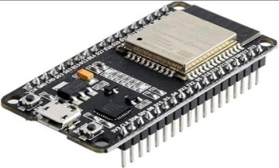
Figure 2: ESP 32 Controllers

Temperature Sensor:
A temperature sensor, such as the popular DHT11 or DS18B20, can be connected to the ESP-32 controller to measure ambient or body temperature. The ESP-32 can read the sensor data and transmit it wirelessly to a remote server or display it locally shown in Fig 3.
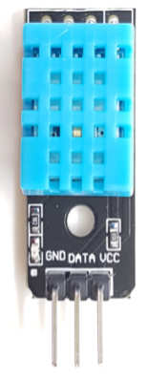
.

Figure 3: Temperature Sensor

HEART BEAT SENSOR
The heartbeat sensor shown in Fig 4 operates on the principle of photoplethysmography, a technique used to measure changes in blood volume within a vascular region of the body. This technique utilizes the fact that the intensity of light passing through or being reflected by the organ can be affected by the variations in blood volume. In applications where monitoring the heart pulse rate is necessary, the timing of the pulses becomes crucial. The flow of blood volume is determined by the rate of heart pulses, and since blood absorbs light, the signal pulses detected are equivalent to the heartbeats.
Photoplethysmography can be implemented in two different ways: transmission and reflection.
In transmission photoplethysmography, a light emitter sends light through a vascular region of the body, such as the earlobe, and the light is then received by a detector. The changes in the intensity of the transmitted light can be used to infer the variations in blood volume. On the other hand, reflection photoplethysmography involves the emission of light from a source, which is then reflected by the vascular regions of interest. The reflected light is then detected and analyzed to determine the blood volume changes. Both types of photoplethysmography offer unique advantages and can be applied to a wide range of industries and systems. They enable enhanced transparency, control, and performance when incorporated into various products or services.

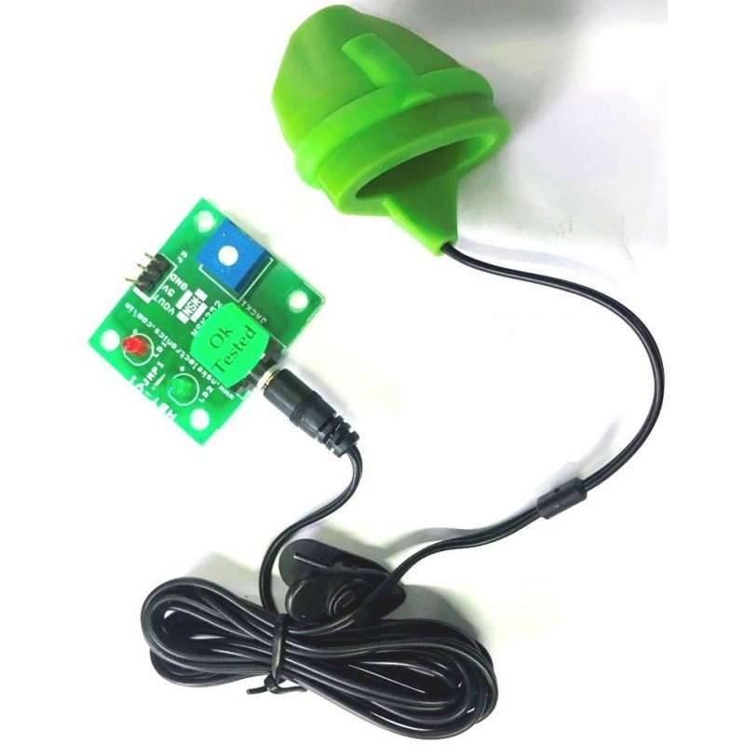
Fig 4 : Heart Beat Sensor

IR Sensor:
An infrared (IR) sensor shown in Fig 5, like the commonly used IR receiver module, can be used with the ESP-32 to detect infrared signals. This can be utilized for applications such as remote control systems, home automation, or proximity detection.
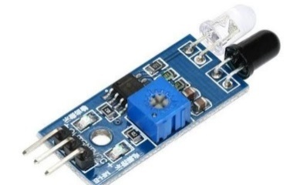
Figure 5: IR Sensor
ECG Sensor:
The ESP-32 can interface with an ECG (Electrocardiogram) sensor shown in Fig 6 to measure and monitor the electrical activity of the heart. ECG sensors, such as the AD8232 module, can be connected to the ESP-32 to capture heart rate and waveform data for healthcare or fitness applications.
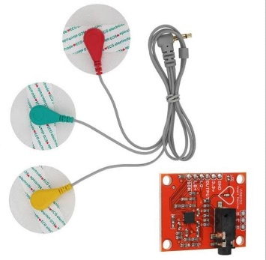
Figure 6: ECG Sensor
Glucose Sensor:
A glucose sensor as in Fig 7, such as the Freestyle Libre or Dexcom G6, is designed to measure blood glucose levels. While the ESP-32 itself does not have a built-in glucose sensor, it can interface with compatible glucose sensors to retrieve data. The collected data can be used for diabetes management or continuous glucose monitoring systems.
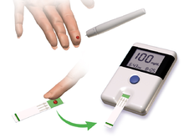
Figure 7: Glucose Sensor

Pulse Sensor:
A pulse sensor as in Fig 8, such as the MAX30102 or the Pulse Sensor Amped, can be connected to the ESP-32 to measure heart rate and blood oxygen saturation levels. This data can be utilized for health and fitness tracking applications.
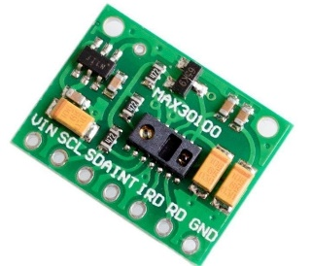
Figure 8: Pulse Sensor
GSM Module:
A GSM (Global System for Mobile Communications) module as shown in Fig 9 is a compact electronic device that enables mobile communication capabilities for other devices, such as microcontrollers or computers. It uses a SIM (Subscriber Identity Module) card to connect to a cellular network and transmit data through voice or text messages. GSM modules can be used in various applications such as security systems, health monitoring systems, and vending machines, among others. They enable health communication and control of devices over long distances and can operate on different frequency bands depending on the region they are deployed in. GSM modules can support different communication standards such as 2G, 3G, or 4G/LTE, with higher generations offering faster data transfer rates and better network coverage. Some modules also come equipped with GPS (Global Positioning System) or GNSS (Global Navigation Satellite System) capabilities, enabling location-based services. GSM modules can be programmed and controlled using standard AT commands, making them easy to integrate with other devices and software applications. Some modules also offer additional features such as built-in TCP/IP protocols, which enable direct communication with servers and cloud-based applications.
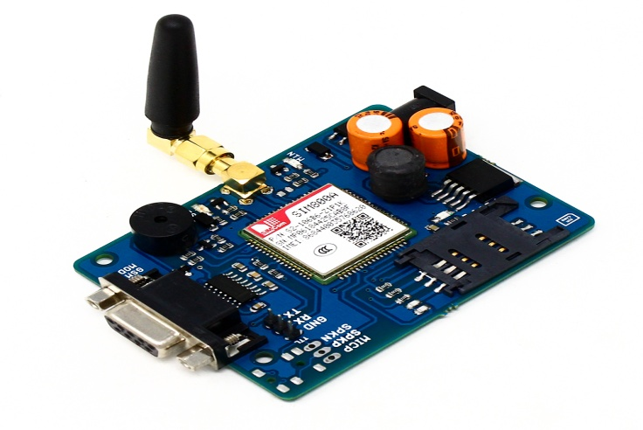
Figure 9: GSM Sensor
Relay:
A relay as in Fig 10 is an electromechanical switch that can be controlled by the ESP-32. By connecting a relay module to the ESP-32, you can remotely control high-power devices such as lights, motors, or appliances using digital signals.
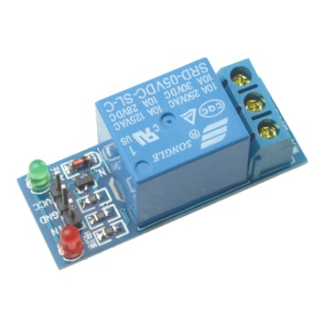
Figure 10: Relay
The ESP32 is a powerful and versatile microcontroller system-on-chip (SoC) developed by Espressif Systems. It serves as a successor to the widely popular ESP8266, offering improved performance, increased functionality, and enhanced capabilities. In this three-page document, we will explore the top view of the ESP32, providing a detailed description of its key components, features, and functionalities.
System-on-Chip (SoC):
The ESP32 integrates a high-performance 32-bit Xtensa LX6 dual-core processor, operating at up to 240MHz. This SoC not only provides processing power but also includes a wide range of peripherals, such as digital interfaces, analog interfaces, GPIOs, SPI, UART, I2C, and more. The presence of a dual-core architecture enables efficient multitasking, allowing the execution of multiple tasks simultaneously.
Wi-Fi and Bluetooth Connectivity:
One of the standout features of the ESP32 is its built-in support for both Wi-Fi (802.11 b/g/n) and Bluetooth (v4.2 and BLE). This combination makes it an ideal choice for a variety of IoT applications that require wireless connectivity. The Wi-Fi module supports station mode, soft access point (AP) mode, and simultaneous AP and station mode. Bluetooth support includes classic Bluetooth and BLE, enabling seamless communication with other devices.
Memory and Storage:
The ESP32 is equipped with a generous amount of memory to accommodate diverse applications. It features up to 520KB of SRAM for data storage and manipulation, as well as up to 4MB of flash memory for program storage. Additionally, it supports external SPI flash up to 16MB, providing ample space for data logging, web server hosting, and other storage-intensive tasks.
Power Management:
Efficient power management is crucial for IoT devices, and the ESP32 incorporates various features to optimize energy consumption. It supports different power modes, including active mode, sleep mode, deep-sleep mode, and hibernation mode. These modes allow developers to strike a balance between performance and power consumption, extending battery life and enhancing overall system efficiency.
Security:
Security is a paramount concern in the IoT landscape, and the ESP32 incorporates robust security features to protect data and ensure device integrity. It supports various cryptographic algorithms, including RSA, AES, SHA, and ECC, enabling secure communication and data encryption. Additionally, it provides secure boot, flash encryption, and secure storage mechanisms to safeguard sensitive information.
Peripherals and Interfaces:
The ESP32 offers a wide range of peripherals and interfaces to facilitate seamless integration with external components. It includes multiple UART, SPI, and I2C interfaces for connecting sensors, actuators, and other devices. Moreover, it supports capacitive touch sensors, ADCs, DACs, PWM, and SDIO for additional functionality. These features make the ESP32 highly adaptable to various project requirements and the pin configuration is Fig 11

The ESP-32 is a powerful, low-cost, low-power system-on-a-chip (SoC) microcontroller with built-in Wi-Fi and Bluetooth capabilities. It is designed and produced by Espressif Systems and is a successor to the ESP8266 microcontroller. The ESP-32 has two Xtensa 32-bit LX6 microprocessors with clock speeds up to 240 MHz, and includes a variety of peripherals such as 34 GPIO pins, multiple analog-to-digital converters, SPI, I2C, UART, and PWM interfaces, and a 12-bit SAR ADC with up to 18 channels. It also includes a range of security features such as hardware-accelerated AES, SHA-2, and RSA encryption, as well as hardware-based secure boot and flash encryption
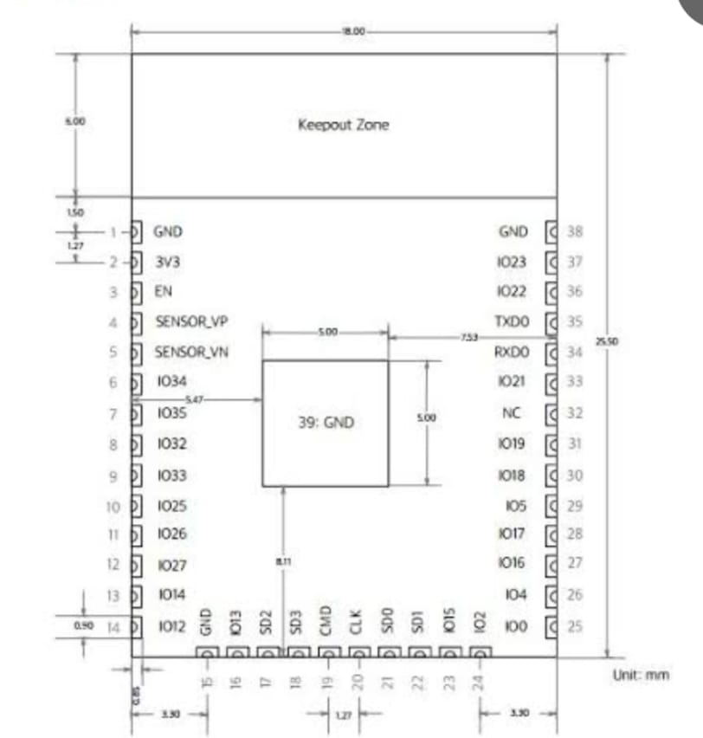
FIG 11: Pin Configuration of ESP 32
.
One of the key features of the ESP-32 is its built-in Wi-Fi and Bluetooth capabilities, which allow it to connect to a variety of wireless networks and devices. It supports both 2.4 GHz and 5 GHz Wi-Fi bands, as well as Bluetooth Classic and BLE (Bluetooth Low Energy) protocols.

The ESP-32 is widely used in a variety of IoT (Internet of Things) applications, such as smart home automation, industrial automation, and robotics, due to its low power consumption, high performance, and rich feature set. It can be programmed using a variety of programming languages, including C, C++, Python, and Arduino.

The top view of the ESP-32 chip shows a small rectangular shape with a size of approximately 7mm x 7mm. The top of the chip is covered with a black epoxy coating, which protects the internal components of the chip.

In the center of the chip, there are two microprocessor cores, which are connected by an internal interconnect. These cores are surrounded by a number of peripheral interfaces, such as GPIO pins, SPI, I2C, UART, and PWM.

Around the edges of the chip, there are a number of bonding pads, which are used to connect the chip to an external printed circuit board (PCB). These bonding pads are arranged in a grid pattern and are used for power and ground connections, as well as for connecting the peripheral interfaces to external devices.

On the top surface of the chip, there are also a number of markings, which indicate the part number, manufacturer, and other relevant information. These markings are typically printed in white ink and are located near the corners of the chip.

Overall, the top view of the ESP-32 chip shows a compact and highly integrated microcontroller with a rich set of features and interfaces, designed for a wide range of IoT applications.

BLYNK App
Blynk is a popular mobile application platform designed for IoT (Internet of Things) projects. It provides a user-friendly interface that allows you to control and monitor your IoT devices and sensors remotely. With the Blynk app, you can create custom dashboards, control widgets, and visualize data in real-time.
Here are some key features and functionalities of the Blynk app:
Dashboard Creation: Blynk allows you to design custom dashboards by adding various widgets, such as buttons, sliders, gauges, graphs, and displays. These widgets can be arranged and customized to suit your specific project requirements.
Widget Control: Each widget in the Blynk app is associated with a specific functionality. For example, a button widget can be used to turn on or off a connected device, a slider widget can control the intensity or speed of a device, and a gauge widget can display sensor data. You can interact with these widgets in real-time to control your IoT devices remotely.
Data Visualization: Blynk provides real-time data visualization capabilities, allowing you to monitor sensor data, device status, or any other relevant information. You can display data in the form of graphs, gauges, or simple value displays, making it easy to track and analyze the performance of your IoT devices.
Event and Notification Management: Blynk supports event-driven programming, allowing you to define triggers and actions based on specific conditions. You can set up notifications to receive alerts or push messages when certain events occur. For example, you can receive an alert when a sensor detects a specific threshold or when a device is turned on/off.
Cloud Connectivity: Blynk offers cloud connectivity, which means you can remotely access and control your IoT devices from anywhere with an internet connection. This allows you to monitor and manage your devices even when you are away from the physical location.
Integration with IoT Platforms: Blynk provides seamless integration with popular IoT platforms and hardware, including Arduino, Raspberry Pi, ESP8266, ESP32, and more. It offers a wide range of libraries and examples to help you quickly get started with your IoT projects.
Overall, the Blynk app simplifies the process of creating mobile interfaces for controlling and monitoring IoT devices. It provides an intuitive and user-friendly platform for building IoT applications without the need for extensive mobile app development knowledge and the architecture is shown in Fig 12.
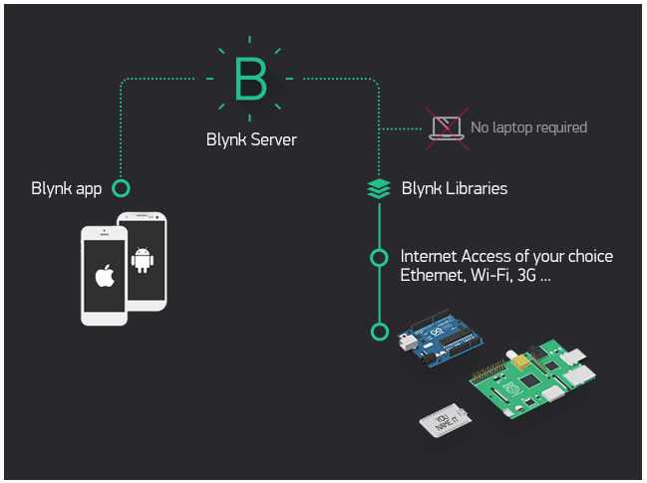
Figure 12 : Blynk architecture
Currently, Blynk libraries work with:
- USB
- Ethernet shield
- WiFi shield
- ESP-32 with Ethernet
- ESP-32 YÚN (testing in progress)
- ESP8266
- Raspberry Pi (Blynk will communicate with Pi's GPIOs)
- more ESP-32 compatible shields and boards (this list will be updated as we test the compatibility)
It's not that easy to take ESP-32 out of your home network, so we've built a Blynk server. It handles all the authentication and communication, and also keeps an eye on your board while the smartphone is offline. Blynk server runs on Java and is open-source. You will be able to run it locally if you really need to. Messaging between mobile apps , Blynk Server and ESP-32 is based on a simple, lightweight and fast binary protocol over TCP/IP sockets.
CREATING A PROJECT IN BLYNK APP
After downloading the app, create an account and log in. Welcome to Blynk!
You’ll also need to install the Blynk ESP-32 Library, which helps generate the firmware running on your ESP8266. Download the latest release from Blynk’sGitHub repo, and follow along with the directions there to install the required libraries as sgown in Fig 13
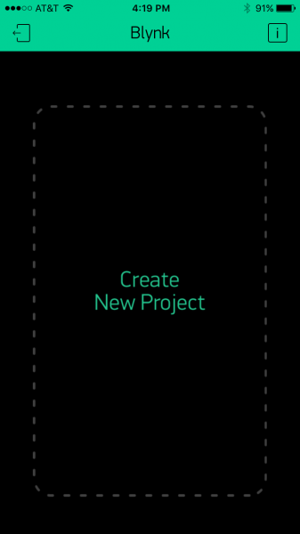
Figure 13: CREATING A BLYNK APP

Create a Blynk Project
Next, click the “Create New Project” in the app to create a new Blynk app. Give it any name you please, just make sure the “Hardware Model” is set to ESP8266 as shown in Fig 14.
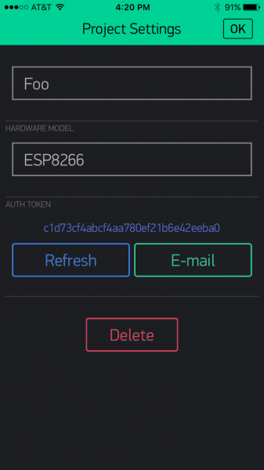
Figure 14 : ESP-32 HARDWARE SETTING
The Auth Token holds significant importance as it serves a crucial role in the functionality of your ESP8266 device's firmware. It is essential to securely incorporate the Auth Token into your firmware for proper operation

Add Widgets to the Project
Then you’ll be presented with a blank new project. To open the widget box, click in the project window to open as shown Fig 15.
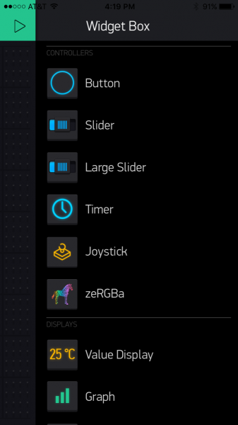
Figure 15: BLYNK APP WIDGET BOX
To configure the Button settings, begin by adding a button component to your setup. Once added, you can modify its properties by clicking on it. This button component enables you to control outputs on the ESP8266 device. For this specific case, you can assign the button's output to gp5, which is connected to an LED on the Thing Dev Board. By doing so, you'll be able to toggle the LED's state using the button. Additionally, it may be necessary to change the button's action to "Switch" as depicted in Fig 16. This action will ensure that the button functions as a toggle switch, allowing you to alternate the LED's state between on and off. By incorporating these adjustments, you can conveniently control the LED on the Thing Dev Board by clicking on the added button and utilizing it as a switch.
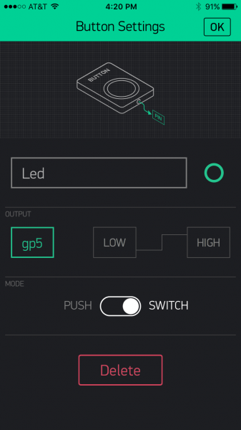
Figure 16 BLYNK APP BUTTON SETTING

Upload the Blynk Firmware
Now that your Blynk project is set up, open ESP-32 and navigate to the ESP8266_Standalone as shown in Fig 17 example in the File>Examples>Blynk>BoardsAndShields menu.

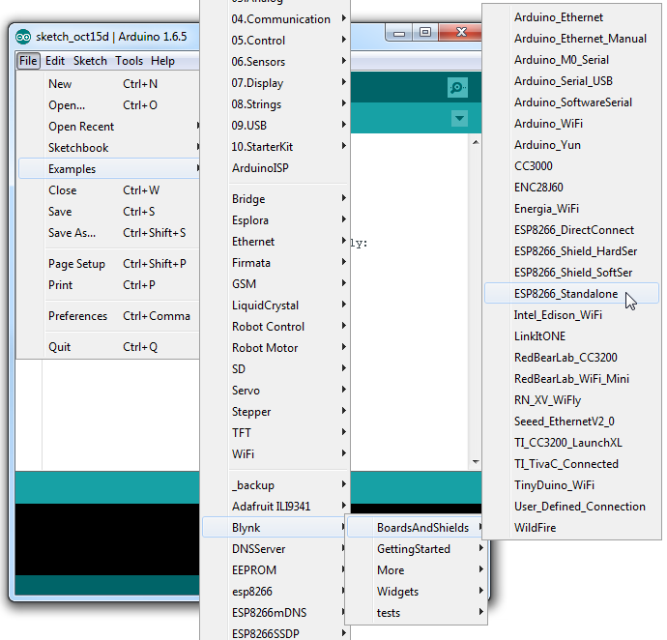
Figure 17: BLYNK APP SET UP
Before uploading, make sure to paste your authorization token into the auth[] variable. Also make sure to load your WiFi network settings into the Blynkbegin(auth, "ssid", "pass") function as shown in Fig 17.
Then upload!

Run the Project
After the app has uploaded, open the serial monitor, setting the baud rate to 9600. Wait for the “Ready (ping: xms).” Message as shown in Fig 18.
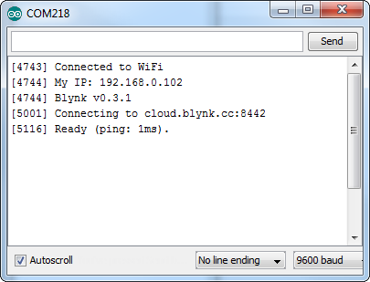
Figure 18: RUNNING THE PROJECT
Then click the “Run” button in the top right corner of the Blynk app. Press the button and watch the LED!
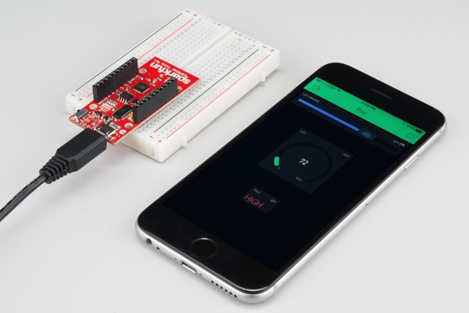
Figure 19: CONNECTING THE DEVICE TO BLYNK APP
Then add more widgets to the project. They should immediately work on the ESP8266 without uploading any new firmware. As shown in Fig 19
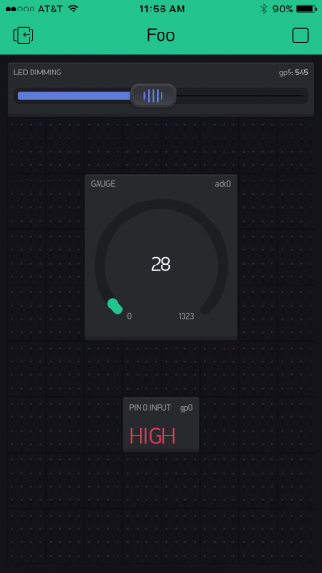
Figure 29: OUTPUT
You can add analog output sliders, digital input monitors, analog input gauges.and the output is shown in Fig20

ThingSpeak:
ThingSpeak as shown ib Fig 21 is an IoT platform and cloud service that enables users to collect, analyze, and visualize data from their IoT devices. It provides a convenient way to store, retrieve, and analyze sensor data in real-time. Here are some key features and functionalities of ThingSpeak:

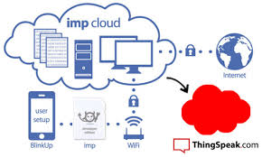
FIG 21: ThingSpeak Architecture
Data Collection: ThingSpeak allows you to send data from your IoT devices to its cloud server. You can send data using various protocols such as HTTP, MQTT, and TCP/IP. ThingSpeak provides APIs and libraries for popular programming languages like MATLAB, Python, and Arduino to facilitate easy integration with your IoT devices.
Data Storage: Once the data is sent to ThingSpeak, it is stored in channels. A channel is a collection of data associated with a specific IoT device or sensor. ThingSpeak provides a RESTful API to create and manage channels. Each channel can have multiple fields to store different types of data.
Data Visualization: ThingSpeak offers built-in visualization tools that allow you to create custom dashboards and plots to visualize your sensor data. You can create line plots, bar graphs, histograms, or custom visualizations using MATLAB functions. ThingSpeak also supports real-time updates, allowing you to monitor and visualize data as it arrives.
Data Analytics: ThingSpeak provides powerful analytics features that enable you to analyze your sensor data. You can apply mathematical operations, perform data filtering, and apply algorithms to extract insights from your data. Additionally, you can use MATLAB code to perform complex data analysis and create predictive models.
IoT Integrations: ThingSpeak seamlessly integrates with other IoT platforms and services, such as MATLAB Analytics, IFTTT, and ThingHTTP. This allows you to leverage additional capabilities and connect your IoT applications with various external services and platforms.
Webhooks and Alerts: ThingSpeak supports webhooks and alerts, which allow you to trigger actions based on specific conditions in your data. You can set up alerts to notify you via email or SMS when certain thresholds are met or when anomalies are detected in your sensor data.
Collaboration and Sharing: ThingSpeak enables collaboration by allowing you to share your channels with others. You can control the permissions for shared channels, allowing others to view, edit, or analyze the data.
ThingSpeak provides a comprehensive IoT platform for collecting, storing, analyzing, and visualizing sensor data. Its integration with MATLAB and extensive API support makes it a versatile tool for developing IoT applications and performing advanced data analytics.

RESULTS & DISCUSSIONS

The system can accurately measure and monitor various vital signs, including temperature, pulse rate, glucose level, and ECG, it also can send alerts to a designated phone number if the pulse rate is abnormal, enabling timely medical attention. And the system can control a water pump, providing additional functionality for health and hygiene applications.
The proposed system can be a valuable asset in hospitals, clinics, and homes where timely health monitoring and security are critical and can potentially improve the quality of life for individuals with health conditions, by providing early detection of health issues and enabling timely medical attention the Temperature output of the patient and its pulse rate are shown in Fig 22 and 23.
The system may raise privacy concerns, and proper measures should be taken to ensure the security of the data collected and transmitted. The system can be expanded with additional sensors or functionality to enhance its capabilities, depending on specific requirements and use cases.If the heart rate is below 60 or above 100 ,it will notify that heart rate is abnormal as shown in Fig 21

.

Figure 22: HEART RATE OUTPUT

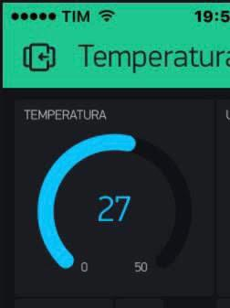

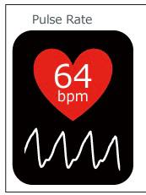
Figure 23 TEMPERATURE OUTPUT

Fig: 24: PULSE RATE OUTPUT

CONCLUSION
Absolutely! A health monitoring and security system that leverages advanced technologies can indeed be a valuable tool for tracking and reporting on an individual's health status. By incorporating wearables, mobile devices, and cloud computing, such a system can provide real-time data on vital signs, activity levels, and other key health metrics. This enables healthcare providers to monitor patients remotely and offer timely advice and interventions. In addition to collecting and updating patient information, a comprehensive health monitoring system can offer several additional features. For example, it can integrate with ambulance services, allowing for quick response and coordination in emergencies. By providing access to a list of leading doctors and their specialties, patients can easily connect with the appropriate healthcare professional for further consultation or treatment. Including information about hospitals and their special facilities enables patients to make informed decisions about where to seek care. Moreover, a health monitoring and security system plays a vital role in maintaining the well-being and safety of individuals in various settings, particularly healthcare facilities. By incorporating sensors, data storage and analysis tools, and alarms or notifications, the system can promptly identify potential health issues or security breaches. This ensures that healthcare providers and patients are alerted to any critical situations requiring immediate attention. To guarantee the privacy and confidentiality of patients' health information, it is crucial for the system to adhere to industry standards and regulations, such as the Health Insurance Portability and Accountability Act (HIPAA) and the General Data Protection Regulation (GDPR). Compliance with these standards helps protect sensitive data and ensures that patient information is handled securely. A well-designed and properly implemented health monitoring and security system can enhance patient outcomes, improve remote monitoring capabilities, and increase security in healthcare settings. By combining advanced technologies, adhering to privacy regulations, and offering additional features, such a system can provide comprehensive support for healthcare providers and patients alike.

REFERENCES

- S.H. Almotiri, M. A. Khan, and M. A. Alghamdi. Mobile health (m- health) system in the context of iot. In 2016 IEEE 4th International Conference on Future Internet of Things and Cloud Workshops (FiCloudW), pages 39–42, Aug 2016
- MOHAMMAD NURUZZAMAN BHUIYAN 1, MD MASUM BILLAH 2, FARZANA BHUIYAN3,MD MAHBUBUR RAHMAN6, (Member, IEEE), MD SIPON MIAH6,7, (Member, IEEE) Based on Design and Implementation of a Feasible Model for the IoT Based Ubiquitous Healthcare Monitoring System for Rural and Urban Areas,date of publication 29 August 2022, date of current version 7 September 2022
- Banka, Shubham and Madan, Isha and Saranya, SS "Smart healthcare monitoring using IoT" In International Journal of Applied Engineering Research, pp. 11948–11989, volume 13, number 15, 2018
- Rahaman, Ashikur and Islam, Md Milon and Islam, Md Rashedul and Sadi, Muhammad Sheikh and Nooruddin, Sheikh "Developing IoT Based Smart Health Monitoring Systems: A Review" In Rev. d’Intelligence Artif, pp. 435–440, volume 13, number 6, 2019
- Al-Ali, Abdul-Rahman and Zualkernan, Imran A and Rashid, Mohammed and Gupta, Ragini and AliKarar, Mazin "A smart home energy management system using IoT and big data analytics approach" In IEEE Transactions on Consumer Electronics, pp. 426–434, volume 63, number 4, 2017
- Zanella, Andrea and Bui, Nicola and Castellani, Angelo and Vangelista, Lorenzo and Zorzi, Michele "Internet of things for smart cities" In IEEE Internet of Things journal, pp. 22-32, volume 1, number 1, 2014
- Lin, Trista and Rivano, Hervé and Le Mouël, Fré déric "A survey of smart parking solutions" In IEEE Transactions on Intelligent Transportation Systems, pp. 22-32, volume 18, number 12, 2017
- Condoluci, Massimo and Araniti, Giuseppe and Mahmoodi, Toktam and Dohler, Mischa "Enabling the IoT machine age with 5G: Machine-type multicast services for innovative real-time applications" In IEEE Access, volume 4, pp. 5555–5569, 2016
- Condoluci, Massimo and Araniti, Giuseppe and Mahmoodi, Toktam and Dohler, Mischa "Enabling the IoT machine age with 5G: Machine-type multicast services for innovative real-time applications" In IEEE Access, volume 4, pp. 5555–5569, 2016
- K. Wei, L. Zhang, Y. Guo and X. Jiang, "Health Monitoring Based on Internet of Medical Things: Architecture, Enabling Technologies, and Applications," in IEEE Access, vol. 8, pp. 27468-27478, 2020, doi: 10.1109/ACCESS.2020.2971654.
- JOEL J. P. C. RODRIGUES, (Senior Member, IEEE), DANTE BORGES DE REZENDE SEGUNDO1,VICTOR HUGO C. DE ALBUQUERQUE 4, (Member, IEEE).Based on Enabling Technologies for the Internet of Health Things, date of publication January 4, 2018, date of current version March 19, 2018.
- K. Zhang and W. Ling, "Health Monitoring of Human Multiple Physiological Parameters Based on Wireless Remote Medical System," in IEEE Access, vol. 8, pp. 71146-71159, 2020, doi: 10.1109/ACCESS.2020.2987058.
- G. Cai, Y. Fang, J. Wen, G. Han and X. Yang, "QoS-Aware Buffer-Aided Relaying Implant WBAN for Healthcare IoT: Opportunities and Challenges," in IEEE Network, vol. 33, no. 4, pp. 96-103, July/August 2019, doi: 10.1109/MNET.2019.1800405.
- Devi CU, TV P, Madhavi M. IoT Based Health Care Monitoring System using Wireless sensor Networks. Indian Journal of Public Health Research & Development. vol. 9, no. 12, pp. 1579–1583, 2018.
.

