THE STRUCTURE AND BRIEF REVIEW ON Ba(NO₃)₂, KNO₃ AND DISPERSED SOLID ELECTROLYTES

I.1 STRUCTURE OF Ba(NO₃)₂ AND KNO₃
I.1.1 Ba(NO₃)₂
Barium nitrate is an isomorphous crystal with other nitrates such as Ca, Sr & Pb forming a group. It has a cubic structure with the space group Pa₃ and it belong to T_{h}⁶ class [1]. In the cubic system the symbol ‘T’ is used for tetrahedral symmetry group with four triad and three diad axes.

CaF₂ in its naturally occurring form is called the ‘fluorite’ and the compounds which crystallize in this form are called fluorites. The Nitrates of Ca, Ba, Sr and Pb are isomorphous and have fluorite type structure [1]. The two and three dimensional structure of fluorite RX₂ lattice is shown in figure 3.1. In a compound RX₂, each ion of species R is surrounded by eight equivalent nearest neighbor ions of species X forming the corners of a cube of which R is the centre. Each ion of species X is surrounded by tetrahedron of four equivalent R ions. More fundamentally the structure has a face centered cubic translational group and a space lattice of symmetry O_{h}⁵.

The structure is interpreted in terms of a primitive cube of side ‘a’. It comprises three interpenetrating face centered cubic lattices. The first is a lattice of species R with its origin at the point (0,0,0) and with primitive translational vectors of (0, 1/2, 1/2) ; (1/2, 0, 1/2); and (1/2, 1/2, 0) in the cube of side a. The X species are located on two further lattices with similar translational vectors but with origins at (1/4, 1/4, 1/4) and at (3/4, 3/4, 3/4a). The site of the R ion has O_{h} symmetry, being at the centre of a cube of eight X ions.
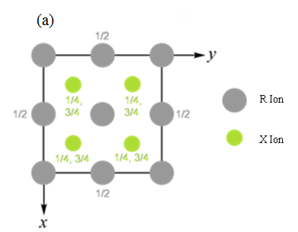
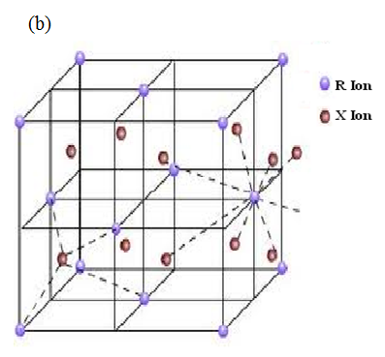
Fig.1.1 The Fluorite structure of the (a) two dimensional and (b) three dimensional RX₂ Lattice.

It is apparent that the fluorite structure provides close contact between the different species of atom or ion. Furthermore, if the ions of species R are sufficiently large, close contact between the ions of species X is prevented. If the constituent species are regarded as hard spheres with radii of r(R) and r(X), contact occurs between the R and X ions to the exclusion of X-X contact and of R-R contact [2] when the radii satisfy the condition 4.45 ≥ r(R) / r(X) ≥ 0.73.

The possibility of close contact between dissimilar ions suggests that the fluorite structure will be favored by strongly ionic compounds with formula RX₂ which possess large ions of type R. In fact the R ions are normally relatively small and it is possible to find several series of compounds in which one is able to pass through the other limiting value, enabling contact between X ions to occur. For example, among the halides of cadmium or of barium one finds that the fluorite lattice structure occurs for the smaller halide (X) ions while the iodides possess orthorhombic or sheet like structures.

The materials found to possess the fluorite structure have been divided by Wyckoff [2] into four main classes:
- The halides of the larger divalent cations (all but two are in fact fluorides) e.g., CaF₂, SrF_{2,} BaF₂, CdF₂, PbF₂, SrCl₂, BaCl₂.
- The oxides of certain large quadrivalent cations.
e.g., ZrO₂, CeO₂, ThO₂, and UO₂.
iii The oxides and other chalcogenides of alkali and other univalent cations.
e.g., K₂S, Na₂S and Li₂Se.
iv Miscellaneous intermetallic compounds and the oxy fluorides and hydrides of rare earth elements.

The nitrates of Ca, Sr, Ba and Pb are structurally similar to the compounds of the category (i) of the above classification. In Ba(NO₃)₂ the anion consisting of nitrogen at the centre and the oxygens occupying the corners of an equilateral triangle replaces the F⁻ ion of CaF₂ structure. There is a difference of opinion whether or not all the four atoms are coplanar. Two hypotheses have been proposed. The older opinion proposed by Vegard [3] where T_{h}⁶ space group is assigned to them has four molecules in the unit cell. In this case all the NO₃ groups are similar and so there is an inversion centre and all the three anions are coplanar with the nitrogen at the centre.

In the second hypothesis proposed by Birnstock [4] based on neutron scattering measurements, T⁴ space group is assigned. In this case two kinds of nitrate groups are distinguished and there is no centre of inversion. The oxygens in this proposal are no more coplanar with the nitrogen, but are thought to be pyramidal with the nitrogen atom displaced from the plane of the oxygens. Bon et al [5] have carried out the studies of infrared reflection spectra on the single crystals of these isomorphous compounds. The results were discussed and they concluded that the T⁴ structure is more appropriate on the basis of their studies.
Considering several properties of these crystals like the melting points, the solubility, thermal expansion, elastic constants, intensity of the Raman lines and the magneto-optic anomaly, srinivasan [6] has concluded that the bond between the metal ion and the nitrate ion is essentially ionic. The binding force of ionic crystals is due to coulomb attraction and is very high, giving rise to a high melting point. Since there are no free electrons ideally, we expect poor electrical and thermal conductivity. At temperatures approaching the melting point the ions become mobile enough to result in some ionic conductivity. The lack of free electrons also implies good optical transparency over large portions of the electro-magnetic spectrum. Optical absorption does not occur until the photon energy is high enough to excite an electron out of one of the filled ionic shells at about 6eV, which corresponds to the far ultraviolet.

I.1.2 KNO₃

Potassium nitrate was discovered in 1958 as a ferroelectric material by Sawada et al [7]. Since then KNO₃ has been investigated by many researchers from the ferroelectric, dielectric, and structural view point [8]. It has been known since the late 1960s that KNO₃ exists in one of the several crystallographic phases depending on external state variables. Only one phase is ferroelectric (phase III) which is known to exist at elevated temperature while cooling from higher temperature. This ferroelectric phase III would be of technological interest if it can be stabilized at room temperature. KNO₃ has been found to possess aragonite structure known as phase II by many researchers at room temperature.

The molecular structure of KNO₃ has been investigated for the first time by electron diffraction by patrov et al [9]. The first stage of structural analysis was performed on the assumption of a bidentate configuration of KNO₃ molecule with C_{2v} symmetry and with D_{3h} local symmetry of the NO₃ fragment. KNO₃ has been found to exist in variety of phases as shown in Table-I. On heating, the crystal structure changes from orthorhombic (phase-II) to rhombohedral (phase-I) and on cooling, the phase-I changes first to phase-III at about 124ºC which is ferroelectric and then to phase-III to phase-II at about 110ºC [10-13].
TABLE-I The different phases of KNO₃
Phase of  KNO3 | Temperature  (ºC) |  | Unit –cell data  (Å) |  |  |  | Crystal structure
 |  | a |  | B |  | C
Phase II | 130 | 5.414 |  | 9.164 | 6.431 |  | Orthorhombic
Phase I | 124 | 5.423 |  | 5.423 | 9.638 |  | Rhombohedral
Phase III | 110 | 5.430 |  | 5.430 | 9.095 |  | Rhombohedral

The crystal structure and related parameters of different phases of KNO₃ are shown in figure 3.2. The phase transitions also accompany the change in volume of the unit cell. The relative volume changes of KNO₃ unit cell associated with the phase II → phase I, phase I → phase III, phase III → phase II transitions are +0.27, -5.375, and -3.56 %, respectively [14].

The phase II → phase I transition increases the overall density of the loosely packed structure. However, the decrease in the volume during the phase I → phase III transition allows the structure to increase the packing density. This packing places the KNO₃ under an effective stress, which is known to affect the phase transition temperatures. This effective applied stress enhances the sintering of the KNO₃ particles [15].

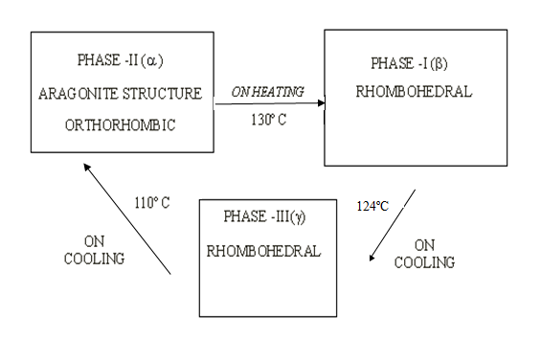
Fig.1.2 Crystal structure changes when KNO₃ was passed
through the heating and cooling cycles.

The crystal structures of the phase I and phase II are non-polar, but that of the phase III is polar. The corresponding crystal structures of aragonite and γ-phase of KNO₃ can be seen in figures 3.3(a) and 3.3(b) respectively. Aragonite is the stable phase of KNO₃ at room temperature and γ-phase is the rhombohedral unit cell in the ferroelectric phase III which contains one molecule of KNO₃ and K⁺ ions occupy its corners whereas NO₃⁻ ion lies near its body center. The NO₃ group forms a regular triangle with the N atom at its center. The plane of the NO₃ group is perpendicular to the c-axis and it does not exist exactly at the body center [15].

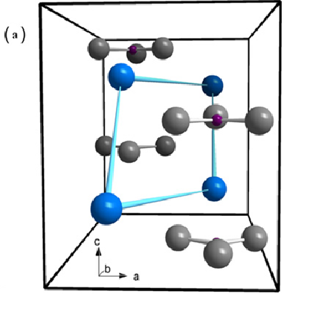
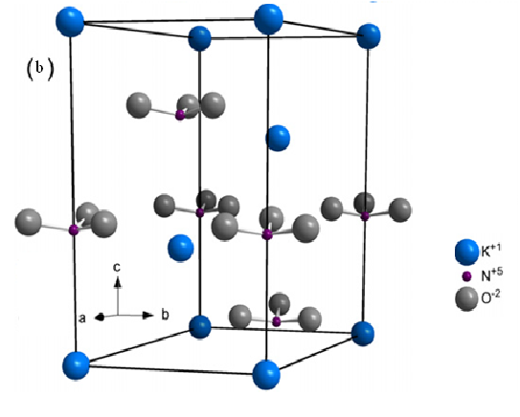
Fig 1.3 Crystal structure views of KNO₃ a) aragonite, (b) γ -phase.
Potassium nitrate is one of the several substances recommended [16] as a standard reference material in thermal analysis. The alkali nitrate crystals are dielectric ones with the variation in both the conductivity and the crystal structures at their phase transitions.

I.2 A BRIEF REVIEW ON MIXED SOLID ELECTROLYTES

Mixed crystals aroused considerable interest, curiosity and motivated extensive investigations because of their wide applications. During the last several years, considerable attention has been devoted to the study of transport processes in ionic crystals. Among the transport processes, conductivity studies provide valuable information on the state of point defects in ionic crystals. The ionic conductivity of such crystals at temperatures not very close to the melting point is due to the migration of positive ion vacancies [17].

Ionic conductivity measurements as a function of temperature have been done by a number of researchers. The most of the work is done on alkali halide crystals doped with anion as well as cation impurities [18-20], since they are easily obtainable ionic compounds of relatively simple crystal structure. However the work on mixed crystals is very limited. Lehfeldt[21], and Phipps and Patridge [22] investigated conductivities of several alkali halides, including KBr and KCl, while Kelting and Witt [23] established the effect of divalent impurities on conductivity. Ionic conductivity studies of Ambrose and Walace [24] on KCl-KBr mixed crystals showed that the conductivity of the mixed crystals is never far outside the range of conductivity fixed by the pure end components, indicating that the population of vacancies in mixed crystals is same as those in the pure end crystals. But the conductivity studies of Schultze[25], Annenkov et al [26], Arends et al [27], and Zayadowskaya et al[28] indicated that the concentration of vacancies in mixed crystals exceed that in the pure end components.

Ionic conductivity studies in KCl-KI mixed crystals have been done by U.V. Subbarao and V. Haribabu [29]. Ionic conductivity studies in KCl–NaCl mixed crystals were done by P.Veerasham et al [30]. Anomalous ionic conduction AgBr-AgI mixed crystals and multiphase systems have been studied by K.Shahi et al [31]. Growth and study of mixed crystals of Ca-Cd iodate were studied by S.L Garud et al [32]. Growth and characterization of mixed crystals of NaBr-KBr were studied by C.M. Padma et al[33]. The conclusion of these studies indicates that structure of defects for mixed crystals is different in contrast with their pure position. The difference of atomic size between mixed crystals cause to local stresses in lattice and this defect change crystal properties, and its lattice parameters [34]. In addition, mixed alkali halides found their applications in optical, opto-electronic and electronic devices.

The work on alkali and alkaline earth nitrates is very limited. Electronic structure of fluorite type compounds and mixed crystals was done by J. Kudrnovsky et al [35]. X-Ray diffractometry studies and lattice parameter calculation on KNO₃-NH₄NO₃ solid solution were studied by Wen-Ming Chien et al [36]. More recently, new attention has been paid to the fluorite-type compounds and derived mixed crystals in connection with their superionic conductivity. Survey of literature indicates that there is no work on dc ionic conductivity of mixed crystals comprising of alkaline earth nitrates as against alkali nitrates in general and no such conductivity work on Ba(NO₃)₂ and KNO₃ mixed crystals in particular.

I.3 A BRIEF REVIEW ON DISPERSED SOLID ELECTROLYTES

The development of dispersed solid electrolytes can be linked to the observations made during the beginning of this century [37] that the conductivity of two phase mixtures may exceed the conductivities of pure constituents. Wagner [38] and Crosbie [39] studied the conductivity behavior of semiconductors, with small inclusions of another non-conducting phase and found that the conductivities exceeded those of pure constituents. Recently, this approach has been extended to solid electrolytes in order to bring about enhancements in their ionic conductivities. Most of the work reported in the literature has been done with the dispersion of insulators such as Al₂O₃, SiO_{2,} fly ash, ZrO₂ etc., in ionic conductors. Among these in the present work the alumina with particle size(1 µm, 0.3µm, 0.06µm), SiO₂(20nm), CeO₂(15nm) were used in the preparation of the dispersed solid electrolyte systems.

In the following sections review of the work already done in the form of dispersed solid electrolyte systems is presented exhaustively.

I.3.1 LITHIUM HALIDES

Liang [40] is almost the founder of studies on dispersed systems who first reported his results in Anhydrous LiI dispersed with Al₂O_{3.} As per his observations there was a maximum in conductivity of about 10⁻⁵ S/Cm at 25⁰C at around 40 mole percent of Al₂O₃. It was found that the electronic conductivity of these systems was insignificant compared to the ionic conductivity. The conduction mechanism was attributed to the cation vacancies which are the species responsible for conduction in pure LiI. It was also confirmed by X-Ray diffractograms(XRD) that there was no indication of formation of any solid solution. The discharge and storage characteristics indicated that the system functioned as a practical, low rate solid-state battery system [41]. However, the conductivity studies [42] on LiI.H₂O showed a significantly higher value than anhydrous LiI. The dispersion of Al₂O₃ or SiO₂ enhanced the conductivity further in this system. It was also suggested that the highest conductivity is reached with very fine alumina powder but alumina powders less than some critical radius are less effective.

LiI-Al₂O₃ composite system was investigated using NMR study which showed evidence for occurrence of highly conductive phase. The self diffusion constant of Li in this system was found to be 8.1 × 10⁻¹⁰ cm²/sec at 300ºK which is 1600 times larger than that in pure LiI matrix. This is a reasonable order of magnitude to explain the enhanced conductivity quantitatively [43]. The effective surface properties of alumina upon the enhancement of conductivity in LiI-Al₂O₃ composite were studied [44] by measuring the thickness of the interface layer. Heat treatment of alumina resulted in a slight decrease of thickness of interfacial layer. The surface properties changed with this treatment. The extent of basic active sites, especially –OH group was found to have an effect on the conductivity enhancement. In their subsequent study [45] they realized further enhancement of conductivity when dispersed with particles of γ- Al₂O₃ whose surface was modified by adsorption of nitrates of alkali and alkaline earths and subsequent thermal decomposition at 800⁰C.

Significant enhancement of conductivity was also noticed in other lithium halide dispersed systems that include: LiCl-Al₂O₃ [46], LiBr-H₂O-Al₂O₃(α, β) [47-49] with different dispersoids such as α- Al₂O₃, SiO₂, γ- Al₂O_{3,} η- Al₂O₃ in LiCl. In the case of η- Al₂O₃(25 m/o) the enhancement was about 2 orders of magnitude measured at 25⁰C and the activation energy was found to decrease by half of that for LiCl. Nakamura and Goodenough [47] reported a maximum enhancement of about 2 orders at 43⁰C for LiBr.H₂O-Al₂O₃(40 m/o), a maximum of 2 orders of magnitude was also measured by Slade and Thompson [48] who showed that the enhancement was a function of the surface area of alumina particles. In the study of Shiuli and Shahi [49] the maximum enhancement recorded was about 2 orders at 302K for 10 m/o of Al₂O₃. The SEM showed that the distribution of Al₂O₃ was not uniform and the particles of Al₂O₃ of 0.05 μm agglomerated to 0.5 μm.

The occurrence of highly conducting phase found to be present in these systems was studied by Chen Liquan in LiCl;η-Al₂O₃ [46] with mole percent and temperature and Takeshi and Shichio [50] in LiBr-Al₂O₃ from Li NMR spin relaxation times. The amount of this highly conducting phase was found to increase with the amount of dispersed oxide at lower m/o Al₂O₃ and was found to be constant later up to 50 m/o, which means that the thickness of highly conducting phase layer was maintained constant up to 50 m/o of Al₂O₃. This layer was found to decrease linearly with Al₂O₃ content beyond 50 m/o. This explains the composition dependence of enhancement effect.
I 3.2 FLUORITES

The enhancement of conductivity in fluorides of Ca and Ba was observed by Fujitsu et al. [51] by dispersing with Al₂O₃ particles of sizes 0.3 and 0.06μm. In CaF₂-Al₂O₃ system a maximum enhancement of 1-2 orders of magnitude was observed for 0.06μm at 5 m/o of Al₂O₃ and for 0.3μm at 10m/o of Al₂O₃ at 500ºC and it was found to depend on composition as well as particle size of Al₂O₃. A similar variation could be observed in BaF₂ - Al₂O₃ where maximum was observed for 20m/o Al₂O₃ at 500ºC for 0.3 and 8μm particles. Explanation for the composition and particle size dependence of conductivity assumed the formation of highly conductive interface between host matrix and Al₂O₃ particles. The conductivity and the thickness of the interface layer at 500ºC were estimated to be 10⁻³ S/cm and 0.3 to 0.6μm respectively by simple mixing model. Addition of Al₂O₃ or ZrO₂ to the polycrystalline CaF₂ [52] was found to increase the conductivity relative to host material. The maximum enhancement was recorded to be 2 orders of magnitude for 10m/o Al₂O₃ powder of the higher surface area from Alcoa Co. and for 5m/o Al₂O₃ samples of lower surface area from Adolf Meller Co. in the low temperature region as well as a decrease in the activation energy for conduction compared to pure CaF₂. The 25m/o composites of both types of alumina showed a decrease in conductivity which was attributed to blocking effects of the insulating Al₂O₃ phase created in the composite.

In ZrO₂ dispersed system a more systematic conductivity behavior was observed where the maximum enhancement occurs at 5m/o in both high and low temperature regions. Increased concentration of fluorine ion interstitials at the interface was thought to be responsible for such enhancement [53]. Measured transport number of fluorine ions in these composites was in support of the above conclusion. The increase in the conductivity was studied in Al₂O₃, CeO₂ dispersed CaF₂ systems by vaidehi et al., [54]. The maximum enhancement observed in Al₂O₃ dispersed system was 2 orders, whereas in CeO₂ dispersed system it was about 3 orders of magnitude at 650º K with respect to pure CaF₂. Build up of space charge regions at the phase boundaries of dispersed solid electrolyte systems were postulated to cause the enhancement of their ionic conductivities. Some aspects of the increase in the ionic conductivities of this system were explained by Maier’s semi-quantitative model based on quasi-parallel switching. It was proposed that a substantial enhancement in the vacancy concentration of CaF₂ brought about by the attraction of F⁻ ions to the surface of Al₂O₃ (or CeO₂) was responsible for the low temperature increase in the conductivity of CaF₂.

The enhancement recorded in fluorite type material SrCl₂-Al₂O₃ system [55] was observed to depend on the composition and the grain size of Al₂O₃ and the method of preparation. The particle sizes used in this study were 0.06, 0.3, 1, 3, 8 and 15μm. These Particle sizes were found to aggregate into larger secondary particles during the sample preparation and their average particle sizes were measured to be 2.6, 8.2 and 10μm whose original sizes were 0.3, 3 and 8μm respectively. It was considered that the interface between SrCl₂ matrix and Al₂O₃ particles played a major role in giving rise to high ionic conductivity. The conductivity enhancement was estimated to be 2 orders of magnitude while the thickness of the interface layer was estimated by simple mixing model to decrease with increase in temperature from 0.6 to 0.15μm.
In order to evaluate the validity of the estimations made by simple mixing model the conductivity studies on a multi-layered sample were undertaken by the authors (Fujitsu et al.) [55]. This multi-layered sample was prepared by dispersing SrCl₂ in sec-butyl alcohol and using this solution to paint both the surfaces of Al₂O₃ as thin plates (50μm.), which were laminated upon each other and finally sandwiched between two thick Al₂O₃ plates. The current was measured parallel to the interface layers. It was observed that the calculated conductivity was slightly higher than the measured conductivity and this was attributed to the imperfect contact between Al₂O₃ plates and SrCl₂ layers or due to an experimental error. This experiment leads the authors to believe in the formation of an interfacial layer of sub micron size between the SrCl₂ and Al₂O₃ that produced the enhancement effects.

Two probe ac impedance measurements carried out on PbF₂ when dispersed with CeO₂, SiO₂, ZrO₂ and Al₂O₃ in the frequency range 10 HZ to 10⁵ HZ showed an enhancement in the extrinsic conduction [56] region. The adsorption of water was estimated to be 0.1% and 0.2% in Al₂O₃ and SiO₂ respectively when they were exposed to air at room temperature. No new phase was detected by X-Ray powder diffraction in any of the mixtures. The conduction mechanism was explained on the basis of the space charge layer formed at the oxide/host interface which was determined by the chemical reactions at the interface. These interactions were discussed by comparing with particle hydrates. A particle hydrate is a composite consisting of colloidal sized particles dispersed in an immobilized aqueous solution. Proton conduction occurs in this immobilized aqueous matrix. If aqueous matrix is initially pure water, then the analogy with a colloidal particle dispersed in a stoichiometric salt is nearly exact except for the crystalline character of the salt.

I.3.3 ALKALINE EARTH NITRATES

Enhancement of dc ionic conductivity is in dispersed solid electrolyte system Sr(NO₃)₂-Al₂O₃ was studied by Narender Reddy et al [57-58]. The maximum enhancement of about 3 orders is observed for 29.3m/o of Sr(NO₃)₂-Al₂O₃ system. XRD showed no evidence of formation of any solid solution and as per them the very high melting point of the insulator Al₂O₃ also could be a reason why it cannot form a solid solution. Enhancement of conductivity was explained on the basis of the formation of space charge layer. Sr(NO₃)₂, being a anti-frenkel type defect solid, enhancement observed in it could be understood as follows: The interaction between the mobile ions of MX and the dispersoid D leads to the formation of vacancies of mobile ion species in the space charge region near the MX/D interface. This can happen both when the mobile ions are attracted to the phase D leaving the vacancies at the interface and repelled in to the matrix MX to form interstitials. Of these the formation of vacancies was thought to be more probable then the formation of interstitials.

They extended their studies on the role of particle size (36.9, 0.3 and 0.06μm) and mole percent of the dispersoid in Sr(NO₃)₂:Al₂O₃ [59] composite solid electrolyte system. The enhancement of conductivity was observed to depend on the size of the particle, however, for a given specific surface area it was found to be same for all the three particle sizes. Enhancement of conductivity was noticed to increase with mole percent of the dispersoid in the extrinsic temperature region. The decrease of enhancement at higher mole percent was attributed to the clustering of dispersoid particles due to the decrease in the total surface area available to interact with the host material.

I.4 THEORETICAL MODELS

Several phenomenological theories have been proposed to understand the ion transport mechanism in composite electrolyte systems. No single unified model exists, as yet, which can explain uniquely various experimental results on different composite electrolyte systems. However, the central feature of the majority of the models, suggested to explain conductivity enhancement in two-phase composite systems, is the existence of a space-charge region (called double layer) at the interface between the host and dispersoid. Various experimental studies have been directed towards this theme, namely dependence of conductivity on the surface area [60, 61] of alumina, apparent effect of surface hydration [61], etc.

In addition to this, bulk interactions have also been suggested as a cause for conductivity enhancements in some composite systems [62]. Most of these models focus on the calculation of compositional dependence of conductivity. They differ only in the methods of calculation and in the assumptions concerning the distribution of the dispersoid particles in the composite system. Some important models proposed for composite electrolyte systems are discussed below.
I.4.1 SPACE CHARGE MODLES
I.4.1.1 JOW AND WAGNER’S MODEL

Kliewer [63] proposed the continuum model for the space charge region near surfaces of Frenkel disorder type compounds(like CuCl) to describe the case of space charge regions surrounding spherical inclusions in matrix material of Frenkel type. In order to explain conductivity enhancement in a CuCl-Al₂O₃ composite electrolyte system, Jow and Wagner [61] extended Kliewer’s theory. They assumed that a space charge region is created at the host and dispersoid interface boundary when a dispersoid phase (A) is introduced in to the electrolyte host matrix (MX). A space charge layer of thickness λ has been created around the dispersoid particles. Figure 3.4 shows the idealized spherical particle and cross-sectional view for analytical calculation. They proposed that the dispersoid particle has a charge, though the spin is not known, at near the surface, which is compensated by the formation of oppositely charged defects in the diffused space charge. As a result, an excess defect concentration in this region is formed.

Jow and Wagner attributed this unexpected enhancement to the space charge region formed near the interface between the matrix electrolyte and the inert second phase. The result of the deduced conductivity for the low content of the second phase was shown as
σ = σ₀ + 3eμ <Δn> λ (1/r)(P /1-P) (3.1)
Where σ is the ionic conductivity of the matrix material in the bulk, e is the absolute electronic charge, <Δn> the average excess charge density in the space charge
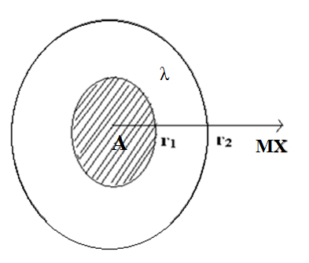
Fig. 1.4 Schematic cross-sectional view of single alumina particle in a host matrix.

region, μ the mobility of the ion or defect species in the matrix material, λ the Debye length, r the radius of the dispersoid of the second phase and p the volume content of the second phase. This model agreed well with the experimental results at low concentrations of the second phase. With regard to the limit of the assumption that the second phase should be much smaller than that of the matrix. This model therefore cannot account for maxima of conductivity observed in several cases for a given mole percentage of the dispersoid.

I 4.1.2 MAIER’S MODEL

Maier [64-66] has proposed, an approach for estimating the bulk ionic conductivity in an ionically conducting matrix MX dispersed with insulating second phase A. In this it is considered that there is no solubility or chemical reaction except that there is a possibility of surface interaction which is known to occur with oxides between the host matrix MX and insulating phase A. He has also discussed the defect chemistry involved in the space charge region at the interface which is responsible for the conductivity enhancement. The surface interactions at the interface results in the formation of space charge which is exponentially decreases with x (distance) into the interior. The defect reaction at the interface is understood by splitting it into the formation of the bulk vacancies and interstitials in Frenkel type solid.
M_{M} + V_{A} ↔ M '_{A} + V¹_{M} (3.2)
M '_{A} + V₁ ↔ M '₁ + V_{A} (3.3)

The first part of the reaction is that when a cation in normal lattice (M_{M}) goes on to the interface (assuming that there is a vacancy at interface site V_{A}) and becomes an interfacial cation (M'_{A}) creating a vacancy in its normal lattice position (V¹_{M}). In the second part, interface cation (M'_{A}) will be moved to interstitial position (assuming that there is an interstitial vacancy at V₁), and becomes interstitial cation (M'₁), leaving the interface site vacant again. Δ_{VA}G⁰, Δ_{IA}G⁰ are the free energies required for the formation of vacancy and interstitial respectively in the presence of the second phase and Δ_{S1}G⁰ is the energy required for the surface interaction due to the presence of the second phase A. The corresponding interaction is given by
M_{S} + V_{A} ↔ M'_{A} + V_{S} (3.4)
Where M_{S} is a surface cation. In this, two cases are possible. One is stabilization of M surface ion by the second phase i.e., an attractive interaction between MX and A-phase. A possible mechanism is shown in Figure 3.5(a). If the energy of this mechanism is sufficient enough to compensate the entropic effects, the free energy of the vacancy formation is lowered and that of interstitials is increased compared to the intrinsic values. If Δ_{VA}G⁰ < Δ_{IA}G⁰, the surface interaction has the consequence that ions will be sucked out of the volume and the concentration of vacancies will be increased. On the other hand, the M ions will be pushed into interstitial sites (repulsive interaction between A and M_{s}) as in Figure 3.5(b). Therefore, in both the cases for sufficiently strong interactions, an extrinsic conductivity enhancement is to be expected. This model treats the space-charge region as separate phase and considers each phase as a parallel resistor. The total conductivity is given by
σ = β_{A}φ_{A}σ_{A} + β_{α}φ_{α}σ_{α} + β_{SC}φ _{SC}σ_{SC} (3.5)
Where α denotes the bulk, A denotes the insulating phase and SC space-charge region. φ_{A} is the volume fraction of the phase A, β is a parameter describing the deviation from the ideal parallel switching. The physical situation is shown in figures 3.6(a) and (b).
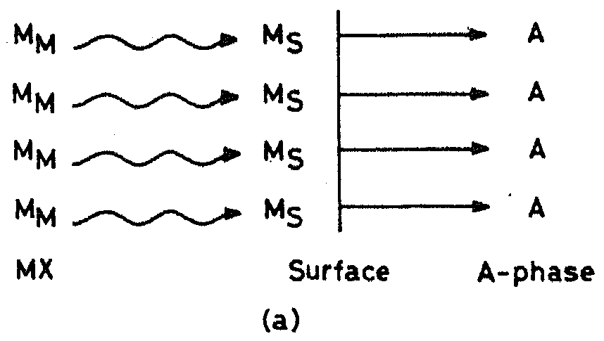

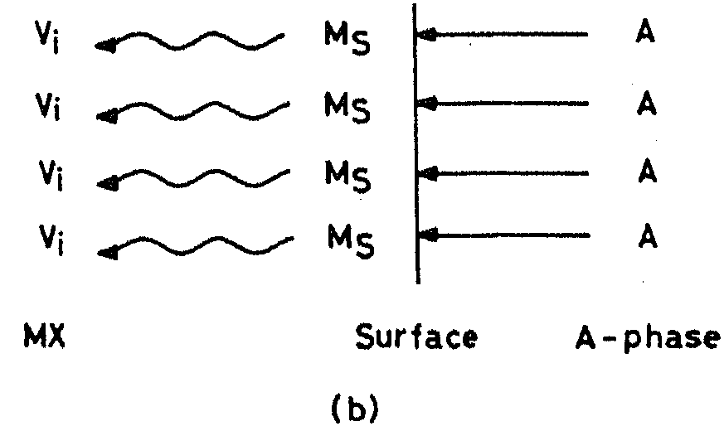
Fig. 1.5 The surface effects of a phase on host matrix
- An attractive interaction results in enrichment of vacancies.
- A repulsive interaction in driving M_{s} surface ions into interstitial positions.
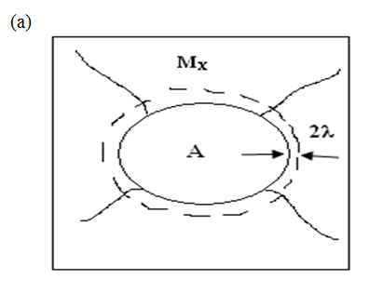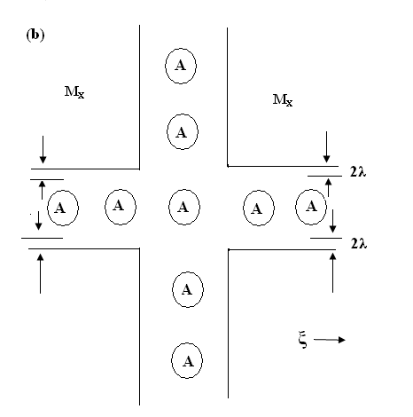
Fig 1.6 (a) Phase A particle embedded in MX material and bearing a space charge layer
(b) Coherent Phase A spheres forming crossing chains or areas.
The conductivity component due to the space charge region, from eq.(3.1) may be written as
σ_{SC} = e (2λ) μ_{V} (C_{V0} C_{Vα}) ^{1/2} (3.6)
here μ_{V} is the mobility of vacancies. C_{V0} and C_{Vα} are the concentrations of vacancies at the surface and the bulk respectively. 2λ is the effective thickness of the space charge layer. The dispersoid particles are assumed to be spherical and surrounded by a space charge region of thickness 2λ. The volume fraction of the space charge layer is obtained by subtracting the volume fraction of inner sphere from that of the outer sphere and is given by
φ_{SC} = 3 (2λ / r_{A}) φ_{A} (3.7)
where r_{A} is radius of the dispersoid particles, so the total conductivity from eqn. (3.6) is given by
σ = (1-φ_{A} ) σ_{α} + 3e^{β}_{SC} 2λ (φ_{A} / r_{A}) μ_{V} (C_{V0} C_{Vα})^{1/2} (3.8)

By adjusting the ideal parallel switching parameter, ^{β}_{SC}, in the range 0.2-0.7 depending upon distribution topology, it has been seen that the above equation explained experimental results such as larger conductivity enhancement at low temperatures, particle size dependence, effect of wet dispersoid etc., for various solid electrolyte systems fairly well. The attractive feature of Maier’s model is that it highlights the mechanism responsible for enrichment of surface defects in the space charge region. Although, Maier’s model explains many characteristic features of composite electrolyte systems well, it failed on several points such as: Maxima in σ versus φ_{A} plots, the assumption of an oversimplified distribution topology being characterized by a β –factor and resulting in quasi-parallel switching, the assumption of spatially constant values for mobility, the dielectric constant and the molar volume, neglecting the structural changes, polarization effect , elastic effects etc.

I.4.2 RANDOM RESISTOR NETWORK MODEL

Jow and Wagner’s and Maier’s models could not account for the typical conductivity variation in most composite electrolyte systems, which is marked by initial increases with increasing concentration of the dispersoid phase followed by rapid decrease. In order to account such threshold a different model namely, random resistor network model has been proposed according to which a dispersoid system can be considered as a three component system consisting of non-conducting, normally conducting and highly conducting bonds because of their distinct interfacial properties. The bonds are distributed in space according to random distribution of insulating material in a normally conducting matrix with a highly conducting interface in between. The resistor model was mapped according to random walk [67-75] which was solved by means of Monte carlo simulations. A special feature of this model is that there exist two threshold concentrations P'_{C} and P''_{C}. Near P'_{C} and P''_{C} they found critical properties corresponding to random conductor/super conductor networks and normal conductor/insulator networks respectively.

The construction of this model in two dimensions is described by assuming a square lattice with the dispersed insulating material randomly occupying the squares with probability P. The same model in three dimensions can be explained by taking simple cubic lattice with randomly occupied unit cubes of probability P. The bonds connecting two neighboring lattice sites are regarded as electrical resistors. And these are distinguished as highly conducting bonds with interface conductance σ_{A}, normally conducting bonds with conductance σ_{B} and non-conducting bonds with σ_{C}=0. In cubic lattice, bonds are insulating if they belong to four occupied cubes and highly conducting if they belong to one, two or three occupied cubes and the remaining bonds are normally conducting. The fractions P_{B}^{(A)}, P_{B}^{(B)} and P_{B}^{(C)} of highly conducting, normally conducting and insulating bonds depend on the concentration P of the dispersoid.

P'_{C} and P''_{C} are obtained from different types of bonds. P'_{C} is related to the interference bonds and defines the lowest concentration where the infinite network of highly conducting bonds develops [interface percolation]. P'_{C} is related to insulating bonds and defines the percolations threshold where all normal and interface bonds get disrupted. In these types of lattices the critical concentrations are related by
P'_{C} = 1- P''_{C} (3.9)
The dependence of total conductivity (σ) on composition P is understood qualitatively by means of figure 3.7. The enhanced interface conductance τ is given by σ_{A}/ σ_{B}(where σ_{A}>σ_{B}) . For P <<P'_{C} a certain enhancement of conductivity is expected due to the increment of current flow along the σ_{A} bonds (figure 3.7(a)) and it saturates to a finite value even in the limit τ →∞, since the σ_{A} bonds form only isolated clusters. At P=P'_{C} the situation changes drastically due to the formation of a percolating path of σ_{A} bonds (figure 3.7(b)) where conductivity increases indefinitely as τ→∞. By further increasing P, the conductivity for a given finite τ will first pass through a maximum and then vanish at P=P''_{C} where all conducting paths become disrupted (figure 3.7(c)). For P>P''_{C} the conducting material is completely immersed in the insulator (figure 3.8(d)). This leads to the relation P'=1- P''_{C} as can be seen from (figures 3.7(a-d)).
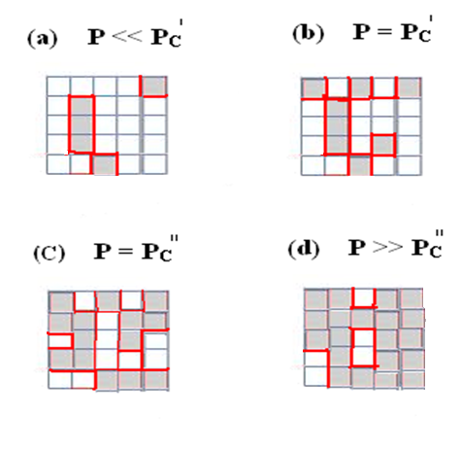Fig. 1.7 The two-phase mixture on a square lattice for different concentrations P of the insulating material, represented by the shaded regions. The highly conducting bonds are marked by bold lines.
In order to determine the total conductivity of the composite conductor quantitatively they mapped three resistor model on random walk. As per which walker jumps between nearest neighbor sites that correspond to the end points of the bonds. The three jump rates τ_{A}⁻¹, τ_{B}⁻¹ and τ_{C}⁻¹ = 0 which are proportional to respective conductance corresponding to the three types of bonds. The probability π_{δ} that the walker takes a step from a given site to its nearest neighbour in the direction δ is proportional to the jump frequency τ_{δ}⁻¹ which takes the values τ_{A}⁻¹,τ_{B}⁻¹ or τ_{C}⁻¹=0 depending on the type of bond considered.
Since

Where Z denotes the number of nearest neighbors in the lattice. After N_{A} steps along A bonds and N_{B} steps along B bonds the total time elapsed is given by
t = N_{A} τ_{B} + N_{B} τ_{B} (3.11)
For large values of t, the mean square displacement < r²(t) > of the walker is proportional to Dt, where D is the diffusion constant proportional to total conductivity according to the Nernst-Einstein relation. Therefore, from the asymptotic behavior of <r²(t)> one can determine the total conductivity of the system.
In most cases the asymptotic regime of the walk where <r²(t)>≈Dt, was reached at typically t=10³ for p<<P''_{C} at t=10⁴-10⁵ for P < P''_{C}. In this model the conductivity for d=3 gives rise to broader curves compared to that of d=2 in conductivity Vs concentration of dispersoid since the value of P'_{C} for d=2 is larger than that for d=3. So, the difference P''_{C} - P'_{C} = 1- 2P'_{C} is correspondingly smaller.

In the case of very small concentrations where the composite is made of highly diluted insulating particles immersed in the conducting matrix, it is expected that an approximation for diffusion constant is obtained by averaging over hopping times
D⁻¹ α P_{B}^{(B)} τ_{B} + P_{B}^{(A)} τ_{A} (3.12)

Here P_{B}^{(A)} and P_{B}^{(B)} are the bond fractions. From this the conductivity (σ) normalized by its value σ ₀ in the pure conductor is found as

σ(P) / σ₀ = 1- P[1+(τ-1/τ) 2^{d-1}.P] (3.13)

where d can take values 2or 3. It is obvious from this eqn. that conductivity does not depend on τ for τ →α. This results reflects that σ(P) saturates to a finite value for increasing τ at smaller concentrations. The calculated values of maximum in the conductivity, σ_{max,} in composite as a function of τ suggests a power law
σ_{max}/ σ₀ = τ^{α} (3.14)
where α= 0.7 for 2 and α=1 for d=3.
The approximate proportionality between σ_{max} and τ for d=3 reflects that most of the bonds are highly conducting near P = 1/2. These results for d=3 model compared with experimental data for LiI-Al₂O₃ system showed a good agreement.

This model also predicts the dependence of the activation energy on the concentration P of the insulating phase which agrees remarkably well with experiments of chen et al in (1985) which suggests a practical way to determine the threshold concentration P'_{c} for a given material. This model successfully explains the concentration dependence of conductivity and the decrease in the activation energy in these systems. This model accounts well for effects of the physical nature (size and shape) of the dispersoid and bulk conductivity of the host-matrix in conductivity enhancement, however, only at P≈50 vol%.

I.5 A NOTE ON ALUMINA

Alumina (Al2O3) or Aluminum Oxide is the only oxide formed by the metal aluminum and occurs in nature as the minerals corundum (Al2O3); diaspore (Al2O3•H 2O), gibbsite (Al2O3•3H2O) and most commonly as bauxite [76]. Oxide activities of some insulating materials such as γ- Al₂O₃, SiO₂ and α - Al₂O₃ are in decreasing order as per Maier [66]. Characteristic of alumina is that in the form of α- alumina, it is an extremely hard material. It is the next hardest material to diamond and as a result has two characteristics: it is extremely stable under high temperatures, high pressure conditions and is an excellent grinding medium in a rector or in pumps, valves, or transfer lines. This property of alumina lends itself for use as an abrasive material. Another useful property of the material is its high melting point, i.e., above 2000°C (3632°F), which makes it useful as a refractory and as linings of special furnaces. Cubic γ-Al₂O₃ has important technical applications and used as a catalyst.
STRUCTURE OF GAMMA ALUMINA
Gamma alumina is cubic with space group Fd-3m and is based on an fcc . . .ABCABC. . . stacking of oxygen. The first two layers of gamma alumina are shown in figure 3.8. The structure is often described as a defect cubic spinel structure with vacancies on part of the cation positions. Each unit cell contains 32 oxygen and 64/3 aluminium ions to fulfill stoichiometry. The aluminium ions occupy both octahedral and tetrahedral positions, but the relative partial occupancy in each position is still a matter of dispute.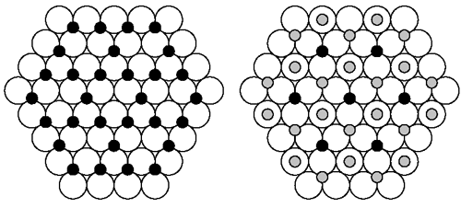
Fig 1.8 Schematic structures of the first two layers in the gamma alumina.
PHYSICOCHEMICAL PROPERTIES OF ALUMINA

Two important physicochemical properties that occur during impregnation of an alumina support with an aqueous solution containing different metallic salts are described below.

Wettability: When the alumina comes into contact with an aqueous solution, the water quickly penetrates into the pores of the support under the influence of capillary forces [76]. A portion of air present in the porosity will be entrapped and compressed under this influence. The hydrophilic nature of the surface of the alumina, combined with the presence of micro pores, induces very high capillary pressures inside the pellet.

Exothermicity: The adsorption of water on the surface of the alumina generates a release of heat. The importance of this phenomenon depends on the structure, the specific surface area, and the degree of dehydration of the support [77-81].

AMPHOTERIC NATURE OF ALUMINA

The most striking feature of alumina is its amphoteric nature, i.e., it has a dual nature wherein it can act as an acid in a basic medium or as a base in an acid medium. Freshly calcined alumina will rehydrate and rehydroxylate itself at ambient temperature in the presence of moist air. This phenomenon corresponds to the dissociative adsorption of water, leading to the creation of OH⁻ groups. These hydroxyl groups of alumina may feature amphoteric behavior in aqueous medium [82-85]. This characteristic translates into different ionizations of the OH⁻ groups according to whether the impregnation solution is acidic or basic.

When alumina is in a medium of Ba(NO₃)₂ : KNO₃ mixed system either of these two events take place. Increasing adsorption of nitrate anions towards the acid medium without the adsorption of K⁺ cations or increasing adsorption of K⁺ towards the basic pH without adsorption of nitrate anions. The pH zone for which the alumina is in balance with impregnation solution is between 8.5 and 9 that correspond to the point of zero charge of alumina (pH_{pzc}).These ion-adsorbing properties of alumina may be profitably taken advantage of to obtain an atomic dispersion of the metallic precursor of the active phase that is to be deposited on the alumina [86-87].

APPLICATIONS OF ALUMINA

More than 90% of alumina produced worldwide is utilized in the production of Aluminum. This is because converting the naturally occurring bauxite into alumina is the necessary first step before it can be converted into Aluminum. The varied applications of alumina are due to its abundance and its multiple forms as well as its properties of stability, purity, refractoriness, and chemical inertia (Ibid.) The applications of Alumina are too many to be covered in this paper. Some of these are described briefly below:

- As an Insulating Material

The dielectric and excellent thermal shock properties of Alumina make it an excellent choice as an insulating material. For applications in very high frequencies (UHF), high purity dense alumina, fired at temperatures above 1600°C, is generally used. Examples are applications for television or satellite transmitter tubes or for microwave generators for heating, or for powerful lasers. (The World of “Alumina” the application of dielectric ceramics)

- Electronics

Alumina is widely used in the electronics industry for passive components such as interconnection, capacitors and resistances, and is specifically employed in applications such as substrates for hybrid circuits, multi-layer interconnection circuits, hyper frequency resonators and materials for type II condensers.

- Mechanical Ceramics

Due to their excellent mechanical properties, alumina-based ceramics are being increasingly used as a substitute material for several applications. These include the use of ceramic for abrasive and cutting tools. Alumina-based ceramics are also used for making extrusion and sanding nozzles and for parts of machinery (particularly in the mining industry) where wear resistant qualities are critical. They are also used for making ice-skate blades and some friction parts such as wear-resistant seals in piston engines.

I.6 A NOTE ON SILICA

Silicon dioxide, also known as silica, is a chemical compound that is an oxide of silicon with the chemical formula SiO₂. Silica is the name given to a group of minerals composed of silicon and oxygen, the two most abundant elements in the earth's crust. Silica is found commonly in the crystalline state and rarely in an amorphous state. There are three crystalline forms of silica; quartz, tridymite, cristobalite and there are two variations of each of these (high and low). (Here the structures of silica is not discussed because the material what we have chosen is in amorphous state). It is composed of one atom of silicon and two atoms of oxygen resulting in the chemical formula SiO₂. It is one of the most common minerals in the earth.

The combination of the relatively good electrical properties of silicon, the excellent insulating properties of SiO₂, and the low-defect interface between them is the key ingredient of modern integrated circuit electronics. Silica will also rehydrate and rehydroxylate itself at ambient temperature in the presence of moist air. This phenomenon corresponds to the dissociative adsorption of water, leading to the creation of OH⁻ groups. These hydroxyl groups of silica may feature amphoteric behavior in aqueous medium. When silica is in a medium of Ba(NO₃)₂ : KNO₃ mixed system two events will take place. They are either the increasing adsorption of nitrate anions towards the acid medium without the adsorption of K⁺ cations or increasing adsorption of K⁺ towards the basic pH without adsorption of nitrate anions.

PHYSICOCHEMICAL PROPERTIES
Silica has good abrasion resistance, electrical insulation and high thermal stability. It is insoluble in all acids with the exception of hydrogen fluoride (HF). The Physical and Chemical Properties are the characteristics of a substance, which distinguishes it from any other substance.
APPLICATIONS

Silica is a fairly widely used ceramic material both as a precursor to the fabrication of other ceramic products and as a material on its own. Silicon is the principal component of glass, cement, ceramics, most semiconductor devices, and silicones, the latter a plastic substance often confused with silicon. Silicon is also an important constituent of some steels and a major ingredient in bricks.

Elemental raw silica and its intermetallic compounds are used as alloy integrals to provide more resistance to the aluminum, magnesium, copper and other metals. Metallurgic silicon with 98-99% purity is used as raw material in the manufacture of t4 organosilicon and silicon resins, seals and oils. Silica chips are used in integrated circuits. Photovoltaic cells for direct conversion of solar energy use thin cut slices of simple silicon crystals of electronic grade.

Silicon dioxide is used as raw material to produce elemental silicon and silicon carbide. Melted quartz sands are transformed in silicon glasses which are used in laboratories and chemical plants, as well as in electric insulators. Silica has extremely good dielectric and insulating properties. For these reasons it is used as an inert, low expansion filler material for epoxy resins in electronic circuits. Due to its chemical and physical properties, it is a very reactive pozzolan. Concrete that contains silica can have very high strength and be very durable. Silica fume consists of amorphous silicon dioxide. Each individual particle of silica fume is very small in the order of 1/100th the size of a cement particle. Silica fume is also used as a filler material in refractory concretes, where its function is to improve the particle packing of the product increasing strength and reducing porosity.
I.7 A NOTE ON CERIA (CeO₂)

Cerium oxide also known as ceric oxide, ceria, cerium oxide or cerium dioxide, is an oxide of the rare earth metal cerium. It is a pale yellow white powder with the chemical formula CeO₂.

STRUCTURE OF CERIA

Cerium oxide has the fluorite structure (Figure 3.9), containing 8 coordinate Ce⁴⁺ and 4 coordinate O^{2–}. In the most stable fluorite phase of ceria, it exhibits several defects depending on partial pressure of oxygen or stress state of the material. The primary defects of concern are oxygen vacancies and small polarons (electrons localized on cerium cations) because these two are located in the "useful" range of ceria. In the case of oxygen defects, the increased diffusion rate of oxygen in the lattice causes increased catalytic activity as well as an increase in ionic conductivity, making ceria interesting as a fuel cell electrolyte in solid-oxide fuel cells.
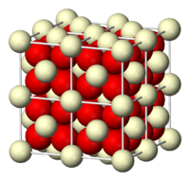
Fig 1.9 Flourite structure of CeO₂.

Cerium is found in the minerals such as synchysite, bastnasite, hydroxylbastnasite, allanite, rhabdophane, monazite, and zircon. Cerium oxide is an oxide of the rare earth metal cerium. Cerium oxide nanoparticles appear in a brown to yellow powder form.

PROPERTIES

Nano-size effects: With a decrease in particle size, ceria nanoparticles demonstrate the formation of more oxygen vacancies[88]. The large surface area to volume ratio existing in a nanoparticle enables CeO₂ to act catalytically, commonly resulting in unique properties. Moreover, nanocrystalline CeO₂ materials also possess some other new properties compared to the coarsened bulk materials, such as the enhanced electronic conductivity[89].

Material properties: CeO₂ crystallizes in the fluorite crystal structure with space group Fm₃ over the temperature range from room temperature to the melting point. The fluorite structure consists of a face-centered cubic (f.c.c.) unit cell of cations with anions occupying the octahedral interstitial sites.

APPLICATIONS

Cerium oxide is used in ceramics, to sensitize photosensitive glass, as a catalyst and as a catalyst support, to polish glass and stones. Cerium oxide has found use in infrared filters, as an oxidizing species in catalytic converter.

Fuel cell electrolyte: Ceria is of interest as a material for solid oxide fuel cells (SOFC) because of its relatively high oxygen ion conductivity (i.e. oxygen atoms readily move through it) at intermediate temperatures (500–650°C). Undoped and doped ceria also exhibit high electronic conductivity at low partial pressures of oxygen due to reduction of the cerium ion leading to the formation of small polarons. This increases the ionic conductivity and results in a better electrolyte.

Catalyst: Ceria has been used in catalytic converters in automotive applications. Since ceria can become non-stoichiometric in oxygen content (i.e. it can give up oxygen without decomposing) depending on its ambient partial pressure of oxygen, it can release or take in oxygen in the exhaust stream of a combustion engine. Ceria is particularly interesting for catalytic conversion economically because it has been shown that adding comparatively inexpensive ceria can allow for substantial reductions in the amount of platinum needed for complete oxidation of NO_{x} and other harmful products of incomplete combustion.

Due to its fluorite structure, the oxygen atoms in a ceria crystal are all in a plane with one another, allowing for rapid diffusion as a function of the number of oxygen vacancies. As the number of vacancies increases, the ease at which oxygen can move around in the crystal increases, allowing the ceria to reduce and oxidize molecules or co-catalysts on its surface. It has been shown that the catalytic activity of ceria is directly related to the number of oxygen vacancies in the crystal, frequently measured by using X-ray photoelectron spectroscopy to compare the ratios of Ce₃⁺ to Ce₄⁺ in the crystal.

Ceria can also be used as a co-catalyst in a number of reactions, including the water-gas shift reaction and steam reforming of ethanol or diesel fuel into hydrogen gas and carbon dioxide, and selected oxidation (particularly with lanthanum). In each case, it has been shown that increasing the ceria oxygen defect concentration will result in increased catalytic activity, making it very interesting as a nanocrystalline co-catalyst due to the heightened number of oxygen defects as crystallite size decreases at very small sizes, as many as 10% of the oxygen sites in the fluorite structure crystallites will be vacancies, resulting in exceptionally high diffusion rates.

REFERENCES

      - R.W.G. Wyckoff, ‘Crystal structures’, Interscience pblishers, 2,(1964), 480.
      - R.W.G. Wyckoff, ‘Crystal Structures’ InterScience Publishers,1,(1963),239.
      - L.Vegard, Z. Phys., 395,(1922), 410.
      - R. Birnstock, Z. Krist., 124, (1967), 310.
      - A.M. Bon, C. Benoit and O. Bernard, Phys. Stat. Sol.(b), 78, (1976),67.
      - R.Srinivasan, Proc. Indian Acad.Sci., 41A, (1955), 49.
      - Sawada, S., Nomura, S. & Fujii, S. (1958). J. Phys. Soc. Jpn, 13, 1549.
      - M K Aydinol, JVMantese and S P Alpay, J. Phys. Condens. Matter, 19, (2007), 210-23.
      - V.M. Patrov, N.I. Giricheva, V.N Petrova and G.V. Girichev Journal of structural chemistry,4,(1991), 494-498.
      - Sawada, S., Nomura, S., Fujii, S., J. Phys.Soc. Japan, 13, (1958),1549.
      - Sawada, S., Nomura, S., Asao, Y., J. Phys.Soc. Japan, 16, (1961), 2486.
      - Nolta, J.P., Schubring, N.W., Phys. Rev.Lett., 9, (1962), 285.
      - Nolta, J.P., Schubring, N.W., Dork, R. A., J.Chem. Phys., 42, (1965), 508.
      - M K Aydinol, JVMantese and S P Alpay,, Journal of physics: Condensed matter 19, (2007), 496210, (23pp).
      - Neeraj Kumar, , Rabinder Nath, J. Mater. Environ. Sci. 2(4), (2011), 379-386 ISSN: 2528-2028.
      - H.G. MCADIE, Thermal Analysis (Proc. Of the 3rd ICTA, Davos, 1971), Birkhauser, Basel, 1, (1972), 591.
      - A.S. Lidiard, Hdb.Phys.Springer-Verlag, 20, (1957).
      - J.Rolfe, Can.J.Phys.48, (1964),2195.
      - M.M. Nekrasov, B.M. Belyakov and M.K. Rodionov, IZV.VUZ.FIZ (USSR) 4, (1967),11.
      - N. Nadler and Rossel, Phys. Stat. Solidi (a), 18, (1973), 711.
      - W. Lehfeldt, Z. Physik 85, (1933),717.
      - T.E. Phipps and E.G. Patridge, J. Am. Chem. Soc. 51, (1929), 1331.
      - H. Kelting and H. Witt, Z. Physik 26, (1949),197.
      - J.E. Ambrose and W.E. Wallace, J. Phys. Chem. 63, (1959),1536.
      - H. Schultze, Thesis university of Gottingen (1952).
      - Yu. M. Annenkov and V. A. Grishukov, IZV. VUZ. FIZ (USSR), 74, (1967),11.
      - J. Arends, H.W. Den Hartog and A.J. Dekker, Phys. Stat. Solidi 10, (1965),105.
      - E. K. Zavadowskaya, J.S. Ivankina and I. Ya. Melik Gaikazyan, IZV. VYW. UCHAB, ZAB. FIZ, 12, (1970),92.
      - U.V.Subbarao and V.Haribabu, Crystal Lattice defects, 8, (1978), 21-26.
      - P. Veeresham, Dr. U. V. Subba Rao, Dr. V. Hari Babu, 18,12, (1983),1581-1584.
      - K. Shahi, J.B. Wagner Jr., Journal of physics and chemistry of solids, 43, 8 , (1982),713-722.
      - S.L. Garud and K.B. Saraf, Bull Mater. Sci, 31, 4, (2008),639-643.
      - C.M. Padma, C.K. Mahadevan, Materials and Manufacturing Processes, 23, 2, (2008), 143-150.
      - Jayaram, “ Optics and spectroscopy part 1 Tm,” Tn Tbs, New Delhi, (1972).
      - J. Kudnovsky, N.E. Christensen, J. Masek, Physical Review B, 43, (1991), 15.
      - Wen-Ming Chien, Dhanesh Chandra, Jennifer Franklin, Claudia J. Rawn and Abdel K. Helmy, JCPDS, 48, (2005).
      - Jander, W., Z.Angew. Chem., 42,(1929),462.
      - Wanger,C., J.Phys.Chem.Solids, 33, (1972),1051.
      - Crosbie, G., J Solid state Chem., 25,(1978),367
      - Liang, C.C., J.Electrochem.Soc., 120,(1973),1289.
      - Liang, C.C., and Bernette, L.M., J.Electrochem.Soc., 123 no.4, (1976),453-458.
      - S.Pack, Abstract No.133, Electrochemical Society meeting, Los Angels,(1979).
      - Takeshi Asai, Ching-Hsing Hu and Shichio Kawai, mat. Res.Bull.,22,(1987),269-274.
      - Takeshi Asai, Ching-Hsing Hu and Shichio Kawai, Solid State Ionics, 26,(1988),1-4.
      - Takeshi Asai, and Shichio Kawai, Solid State Ionics, 34,(1989), 195-199.
      - Liquan Chen, Zonguan Zhao, Chaoying Wang and Lizirong Kexue Tongbo, 26,(1981),308.
      - Nakamura,O.and Goodenough,J.B., Solid State Ionics, 7,(1982),125-128.
      - Slade,C.T. and Thompson, M.,Solid State Ionics, 26,(1988),287-294.
      - Shiuli Gupta, patnaik, S., Chaklanobis, S. Chaklanobis, S. and Shahi,K., Solid state Ionics,31,(1988),5-8.
      - Takeshi Asai and Shichio Kawai, Solid State Ionics, 20,(1986),225-229.
      - Fujitsu,S., Miyayama,M., Koumoto,K. and Yanagida,H., J.Mat.Sci., 20,(1985),2103-2109.
      - Kandkar,A., Tare,V.B. and Wagner,J.B., Revue de Chemie Minerale, t.23,(1986),274.
      - Wen,T.L., Huggins,R.A., Rabenau,A. and Weppner, W., Revue de Chimie Minerale, 20,(1983),643.
      - Vaideshi,N., Akila, R., Shukla,A.K. and Jacob,K.T., Mat.Res.Bull., 21,(1986),909.
      - Fujitsu,S., Koumoto,K. and Yanagida,H., SolidState Ionics, 18 and 19,(1986),1146-1149.
      - Shukla,A.K., ManoharanR. And Goodenough,J.B., SolidState Ionics,26,(1988),5-10.
      - S.Narender Reddy, A.Sadananda Chary and T.Chiranjivi, Solid State Ionics 34,(1989),73-77.
      - S.N.Reddy, and A.S.Chary and T.Chiranjivi, J. of Materials sci-Mat. In Electronois.
      - S.Narender Reddy, A.S.Chary and T.Chiranjivi, Solid State Ionics, 66,(1993),131.
      - shahi,k. and wagner, J.B., J.Solid State Chem.41,(1982),107.
      - Jow and Wagner, J.B., J.Electrochem.Soc. 126,(1979),163.
      - Chowdary,P., Tare,V.B. and Wagner J.B., J.Electrochem.Soc.,(1985),123-124.
      - K.L.Kliewer, J.Phys.Chem.Solids, 27,(1966),705.
      - Maier,J., Phys.Stat.Sol(b), 123,(1984),K89.
      - Maier,J., J.Mat.Res.Bull., 20,(1985),383-392.
      - Maier,J., Prog.Solid.State Chem., 23,(1995).
      - N.J.Dudney, J.Amer.Ceram.Soc., 68,(1985),538.
      - J.C.Wang and N.J.Dudney, Solid State Ionics, 18-19,(1986),112.
      - A.Bunde, W.Dicterich and E.Roman, Phys.Rev.Lett.,55,(1985),5.
      - A.Bunde, W.Dieterich and E.Roman, Solid State Ionics, 18-19,(1986),147.
      - A.Bunde, Solid State Ionics, 75,(1995),147.
      - E.Roman, A.Bunde and W.Dieterich, in “transport Structure Relations in Fast ion and Mixed Conductors “ edited by F.W.Poulsen, N.H.Andersen, K.Clausem, S.Skaarup and O.T.Sorensen, Rise National Laboratory, Roskilde, Denmark, (1986),165.
      - E.Roman, A.Bunde and W.Dieterich, Phys.Rev.,B34,(1986),3439.
      - R.Blender and W.Dieterich, J.Phys.,C20,(1987),6113.
      - R.Blender and W.Dieterich, Solid State Ionics, 28-30,(1988),82.
      - Regis Poisson, Jean-Pierre Brunelle, and Patrice Nortier,“Catalyst Supports and Supported catalysts” Theoretical & Applied Concepts ed. By Alvin B.Stiles, Butterworth Publishers, 80 Montvale Avenue, Stoneham, MA(1987) ,11-55.
      - W.H.Wade and N.Hackerman. J.Phys.Chem.,64,(1960),1196.
      - D.S.Maliver, H.H.Tobin, and R.T.Barth. J.Catal.,2,(1963),485.
      - T.W.Healy and D.W.Fuerstenau, J.Colloid.Interface Sci.,20,(1965),376.
      - D.A.Griffiths and D.W.Fuerstenau. J.Colloid.Interface Sci.80(1981)271
      - T.Morimoto, K.Shiomi, and H.Tarnaka, Bull.Chem.Soc. Japan, 37,(1964),392.
      - G.A.Parks. Chem.Rev.,65,(1965),177.
      - C.P.Huang and W.Stumm. J.Colloid.Interface Sci.43,(1973),409.
      - L.Wang and W.K.Hall. J.Catal., 66,(1981),251.
      - H.P.Bochm. Discuss. Faraday Soc., 52,(1971),264.
      - H.A.Benesis, R.M.Curtis. and H.P.Studer J.Catal., 10,(1968),328.
      - J.P.Brunelle. Pure Appl.Chem., 50,(1978),1211.
      - S.Deshpande, S. Patil, S. V. N. T. Kuchibhatla and S. Seal, Appl. Phys. Lett., 87,(2005), 133-113.
89) Y. M. Chiang, E. B. Lavik, I. Kosacki and H. L. Tuller, J. Electroceram.,1,(1997), 7–14.

